PROJECT IMPLEMENTATION ROADMAP
NAGIPGS
Technology Stack, Database Design & Phase-by-Phase Build Plan
A complete starting reference for the development team
Single-database architecture: PostgreSQL + PostGIS + pgvector
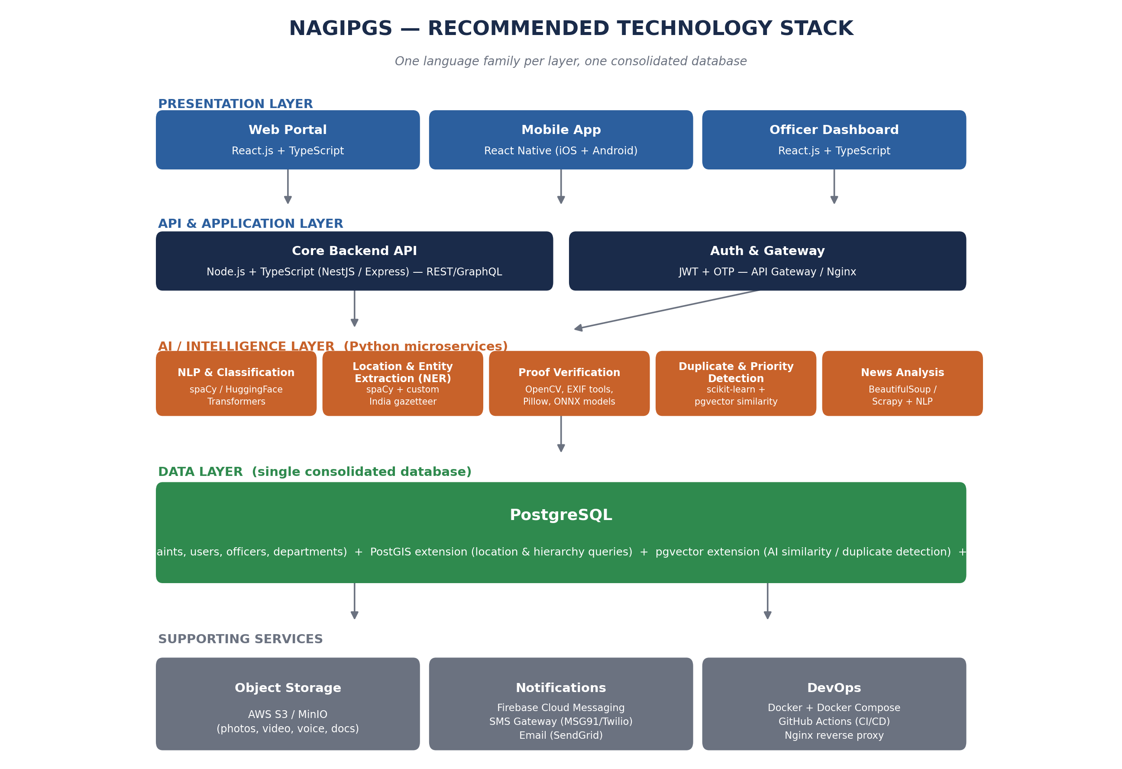
Version 1.0 | 31 July 2026

1. Purpose of This Document
This document gives the development team everything needed to start building NAGIPGS: the recommended technology stack, the single-database design, a phase-by-phase build plan with realistic durations, and a full checklist of requirements — technical, infrastructural, and human — needed to take the project from an empty repository to a working pilot deployment.

2. Recommended Technology Stack
One consolidated database (PostgreSQL) and a small, consistent set of languages per layer — this keeps the codebase maintainable for a small-to-medium team rather than requiring specialists in ten different systems.
Figure 1 — Full technology stack, from citizen-facing apps down to the single database.

2.1 Languages & Frameworks by Layer
Layer | Language / Framework | Purpose
Web Portal (Citizen + Officer) | TypeScript + React.js | Responsive web app for complaint submission and the officer dashboard
Mobile App | TypeScript + React Native | iOS/Android app so citizens can report from anywhere, with camera/mic/GPS access
Core Backend API | TypeScript + Node.js (NestJS or Express) | Handles complaints, users, notifications, hierarchy/routing logic
AI / Intelligence Services | Python (FastAPI) | NLP, classification, entity extraction, proof verification, news analysis — run as separate microservices
Database | SQL (PostgreSQL) | All structured data, geolocation, and AI embeddings in one place
DevOps / Infrastructure | YAML (Docker Compose), Bash | Containerization, environment configuration, deployment scripts

2.2 Why Two Backend Languages (Node.js + Python)
A single backend language would be simpler, but Python's AI/ML ecosystem (spaCy, HuggingFace Transformers, OpenCV, scikit-learn) is significantly ahead of Node.js's for this project's core AI requirements. The recommended split:
- Node.js (TypeScript) — the main application API: complaints, users, notifications, dashboards. Fast, widely used, easy to hire for.
- Python (FastAPI) — a separate internal AI service that the Node.js API calls over HTTP for classification, location extraction, and proof verification.
- If the team strongly prefers one language, Python alone (Django/FastAPI for everything) is a workable single-language alternative — slightly slower to build the citizen-facing apps, but avoids maintaining two backend codebases.

3. Database Design — Single PostgreSQL Instance
As agreed, the project uses one consolidated database: PostgreSQL, extended with PostGIS (geospatial data) and pgvector (AI similarity search). This avoids operating multiple database systems while still covering every requirement in the project.
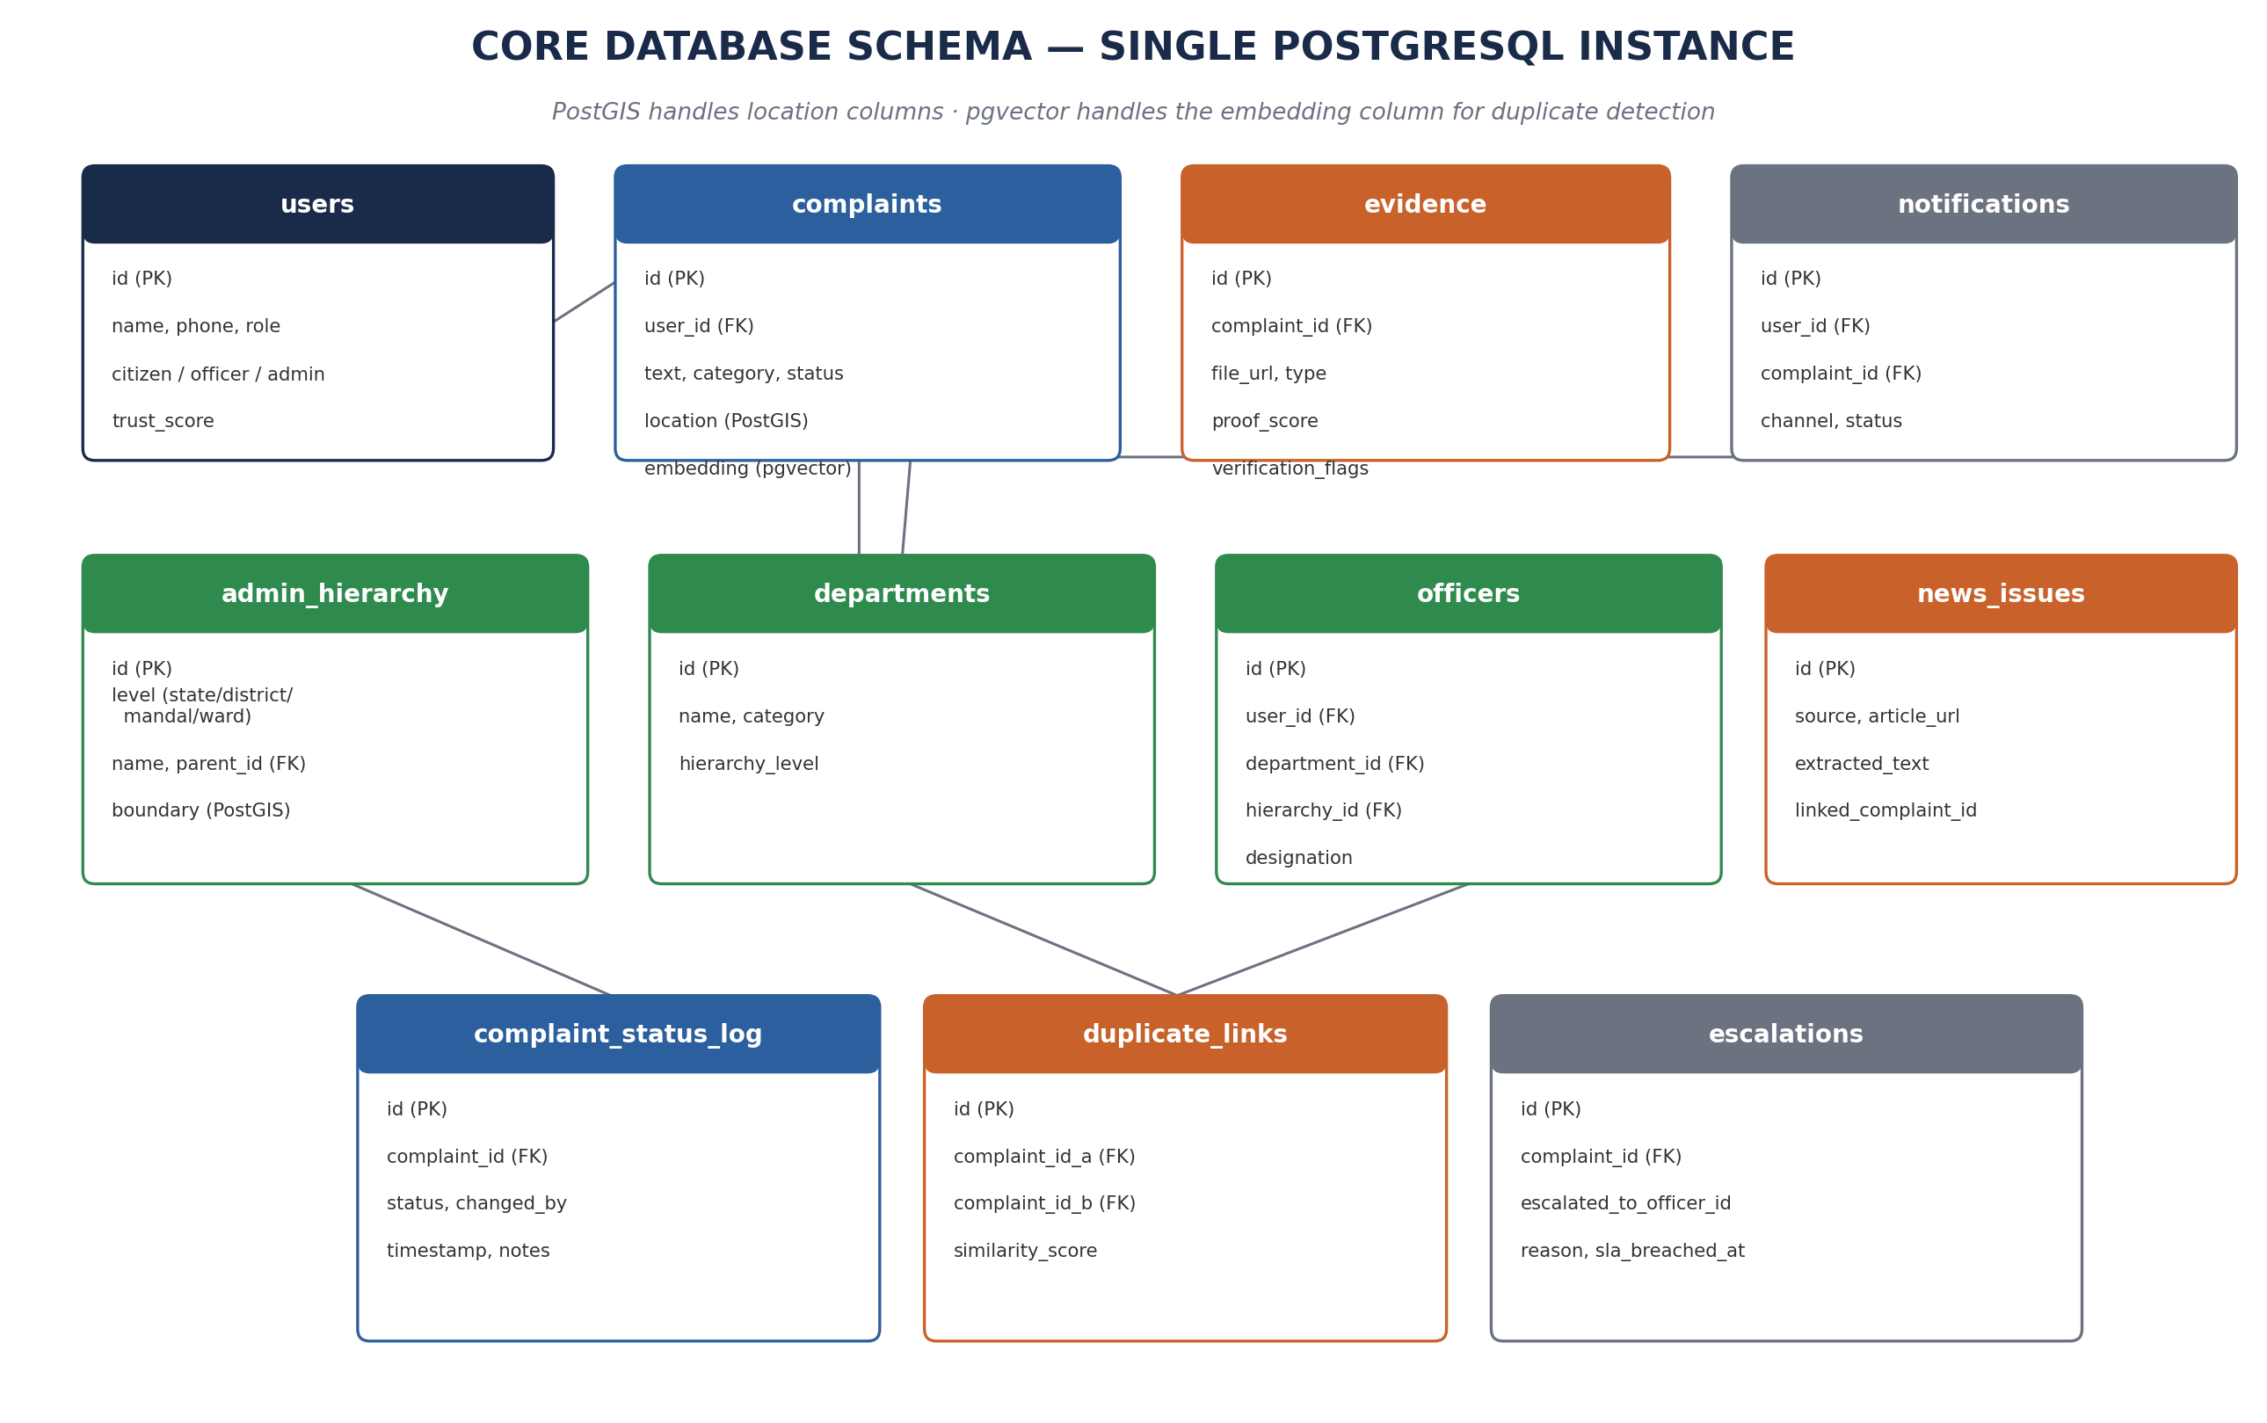
Figure 2 — Core schema. Every table lives in the same PostgreSQL instance; PostGIS and pgvector are extensions, not separate servers.

3.1 Core Tables
Table | Purpose
users | Citizens, officers, and admins — one table with a role column and a trust_score for citizens
complaints | The core record: text, category, status, PostGIS location point, pgvector embedding for duplicate detection
evidence | Photos/video/voice/document references (file stored in object storage; only the URL and proof_score live here)
admin_hierarchy | Self-referencing table for State → District → Mandal → Ward, each with a PostGIS boundary
departments | Configurable department list (Roads, Water, Police, Health, etc.)
officers | Links a user to a department and a hierarchy node — this is what routing resolves to
news_issues | Issues extracted from monitored news sources, optionally linked to an auto-generated complaint
complaint_status_log | Full audit trail of every status change, for traceability
duplicate_links | Pairs of complaints flagged as likely duplicates, with a similarity score
escalations | SLA-breach records and who a complaint was escalated to

3.2 Required PostgreSQL Extensions
Extension | Enables
postgis | Storing location as real geographic points/boundaries; distance and “nearest officer” queries
pgvector | Storing AI-generated embeddings and running similarity search for duplicate-complaint detection
pg_trgm (built-in contrib) | Fuzzy text matching, useful for searching place names and departments with typos

4. Phase-by-Phase Build Plan
Thirteen phases, roughly ordered by dependency. Phases 4–9 can run partly in parallel across sub-teams once the database schema (Phase 2) and auth (Phase 3) are stable.
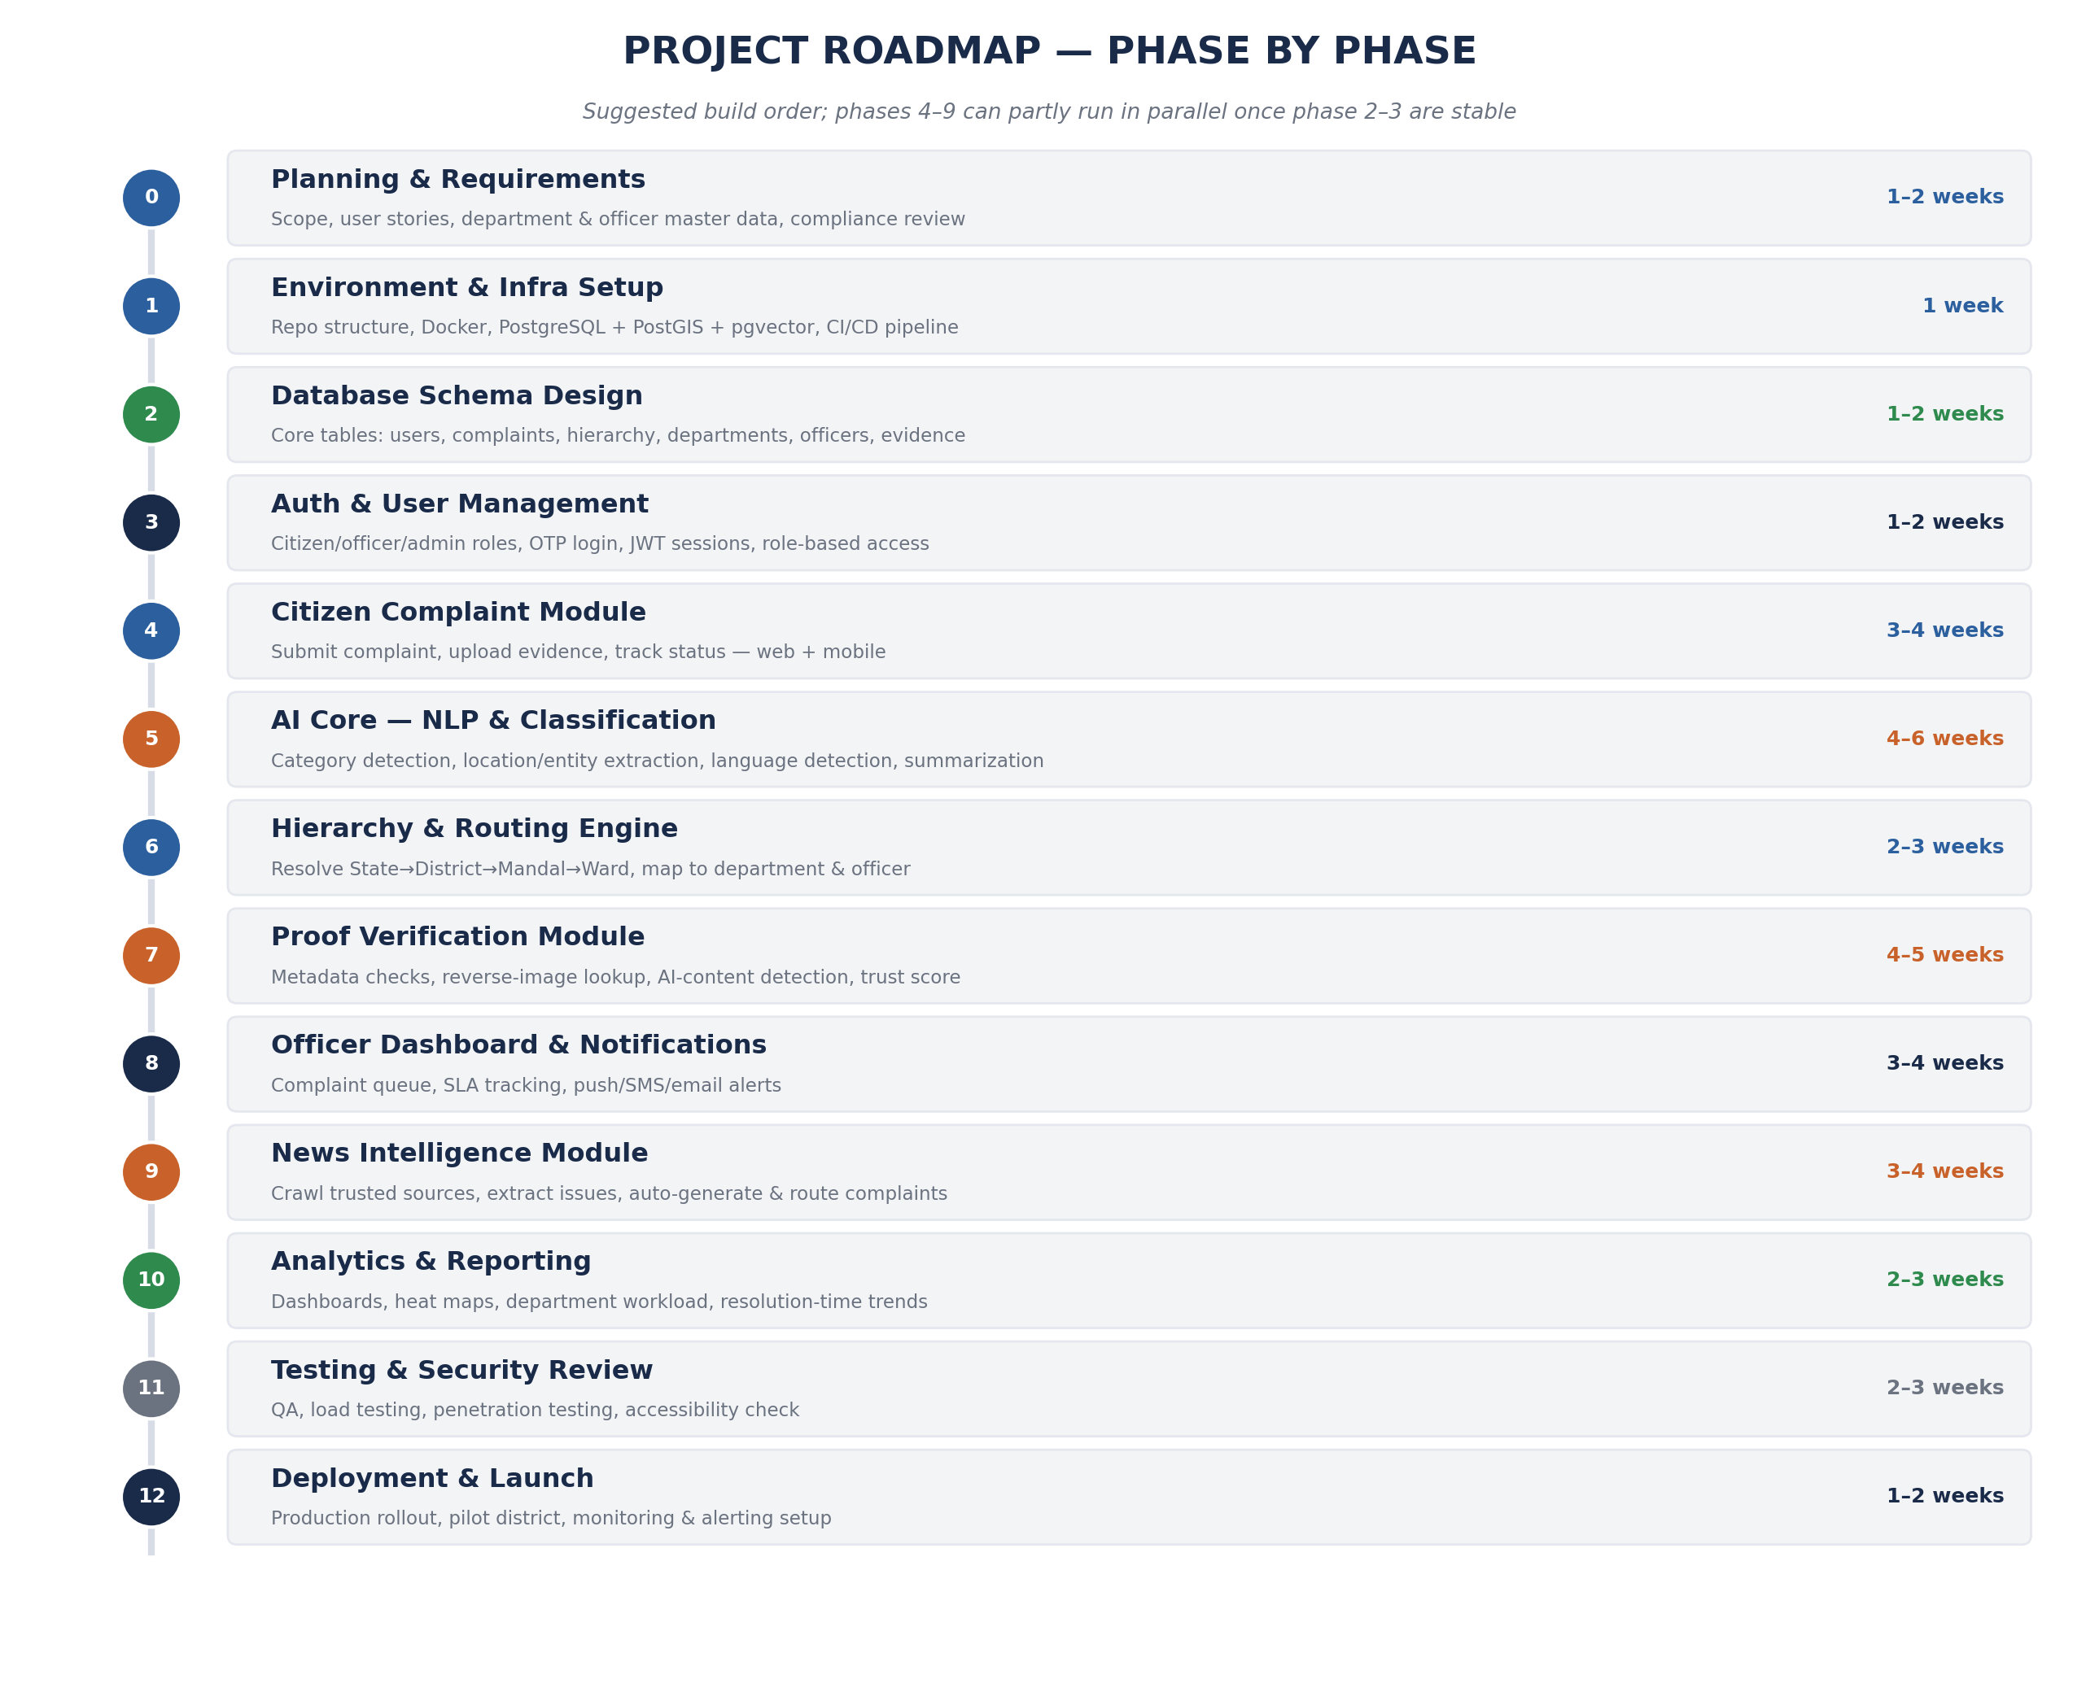
Figure 3 — Suggested phase sequence with estimated duration for a small team.

4.1 Phase Details
Phase | Key Deliverables | Primary Tech
0. Planning & Requirements | Finalized user stories, department/officer master data, data-privacy & compliance review | Documentation, stakeholder interviews
1. Environment & Infra Setup | Git repo structure, Docker Compose with PostgreSQL, base CI/CD pipeline | Docker, GitHub Actions
2. Database Schema Design | All core tables created with migrations; PostGIS & pgvector enabled | PostgreSQL, SQL migration tool (e.g. Prisma or Alembic)
3. Auth & User Management | OTP login, JWT sessions, citizen/officer/admin roles, role-based access control | Node.js, JWT, SMS gateway
4. Citizen Complaint Module | Submit complaint with photo/video/voice/text, track status, web + mobile | React, React Native, Node.js API
5. AI Core — NLP & Classification | Category detection, location/entity extraction, multilingual support, summarization | Python, FastAPI, spaCy/Transformers
6. Hierarchy & Routing Engine | Resolve complaint location to State/District/Mandal/Ward and the responsible officer | PostGIS, Node.js
7. Proof Verification Module | Metadata checks, reverse-image lookup, AI-content detection, Proof Confidence Score | Python, OpenCV, pgvector
8. Officer Dashboard & Notifications | Complaint queue, SLA tracking, push/SMS/email alerts | React, Firebase Cloud Messaging, SendGrid
9. News Intelligence Module | Crawl trusted sources, extract public issues, auto-generate & route complaints | Python, Scrapy/BeautifulSoup, NLP
10. Analytics & Reporting | Dashboards: complaints by state/district, workload, resolution time, heat maps | SQL aggregation, charting library (Recharts/Chart.js)
11. Testing & Security Review | QA test suite, load testing, penetration testing, accessibility check | Jest/Pytest, OWASP ZAP, k6
12. Deployment & Launch | Production rollout in a pilot district, monitoring & alerting configured | Docker, cloud hosting, Grafana/Prometheus

5. Full Requirements Checklist

5.1 Functional Requirements
- Citizens can register, log in, and submit complaints with photo/video/voice/text evidence
- System auto-detects category, location, and priority from complaint text
- System resolves the correct department and officer through the administrative hierarchy
- System scores submitted evidence and flags low-confidence complaints for review
- Officers receive notifications and can update complaint status through a dashboard
- Citizens receive status notifications and can rate the resolution
- System monitors trusted news sources and auto-generates complaints for detected public issues
- Admins can configure departments, officers, and escalation rules
- Search and analytics available by state, district, department, officer, category, date, and status

5.2 Non-Functional Requirements
- Scalability: architecture must support nationwide usage without redesign (proper indexing, pagination, async processing)
- Security: encrypted data in transit (HTTPS) and at rest; role-based access control; audit logging
- Availability: target uptime suitable for a public government service (e.g. 99.5%+)
- Multilingual support: at minimum, major regional languages relevant to the pilot state(s)
- Accessibility: web and mobile apps usable by people with basic digital literacy and assistive technology
- Data privacy: compliance with applicable Indian data protection regulations for citizen and government data

5.3 Infrastructure & Third-Party Services
Category | Requirement
Hosting | Cloud VM or managed Kubernetes (AWS / Azure / GCP / NIC cloud for government workloads)
Database hosting | Managed PostgreSQL (e.g. AWS RDS) or self-hosted with backups and replication
Object storage | AWS S3 or self-hosted MinIO, with a CDN for media delivery
SMS / OTP gateway | MSG91, Twilio, or a government-approved SMS provider
Push notifications | Firebase Cloud Messaging (free tier sufficient to start)
Email delivery | SendGrid, Amazon SES, or equivalent transactional email service
Domain & SSL | Registered domain + TLS certificate (Let's Encrypt is free and sufficient)
Monitoring & logging | Grafana + Prometheus, or a managed equivalent (Datadog, New Relic)
Version control & CI/CD | GitHub or GitLab, with GitHub Actions / GitLab CI for automated testing and deployment
Map/geocoding data | Open-source India administrative boundary data (e.g. from data.gov.in) + a geocoding API for address lookup

5.4 Suggested Team Roles
Role | Responsibility
Project Lead / Product Owner | Requirements, stakeholder coordination, prioritization across phases
Backend Developer(s) — Node.js | Core API, hierarchy/routing engine, notifications, dashboard endpoints
AI/ML Engineer — Python | NLP classification, proof verification models, news analysis
Frontend Developer(s) — React | Citizen web portal, officer dashboard
Mobile Developer — React Native | Citizen mobile app
Database Administrator | Schema design, indexing, PostGIS/pgvector configuration, backups
DevOps Engineer | Docker, CI/CD, hosting, monitoring, security hardening
QA Engineer | Test plans, automated testing, load and security testing
UX Designer | Citizen-facing and officer-facing interface design, accessibility

6. Suggested Repository Structure
A monorepo keeps related services easy to coordinate during early development; it can be split into separate repositories later if team size grows.
Path | Contents
/apps/web | React.js citizen portal + officer dashboard
/apps/mobile | React Native citizen app
/services/api | Node.js (NestJS) core backend API
/services/ai | Python (FastAPI) AI/NLP/proof-verification microservice
/services/news-crawler | Python news monitoring and extraction service
/database/migrations | SQL migration files for schema changes
/infra | Docker Compose files, deployment scripts, CI/CD configuration
/docs | Architecture documents, API specs, onboarding guides

7. Getting Started — Phase 0 Checklist
Before any code is written, these should be finalized:
- Confirm the pilot scope (which state/district to launch in first)
- Collect and digitize the department and officer master data for the pilot area
- Confirm data-privacy and compliance requirements with the relevant government body
- Set up the Git repository with the folder structure above
- Provision a development PostgreSQL instance with PostGIS and pgvector enabled
- Set up a basic CI/CD pipeline (lint + test on every commit)
- Confirm hosting provider and register the domain

Once these are in place, Phase 1 (Environment & Infra Setup) can begin immediately, followed by the database schema in Phase 2.

