DHA – Digital Image Processing
Nishi Hotani
154029 - 4th Year – Civil
31-10-18

Q. Imporve the Image.

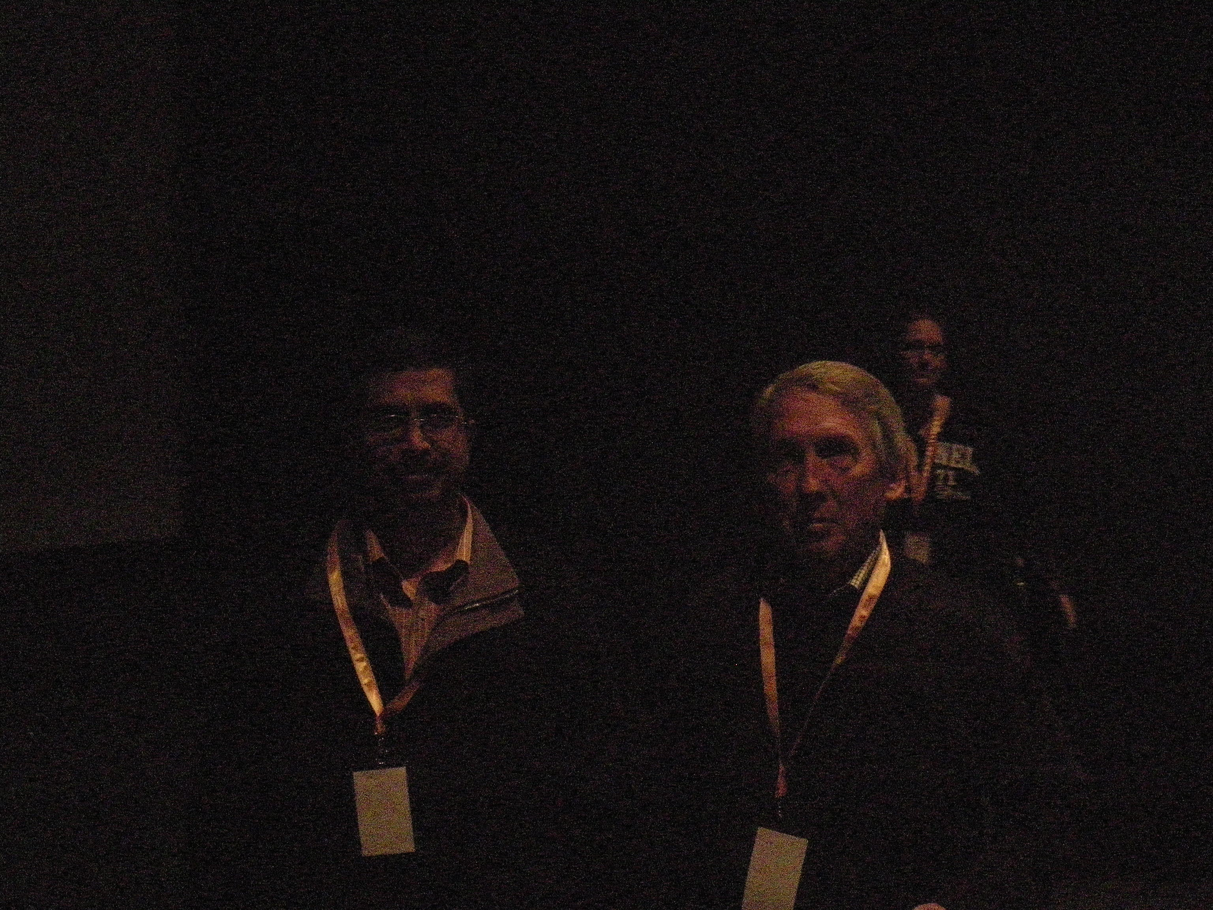
Ans.

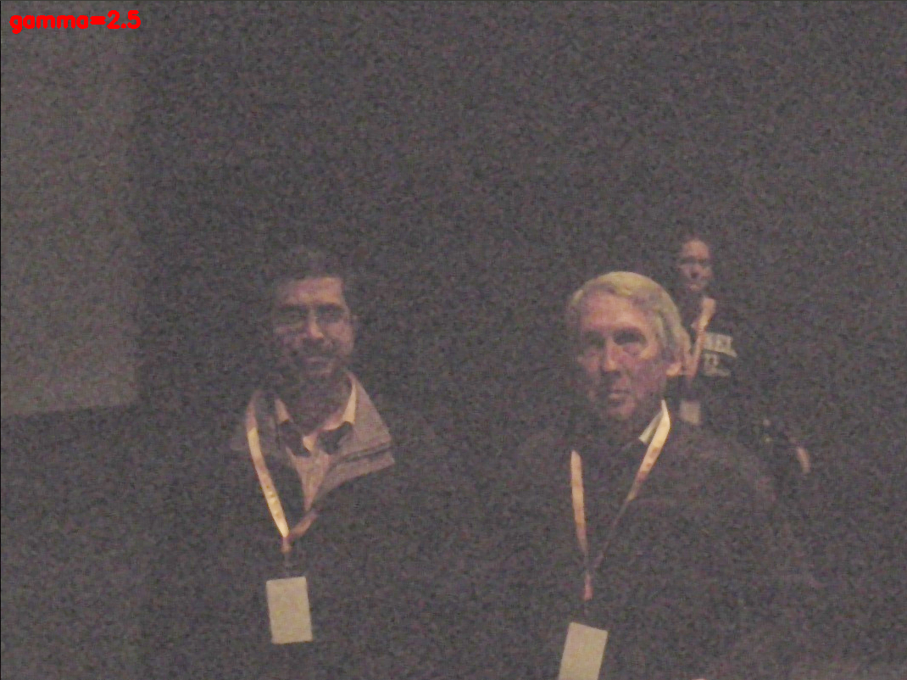
Original Image

After enhancing the image

Firstly i resize the image, then apply median filtering, then apply gamma correction with a factor of 2.5

