**Mid Term Report**

**On**

**Cafeteria Automation System**



Institute of Engineering & Technology

Department of Computer Engineering and Applications

**Submitted by:**

Mudit Mangal(171500194)

Kunal Goyal(171500171)

Mayank Garg(171500185)

Akash Agarwal(171500024)

Under the Supervision of

Ms. Ruchi Gupta

**(Technical Trainer)**

**GLA UNIVERSITY**

**MATHURA-281406,INDIA**

**Abstract**

The main objective of Cafeteria Automation system is to automate the existing manual system with the help of advance computerized software so that valuable data can be stored for longer period with easy accessing and manipulation of the same.

The registered user can access the account with valid credentials. User can surf the food items according to categories. User can track their orders with the food details.

In Cafeteria Automation System Admin can handle the functionalities like add new food items, edit/delete food items, Enable/Disable the food items according to season and availability. Admin have authority to view order details and update the delivery status of food. The various orders details and user details are also viewable to admin.

This website will provide the list of different menu list with different categories. User can select any item from canteen and can order for it by using debit card payment or wallet Payment. It will provide fast services to their college students, Staffs etc.

**Contents**

1.Introduction

1.1 General Introduction to the topic

1.2 Area of Computer Science

1.3 Hardware and Software requirements

2. Problem Definition

3. Objectives

4. Methodology

5. Implementation Details

6. Contribution Summary

7. Progress till date & the Remaining work.

8. References

**Introduction**

**General Introduction of Project :**

The main objective of Cafeteria Automation system is to automate the existing manual system with the help of advance computerized software.

In Cafeteria Automation System Admin can handle the functionalities like add new food items, edit/delete food items, Enable/Disable the food items according to season and availability. Admin have authority to view order details and update the delivery status of food. The various orders details and user details are also viewable to admin.

This website will provide the list of different menu list with different categories. User can select any item from canteen and can order for it by using debit card payment or wallet Payment. It will provide fast services to their college students, Staffs etc.

**Area of Computer Science :**

This project mainly covers the Area of Web Development of Computer Science. Through this project, we are trying to climb one step in this vast field of Computer Science. It is totally of web development project. **Web development** is the work involved in developing a web site for the Internet or an intranet (a private network) Web development can range from developing a simple single static page of plain text to complex web-based internet application. We are trying this kind of thing.

**Hardware and Software Requirements :**

**Hardware Requirements :**

1. A PC minimum of 2GB RAM
2. I3 Based Computer or Higher

**Software Requirements :**

1. One Text editor (VCS, Sublime, Brackets etc.)
2. BootStrap4
3. PHP

**Problem Statement**

The main objective of Cafeteria Automation system is to automate the existing manual system with the help of advance computerized software so that valuable data can be stored for longer period with easy accessing and manipulation of the same. Canteen management system is to provide fast services to their college students, Staffs etc. Usually People have to go to canteen and order the foods and they have to wait in queue for a long time to get the orders. But with the help of this you just have to follow a very simple process to order your stuffs. And you need not to wait in the long queue.

**Objective**

**1.**With this booking system customer can easily choose their respective food items by just a few clicks.

1. To optimize time saving.
2. To ensure easier, reliable and faster booking service.
3. Show information and description of the item.
4. To remove manual work of a waiter.
5. Providing search facilities based of categories and food items.

**Methodology**

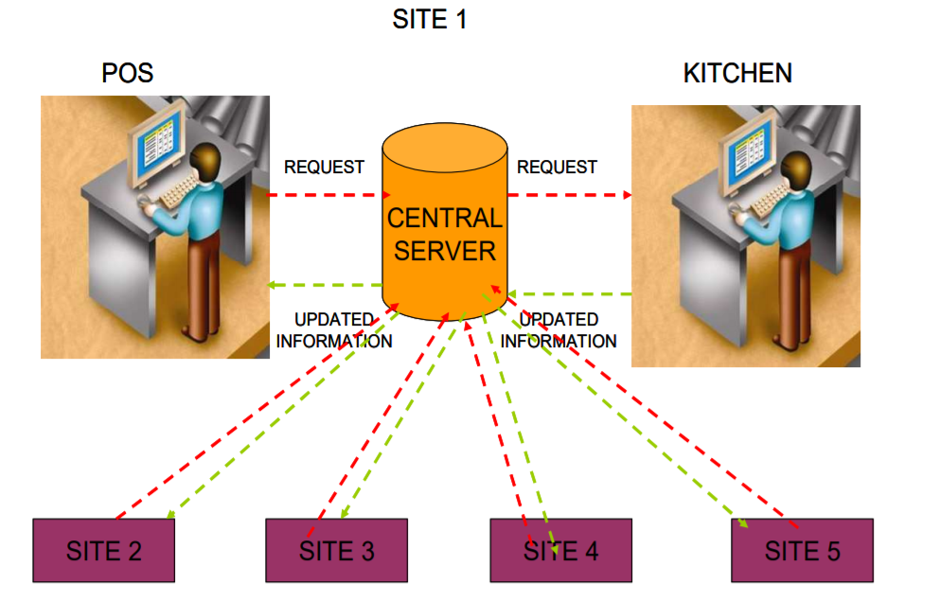

**Implementation Details**

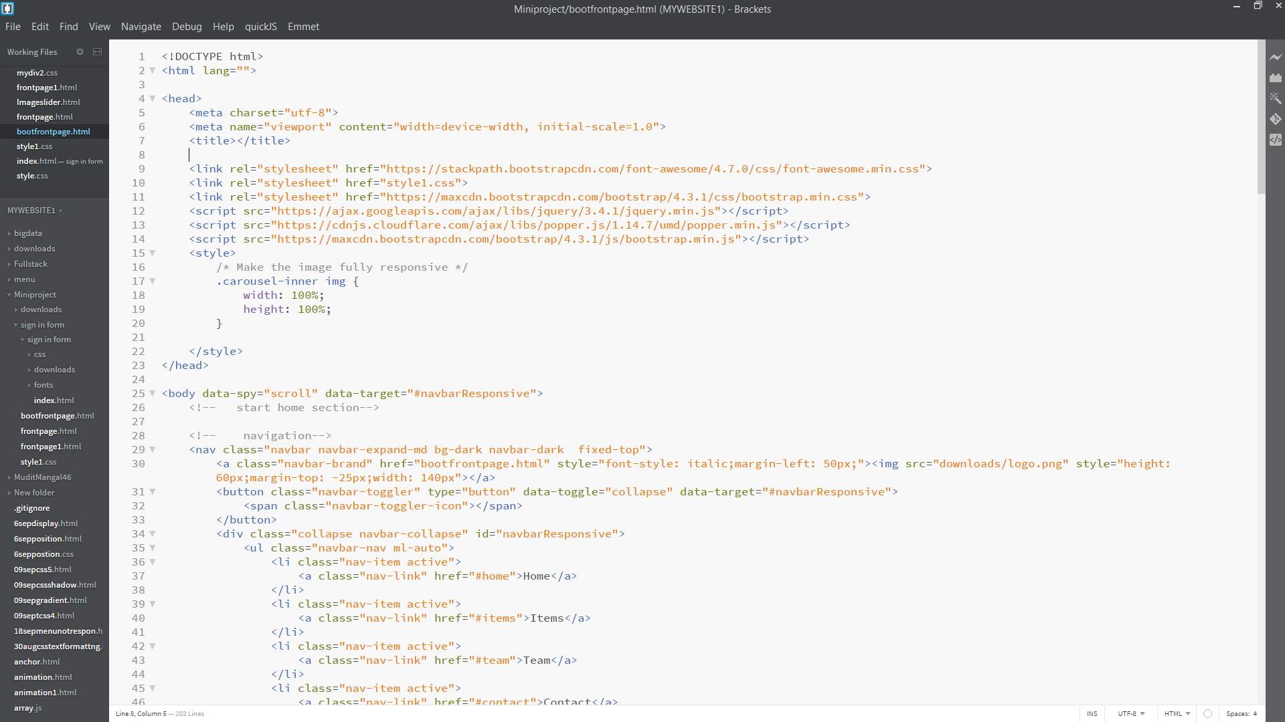

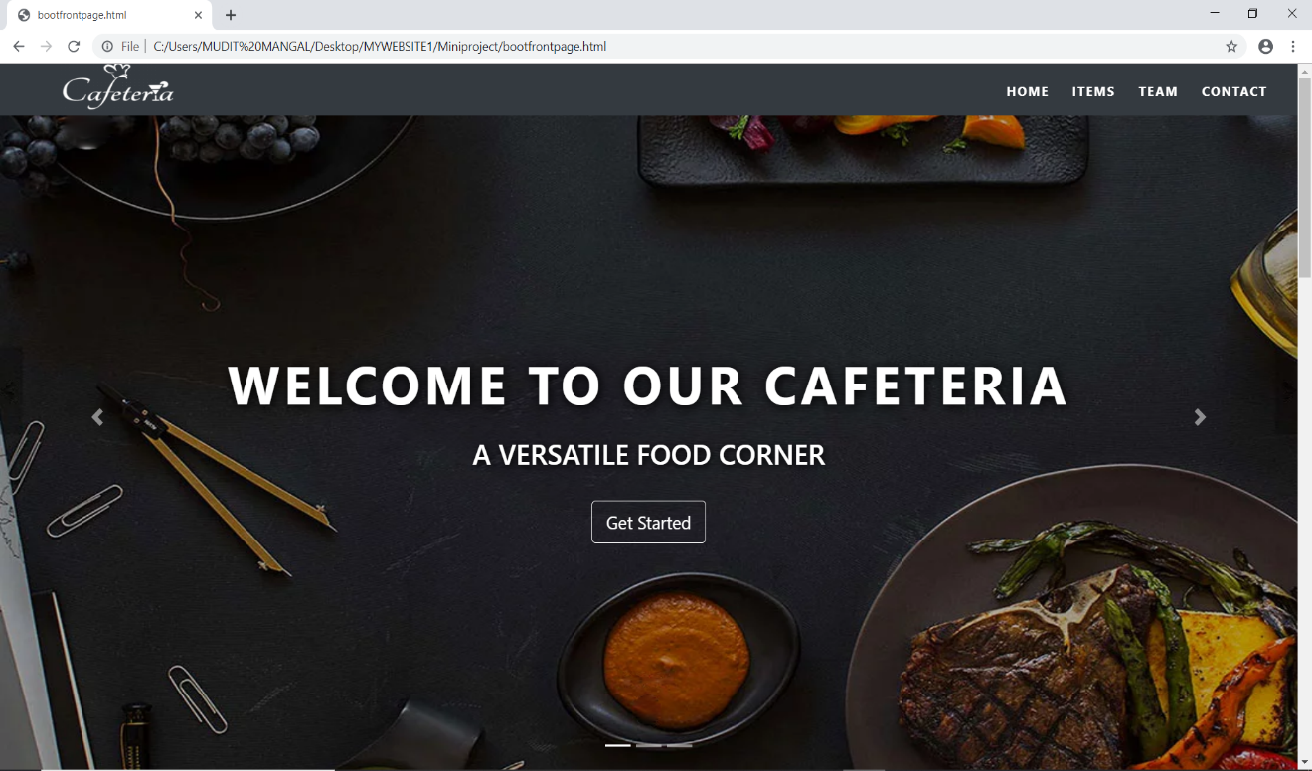

Front Page of Website

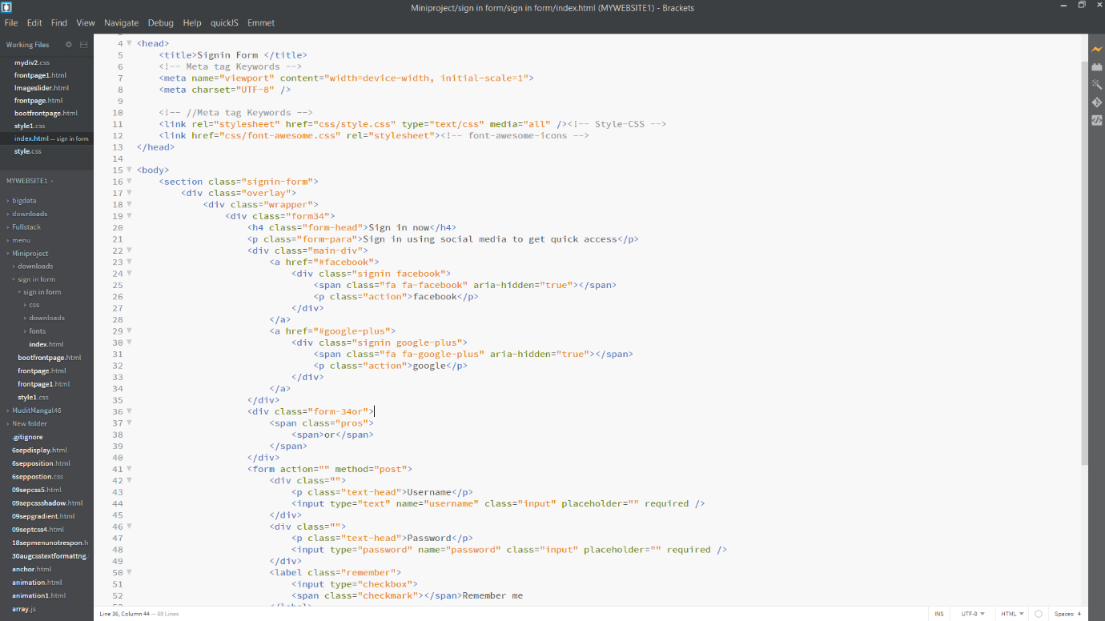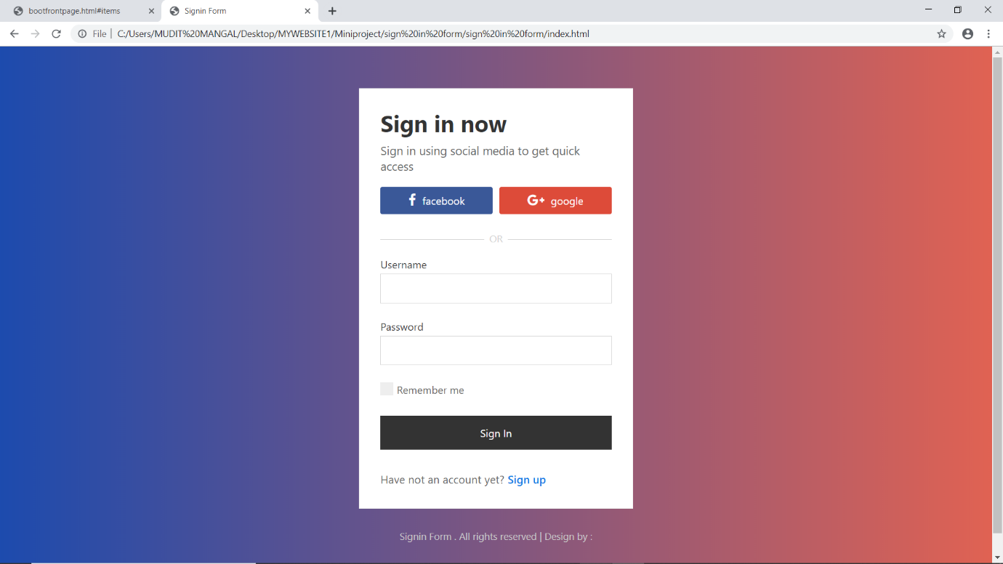

Sign up Page

**Contribution summary**

Sign up Page: This page consist of different components like sign up through google, sign up through facebook. Signing up will take the customer to next page of our website where he/she can select his/her food items. Our Group member Mudit Mangal worked on this model and completed the frontend of this model.

Main page: This page is basically designed so that the customer can search, select his/her favourite food items by going under the food items section. It also describes about the team members who has made this website. Our Group member Mudit Mangal worked on this model and completed the frontend of this model.

**Progress Till Date:**

We have almost completed the front end part of the project in which the sign up and sign page has been designed . Further, We have designed the main pages of our Cafeteria Automation System. We have started working on back end of the project now.

**References:**

1. <https://www.w3schools.com/bootstrap4>
2. <https://www.w3schools.com/php>
3. <http://wampserver.aviatechno.net/>