Mini Project-1




(2019-2020)
Cafeteria Automation
System


Synopsis
Institute of Engineering & Technology
Team Members:

Mudit Mangal
(171500194)
Kunal Goyal
(171500171)
Mayank Garg
(171500185)
Akash Agarwal
(171500024)
Supervised By:
Mrs. Ruchi Gupta
Asst. Professor
Department of Computer Engineering & Applications
Main Objective:
The main objective of Cafeteria Automation system is to automate the existing manual system with the help of advance computerized software so that valuable data can be stored for longer period with easy accessing and manipulation of the same.
The registered user can access the account with valid credentials. User can surf the food items according to categories. User can track their orders with the food details.
In Cafeteria Automation System Admin can handle the functionalities like add new food items, edit/delete food items, Enable/Disable the food items according to season and availability. Admin have authority to view order details and update the delivery status of food. The various orders details and user details are also viewable to admin.

Proposed System:
The system comprises of 2 major modules and their sub modules as follows:
- Admin
  - Login: Canteen person need to login using valid login credentials in order to access the web application.
  - Add / Manage Items: Can add new food items with details such as name, image, cost, description, etc. and also can manage added details.
  - View / Update Orders: Can view all the canteen orders received from the student.

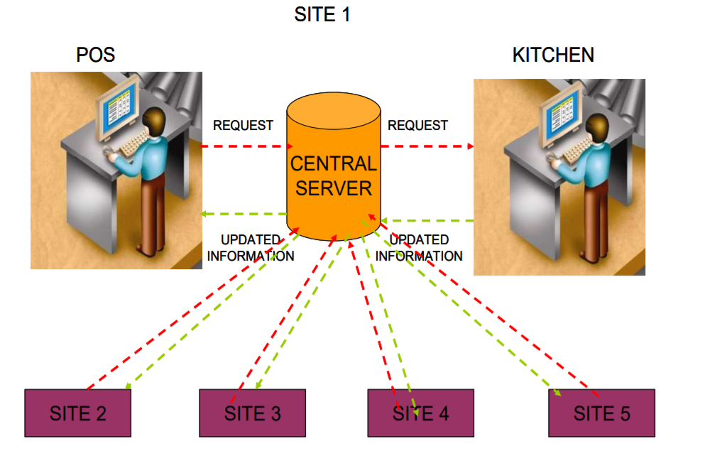

- Customer
- Register: Customer need to register first with basic registration details and need to create a valid login id and password.
b) Login: Customer need to login using their valid login credentials in order to access the web application.
c) View Items: All the food items will be displayed to the Customer at once with description and cost.
d) View Recommendation: Food recommendation list will also be displayed based on their previous orders.
e)Add to Cart: Single or multiple food item can be added to cart by selecting quantity.
f) Order History: All the past and recent order will be displayed.
Technologies used:
Hardware Requirements Specifications:
- I3 Based Computer or Higher
- Hard Drive : 50GB
- Memory: 1 GB RAM

Software Requirements Specifications:
- Windows 7 or higher
- Brackets
- PHP

Programming language Specifications:
- HTML5
- CSS3
- JQUERY
- BOOTSTRAP

Audience Targeted:
All the Restaurants as well as all the people will be connected through this application.

THANK YOU!!

