Website UX/UI Analysis & Improvement Proposal – UnderGrads Media
Objective:
This document highlights key UX, UI, layout, navigation and conversion improvements identified during the review of the UnderGrads Media website. The goal is to improve user experience, brand perception, readability and lead generation.

Hero Section Analysis
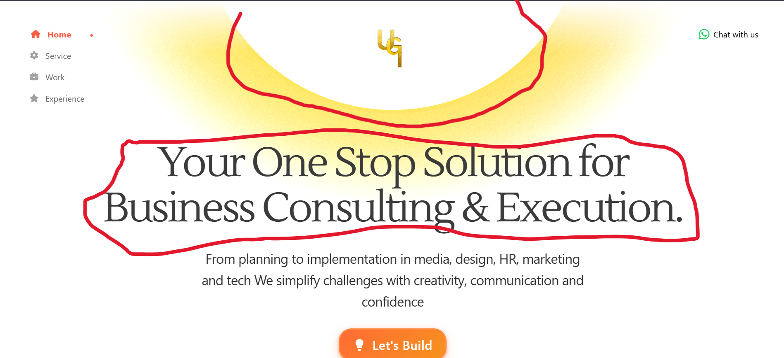
- Reduce excessive empty space around the logo area.
- Replace generic headline with a stronger value proposition.
- Add trust indicators such as projects completed, client count and testimonials.
- Improve CTA clarity (e.g., Book a Consultation, Get a Proposal).
- Enhance typography hierarchy and visual balance.

Services Section Analysis
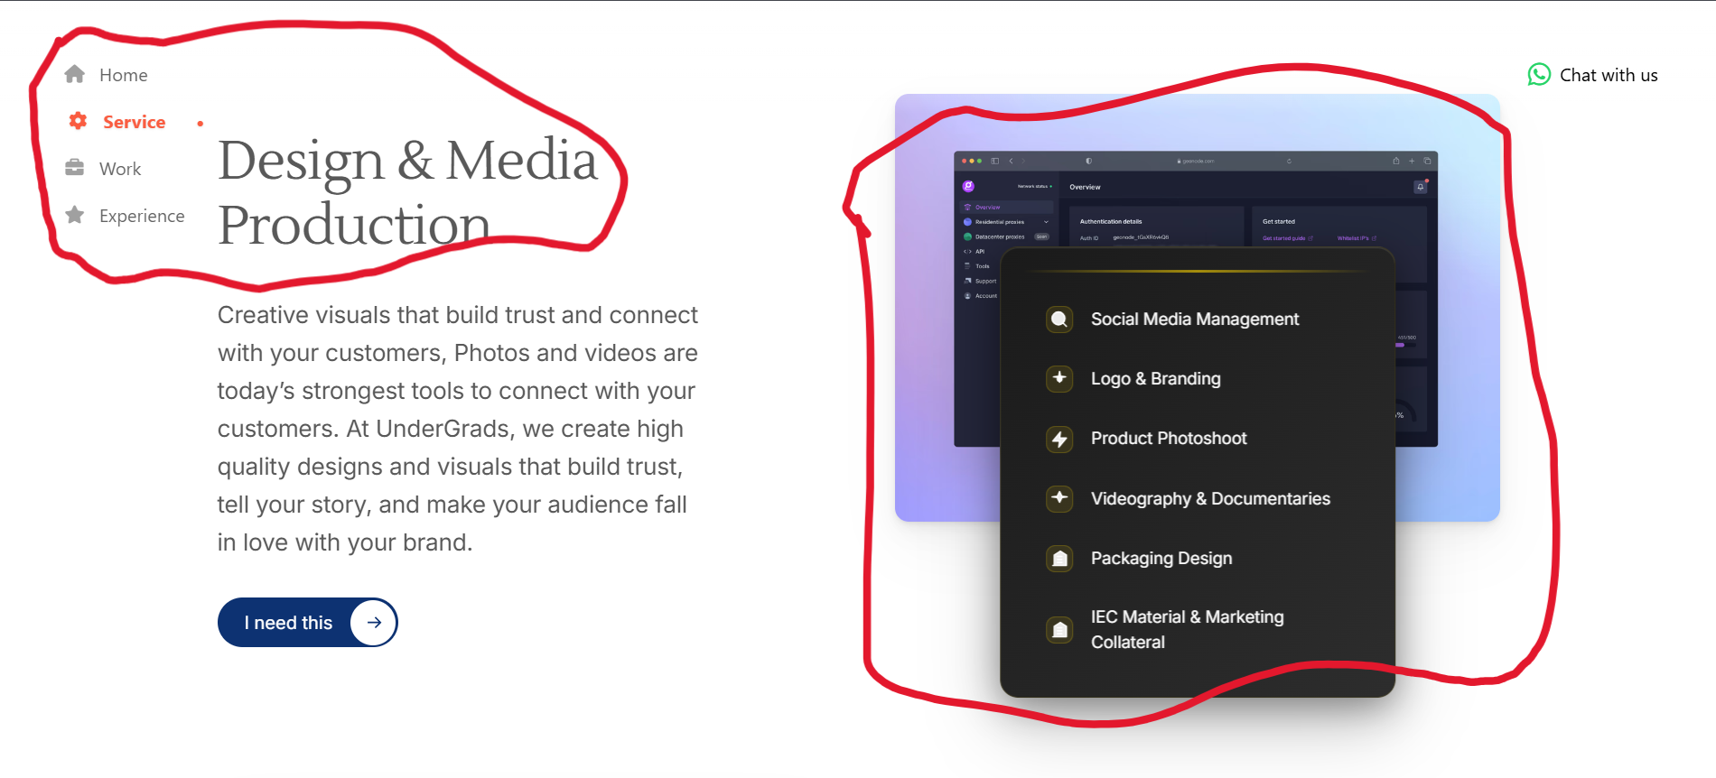
- Improve heading alignment and spacing.
- Use stronger visual hierarchy between content and service cards.
- Replace generic dashboard imagery with real portfolio visuals.
- Convert large paragraphs into concise, scannable content.
- Add hover animations and service outcomes.

Work / Portfolio Section Analysis
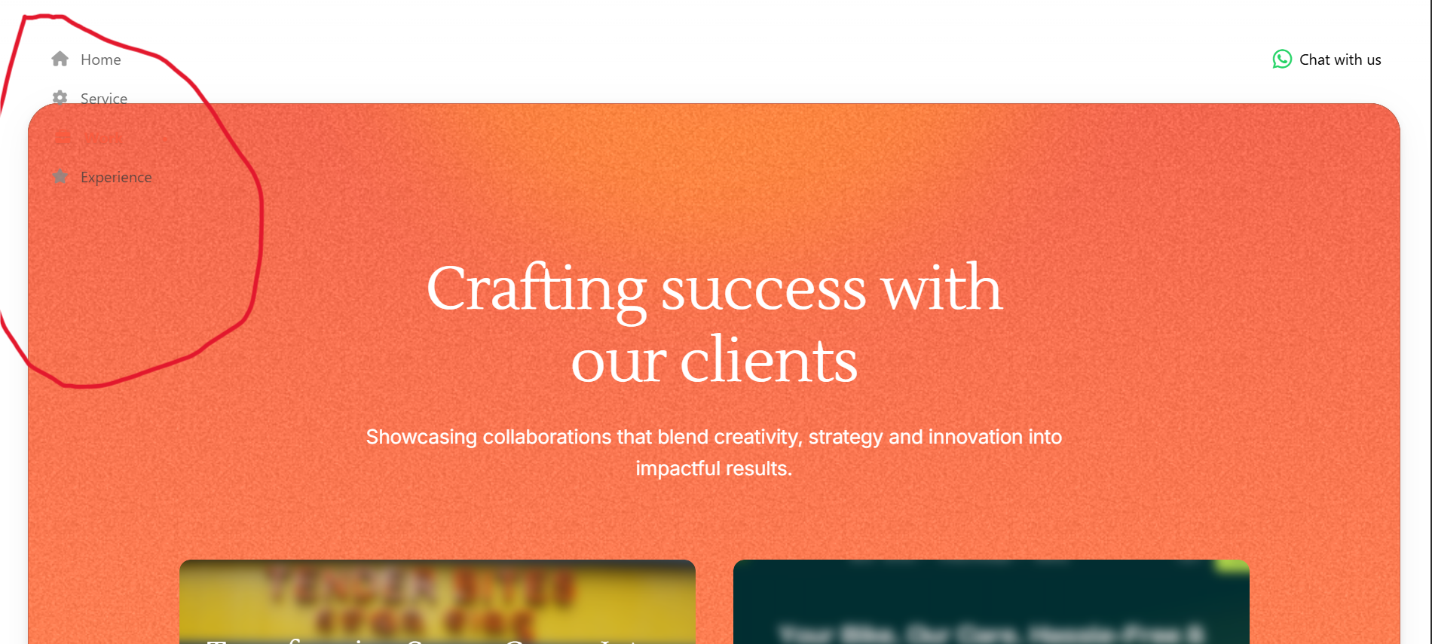
- Sidebar navigation overlaps visually with the portfolio section.
- Improve content spacing and alignment.
- Add project categories and filters.
- Show measurable client results and case-study metrics.
- Introduce smoother section transitions and animations.

About & Experience Section Analysis
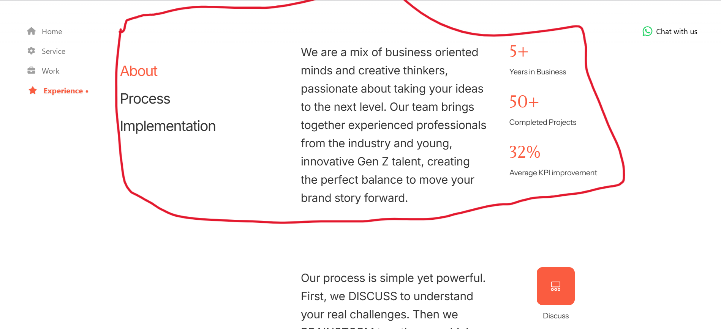
- Improve content structure and readability.
- Reduce large empty areas.
- Strengthen statistics presentation using cards or counters.
- Add team imagery and stronger social proof.
- Improve typography consistency and spacing.

Footer & Navigation Analysis
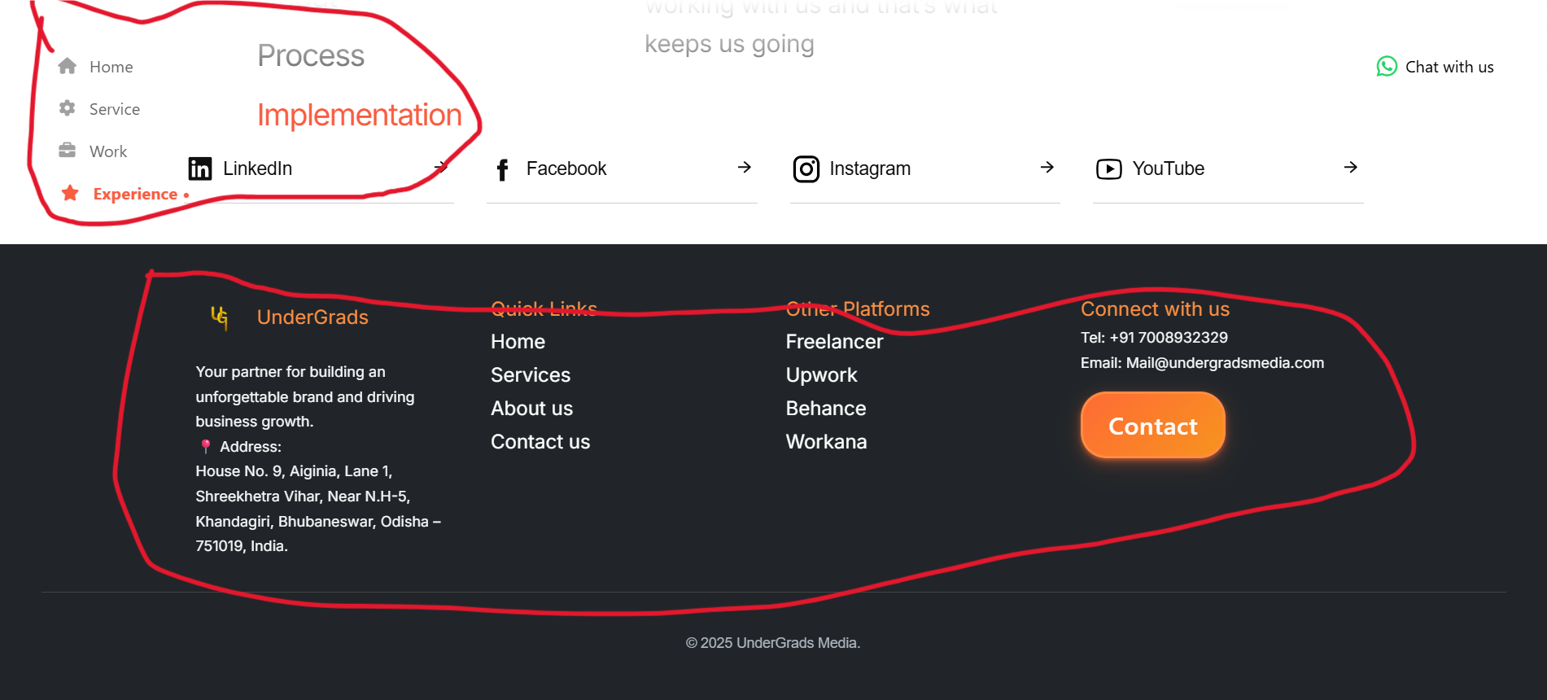
- Redesign footer with better information hierarchy.
- Improve navigation placement and alignment.
- Reduce visual clutter and increase readability.
- Add modern footer sections such as Case Studies, Blog and Resources.
- Use a more consistent color palette and typography system.

Recommended Modern Layout
1. Sticky Top Navigation Bar
2. Hero Section with Strong Value Proposition
3. Client Logos / Trust Section
4. Services Grid
5. Featured Projects & Case Studies
6. Testimonials Section
7. Process Timeline
8. Call-to-Action Section
9. Modern Footer
Additional Enhancements:
• Smooth scrolling using Lenis or similar solution
• Scroll-triggered animations
• Improved typography scale
• Better spacing system
• Consistent color palette
• Mobile responsiveness improvements
• Higher conversion-focused CTA placement

Conclusion
The website already has a strong foundation and professional intent. However, improvements in layout structure, navigation alignment, typography, visual hierarchy, animations, footer design and conversion-focused content can significantly enhance user engagement and overall brand perception.

