
Session: 2026-2027 CivicSense: AI Based Citizen Analyzer of Citizen Complaint
Guide:- Dr. Manisha Khadse
Name of Candidates :- 1.Mudit Gupta 2.Alankrit Kashyap 3.Ashraf Pathan 4.Abhishek Pattir
1. Abstract:
CivicSense is an automated computer software package designed to optimize municipal grievance redressal by converting unstructured citizen complaints into actionable governance intelligence. Traditional complaint systems rely on manual triage, leading to misclassification, duplicate entries and delayed response times. CivicSense addresses this through a proprietary, end-to—end six-stage processing pipeline: centralized data ingestion (via web forms and REST APIs), linguistic preprocessing with automated sequence-matching duplicate detection, machine learning classification, explainable multi-signal priority scoring, weekly digest summarization and automated administrative report generation. The classification engine utilizes TF-IDF feature extraction paired with a Linear Support Vector Classifier (LinearSVC) to route complaints into five specific municipal categories: Roads, Electricity, Water Supply, Waste Management and Public Safety. Incoming grievances are simultaneously evaluated by a deterministic priority engine that calculates an explainable urgency score based on hazard keyword severity, base category risk, emotive sentiment and temporal frequency within the reporting ward. High volumes of complaint records are compressed into structured weekly digests and exported on demand as formatted PDF or Excel reports via a local, offline-capable Flask web dashboard. Authored primarily in Python 3.12 utilizing Flask, scikit-learn, NLTK and SQLite, this registration covers the underlying source code, algorithmic scoring logic, pipeline architecture and associated web interfaces of the CivicSense platform.

Methodology: The AI CivicSense platform streamlines public grievance management through an intelligent, end-to-end workflow. Citizens submit multimodal complaints (text, audio, image, video) that the system centrally stores, preprocesses and analyzes using NLP and machine learning. The platform automatically classifies these issues, flags duplicates and suspicious entries, assigns priority levels and routes them to the appropriate government departments. While citizens track their complaint status in real time, authorities utilize generative AI summaries, dynamic dashboards and location-based hotspot analysis to efficiently resolve issues, allocate resources and make data-driven decisions.

Objectives:
1. Build an end-to-end complaint-analysis platform implementing all six stages of the paper's pipeline.
2. Achieve high, honestly-measured classification accuracy across the five service categories (Roads, Electricity, Water Supply, Waste Management, Public Safety).
3. Assign explainable High / Medium / Low priorities using the same signals the paper describes (urgency wording, category risk, emotive language, same-ward frequency, age).
4. Generate weekly narrative digests in the paper's style and export them as PDF and Excel reports.
5. Provide a dashboard that gives officers at-a-glance insight (category mix, priority mix, daily inflow, ward hotspots, trending keywords).
6. Validate everything with an automated end-to-end test suite.
Conclusion:
This project delivered a complete, working implementation of the CivicSense proposal. A six-stage AI pipeline was designed and built - centralised data collection, linguistic preprocessing with duplicate detection, TF-IDF+SVM classification across the paper's five categories, an explainable High/Medium/Low-priority engine driven by the paper's four signals, generative-style weekly digests and PDF/Excel reporting -all exposed through an officer dashboard and a REST API. The system was validated end-to-end: all 25 automated checks pass; the classifier reaches 82.2% ± 5.5% cross-validated accuracy with every base-paper example classified correctly; priorities distribute realistically (68/94/22); duplicates are caught at a believable 16% rate; and weekly digests reproduce the paper's exact narrative style, including ward-level highlights and resource-allocation suggestions. The development process also produced genuine engineering lessons -corpus quality and metric honesty matter as much as model choice, as demonstrated by the three significant defects found and fixed during testing. CivicSense shows how NLP and Generative AI can turn the citizen's voice into actionable governance intelligence, moving municipalities from reactive complaint handling to proactive, data-driven urban management -exactly the vision the base paper sets out.
Literature Review
Sr. No | Paper Title
1 | Centralised Public Grievance Redress and Monitoring System (PIB, 2026)
2 | Classification of User Complaints and Requests in Customer (EPESS, 2025)
3 | AI-Driven Citizen Grievance Redressal System (IJERT, 2026)
4 | Smart Cities: A Systematic Review of Emerging Technologies (MDPI, 2026)
5 | Geospatial Sentiment Analysis Using Twitter Data on Natural Disasters (ResearchGate, 2026)

Scope:
The project covers the complete software implementation: data model, NLP pipeline, trained classifier, priority engine, digest generator, report export, dashboard and tests. It uses SQLite as the central database (the paper suggests PostgreSQL/MongoDB for production scale) and a curated synthetic demonstration dataset, processed through the real pipeline so every statistic reflects genuine model behaviour. Live integration with external complaint portals, multilingual support and geospatial mapping are out of scope for this version and are listed as future work.
Introduction: Urban governance depends on the timely redressal of citizen grievances. Every day, citizens lodge complaints about broken roads, power cuts, water scarcity, uncollected garbage and unsafe public spaces. These complaints arrive through many channels -mobile apps, web portals, email, call centres and social media -and in very different styles: some are formal, some use slang, some are incomplete ("No water", "Road bad").
National and municipal programmes such as India's CPGRAMS, Singapore's OneService app and New York's NYC 311 demonstrate the scale of the problem, but their back-ends still rely heavily on manual classification and status updates. The result, as the base paper notes, is delayed responses, duplicate records, poor categorisation and no real-time insight into where problems are concentrated. Authorities end up reacting to issues that have already become significant instead of acting on trends.
Workflow Diagram 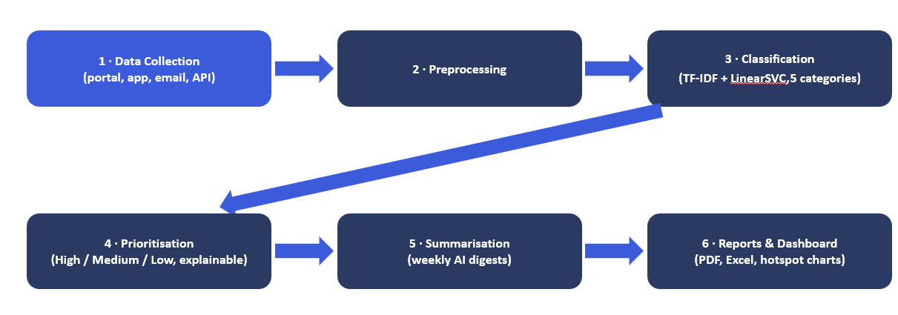
References:
1. Aakash P., Chandru T., Kiruba Wesley. *CivicSense: AI-Based Citizen Complaint Analyzer* Proceedings of the Global Conference on Sustainable Energy Systems, Smart Electronics and Intelligent Computing (GCSESEIC 2025), Advances in Engineering Research 297. (Base paper — project source document.)
2. Government of India. *Centralized Public Grievance Redress and Monitoring System (CPGRAMS)*. DARPG, 2023.
3. Municipal Services Office. OneService App. Government of Singapore, 2023.
4. City of New York. NYC 311 Service Request Platform, 2023.
5. Devlin, J. et al. *BERT: Pre-training of Deep Bidirectional Transformers for Language Understanding.* NAACL-HLT, 2019.
6. Pedregosa, F. et al. Scikit-learn: Machine Learning in Python. JMLR 12,2011.
7. Bird, S., Klein, E., Loper, E. Natural Language Processing with Python. O'Reilly, 2009.
8. Flask Documentation — https://flask.palletsprojects.com
9. ReportLab Documentation — https://docs.reportlab.com
10. Van Rossum, G. Python Language Reference — https://docs.python.org

