Problem 1 – DATA MODELLING
Solution –
Designing a database schema for an e-commerce platform involves careful consideration of the entities, their attributes, and the relationships between them. Below, I'll provide you with a simplified star-schema model for the given requirements, including an entity-relationship diagram (ERD), and then I'll guide you through generating sample data for this model.
Entity-Relationship Diagram (ERD):
Here's the ERD for the star-schema model:
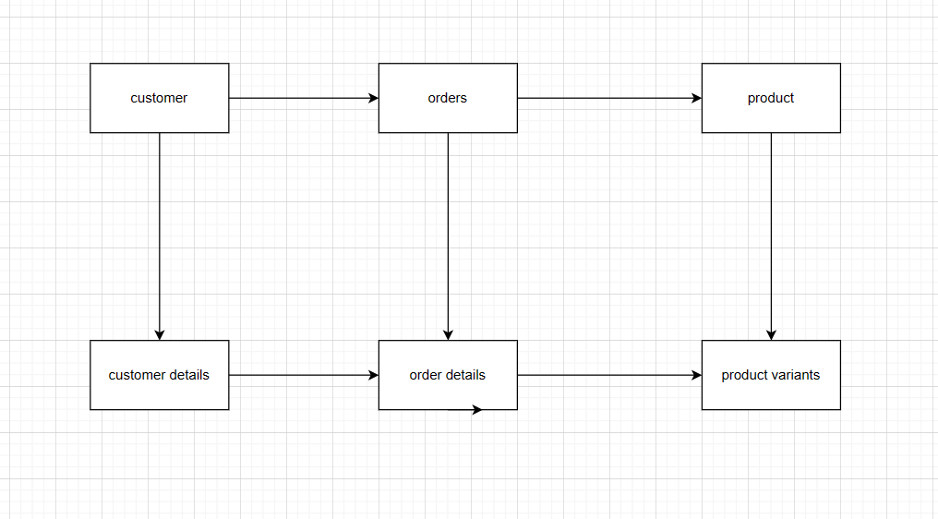
Explanation of the Entities and Relationships:
Customers:
Attributes: CustomerID (PK), FirstName, LastName, ShippingAddress, ContactNumber
This entity stores customer information.
CustomerDetails:
Attributes: CustomerDetailID (PK), CustomerID (FK), ShippingAddress, ContactNumber, EffectiveDate
This entity stores historical changes in customer details. It has a foreign key to the Customers table.
Orders:
Attributes: OrderID (PK), CustomerID (FK), OrderDate, TotalAmount
This entity stores order information.
OrderDetails:
Attributes: OrderDetailID (PK), OrderID (FK), ProductID (FK), Quantity, UnitPrice
This entity stores details about products within orders.
Products:
Attributes: ProductID (PK), ProductName
This entity stores product information.
ProductVariants:
Attributes: VariantID (PK), ProductID (FK), VariantName, LaunchDate, DiscontinuedDate
This entity stores historical information about product variants.
Sample Data Generation:
To generate sample data, you can use programming languages like Python. Here's a simplified example using Python's faker library for generating random data:

from faker import Faker
import random
import datetime

fake = Faker()

# Generate Customers
num_customers = 10
customers = [{'CustomerID': i + 1, 'FirstName': fake.first_name(), 'LastName': fake.last_name()} for i in range(num_customers)]

# Generate CustomerDetails with historical changes
customer_details = []
for customer in customers:
num_changes = random.randint(1, 5)
for _ in range(num_changes):
customer_details.append({
'CustomerID': customer['CustomerID'],
'ShippingAddress': fake.address(),
'ContactNumber': fake.phone_number(),
'EffectiveDate': fake.date_this_decade()
})

# Generate Products
num_products = 10
products = [{'ProductID': i + 1, 'ProductName': fake.word()} for i in range(num_products)]

# Generate ProductVariants with historical changes
product_variants = []
for product in products:
num_variants = random.randint(1, 3)
for i in range(num_variants):
launch_date = fake.date_this_year()
discontinued_date = fake.date_this_year() if i < num_variants - 1 else None
product_variants.append({
'ProductID': product['ProductID'],
'VariantName': f'Variant {i + 1}',
'LaunchDate': launch_date,
'DiscontinuedDate': discontinued_date
})

# Generate Orders
num_orders = 24 # 2 years of monthly orders
orders = []
for i in range(num_orders):
order_date = fake.date_time_this_year()
total_amount = round(random.uniform(50, 300), 2)
customer_id = random.choice(customers)['CustomerID']
orders.append({
'OrderID': i + 1,
'CustomerID': customer_id,
'OrderDate': order_date,
'TotalAmount': total_amount
})

# Generate OrderDetails
order_details = []
for order in orders:
num_items = random.randint(1, 5)
chosen_products = random.sample(products, num_items)
for product in chosen_products:
quantity = random.randint(1, 5)
unit_price = round(random.uniform(10, 100), 2)
order_details.append({
'OrderID': order['OrderID'],
'ProductID': product['ProductID'],
'Quantity': quantity,
'UnitPrice': unit_price
})

# Now you can insert this generated data into your database
# using your preferred database connection and manipulation method.

Problem 2 – SQL
Solution
Assuming you have the following tables:
Customers (CustomerID, FirstName, LastName)
Orders (OrderID, CustomerID, OrderDate, TotalAmount)
OrderDetails (OrderDetailID, OrderID, ProductID, Quantity, UnitPrice)
Products (ProductID, ProductName)
ProductVariants (VariantID, ProductID, VariantName, LaunchDate, DiscontinuedDate)
Here are the queries:
- Retrieve the top 5 customers with the highest average order amounts in the last 6 months:
SELECT c.CustomerID, c.FirstName, c.LastName, AVG(o.TotalAmount) AS AvgOrderAmount
FROM Customers c
JOIN Orders o ON c.CustomerID = o.CustomerID
WHERE o.OrderDate >= DATE_SUB(CURDATE(), INTERVAL 6 MONTH)
GROUP BY c.CustomerID, c.FirstName, c.LastName
ORDER BY AvgOrderAmount DESC
LIMIT 5;

- Retrieve the list of customers whose order value is lower this year compared to the previous year:

SELECT c.CustomerID, c.FirstName, c.LastName
FROM Customers c
JOIN Orders o ON c.CustomerID = o.CustomerID
WHERE YEAR(o.OrderDate) = YEAR(CURDATE()) - 1
GROUP BY c.CustomerID, c.FirstName, c.LastName
HAVING SUM(o.TotalAmount) > 0
AND SUM(o.TotalAmount) > (
SELECT COALESCE(SUM(TotalAmount), 0)
FROM Orders
WHERE CustomerID = c.CustomerID
AND YEAR(OrderDate) = YEAR(CURDATE())
);

- Create a table showing cumulative purchase by a particular customer, broken down by product category:

CREATE TABLE CumulativePurchaseByCategory AS
SELECT c.CustomerID, p.CategoryID, SUM(od.Quantity) AS CumulativeQuantity
FROM Customers c
JOIN Orders o ON c.CustomerID = o.CustomerID
JOIN OrderDetails od ON o.OrderID = od.OrderID
JOIN Products p ON od.ProductID = p.ProductID
GROUP BY c.CustomerID, p.CategoryID;

- Retrieve the list of top 5 selling products, further bifurcated by product variants:

SELECT p.ProductName, pv.VariantName, SUM(od.Quantity) AS TotalQuantity
FROM Products p
JOIN ProductVariants pv ON p.ProductID = pv.ProductID
JOIN OrderDetails od ON p.ProductID = od.ProductID
GROUP BY p.ProductName, pv.VariantName
ORDER BY TotalQuantity DESC
LIMIT 5;

Problem 3 - ETL

- Load and Normalize JSON Data Using Python:

import json

# Load JSON data
with open('data.json', 'r') as f:
data = json.load(f)

# Perform necessary transformations to normalize the data
# Create separate tables for orchestra, concerts, works, artists, etc.
# Store relationships using foreign keys

# Example of creating normalized tables
orchestra_table = []
concerts_table = []
works_table = []
artists_table = []

for concert in data['concerts']:
concerts_table.append({
'concert_id': concert['id'],
'orchestra_id': concert['orchestra']['id'],
'date': concert['date']
})
for work in concert['works']:
works_table.append({
'work_id': work['id'],
'title': work['title'],
'composer': work['composer']
})
for artist in work['artists']:
artists_table.append({
'artist_id': artist['id'],
'name': artist['name']
})

# Repeat similar process for other entities

# Store these tables in a database or file

- Prepare an ERD of the Normalized Data Tables:

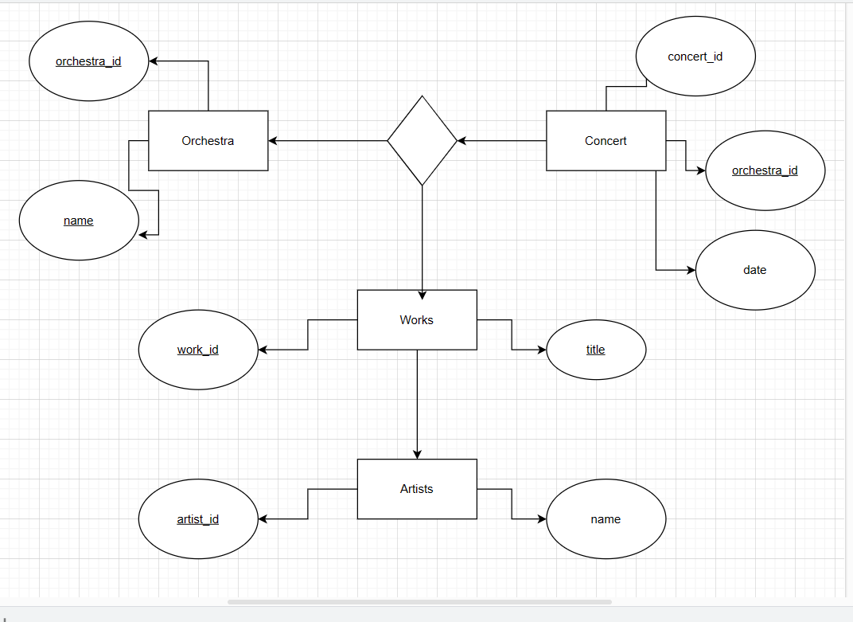

- Implement the Transformation Using SQL:

-- Create Orchestra table
CREATE TABLE Orchestra (
orchestra_id INT PRIMARY KEY,
name TEXT
);

-- Create Concert table
CREATE TABLE Concert (
concert_id INT PRIMARY KEY,
orchestra_id INT,
date DATE,
FOREIGN KEY (orchestra_id) REFERENCES Orchestra(orchestra_id)
);

-- Create Works table
CREATE TABLE Works (
work_id INT PRIMARY KEY,
title TEXT,
composer TEXT
);

-- Create Artists table
CREATE TABLE Artists (
artist_id INT PRIMARY KEY,
name TEXT
);

-- Create a junction table for Concerts to Works relationship
CREATE TABLE ConcertWorks (
concert_id INT,
work_id INT,
FOREIGN KEY (concert_id) REFERENCES Concert(concert_id),
FOREIGN KEY (work_id) REFERENCES Works(work_id)
);

-- Create a junction table for Works to Artists relationship
CREATE TABLE WorkArtists (
work_id INT,
artist_id INT,
FOREIGN KEY (work_id) REFERENCES Works(work_id),
FOREIGN KEY (artist_id) REFERENCES Artists(artist_id)
);

Problem 4 - Streaming
Solution

1. Ingest JSON Files Using Databricks Autoloader:
Databricks Autoloader is a feature that automatically ingests new data files as they are added to a specified cloud storage location.
2. Write Ingested Data to a Table:
You can use the Delta Lake storage format in Databricks to write the ingested data into a table. Delta Lake provides ACID transactions, schema enforcement, and other features on top of Apache Spark.
3. Infer Schema Automatically:
By default, Autoloader will infer the schema of the ingested JSON files. However, you can also specify a schema if needed.
4. Auto-Detection of New Files:
Databricks Autoloader automatically detects new files as they are added to the specified storage location, ensuring that new data is ingested into the table without manual intervention.
Here's a general outline of the process:
Upload the json_files.zip to your cloud storage (e.g., AWS S3, Azure Blob Storage, GCP Storage).
Create a Databricks cluster if you haven't already.
Create a Databricks notebook for the following steps.
Step-by-Step Implementation in Databricks:

# Configure access to your cloud storage
storage_account_name = "your_storage_account_name"
storage_account_key = "your_storage_account_key"
container_name = "your_container_name"
storage_path = "your_storage_path" # Path to the uploaded json_files.zip

# Mount the cloud storage to Databricks
dbutils.fs.mount(
source = "wasbs://%s:%s@%s.blob.core.windows.net/%s" % (container_name, storage_account_key, storage_account_name, storage_path),
mount_point = "/mnt/json_files",
extra_configs = {"<conf-key>":dbutils.secrets.get(scope = "<scope-name>", key = "<key-name>")}
)

# Set up the source path for Autoloader
source_path = "/mnt/json_files/"

# Define the destination table name
destination_table = "raw_data"

# Define the checkpoint location for structured streaming
checkpoint_location = "/mnt/checkpoints"

# Read data using Autoloader and write to Delta Lake table
from pyspark.sql.types import StringType
from pyspark.sql.functions import from_json

data = spark.readStream \
.format("cloudFiles") \
.option("cloudFiles.format", "json") \
.option("cloudFiles.useNotifications", "true") \
.schema(StringType()) \ # Inferred schema
.load(source_path)

# Parse JSON data
parsed_data = data.select(from_json(data.content, "<schema>").alias("parsed_data"))

# Write to Delta Lake table
parsed_data.writeStream \
.format("delta") \
.outputMode("append") \
.option("checkpointLocation", checkpoint_location) \
.table(destination_table)

Please note that you'll need to replace placeholders like your_storage_account_name, your_storage_account_key, your_container_name, your_storage_path, <conf-key>, <scope-name>, <key-name>, and <schema> with your actual values.
This code sets up a structured streaming pipeline using Databricks Autoloader, infers the schema of the ingested JSON data, and writes it to a Delta Lake table. It will also automatically detect and process new files added to the cloud storage location

Problem 5 – Time Series
Solution
To achieve this, we'll need to identify the continuous periods of work done by each bot. This requires identifying when a bot starts working (i.e., at least one task is ongoing) and when it stops working (i.e., all tasks are completed). We'll perform this transformation using both Python and SQL.
- Perform Transformations Using Python:

import pandas as pd

# Load the Excel data
data = pd.read_excel("Time Series.xlsx")

# Convert the datetime columns to datetime format
data['Start Time'] = pd.to_datetime(data['Start Time'])
data['End Time'] = pd.to_datetime(data['End Time'])

# Sort the data by 'Bot' and 'Start Time'
data.sort_values(by=['Bot', 'Start Time'], inplace=True)

# Initialize variables to track periods
current_bot = None
current_period_start = None
current_period_tasks = []

# Function to process and output the current period
def output_current_period():
global current_bot, current_period_start, current_period_tasks
if current_bot is not None and current_period_start is not None:
print(f"Bot: {current_bot}, Start Time: {current_period_start}, End Time: {current_period_tasks[-1]['End Time']}, Tasks: {current_period_tasks}")

# Process the data to identify continuous work periods
for index, row in data.iterrows():
if current_bot != row['Bot']:
output_current_period()
current_bot = row['Bot']
current_period_start = row['Start Time']
current_period_tasks = []

if not current_period_tasks or current_period_tasks[-1]['End Time'] <= row['Start Time']:
current_period_tasks.append(row)
else:
output_current_period()
current_period_start = row['Start Time']
current_period_tasks = [row]

output_current_period() # Output the last period

2. Perform Transformations Using SQL:
Assuming you have loaded the Excel data into a database table, you can use SQL to achieve the same result:

WITH RankedTasks AS (
SELECT
Bot,
[Start Time],
[End Time],
ROW_NUMBER() OVER (PARTITION BY Bot ORDER BY [Start Time]) AS TaskRank
FROM WorkData
)

SELECT
t1.Bot,
t1.[Start Time] AS PeriodStart,
MIN(t2.[End Time]) AS PeriodEnd,
ARRAY_AGG(t2.Activity) AS Tasks
FROM RankedTasks t1
JOIN RankedTasks t2 ON t1.Bot = t2.Bot AND t1.TaskRank <= t2.TaskRank
GROUP BY t1.Bot, t1.[Start Time]
HAVING t1.[Start Time] <= MIN(t2.[End Time])
ORDER BY t1.Bot, t1.[Start Time];

