

**Dayananda Sagar University**

**School of Engineering**

**Kudlu Gate, Bengaluru-560068**

**A Project Report**

On

**“Fingerprint-Based Voting System”**

**Submitted in fulfillment of the requirements for the award of the degree.**

**BACHELOR OF TECHNOLOGY**

**in**

**COMPUTER SCIENCE AND ENGINEERING**

**BY**

**Saurabh Kumar DSU15CS0072**

**Shalin DSU15CS0073**

**Rahul Kumar DSU15CS0064**

**Anushrav Mishra DSU15CS0015**

**Under the guidance of**

**Prof. RASHMI M**

**Assistant Professor**

**Department of CSE**

**SoE, DSU**

**Department of Electronics and Communication Engineering**

**Dayananda Sagar University, Bengaluru 560068**

**Academic Batch: 2015-2019 Year : 2018-2019**



Dayananda Sagar University

School of Engineering

K Kudlu Gate, Bengaluru-560068

***CERTIFICATE***

*This is to certify that the* ***Project*** *entitled* ***“Finger Print Based Voting System”*** *has been successfully carried out by* **SAURABH KUMAR** *(****USN DSU15CS0072) ,* SHALIN(USN DSU15CS0073)***,* **RAHUL KUMAR (USN DSU15CS0064), ANUSHRAV MISHRA(USN DSU15CS0015)** *in fulfillment of the requirement for the award of the degree* ***BACHELOR OF TECHNOLOGY*** *in* ***COMPUTER SCIENCE & ENGINEERING*** *by* ***DAYANANDA SAGAR UNIVERSITY*** *during the academic year 2018-19.*

_________________ _________________ _________________

Signature of the Guide Signature of the Coordinator-1 Signature of the Coordinator-2

Prof. Rashmi M Dr. Reeja S R Dr. Venkateswarlu Bondu

Asst.prof, Dept. of CSE Asst.prof, Dept. of CSE Asst.prof, Dept. of CSE

SoE-DSU, Bengaluru SoE-DSU, Bengaluru SoE-DSU, Bengaluru

.

________________________ _____________________________

Signature of the Chairman Signature of the Dean

**Dr. M K Banga**  **Dr. A Srinivas**

Dept. of CSE SoE-DSU, Bengaluru

SoE-DSU, Bengaluru

External Examiner

1) ___________________________ ______________________

Name Signature

2) ___________________________ ______________________

Name Signature

**CANDIDATE’S DECLARATION**

I, hereby declare that, the in-house project presented in this report titled *“Fingerprint-Based Voting System*” in fulfillment of the requirements for of the award of the degree of Bachelor of Technology in Computer Science and Engineering have to submit in School of Engineering, Dayananda Sagar University, Bengaluru, is an authentic record of my own work that would be carried out that would e carried out during 8th semester (period from January 2019 to May 2019) under the guidance of “Prof. Rashmi M*”, Dept of CSE,* SoE, Dayananda Sagar University, Bengaluru. The matter embodied in this Project Report has been submitted by us for the award of the degree of Bachelor of Technology.

Date:  
  
Place: Bengaluru

(Students Name and Signature)

**Acknowledgment**

We are pleased to present **“Fingerprint Election System”** projectand takethis opportunity to express our profound gratitude to all those people who helped us in the completion of this project.

We take immense pleasure in thanking **Dr. M K Banga**, Chairman, Dept of Computer Science and Engineering, Dayananda Sagar University, Bengaluru for his enthusiastic support.

We thank our college for providing us with excellent facilities that helped us to complete and present this project. We would also like to thank the staff members and lab assistants for permitting us to use computers in the lab as and when required.

We would like to extend my deepest gratitude of our guide **Prof. Rashmi M**, Dept. of Computer Science and Engineering, Dayananda Sagar University, Bengaluru without whom this project would have been incomplete. Her understanding, encouraging and personal guidance have provided a good basis for this project report. We would also like to thank her for providing us with all the proper facilities and support as the project guide. We would like to thank her for support, patience, and faith in our capabilities and for giving us flexibility in terms of working and reporting schedules.

We would like to thank our coordinator **Dr. Reeja S R** and **Dr. Venkateswarlu Bondu**, Associate Professor, Dept. of Computer Science and Engineering, Dayananda Sagar University, Bengaluru for their insightful suggestions.

We would like to thank all our friends for their smiles and friendship making the college life enjoyable and memorable and family members who always stood right beside us and provided the utmost important moral support.   
 Finally, we would like to thank everyone who has helped us directly or indirectly in our project.

**ABSTRACT**

The main objective of democracy is "vote" by which the people can elect the candidates for forming an efficient government to satisfy their needs and requests such that their standard living can be improved. In developing countries like "INDIA", the election commission follows manual voting mechanism which is done by the electronic voting machine. But instead of this, The poll rate of India has only increased by 4 percent from 1952 to 2014. So a machine was required to automate the process and can be avail machine is placed in the poll booth center and is monitored by higher officials, due to some illegal activities the polling center are misused and people's right to has been denied. This seldom occurs in rural areas as well as in urban cities because the educated people are not interested in casting their votes to candidates who represent their respective areas. To ensure 100% voting, automation came into play. But this automated system has been approved only on some developed countries since security have not been ensured to a large extent. The poll percentage of India have never exceeded 67% till date.

The main problem is people either do not leave in the area where they are registered as a voter or they do not go to the poll center because of any other reason. The queue at the poll center is also one of the major reason for less poll percentage. Some people cast their vote, and approximate 2% of the vote each time become invalid, due to any reason. To overcome all the drawbacks of traditional methods of voting, We have come up with an innovating solution to solve all the above-discussed problems.

Fingerprint Based Voting Project is an application where the user is recognized by his finger pattern or IRIS (or any other biometrics in the future). Since the finger pattern of each human being is different, the voter can be easily authenticated. The system allows the voter to vote through his fingerprint. The fingerprint is used to uniquely identify the user. The fingerprint minutiae features are different for each human being. Fingerprint is used as an authentication of the voters. A voter can vote the candidate only once, the system will not allow the candidate to vote for the second time. The system will allow admin to add the candidate name and candidate photo who are nominated for the election. Admin only has the right to add a candidate name and photo who are nominated. Admin will register the voter's name by verifying voter. Admin will authenticate the user by verifying the user’s identity proof and then admin will register the voter. The number of candidates added to the system by the admin will be automatically deleted after the completion of the election. Admin has to add the date when the election going to end. Once the user has got the user id and password from the admin the user can log in and vote for the candidate who is nominated.

The system will allow the user to vote for only one candidate. The system will allow the user to vote for one time for a particular election. Admin can add any number of candidates when the new election will be announced. Admin can view the election result by using the election id. Even user can view the election result.

We with the help of this system aims to achieve a target of 80+ percent by the end of the year 2029. We have designed this system in such a way that is affordable with minimum hardware requirement and the software will be provided by ECI free of cost.

**CONTENTS**

|  |  |  |  |  |  |  |  |  |  |  |  |  |
| --- | --- | --- | --- | --- | --- | --- | --- | --- | --- | --- | --- | --- |
| **Annexures** | | | |  |  | |  |  |  |  | |  |
| 1 | Cover page | | | |  | |  |  |  |  | | i |
| 2 | Certificate | | | |  | |  |  |  |  | | ii |
| 3 | Candidate Declaration | | | | | |  |  |  |  | | iii |
| 4 | Acknowledgment | | | | | |  |  |  |  | | iv |
| 5 | Abstract | | |  |  | |  |  |  |  | | v |
| 6 | Contents | | |  |  | |  |  |  |  | | vii |
| 7 | List of Tables | | | |  | |  |  |  |  | | x |
| 8 | List Of Abbreviations | | | | | |  |  |  |  | | x |
| 9 | List of Figures | | | |  | |  |  |  |  | | xi |
|  |  | | |  |  | |  |  |  |  | |  |
| **Chapter** | | **Index** | | | | | |  |  |  | **Page No.** | |
| 1 |  | Introduction | | | | |  |  |  |  | 1 | |
|  |  | 1.1 | basics | | | |  |  |  |  | 1 | |
|  |  | 1.2 | Purpose | | | |  |  |  |  | 1 | |
|  |  | 1.3 | System Analysis | | | | |  |  |  | | 2 |
|  |  | 1.4 | Modules and Their Descriptions | | | | | | |  | | 2 |
|  |  | 1.5 | Existing System | | | | |  |  |  | | 3 |
|  |  | 1.6 | Proposed System | | | | |  |  |  | | 4 |
|  |  |  |  | | | |  |  |  |  | |  |
| 2 |  | Problem Statement | | | | | |  |  |  | | 5 |
|  |  | 2.1 | Low Turnaround Ratio | | | | | |  |  | | 5 |
|  |  | 2.2 | Reason for Low Turnaround | | | | | |  |  | | 6 |
|  |  | 2.3 | Approach | | | |  |  |  |  | | 7 |
|  |  |  |  | | | |  |  |  |  | |  |
| 3 |  | Background And Literature Survey | | | | | |  |  |  | | 8 |
|  |  | 3.1 | First Generation Voting System | | | | | | |  | | 8 |
|  |  | 3.2 | Second Generation Voting System | | | | | | |  | | 8 |
|  |  | 3.3 | Third Generation Voting System | | | | | | |  | | 8 |
|  |  | 3.4 | Fourth Generation Voting System | | | | | | |  | | 9 |
|  |  |  |  | | | |  |  |  |  | |  |
| 4 |  | Implementation | | | | |  |  |  |  | | 11 |
|  |  | 4.1 | Hardware | | | | |  |  |  | | 11 |
|  |  |  | 4.1.1 | | | Secugen hamster Pro 20 | | | |  | | 11 |
|  |  |  | 4.1.2 | | | System With Minimum Configuration | | | | | | 12 |
|  |  | 4.2 | Software | | |  | |  |  |  | | 12 |
|  |  |  | 4.2.1 | | | Windows OS | | |  |  | | 12 |
|  |  |  | 4.2.2 | | | Sublime Text | | |  |  | | 12 |
|  |  |  | 4.2.3 | | | MS Visual Studio 2019 | | | |  | | 12 |
|  |  |  | 4.2.4 | | | MS SQL Server 2008 | | |  |  | | 12 |
|  |  |  | 4.2.5 | | | Atom | |  |  |  | | 12 |
|  |  |  |  | | |  | |  |  |  | |  |
|  |  |  | | | |  | |  |  |  | |  |
| 5 |  | Methodology | | | |  | |  |  |  | | 13 |
|  |  | 5.1 | Tools Required During Implementations | | | | | | |  | | 13 |
|  |  |  | 5.1.1 | | | Software | |  |  |  | | 13 |
|  |  |  | 5.1.2 | | | Hardware | | |  |  | | 14 |
|  |  | 5.2 | Technologies Used For Implementation | | | | | | |  | | 14 |
|  |  | 5.3 | Interface | | |  | |  |  |  | | 14 |
|  |  |  | 5.3.1 | | | Admin Section | | |  |  | | 14 |
|  |  |  | 5.3.2 | | | Non-Admin Section | | |  |  | | 17 |
|  |  | 5.4 | Security | | |  | |  |  |  | | 18 |
|  |  |  |  | | |  | |  |  |  | |  |
| 6 |  | DESIGN | | | |  | |  |  |  | | 19 |
|  |  | 6.1 | ER Diagram | | | | |  |  |  | | 19 |
|  |  | 6.2 | Block Diagram | | | | |  |  |  | | 20 |
|  |  | 6.3 | Data Flow Diagram | | | | |  |  |  | | 21 |
|  |  | 6.4 | database Details | | | | |  |  |  | | 23 |
|  |  |  |  | | |  | |  |  |  | |  |
| 7 |  | Implementation | | | |  | |  |  |  | | 24 |
|  |  | 7.1 | Installation Of Drivers | | | | | |  |  | | 24 |
|  |  | 7.2 | Front End | | |  | |  |  |  | | 25 |
|  |  |  | 7.2.1 | | | Admin Login | | |  |  | | 25 |
|  |  |  | 7.2.2 | | | Admin Dashboard | | |  |  | | 26 |
|  |  | 7.3 | Back End | | |  | |  |  |  | | 28 |
|  |  |  |  | | |  | |  |  |  | |  |
| 8 |  | Evolution And Testing | | | | | |  |  |  | | 29 |
|  |  | 8.1 | Evolution | | |  | |  |  |  | | 29 |
|  |  |  | 8.1.1 | | | Building The Front End | | | |  | | 29 |
|  |  |  | 8.1.2 | | | Designing The Back End | | | |  | | 30 |
|  |  | 8.2 | Testing | | |  | |  |  |  | | 31 |
|  |  |  | 8.2.1 | | | Unit Testing | | |  |  | | 32 |
|  |  |  | 8.2.2 | | | Integration Testing | | |  |  | | 32 |
|  |  |  | 8.2.3 | | | System Testing | | |  |  | | 32 |
|  |  |  | 8.2.4 | | | Validation Testing | | |  |  | | 32 |
|  |  |  | 8.2.5 | | | Output Testing | | |  |  | | 33 |
|  |  |  | 8.2.6 | | | User Validation Testing | | | |  | | 33 |
|  |  |  |  | | | |  |  |  |  | |  |
| 9 |  | Output And Result Analysis | | | | | |  |  |  | | 34 |
|  |  | 9.1 | Voter's Menu | | | | |  |  |  | | 34 |
|  |  | 9.2 | Admin Login Screen | | | | |  |  |  | | 34 |
|  |  | 9.3 | Admin Dashboard | | | | |  |  |  | | 35 |
|  |  | 9.4 | Count Vote And Result | | | | | |  |  | | 36 |
|  |  |  |  | | | |  |  |  |  | |  |
| 10 |  | Conclusion And Future Scope | | | | | | |  |  | | 38 |
|  |  | 10.1 | Conclusion | | | | |  |  |  | | 38 |
|  |  | 10.2 | Future Scope | | | | |  |  |  | | 39 |
|  |  |  |  | | | |  |  |  |  | |  |
| 11 |  | References | | | | |  |  |  |  | | 40 |
|  |  | 11.1 | Website | | | |  |  |  |  | | 40 |
|  |  | 11.2 | Publications | | | | |  |  |  | | 41 |
|  |  | 11.3 | Books | | | |  |  |  |  | | 41 |
|  |  | | |  |  | |  |  |  |  | |  |

**List Of Tables**

|  |  |  |
| --- | --- | --- |
| **Table Number** | **Name** | **Page** |
|  |  |  |
| Table 2.1 | The Number of Votes Cast Since 1952 | 6 |
| Table 2.2 | The Number OF Votes Of Some state in 2019. | 7 |

**List Of Abbreviations**

|  |  |
| --- | --- |
| DNA | Deoxyribonucleic Acid |
| EVM | Electronic Voting Machines |
| BEL | Bharat Electronics Limited |
| ECIL | Electronics Corporation of India Limited |
| TAR | Turn Around Ratio |
| ECI | Election commission of India |
| TOI | Time Of India |
| GOI | Government Of India |
| UIDAI | Unique Identification Authority of India |
| SQL | Standardized Query Language |
| SHP20 | SecuGen Hamster Pro 20 |
| RAM | Random Access Memory |
| OS | Operating System |
| MS | Microsoft |

**List Of Figures**

|  |  |  |
| --- | --- | --- |
| Figure | Nane | Page |
|  |  |  |
| Figure 1.1 | Traditional Voting System | 3 |
| Figure 2.1 | Graph Of turnaround ratio till 2014 | 5 |
| Figure 4.1 | SecuGen Hamster Pro 20 | 11 |
| Figure 5.1 | Add Candidate ScreenShot | 15 |
| Figure 5.2 | Add Voter ScreenShot | 16 |
| Figure 5.3 | Admin and Non-Admin section | 18 |
| Figure 6.1 | ER Diagram | 19 |
| Figure 6.2 | Block Diagram | 20 |
| Figure 6.3 | Data Flow Diagram | 21 |
| Figure 6.4 | Basics of DFD | 22 |
| Figure 6.5 | Database Details | 23 |
| Figure 7.1 | MySql | 28 |
| Figure 8.1 | Testing | 31 |
| Figure 9.1 | The Voters Menu | 34 |
| Figure 9.2 | Admin Login Page | 35 |
| Figure 9.3 | Admin Dashboard | 36 |
| Figure 9.4 | Result Declearation | 37 |

**CHAPTER 1**

**INTRODUCTION**

**1.1 Basics**

Biometrics is the statistical analysis for measuring biological data. It refers to technologies that calculate and find human body characteristics, such as DNA, fingerprint, retina, irises, voice or any type of noisy patterns, facial patterns and hand gesture measure, for authentication and verification purposes.

In our research, we have used fingerprint for the purpose of voter identification and authentication. As each and every individual has unique fingerprint patterns, it helps to attain maximum accuracy.

A database is developed that stores fingerprint of every individual in the constituency. So, It checks the illegal and the repetition of votes. Hence the elections would be conducted fair and free from any type of rigging.

“**Fingerprint Election System**” is the system we designed that helps the user to vote smoothly and effectively.

* The Voting system will have server services which are each connected to a remote link database for storing persistent data.
* Admin will maintain all information regarding voter and responsible for fair conduction of the elections.

**1.2. Purpose**

* The Purpose of this project is to conduct an election easily and effectively. Hence, the election will be fair and free from any bad practice.
* This research intends to make an election dynamic. So, any number of candidates can apply for the election.
* This research on “Fingerprint Election System” which is being developed as required for an academic course.
* This research is done to provide a detailed specification of the requirements for the developers.

**1.3 System Analysis**

**Study of the System**

System Analysis is the primary stage according to System Development Life Cycle model. This primary begins with the analyst.

The hardware requirement of this project is an external fingerprint sensor i.e. Hamster Pro H20.

The software implementation includes sublime text 3(Version-3207), Microsoft Visual Studio 2019, MySql Server 2008 R2, X-Code(For Testing), Windows Platform.

**1.4 Modules and their Description**

The system has 1 major module and its submodules:

1. **Admin Login**
2. **AddCandidate:**  
   **-> A**dmin can add as many numbers of candidate dynamically who wanna contest the election.
3. **Add Election:**  
   **-> S**ystem allows admin to add election.
4. **View Election:**  
   **->** After creating an election, the admin would be able to see the details of election expect who cast votes to whom.
5. **Add Voter:**  
   **->** System allows admin to register voters by scanning their thumb impressions scanned and storing their details into the remote database.
6. **View Result:**  
   **->** Post elections admin can view results and can check who won the election.

**1.5 Existing System**

* **Problem with the current scenario**

Elections are the strength of democracy, but all too frequently, We never care about the mechanism of the election. Electronic Voting Machines (“EVM") was commissioned by the Chief Election Commissioner in 1977. The EVMs were designed and manufactured by Election Commission of India in collaboration with Bharat Electronics Limited (BEL) and Electronics Corporation of India Limited (ECIL).

EVM consists of two major units, i) Control Unit, ii) Balloting Unit. The two units are interfaced by a five-meter cable. The Control Unit is with the concerned officer assigned and the Balloting Unit will be kept inside the voting compartment.

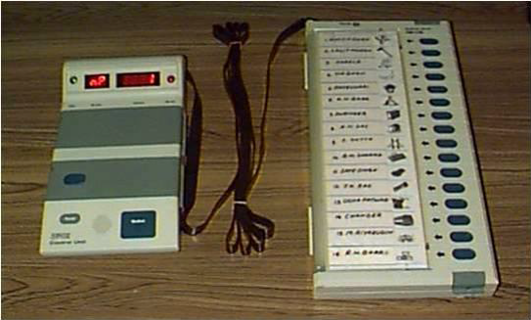

***Figure 1.1***

There are 2 types of problems with EVM which is currently in use:

1. **Security Problems:** Individual can change the program installed in the EVM and can tamper the results after the polling for the favor of the candidate.
2. **Illegal Voting (Rigging):** Rigging is the most common problem faced by the election commission of India.In which an individual cast more than one vote in a different constituency
3. **Manual adding of candidature:** India is a democratic country, Each and Every individual has right to stand at the election, If a large number of candidates contest the election it will create difficulty to the election commission to conduct elections. Since our project is dynamic, we can add as many candidates we want.

**1.6 Proposed System:**

We develop our system in such a manner so that we can eliminate the drawbacks of the existing system and enhance the authentication and verification process of the election.

A pattern recognition system works by the acquired data and comparing the features set against the data stored in the remotely and safe database. So, It checks the illegal and the repetition of votes. Hence the elections would be conducted fair and free from any type of rigging. It will fully automate the process of casting the election and then it will be much easier for the people to cast the votes and elect their favorite candidate and hence it will add power to the running democracy.

**CHAPTER 2**

## PROBLEM STATEMENT

**2.1 Low Turnaround Ratio**

As now we all know that till date no more than 67 percent of poll turn around ratio is noted in India. Well, this has happened mainly because India is a vast country with a lot of Career opportunities for its citizen in a different part of-of the country. But due to this, the friction of people living in India have to shift to a different part of the country to earn a livelihood. When the election dates are announced, Legally the people should go to their place where they are registered as voters and cast their votes. But in most of the cases, This does not happen, As this process costs money and time to travel, Which people are not willing to spend. This is the reason the poll turnaround ratio of India has never recorded above 67 percent and in the past 62 years, It has increased only by 4.89 percent. So the main problem is lesser poll turnaround ratio, But this is not the only reason for such lesser poll percentage.

***Figure 2.1***

***Figure 2.1***

|  |  |  |
| --- | --- | --- |
| **Year** | | **Turnaround in percentage** |
| 1952 | 61.17 | |
| 1957 | 62.23 | |
| 1962 | 55.42 | |
| 1967 | 61.04 | |
| 1971 | 55.25 | |
| 1977 | 60.49 | |
| 1980 | 56.92 | |
| 1984 | 63.56 | |
| 1989 | 61.98 | |
| 1991 | 56.73 | |
| 1996 | 57.94 | |
| 1998 | 61.97 | |
| 1999 | 59.99 | |
| 2004 | 58.07 | |
| 2009 | 58.17 | |
| 2014 | 66.4 | |

***Table 2.1***

This table shows the percentage of vote cast each year from 1952 to the year 2014. We didn’t have the data of the election of the year 2019 at the time of making this table. All the data on the right side of the table is in percentage.

**2.2 Reason for Low Turnaround**

Most of the people who live in town or city are not willing to get out of their house from their comfort zone and go to cast the votes. In a study by Times Of India, It is stated that there are more than 11.4 percent people who live at the place where they are registered as voters but they do not go and cast their votes. Another survey by TOI states that there are approximately 1.47 percent people who are alive but medically not in a condition to go to the poll centers and cast their vote for the formation of new democratic governments. A survey by ECI states that

Approximately 1 percent of people who live in villages are unaware of election dates and often they miss the dates of election to cast the votes. To solve this problem the ECI has already started the advertisement to make the people aware of dates in their areas.

One of the major problems which were noted during the election process was invalid votes. The system which is running currently makes the vote as Invalid vote If a voter press two buttons at a time. At the time of ballot papers, When the mark exceeds the boundary reason by 25 percent or more then the counting person gets confused that which candidates he has cast the vote for and they declare that vote as invalid.

|  |  |
| --- | --- |
| **States** | **Poll Percent Of 2019** |
| Bihar | 53.36 |
| Chandigarh | 63.57 |
| Himachal Pradesh | 70.4 |
| Jharkhand | 71.16 |
| Karnataka | 72.28 |
| Madhya Pradesh | 75.48 |
| Punjab | 64.71 |
| Uttar Pradesh | 58.01 |
| West Bengal | 62.88 |

***Table 2.2***

A survey by The Hindustan Times states that sometimes the voter gets confused that which candidate he has to cast the vote. This makes the democracy weaker, If a user has no prior knowledge of the candidates.

Only the Symbol is given by ECI and the name of the candidate is printed on the machine which is available as of now. No image, history, about the candidate, Education qualification, or achievements are written. Well knowing all these will help the voter to cast their vote wisely to make the country developed.

**2.3 Approach**

Everything we are doing with the comfort of just one click, Then why don’t we vote smartly. This project will help in saving the most precious time of voters and avoiding the long hectic queue of the polling centers and saving money. This project will also reduce the number of Invalid voters cast per election as even one vote can create a difference. We, With the help of this project, aims to achieve a polling turnaround ratio of 80 Percent or ab[ove by 2029. We are also using biometric to identify the person so that one person can’t cast the vote again. This will make democracy even stronger.

**CHAPTER 3**

**BACKGROUND AND LITERATURE SURVEY**

**3.1 First Generation Voting System.**

In the beginning, Vishal Vilas Natu proposes that the voting system mechanism is totally based on paperwork and electronic machine. There is a lot of paperwork involved in the process like to save the voters information and also the voter needs to go to the ballot box by carrying a Voter id for authentication purpose. Once the authentication process is done by the election officials then the voter cast their vote by making use of the electronic machine. The electronic machine has the details of the list of candidates stored in it and has multiple buttons in front of the candidate name. By pushing the button the voters can vote to their candidate. But it has certain drawbacks like it was taking a long time to cast the vote. And according to GOI, India has 280,273 polling centers across the country. This makes the entire system very slow and the counting process was also a lot of time-consuming. To overcome this traditional election system a study of digital technology and their security.

**3.2 Second Generation Voting System.**

Khasawneh Metal. said that in a paper-based election, there is a ballot box to which voters deposit their votes. The ballot box is a sealed container which is distributed across the electoral circuits around a given country. when the election period ends, the ballot boxes are opened and the votes are counted manually in the presence of the officials from the election commission of India. During the process of counting of voters, there can be some errors in counting. Also in some cases, voters may find ways to vote more than once. Sometimes, votes can also be manipulated to change the result of the election in favor of a candidate. Hence this system was not efficient and need to be replaced as quickly as possible.

**3.3 Third Generation Voting System**

An electronic voting system was introduced by Virendra Kumar that Was capable of automatically performing authentication, validation, and counting with the help of UIDAI(Unique Identification Authority of India). The proposed electronic system can be implemented along with the traditional election system. The Proposed approach will use the data provided by UIDAI in the electronic voting system. But again this system was not secured and the cost of manufacturing of each unit was higher as it includes hardware as well as software in it.

The concept of untraceable electronic mail and digital pseudonyms, which can apply for electronic voting for anonymity was introduced by David Chaum. This system effective but much secure which was needed as security is the most important concern in systems like this.

Virendra Kumar Yadav provided an approach in which data or information can be used, provided by the UIDAI in the smart voting system. The steps or procedures that were involved in this system were carried mainly in a few stages: Registration, Verification, and Validation also known as R, V, and V.

**3.4 Fourth Generation Voting System**

D. Ashok Kumar made an analysis of fingerprint matching Algorithms for EVM. In which fingerprint matches voter can vote to the candidate by using EVM. the fingerprint is a more secure method for EVM. The computer of critique and security communication insecure voting system was reviewed by Jefferson D. The web-based voting system being built by Accenture. Fingerprint technology is used as security in this approach.

Qijun Zha proposed an approach in which adaptive pore model for fingerprint pore extraction was introduced. This model was proven to be more secure. In automated fingerprint recognition, sweat pores have been recently employed in which the pores are extracted by making use of the computationally expensive skeletonization method or a unitary scale isotropic pore model.

A System was introduced by R. Moheb et al. . in this approach to image extraction and accurate skin detection from web pages. Their System to extract images from the webs and then detect the skin color regions of these images.

Manjeet Kaur proposed a fingerprint verification system which makes use of the minutiae extraction technique. Most of the fingerprint verification techniques are based on minutiae matching and they have been well studied.

Online fingerprint identification with a fast and distortion tolerant hashing method was proposed by Hoi Le and The Duy Bui. In this approach, they presented a specific contribution by introducing a new robust indexing scheme. This scheme was not only baled to fasten the fingerprint recognition process but also to improve the accuracy of the system.

Mayank Vatsa proposed combining pores and ridges with minutiae for improved fingerprint verification. This paper presents a fast fingerprint verification algorithm using level-2 minutiae and live;-3 pore and ridge features. The provided algorithm makes use of a two-stage process to register fingerprint images.

Umut Uludag proposed a biometric template selection and update: a case study in fingerprints. In automated fingerprint recognition, sweat pores have been recently employed where the pores are extracted by making use of the computationally expensive method or a unitary scale isotropic pore model.

Andrew Ackerman introduced the smart e-voting system has been done on fingerprints. The two main fundamental goals that have risen from the voting process are first a person’s fingerprint will not change the structure naturally after about one year of birth and second the fingerprints of individuals are different. Even the twins in fingerprints are not the same.

**CHAPTER 4**

**SYSTEM REQUIREMENTS**

System analysis is a very much complex process used by professional in order to maintain and develop computer-based system It helps to understand what does a system do and what are its requirement and how it will be maintained, so it’s quite crucial to know and understand users requirement.

The project requires both hardware and software tools. The hardware tools are SecuGen Hu20 Pro. Software components are Windows OS, Sublime Text 3 (version-3.207), Microsoft Visual Studio 2019, MySql Server 2008 R2.

**4.1 HARDWARE COMPONENTS:**

**4.1.1 SecuGen Hu20 Pro:**

The Hamster Pro is high resolution based image quality USB fingerprint reader that is quite affordable and work for a very large number of deployments. It is water resistive and built with the industry’s most advanced paid optical sensor. This device can be used for verification, authentication and identification functions that can help ones' fingerprints to work as digital passwords which cannot be lost or stolen.

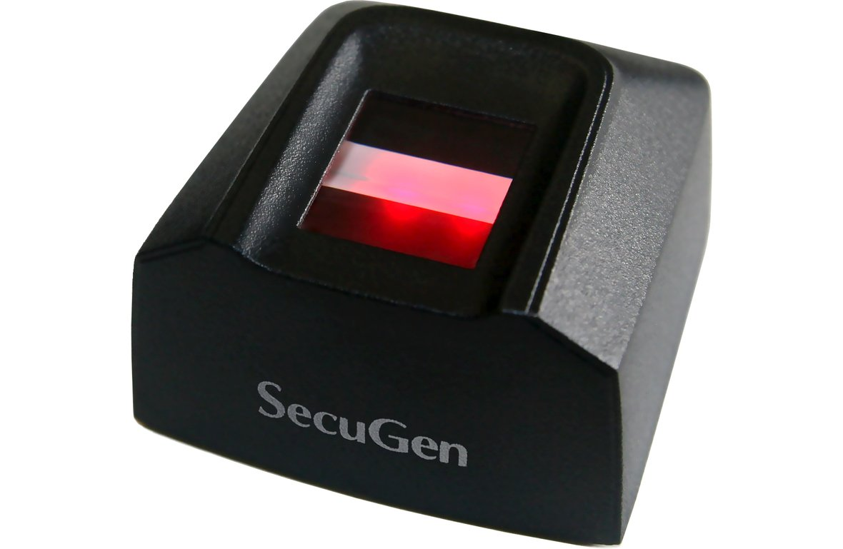

***Figure 4.1***

**4.1.2 System with minimum configuration.**

We need a windows system with a minimum configuration of RAM 1GB, Installation Space of 5 GB, and the core of i3. This will make sure the system will run smoothly. Any Hardware system though will be able to run the system. The run the above software smoothly will need an installation space of minimum 20 GB, A intel processor of i5 (5th Gen) and RAM of 4GB.

**4.2 SOFTWARE COMPONENTS:**

**4.2.1 Windows OS:**

Since our project is not platform independent yet, It is based on Windows OS. In future enhancement, we will make it platform independent so that it is compatible with every operating system.

**4.2.2 Sublime Text :**

We use Sublime Text as an editor because this software uses data mining concept, which can predict our next move and help us to perform our work smoothly.

**4.2.3 Microsoft Visual Studio 2019:**

With the help of Microsoft visual studio, we can write our code fast and debug accordingly. It provides several tools for testing and debugging.

**4.2.4 MySql Server 2008 R2 :**

This can be used for developing, learning and web server application. It supports each and every type of function, views, and triggers.

**4.2.5 Atom**

The Atom is used during the implementation of software to do the front end. We will use this software for linking front end to back end.

**CHAPTER 5**

**METHODOLOGY**

This section of the paper is about how we are actually going to solve the problem to make the system functioning. We have used all Microsoft technologies, which we will see all of them one by one in detail.

**5.1 Tools Required During Implementation**

During the implementation of this project have used all the open source software. We have used **SUBLIME** **TEXT** **3** Community Edition (version 3.2.1) and **ATOM** (Version 1.3.7) for Mac Operating System and Microsoft Visual Basic 2019 for Windows Operating System as an editor for writing the codes of the Interface. Again We have used Notepad++ along with sublime text for designing the project.

We have used Microsoft SQL Server 2008 for creating and maintaining all the servers to run on a windows machine. We have used the Windows Operating system platform and running the software. We have used Xcode of Mac Operating System to automate the testing process. Apart from these, we have used a fingerprint sensor **SECUGEN HAMSTER PRO 20** as hardware to capture and scan the fingerprints. We have used all its drivers to run this hardware smoothly. These are the basic software and hardware which we used during the implementation of this project.

We have used

**5.1.1 Software**

1) Windows Plateform.

3) Microsoft Visual Studio.

4) Microsoft SQL Server 2008.

5) Sublime Text.

6) Atom.

**5.1.2 Hardware**

1) A system with a basic configuration.

2) SecuGen Hamster Pro 20 Fingerprint Sensor.

**5.2 Technologies Used For Implementation**

We are using the following technologies.

1. **C#**: It is basically an object-oriented programming language mostly used for networking and web development. Since we are using both web forms to create the forms and Networking to link the system from the host which will store the database of the system. We found this language suits the best with our system.
2. **.Net FrameWork:** It's basically a software development tool provided by Microsoft. This framework is used to create the software to run on windows machine platform.
3. **MySQL:** It's an opensource and one of the most popular syntax query language processing tool. We are using a database to store all the information of candidates, Voters, and many more. We are using MySQL to manage the database.

**5.3 Interface**

Designing a user-friendly interface was one of our major challenge and area of focus. We use multiple tools and have tested and verified with many types of people. The user interfaces consist of two parts. The first part will deal with the Administrator and one candidate will be given special access to the following features.

**5.3.1 Admin Section**

* **Add Candidates:**

The admin who will be the member of election commission team will be given admin login credentials and after login, He can add the candidate list who want to take part in the election. It will be basically the nomination process and all the candidate who wants to participate can enroll themselves during the nomination. This page is designed dynamically and hence it will ask for the number of candidates who wants to enroll. Once the admin gives the details such as candidate id, Candidate name, Candidate photo, etc. It will be saved in the database.And at the end, By clicking on submit, If any details are not filled or are empty, It will throw a pop up message that all the fields are not filled correctly or are empty.

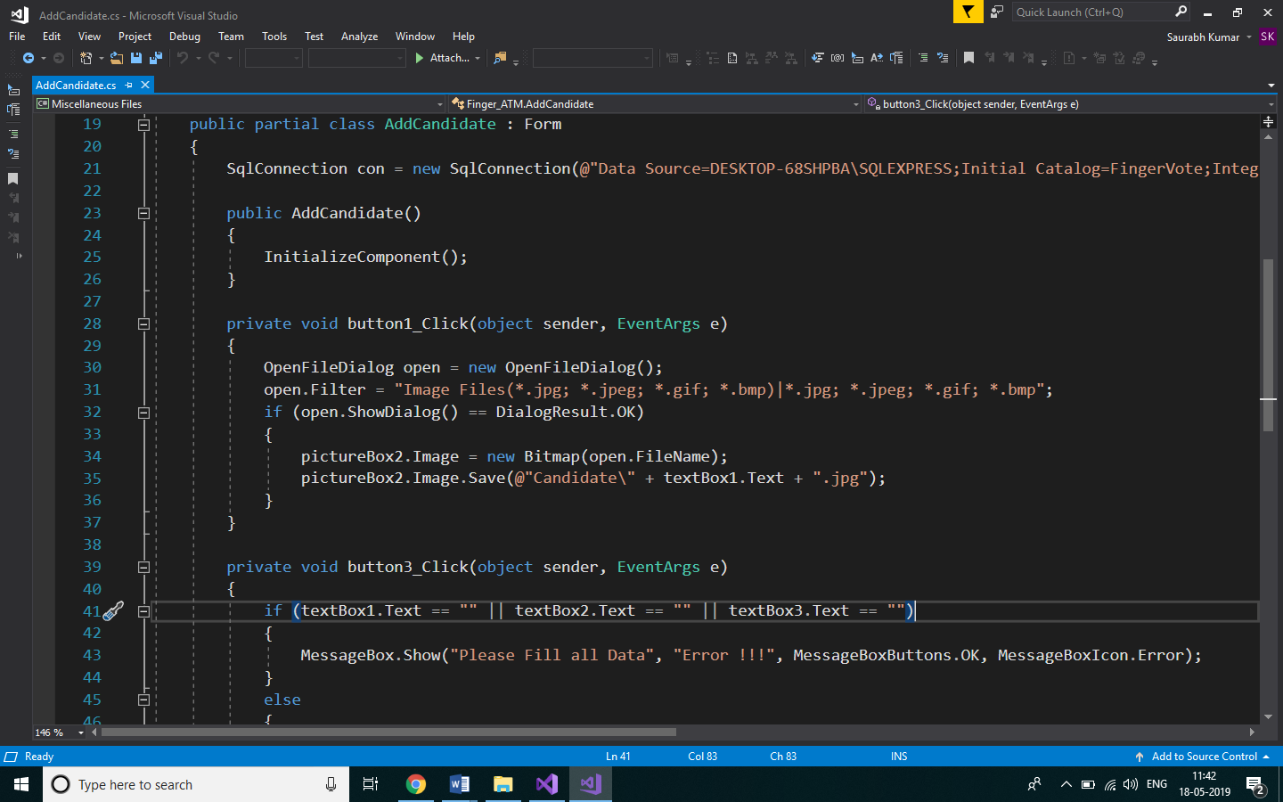

***Figure 5.1***

* + - **Add Voters:** This another feature of admin login is to add the voters who live in that particular area so that they are eligible to vote electronically. Well for that, The admin needs to take the details from voter such as photo, voter id, Voter name, Address, Mobile number, and while clicking on submit, Place the right thumb on the fingerprint scanner and click on submit. If any field is left unfilled it will again send a message saying that one or more details are left unfilled and try again. If everything goes well, It will capture the image of thumb and store the whole data in a database for future access

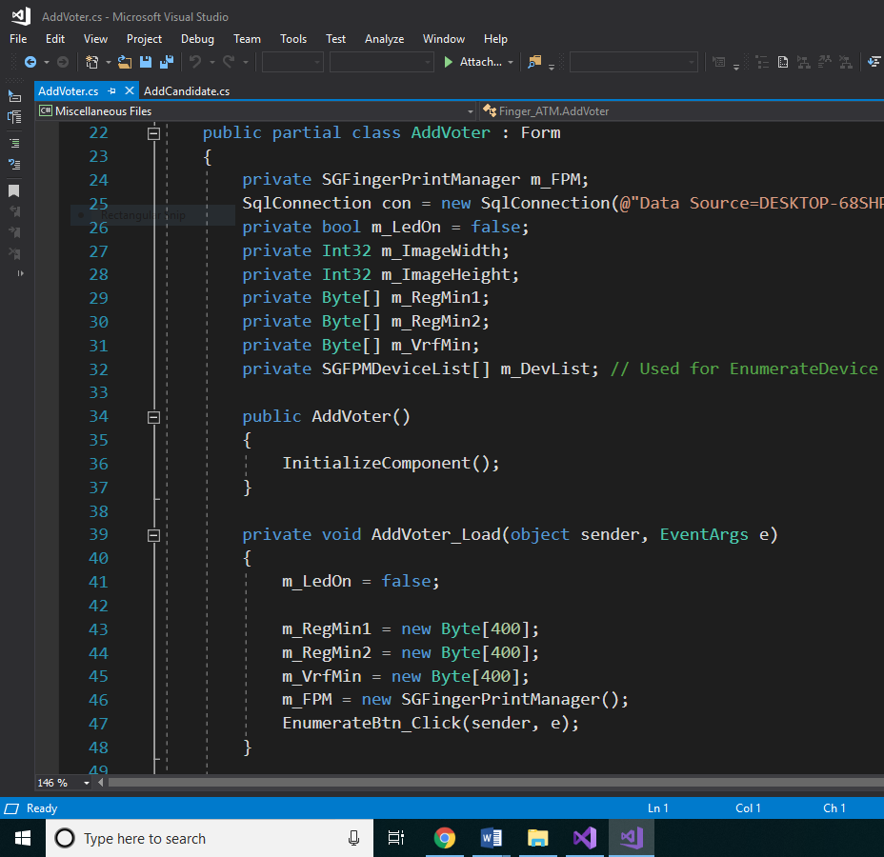***Figure 5.2***

* + - **Add Election:** The admin will have access to add the election as commanded by the election commission of India. He can add the election with specific dates and a dynamic page will appear which will ask the number of a candidate participating in the election. One the admin will give a number such as four, a page will appear asking the details of 4 candidates. If only two candidates are participating then only two names will be asked by the system. One the name is given, It will ask for the election agenda. Basically the purpose of the election. Suppose if the election is being conducted for electing the member of parliament, It will be given therein agenda field. Once done with all, The admin needs to give the dates of the election. And the result of that particular election can be declared only after that day.
    - **Calculate Result:**  Once the election day is over, The admin can calculate the result to declare the winner of the election. This counting process requires election id to declare the result. It will show the winner of the election and the number of votes he got to win the election which can be again viewed in the result section.
    - **Result:** The is a feature of admin as well as for normal voter. It will show who won the election and how much votes he got. It will also show the list of previous elections and their winners. So it keeps all the records of the election.
    1. **Non-Admin Section:** The voters and other peoples are non-admin and the majority of them come under the nonadmin section. This section will be used basically for casting the votes. From here, The admin will enter into the admin page and will access all the data of the admin and hence can add voter, Candidate, Election, etc.In this section, The the voters and other public can directly get into the page to cast the vote and they will have the access of the view result option as well from where they can view all the declared results till date. The snapshot of the entry looks somewhat like a figure

1. **Admin Section.**
2. **Non-Admin Section.**

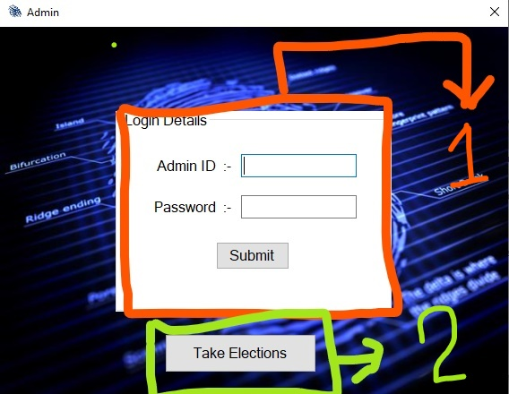

***Figure 5.3***

**5.4 Security**

Admin can only add voters, Add candidate, Add Elections, Calculate results, etc. But Even the admin will not have access to the database as it will be stored in another location. The database will be stored in a remote location and only the authorized person of Election Commission Of India will be knowing the remote location and will have the access. The server name will be encrypted using the Vinegar Cipher algorithm of cryptography so that no third party can hack the IP. This feature makes it more secured. Once the casted vote can’t change as the counter counts the number only, Not any other details. The system will check for the validation of the vote. Once a voter cast their vote, Will not be able to cast the vote again. And hence it preserves the rule of democracy.

**CHAPTER 6**

**DESIGN**

**6.1 ER Diagram**

Voter no.

Name

Voter

Block

Address

State

**Participates**

Party

Candidate

Fingerprint Election

Date

**has**

Vote no

No.

Name

Candidates

Party

Total vote

Result

Winner

Vote no

***Figure 6.1***

**6.2 The Block Diagram**

Election Commissioner Voting Day Set

Voter Id

Result Preparation

Name

Voter

Password

Voting List

Address

City

Personal Information

Result

Voting

Candidate View

Nation Wide

State Wise

Cast Vote

Party Wise

Voter List Validation

***Figure 6.2***

**6.3 Data Flow Diagram**

Voter ID Result

Voting Date Voting Validation

Candidate

Validate user

Voter ID Validation VVvvV

Validate Voting Date

Voter Date Validate

All Voters

Voting

Candidate List

Result

***Figure 6.3***

DFD is used to graphically represent the flow of data in a system. This shift the transaction flow from one vertex to another to process another data. There is a certain symbol which is used are as follow:

Process that transforms data flow.

Source or Destination of data

Data flow

Data Store

***Figure 6.4***

**6.4 DATABASE DETAIL**

Fingerprint Election System DB

0.0

User

Database

Query

Process

Request

1.0

User

Query

Database

Feedback For

User

Check for user

Requirement

User need

Relevant

Data

1.1

***Figure 6.5***

**CHAPTER 7**

**IMPLEMENTATION**

In this chapter, We will deal with the actual process which we have done to make the design working. The design which was designed earlier will be implemented using the code and structures, With the help of different software so that it works as planned. So let's look over the implementation methods one by one.

**7.1 Installation Of The Drivers**

All the hardware require their drivers to run in the system. We are using SecuGen Hamster Pro 20 as hardware to scan the fingerprint and storing and matching. There are many ways to read the fingerprint, But we are using hybrid technology which is more accurate and will give the efficient way to recognize the fingerprint. And also this process is very fast when compared to other technologies. The hybrid technology will also work if a person's finger is sweating and it will help in clearing those sweat and then identifying the finger. Once the finger Image is scanned and only the useful information we will store in the database. Not the entire fingerprint. So basically, What we are going to do is we take the finger, Scan it with SHP20 and extract the patter in the form of data. Store this data in the database and the remaining will not be stored. At the time of validation, The fingerprint will again be scanned and the useful information will be extracted. This extracted information will be matched with the database. If it matches, Then the user is a registered voter and then again check whether the voter has cast the votes or not. If cast the send a pop message saying that You can’t cast the vote again as you have cast the vote already. If the user has not cast the vote, The give him the menu to cast the vote. The user can check the profile of the candidate and the photo including the past works and all other information about the user.

Drivers play an important role in the working of the hardware. We are using the SHP20 Web API driver of Windows 10 (Version 1.0.0.54). As it includes all the file which we require for Scanning fingerprint, Extracting useful information, And Comparing it with other information. And that's all we need. Our project code will take care of the rest of things.

**7.2 Front End.**

The front end is the major part of any software as the user can only view this part of the software. The front-end would be designed in such a way that it is user-friendly and it can help in smoothly access to the software. If a user can’t access the software, It is of no use. So designing the front end is one of the tasks, Which needs a lot of Attention, Creativity and Hard work.

**7.2.1 Admin Login Page**

/*

*

* Code by Saurabh

* Date: 13/03/2019

*

* */

using System;

using System.Collections.Generic;

using System.ComponentModel;

using System.Data;

using System.Drawing;

using System.Linq;

using System.Text;

using System.Windows.Forms;

using System.Data.SqlClient;

namespace Finger_ATM

{

public partial class AdminLogin: Form

{

SqlConnection con = new SqlConnection(@"Data Source=DESKTOP-68SHPBA\SQLEXPRESS;Initial Catalog=FingerVote;Integrated Security=True");

public AdminLogin()

{

InitializeComponent();

}

private void groupBox1_Enter(object sender, EventArgs e)

{

}

private void button1_Click(object sender, EventArgs e)

{

SqlCommand cmd = new SqlCommand("Select Pass from Admin where Id = '"+textBox1.Text+"'",con);

con.Open();

SqlDataReader dr = cmd.ExecuteReader();

if (dr.HasRows)

{

dr.Read();

if (dr[0].ToString() == textBox2.Text)

{

con.Close();

this.Hide();

AdminMenu am = new AdminMenu();

am.Show();

}

else

{

con.Close();

MessageBox.Show("Invalid Password", "Error !!!", MessageBoxButtons.OK, MessageBoxIcon.Error);

}

}

else

{

MessageBox.Show("Invalid ID","Error !!!",MessageBoxButtons.OK,MessageBoxIcon.Error);

}

}

private void AdminLogin_Load(object sender, EventArgs e)

{

}

private void button2_Click(object sender, EventArgs e)

{

TakeElection te = new TakeElection();

te.Show();

this.Hide();

}

}

}

**7.2.2 Admin Dashboard**

/*

*

* Code by Rahul

* Date: 18/03/2019

*

* */

using System;

using System.Collections.Generic;

using System.ComponentModel;

using System.Data;

using System.Drawing;

using System.Linq;

using System.Text;

using System.Windows.Forms;

namespace Finger_ATM

{

public partial class AdminMenu : Form

{

public AdminMenu()

{

InitializeComponent();

}

private void addCandidateToolStripMenuItem_Click(object sender, EventArgs e)

{

AddCandidate a = new AddCandidate();

a.MdiParent = this;

a.Show();

}

private void logoutToolStripMenuItem_Click(object sender, EventArgs e)

{

Application.Exit();

}

private void addElectionToolStripMenuItem_Click(object sender, EventArgs e)

{

AddElection a = new AddElection();

a.MdiParent = this;

a.Show();

}

private void addVotersToolStripMenuItem_Click(object sender, EventArgs e)

{

AddVoter a = new AddVoter();

a.MdiParent = this;

a.Show();

}

private void viewResultToolStripMenuItem_Click(object sender, EventArgs e)

{

ViewResult a = new ViewResult();

a.MdiParent = this;

a.Show();

}

private void viewCandidateToolStripMenuItem_Click(object sender, EventArgs e)

{

ViewCandidate a = new ViewCandidate();

a.MdiParent = this;

a.Show();

}

private void caculateResultToolStripMenuItem_Click(object sender, EventArgs e)

{

Result a = new Result();

a.MdiParent = this;

a.Show();

}

}

}

**7.3 Back-End**

We have used MySQL to manage the databases. This tool will help in accessing the database to store and retrieve the information from it. We are using Microsoft SQL Server 2008 R2 as a server to host the system and all the backend thing will be available in it. One can access the backend only he knows the location of the server. The Ip of the server is encrypted using Viginier Cipher. The one who knows the physical location of the server, as well as the key of encryption, can only access the database which will be known to the higher authority of ECI. Even though, the ECI people can’ t make any alterations to the vote cast by the voter. We are using the access control algorithm to secure the system. Even the admin can’t see which candidate the user has cast the vote, As only the count of the vote will increase. And the voter will be marked as voted and hence he or she can’t cast the vote in this election any further. The admin will have the access only to add candidates, Add voters add Election, etc which will be saved in the DB. We have used MySQL as backend Language.



***Figure 7.1***

**CHAPTER 8**

**EVOLUTION AND TESTING**

**8.1 Evolution**

**8.1.1 Building The Front End.**

The Project started with analyzing the need from the project and the front end had to be designed in a similar manner. Like the front end, itself was the main UI, it needed to be as efficient and as smooth as possible. The first thing was deciding the technology stack that would be used to build the complete front end of the project. We decided to go with Microsoft.net technology as it is one of the best technology for the front end design. It consists of various libraries which helps in designing a very interactive User interface.

The design went on first by understanding the need of the system and then analyzing the above result and henceforth building or writing the code for the front end. During the initial stage, our front end wasn't very much interactive and was lagging behind in many other features, with basic code faults, like smaller buttons and large text and improper frames.

Then again we had to re-analyze the results to get a better front end, and hence we worked again on the code to get a much better and customized front end design. After making a few important changes in the code we were able to get a proper design of the front end, with the present UI.

We had to face many major challenges in the front end design some of them has been listed below:

1. User-friendly design.
2. A candidate needed to be added dynamically. ie, if the election had 2 candidates only those two needed to be shown similarly for 4,8,10 candidates.
3. Designing a system that is easily usable on the various system, ie making a versatile system.
4. Designing a bug-free system such that there are zero errors.
5. Designing a portable system that can accommodate the need of all the user.

**8.1.2 Designing the backend.**

In the backend, we use the Microsoft SQL server technology 2008 as our prominent database, in order to store the data of the user. As we all know the data plays a very major role in our application, we need to design a very robust backend that can easily accommodate the need of the user and can be very much reliable. There are various issues with Database implementation. Many of the times the data retrieval process becomes very tedious, hence the backend design should literally error-free.

There were various challenges that we faced while designing the backend, one of the major was the complete crashing of the database and application shutdown. After analysis and planning, we were able to overcome this issue.

Another major challenge was maintaining the integrity of the user data and election data. Since this application needs to be very much highly secured, maintaining the security of the database was very much necessary. As we all know many databases can be easily hacked and modified, hence we had to design our system in such a way it was hack proof.

For this we implemented our database on remote servers, ie installing on a database on different systems placed at different places. We have also tried to mask the IP address of the server so that any information about the server isn’t available. This was done using an encryption algorithm called AES algorithm, it is a symmetric encryption algorithm that is efficient in software as well as hardware and supports a block length of 128 bits and key lengths of 128,192 and 256 bits.

We learn about various encryption techniques in order to make the application

much more secure.

**8.1.3 The fingerprint sensor**

We have a Used a secure hamster pro HU20 fingerprint sensor to capture the voters and candidates fingerprint so that it can be easily used in our system. We tried various fingerprint sensors but the major issue that we were facing was linking the module with technology stack and making it possible to get finger impressions without any errors as many people have cuts on their finger and hence their finger impressions can be captured properly and easily.

**8.2 TESTING**

As the project is on a bit large scale, we always need testing to make it successful. If each component works properly in all respect and gives desired output for all kind of inputs then the project is said to be successful. So the conclusion is to make the project successful, it needs to be tested. The main testing done was System Testing in order to check whether the user requirements were being satisfied or not. The code for the new system has been written completely using ASP .NET with C# as the coding language, C# as the interface for front-end designing. Our system has been tested with the help of various user and application has been successfully verified from all the aspect.

Although we were able to find a few errors in the application, all these errors were analyzed and hence were corrected making the application error-free. The overall flow of the application is made quite similar to the actual process.

In order to make the application error-free we have deployed a concept of multiple levels of testing before the final user acceptance testing takes place. The complete steps taken for a different level of testing are-

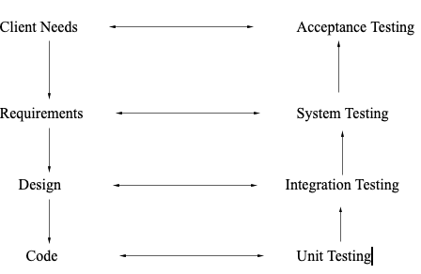

***Figure 8.1***

The steps Involved have been mentioned below:

**8.2.1   Unit Testing**

In the process of Unit testing, we try to test the application by testing the units of the application or we could say the modules. The complete application is divided into different sets of Modules and each module is hence tested separately in order to scan out even the smallest possible error in the application. This is also commonly known as module testing.

**8.2.2   Integration Testing**

Data can be grossed across an interface**;** one module can have adverse efforts on another**.** Integration testing is systematic testing for constructing the program structure while at the same time testing to uncover errors associated with the interface. The primary aim is to take Unit tested Modules and building the complete structure as a whole**.** All the modules are combined and tested as a whole**.** Here correction is difficult because the isolation of cause is complicated by the vast expense of the entire program. Thus in the integration testing stop**,** all the errors uncovered are corrected for the text testing steps**.**

**8.2.3   System testing**

System testing is a process where the Complete and integrated software is tested for any errors. It is a type of black box testing technique. In system testing the software is tested as a whole. System testing makes a logical assumption that if all the parts of the system are correct, the goal will be successfully achieved.

**8.2.4   Validation Testing**

After performing all the above levels of-of testing the software now has been bundled as complete package uncovering all the possible error and these errors have been corrected the final series of testing begins which is validation testing.

In the process of validation testing, we have to test the software such that it can be easily accepted by the customer. Once we have performed the validation testing either one of the two situations exists in front of us ie,  The function or the performance of the application is accepted and satisfies the client need or the application deviates from the expectations of the client and is a need to debug.

**8.2.5   Output Testing**

Once validation testing is over, the nest we move on to the Output testing. As we all know any system with output without in proper format is not considered as a valid system. Hence we ask the users about the required format of the output and testing the system against the given system generated output.

We consider the output format in 2 ways ie, the output that is shown on the screen and the output that is printed on a paper using a printer. If the output format on the screen is found to be matching with the output specified by the user and similarly for the output on the printed format, then we don't need to change anything in system and our system has passed the Output testing process.

**8.2.6   User Acceptance Testing**

User acceptance of a system plays a very vital role in deciding the overall success of the system. The system under evaluation is constantly tested by the system's user for user acceptance. We constantly stay in touch with the users at the time of developing and make changes whenever required.

**CHAPTER 9**

**OUTPUT AND RESULT ANALYSIS**

**9.1 The voter's menu**

The voter will get the menu to cast the vote to their desired candidate. If the voter wants to view the profile or image of the candidate, Then he/she can by clicking on view profile. All the casted votes will increase the count of the votes of the candidate, and it will not store which person cast the vote to whom. The result can also be transformed in the form of .xls or excel file for further analysis.

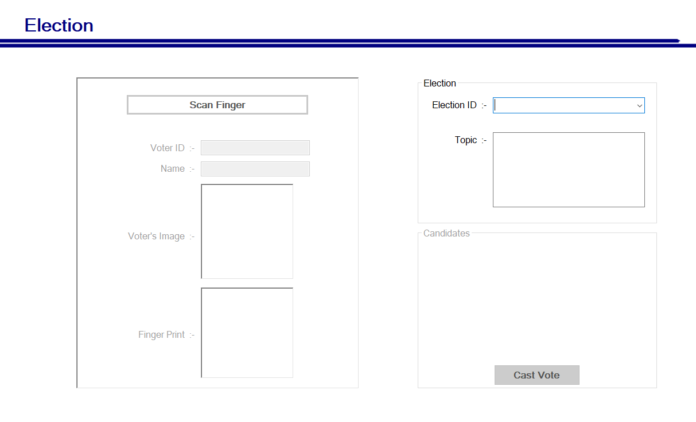

**Figure 9.1**

**9.2 The Admin Login Screen**

The admin only can log in with the admin login id and password and it. The admin will have access to login in and do things which are mentioned below.

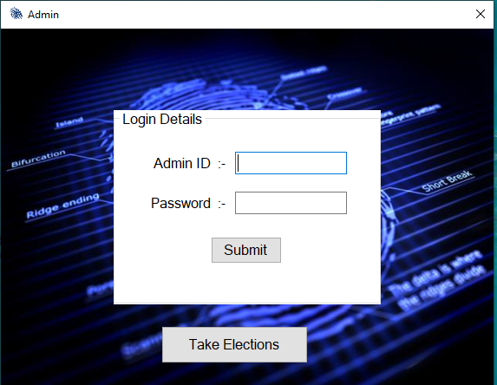

**Figure 9.2**

**9.3 Admin Dashboard.**

An admin dashboard is a place from where the admin can get the access of all his tools like he can add voters, Add candidates, Add election, Calculate and view result and store all in a database. All the function will have their specific meaning and designed in such a way that it is user-friendly and easily understandable with a person who understands basic English. We will have text to speed function for a blind person which we will implement later in this project. We have separated the election and login part So that for voting, The voter won’t need the admin access. It can directly be done without admin. And it will be done only on the date of voting and can’t be done any day before or after it. The admin can log out from dashboard and voters can cast their vote. The fingerprint sensor will be detected automatically and we have kept the capture button as submit. So one has to keep the finger on the sensor and click submit to get the cast vote menu.

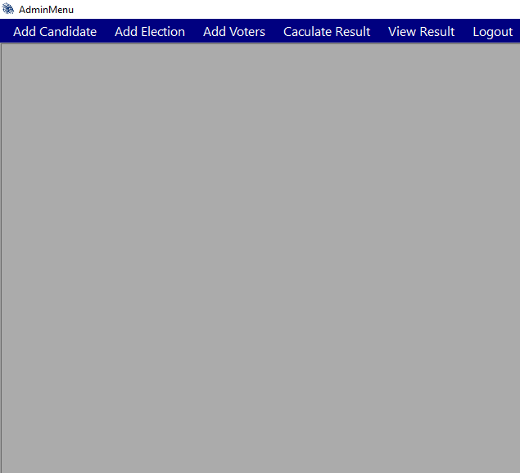

***Figure 9.3***

**9.4 Count Vote and Result.**

The count vote and result is final output section where the admin can count the vote and the result can be viewed by both the admin and the user. The admin can calculate the result when the date of election changes, Not on the same day of the election. For further analysis, the result will be extracted from the software in the form of an excel sheet which will show the detailed analysis of the vote of each candidate.

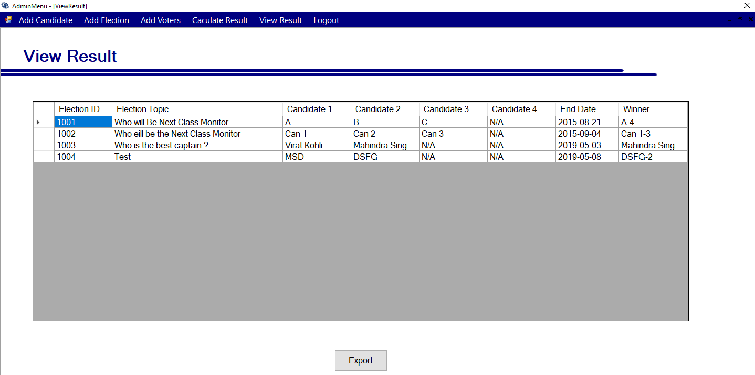

***Figure 9.4***

**CHAPTER 10**

**CONCLUSION AND FUTURE SCOPE**

**10.1 Conclusion**

In total, this system overcomes most of the problems that are faced in the traditional approach of the voting system The efficiency of this system depends upon the web interface, its usability. This will surely ensure a safer voting method which is very much what is required for the healthy growth of a developing nation.

The proposed fingerprint based voting system which is better and faster than the previous system. The new system prevents access to illegal voters, provides ease of use, transparency and maintains the integrity of the voting process. The system also solves the problem of RIGGING, means it does not allows a user to vote multiple times since his fingerprint is recorded once in an election. The system does not allow the voter to vote for more than once in the same election.

The fingerprint-based voting system has provided a chance to avoid invalid votes, it reduces the polling time, easy carrying to polling center from the polling box, Reduce the staff of the voting center, It provides easy and accurate cutting without any trouble.

The developed system provides an interface to the user where the user will be shown the list of candidates along with their basic pieces of information. The voter needs to be first registered with the system after that only he/she will e allowed to the vote in the election.

The system provides the result in a very short span of time without any errors. It reduces the possibility of changing votes or favoring any candidate. The system is totally automated and does allow even the admins to change the vote. It does not allow the admins to see who has been the vote cast by the voter.

Not only this, but It will also save the time which is spent in distributing and restoring the boxes to the ECI. It a be started with minimum system configuration and a fingerprint sensor.

**10.2 Future Scope**

The present study is based on the use of only one module. In the future, we interface a few more modules which will use a few more biometrics for more authenticity and verification for the user like Iris Scanner.

ADVANTAGES:

* Iris recognition hasa maximum accuracy rate.
* It is proved that iris recognition has no false matches yet over two million cross-comparisons.
* Iris recognition can control very huge populations at maximum speed. It has the power to perform very large searches within a milliseconds
* It is completely non-invasive and purely inherently safe.
* It remains unchanged and constant throughout a person’s life.

For the security of our system, we will implement Block Chain to ensure all the copies of the database are the same and the network is doing constant checks. The data structure which is used blockchain is only appended. So, the data cannot be altered or deleted from any individual. The transactions are set in sequential or the chronological order

In order to enhance the scalability of the proposed system, we use NoSql Database like MongoDB, which will increase the efficiency and stability and that will be it is a schema-less database. It is compatible with dynamic queries.

Moreover, since our system is compatible for windows platform only. In the future, our proposed system will be the platform independent so that it will run any type of environment. So that usability our system enhanced to the maximum.

**CHAPTER 11**

**REFERENCES**

**11.1 Websites**

* The website of Election commission of India.<https://eci.gov.in/>
* The website for General Knowledge**.**[https://en.wikipedia.org](https://en.wikipedia.org/)
* Taking the poll percent of 2019.<https://eci.gov.in/uploads/monthly_2019_05/1743823079_pollturnoutupto0930.PNG.d2824509bf4669cb1f0af5de550a6b9c.PNG>
* For taking the data of election of previous years.  
  <http://www.indiavotes.com/>
* Evolution of voting system in India.  
  <http://employmentnews.gov.in/Evolution-of-Electoral-System-of-India.pdf>
* Developed assistant of Microsoft.  
  <https://developer.microsoft.com/en-us/>
* Downloading sublime text.  
  <https://www.sublimetext.com/>
* Downloading Atom for Windows 10.  
  <https://atom.io/>
* Help for Microsoft Visual Studio.  
  <https://visualstudio.microsoft.com/>
* Help and guide for C#.  
  <https://docs.microsoft.com/en-us/dotnet/csharp/tutorials/>
* The company manufacturing the EVM for General Election in India  
  <https://eci.gov.in/evm/>

**11.2 Publications**

* <https://ieeexplore.ieee.org/abstract/document/7972261>
* <https://ieeexplore.ieee.org/document/8261341>
* <https://ieeexplore.ieee.org/document/6545943>
* <https://ieeexplore.ieee.org/document/5734969>
* <https://ieeexplore.ieee.org/document/7073090>
* <https://circuitdigest.com/microcontroller-projects/fingerprint-based-biometric-voting-machine-arduino>
* <https://www.researchgate.net/publication/322789967_Fingerprint_Voting_System_Using_Arduino>

**11.3 Books**

* Electrical system-A comprehensive introduction by David M Farrell(Page 183 to page 187).
* Behind the Ballot Box Douglas J. Amy (Page 27 to page 28 and page 117 to page 123).
* Comparing Democracies 2: New Challenges in the Study of Elections and Voting by Pippa Norris (Page 56 to page 59).
* The Great March of Democracy: Seven Decades of India’s Elections by S.Y.Quasi (page 193 to 207).
* A Handbook of Poll Surveys in Media: An Indian Perspective by Dr. N. Bhaskara Rao (Page 108 to 111).