PROJECT REPORT
DeepGuard: A Deepfake Detection and Alert System
Frame-level CNN classification of face crops, video-level risk scoring, suspicious-segment localisation and live screen-share monitoring
Submitted by
Name | Enrollment No.
Mudit Garg | A2305224054
Harmeet Suri | A2305224090
GitHub Repository
https://github.com/MuditGarg007/deepfake-detection
October 2026

Abstract
Synthetic face manipulation ("deepfakes") has become cheap enough that a convincing face swap can be produced on a consumer GPU in minutes, while the tools people use to consume video — social feeds and video calls — offer no signal about authenticity. This project builds DeepGuard, an end-to-end system that accepts an uploaded video or a live screen share and returns a frame-by-frame fake probability, an overall risk verdict (REAL, SUSPICIOUS or HIGH RISK) and the time window in which the manipulation is most evident. The detector is an ImageNet-pretrained CNN fine-tuned on 99,586 MTCNN face crops from FaceForensics++ (c23) with an identity-disjoint 70/15/15 split. EfficientNet-B0 reaches 99.12% accuracy, 0.9912 F1 and 0.9989 ROC-AUC on the held-out test split at 2.76 ms per image, matching a 5× larger Xception baseline. Because in-domain accuracy overstates real-world ability (0.840 AUC on unseen Celeb-DF-v2), we further study cross-method generalisation on a 305,666-crop corpus spanning 13 training manipulation families: a frozen CLIP ViT-L/14 tuning only LayerNorm parameters, with Self-Blended Image augmentation, raises held-out AUC from 0.672 to 0.861 over the same-data EfficientNet control while training 40× fewer parameters. The system is served through a FastAPI backend with PostgreSQL history, Clerk authentication and a web dashboard that includes a picture-in-picture live verdict.

1. Problem Statement
Deepfake videos replace or re-animate a person's face using generative models. They are now used for fraud (impersonating executives on video calls), non-consensual imagery, and political misinformation. Human viewers detect high-quality deepfakes at close to chance level, so an automated, explainable signal is needed at the point where video is consumed.
Existing academic detectors are usually released as research code that scores pre-cropped face images and reports a single benchmark number. They do not answer the practical questions a user has: Is this whole video likely fake? How confident is the system? Which part of the clip is suspicious? Can I check a video call while it is happening? Additionally, detectors trained on one manipulation method are known to collapse on methods they have not seen, so a high benchmark accuracy can give a false sense of security.

1.1 Objectives
- Train and compare CNN classifiers that map a 224×224 face crop to a fake probability, with an evaluation protocol free of identity leakage.
- Convert frame scores into a video-level verdict with calibrated risk bands and localise the most suspicious time segment.
- Support both offline video upload and real-time screen-share monitoring with a stable (non-flickering) verdict.
- Measure, rather than assume, generalisation to unseen manipulation methods and degraded (compressed / downscaled) video, and improve it.
- Deliver the system as a usable, authenticated web application with analysis history.

2. Work Done
The project was executed in phases, each with an explicit exit criterion. All code, training logs and evaluation reports are in the GitHub repository.
Phase | Work | Key output
1. ML model (v1) | Downloaded FF++ c23 (1,000 real + 1,000 Deepfakes videos); built MTCNN face-crop pipeline; trained EfficientNet-B0 and Xception; evaluated and compared. | 99,586 crops; EfficientNet-B0 checkpoint, test AUC 0.9989
2. Video processing | Frame sampling identical to training, largest-face selection, single batched forward pass per video, mean aggregation. | video → fake probability
3. Suspicious segments | Longest contiguous run of high-probability frames reported as start/end timestamps. | suspicious_start / suspicious_end
4. Backend | FastAPI service with upload, analysis, history, video playback, live-session and screenshot endpoints; PostgreSQL (Neon) persistence with hand-written SQL; Clerk JWT auth; admin panel. | REST API, smoke-tested
5. Frontend | Web dashboard: upload card, result panel with alert banner, per-frame timeline, history panel, live screen-share with picture-in-picture verdict overlay, sign-in/sign-up. | DeepGuard web app
6. Live detection | Screen capture at ~2 fps, JPEG q0.95, server-side session with EMA smoothing, hysteresis and periodic face re-detection. | real-time verdict
7. Generalisation study (v2) | Built 305,666-crop multi-method corpus (FF++, Celeb-DF-v2, DFDCP, UADFV, DF40); held-out protocol; CLIP LayerNorm tuning, SBI and codec augmentation; 10-run ablation sweep. | held-out AUC 0.672 → 0.861
8. Deployment | Dockerised CPU-only backend behind Caddy reverse proxy on a VPS, resource-capped (2 CPU, 2.5 GB). | public deployment

2.1 Technology stack
- Machine learning: Python 3.12, PyTorch, timm, torchvision, facenet-pytorch (MTCNN), OpenCV, scikit-learn, open_clip (v2).
- Backend: FastAPI, Uvicorn, psycopg2, PostgreSQL (Neon), Clerk JWT verification.
- Frontend: Next.js 16, React 19, TypeScript, Tailwind CSS 4, Clerk, Screen Capture API.
- Hardware: NVIDIA GeForce RTX 4060 Laptop GPU (8 GB), 16-core CPU, 15 GB RAM.

3. Algorithm
The system is composed of four algorithms: model training (offline), video analysis, suspicious-segment detection and live-session smoothing. Notation: p_i is the fake probability of frame i, τ_s = 0.4 and τ_h = 0.7 are the suspicious and high-risk thresholds.
Algorithm 1 — Training the frame classifier
Input : videos V with labels y ∈ {real=0, fake=1}
Output: checkpoint θ*
1 group videos by source identity (033.mp4, 033_097.mp4 → id 033)
2 shuffle identities (seed 42); assign 70/15/15 → train / val / test
3 for each video v:
4 sample frames at ~5 fps, uniformly thin to ≤ 50
5 run MTCNN; keep boxes with conf ≥ 0.95; pick LARGEST box
6 expand box by 20 px, crop, resize to 224×224, save
7 model ← timm backbone (ImageNet, pooled features of size d)
→ Linear(d,128) → ReLU → Dropout(0.2) → Linear(128,1)
8 for epoch = 1 … 15:
9 for batch (x, y) in train (augmented):
10 loss ← BCEWithLogits(model(x), y, pos_weight = N_real / N_fake)
11 AMP backward; clip ‖g‖ ≤ 1.0; Adam step (lr 1e-4, wd 1e-5)
12 auc ← ROC-AUC on val
13 if auc > best: save θ* ; else if 5 epochs w/o gain: stop
Algorithm 2 — Video analysis
Input : video file, checkpoint θ*
Output: probability P, status, frame timeline, suspicious window
1 F ← sample frames at ~5 fps, uniformly thin to ≤ 100
2 C ← [ crop(largest MTCNN face with conf ≥ 0.95, +20 px) for f in F ]
3 if C is empty: return error 422 (no face)
4 p ← sigmoid( model_θ*( batch(C) ) ) # one forward pass
5 P ← mean(p)
6 status ← REAL if P < τ_s ; SUSPICIOUS if P ≤ τ_h ; else HIGH_RISK
7 window ← Algorithm 3(p, timestamps)
8 store (P, status, p, window) in PostgreSQL; return
Algorithm 3 — Suspicious window
Input : frame probabilities p_1 … p_n, timestamps t_i, threshold τ_f = 0.7
1 best ← ∅ ; run ← ∅
2 for i = 1 … n:
3 if p_i ≥ τ_f: append i to run ; if |run| > |best|: best ← run
4 else: run ← ∅
5 if |best| < 3: return null
6 return ( t_first(best), t_last(best) )
Algorithm 4 — Live session (per incoming frame)
Input : JPEG frame, session state {ema, status, box, k}
1 if k mod 5 == 0: box ← MTCNN(frame) # re-detect every 5th frame
2 if box = ∅: return standing verdict (face_found = false)
3 p ← model(crop(frame, box))
4 ema ← p if first frame else 0.2·p + 0.8·ema
5 # hysteresis gap g = 0.1: entering a state needs the full threshold,
6 # leaving it needs the score to fall g below that threshold
7 hi ← τ_h − g if status = HIGH_RISK else τ_h
8 su ← τ_s − g if status ∈ {SUSPICIOUS, HIGH_RISK} else τ_s
9 status ← HIGH_RISK if ema ≥ hi ; SUSPICIOUS if ema ≥ su ; else REAL
10 (a frame arriving while the previous one is scoring is dropped, not queued)

4. Previous Work vs. Our Work
Table 4.1 positions this project against representative prior detectors. Table 4.2 compares our own first-generation model (v1) with the generalisation-focused second generation (v2).
Table 4.1 — Prior approaches compared with DeepGuard
Approach | Core idea | Limitation | DeepGuard
MesoNet (Afchar et al., 2018) | Shallow CNN on mesoscopic image features | Low capacity; weak on compressed video | Pretrained EfficientNet-B0 / CLIP backbone, evaluated on c23-compressed video
XceptionNet baseline (Rössler et al., 2019) | Fine-tuned Xception on FF++ face crops | Frame-level only; generalises poorly to unseen methods | Same baseline reproduced and matched by 5× smaller EfficientNet-B0; cross-method gap measured and reduced
RNN-based (Güera & Delp, 2018) | CNN features + LSTM over frames | Needs long clips; heavy; not real-time | Frame-level scoring + mean / EMA aggregation; real-time on CPU
Face X-ray (Li et al., 2020), SBI (Shiohara & Yamasaki, 2022) | Learn the blending boundary common to face swaps | Research code; no video verdict or UI | SBI adopted as an augmentation inside a full product pipeline
UnivFD (Ojha et al., 2023) | Linear probe on frozen CLIP features | Linear probe under-fits face forgeries | LayerNorm tuning of CLIP: 0.79–0.85 held-out AUC vs 0.64 for a linear probe (our ablation, same protocol)
Typical research releases | Score one image, report one benchmark number | No risk bands, timestamps, history or live use | Risk verdict, suspicious window, history, live screen-share with PiP overlay

Table 4.2 — Our v1 model vs. v2 model
Aspect | v1 (shipped) | v2 (generalisation study)
Training data | FF++ Deepfakes c23 only (1 method) | 13 held-in methods; 305,666 crops from 5 corpora
Backbone | EfficientNet-B0, full fine-tune (4.17 M trainable) | Frozen CLIP ViT-B/16 or ViT-L/14, LayerNorm-only (0.04–0.10 M trainable)
Augmentation | Flip, affine, colour jitter | + JPEG/codec degradation, downscaling, Self-Blended Images
Model selection | In-domain val ROC-AUC | Val-unseen methods (never trained on)
In-domain AUC | 0.9989 | 0.965 (held-in, ViT-L/14)
Held-out / unseen AUC | 0.840 (Celeb-DF-v2 only) | 0.861 (mean over 14 unseen methods & corpora)
Real-video false-positive rate @0.5 | 0.081 | 0.079

5. Process Diagram
Figure 5.1 shows the two pipelines. The offline pipeline (top) produces a checkpoint; the online pipeline (bottom) reuses exactly the same frame-sampling and face-cropping rules so that the model sees inference crops drawn from the same distribution it was trained on.
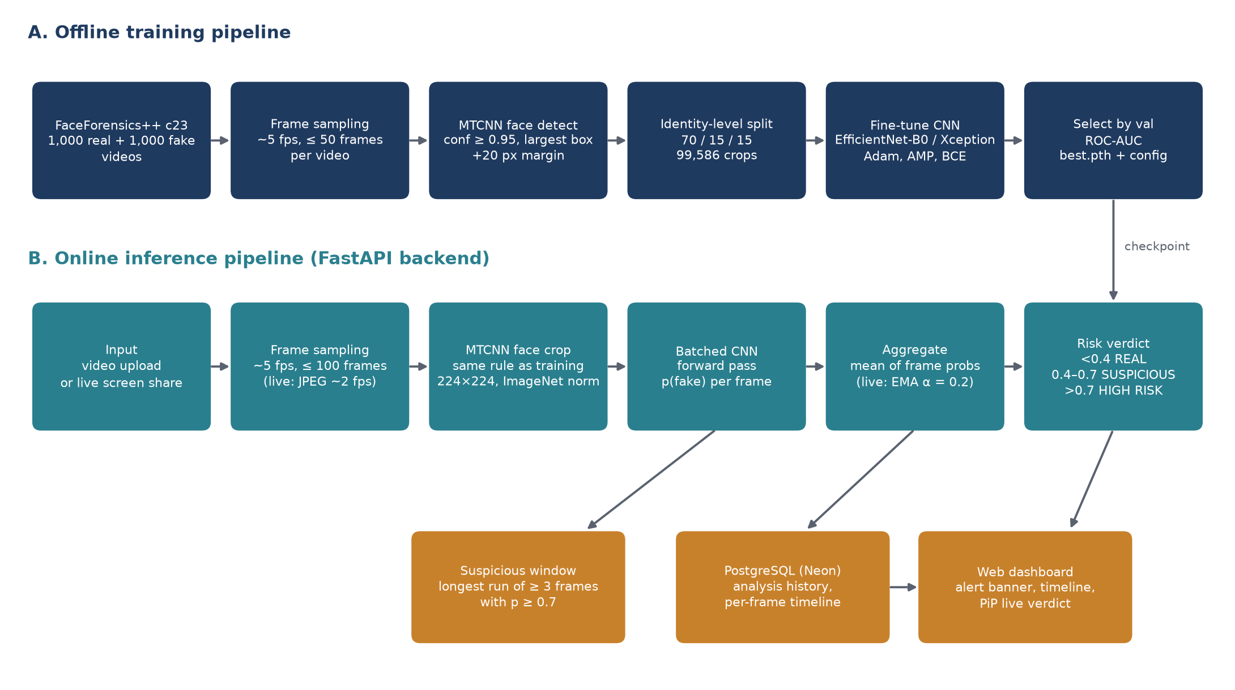
Figure 5.1 — DeepGuard training and inference pipelines

5.1 System architecture
- Client (browser): Next.js dashboard. Upload card posts a multipart video; live mode captures the screen with getDisplayMedia, encodes 640 px JPEG frames at quality 0.95 about twice per second and posts them to the session endpoint.
- API (FastAPI): loads the checkpoint in-process (no separate model server), verifies Clerk session tokens against the JWKS, runs Algorithms 2–4 and serves stored videos with HTTP range support.
- Storage: PostgreSQL tables uploads, live_sessions and screenshots, with the per-frame timeline stored as JSONB; uploaded videos on a persistent volume.
- Deployment: Docker image with CPU-only PyTorch, behind a Caddy reverse proxy with TLS, capped at 2 CPUs and 2.5 GB RAM.

6. Techniques Used

6.1 Data preparation
- Identity-disjoint splitting. FF++ names a fake after its source (033_097.mp4 is derived from 033.mp4). Videos are grouped by source identity so that no face appears in more than one split, removing identity and near-duplicate-frame leakage that inflates many published numbers.
- Train/inference crop parity. MTCNN (min face 40 px, confidence ≥ 0.95) is used in both training and serving, choosing the largest face rather than the most confident one and adding a fixed 20 px margin. Feeding a model a framing it never saw silently costs accuracy.
- Efficient decoding. Frames are seeked with OpenCV grab() so skipped frames are never decoded; decoding runs in a thread pool ahead of GPU face detection.

6.2 Model and training
- Transfer learning. ImageNet-pretrained EfficientNet-B0 (compound-scaled CNN, 4.17 M parameters) and Xception (depthwise-separable convolutions, 21.07 M) from timm, with global-average-pooled features feeding a 128-unit MLP head and a single logit.
- Loss and optimisation. Binary cross-entropy with logits and class-ratio pos_weight; Adam (lr 1e-4, weight decay 1e-5); mixed-precision (fp16) training with GradScaler; gradient-norm clipping at 1.0; channels-last memory format.
- Augmentation. Horizontal flip (p 0.5), ±10° rotation, ±5% translation, brightness/contrast jitter 0.2 — mild enough to keep faces natural.
- Early stopping on ROC-AUC (patience 5) rather than loss, because AUC is threshold-free and is the metric of interest.

6.3 Generalisation techniques (v2)
- Frozen foundation backbone with LayerNorm tuning. Only the LayerNorm affine parameters of a CLIP ViT and the head are trained (41 k – 103 k parameters). Full fine-tuning is what allowed v1 to overwrite generic features with method-specific shortcuts.
- Self-Blended Images (SBI). Pseudo-fakes are synthesised from real faces by blending a slightly transformed copy of a face onto itself, teaching the blending boundary that every face swap shares regardless of generator. In our ablation, removing SBI gave the lowest held-out AUC of all LayerNorm-tuned variants (Section 7.6).
- Degradation augmentation. JPEG re-compression, downscaling and noise simulate social-media and video-call codecs, since training crops are pristine while deployment input is codec output.
- Held-out evaluation protocol. Methods are partitioned into held-in (training), val-unseen (model selection only) and held-out (reporting only). Selecting on in-domain validation would have shipped a worse detector.

6.4 Serving techniques
- Batched inference. All face crops of a video are scored in one forward pass.
- Temporal smoothing and hysteresis (Algorithm 4) keep the live badge stable when the score hovers near a threshold.
- Detection caching. MTCNN costs 2.3× the rest of the per-frame pipeline, so in live mode it runs every 5th frame and the box is reused in between.
- Back-pressure. A frame that arrives while the previous one is still being scored is dropped rather than queued, so latency never accumulates.
- Privacy. Live frames exist in memory only for the duration of a request; stored rows hold scores, never images.

7. Results

7.1 Dataset statistics (v1)
Split | Face crops | Share
Train | 69,767 | 70.1%
Validation | 14,887 | 14.9%
Test | 14,932 | 15.0%
Total | 99,586 | 49.98% fake
MTCNN found a face above confidence 0.95 in 99.83% of sampled frames. Pre-processing took 12 minutes; training took 24 min (EfficientNet-B0) and 42 min (Xception).

7.2 Model comparison on the held-out FF++ test split (threshold 0.5)
Model | Accuracy | Precision | Recall | F1 | ROC-AUC | ms / img | Params
EfficientNet-B0 | 0.9912 | 0.9887 | 0.9938 | 0.9912 | 0.9989 | 2.76 | 4.17 M
Xception | 0.9858 | 0.9919 | 0.9796 | 0.9857 | 0.9990 | 2.08 | 21.07 M

The ROC-AUC difference (0.0001) is below the 0.001 margin treated as a tie, so the decision falls to F1: EfficientNet-B0 is the deployed checkpoint — equal accuracy at one fifth of the parameters and half the training time. Its confusion matrix on 14,932 test crops is TN 7,388, FP 85, FN 46, TP 7,413. Xception is the more conservative model (fewer false alarms, more missed fakes).
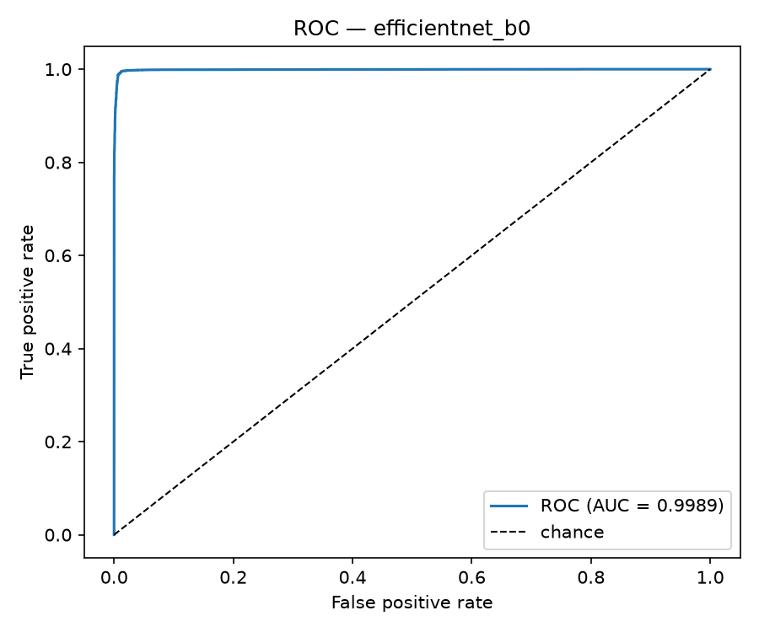  Figure 7.1 — ROC curve, EfficientNet-B0 | 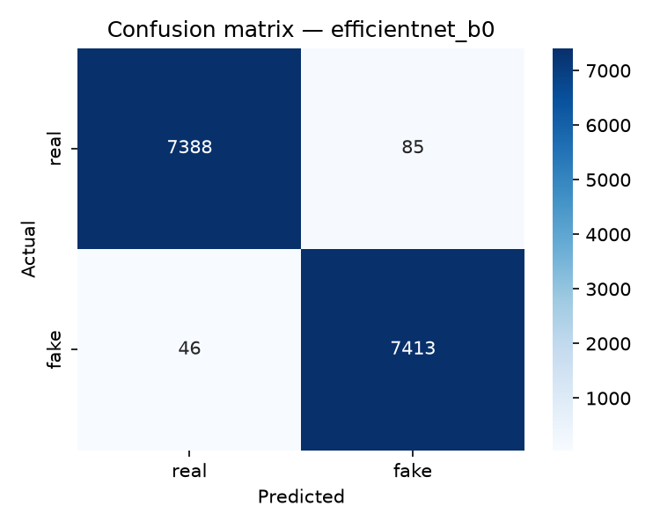  Figure 7.2 — Confusion matrix, EfficientNet-B0

7.3 Threshold sensitivity
Threshold | Precision | Recall | F1 | Accuracy
0.41 | 0.9880 | 0.9949 | 0.9915 | 0.9914
0.50 | 0.9887 | 0.9938 | 0.9912 | 0.9912
0.70 | 0.9905 | 0.9910 | 0.9908 | 0.9908
Performance is essentially flat across the 0.4–0.7 risk band, so the default REAL / SUSPICIOUS / HIGH RISK cut-offs needed no retuning.

7.4 End-to-end system check
With the deployed checkpoint, the backend smoke test classifies FF++ real video 006.mp4 as REAL (0.0000) and its deepfake 006_002.mp4 as HIGH RISK (0.9733) with a suspicious window of 0.0–10.2 s, 52 frames scored each. Mean predicted probability over sampled test crops is 0.0099 for real and 0.9862 for fake.

7.5 Cross-method generalisation (v2)
The v1 model scores 0.9989 AUC on its own test set but only 0.840 on unseen Celeb-DF-v2, falling to 0.758 after JPEG q40 compression — the in-domain number reflects the training manipulation being memorised. Figure 7.3 shows held-out AUC (mean over manipulations never seen in training) for the v2 runs.
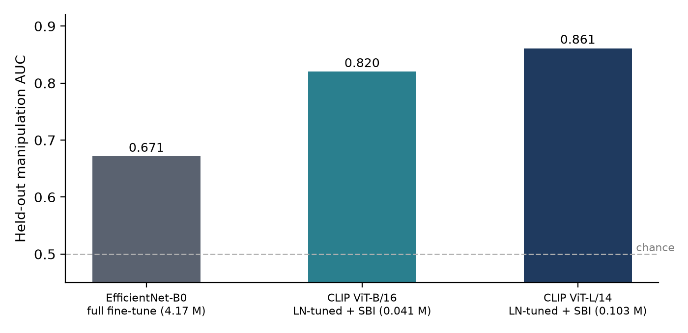
Figure 7.3 — Held-out AUC by backbone (same v2 corpus, augmentation and sampler; trainable parameters in brackets)
Run | Trainable params | Val-unseen AUC | Held-out AUC | Video AUC | Real FPR @0.5
EfficientNet-B0 (control) | 4.17 M | 0.9048 | 0.6715 | 0.7874 | 0.220
CLIP ViT-B/16, LN + SBI | 0.041 M | 0.9679 | 0.8200 | 0.8871 | 0.086
CLIP ViT-L/14, LN + SBI | 0.103 M | 0.9803 | 0.8611 | 0.9247 | 0.079

On the same data, swapping full fine-tuning of EfficientNet for LayerNorm tuning of a frozen CLIP backbone lifts held-out AUC by +0.15 with ViT-B/16 (100× fewer trainable parameters) and +0.19 with ViT-L/14 (40× fewer), and cuts the real-video false-positive rate from 22% to 8%. Unlike the EfficientNet run, neither CLIP run overfits: unseen-method AUC stays above in-domain validation AUC at every epoch.
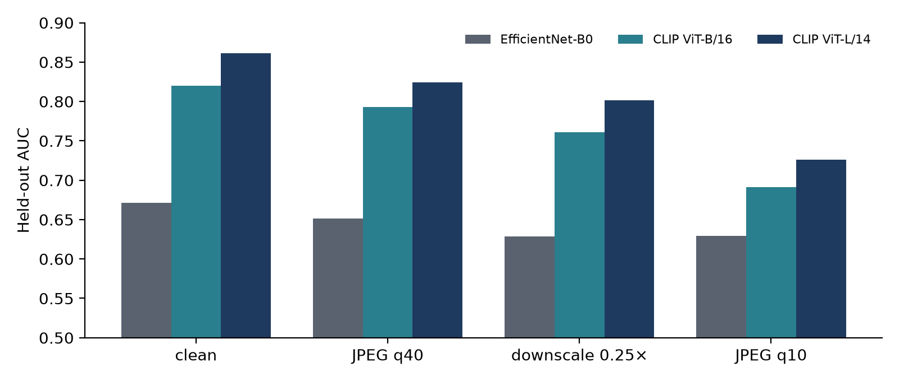
Figure 7.4 — Held-out AUC under compression and downscaling
ViT-L/14 wins under every degradation, though heavy compression (JPEG q10) remains the hardest condition for all models.

7.6 Ablation study
Each ablation changes one factor of the ViT-B/16 recipe. These runs were scored on the repaired corpus, averaging over 23 held-out manipulations, so they are compared with each other and not with the 14-method numbers above.
Variant (ViT-B/16) | Held-out AUC (23) | AUC @ JPEG q10 | Real FPR clean | Real FPR q10
Light augmentation | 0.8536 | 0.5961 | 0.088 | 0.452
MLP head instead of hyperspherical | 0.8204 | 0.6707 | 0.158 | 0.486
No latent-space augmentation | 0.8086 | 0.6514 | 0.094 | 0.467
Heavy + wide degradation | 0.7938 | 0.6403 | 0.102 | 0.316
No Self-Blended Images | 0.7296 | 0.6009 | 0.124 | 0.253
Linear probe (frozen, no LN tuning) | 0.6407 | 0.5461 | 0.279 | 0.698

Removing SBI gives the lowest held-out AUC of all LayerNorm-tuned variants (0.730 vs 0.794–0.854), confirming that learning the generic blending boundary is the main driver of cross-method transfer. A linear probe on frozen CLIP features under-fits badly (0.641), so tuning the normalisation layers is essential. Heavier degradation augmentation trades some clean AUC for a lower false-positive rate under heavy compression.

8. Outcome
- A working, deployed web application that turns any video or live screen share into a frame-level fake-probability timeline, a three-level risk verdict, and a localised suspicious segment, with per-user history and authentication.
- A reproducible training pipeline with identity-disjoint evaluation; the deployed EfficientNet-B0 achieves 99.12% accuracy and 0.9989 ROC-AUC at 2.76 ms per face on GPU and runs in real time on a 2-CPU server.
- An empirical model comparison showing EfficientNet-B0 matches Xception with 5× fewer parameters.
- A quantified generalisation finding: single-method training memorises the manipulation (0.999 → 0.840 AUC on an unseen corpus), and frozen-foundation-model tuning with SBI and degradation augmentation recovers held-out AUC to 0.861 across 14 unseen methods and corpora.
- Engineering lessons that transfer to other ML products: keep preprocessing identical between training and serving, select models on unseen data rather than in-domain validation, and treat JPEG quality as a model input (the classifier reads a known fake as REAL below quality ≈ 0.85, so live capture uses 0.95).

9. Future Work
- Ship the v2 detector. Re-score all v2 runs on one manifest, then deploy the CLIP ViT-L/14 LN-tuned model (with its matching DeepfakeBench-style face crop), using quantisation or distillation to fit CPU latency budgets.
- Temporal modelling. Talking-head methods such as SadTalker animate a single still image, so ~97% of pixels are unmodified and no frame-level model can catch them (held-out AUC 0.42). A within-video pixel-variation statistic already separates SadTalker at 0.99 AUC and should be added as an independent video-level signal; a sequence model over stored per-frame features is the longer-term route.
- Audio and lip-sync analysis to detect voice cloning and audio-visual mismatch (e.g. Wav2Lip).
- Robustness to heavy compression. At JPEG q10 the false-positive rate of ViT-L/14 rises from 0.079 to 0.186; wider degradation augmentation and per-condition calibration are planned.
- Fully synthetic faces (diffusion / MidJourney) remain weak; resolution-aware preprocessing that preserves high-frequency generator artefacts is needed.
- Explainability via Grad-CAM heat-maps over the face crop, and a browser extension that runs the live check inside video-call tabs.
- Scalability: move live sessions from process memory to a shared store so the API can scale horizontally without session affinity; add GPU inference workers.

10. References
- A. Rössler, D. Cozzolino, L. Verdoliva, C. Riess, J. Thies and M. Nießner, "FaceForensics++: Learning to Detect Manipulated Facial Images," in Proc. IEEE/CVF ICCV, 2019.
- M. Tan and Q. V. Le, "EfficientNet: Rethinking Model Scaling for Convolutional Neural Networks," in Proc. ICML, 2019.
- F. Chollet, "Xception: Deep Learning with Depthwise Separable Convolutions," in Proc. IEEE CVPR, 2017.
- K. Zhang, Z. Zhang, Z. Li and Y. Qiao, "Joint Face Detection and Alignment Using Multitask Cascaded Convolutional Networks," IEEE Signal Processing Letters, vol. 23, no. 10, 2016.
- Y. Li, X. Yang, P. Sun, H. Qi and S. Lyu, "Celeb-DF: A Large-Scale Challenging Dataset for DeepFake Forensics," in Proc. IEEE/CVF CVPR, 2020.
- B. Dolhansky, J. Bitton, B. Pflaum, J. Lu, R. Howes, M. Wang and C. C. Ferrer, "The DeepFake Detection Challenge (DFDC) Dataset," arXiv:2006.07397, 2020.
- Z. Yan et al., "DF40: Toward Next-Generation Deepfake Detection," in Proc. NeurIPS Datasets and Benchmarks Track, 2024.
- Z. Yan, Y. Zhang, X. Yuan, S. Lyu and B. Wu, "DeepfakeBench: A Comprehensive Benchmark of Deepfake Detection," in Proc. NeurIPS Datasets and Benchmarks Track, 2023.
- A. Radford et al., "Learning Transferable Visual Models From Natural Language Supervision," in Proc. ICML, 2021.
- A. Yermakov, J. Cech and J. Matas, "Unlocking the Hidden Potential of CLIP in Generalizable Deepfake Detection," arXiv:2503.19683, 2025.
- K. Shiohara and T. Yamasaki, "Detecting Deepfakes with Self-Blended Images," in Proc. IEEE/CVF CVPR, 2022.
- L. Li, J. Bao, T. Zhang, H. Yang, D. Chen, F. Wen and B. Guo, "Face X-ray for More General Face Forgery Detection," in Proc. IEEE/CVF CVPR, 2020.
- U. Ojha, Y. Li and Y. J. Lee, "Towards Universal Fake Image Detectors that Generalize Across Generative Models," in Proc. IEEE/CVF CVPR, 2023.
- D. Afchar, V. Nozick, J. Yamagishi and I. Echizen, "MesoNet: a Compact Facial Video Forgery Detection Network," in Proc. IEEE WIFS, 2018.
- D. Güera and E. J. Delp, "Deepfake Video Detection Using Recurrent Neural Networks," in Proc. IEEE AVSS, 2018.
- D. P. Kingma and J. Ba, "Adam: A Method for Stochastic Optimization," in Proc. ICLR, 2015.
- R. Wightman, "PyTorch Image Models (timm)," GitHub repository, https://github.com/huggingface/pytorch-image-models, 2019.

