**VCC Assignment**

**Below is the Image of the Assignment:**

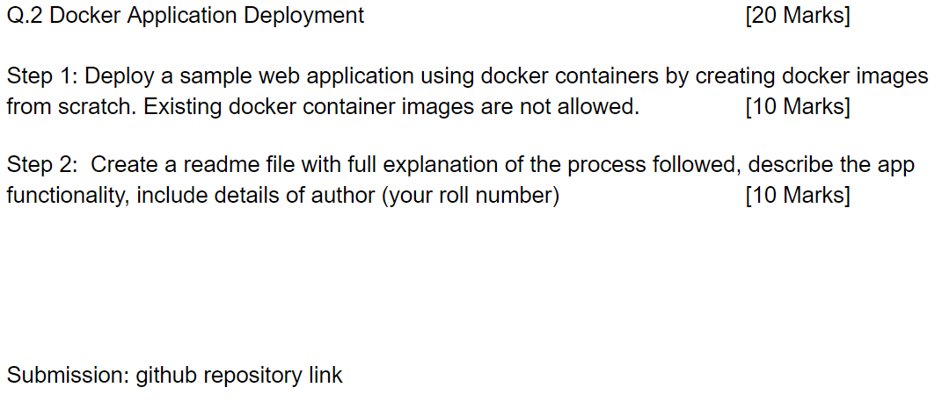

**Below are the steps followed for Assignment completion:**

* Download and Install Docker desktop (Using Windows machine)
* Create a dummy Flask Application.A screenshot of a computer program

  Description automatically generated
* Once the Application is created create a requirement.txt file containing all the Python libraries we need to Install. In our case, we only required Flask.

* Next we have to create a Dockerfile - A [Dockerfile](https://docs.docker.com/engine/reference/builder/) is a simple text file that contains a list of commands that the Docker client calls while creating an image. It's a simple way to automate the image creation process. The best part is that the [commands](https://docs.docker.com/engine/reference/builder/#from) you write in a Dockerfile are *almost* identical to their equivalent Linux commands. A screenshot of a computer

  Description automatically generated

Here I am using Python version 3.11 and the name of my Flask application file is dummy_app.py. We have mentioned this. Also, in my Python Flask APP, the application is running on port 5000. So, I have exposed it on dockerfile.

* Next, we have to build a docker image using docker build command as per screenshot: 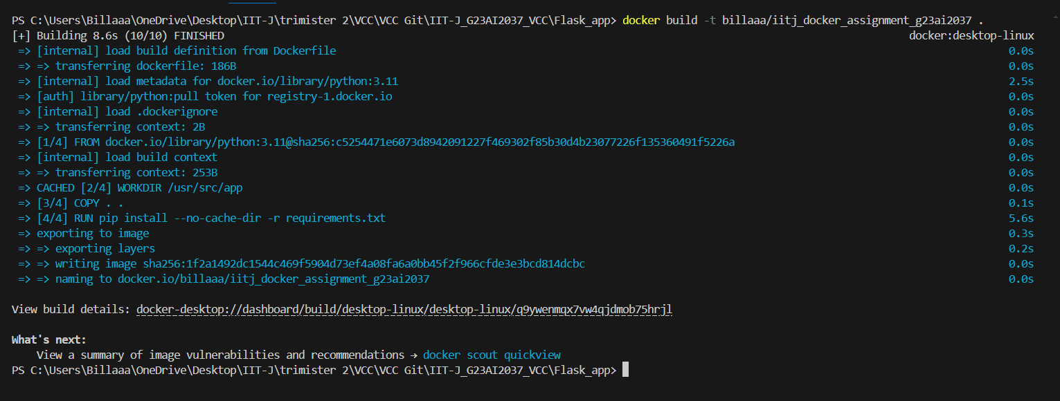
* Once the Docker Image is built , test the image by running it using docker run command: A black screen with colorful text

  Description automatically generated
* Now we clicked on the url mentioned in above screenshot result:

Here we are able to view the Flask App on the URL.

Once we visited the URL , there is an entry created on the terminal for our App access

* Now for publishing the docker image on dockerhub we use docker push command. Below image shows the published docker image on DockerHub.

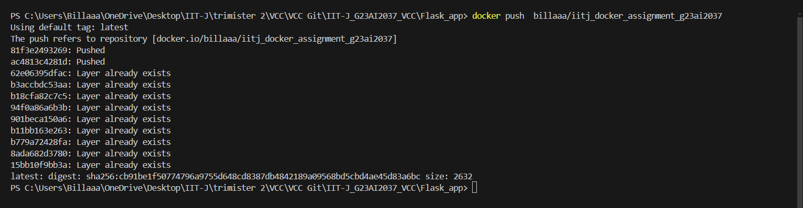

* We can pull this image from dockerHub using the Docker Pull command: