COVID-19 Patient Data
Exploratory Data Analysis Report
Understanding Patient Demographics, Comorbidities, and Mortality Patterns

1. Project Objective
This project analyzes a COVID-19 patient dataset to understand the factors affecting patient outcomes, particularly mortality. The dataset includes demographic details, pre-existing medical conditions (comorbidities), and treatment-related attributes such as hospitalization type and ICU admission.
Data cleaning and feature engineering were performed first, followed by exploratory data analysis (EDA) across four stages: univariate, bivariate, multivariate, and time-series analysis. The goal was to identify relationships between age, comorbidities, ICU admission, and death outcomes, and to understand how COVID-19 mortality trends changed over time.

Analysis Structure
- Univariate Analysis — individual distribution of key patient attributes
- Bivariate Analysis — relationship between comorbidities/attributes and death outcome
- Multivariate Analysis — combined effect of multiple factors on mortality
- Time-Series Analysis — how death counts trended across months and years

2. Dataset Overview
The raw dataset contains patient-level records with demographic, clinical, and outcome fields. Key preprocessing steps performed before analysis:
- Encoded placeholder values (97, 98, 99) in Yes/No health columns were converted to "Unknown" to correctly represent missing/not-applicable data.
- SEX and PATIENT_TYPE codes were mapped to readable labels (Female/Male, returned home/hospitalization).
- A death_status column was derived from DATE_DIED (Survived vs Died), along with death_year, death_month, and death_month_year for time-series analysis.
- New engineered features were added: COVID_Status (test classification), medical_unit_type, age_group (Child/Teen/Adult/Mid-age/Senior), severity (Critical if ICU or Intubated = Yes), and total_diseases (comorbidity count per patient).

3. Univariate Analysis
Individual distributions of key attributes were examined to understand the overall composition of the patient population.

3.1 Age Distribution
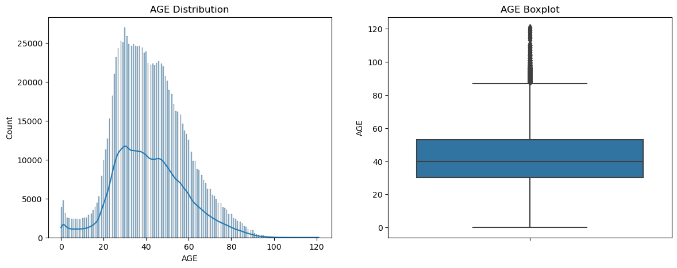
Figure 1: Age distribution and boxplot — patient ages are broadly spread with a concentration between ~30 and 60 years.

3.2 Gender Distribution
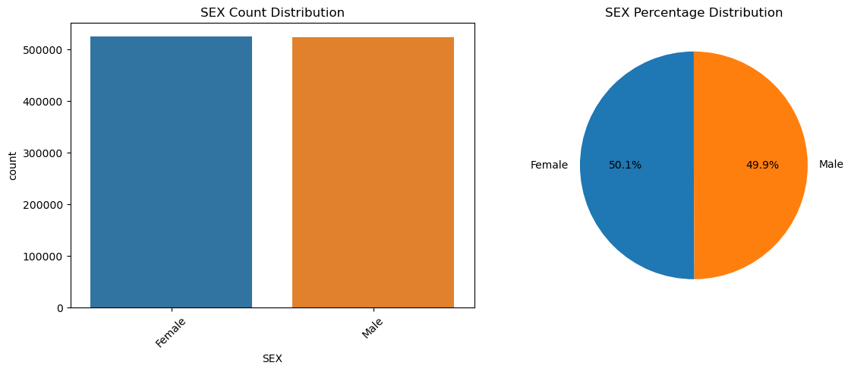
Figure 2: Gender distribution is nearly balanced between male and female patients.

3.3 Patient Type (Hospitalization Status)
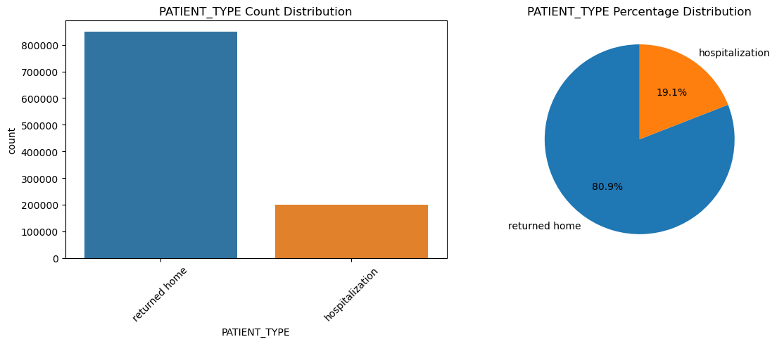
Figure 3: Most patients returned home; a smaller share required hospitalization.

3.4 Death Status (Target Variable)
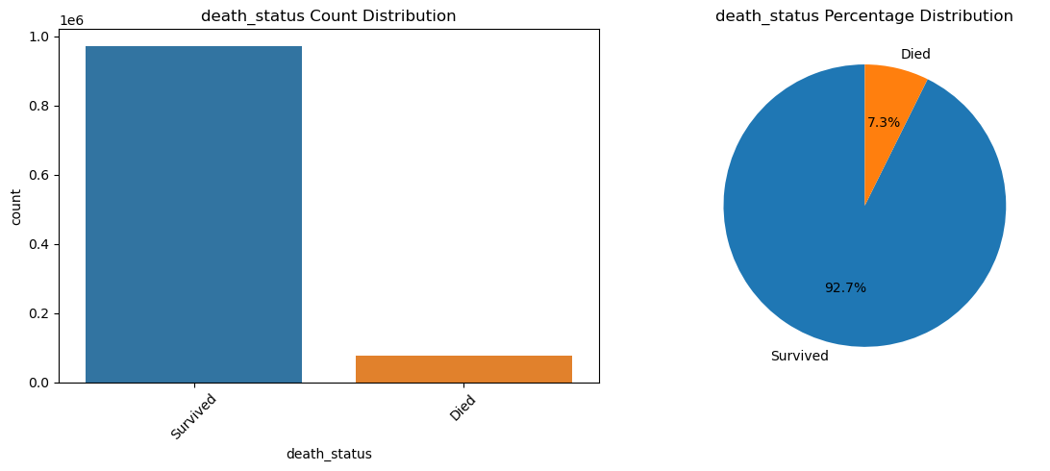
Figure 4: Roughly 7.3% of patients died and 92.7% survived — a highly imbalanced target variable, important context for any later modelling.

4. Bivariate Analysis
Each attribute was compared against death_status to identify which factors are associated with higher mortality.

4.1 Comorbidities vs Death Status — Overview
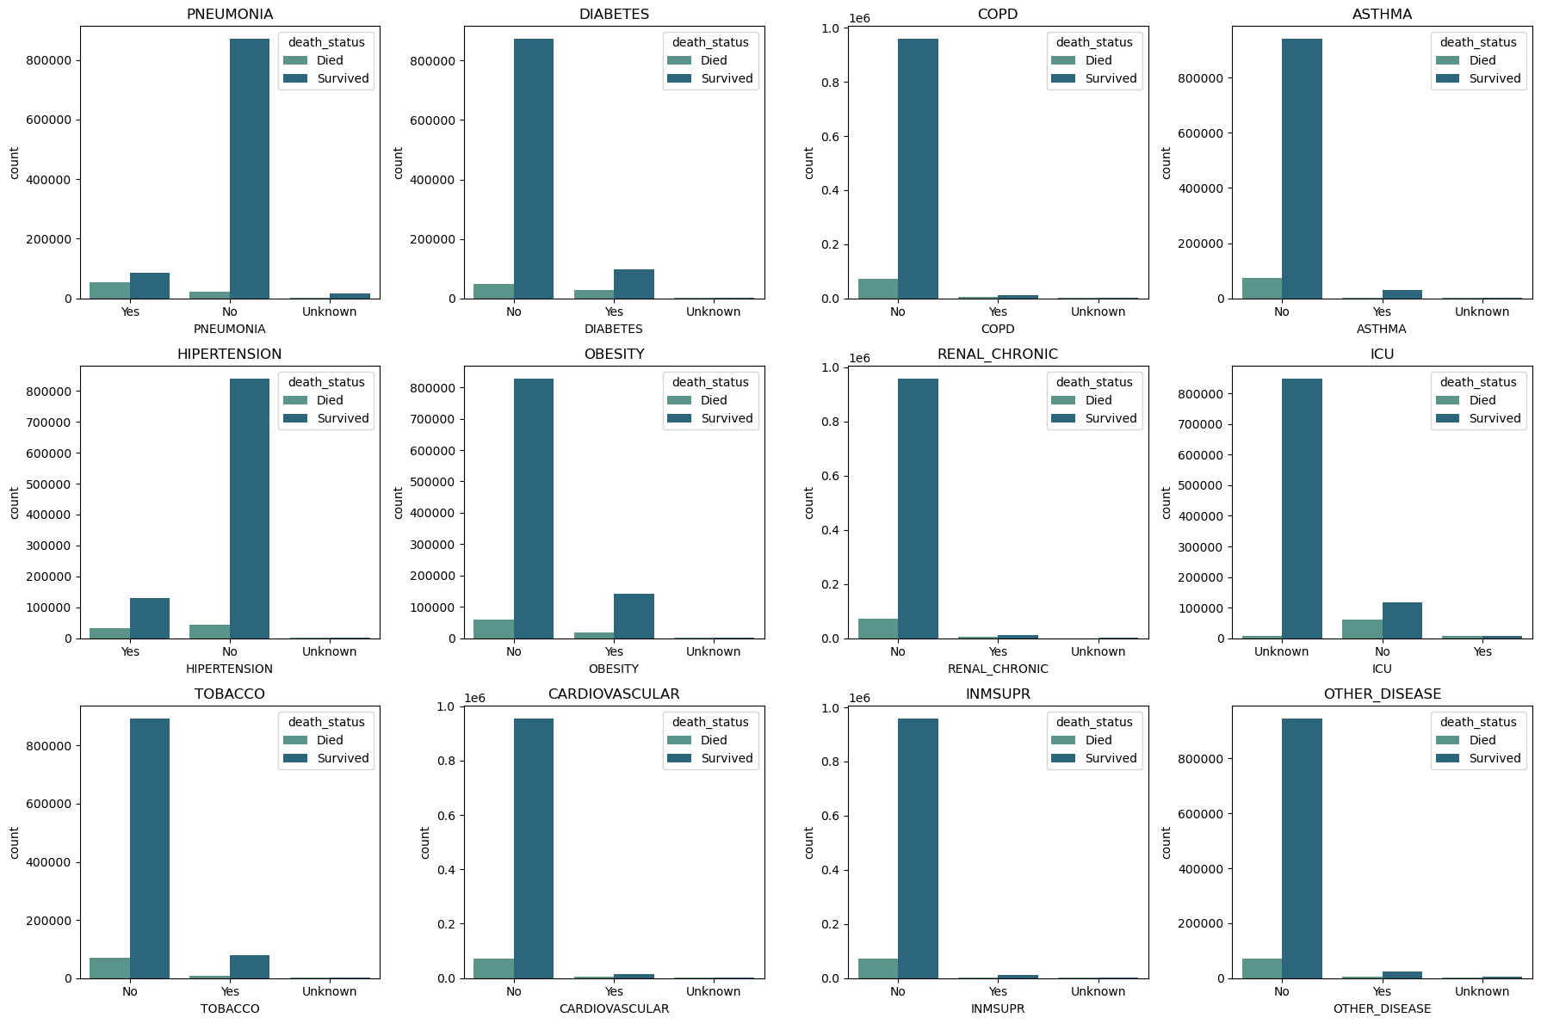
Figure 5: Count of Survived vs Died patients across 12 comorbidities/conditions (Pneumonia, Diabetes, COPD, Asthma, Hypertension, Obesity, Renal disease, ICU, Tobacco use, Cardiovascular disease, Immunosuppression, Other disease). Pneumonia, ICU admission, and hypertension show visibly higher death counts among "Yes" patients.

4.2 Patient Type vs Death Status
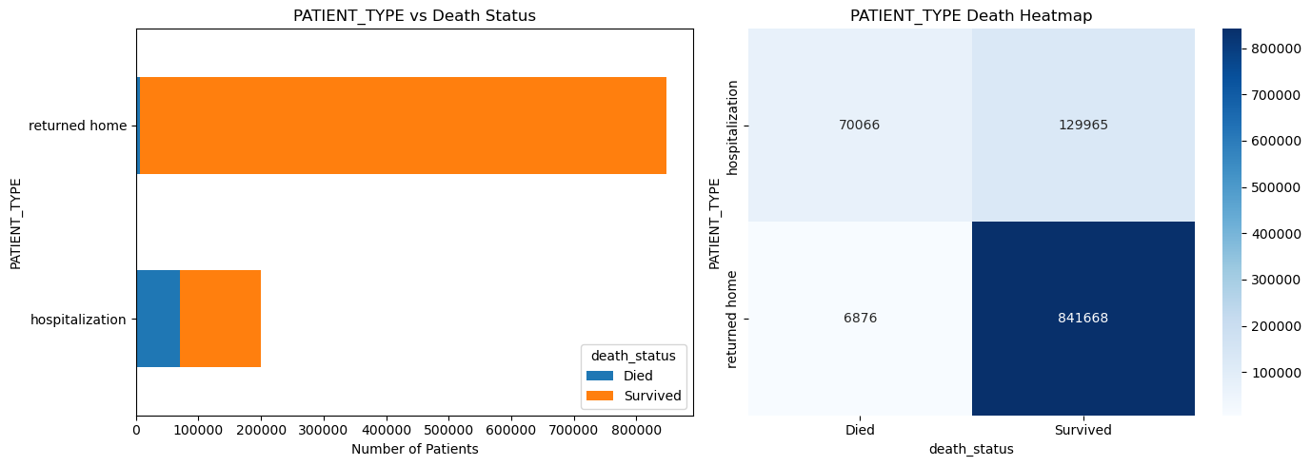
Figure 6: Hospitalized patients show a markedly higher death rate than patients who returned home, confirming hospitalization severity as a risk indicator.

4.3 ICU Admission vs Death Status
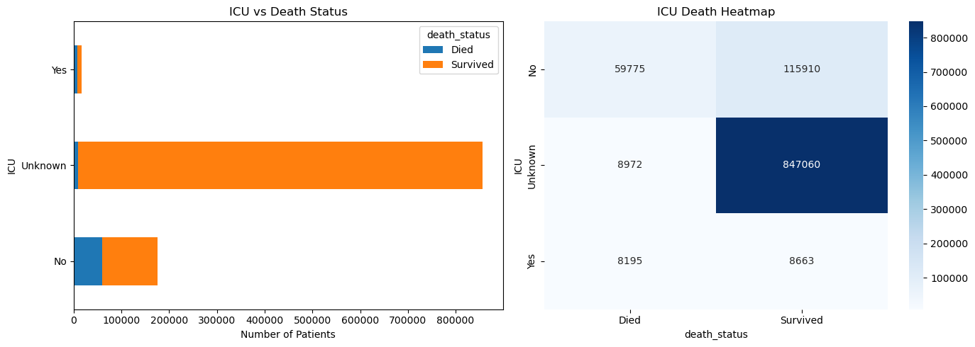
Figure 7: Patients admitted to the ICU have a substantially higher proportion of deaths compared to non-ICU patients.

4.4 COVID Test Status vs Death Status
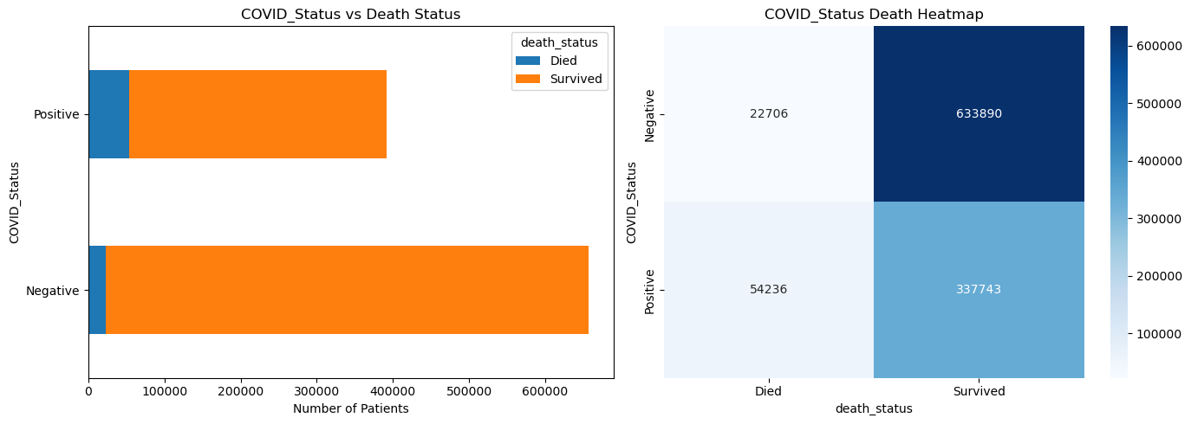
Figure 8: COVID-positive patients show a higher death count than COVID-negative patients, as expected.

4.5 Age Group vs Death Status
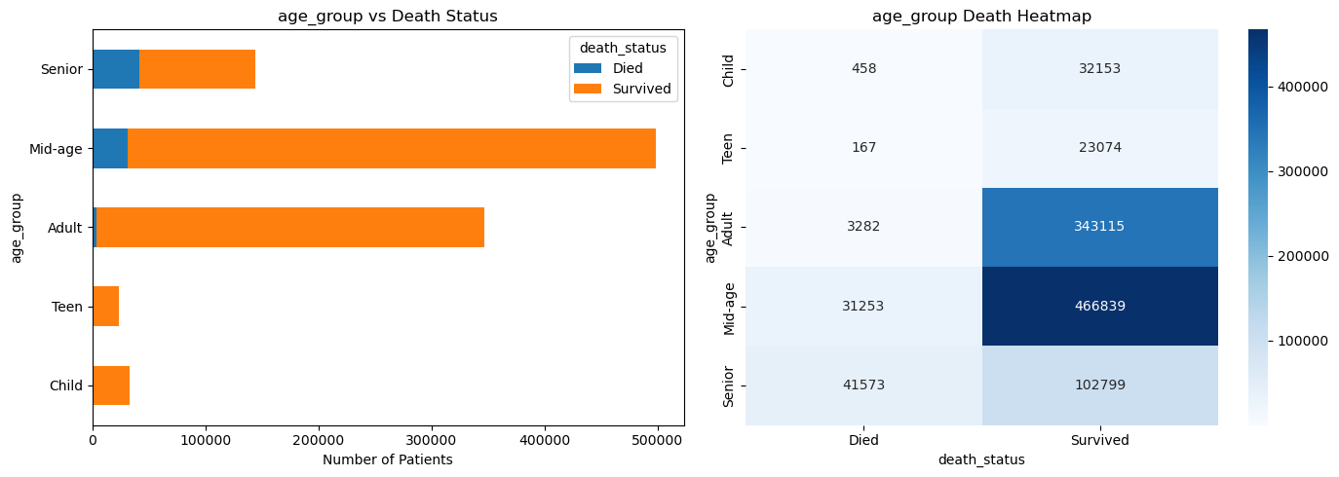
Figure 9: Mortality rises sharply with age — Senior and Mid-age groups account for the large majority of deaths.

4.6 Severity (ICU/Ventilator) vs Death Status
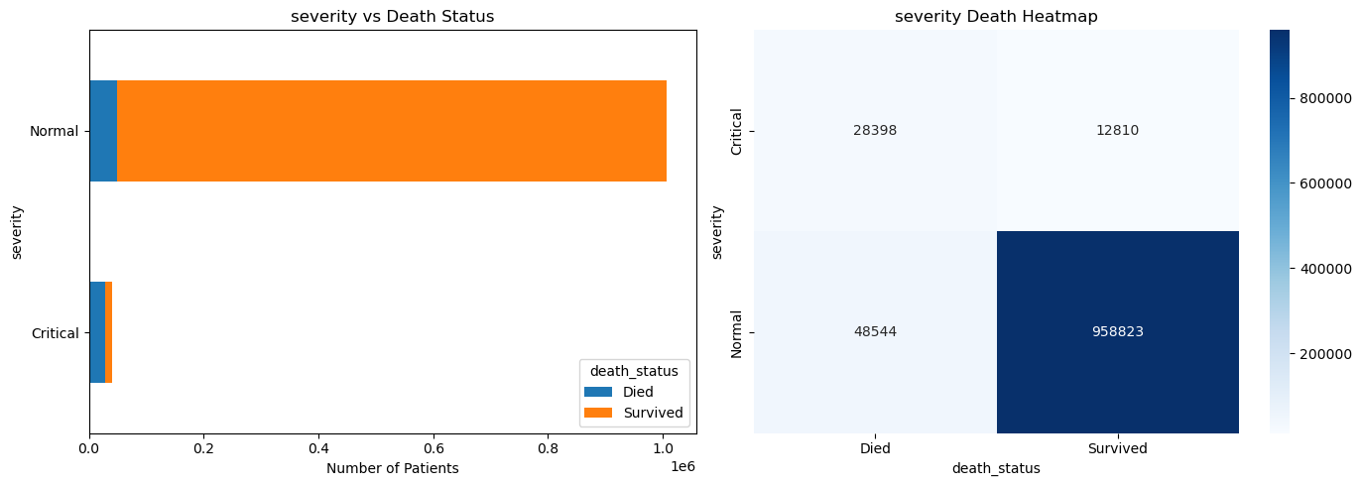
Figure 10: Patients classified as "Critical" (ICU admission or ventilator support) show a much higher death proportion than "Normal" patients.

4.7 Age Distribution by Death Status
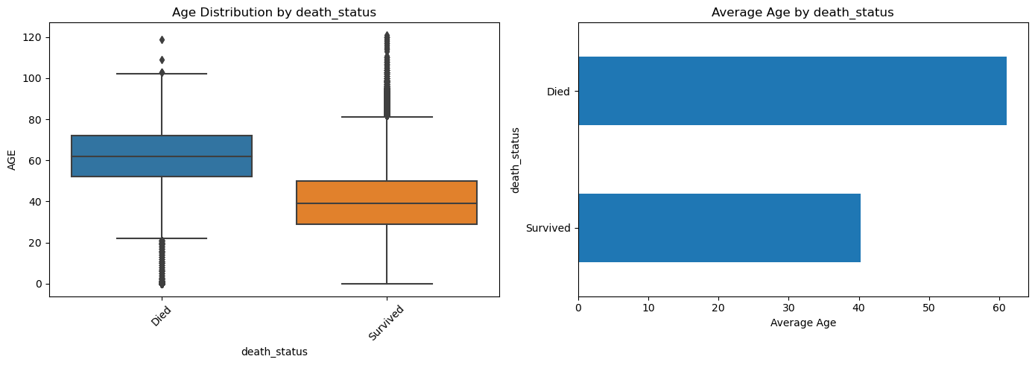
Figure 11: Boxplot and average-age comparison confirm that patients who died were, on average, considerably older than patients who survived.

5. Multivariate Analysis
Combining multiple factors together helps reveal compounded risk — for example, whether the effect of age on mortality changes depending on the presence of a comorbidity.

5.1 Age Group × Diabetes × Death Status
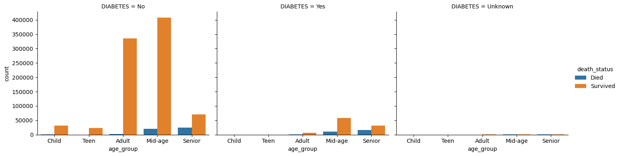
Figure 12: Death counts by age group, split by diabetes status. Within every age group, diabetic patients (Yes) show a higher relative death count than non-diabetic patients, and this gap widens for older age groups.

6. Time-Series Analysis
Death records were analyzed over time using the death date to identify mortality trends across the pandemic period covered by the dataset.

6.1 Deaths by Year
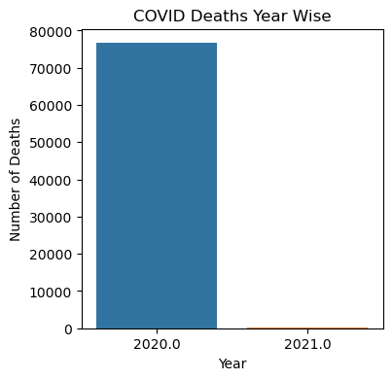
Figure 13: The overwhelming majority of recorded deaths (76,625) occurred in 2020, compared to only 317 in 2021 — reflecting the period of data coverage and the pandemic's peak impact.

6.2 Deaths by Month — 2020 vs 2021
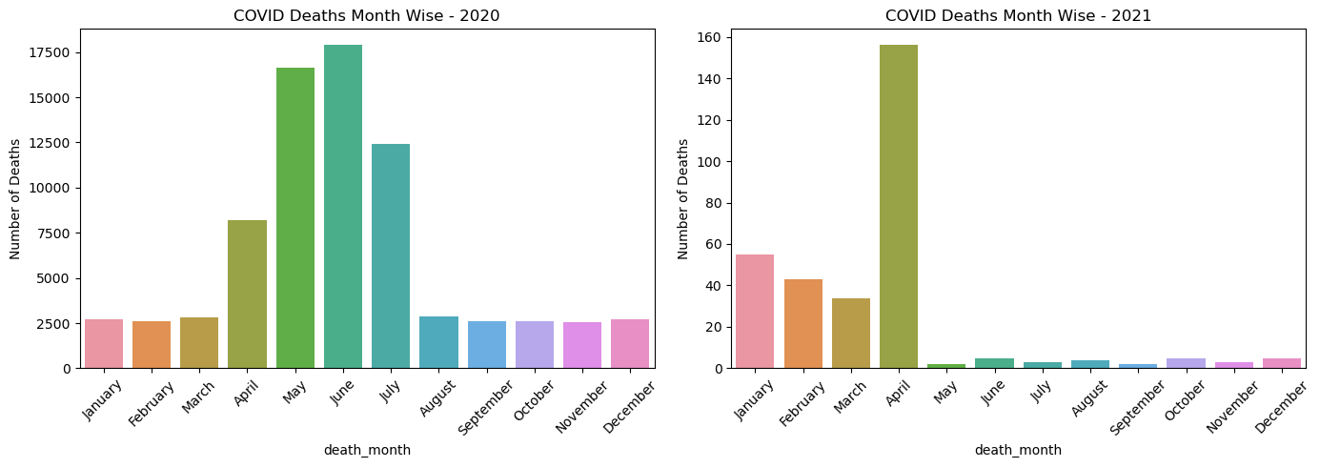
Figure 14: Monthly death counts for 2020 and 2021 shown separately. 2020 shows a clear peak around May–June, indicating the period of highest mortality; 2021 data is comparatively sparse.

7. Key Findings
- The dataset is highly imbalanced on the target variable: ~7.3% of patients died vs ~92.7% survived.
- Age is one of the strongest risk factors — mortality increases steadily with age, peaking in the Senior group.
- ICU admission and ventilator support ("Critical" severity) are strongly associated with higher death rates.
- Hospitalized patients have a much higher death rate than patients who returned home, as expected for more severe cases.
- Comorbidities such as pneumonia, hypertension, diabetes, and obesity are all associated with elevated mortality, with pneumonia showing the strongest visual association.
- The combined effect of age and diabetes shows compounded risk — diabetic patients in older age groups face notably higher mortality than non-diabetic patients of the same age.
- Almost all recorded deaths occurred in 2020 (76,625) versus 2021 (317), with a peak around May–June 2020.
- Missing values (coded 97/98/99 or blank dates) were concentrated in medical-condition columns and were treated as "Unknown" rather than dropped, preserving dataset size without materially distorting the overall distributions.

Conclusion
This EDA shows that age, ICU admission/ventilator use, hospitalization status, and select comorbidities (especially pneumonia, hypertension, diabetes, and obesity) are the most visible risk factors for COVID-19 mortality in this dataset. These patterns provide a strong foundation for further statistical testing or predictive modelling of patient risk.

