Title: Model Loading & Chat Interface
Students: Podkorytov Nikolai, Ahammad Jony, Kumara Muditha , Shrestha Bata Prabesh
Course: Applied artificial intelligence
Date: 17.04.2026
1. Objective
The goal of this work is to build a simple interactive interface in Jupyter Notebook that simulates loading a language model and enables basic chat interaction using ipywidgets. The interface includes model loading, status messages, a chat template preview, and a functional chat box.
2. Environment Setup
The project was implemented in Jupyter Notebook using Python and the following libraries:
- ipywidgets
- IPython.display
- time
These tools were used to create interactive UI elements such as buttons, text fields, and output areas.
3. Step-by-Step Implementation
3.1 Model Selection Interface
A dropdown menu was created to simulate selecting a model from a catalog.
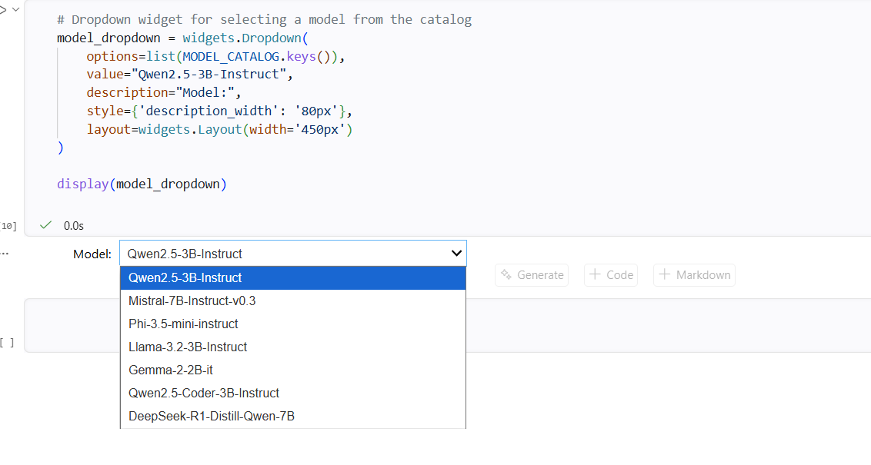
Screenshot 1: Model selection interface.
3.2 Load Model Button
A button labeled “Load Model” was added. When pressed, it displays a loading message and then a success message.
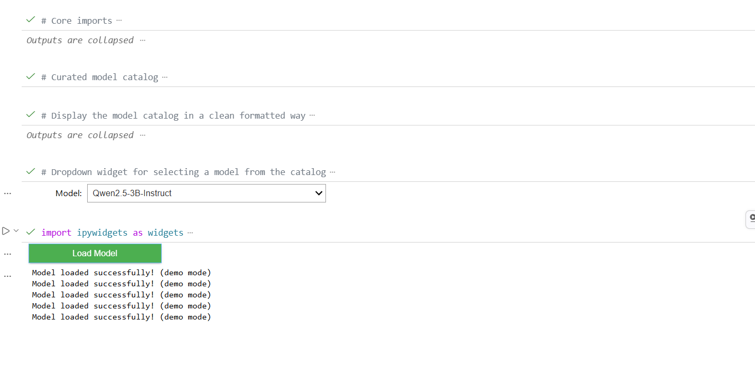
Screenshot 2: Load Model button and status output.
3.3 Model Loading (Demo Mode)
Since downloading real models can require several gigabytes, a demo mode was implemented. The system simulates loading by waiting for 2 seconds and then printing:
Model loaded successfully! (demo mode)
Screenshot 3: Successful model loading message.
3.4 Chat Template Preview
A Markdown preview was added to show how messages will be formatted before being sent to the model.
Example:
<|user|>
Hello, how are you?
<|assistant|>
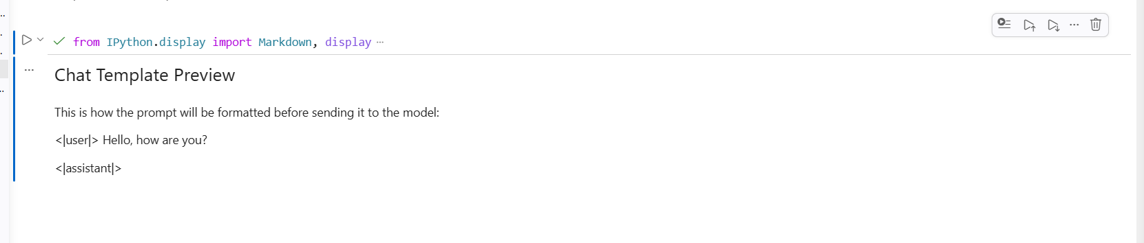
Screenshot 4: Chat template preview.
3.5 Chat Interface
A simple chat interface was implemented using:
- a text input box
- a Send button
- an output area displaying the conversation
Each message is printed in the following format:
User: <message>
Assistant: (demo response) This is a placeholder reply.
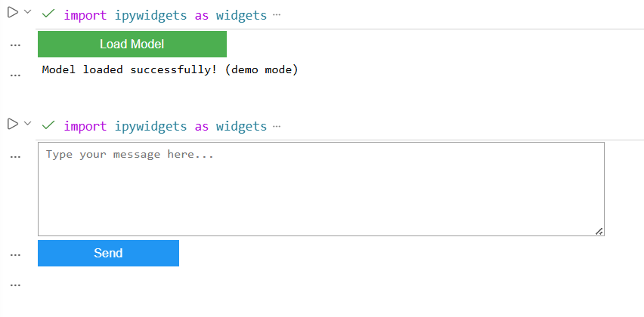
Screenshot 5: Chat interface.
3.6 Test Conversation
A short test conversation was performed to demonstrate the functionality of the chat interface.
Example:
User: Hi, I want to talk.
Assistant: (demo response) This is a placeholder reply.
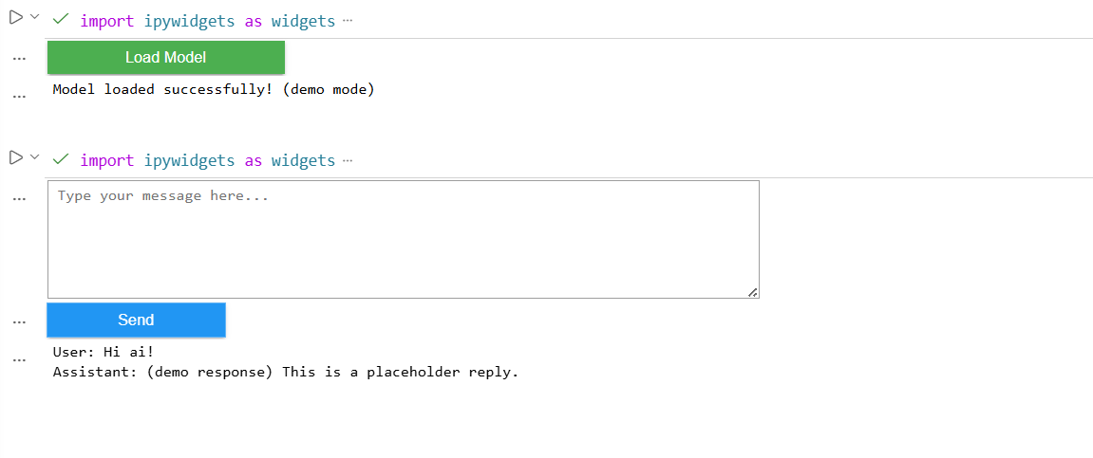
Screenshot 6: Test conversation.
4. Code Snippets
4.1 Demo Model Loader
python
import ipywidgets as widgets
from IPython.display import display, clear_output
import time
load_button_fake = widgets.Button(
description="Load Model",
button_style="success",
layout=widgets.Layout(width='200px')
)
load_status_fake = widgets.Output()
loaded_model = "FAKE_MODEL"
loaded_tokenizer = "FAKE_TOKENIZER"
def fake_load(b):
load_status_fake.clear_output()
with load_status_fake:
print("Loading model... please wait.")
time.sleep(2)
with load_status_fake:
load_status_fake.clear_output()
print("Model loaded successfully! (demo mode)")
load_button_fake.on_click(fake_load)
display(load_button_fake, load_status_fake)
4.2 Chat Template Preview
python
from IPython.display import Markdown, display
chat_template_preview = """
### Chat Template Preview
This is how the prompt will be formatted before sending it to the model:
<|user|>
Hello, how are you?
<|assistant|>
"""
display(Markdown(chat_template_preview))
4.3 Chat Interface
import ipywidgets as widgets
from IPython.display import display, clear_output
user_input = widgets.Textarea(
placeholder="Type your message here...",
layout=widgets.Layout(width='600px', height='100px')
)
send_button = widgets.Button(
description="Send",
button_style="primary",
layout=widgets.Layout(width='150px')
)
chat_output = widgets.Output()
def on_send_clicked(b):
message = user_input.value.strip()
if not message:
return
with chat_output:
print(f"User: {message}")
print("Assistant: (demo response) This is a placeholder reply.\n")
user_input.value = ""
send_button.on_click(on_send_clicked)
display(user_input, send_button, chat_output)
5. Conclusion
A fully functional interactive interface was created to simulate loading a model and performing chat interactions. The system includes UI components, status messages, a chat template preview, and a working chat box. All components were tested and demonstrated successfully.
6.Group Reflection
As a group of four students, we found this assignment both practical and insightful. Working with interactive UI components in Jupyter Notebook helped us better understand how model-driven applications are structured, even when the model itself is simulated. The process of building the interface step by step — from model selection to chat interaction — allowed us to divide responsibilities, discuss implementation choices, and support each other when unexpected issues appeared.
One of the key takeaways for the group was realizing how important it is to design clear user feedback mechanisms. Even in demo mode, the loading indicators, status messages, and chat outputs made the interface feel more complete and user-friendly. This assignment strengthened our teamwork, improved our communication, and helped us practice debugging together in a structured way.
6.1 Podkorytov Nikolai
This assignment helped me better understand how interactive components work inside Jupyter Notebook. I faced a few challenges with model loading and widget behavior, but resolving them taught me to simplify the workflow and focus on the core logic instead of getting stuck on technical limitations. I also improved my ability to troubleshoot step by step and keep the interface clean and functional. Overall, the project strengthened my confidence in building small AI-driven tools and organizing code in a clear, user-friendly way.
6.2 Ahammad Jony
Building the interface helped me understand how widgets and event handlers work in Jupyter Notebook. I contributed to testing the UI and checking that each component behaved correctly.

6.3 Kumara Muditha
This assignment taught me how simple interactive tools can simulate model behavior. Working with the group helped me understand the structure of a basic chat interface.

6.4 Shrestha Bata Prabesh
I assisted with testing the model loading simulation and the chat workflow. The project improved my understanding of user interaction design and teamwork in notebook environments.

