Report: Audio Processing
Students: Podkorytov Nikolai, Ahammad Jony, Kumara Muditha , Shrestha Bata Prabesh
Course: Applied artificial intelligence
Date: 18.04.2026
3. Audio Processing
3.1. Time Domain Representation (Waveform)
A simple sine wave with a frequency of 440 Hz was generated and visualized in the time domain. This plot shows how the amplitude of the signal changes over tim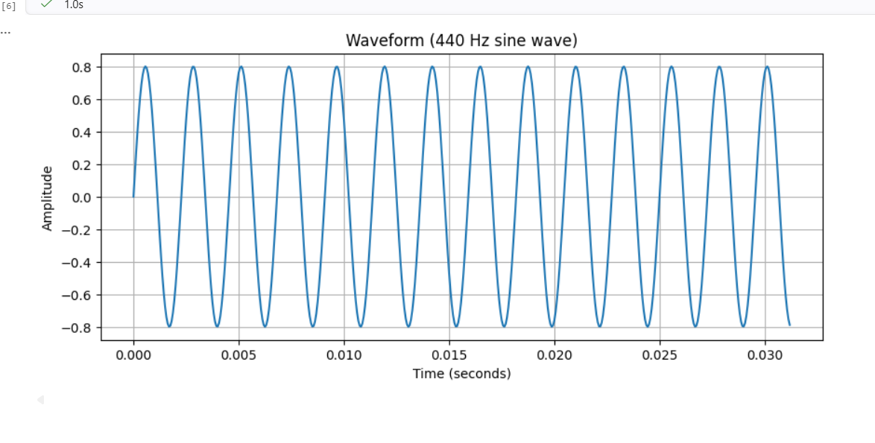
Screenshot Audio 1: Waveform
3.2. Frequency Domain Representation (FFT Spectrum)
The Fast Fourier Transform (FFT) was applied to the same signal to analyze its frequency components. The spectrum clearly shows a dominant peak at 440 Hz, which corresponds to the sine wave frequency.
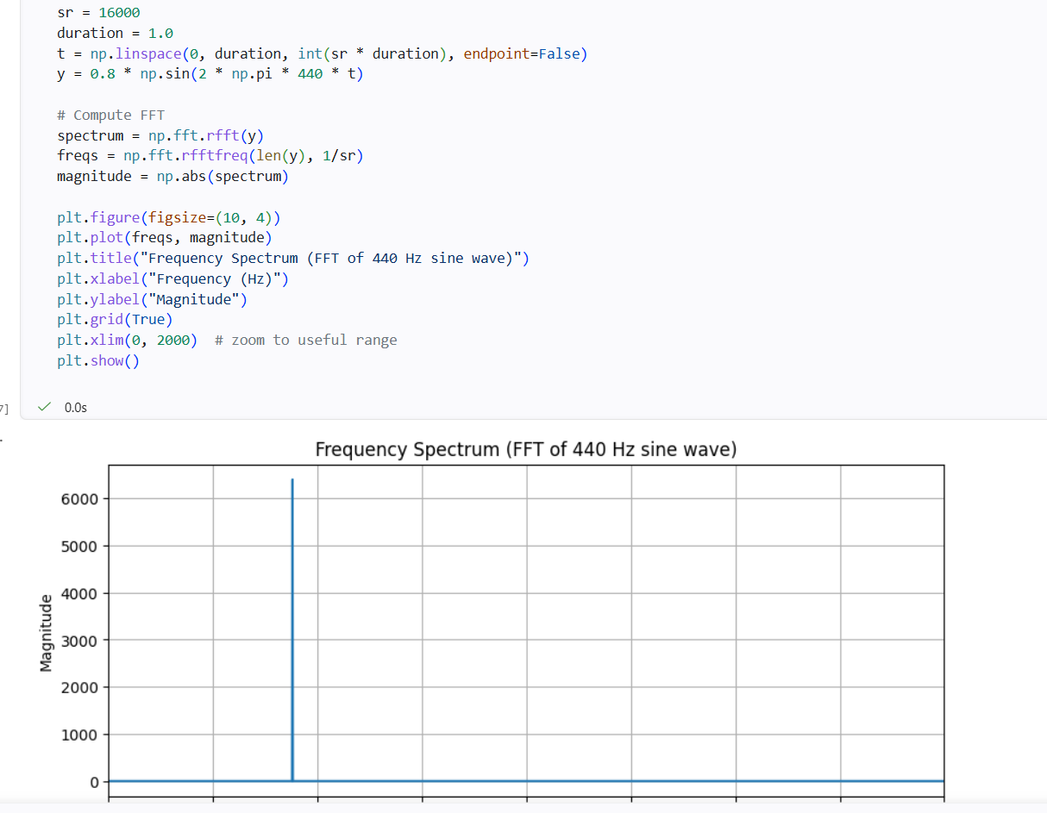
Screenshot Audio 2: Frequency Spectrum
3.3. Sampling Rate Comparison (16 kHz vs 8 kHz)
Two versions of a 3 kHz tone were generated using different sampling rates:
- 16 kHz — high resolution, smooth waveform
- 8 kHz — lower resolution, fewer samples, closer to the Nyquist limit
This comparison demonstrates how sampling rate affects signal accuracy.
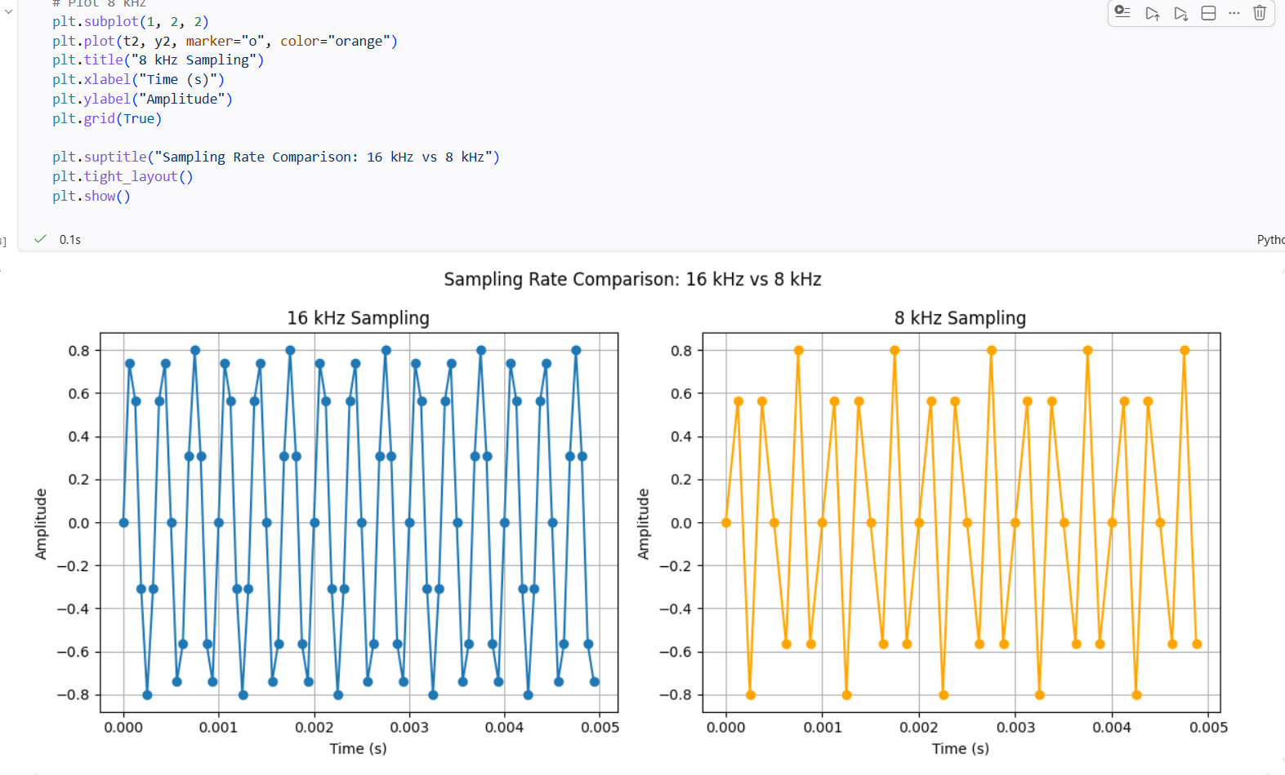
Screenshot Audio 3: Sampling Rate Comparison
3.4. Saved Audio File Metadata
A generated audio signal was saved as a WAV file. The metadata table includes:
- sample rate
- number of channels
- number of frames
- duration
- file format
- subtype (PCM encoding)
This confirms correct audio file creation and storage.
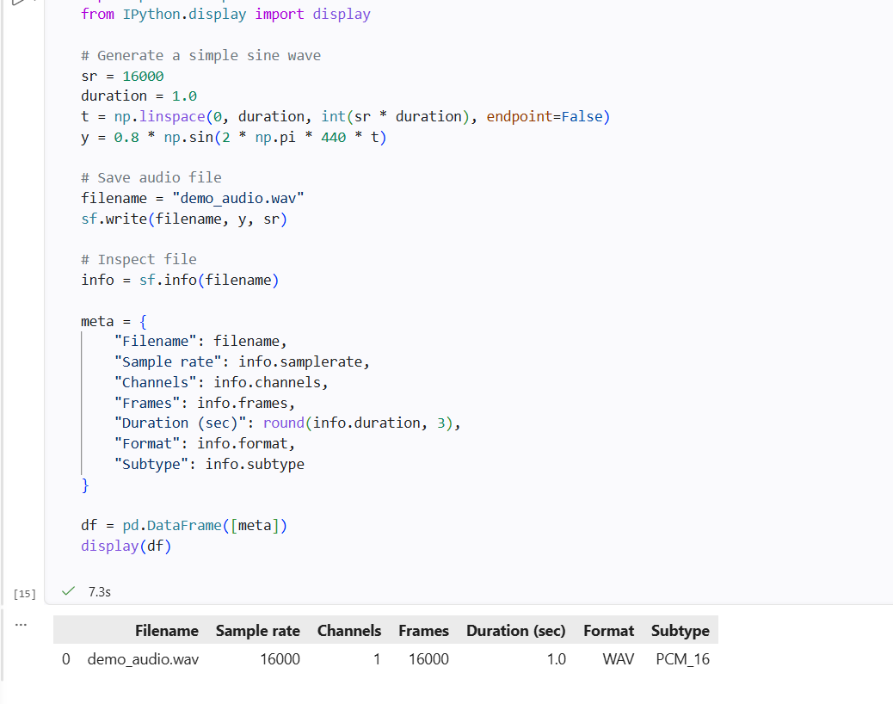

Screenshot Audio 4: Audio Metadata Table
3.5. Spectrogram (STFT)
A Short-Time Fourier Transform (STFT) was used to compute the spectrogram. The spectrogram shows how the frequency content of the signal evolves over time, represented as a heatmap.
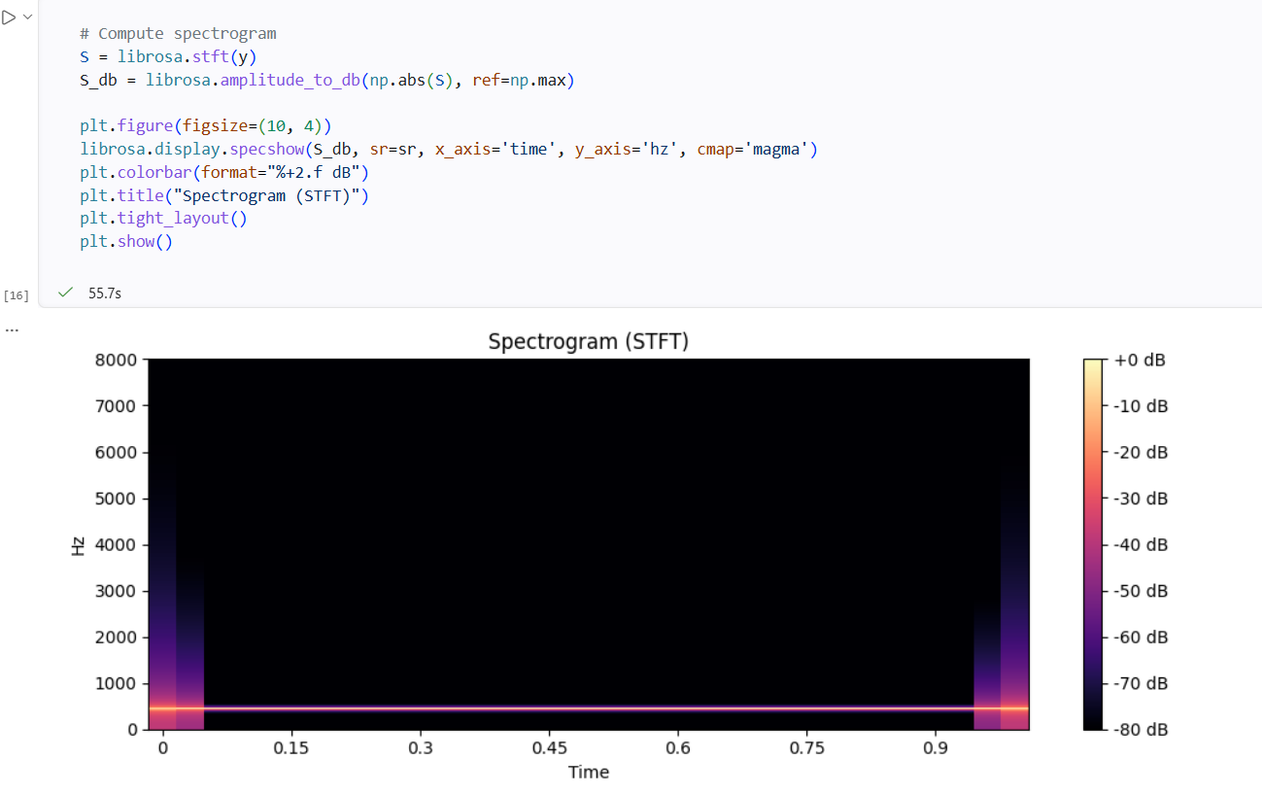
Screenshot Audio 5: Spectrogram
3.6. Mel Spectrogram
A Mel spectrogram was computed using a Mel filter bank. This representation is widely used in speech recognition and text-to-speech systems because it approximates human auditory perception.
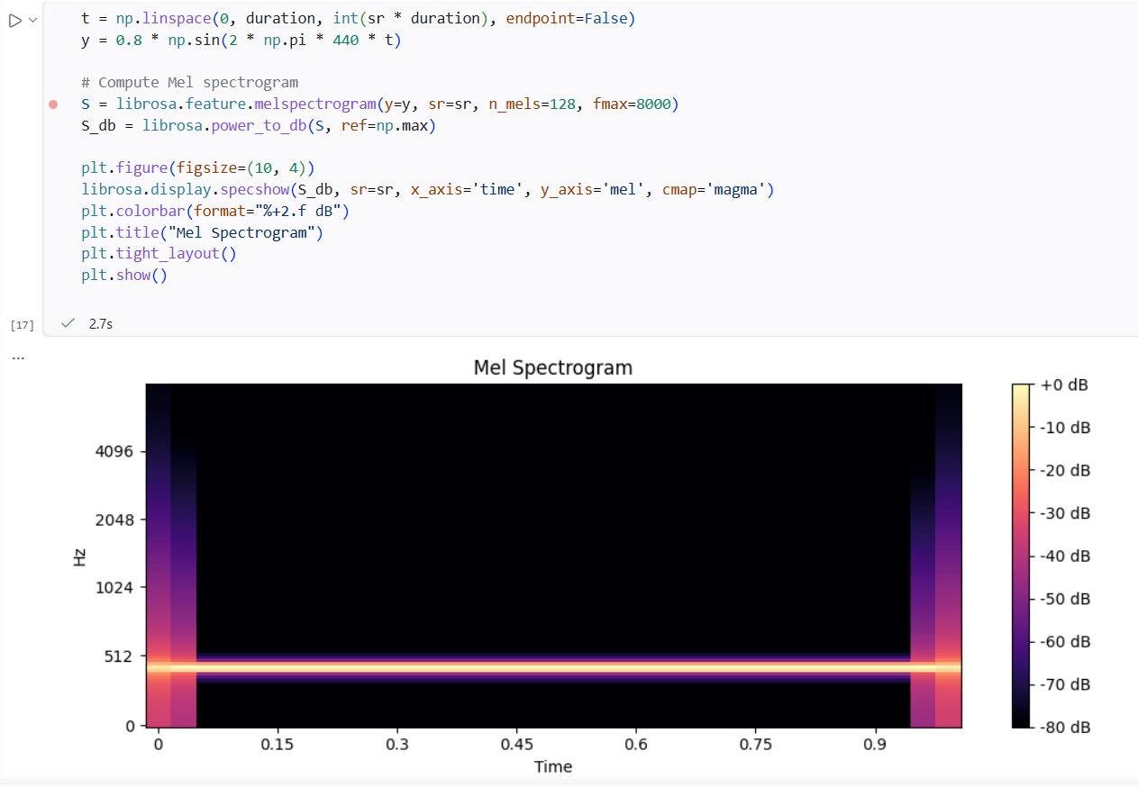
Screenshot Audio 6: Mel Spectrogram
4. Conclusion
The audio processing module demonstrated:
- generation of synthetic audio signals
- visualization in both time and frequency domains
- comparison of different sampling rates
- saving audio files and inspecting metadata
- construction of spectrograms and Mel spectrograms
These techniques form the foundation of modern digital audio analysis and speech processing.
5. Reflection
As a group, we were able to complete the audio processing tasks effectively by dividing responsibilities and supporting each other during debugging. Working together helped us better understand the concepts behind waveform analysis, FFT, sampling rates, and spectrograms. Each member contributed to testing the code, interpreting the visualizations, and verifying the results. Overall, the collaboration made the workflow smoother and improved our collective understanding of digital audio processing.
5.1 Nikolai Podkorytov
During this work, I gained practical experience with:
- generating and manipulating audio signals
- applying FFT and STFT
- understanding sampling theory
- working with spectrograms and Mel-scale representations
- using Python libraries such as NumPy, Matplotlib, SoundFile, and Librosa
This module strengthened my understanding of digital signal processing and audio feature extraction.
5.2 Ahammad Jony
Working on the audio tasks helped me understand how different sampling rates and transformations affect a signal. I also gained confidence in interpreting spectrograms and frequency-domain visualizations.
5.3 Kumara Muditha
This assignment helped me learn how audio features are generated and analyzed using Python tools. I contributed to running the experiments and reviewing the results as a team.
5.4 Shrestha Bata Prabesh
I supported the group during debugging and testing the audio code. The work improved my understanding of FFT, STFT, and how audio data is represented visually.

