Title: Computer Vision – Image Processing Experiments
Students: Podkorytov Nikolai, Ahammad Jony, Kumara Muditha , Shrestha Bata Prabesh
Course: Applied artificial intelligence
Date: 17.04.2026
1. Introduction
As a group, we explored several foundational image-processing techniques using Python, NumPy, OpenCV, and Matplotlib. We worked through the provided vision notebook, actively running the code, modifying parameters, and observing how different transformations affect the image. The purpose of this assignment was not only to execute the code but to understand the underlying concepts, reflect on our learning process, and discuss insights as a team.
2. Summary of Experiments
Throughout the notebook, we investigated:
- Geometric transformations: comparing standard resizing with letterboxing and analyzing how each affects object proportions.
- Color spaces: converting RGB images into HSV and LAB to understand alternative representations.
- Gamma correction: applying nonlinear brightness adjustments and observing their impact.
- JPEG compression: comparing high-quality and low-quality compression artifacts.
- Histograms: analyzing pixel-intensity distributions before and after transformations.
We approached the notebook interactively, experimenting with different values, discussing results, and validating our understanding through visual outputs.

3. Original Image
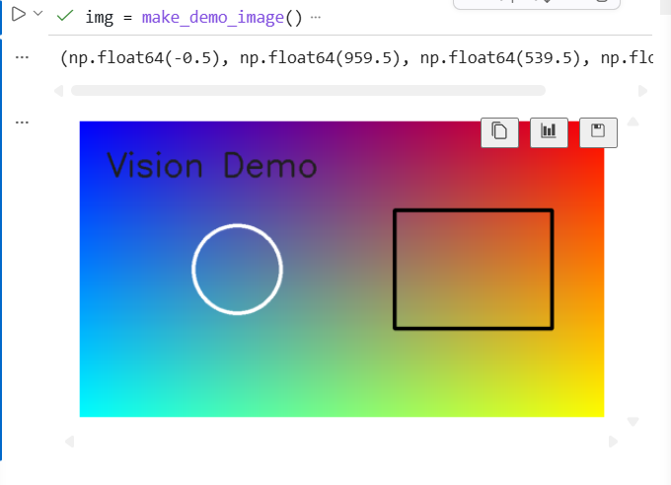
Screenshot 1. Original synthetic image (make_demo_image)
4. Resize vs Letterbox
4.1 Resize (distortion)
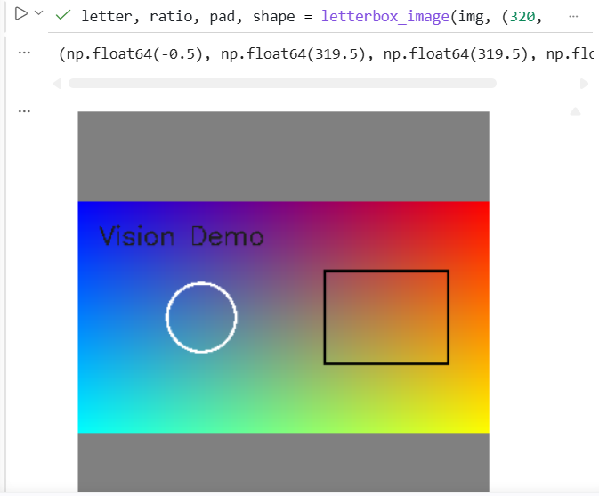
Screenshot 2. Resize 320×320
Conclusion: Standard resizing changes the aspect ratio of the image. Circular shapes become oval, and rectangular shapes become square. This distortion can negatively affect computer-vision models that rely on geometric consistency.
4.2 Letterbox (preserves geometry)
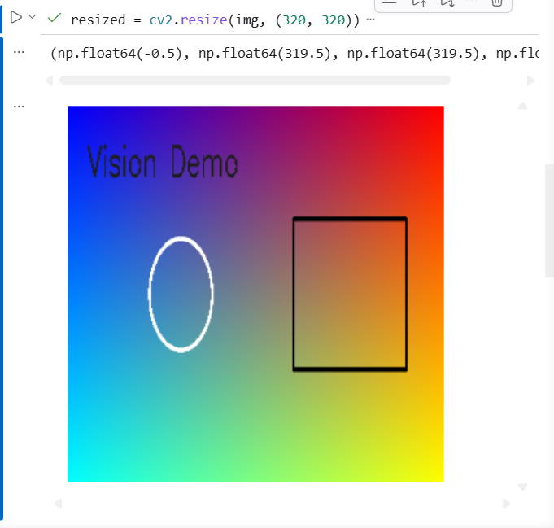
Screenshot 3. Letterbox 320×320
Conclusion: Letterboxing preserves the original proportions by adding padding. All shapes remain geometrically correct, which is essential for tasks like object detection.
5. Color Spaces
5.1 HSV
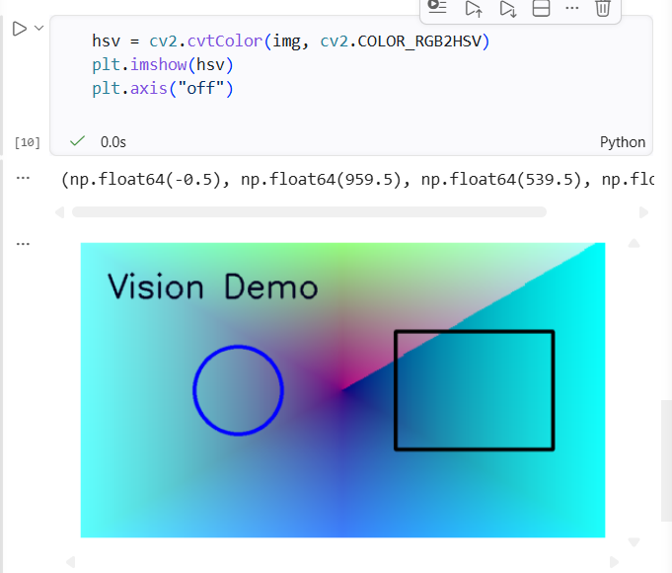
Screenshot 4. HSV image
Conclusion: HSV separates brightness from color information. This makes it useful for segmentation, thresholding, and tasks where lighting conditions vary.
5.2 LAB
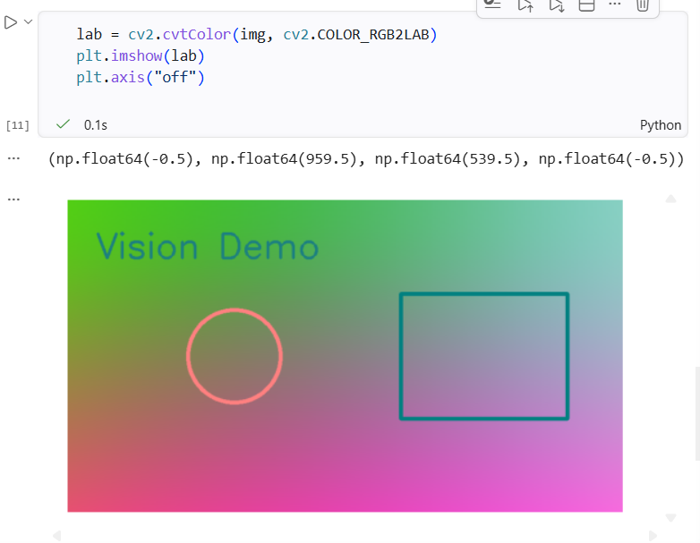
Screenshot 5. LAB image
Conclusion: LAB is perceptually uniform and closer to human color perception. It is often used for color correction and contrast enhancement.
6. Gamma Correction
6.1 Gamma = 0.5 (brightening)
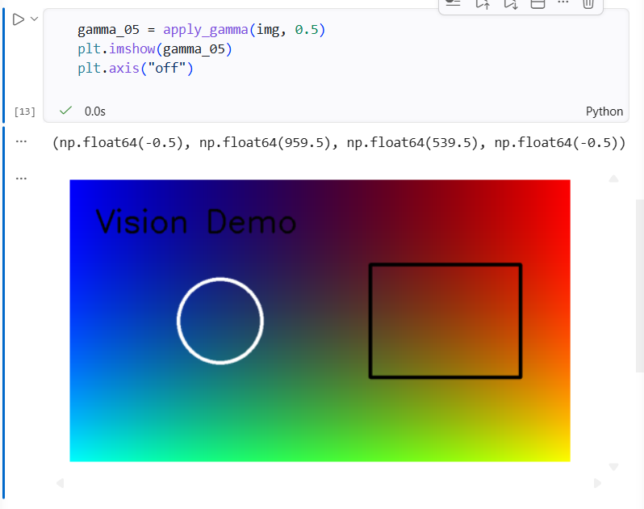
Screenshot 6. Gamma 0.5
6.2 Gamma = 2.0 (darkening)
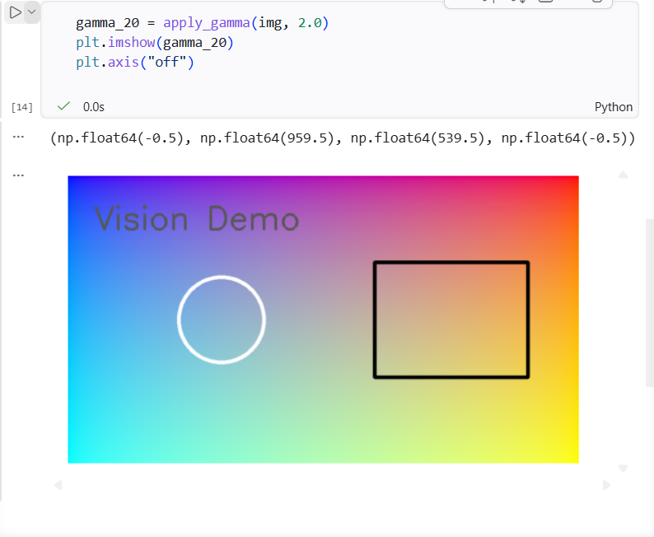
Screenshot 7. Gamma 2.0
Conclusion: Gamma < 1 brightens the image, especially in darker regions. Gamma > 1 darkens the image, reducing highlights. Gamma correction is nonlinear and significantly affects midtones.
7. JPEG Compression
7.1 High quality (95)
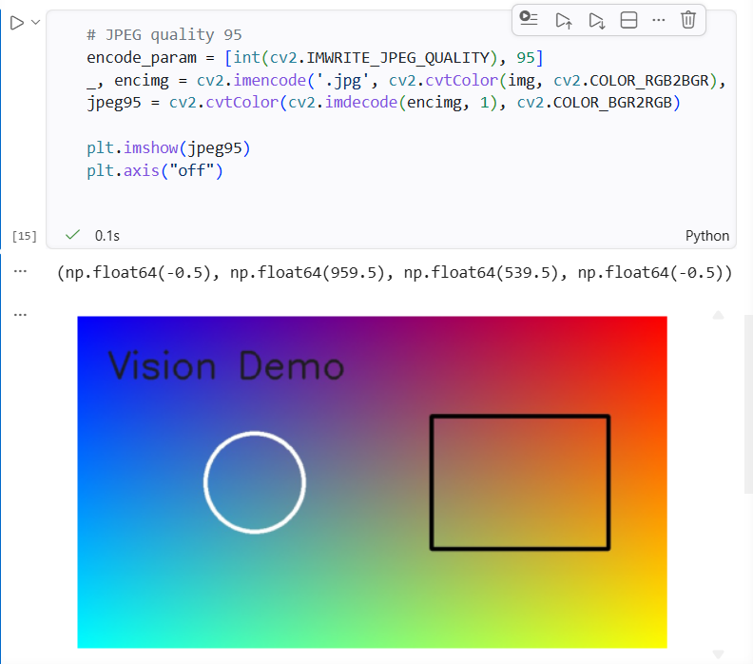
Screenshot 8. JPEG quality 95
7.2 Low quality (10)
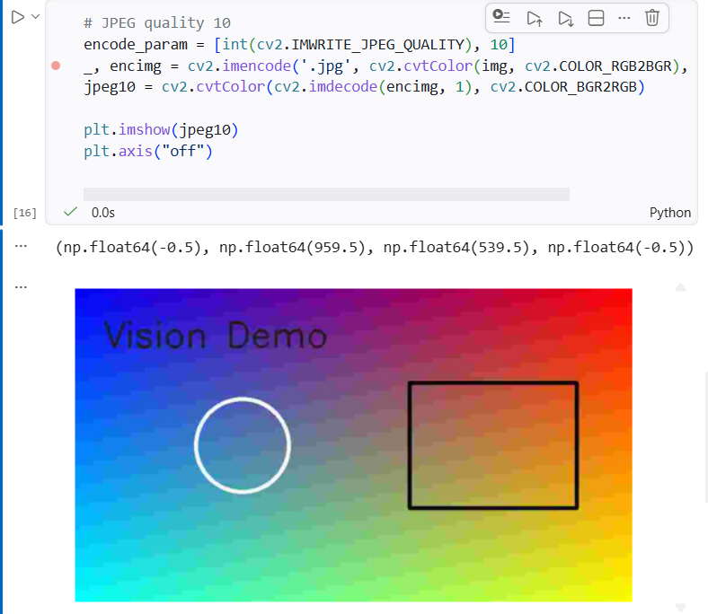
Screenshot 9. JPEG quality 10
Conclusion: High-quality JPEG preserves most details. Low-quality JPEG introduces blocky artifacts and destroys fine textures. This demonstrates the trade-off between file size and visual fidelity.
8. Histograms
8.1 Original histogram
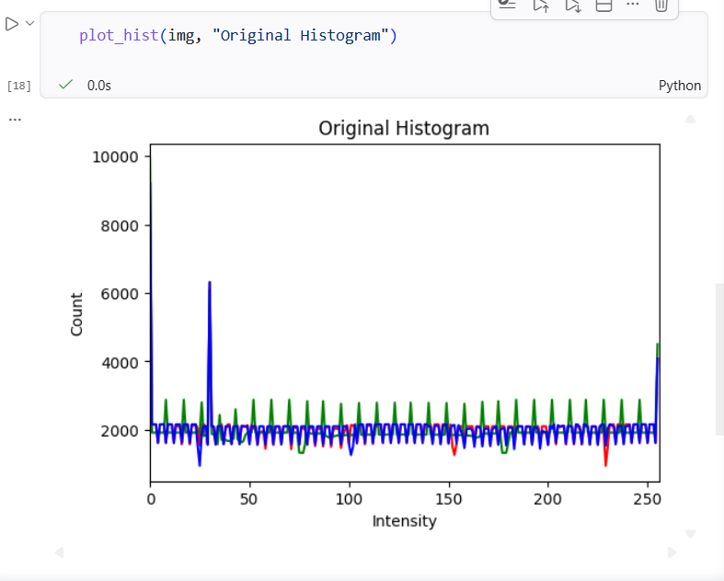
Screenshot 10. Histogram (original)
8.2 Gamma 0.5 histogram
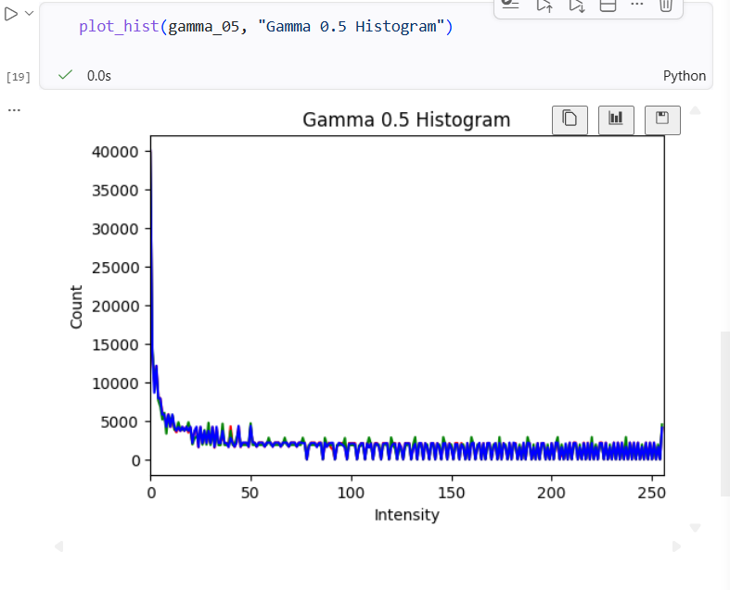
Screenshot 11. Histogram (gamma 0.5)
8.3 Gamma 2.0 histogram
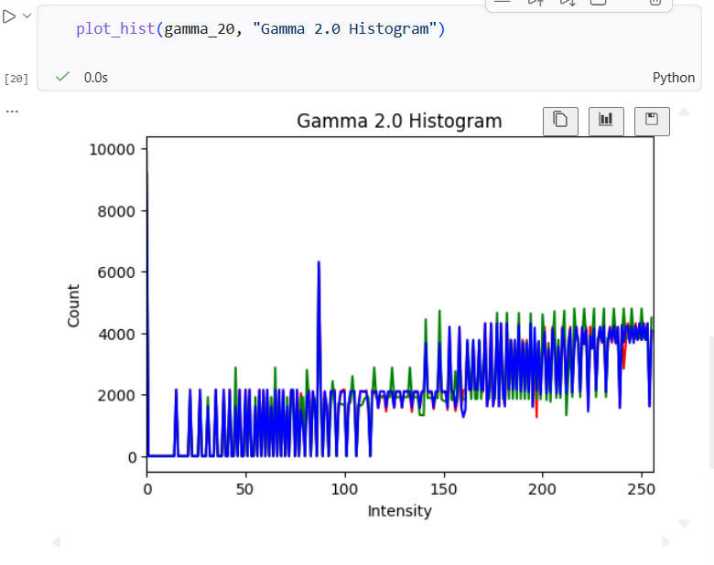
Screenshot 12. Histogram (gamma 2.0)
Conclusion: Histograms clearly show how pixel intensities shift after gamma correction. Gamma 0.5 shifts the distribution left (brighter). Gamma 2.0 shifts it right (darker). This visualization helped us understand the mathematical effect of gamma on brightness.
8. Group Reflection
Working through the notebook as a group helped us understand how image-processing pipelines operate in practice. Instead of passively reading the code, we executed each cell, experimented with parameters, and discussed the results together.
Nikolai Podkorytov
- I learned how geometric transformations affect image shape.
- I explored multiple color spaces and understood their practical use.
- I applied gamma correction and saw how it changes brightness distribution.
- I analyzed JPEG compression artifacts.
- I visualized pixel intensity distributions using histograms.

10. Challenges and Debugging (Group Experience)
During the assignment, our group encountered several technical challenges that helped us better understand how Python, NumPy, and OpenCV behave.
10.1 NumPy shape mismatches
The initial gradient generation produced R, G, and B channels with different shapes, causing stacking errors. Solution: we rewrote the gradient using np.tile to ensure consistent dimensions.
10.2 Incorrect function arguments
The letterbox_image() function did not accept the argument new_shape, even though some examples online use it. Solution: we used positional arguments instead.
10.3 Display issues in VS Code
Some images did not appear until we enabled %matplotlib inline and selected the correct Python kernel.
These challenges were valuable learning experiences. They helped us understand how to interpret error messages, how NumPy arrays work, and how to debug image-processing code effectively.
11. Conclusion
As a group, we successfully completed all required experiments, analyzed the results, and prepared a structured report. This assignment improved our understanding of image preprocessing, strengthened our debugging skills, and gave us practical experience with tools commonly used in computer vision.

