**PROJECT REPORT**

**On**

**PICTORIAL ALGO APPLICATION**

**For the partial fulfilment of Degree of B. Tech in Computer Science**

**Course: UCS503 Software Engineering**

**Martin Kaushal (Roll No. 102017135)**

**Mudrika Jain (Roll No. 102017143)**

**Nandini Setia (Roll No. 102017121)**

**(Students of 2nd Year B.Tech/B.E. (Computer Science)**

**Under the Guidance of:**

**Mr Vinod**

Thapar Institute of Engineering & Technology, Patiala



**Submitted to**

**THAPAR INSTITUTE OF ENGINEERING AND TECHNOLOGY**

**(Deemed to be University)**

**PATIALA – 147004**

**PUNJAB – INDIA**

**2022**

**Copyright Notice**

**Copyright © 2021 Thapar Institute of Engineering & Technology, Patiala**

All rights reserved. This material may not be duplicated for any profit-driven approach. The reports contained in these Internet-accessible directories are included by the contributing authors as a mechanism to ensure timely dissemination of scholarly and technical information on a non-commercial basis. Copyright and all rights therein are maintained by the authors, despite their having offered this information electronically. Everyone copying this information must adhere to the terms and constraints invoked by each author's copyright.

Reports may not be copied for commercial redistribution, republication, or dissemination without the explicit permission.

**Pictorial-Algo**

**Table of Contents**

Chapter No. Page No.

1. Introduction

1.1 Purpose of this Document 5

1.2 Scope of the Development Project 5

1.3 Overview 6

2. Overall Description

2.1 Product Perspective 6

2.2 Product functions 7

2.3 General Constraints, Assumptions and Dependencies 7

3. Specific Requirements 4

3.1 Detailed Description of Functional Requirements 7

3.2 Non-functional requirements 10

3.3 Logical database requirements 11

3.4 System Entities and their Attributes 12

4.Data Flow Diagram 13

5. Class Model 14

6. Use – Case Diagram 15

7. Use – Case Template 16

8. Activity Diagram 18

9. Sequence Diagram 19

10. Collaboration Diagram 21

1. **Introduction**
   1. **Purpose of this Document**

The purpose of this SRS document is to provide a detailed overview of our software product, its parameters and goals. This document describes the project's target audience and its user interface and software requirements. It defines how our client, team and audience see the product and its functionality.

**1.2 Scope of the Development Project**

Our project focuses on helping the students to understand data structures and algorithms in a better way with visual explanation and allow them to imagine their solutions and learn the basics on their own and at their own pace. The main audience of this project is the students who are involved in Computer Science field or want to kick-start learning algorithms and for the faculty teachers to teach more efficiently by showing their students how an algorithm works.

The software must be able to perform the following operations:

**1. List of Algorithms** – It must be able to list the algorithms that are important in programmers’ life. This list must be prepared keeping in mind their use in competitive programming and current development practices.

**2. Brief Explanation** -It must be able to provide a brief explanation of the selected algorithm. It must explain what the logic behind the algo is and consist of a series of instructions that would help the user to choose an optimal solution for a problem.

**3. Algorithm Code-** When an algorithm is selected it must be able to display a well-designed series of code with line-by-line explanation in C++ language. This language is used keeping in mind that almost every person is at least familiar with the term “C and C++ programming” when it comes to Computer Science.

**4. Visual Representation-** It must be able to represent the algorithm visually using graphic elements like points, line segments, two-dimensional bars. Using animation, it must show a continuous, movie-like presentation of an algorithm’s operations.

**5. Random and Custom Input Generator**- The application must be able to randomly generate an input within a set range corresponding to the selected algorithm. It must satisfy the needs of the user who want to give a custom input.

**6. Doubt Section-** The application should include a doubt section which will be present on every algorithm page so that students can ask or help other students in understanding code or algorithm better. The purpose of this feature is to make this application a one-stop guide for students to learn DSA better.

* 1. **Overview**

The remaining sections of this document provide a general description, including characteristics of the users of this project, the product's hardware, and the functional and data requirements of the product. General description of the project is discussed in section 2 of this document. Section 2 gives the functional requirements, data requirements and constraints and assumptions made while designing the multi-utility system. It also gives the user viewpoint of product use. Section 3 gives the specific requirements of the product. Section 3.0 also discusses the external interface requirements and gives detailed description of functional requirements.

1. **Overall Description**

**2.1 Product Perspective**

The best way to understand complex data structures is to see them in action. In this application we show the live explanation of DSA algorithms step by step. It will have a user-friendly interface which has different options for e.g.- if the user wants to understand the explanation of sorting algorithm, then he/she will create the array and then accordingly our app will use the inbuilt algo to solve it. It will give various options to users such as to know the detailed explanation through various slides iteration-wise and the user will also have an option to directly view the answer. The website will have user-friendly filters to search for the required pictorial-representation of the algorithm. People from different Universities can use it.

**2.2 Product Functions**

The product should be able to perform the following operations:

1. To login to Pictorial Algo
2. To create an account on Pictorial Algo.
3. To provide the list of various algorithms.
4. To provide the desired explanation and code of the selected algorithm.
5. To provide the functionality of visual representation for better understanding.
6. To provide the flexibility to the user to generate random as well as custom input.
7. To provide a drop-down list and present to the users with search suggestions.
8. To provide a doubt section which can be used by any user to ask questions or to answer other people’s question.
9. To view answer and question which was previously saved by user.

**2.3 General Constraints, Assumptions and Dependencies**

Members of the project team would have access to the tools they need to execute their respective tasks on schedule, including advanced equipment and software as well as electricity during working time. This application is easily available and easily accessible in all type devices. But the constraint comes when we talk about application and software version of this system. The product must have a user-friendly interface that is simple enough for all types of users to understand. Response time for loading the software and for processing a transaction should be no longer than five seconds. A general knowledge of basic computer skills is required to use the product.

**Specific Requirements**

**3.1 Detailed Description of Functional Requirements:**

Functional requirements define the specific functions that the system performs, along with the data operated on by the functions. The functional requirements are presented in scenarios that depict an operational system from the perspective of its end users. Included are one or more examples of all system features and an enumeration of all the specific requirements associated with these features.

**FR 3.1.1 Log-In**

|  |  |
| --- | --- |
| **Purpose:** | To login to Pictorial Algo |
| **Input:** | Click on log-in button. |
| **Output:** | User logged in to home page |
| **Processing:** | It will verify the input from database and then proceed according to it. |

**FR 3.1.2 Sign Up**

|  |  |
| --- | --- |
| **Purpose:** | To create an account on Pictorial Algo. |
| **Input:** | Fill up the form and click on submit button |
| **Output:** | It will save the information to database for further proceed. |
| **Processing:** | A popup will come with confirmation of created account. |

**FR 3.1.3 Drop Down List**

|  |  |
| --- | --- |
| **Purpose:** | To choose an algo from the list of algorithms |
| **Input:** | Click on desired algorithm |
| **Output:** | Page about the algorithm will pop up |
| **Processing:** | The algorithm will be selected and page regarding it will pop up |

**FR 3.1.4 Choose an algorithm**

|  |  |
| --- | --- |
| **Purpose:** | To choose an algo by searching |
| **Input:** | Enter the name of desired algorithm |
| **Output:** | Page about the algorithm will pop up |
| **Processing:** | It will verify the input from the options available and then proceed according to it. |

**FR 3.1.5 Explanation**

|  |  |
| --- | --- |
| **Purpose:** | To provide the desired explanation of the selected algorithm. |
| **Input:** | Click on the explanation button of the selected algo. |
| **Output:** | Entire explanation will open up. |
| **Processing:** | It will check for the explanation linked in the database and show it. |

**FR 3.1.6 Algorithm Code**

|  |  |
| --- | --- |
| **Purpose:** | To provide the desired code of the selected algorithm. |
| **Input:** | Click on the algorithm code button of the selected algo. |
| **Output:** | Algorithm and the code related will open up. |
| **Processing:** | It will check for the code linked in the database and show it. |

**FR 3.1.7 Visual Representation**

|  |  |
| --- | --- |
| **Purpose:** | It shows the visual explanation of the selected algo using animation. |
| **Input:** | Click on the visual representation button. |
| **Output:** | A new window will open with visual animation related to that algo. |
| **Processing:** | It will use the inbuilt code to develop the required representation. |

**FR 3.1.8 Random Input Generator**

|  |  |
| --- | --- |
| **Purpose:** | To generate the random input for the user. |
| **Input:** | User will provide input on his own. |
| **Output:** | A new window will open with all questions and answers saved previously by user. |
| **Processing:** | It will fetch all the bookmarked questions and answers from database. |

**FR 3.1.9 Add Question**

|  |  |
| --- | --- |
| **Purpose:** | To ask or add any question on Pictorial Algo |
| **Input:** | Click on the add question button. |
| **Output:** | A new window will open for take input and submit. |
| **Processing:** | It will verify the question and will add it to database. |

**FR 3.1.10 Answer**

|  |  |
| --- | --- |
| **Purpose:** | To give answer of the available questions |
| **Input:** | Click on the answer button. |
| **Output:** | A new window will open with some options. |
| **Processing:** | It will take the options from database and will show it. |

**3.2 NON-FUNCTIONAL REQUIREMENTS**

Non-Functional requirements define the needs in terms of performance, logical database

requirements, design constraints, standards compliance, reliability, availability, security,

maintainability, and as well as portability.

**3.2.1 Availability**

The system is available at all times, meaning the user can access it using any device. It is available in android as well as iOS platform. The app is available at a common plane where the user can access it to install and look for regular updates.

**3.2.2 Use-ability**

The app should have a user-friendly interface with good UX designing so that user can be able to understand the flow of the app easily that is users should be able to use the app without any guidelines or help from experts/manuals.

**3.2.3 Performance Requirements**

System shall be available from all over the world at all times. Being a social network, any interruption in the sharing chain will cause people to give up on Pictorial Algo, therefore it is essential that the system shall be available at all times. System shall not be affected from the number of active users in the system and should take minimum response time. Being a worldwide network, assuming that a large number of users are reaching to the website is a legitimate and necessary requirement.

**3.2.4 Responsiveness**

The application should be responsive to the user input or to any external interrupt which is of the highest priority and return back to the same state. When app gets interrupted by call then app should be able to save state and return to same state/page which was there before it got interrupted.

**3.2.5 External Interface Requirements**

The following list presents the external interface requirements:

1. The product does not require any login details.
2. Sound is not an essential feature.
3. To add different topics for learning algorithms.

**3.3 Logical Database Requirements**

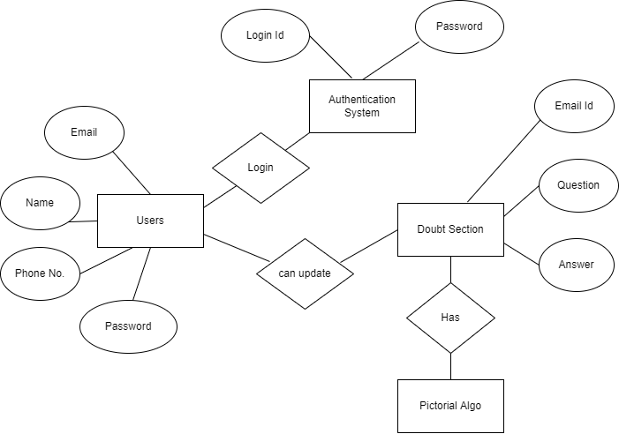

**Figure 1** shows the ER diagram of the Pictorial Algo

**3.4 System Entities and their Attributes**

**User Entity-** Attributes of user are Email_id, name, phone_no, password

**Doubt Section Entity**- Attributes of Doubt Section are email id, question and answer

1. The details of User are stored into the User Table.
2. Each entity contains Primary key and foreign keys.
3. The entity User has bonded with Doubt section entity with foreign key.
4. There is one-to-one and one-to-many relationships available between the entities.
5. All the entities are normalized and reduce duplicity of records.

**4. Data Flow Diagram for the system**

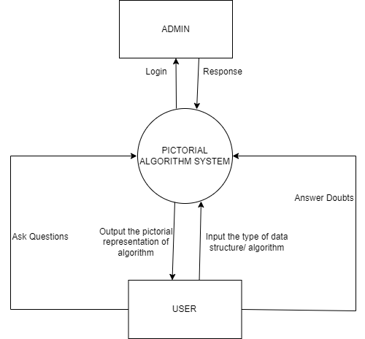

**Figure 2** shows the Level-0 data flow diagram of the Pictorial Algo

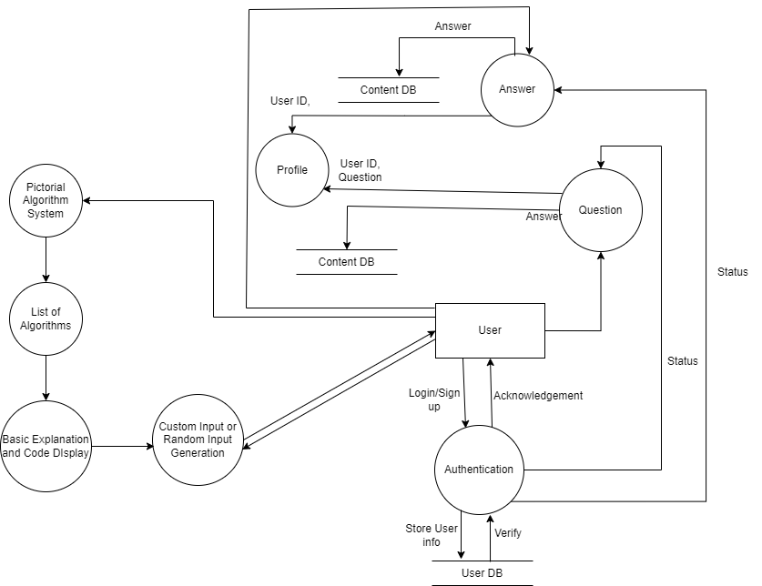

**Figure 3** shows the Level-1 data flow diagram of the Pictorial Algo

**5. Class Model**

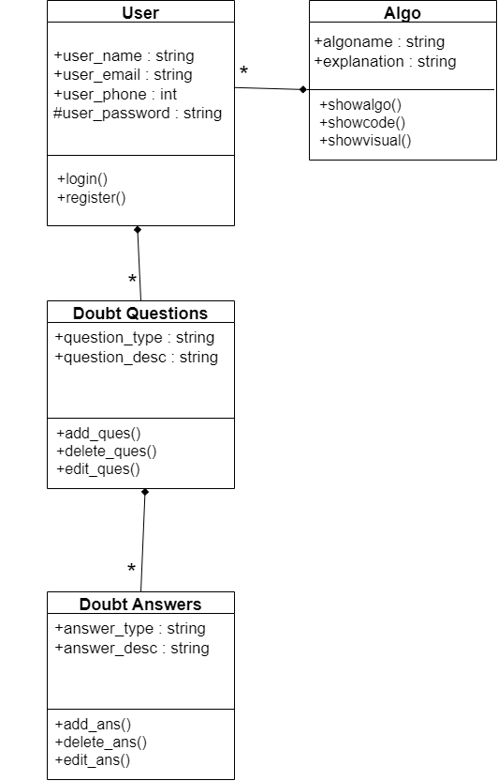

1. **Use – Case Diagram**

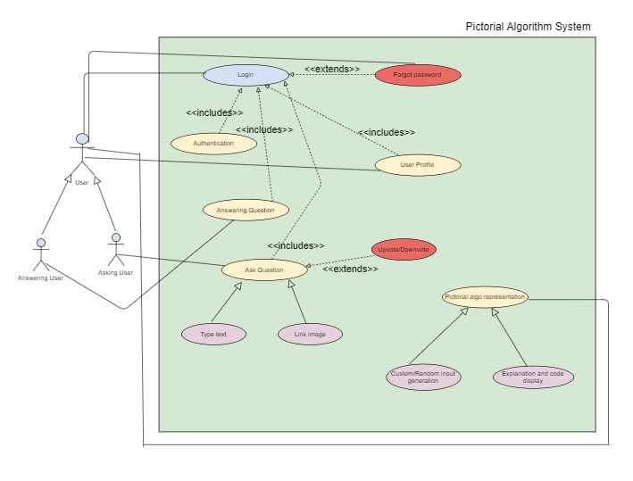

1. **Use – Case Templates**

**Template 1**

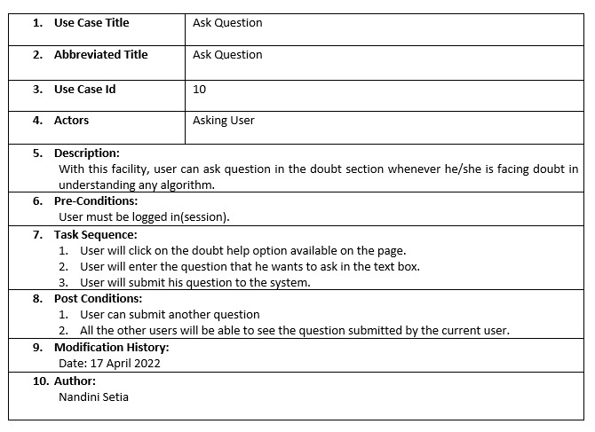

**Template 2**

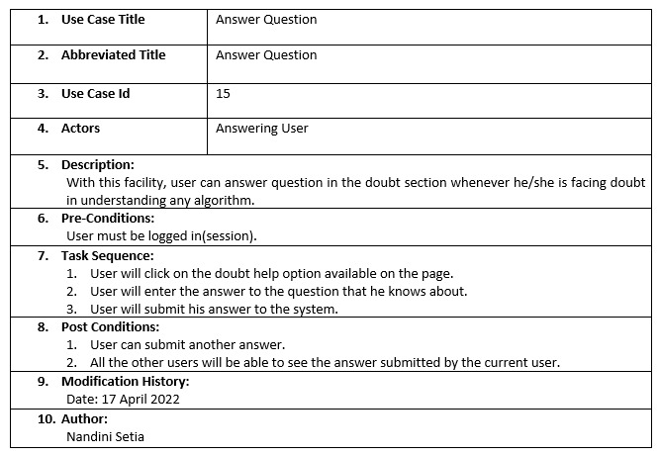

**Template 3**

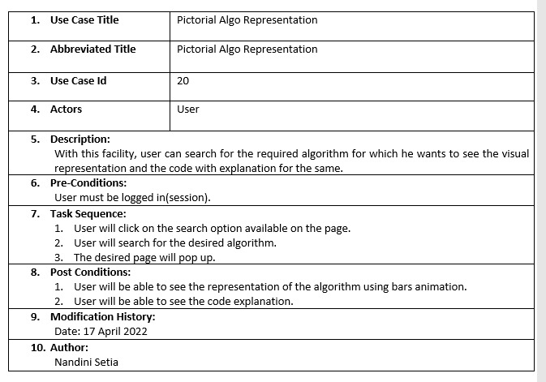

1. **Activity Diagram**

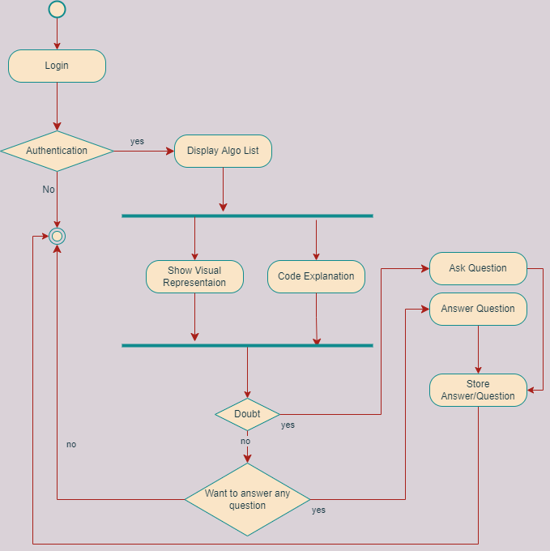

1. **Sequence Diagram**

**Login**

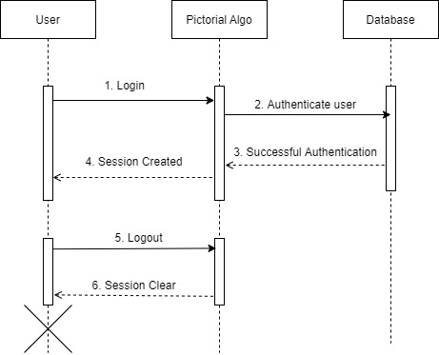

**Upload**

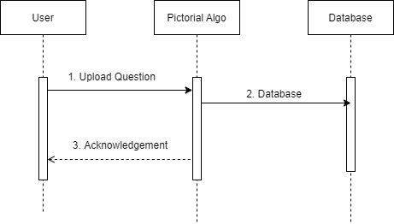

**Searching**

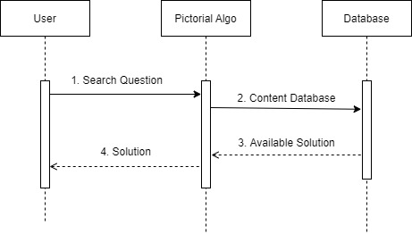

**Profile Module**

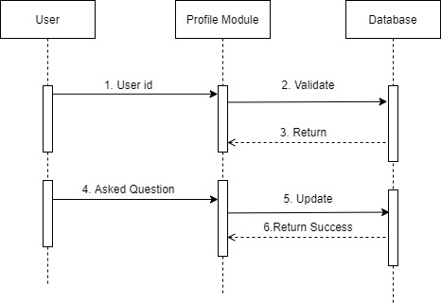

**Custom Input**

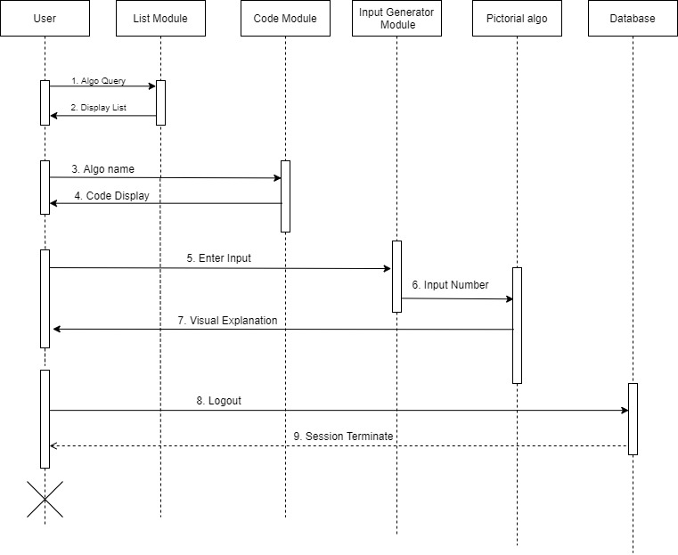

1. **Collaboration Diagram**

**Login**

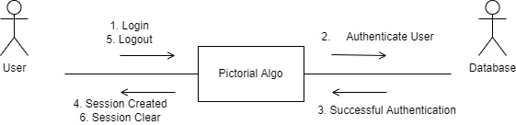

**Upload**

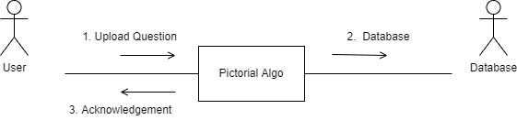

**Searching**

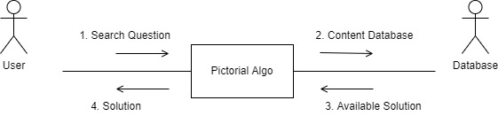

**Profile Module**

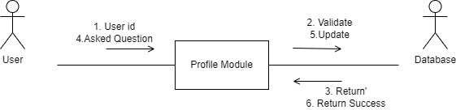

**Custom Input**

