Predictive Modeling Framework
Internship Project – Week 4 Deliverable

This Photo by Unknown Author is licensed under CC BY
Prepared By: Mudrika Mishra
Program: PGDM (Business Analytics)
Jaipuria Institute of Management
Internship: Junior Data Scientist – Agribusiness Data Analysis
Date: October 2026

1. Executive Summary
This report presents a practical predictive modeling framework for estimating crop yield using an agribusiness dataset containing 1,000,000 observations and 10 variables. For modeling, the 231 records with negative yield values identified during data cleaning were removed because negative physical crop yield is not meaningful in this context, leaving 999,769 observations.
Three regression approaches were evaluated: Linear Regression, Decision Tree Regressor, and Random Forest Regressor. Categorical variables were one-hot encoded, numerical variables were retained in their numeric form, and the data was divided into 80% training and 20% testing sets. Linear Regression produced the strongest test-set performance among the three models, with MAE of 0.3983 tons/hectare, RMSE of 0.4993 tons/hectare, and R² of 0.9132.
The results indicate that the selected features contain substantial predictive information for crop yield in this dataset. However, the results are specific to the dataset and train-test split used and should not be interpreted as proof that the model will perform identically in all agricultural environments.

2. Objective
The objective of this week's work was to develop and demonstrate a predictive modeling framework for agricultural yield prediction. The framework focuses on identifying relevant yield-influencing features, preparing them for machine learning, training alternative regression models, evaluating their performance, and selecting a suitable model based on objective performance metrics.

3. Rationale for Predictive Modeling in Agribusiness
Crop yield prediction can support agribusiness decision-making by providing estimates of expected production under different observed conditions. A predictive model can help analysts investigate the contribution of environmental, crop, soil, and farm-management variables and can provide a data-driven basis for resource planning.
- Support yield estimation before harvest using available input information.
- Assist resource planning related to irrigation and fertilizer use.
- Help identify variables with strong predictive relationships with yield.
- Provide a repeatable analytical framework that can be adapted to other agribusiness datasets.

4. Dataset and Target Variable
The analysis used the crop yield dataset selected during the earlier internship tasks. The original dataset contained 1,000,000 rows and 10 columns.
Variable | Role / Description
Region | Categorical predictor
Soil_Type | Categorical predictor
Crop | Categorical predictor
Rainfall_mm | Numerical predictor
Temperature_Celsius | Numerical predictor
Fertilizer_Used | Binary categorical predictor
Irrigation_Used | Binary categorical predictor
Weather_Condition | Categorical predictor
Days_to_Harvest | Numerical predictor
Yield_tons_per_hectare | Target variable

5. Data Preparation for Modeling
The Week 2 cleaning process was reproduced before modeling to maintain consistency and reproducibility. The original dataset contained 231 negative yield records. These observations were removed because a negative crop yield is physically invalid for the target variable.
- Rows before cleaning: 1,000,000
- Negative-yield rows removed: 231
- Rows available for modeling: 999,769
- Missing values after cleaning: 0
- Duplicate rows after cleaning: 0
- Target variable: Yield_tons_per_hectare
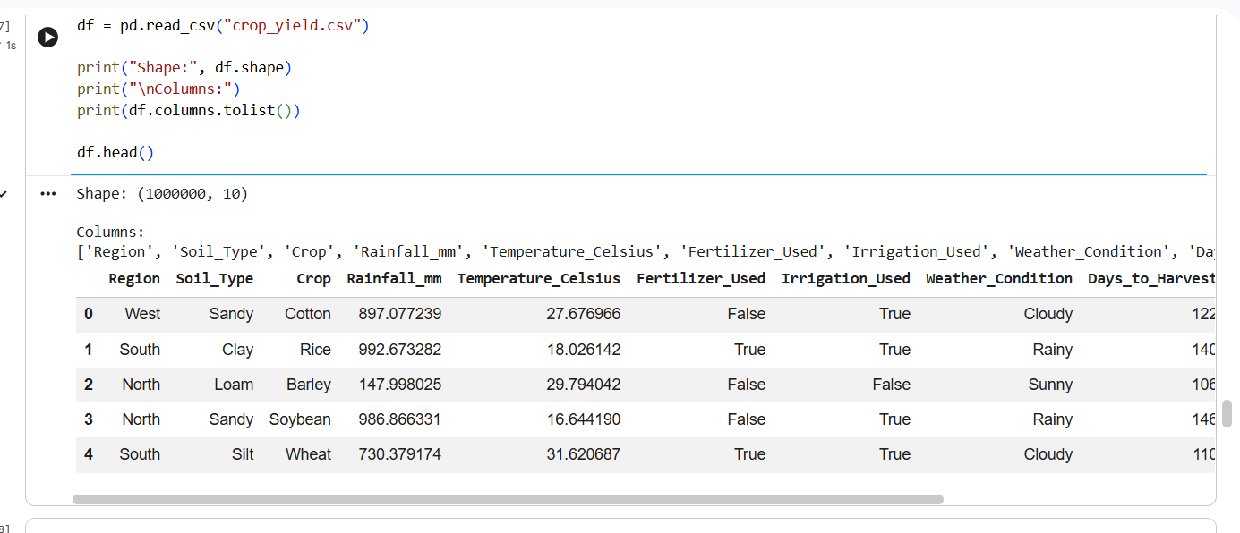

6. Predictive Modeling Workflow
The modeling workflow followed a sequential process designed to reduce leakage and maintain a fair comparison between algorithms.
1. Load the original crop yield dataset.
2. Reproduce the cleaning step by removing negative target values.
3. Separate predictor variables (X) from the target variable (y).
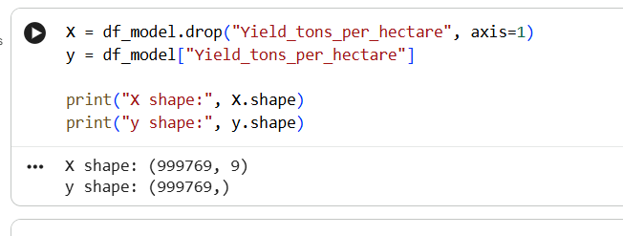
4. Split the data into 80% training and 20% testing subsets using random_state=42.
5. Identify categorical and numerical predictors.
6. Apply One-Hot Encoding to categorical variables using handle_unknown='ignore'.
7. Fit the encoder only on the training data and transform the test data using the fitted encoder.
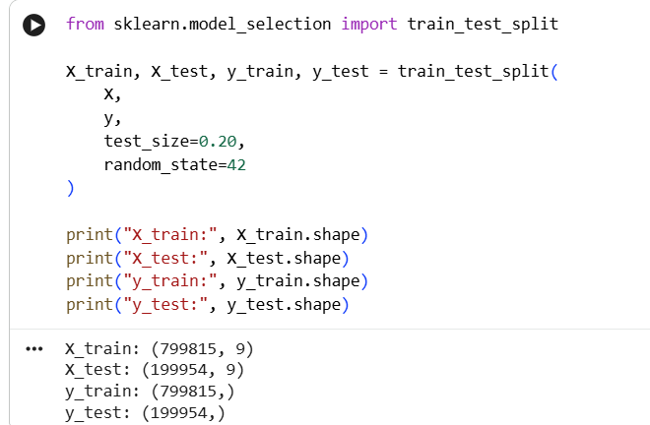
rom sklearn.compose import ColumnTransformer
from sklearn.preprocessing import OneHotEncoder

categorical_features = [
"Region",
"Soil_Type",
"Crop",
"Fertilizer_Used",
"Irrigation_Used",
"Weather_Condition"
]

numerical_features = [
"Rainfall_mm",
"Temperature_Celsius",
"Days_to_Harvest"
]

preprocessor = ColumnTransformer(
transformers=[
("cat", OneHotEncoder(handle_unknown="ignore"), categorical_features),
("num", "passthrough", numerical_features)
]
)

X_train_encoded = preprocessor.fit_transform(X_train)
X_test_encoded = preprocessor.transform(X_test)

print("Encoded training shape:", X_train_encoded.shape)
print("Encoded testing shape:", X_test_encoded.shape)

8. Train Linear Regression, Decision Tree, and Random Forest regression models.
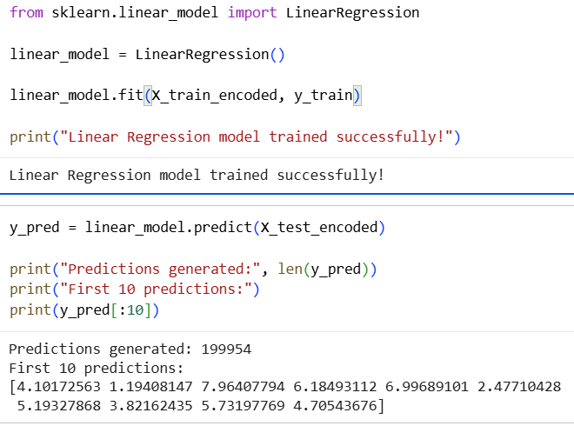
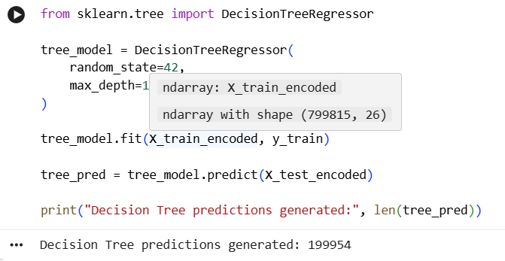
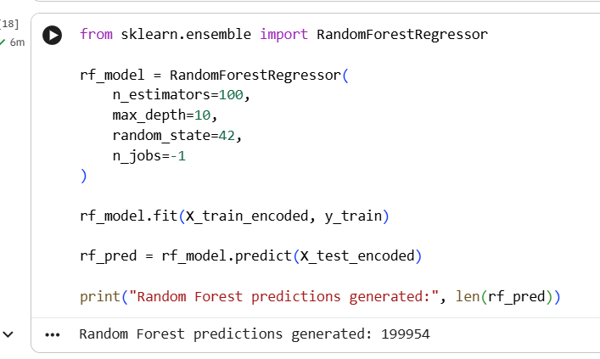
9. Generate predictions on the unseen test set.
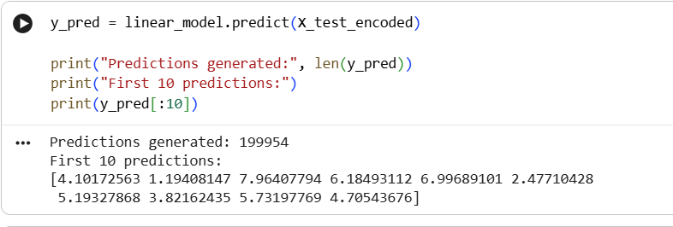
10. Evaluate each model using MAE, RMSE, and R².
11. Compare the results and select the strongest model based on test-set performance.

7. Feature Engineering and Encoding
The dataset contains categorical variables that cannot be directly used by standard regression models in their original text form. One-Hot Encoding was therefore applied to Region, Soil_Type, Crop, Fertilizer_Used, Irrigation_Used, and Weather_Condition. Rainfall_mm, Temperature_Celsius, and Days_to_Harvest were retained as numerical features.
The transformation produced 26 model features. The encoder was fitted on the training set only and then applied to the test set. This prevents information from the test data from influencing the encoding process.

8. Models Evaluated
Model | Purpose | Key Configuration
Linear Regression | Baseline linear regression model for yield prediction. | Default LinearRegression
Decision Tree Regressor | Captures non-linear decision rules. | max_depth=10, random_state=42
Random Forest Regressor | Combines multiple decision trees for a more stable non-linear model. | n_estimators=100, max_depth=10, random_state=42, n_jobs=-1

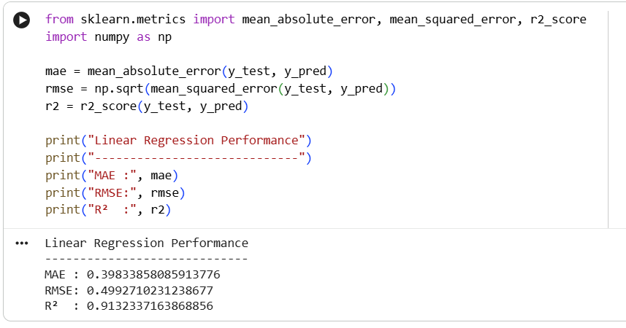

9. Model Evaluation Metrics
Three metrics were used to compare predictive performance. MAE measures the average absolute difference between actual and predicted yield. RMSE also measures prediction error but gives greater weight to larger errors. R² indicates the proportion of variation in the target that is explained by the model on the test set. For MAE and RMSE, lower values are better; for R², higher values are better.

10. Model Performance Results
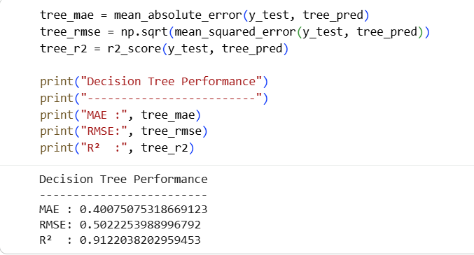
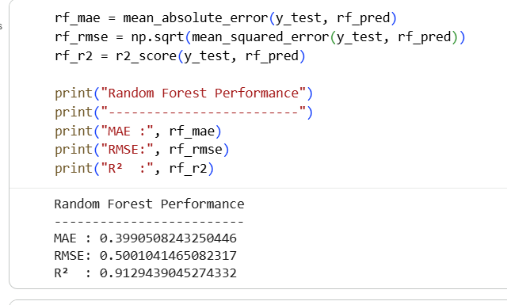
model_comparison = pd.DataFrame({
"Model": [
"Linear Regression",
"Decision Tree",
"Random Forest"
],
"MAE": [
mae,
tree_mae,
rf_mae
],
"RMSE": [
rmse,
tree_rmse,
rf_rmse
],
"R2": [
r2,
tree_r2,
rf_r2
]
})

model_comparison
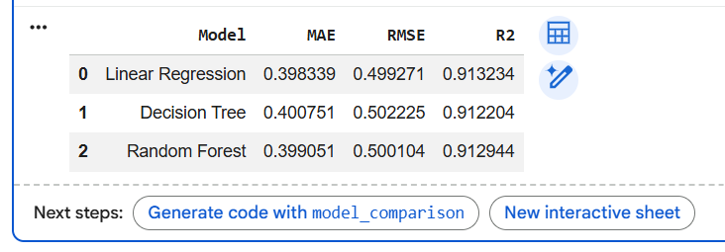
Model | MAE | RMSE | R² | Rank
Linear Regression | 0.398339 | 0.499271 | 0.913234 | 1
Decision Tree | 0.400751 | 0.502225 | 0.912204 | 2
Random Forest | 0.399051 | 0.500104 | 0.912944 | 3
Linear Regression achieved the lowest MAE (0.398339) and RMSE (0.499271), as well as the highest R² (0.913234). Therefore, it was selected as the best-performing model among the three evaluated approaches for this experiment.

11. Interpretation of the Selected Model
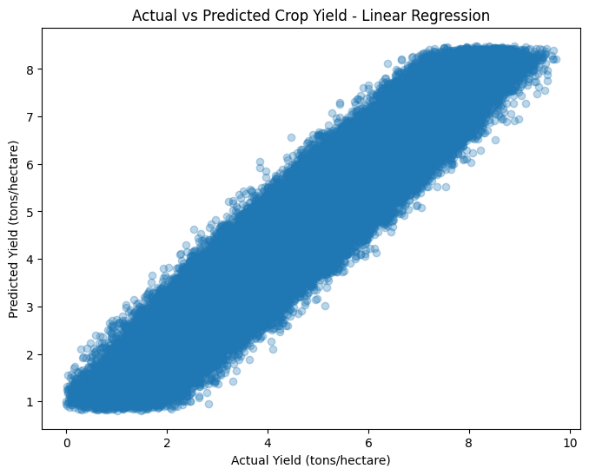
The Linear Regression model achieved an R² of approximately 0.9132 on the test set. In the context of this experiment, this means that approximately 91.32% of the variation in observed yield values in the test data is explained by the model's feature representation. The MAE of approximately 0.3983 tons/hectare indicates the average absolute prediction error was about 0.40 tons/hectare.
The actual-versus-predicted plot showed a clear upward pattern: higher actual yield observations were generally associated with higher predicted yields. This visual pattern is consistent with the strong R² obtained by the selected model. The predictions are not perfect, and deviations from the ideal relationship represent prediction errors.

12. Model Reliability and Validation Considerations
The model was evaluated on a held-out test set that was not used for model fitting. This provides a basic measure of out-of-sample performance. However, the experiment uses a random train-test split rather than a chronological split because the dataset does not contain a date or time variable. Therefore, the task should be described as crop yield prediction rather than true time-series forecasting.
- The reported metrics apply to the selected dataset, feature set, preprocessing method, and random split.
- A future study should use cross-validation to assess stability across multiple splits.
- Hyperparameter tuning could be used to optimize tree-based models.
- External validation on a separate agricultural dataset would strengthen generalizability.
- Additional variables such as historical yield, location-specific information, input quantities, and time/season data could improve future models if available.

13. Applicability to Other Agribusiness Scenarios
The overall framework is transferable to other agribusiness prediction problems. The same sequence of data validation, target definition, feature preparation, train-test separation, model training, and objective evaluation can be adapted to datasets involving crop yield, production volume, resource demand, or other measurable agribusiness outcomes.
- Define the business prediction target clearly.
- Validate and clean the source data.
- Identify numerical and categorical predictors.
- Prevent data leakage during preprocessing.
- Establish a simple baseline model.
- Compare alternative algorithms using consistent evaluation metrics.
- Validate the selected model before operational use.
- Document assumptions, limitations, and data requirements.

14. Limitations
- The dataset does not include a date or season variable, so seasonal or chronological forecasting could not be evaluated.
- The dataset does not contain market price information, so price forecasting was outside the scope of this model.
- Fertilizer_Used and Irrigation_Used indicate usage status rather than quantities, limiting interpretation of input intensity.
- The model identifies predictive relationships but does not establish causal relationships.
- The small performance differences among the three models suggest that model complexity did not provide a meaningful improvement in this experiment.

15. Reproducibility and Documentation
The analysis was implemented in Python using pandas, NumPy, and scikit-learn. A fixed random_state of 42 was used for the train-test split and applicable models so that the experiment can be reproduced. The preprocessing transformation was fitted on training data before being applied to test data. The final model comparison table was also exported as a CSV file named week4_model_comparison.csv.
Key software components used: Python, pandas, NumPy, scikit-learn, and Matplotlib.

16. Conclusion
This Week 4 exercise developed a complete predictive modeling workflow for crop yield prediction. After reproducing the data-cleaning process, the prepared dataset was transformed into a machine-learning ready format and three regression models were trained and evaluated. Linear Regression achieved the strongest performance on the held-out test set, with MAE of 0.3983, RMSE of 0.4993, and R² of 0.9132.
The exercise demonstrates that a relatively simple regression model can perform strongly when the available features contain substantial predictive information. At the same time, further validation, additional data, and broader testing would be required before using the model for real-world agricultural decision-making.

17. Appendix: Key Experimental Results
Dataset used for modeling: 999,769 cleaned observations and 9 predictor variables. Training set: 799,815 observations. Test set: 199,954 observations. Encoded feature count: 26.
Linear Regression test metrics: MAE = 0.3983385809; RMSE = 0.4992710231; R² = 0.9132337164.
Decision Tree test metrics: MAE = 0.4007507532; RMSE = 0.5022253989; R² = 0.9122038203.
Random Forest test metrics: MAE = 0.3990508243; RMSE = 0.5001041465; R² = 0.9129439045.

