Data Cleaning and Preprocessing Strategy

Internship Project – Week 2 Deliverable


This Photo by Unknown Author is licensed under CC BY-NC-ND
Prepared By: Mudrika Mishra
Program: PGDM (Business Analytics)
Institute: Jaipuria Institute of Management, Noida
Internship Role: Junior Data Scientist Intern
Organization: YuvaIntern
Project Area: Agribusiness Data Analysis
Date: October 2026

1. Introduction
Data cleaning and preprocessing are important steps in any data science project because the quality of the data directly affects the reliability of analysis and machine learning models.
For Week 2 of the internship, the objective was to examine the selected agribusiness dataset for common data-quality issues such as missing values, duplicate records, invalid values, inconsistent categorical entries, inappropriate data types, and statistical outliers.
Python and Pandas were used to inspect, clean, validate, and prepare the dataset. The cleaning process was designed to be systematic and reproducible.

2. Dataset Overview
The dataset contains 1,000,000 observations and 10 variables related to agricultural production and crop yield.
The target variable for the dataset is:
Yield_tons_per_hectare
The variables included in the dataset are:
Variable | Description | Type
Region | Geographical region | Categorical
Soil Type | Type of soil | Categorical
Crop | Crop being cultivated | Categorical
Rainfall mm | Rainfall received in millimetres | Numerical
Temperature Celsius | Temperature in degrees Celsius | Numerical
Fertilizer Used | Whether fertilizer was used | Boolean
Irrigation Used | Whether irrigation was used | Boolean
Weather Condition | Weather condition | Categorical
Days_to_Harvest | Number of days required for harvest | Numerical
Yield_tons_per_hectare | Crop yield per hectare | Numerical/Target

Screenshot 1 – Dataset Preview

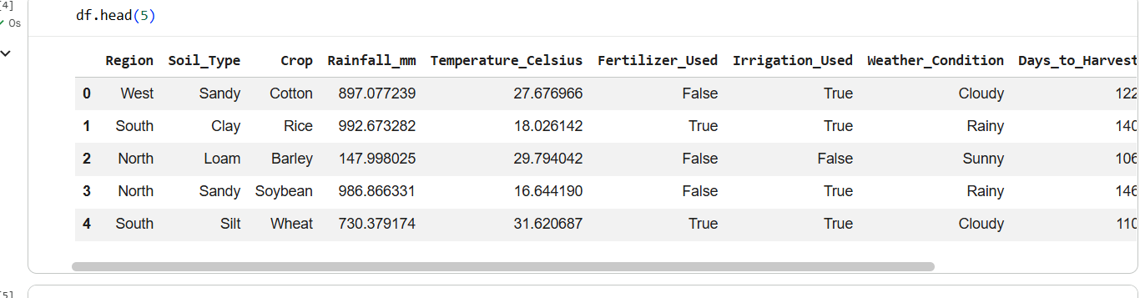
Figure 1. Initial preview of the agribusiness dataset using Python.

3. Data Quality Assessment
The first stage of preprocessing was to assess the overall quality of the dataset before making any modifications.
The following checks were performed:
- Dataset dimensions
- Missing values
- Duplicate records
- Descriptive statistics
- Minimum and maximum values
- Categorical consistency
- Data types
- Statistical outliers
The dataset initially contained 1,000,000 rows and 10 columns.

Initial Data Quality Findings
Quality Check | Result
Total rows | 1,000,000
Total columns | 10
Missing values | 0
Duplicate rows | 0
Negative yield values | 231
The initial assessment showed that the dataset did not contain missing values or duplicate records. However, invalid negative values were identified in the target variable.

Screenshot 2 – Initial Missing and Duplicate Check

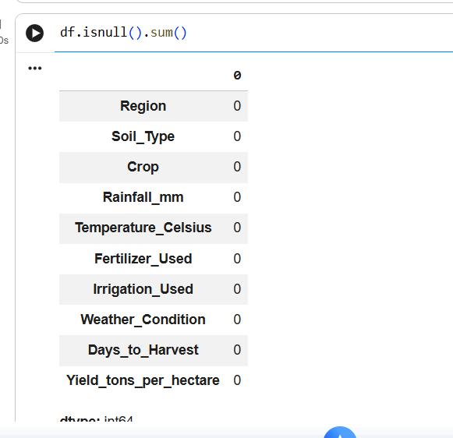

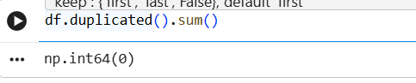
Figure 2. Initial missing-value and duplicate-record assessment.

4. Descriptive Statistical Analysis
Descriptive statistics were examined for the numerical variables to understand their distributions and identify potentially unusual values.
The main numerical variables were:
- Rainfall mm
- Temperature Celsius
- Days_to_Harvest
- Yield_tons_per_hectare
The initial descriptive statistics showed:
Variable | Mean | Minimum
Rainfall mm | 549.9819 | 100.0009
Temperature Celsius | 27.5050 | 15.0000
Days_to_Harvest | 104.4950 | 60
Yield_tons_per_hectare | 4.6495 | -1.1476
The negative minimum for crop yield required further investigation because a negative physical crop yield is not logically meaningful.

Screenshot 3 – Descriptive Statistics

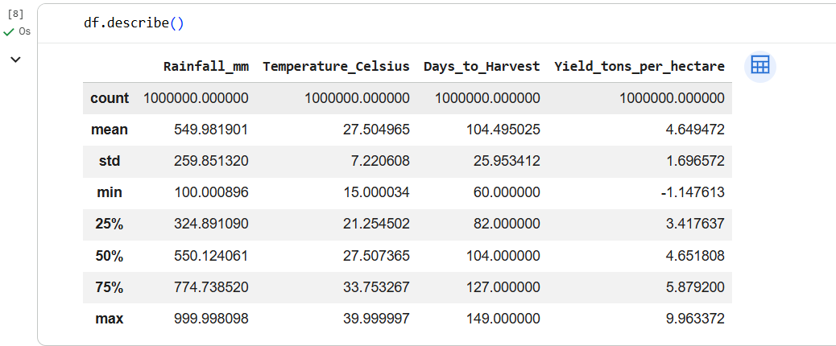
Figure 3. Descriptive statistics of numerical variables.

5. Identification and Treatment of Invalid Values
The target variable Yield_tons_per_hectare was specifically examined for negative values.
The analysis identified:
231 negative yield observations.
The minimum yield before cleaning was:
−1.147613 tons/hectare
Since crop yield cannot logically have a negative physical value, these observations were treated as invalid records.
No zero-yield observations were found.

Findings
- Negative yield observations: 231
- Zero-yield observations: 0
- Minimum yield before cleaning: −1.147613
The invalid observations were removed rather than replaced with a mean or median because the variable is the target of the analysis. Imputing an artificial target value could distort the relationship between the predictors and the target.

Screenshot 4 – Negative Yield Identification

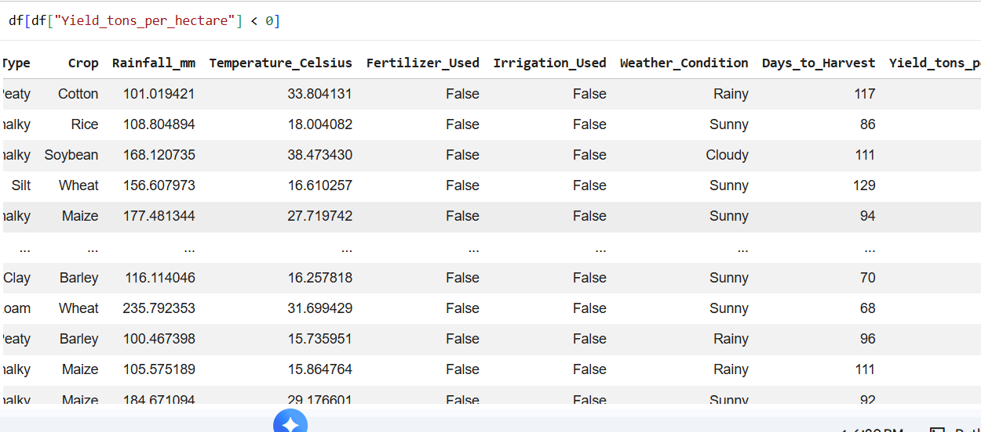

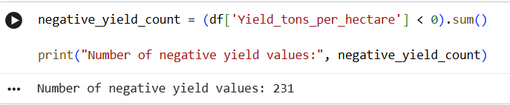
Figure 4. Identification of invalid negative crop-yield observations.

6. Range Validation
The numerical variables were also checked for their minimum and maximum values.
Variable | Minimum | Maximum
Rainfall mm | 100.0009 | 999.9981
Temperature Celsius | 15.0000 | 40.0000
Days_to_Harvest | 60 | 149
Yield_tons_per_hectare | -1.1476 | 9.9634
Rainfall, temperature, and days to harvest did not show values outside the observed dataset ranges that required removal.
The negative values in the yield variable remained the primary invalid-value issue.

Screenshot 5 – Numerical Range Check

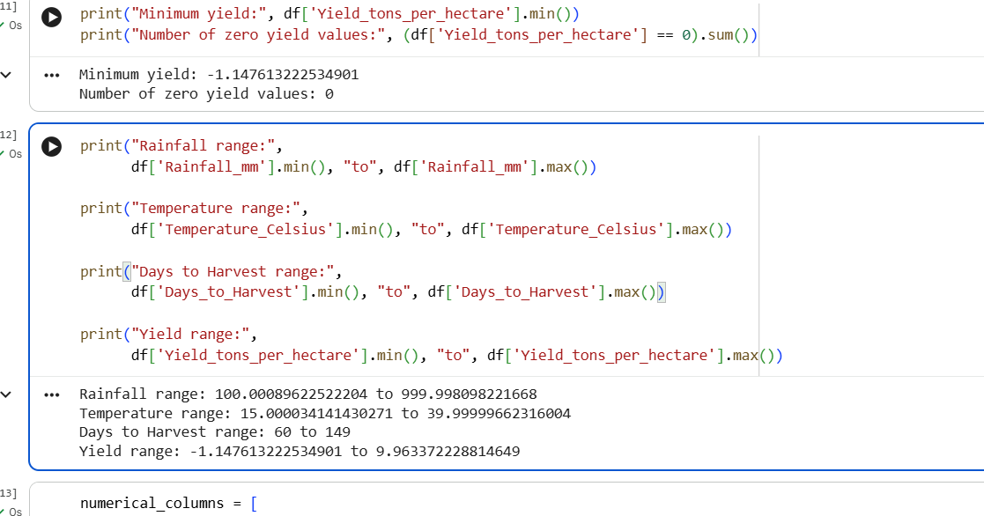
Figure 5. Range validation of numerical variables.

7. Outlier Detection Using the IQR Method
The Interquartile Range (IQR) method was used to identify statistically unusual observations.
The IQR is calculated as:
IQR = Q3 − Q1
The lower and upper boundaries were calculated using:
Lower Bound = Q1 − 1.5 × IQR
Upper Bound = Q3 + 1.5 × IQR

Outlier Detection Results
Variable | Number of IQR Outliers
Rainfall mm | 0
Temperature Celsius | 0
Days_to_Harvest | 0
Yield_tons_per_hectare | 84
The IQR method identified 84 observations in the yield variable as statistical outliers.
The yield IQR boundaries were:
- Q1 = 3.4176
- Q3 = 5.8792
- IQR = 2.4616
- Lower bound = −0.2747
- Upper bound = 9.5715

Screenshot 6 – IQR Outlier Analysis

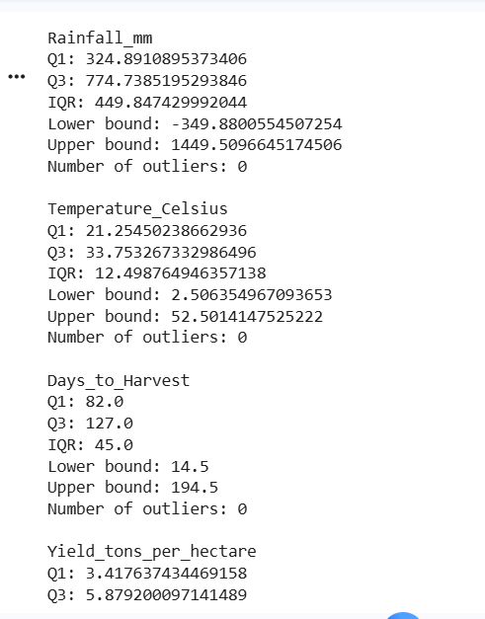
Figure 6. IQR-based statistical outlier detection.

8. Investigation of Yield Outliers
The identified yield outliers were inspected instead of being automatically removed.
The investigation showed that the outliers included both negative yields and high positive yields.
For example, some positive values were approximately:
- 9.7270 tons/hectare
- 9.6134 tons/hectare
- 9.5802 tons/hectare
- 9.6477 tons/hectare
The negative observations were already identified as invalid based on their physical meaning.
The positive extreme observations were retained because there was insufficient evidence to classify them as data-entry errors. Automatically deleting statistically unusual but potentially valid observations could result in unnecessary loss of information.
Therefore:
- Negative yield values were treated as invalid.
- Plausible positive extreme values were retained.
- IQR outliers were not automatically deleted.

Screenshot 7 – Investigation of Yield Outliers

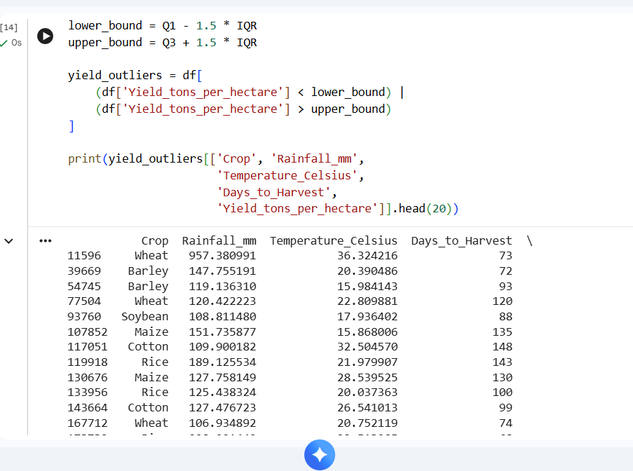
Figure 7. Sample inspection of statistically identified yield outliers.

9. Removal of Invalid Negative Yield Values
A cleaned copy of the original dataset was created to preserve the original data.
The invalid observations were removed using the condition that yield must be greater than or equal to zero.

Before Cleaning
Rows: 1,000,000

After Cleaning
Rows: 999,769

Records Removed
231
Therefore, the cleaning process removed only the observations that contained invalid negative yield values.

Screenshot 8 – Cleaning Result
: 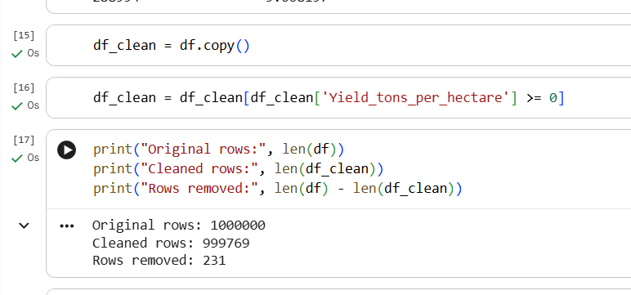
- Original rows: 1,000,000
- Cleaned rows: 999,769
- Rows removed: 231
Figure 8. Dataset size before and after removal of invalid observations.

10. Verification After Cleaning
After removing the invalid records, the cleaned dataset was checked again to ensure that no negative yield values remained.
The verification produced the following results:
- Negative yields remaining: 0
- Minimum yield after cleaning: 0.0004108724 tons/hectare
This confirmed that the invalid negative values had been successfully removed.

Screenshot 9 – Cleaning Verification

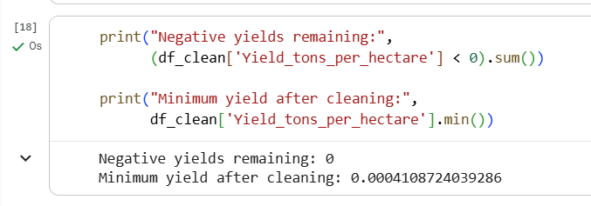
Figure 9. Verification of successful removal of negative yield values.

11. Categorical Consistency Check
Categorical variables were examined using unique-value checks to identify possible spelling, capitalization, or formatting inconsistencies.
The following categories were found:
Variable | Unique Values
Region | West, South, North, East
Soil Type | Sandy, Clay, Loam, Silt, Peaty, Chalky
Crop | Cotton, Rice, Barley, Soybean, Wheat, Maize
Fertilizer Used | True, False
Irrigation Used | True, False
Weather Condition | Cloudy, Rainy, Sunny
No obvious spelling or capitalization inconsistencies were identified.
Therefore, no categorical-value correction was required.

Screenshot 10 – Categorical Consistency
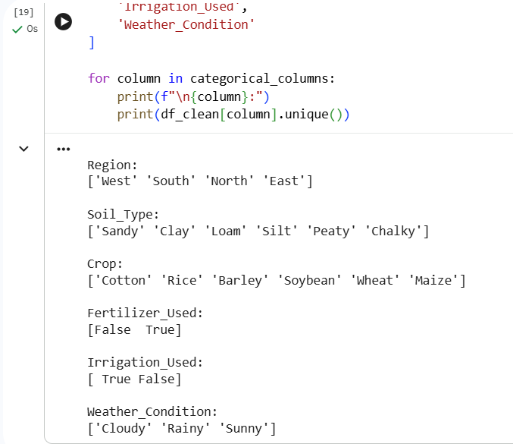
Figure 10. Categorical-value consistency assessment.

12. Data Type Validation
The data types of all variables were examined after cleaning.
The results showed that:
- Numerical measurements were stored as integer or floating-point values.
- Categorical variables were stored as object/string values.
- Fertilizer and irrigation indicators were stored as Boolean values.
- The target yield variable was stored as a floating-point value.
The data types were therefore considered appropriate for further analysis.

Screenshot 11 – Data Types
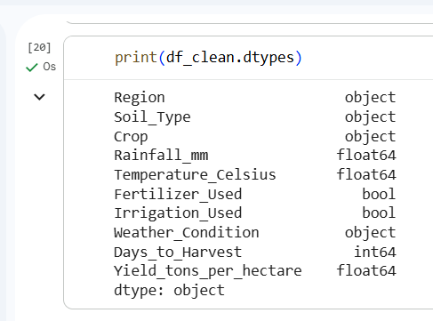
Figure 11. Data-type validation after cleaning.

13. Final Quality Check
After the cleaning operations, the dataset was checked again for missing values and duplicate records.
The results were:
- Missing values after cleaning: 0
- Duplicate rows after cleaning: 0
This confirmed that the cleaning operation did not introduce missing or duplicate records.
The final cleaned dataset contained:
999,769 rows and 10 columns.

Screenshot 12 – Final Quality Check

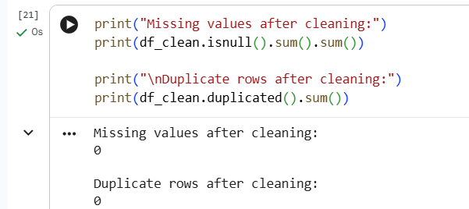
Figure 12. Final validation of the cleaned dataset.

14. Preprocessing Strategy for Machine Learning
After data cleaning, additional preprocessing may be required before developing a machine-learning model.

14.1 Categorical Encoding
The dataset contains categorical variables such as:
- Region
- Soil Type
- Crop
- Weather Condition
Machine-learning algorithms generally require numerical representations of categorical information. Therefore, categorical variables can be transformed using suitable encoding techniques, such as one-hot encoding, during model preparation.
Boolean variables such as Fertilizer Used and Irrigation Used can be represented numerically as required by the selected model.

14.2 Feature Scaling
The numerical variables have different ranges. For example, rainfall is measured approximately from 100 to 1000 mm, while temperature ranges approximately from 15 to 40°C.
For algorithms that are sensitive to feature magnitude, numerical features can be standardized or normalized during model preparation.
Scaling should be performed after splitting the data into training and testing sets, with the scaler fitted only on the training data to prevent data leakage.

14.3 Target Variable
Yield_tons_per_hectare will be retained as the target variable for the planned crop-yield prediction task.
The invalid negative target observations were removed during the cleaning stage.

15. Data Cleaning and Preprocessing Workflow
The overall workflow followed during Week 2 was:
Raw Dataset
↓
Dataset Inspection
↓
Missing Value Check
↓
Duplicate Check
↓
Descriptive Statistics
↓
Range Validation
↓
Invalid Negative Yield Detection
↓
IQR-Based Outlier Detection
↓
Outlier Investigation
↓
Removal of Invalid Negative Yield Records
↓
Categorical Consistency Check
↓
Data Type Validation
↓
Final Missing/Duplicate Check
↓
Cleaned Dataset
↓
Ready for Further Preprocessing and Machine Learning

16. Reproducibility
Python and the Pandas library were used to perform the data-cleaning operations.
A separate cleaned DataFrame, df_clean, was created so that the original dataset remained unchanged.
The cleaned dataset was exported as:
cleaned_crop_yield_dataset.csv
This approach improves reproducibility because the cleaning steps can be repeated using the same code and applied consistently to the dataset.

Screenshot 13 – Cleaned Dataset Export
. 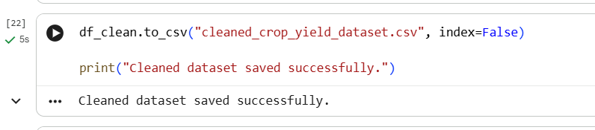
Figure 13. Export of the cleaned dataset for reproducible use.

17. Before-and-After Summary
Metric | Before Cleaning | After Cleaning
Number of rows | 1,000,000 | 999,769
Number of columns | 10 | 10
Missing values | 0 | 0
Duplicate rows | 0 | 0
Negative yield values | 231 | 0
Minimum yield | −1.1476 | 0.00041
Categorical consistency | Consistent | Consistent
Data types | Appropriate | Appropriate
The cleaning process therefore removed 231 invalid observations, while retaining the remaining 999,769 records for further analysis.

18. Conclusion
The Week 2 data-cleaning and preprocessing exercise established a systematic approach for preparing the agribusiness dataset for further analysis and machine-learning development.
The dataset initially contained 1,000,000 records. No missing values or duplicate records were identified. However, 231 negative crop-yield observations were detected and treated as invalid because negative physical crop yield is not logically meaningful.
IQR-based analysis identified 84 statistical outliers in the yield variable. These observations were investigated rather than automatically removed. Plausible positive extreme values were retained, while invalid negative values were handled separately.
Categorical variables were checked for consistency, and the existing data types were found to be appropriate. After cleaning, the dataset contained 999,769 records with no missing values, no duplicate rows, and no negative yield values.
The cleaned dataset has therefore been prepared for subsequent preprocessing, exploratory analysis, and machine-learning model development.

Final Deliverable Summary
Dataset: Agribusiness Crop Yield Dataset
Initial Records: 1,000,000
Final Records: 999,769
Invalid Records Removed: 231
Missing Values: 0
Duplicate Records: 0
Negative Yields Remaining: 0
Cleaning Tool: Python/Pandas
Output File: cleaned_crop_yield_dataset.csv

