Week 1 Report – Data Cleaning and Preliminary Analysis Using R
Virtual R Data Analyst Internship Project

Prepared By: Mudrika Mishra
INTRODUCTION
Financial markets are highly dynamic in nature, where stock process continuously fluctuate due to changes in economic conditions, investor sentiment, company performance and market expectations. Understanding these fluctuations is important for investors, financial analysts, and businesses because stock movements directly influence investment decisions, portfolio management, and risk assessment. In recent years, econometric technique has become an essential tool in finance for analyzing market behavior and identifying patterns in financial data
This study focuses on the stock performance of reliance industries limited one of the largest and most influential companies in India. Reliance industries plays an important role in the Indian stock market due to its strong market capitalization, diversified business operations, and high trading activity. Because of its active presence in the market, the company’s stock prices provide a suitable dataset for analyzing financial behavior and volatility. The main objective of this project is to examine the relationship between stock returns and selected market variables using econometrics techniques in R studio. The study uses daily stock market data consisting of variables such as opening price, high price, low price, closing price, trading volume, and stock returns. Diagnostics tests were then conducted to identify econometric issues such as multicollinearity, heteroskedasticity, autocorrelation, and non-normality of residuals. Based on the diagnostics results, the regression model was improved to achieve better statistical reliability.
Data Description
The dataset used in this study consists of daily stock market data of Reliance Industries Limited collected for the purpose of financial econometric analysis. The data includes important market variables such as opening price, highest price, lowest price, closing price, trading volume, and daily stock returns. the dataset was imported and analyzed using R studio.
The study uses daily observations because daily financial data captures short-term market fluctuations and volatility more effectively compared to monthly or yearly data. Since stock prices are influenced by market sentiment, investor behavior, and economic conditions, daily data provides a better understanding of returns movements and volatility patterns
The variables used in the analysis are described below:
Variable | Description
DATE | Trading date
OPEN | Opening stock price
HIGH | Highest stock price during the trading day
LOW | Lowest stock price during the trading day
CLOSE | Closing stock price
VOLUME | Number of shares traded
RETURNS | Daily stock returns

Data collection
Daily stock data was obtained from the NSE India (National Stock Exchange) historical database, accessed in May 2026.
The study is based on daily stock market data of reliance industries ltd. The dataset includes variables such as open price, high price, low price, close price, trading volume, and daily returns. The data covers the period from July 2025 to May 2026. Daily observations were used because stock prices fluctuate continuously and daily data provides a better understanding of short-term market movements and volatility behavior.
The data was collected from publicly available financial market sources and imported into R studio for analysis. Before performing econometrics analysis, the dataset was cleaned and checked for missing values to ensure accuracy and consistency.
Variables used in the study
The study uses both dependent and independent variables to examine the relationship between stock returns and market indicators.
Variable | Type | Description
RETURNS | Dependent Variable | Daily stock returns of Reliance Industries Ltd.
CLOSE | Independent Variable | Daily closing stock price
VOLUME | Independent Variable | Daily trading volume

Initially, OPEN, HIGH, and LOW prices were also included in the regression model, however, diagnostic tests showed the presence of multicollinearity among these variables. Therefore, the final model retained CLOSE and VOLUME as explanatory variables to improve reliability and interpretation.

Data Description and Summary Statistics

Data description
The dataset used in this study consists of daily stock market data of reliance industries ltd. From july2025 to May 2026. The variables included in the dataset are Open Price, High Price, Low Price, Close Price, Trading Volume, and Daily Returns
The study uses RETURNS AS THE DEPENDENT variable, while CLOSE and VOLUME are used as independent variable in the final regression model. The data was imported into R studio and checked for missing values before performing the analysis.
Daily stock data was selected because it helps in understanding short-term price movements and volatility behavior in finance markets.

Summary statistics
Summary statistics were calculated to understand the behavior of the variables used in the study. Measures such as mean, minimum value, maximum value, and standard deviation were used to analyze the distribution

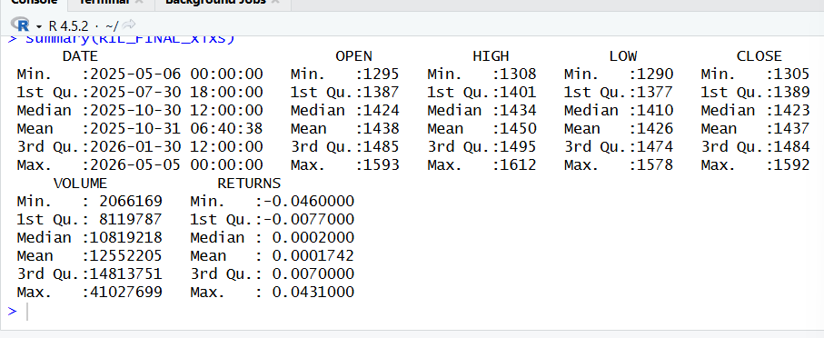

The results show that the stock prices fluctuated during the study period, reflecting changes in market conditions and investor sentiment. The returns variable contains both positive and negative values, indicating gains and losses across trading days. Trading volume also varied significantly, showing differences in market activity over time.

Correlation analysis
Correlation analysis was conducted to examine the relationship between the variables.
The correlation matrix showed a high correlation among OPEN, HIGH, LOW, and CLOSE prices indicating possible multicollinearity in regression model. Trading volume showed relatively over correlation with stock prices.
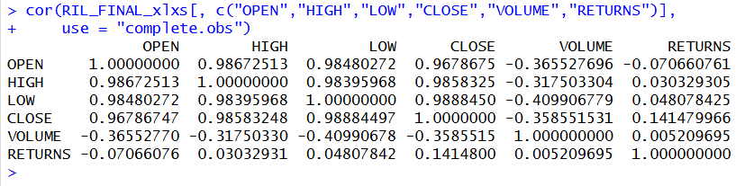
Based on the correlation results and further diagnostics testing, the regression model modified by retaining CLOSE and VOLUME as explanatory variables.

Abnormal value analysis
“Daily returns were examined for abnormal values using both the standard deviation rule and the IQR method. The standard deviation approach identified 16 abnormal values, with an average abnormal return of approximately 0.0028. The IQR method detected 12 abnormal values, with an average abnormal return of about -0.00096. These results indicate that while most returns remained within a normal range, occasional extreme movements occurred, reflecting sudden market shocks. Such abnormal values contribute to volatility clustering and justify the application of GARCH modelling for forecasting.”
Statistic | Value
Mean Return | 0.00017
Standard Deviation | 0.01304
No. of Abnormal Values | 16
Average Abnormal Value | 0.00283

The standard deviation rule identified 16 abnormal values, showing occasional extreme positive returns in the dataset.

Abnormal value analysis (IQR RULE)

Statistic | Value
Q1 | -0.0077
Q3 | 0.0070
IQR | 0.0147
No. of Abnormal Values | 12
Average Abnormal Value | -0.00096
The IQR method detected 12 abnormal values, with a slightly negative average, indicating that extreme downward movements also occurred.

Findings
The preliminary analysis of Reliance Industries’ daily stock data revealed important insights into market behavior. The summary statistics highlighted that returns fluctuated between positive and negative values, reflecting both gains and losses across trading days. Trading volume showed significant variation, indicating periods of heightened investor activity. The abnormal value analysis identified 16 extreme returns using the standard deviation rule and 12 abnormal returns using the IQR method. These abnormal values represent sudden shocks in the market, such as unexpected news or investor reactions, and contribute to volatility clustering. The correlation analysis further showed strong relationships among OPEN, HIGH, LOW, and CLOSE prices, suggesting multicollinearity among price variables. Overall, the findings emphasize the importance of cleaning and preparing the dataset to ensure reliable analysis in subsequent stages.

Conclusion
This Week 1 task successfully cleaned and organized the Reliance Industries dataset, addressed missing values, and identified abnormal returns. By applying descriptive statistics and correlation analysis, the study provided initial insights into stock price behavior and trading activity. The detection of abnormal values highlights the dynamic nature of financial markets and sets the foundation for deeper volatility and regression analysis in later weeks. With the dataset now properly structured and validated, it is ready for advanced visualization in Week 2 and predictive modeling in Week 3, ensuring a smooth progression of the internship project.

