**INSTRUCTIONS:** **These persons have a problem. Please give them 5 recommendations that can help them to solve their situation. USE SHOULD OR SHOULDN´T to construct your sentences.**

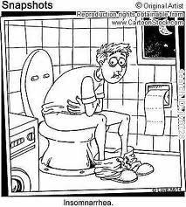

1.___________________________________________

2.___________________________________________

3.___________________________________________

4.___________________________________________

5.___________________________________________

1.___________________________________________

2.___________________________________________

3.___________________________________________

4.___________________________________________

5.___________________________________________

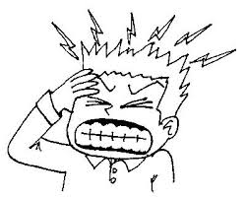

**INSTRUCTIONS: Imagine you are the director of a museum. Write 10 rules that the visitors and tourist have to follow. Use MUST or MUSTN´T to construct your ideas.**

1. _____________________________________________________________________________________________________

2. ______________________________________________________________________________________________________

3.______________________________________________________________________________________________________

4.______________________________________________________________________________________________________

5.______________________________________________________________________________________________________

6. ______________________________________________________________________________________________________

7. ______________________________________________________________________________________________________

8. ______________________________________________________________________________________________________

9______________________________________________________________________________________________________

10______________________________________________________________________________________________________