

Name: Muhammad Hasnain Mirza
Sap Id: 74613
Section: CY-1
Subject: Application of ICT
Project Topic: PowerPoint

Project: PowerPoint

Abstract:
This study investigates the essential role and continuous evolution of Microsoft PowerPoint (PPT) within modern Information and Communication Technology (ICT) and professional communication. As the dominant software for visual presentation globally, PowerPoint is more than just a slide creator; it is a critical tool that shapes how information is processed, visualized, and delivered across various sectors.
The documentation first explores the core functionalities of PowerPoint, ranging from its user interface and Slide Master capabilities to advanced features like multimedia integration, data visualization tools (charts and graphs), and presenter controls. Subsequently, the paper analyzes the practical application and impact of PPT in key areas such as corporate business, education, and academic research, highlighting its necessity for effective knowledge transfer and persuasive reporting.
A key objective of this research is to define the principles of effective presentation design and identify best practices that maximize clarity and audience engagement, thereby bridging the gap between simply creating slides and delivering powerful communication. Ultimately, this project affirms PowerPoint's status as an indispensable application in the ICT landscape, providing a framework for students and professionals to utilize its capabilities responsibly and effectively.

Introduction: 5
1. The User Interface and Navigation 5
• The Ribbon: 5
• Slide Pane and Outline View 5
• Notes Pane: 5
2. Slide Management and Design Consistency 5
• Slide Master: 5
• Layouts: 6
• Themes and Templates: 6
3. Multimedia Integration and Enhancement 6
• Visual Data Tools: 6
• SmartArt Graphics: 6
• Media Embedding: 6
4. Animation and Transition Effects 6
5. Delivery and Collaboration Tools 7
Core features and functionality of MS PowerPoint: 7
1. The User Interface and Command Hub 7
Implementation Steps (Accessing Advanced Settings): 7
2. Slide Management for Visual Consistency 8
Implementation Steps (Editing the Slide Master): 8
3. Multimedia Integration and Data Visualization 9
Implementation Steps (Inserting and Linking a Chart): 9
Implementation Steps (Configuring Video Playback): 10
4. Enhancements: Themes, SmartArt, and Movement 10
Implementation Steps (Converting Text to SmartArt): 11
Implementation Steps (Applying an Animation): 11
5. Presenter Tools for Confident Delivery 12
Implementation Steps (Using Presenter View): 12
6. Collaboration and Versatile Sharing 13
Implementation Steps (Exporting as Video): 13
Conclusion: 14
Reference and bibliographic: 14

Introduction:

1. The User Interface and Navigation
The foundation of PowerPoint usability rests on its intuitive interface:
- The Ribbon: This centralized command center organizes tools into logical tabs (Home, Insert, Design, Animations, Slide Show, etc.). This structure minimizes searching and organizes complex features into accessible groups.
- Slide Pane and Outline View: Users manage the flow of the presentation through the Slide Pane, which displays thumbnails of all slides. The Outline View allows for focused text editing and restructuring of content without visual distractions.
- Notes Pane: Crucial for professional delivery, the Notes Pane allows the presenter to type detailed Speaker Notes that are visible only to them during the presentation via Presenter View.

2. Slide Management and Design Consistency
Effective presentations require visual harmony, which is managed through powerful master tools:
- Slide Master: This is arguably the most critical feature for efficiency and brand consistency. The Slide Master controls the default fonts, color schemes, backgrounds, and placement of logos for the entire presentation. By editing the master, a single change is propagated across all slides, ensuring a uniform, professional appearance.
- Layouts: The Slide Master incorporates several pre-defined Slide Layouts (e.g., Title Slide, Title and Content, Two Content) that provide structured placeholders for different types of content, ensuring text and visuals are organized effectively.
- Themes and Templates: PowerPoint offers professional Themes (pre-set color palettes, fonts, and effects) and allows users to apply custom or downloaded Templates, significantly accelerating the design process while adhering to high aesthetic standards.

3. Multimedia Integration and Enhancement
PowerPoint’s strength lies in its ability to combine diverse media types into a single, cohesive narrative:
- Visual Data Tools: The program excels at transforming raw data into comprehensible visuals. Users can directly insert and edit Charts and Graphs (linked dynamically to Excel data) and create detailed Tables.
- SmartArt Graphics: This feature enables the rapid creation of complex informational graphics, such as organizational charts, process flows, timelines, and relationship diagrams, using structured, professional layouts.
- Media Embedding: High-quality presentation demands dynamic media. PowerPoint allows for the seamless embedding of Video (from local files or online sources like YouTube) and Audio clips, which can be configured to play automatically or upon a click.

4. Animation and Transition Effects
These tools control the timing and movement of content, guiding the audience's focus:
- Animations: Applied to individual objects (text boxes, images, charts), animations control their entrance, emphasis, or exit. Careful use of animations can highlight key data points or reveal bullet points sequentially ("building" content), preventing information overload.
- Transitions: These are visual effects applied between slides, managing the shift from one idea to the next. They should be used sparingly and consistently to avoid distraction, typically favoring subtle effects like Fade or Push.

5. Delivery and Collaboration Tools
Modern PowerPoint extends its utility beyond creation to include presentation delivery and teamwork:
- Presenter View: This dedicated mode is vital for speakers. It displays the current slide, the next slide, and the all-important Speaker Notes on the presenter's screen, while only the main slide is shown to the audience.
- Rehearse Timings: This feature allows the presenter to practice their talk and record the time spent on each slide, optimizing pacing for delivery.
- Co-authoring and Cloud Integration: With integration into Microsoft 365 and OneDrive, multiple users can edit the same presentation simultaneously, facilitating real-time collaboration among geographically dispersed teams.

Core features and functionality of MS PowerPoint:
PowerPoint is a critical application defined by a robust suite of features that facilitate the structured creation, enhancement, and professional delivery of digital presentations. Mastery of these tools is a fundamental skill in modern communication, allowing users to move beyond simple slide creation to engaging visual storytelling. Effective use hinges on understanding the organizational structure of the interface, the management tools for visual consistency, the integration capabilities for rich media, and the specialized features designed for confident delivery.

1. The User Interface and Command Hub
The operational heart of PowerPoint is the Ribbon interface, which logically organizes all functionality into context-specific tabs (Home, Insert, Design, Animations, etc.). This design promotes efficient workflow by clustering related tools into Groups (e.g., Font or Paragraph). For access to detailed settings beyond the standard buttons, users can locate the small dialog box launcher arrow in the corner of certain tool Groups.

Implementation Steps (Accessing Advanced Settings):
  - Click on the relevant tab (e.g., Home).
  - Locate the specific tool Group (e.g., Font).
  - Click the tiny dialog box launcher arrow in the bottom-right corner of that Group to open the comprehensive settings window.
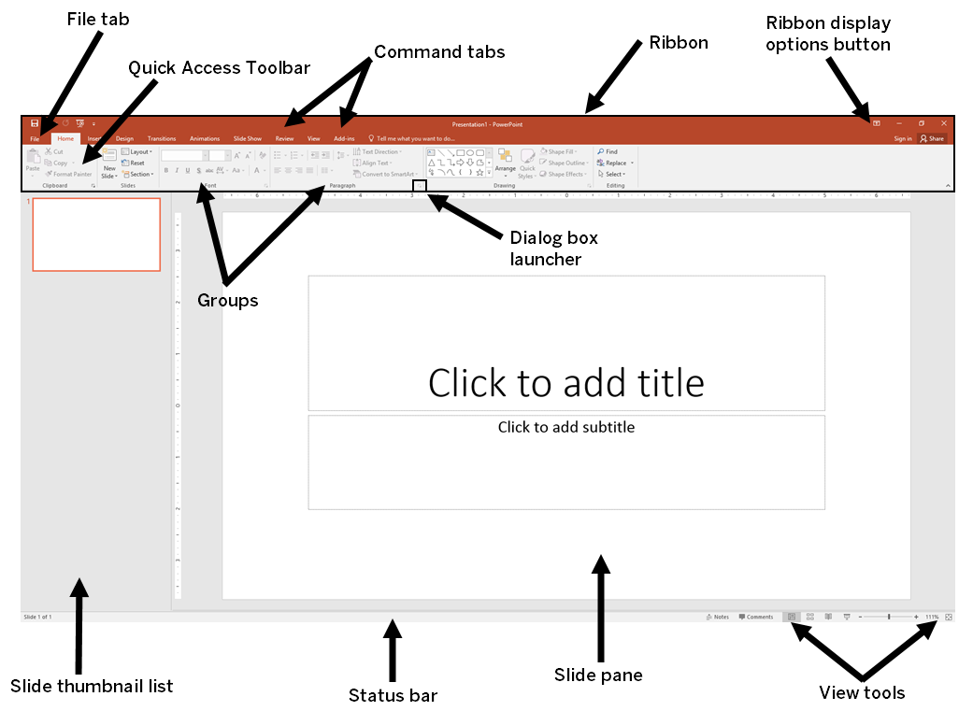

2. Slide Management for Visual Consistency
Achieving a professional presentation relies heavily on maintaining visual consistency, which is controlled efficiently through specific management features. Using Slide Layouts ensures content placeholders are structured correctly for effective organization. Critically, the Slide Master, accessed via the View tab, controls the default design elements fonts, colors, and logos for the entire presentation. By modifying the Master slide, designers guarantee immediate and effortless adherence to branding guidelines across all slides.

Implementation Steps (Editing the Slide Master):
  - Go to the View Tab and click the Slide Master button.
  - Select the largest top slide in the left-hand pane to apply global changes.
  - Make necessary modifications (e.g., inserting a corporate logo or setting the title font).
  - Return to the dedicated Slide Master Tab and click Close Master View.
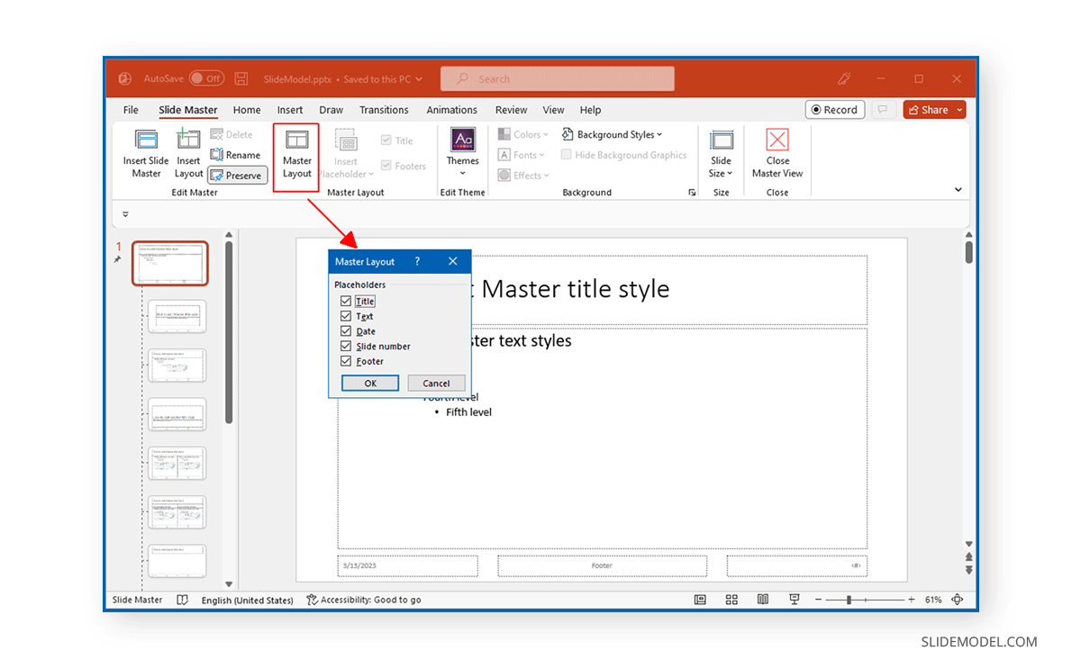

3. Multimedia Integration and Data Visualization
The Insert tab acts as the gateway for transforming simple text into a rich visual narrative by supporting diverse media. PowerPoint excels at data visualization, allowing users to insert professional Charts and Graphs that are dynamically linked to an underlying Excel sheet for easy data updates. Furthermore, the seamless embedding of local or online Video and Audio files adds dynamic quality, with dedicated Playback options available for configuration.

Implementation Steps (Inserting and Linking a Chart):
  - Go to the Insert Tab and click Chart.
  - Select the desired graph type (e.g., Column).
  - Replace the sample data in the automatically opened, linked Excel sheet with the project's data; the chart updates in real-time.

Implementation Steps (Configuring Video Playback):
  - Insert the video file via the Insert Tab.
  - With the video selected, go to the context-sensitive Playback Tab.
  - Set the video to start automatically or On Click as required.
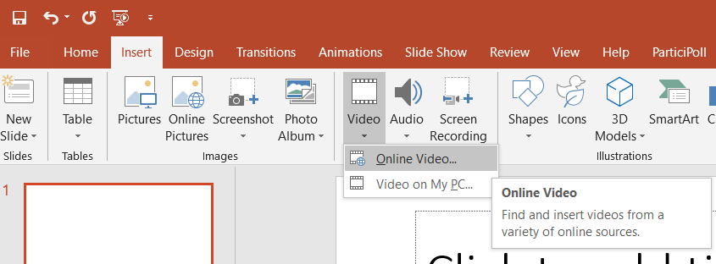
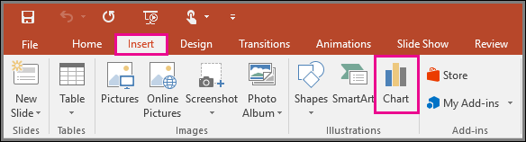

4. Enhancements: Themes, SmartArt, and Movement
Visual appeal and logical structure are enhanced through specialized design tools. Themes (in the Design Tab) provide instant, pre-packaged aesthetic upgrades. SmartArt Graphics allow users to convert simple text into professional, schematic diagrams (like process flows or hierarchies), improving comprehension. For controlled movement, Animations are applied to individual objects on a slide, managing their appearance, while Transitions manage the visual flow between slides.

Implementation Steps (Converting Text to SmartArt):
  - Select the text box containing the bulleted list.
  - On the Home Tab, click the Convert to SmartArt Graphic button.
  - Choose the visual layout that best represents the relationship (e.g., Hierarchy or Process).

Implementation Steps (Applying an Animation):
  - Select the specific object (e.g., an image).
  - Go to the Animations Tab and select an effect (e.g., Wipe).
  - Use the Animation Pane to precisely adjust the timing and order of the effect
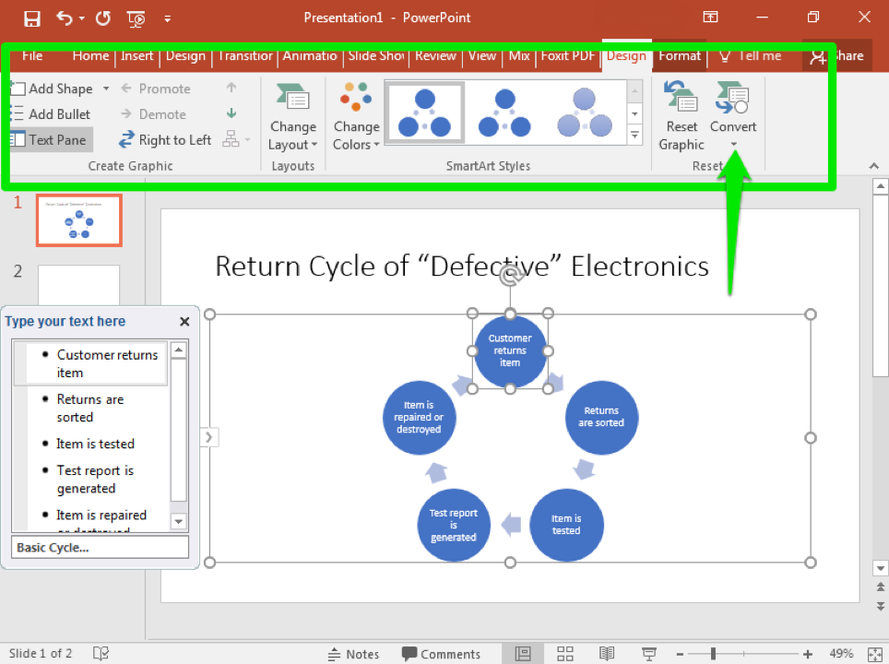
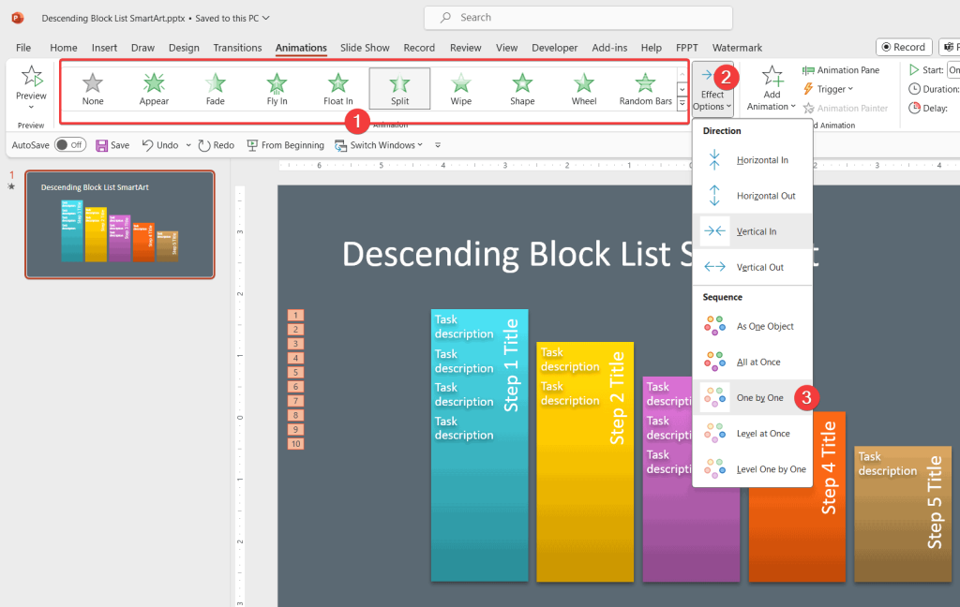

5. Presenter Tools for Confident Delivery
Effective presentation delivery relies on separating the audience's view from the speaker's private controls. The Notes Pane allows the speaker to write Speaker Notes, which are visible only when utilizing Presenter View. This vital feature provides the presenter with a private dashboard showing the current slide, the next slide, the essential notes, and a running clock, ensuring a smooth and well-timed delivery. The Rehearse Timings tool further aids professionalism by recording the time spent on each slide, optimizing pacing.

Implementation Steps (Using Presenter View):
  - Add detailed talking points to the Notes Pane beneath the slide.
  - Go to the Slide Show Tab and ensure the Use Presenter View checkbox is selected.
  - Start the presentation (F5); the presenter view will launch on the secondary screen.
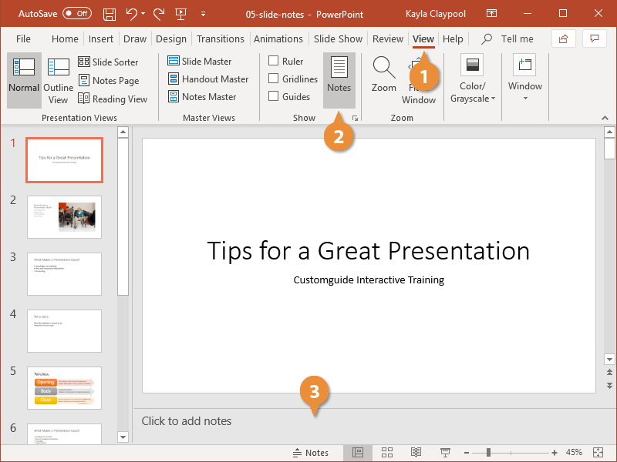

6. Collaboration and Versatile Sharing
Modern PowerPoint integrates seamlessly with cloud platforms to enable teamwork and versatile distribution. By saving files to OneDrive or SharePoint, users activate real-time co-authoring, allowing multiple team members to edit simultaneously via the Share button. Furthermore, files can be exported efficiently as non-editable PDFs or as high-quality Video files, which are ideal for digital training and online sharing.

Implementation Steps (Exporting as Video):
  - Go to the File Tab and select Export.
  - Choose Create a Video.
  - Select the desired quality (e.g., Full HD) and click Create Video to save the resulting MP4 file.
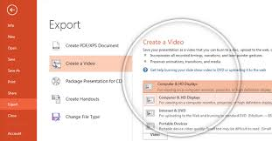

Conclusion:
This study confirms that Microsoft PowerPoint (PPT) is a vital and necessary tool in all modern communication. We looked closely at its main features, proving it is much more than just a simple program for making slides.
The research showed how essential tools like the Slide Master help keep designs consistent and how the program easily handles videos, charts, and images. We also learned that using PPT effectively requires following simple design rules and using presenter tools like Presenter View for confident speaking.
In summary, PowerPoint is the clear leader for visual communication. Knowing how to use it well—from creating clear charts to sharing files online—is a key skill in today's world. This project confirms that PPT is an indispensable part of the modern ICT toolkit, preparing users for success in any academic or professional field.

Reference and bibliographic:
- Microsoft Corporation. (2025). Microsoft PowerPoint Overview and Features. Retrieved from: https://www.microsoft.com/en-us/microsoft-365/powerpoint
- Microsoft Corporation. (2025). Use Presenter View. Microsoft Support. Retrieved from: [https://support.microsoft.com/en-us/office/research-a-topic-with-powerpoint-quickstarter-4784f273-0b2c-456c-9c89-24e5b977c224]
- Naegle, K. M. (2021). Ten simple rules for effective presentation slides. PLOS Computational Biology. Retrieved from: [Ten simple rules for effective presentation slides]
- Alley, M., et al. (2006). How the Design of Headlines in Presentation Slides Affects Audience Retention. Technical Communication, 53(4). Retrieved from: [how to design headlines in PowerPoint]

