Report:

(i) Briefly describe the task

* The task was to use the Fashion MNIST dataset and tryout at least three different types of CNN architectures and compare and contrast between them.

(ii) Describe or Draw the CNN Architectures you tried:

* I tried three different types of Architectures. The block diagram of each of them is shown below.

**Model 1:**

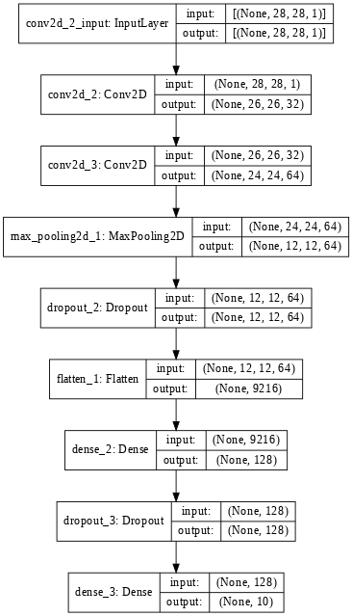

**Model 2:**

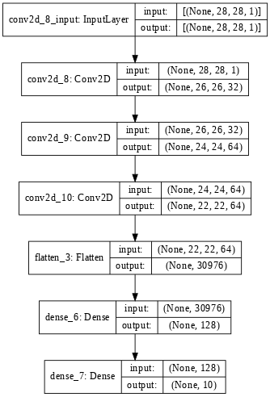

**Model 3:**

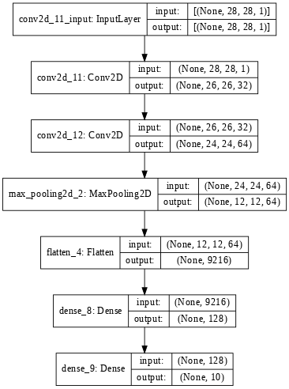

(iii) Show the accuracy results you got in a table or graph as well as report the training time.

|  |  |  |
| --- | --- | --- |
| **Model Number** | **Accuracy** | **Training Time** |
| Model 1 | 92.35% | 1442.9196 sec |
| Model 2 | 91.14% | 3155.1404 sec |
| Model 3 | 91.93% | 1370.6323 sec |

(iv) Comment on the relative performance of the methods.

* The best performing model was the one which Convolution Layer, Max Pool layer and Dropout layer.
* Second best was the model which had Convolution layer and Max Pooling layer but no Dropout layer.
* The worst model was the one which had only Convolutional Layers in it.

(v) Error Analysis

* For the error analysis, I looked at the images misclassified by the best model and below are some of them. As you can see, due to the similarity in the size of the two trousers, the algorithm interpreted it as a shirt.

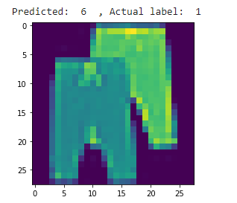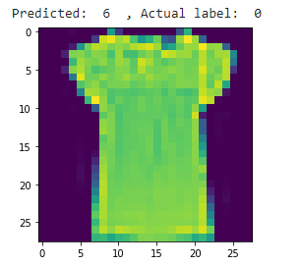

* In this image, algorithm classified it as a trouser whereas it is a top.

(vi) Conclusion:

* From this assignment, I conclude that for a model to perform better it needs to have all the three kinds of layers as it will help it not to overfit and perform the best at the same time.