HDS 5310

Analytics and Statistical Programming

**MATERNAL MORTALITY RATE IN THE UNITED STATES**

**05/8/2025**

Deena Rakshitha Borelli, Megan Johnson, Monyya Sree Kommineni, Matt Mueller

**Background information**

A mother's death is considered maternal mortality when it occurs during pregnancy or childbirth and a 42-day period following birth because pregnancy-related and potential management factors contribute to the death. Maternal mortality rate serves as an essential metric for population health because it shows both healthcare service quality and the influence of social factors and economic and cultural aspects.

The global reduction of maternal fatalities from the past decades shows remarkable progress yet the gap between nations regarding these numbers remains intense along with internal nation-wide differences. Information from the World Health Organization (WHO) shows that pregnancy-related causes killed 287,000 women worldwide during 2020. According to worldwide statistics, death rates from pregnancy-related causes amounted to 95% of all maternal deaths and these deaths primarily affected sub-Saharan Africa and Southern Asian regions and low- and middle-income countries.

Maternal mortality in the United States has undergone a rising trend thus making it an unusual case among wealthy nations since its mortality rate is increasing against international trends. The Centers for Disease Control and Prevention (CDC) show that maternal death rates among Black women stand at about three times higher than those of White women. Maternal deaths escalate because disadvantaged populations struggle to obtain satisfying healthcare services while dealing with chronic medical issues and face systematic racial discrimination and social health disparities including education level and financial instability. Many of these deaths might have been avoided, pointing to systemic flaws that need immediate fix (Petersen et al., 2019).

Caring for mothers facing mortality necessitates medical treatments and federal regulations combined with neighborhood-based population support. Detailed analysis and authoritative data collection determine the identification of vulnerable populations as well as the monitoring of trends for developing proven interventions to minimize avoidable maternal fatalities.

In addition to racial differences, geography is a significant factor. There is very little access to prenatal and obstetric healthcare in many rural areas that are categorized as "maternity care deserts". To facilitate a more informed conversation regarding maternal health disparities in the United States, our project will analyze county-level data, including birth and death data spanning several years, in order to find trends and contributing factors. The fundamental social and structural elements that lead to differences in maternal mortality outcomes—particularly across racial and ethnic gaps and urban-rural divides—are the focus of our research inquiry.

Our health data source for this project is the CDC WONDER online database. To calculate maternal mortality rates, we used two datasets. The first dataset was the Multiple Cause of Death dataset (2018-2025), which contains cause of death data for deaths in the U.S. We filtered this dataset to only include deaths falling under the definition of maternal mortality (pregnancy-related underlying cause of death occurring within 42 days of giving birth). This includes ICD-10 codes A34, O00-O95, O98, and O99. The second dataset was the Natality Expanded dataset (2016-2023), which contains annual birth count data. Merging these datasets allows us to compute the maternal mortality rate (MMR), which is defined as the number of maternal deaths per 100,000 births, for the years 2018-2023. This MMR value is the dependent variable in our analysis. Our independent variables are Race (race/ethnicity category), Urban (county-based urbanization classifications), and Year. We chose these independent variables because they allow us to investigate important Social Determinants of Health (SDOH) and their possible relationships with maternal mortality outcomes over time.

According to the CDC (2022), the identification of counties and demographic categories with high rates of maternal death can help guide specific public health initiatives, like increasing Medicaid coverage for postpartum care and funding maternal healthcare infrastructure in remote areas. Given that women of color are frequently disregarded or neglected by healthcare practitioners, healthcare systems can utilize our findings to create culturally sensitive treatments that enhance prenatal care and the birthing experience for these women (Taylor et al 2019).

To further ensure that the communities most at risk receive the assistance they require, public health groups and local governments can use this data to prioritize financing and distribute resources more fairly. Furthermore, by identifying regions that require more detailed data or longitudinal studies, this work establishes the groundwork for future scholarly investigations.

Our initiative adds to the expanding corpus of research on using evidence to drive change and minimize unnecessary maternal deaths by utilizing data science to address this pressing health equity issue.

**Methodology**

*Descriptive Statistics:*

For our continuous variables (MMR, Deaths, Births), we computed the mean, median, standard deviation, and the interquartile range as the descriptive statistics. For the categorical data (Year, Race, Urban), we computed the counts for each level and presented the results in a frequency table as shown in **Table 1**. Performing these descriptive statistics gives us an idea of the central tendency and dispersion of the data as well as how many observations of maternal mortality occur for each Race and Urban combination.

**Table 1: Descriptive Statistics for MMR**

| **Variable** | **Overall** |
| --- | --- |
| n | 78 |
| Year (%) |  |
| 2018 | 13 (16.7) |
| 2019 | 13 (16.7) |
| 2020 | 14 (17.9) |
| 2021 | 13 (16.7) |
| 2022 | 13 (16.7) |
| 2023 | 12 (15.4) |
| Race (%) |  |
| Asian | 7 ( 9.0) |
| Black or African American | 35 (44.9) |
| White | 36 (46.2) |
| Urban (%) |  |
| Large Central Metro | 16 (20.5) |
| Large Fringe Metro | 15 (19.2) |
| Medium Metro | 12 (15.4) |
| Small Metro | 12 (15.4) |
| Micropolitan (Nonmetro) | 12 (15.4) |
| NonCore (Nonmetro) | 11 (14.1) |
| Deaths (median [IQR]) | 53.50 [21.25, 90.00] |
| Births (median [IQR]) | 166894.50 [78935.50, 265669.75] |
| MMR (median [IQR]) | 29.48 [16.39, 48.19] |

*Data Visualization:*

To visualize the distribution of the MMR variable, we used a histogram as shown in Figure 1. The histogram appears right-skewed, so it is clearly not normally-distributed. To visualize the difference of MMR between Race categories, we used a box plot provided in Figure 2. The box plot by Race shows MMR is higher in Black mothers than it is for Asian or White mothers. The difference is notable, as the IQR for Black/African American does not overlap with the IQRs of the other groups. We also used a box plot to show the difference in MMR between different urbanization classifications, presented in Figure 3, which shows that the median MMR increases as the groups become more rural. This trend suggests greater mortality in mothers who reside in less urban places, possibly due to being further from medical care. The scatter plot in Figure 4 again shows that MMR is higher in Black mothers which is true across all years present in the data.

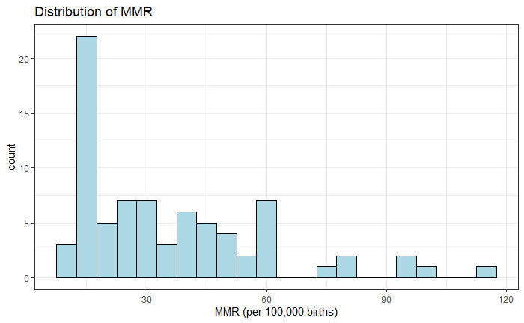

Figure 1: Distribution of Maternal Mortality Rate

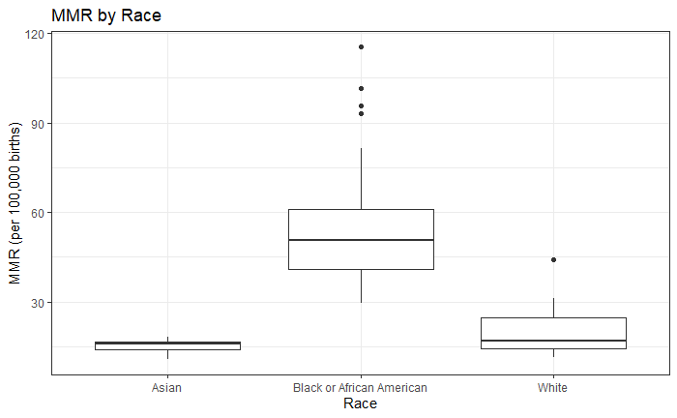

Figure 2: Maternal Mortality Rate by Race

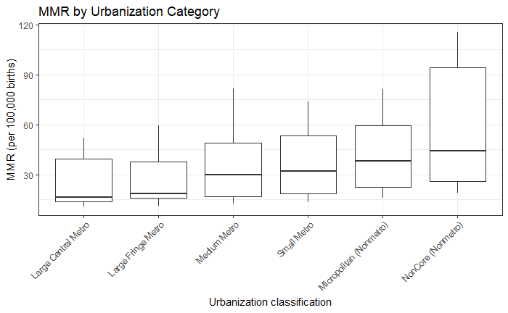

Figure 3: Maternal Mortality Rate by Urbanization Category

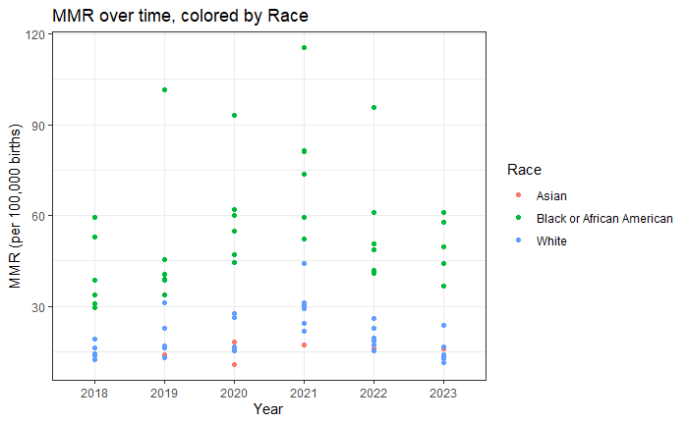

Figure 4: Maternal Mortality Rate by Year and colored by Race

*Data Management:*

Our data is from the CDC WONDER Database which includes Multiple Cause of Death data. The maternal deaths were extracted from this data by ICD-10 codes (A34, 000-095, 098, and 099). This data did not include birth counts per year, so we retrieved this data separately and merged the datasets together. This allowed us to calculate the Maternal Mortality Rate (MMR) which is the deaths per 100,000 births. To process this data for analysis, we converted the categorical variables Year, Race, and Urbanization to factors. We also calculated the median and IQR for the continuous variables to add to our dataframe, and created a table using the row names. Following these data management steps, we performed our statistical tests and post-hoc analysis.

*Statistical tests:*

For the ANOVA test to assess the Race variable, we checked the assumptions using the Shapiro-Wilk normality test and the Levene test. Both of these tests proved that the assumptions of normality and homogeneity of variance were violated, so we proceeded with a Kruskal-Wallis test. The Kruskal-Wallis test p-value of 8.452e-13 is much smaller than 0.05, so the null hypothesis that MMR distribution is the same across groups is rejected. We conclude that the median MMR is significantly different between at least two of the Race groups. Post-hoc analysis using a pairwise Wilcoxon rank sum test with Benjamini-Hochberg correction revealed that MMR differed significantly between Black and White (p=5.1e-12) and Black and Asian (p=5.7e-05) groups. However, MMR did not differ significantly between White and Asian groups (p=0.12).

We performed a second ANOVA test to assess the Urban variable, and the assumptions again were not met for the ANOVA test, so we proceeded with a Kruskal-Wallis test. The Kruskal-Wallis test p-value of 0.02313 is smaller than 0.05, so the null hypothesis that MMR distribution is the same across Urban groups is rejected. We conclude that the median MMR is significantly different between at least two of the Urban groups. Therefore, we concluded that the median MMR is significantly different between at least two of the Urban groups, and performed post-hoc analysis using the Wilcoxon rank sum test to assess which Urban groups were statistically significantly different. This test revealed that, although the Kruskal-Wallis test showed significance, pairwise comparisons between Urban groups are not significant.

To test if there are differences between Urban groups in terms of MMR, we used an Independent t-test. We first grouped the samples into Rural and Urban categories, with a frequency of 23 and 55, respectively. The t-test resulted in a p-value of 0.008708 which allows us to reject the null hypothesis and conclude that MMR does differ between urban and rural areas. To measure the effect size for this significant result, we calculated Cohen’s d which was 0.86 suggesting a large effect size (d > 0.8). In addition, the confidence interval does not include 0, suggesting that the effect is meaningful, and we can conclude that there is a large difference in MMR between urban and rural settings.

For the Chi-squared test, we examined the residuals to identify which cells are driving the association between Race and Urban categories. The p-value for the Chi-squared test is 0.2864, which is not significant. After checking the assumptions of the Chi-square test, multiple expected values are less than 5, so the Chi-squared assumptions are not met, and we proceeded with the alternative Fisher’s Exact Test. The result of the Fisher's Exact Test was not statistically significant (p=0.511). Therefore, the racial disparities in MMR are not explained by geographic distribution alone.

For our model, we chose to use a general linear model to predict our dependent variable because it is a continuous variable. This allows us to look at the combined effect of Urban and Race on MMR. After fitting the model, we got an R-squared value of 0.7679 which indicates that the model explains about 76.79% of the variance in MMR (p-value < 2.2e-16). We then performed an ANOVA test for the linear model. The ANOVA table for the linear model showed Urban and Race were both significant predictors of MMR. Following this, we performed additional analysis using a base linear model with only the Urban variable along with a full model using Urban, Race, and their interaction. Both the linearity and homoscedasticity assumptions were met for the model, but the residuals were not normally distributed as shown in Figure 5 which violates the assumption for linear regression. After adding the interaction terms and comparing the base linear model with the full linear model, it was found that the interaction model is highly significant (p< 2.2e-16). This shows that the interaction explains more variance in MMR than Urban does on its own, and the relationship between location and MMR differs across race groups. However, the normality assumption for linear regression was violated, so we should be cautious about these conclusions.

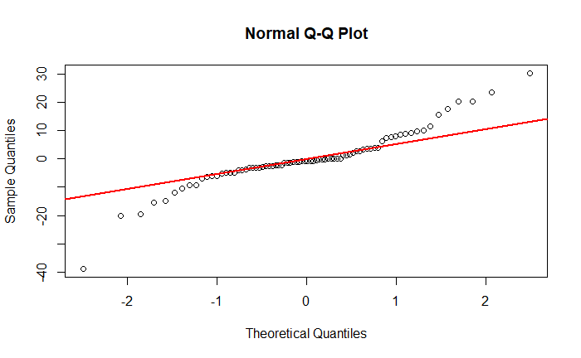

Figure 5: QQ-plot of the residuals for the linear model

**Results, Discussion, and Conclusion**

Our analysis revealed significant disparities in maternal mortality rates (MMR) across both racial and urbanization categories. The Kruskal–Wallis test for Race (p = 8.45 × 10⁻¹³) demonstrated that median MMR differs by racial group. Post-hoc Wilcoxon comparisons showed Black women experience significantly higher MMR than White (p = 5.1 × 10⁻¹²) and Asian women (p = 5.7 × 10⁻⁵), while White and Asian rates did not differ (p = 0.12). The Kruskal–Wallis test for Urbanization (p = 0.023) suggested overall differences, but pairwise tests among multiple urban–rural categories were not individually significant. However, grouping the categories into Rural vs. Urban and performing an independent t-test yielded p = 0.0087 and Cohen’s d = 0.86 indicating a large effect size. This indicated that the Rural group had significantly higher MMR than Urban.Our general linear model incorporating Race, Urbanization, and their interaction explained 76.8 % of MMR variance (R² = 0.7679, p < 2.2 × 10⁻¹⁶). Both the main effects and the interaction term were highly significant, underscoring that the impact of geography on maternal mortality varies by race.

These results carry important implications for public health policy. The effect of urbanization suggests systemic barriers to people within more rural areas, and the racial disparities affecting Black/African American mothers suggest a lower access to care and quality maternal services. These findings can help guide the expansion of Medicaid to postpartum coverage, increase the maternal healthcare system in rural areas, and tailoring the allocation of resources and research efforts to the most affected regions and demographics. This study highlights the maternal mortality inequities within the United States across race and geographic location, and highlights the importance of evidence-based policy changes and community-driven initiatives to improve the access to and the quality of medical care for pregnant and postpartum mothers. Following this, we can reduce or eliminate avoidable maternal mortality in these underserved communities.

**References**

Harris JK. *Statistics with R: Solving Problems Using Real-World Data.* Thousand Oaks, CA: SAGE; 2021.

Centers for Disease Control and Prevention (CDC). (2022). Maternal mortality rates in the United States, 2020. National Center for Health Statistics. https://www.cdc.gov/nchs/data/hestat/maternal-mortality/2020/maternal-mortality-rates-2020.htm

Hoyert, D. L. (2023). Maternal mortality rates in the United States, 2021. National Center for Health Statistics. https://www.cdc.gov/nchs/data/hestat/maternal-mortality/2021/maternal-mortality-rates-2021.htm

Petersen, E. E., Davis, N. L., Goodman, D., et al. (2019). Vital signs: Pregnancy-related deaths—United States, 2011–2015, and strategies for prevention, 13 states, 2013–2017. Morbidity and Mortality Weekly Report, 68(18), 423–429. https://doi.org/10.15585/mmwr.mm6818e1

Taylor, J., Novoa, C., Hamm, K., & Phadke, S. (2019). Eliminating racial disparities in maternal and infant mortality. Center for American Progress. https://www.americanprogress.org/article/eliminating-racial-disparities-maternal-infant-mortality

**Appendix**

