#—————————– require(envimaR) # MANDANTORY: defining the root folder DO NOT change this line rootDIR = “C:/Users/jomue/edu/geoAI” source(file.path(envimaR::alternativeEnvi(root_folder = rootDIR),“src/geo_AI_setup.R”),echo = TRUE) #read data Koralle<-sf::st_read(“E:/Koralle/images/Coral_bleaching_10m_2022.shp”) Koralle Coral_ras = raster::stack(“E:/Koralle/images/Coral_2018.tif”) Coral_ras names(Coral_ras)<-c(“red”,“green”,“blue”) Coral_ras<-subset(Coral_ras,c(“red”,“green”,“blue”)) Koralle = sf::st_transform(Koralle, crs(Coral_ras)) Koralle<-Koralle[,c(2:6)]

Coral_extent <- raster::extent(Coral_ras) Koralle <- sf::st_crop(Koralle, Coral_extent) Koralle # rasterize the coral rasterized_vector <- raster::rasterize(Koralle, Coral_ras[[1]])

# reclassify to 0 and 1

rasterized_vector[is.na(rasterized_vector[2:4])] <- 1 rasterized_vector[is.na(rasterized_vector[1,3,4])] <- 2 rasterized_vector[is.na(rasterized_vector[1,2,4])] <- 3 rasterized_vector[is.na(rasterized_vector[1:3])] <- 4 #save raster::writeRaster(rasterized_vector, (“E:/Koralle/images/Coral_Mask_2018_bleaching.tif”), overwrite = T) # divide to training and testing extent e_test <- raster::extent(3e+05, 7390240, 409800, 74300000) e_train <- raster::extent(3e+05, 74300000, 409800, 7500040)

coral_mask_train <- raster::crop(rasterized_vector, e_train) coral_dop_train <- raster::crop(Coral_ras, e_train)

coral_mask_test <- raster::crop(rasterized_vector, e_test) coral_dop_test <- raster::crop(Coral_ras, e_test)

raster::writeRaster( coral_mask_test, (“E:/Koralle/images/Coral_Mask_bleaching_2018_test.tif”), overwrite = T )

raster::writeRaster( coral_dop_test, (“E:/Koralle/images/Coral_Dop_bleaching_2018_test.tif”), overwrite = T )

raster::writeRaster( coral_mask_train, (“E:/Koralle/images/Coral_Mask_bleaching_2018_train.tif”), overwrite = T )

raster::writeRaster( coral_dop_train, (“E:/Koralle/images/Coral_Dop_bleaching_2018_train.tif”), overwrite = T )

subset_ds <- function(input_raster, model_input_shape, path, targetname = ““, mask = FALSE) { # determine next number of quadrats in x and y direction, by simple rounding targetsizeX <- model_input_shape[1] targetsizeY <- model_input_shape[2] inputX <- ncol(input_raster) inputY <- nrow(input_raster) # determine dimensions of raster so that # it can be split by whole number of subsets (by shrinking it) while (inputX %% targetsizeX != 0) { inputX = inputX - 1 } while (inputY %% targetsizeY != 0) { inputY = inputY - 1 } # determine difference diffX <- ncol(input_raster) - inputX diffY <- nrow(input_raster) - inputY # determine new dimensions of raster and crop, # cutting evenly on all sides if possible newXmin <- floor(diffX / 2) newXmax <- ncol(input_raster) - ceiling(diffX / 2) - 1 newYmin <- floor(diffY / 2) newYmax <- nrow(input_raster) - ceiling(diffY / 2) - 1 rst_cropped <- suppressMessages(raster::crop( input_raster, raster::extent(input_raster, newYmin, newYmax, newXmin, newXmax) )) agg <- suppressMessages(raster::aggregate(rst_cropped[[1]], c(targetsizeX, targetsizeY))) agg[] <- suppressMessages(1:ncell(agg)) agg_poly <- suppressMessages(raster::rasterToPolygons(agg)) names(agg_poly) <-”polis” if (mask) { lapply( seq_along(agg), FUN = function(i) { subs <- local({ e1 <- raster::extent(agg_poly[agg_poly$polis == i,]) subs <- suppressMessages(raster::crop(rst_cropped, e1)) }) writePNG(as.array(subs), target = paste0(path, targetname, i, ".png")) } ) } else{ lapply( seq_along(agg), FUN = function(i) { subs <- local({ e1 <- raster::extent(agg_poly[agg_poly$polis == i,]) subs <- suppressMessages(raster::crop(rst_cropped, e1)) # rescale to 0-1, for png export if (mask == FALSE) { subs <- suppressMessages((subs - cellStats(subs, “min”)) / (cellStats(subs, “max”) - cellStats(subs, “min”))) } }) writePNG(as.array(subs), target = paste0(path, targetname, i, “.png”)) } ) } rm(subs, agg, agg_poly) gc() return(rst_cropped) } remove_files <- function(df) { lapply( seq(1, nrow(df)), FUN = function(i) { local({ fil = df$list_masks[i] png = readPNG(fil) len = length(png) if (AllEqual(png)) { file.remove(df$list_dops[i]) file.remove(df$list_masks[i]) } else { } }) } ) }

# read training data

coral_mask_train <- raster::stack(“E:/Koralle/images/Coral_Mask_bleaching_2018_train.tif”) coral_dop_train <- raster::stack(“E:/Koralle/images/Coral_Dop_bleaching_2018_train.tif”) # set the size of each image model_input_shape = c(128, 128)

subset_ds( input_raster = coral_mask_train, path = “E:/Koralle/images/Cor_bleaching_2018/”, mask = TRUE, model_input_shape = model_input_shape )

subset_ds( input_raster = coral_dop_train, path = “E:/Koralle/images/Dop_bleaching_2018/”, mask = FALSE, model_input_shape = model_input_shape )

# list all created files in both folders

list_dops <- list.files(“E:/Koralle/images/Dop_bleaching_2018/”, full.names = TRUE, pattern = “*.png”) list_masks <- list.files(”E:/Koralle/images/Cor_bleaching_2018/”, full.names = TRUE, pattern = ”*.png”)

# create a data fram

df = data.frame(list_dops, list_masks)

remove_files(df)

# list the files again

files <- data.frame( img = list.files( file.path(“E:/Koralle/images/Dop_bleaching_2018/”), full.names = TRUE, pattern = “*.png” ), mask = list.files( file.path(”E:/Koralle/images/Cor_bleaching_2018/”), full.names = TRUE, pattern = ”*.png” ) ) # split randomly into training and validation (not testing!!) data sets set.seed(7) data <- initial_split(files, prop = 0.8)

# function to prepare your data set for all further processes

prepare_ds <- function(files = NULL, train, predict = FALSE, subsets_path = NULL, model_input_shape = c(256, 256), batch_size = batch_size, visual = FALSE) { if (!predict) { # function for random change of saturation,brightness and hue, # will be used as part of the augmentation spectral_augmentation <- function(img) { img <- tf $image$ random_brightness(img, max_delta = 0.1) img <- tf $image$ random_contrast(img, lower = 0.9, upper = 1.1) img <- tf $image$ random_saturation(img, lower = 0.9, upper = 1.1) # make sure we still are between 0 and 1 img <- tf$clip_by_value(img, 0, 1) } # create a tf_dataset from the input data.frame # right now still containing only paths to images dataset <- tensor_slices_dataset(files) # use dataset_map to apply function on each record of the dataset # (each record being a list with two items: img and mask), the # function is list_modify, which modifies the list items # 'img' and 'mask' by using the results of applying decode_png on the img and the mask # -> i.e. pngs are loaded and placed where the paths to the files were (for each record in dataset) dataset <- dataset_map(dataset, function(.x) list_modify( .x, img = tf$image $decode_{p}ng$ io $read_{f}ile$ img)), mask = tf $image$ decode_png(tf $io$ read_file(.x$mask)) )) # convert to float32: # for each record in dataset, both its list items are modified # by the result of applying convert_image_dtype to them dataset <- dataset_map(dataset, function(.x) list_modify( .x, img = tf$image $convert_{i}mage_{d}type$ img, dtype = tf $float32,mask=tf$ image $convert_{i}mage_{d}type$ mask, dtype = tf$float32) )) # data augmentation performed on training set only if (train) { # augmentation 1: flip left right, including random change of # saturation, brightness and contrast # for each record in dataset, only the img item is modified by the result # of applying spectral_augmentation to it augmentation <- dataset_map(dataset, function(.x) list_modify(.x, img = spectral_augmentation(.x$img))) #…as opposed to this, flipping is applied to img and mask of each record augmentation <- dataset_map(augmentation, function(.x) list_modify( .x, img = tf $image$ flip_left_right(.x $img,mask=tf$ image $flip_{l}eft_{r}ight$ mask) )) dataset_augmented <- dataset_concatenate(augmentation, dataset) # augmentation 2: flip up down, # including random change of saturation, brightness and contrast augmentation <- dataset_map(dataset, function(.x) list_modify(.x, img = spectral_augmentation(.x $imgaugmentation<−dataset_{m}ap$ image $flip_{u}p_{d}own$ img), mask = tf $image$ flip_up_down(.x$mask) )) dataset_augmented <- dataset_concatenate(augmentation, dataset_augmented) # augmentation 3: flip left right AND up down, # including random change of saturation, brightness and contrast augmentation <- dataset_map(dataset, function(.x) list_modify(.x, img = spectral_augmentation(.x$img))) augmentation <- dataset_map(augmentation, function(.x) list_modify( .x, img = tf $image$ flip_left_right(.x $img,mask=tf$ image $flip_{l}eft_{r}ight$ mask) )) augmentation <- dataset_map(augmentation, function(.x) list_modify( .x, img = tf $image$ flip_up_down(.x $img,mask=tf$ image $flip_{u}p_{d}own$ mask) )) dataset_augmented <- dataset_concatenate(augmentation, dataset_augmented) } # shuffling on training set only # unsauber if (!visual) { if (train) { dataset <- dataset_shuffle(dataset_augmented, buffer_size = batch_size * 256) } # train in batches; batch size might need to be adapted depending on # available memory dataset <- dataset_batch(dataset, batch_size) } if (visual) { dataset <- dataset_augmented } # output needs to be unnamed dataset <- dataset_map(dataset, unname) } else{ # make sure subsets are read in in correct order # so that they can later be reassembled correctly # needs files to be named accordingly (only number) o <- order(as.numeric(tools::file_path_sans_ext(basename( list.files(subsets_path) )))) subset_list <- list.files(subsets_path, full.names = T)[o] dataset <- tensor_slices_dataset(subset_list) dataset <- dataset_map(dataset, function(.x) tf $image$ decode_png(tf $io$ read_file(.x))) dataset <- dataset_map(dataset, function(.x) tf $image$ convert_image_dtype(.x, dtype = tf$float32)) dataset <- dataset_batch(dataset, batch_size) dataset <- dataset_map(dataset, unname) } }

# one more parameter

batch_size = 8

# prepare data for training

training_dataset <- prepare_ds( training(data), train = TRUE, predict = FALSE, model_input_shape = model_input_shape, batch_size = batch_size )

# also prepare validation data

validation_dataset <- prepare_ds( testing(data), train = FALSE, predict = FALSE, model_input_shape = model_input_shape, batch_size = batch_size )

# we first get a all our training data

it <- as_iterator(training_dataset) it <- iterate(it) # head(it)

# we convert our data to an array and also subset our iterator e.g.

# with the 4th batch ([[4]]) of the images ([[1]])

im <-as.array(it[[4]][[1]]) # then we subset just take the first image out of our batch im <- im[1,,,] # and plot it plot(as.raster(im))

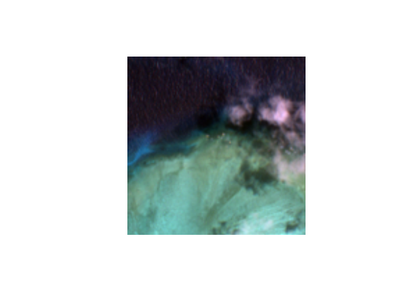

# and for the according mask it is almost the same

ma <-as.array(it[[4]][[2]]) ma <- ma[1,,,] plot(as.raster(ma))



#U-Net # function to build a U-Net # of course it is possible to change the input_shape get_unet_128 <- function(input_shape = c(128, 128, 3), num_classes = 1) { inputs <- layer_input(shape = input_shape) # 128 down1 <- inputs %>% layer_conv_2d(filters = 64, kernel_size = c(3, 3), padding = “same”) %>% layer_activation(“relu”) %>% layer_conv_2d(filters = 64, kernel_size = c(3, 3), padding = “same”) %>% layer_activation(“relu”) down1_pool <- down1 %>% layer_max_pooling_2d(pool_size = c(2, 2), strides = c(2, 2)) # 64 down2 <- down1_pool %>% layer_conv_2d(filters = 128, kernel_size = c(3, 3), padding = “same”) %>% layer_activation(“relu”) %>% layer_conv_2d(filters = 128, kernel_size = c(3, 3), padding = “same”) %>% layer_activation(“relu”) down2_pool <- down2 %>% layer_max_pooling_2d(pool_size = c(2, 2), strides = c(2, 2)) # 32 down3 <- down2_pool %>% layer_conv_2d(filters = 256, kernel_size = c(3, 3), padding = “same”) %>% layer_activation(“relu”) %>% layer_conv_2d(filters = 256, kernel_size = c(3, 3), padding = “same”) %>% layer_activation(“relu”) down3_pool <- down3 %>% layer_max_pooling_2d(pool_size = c(2, 2), strides = c(2, 2)) # 16 down4 <- down3_pool %>% layer_conv_2d(filters = 512, kernel_size = c(3, 3), padding = “same”) %>% layer_activation(“relu”) %>% layer_conv_2d(filters = 512, kernel_size = c(3, 3), padding = “same”) %>% layer_activation(“relu”) down4_pool <- down4 %>% layer_max_pooling_2d(pool_size = c(2, 2), strides = c(2, 2)) # # 8 center <- down4_pool %>% layer_conv_2d(filters = 1024, kernel_size = c(3, 3), padding = “same”) %>% layer_activation(“relu”) %>% layer_conv_2d(filters = 1024, kernel_size = c(3, 3), padding = “same”) %>% layer_activation(“relu”) # center up4 <- center %>% layer_upsampling_2d(size = c(2, 2)) %>% { layer_concatenate(inputs = list(down4, .), axis = 3) } %>% layer_conv_2d(filters = 512, kernel_size = c(3, 3), padding = “same”) %>% layer_activation(“relu”) %>% layer_conv_2d(filters = 512, kernel_size = c(3, 3), padding = “same”) %>% layer_activation(“relu”) %>% layer_conv_2d(filters = 512, kernel_size = c(3, 3), padding = “same”) %>% layer_activation(“relu”) # 16 up3 <- up4 %>% layer_upsampling_2d(size = c(2, 2)) %>% { layer_concatenate(inputs = list(down3, .), axis = 3) } %>% layer_conv_2d(filters = 256, kernel_size = c(3, 3), padding = “same”) %>% layer_activation(“relu”) %>% layer_conv_2d(filters = 256, kernel_size = c(3, 3), padding = “same”) %>% layer_activation(“relu”) %>% layer_conv_2d(filters = 256, kernel_size = c(3, 3), padding = “same”) %>% layer_activation(“relu”) # 32 up2 <- up3 %>% layer_upsampling_2d(size = c(2, 2)) %>% { layer_concatenate(inputs = list(down2, .), axis = 3) } %>% layer_conv_2d(filters = 128, kernel_size = c(3, 3), padding = “same”) %>% layer_activation(“relu”) %>% layer_conv_2d(filters = 128, kernel_size = c(3, 3), padding = “same”) %>% layer_activation(“relu”) %>% layer_conv_2d(filters = 128, kernel_size = c(3, 3), padding = “same”) %>% layer_activation(“relu”) # # 64 up1 <- up2 %>% layer_upsampling_2d(size = c(2, 2)) %>% { layer_concatenate(inputs = list(down1, .), axis = 3) } %>% layer_conv_2d(filters = 64, kernel_size = c(3, 3), padding = “same”) %>% layer_activation(“relu”) %>% layer_conv_2d(filters = 64, kernel_size = c(3, 3), padding = “same”) %>% layer_activation(“relu”) %>% layer_conv_2d(filters = 64, kernel_size = c(3, 3), padding = “same”) %>% layer_activation(“relu”) # 128 classify <- layer_conv_2d( up1, filters = num_classes, kernel_size = c(1, 1), activation = “sigmoid” ) model <- keras_model(inputs = inputs, outputs = classify) return(model) }

unet_model <- get_unet_128() # compile the model unet_model %>% compile( optimizer = optimizer_adam(learning_rate = 0.0001), loss = “binary_crossentropy”, metrics = “accuracy” )

# train the model

hist <- unet_model %>% fit( training_dataset, validation_data = validation_dataset, epochs = 10, verbose = 1 )

# 

# save the model

unet_model %>% save_model_hdf5(file.path(“E:/Koralle/images/models/”, “unet_corals_2018_bleaching.hdf5”),overwrite=T)

plot(hist)

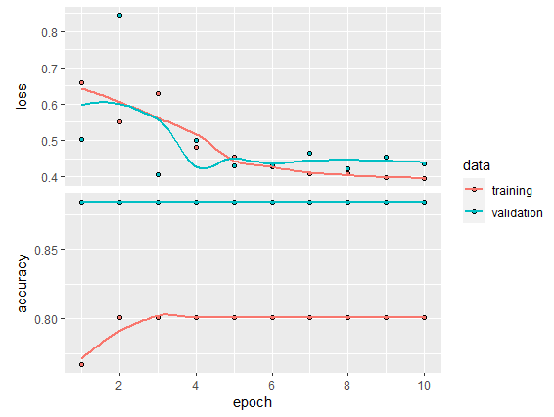

# load the test data

coral_mask_test <- stack(“E:/Koralle/images/Coral_Mask_bleaching_2018_test.tif”) coral_dop_test <- stack(“E:/Koralle/images/Coral_Dop_bleaching_2018_test.tif”) target_rst <- subset_ds( input_raster = coral_mask_test, path = “E:/Koralle/images/Cor_test_bleaching_2018/”, mask = TRUE, model_input_shape = model_input_shape ) subset_ds( input_raster = coral_dop_test, path = “E:/Koralle/images/Dop_test_bleaching_2018/”, mask = FALSE, model_input_shape = model_input_shape ) # write the target_rst to later rebuild your image writeRaster( target_rst, file.path(“E:/Koralle/images/models/model_test_2018_bleaching/”,“coral_mask_bleaching_2018_test_target.tif”), overwrite = T ) test_file <- data.frame( img = list.files( file.path(“E:/Koralle/images/Dop_test_bleaching_2018”), full.names = T, pattern = “*.png” ), mask = list.files( file.path(”E:/Koralle/images/Cor_test_bleaching_2018”), full.names = T, pattern = ”*.png” ) )

testing_dataset <- prepare_ds( test_file, train =FALSE, predict = FALSE, model_input_shape = model_input_shape, batch_size = batch_size ) # load a U-Net unet_model <- load_model_hdf5(file.path(“E:/Koralle/images/models/”, “unet_corals_2018_bleaching.hdf5”), compile = TRUE) # evaluate the model with test set ev <- unet_model$evaluate(testing_dataset)

# prepare data for prediction

prediction_dataset <- prepare_ds( predict = TRUE, subsets_path = paste0(file.path(“E:/Koralle/images/Dop_test_bleaching_2018/”)), model_input_shape = model_input_shape, batch_size = batch_size ) # get sample of data from testing data t_sample <- floor(runif(n = 5, min = 1, max = nrow(test_file))) # simple visual comparison of mask, image and prediction for (i in t_sample) { png_path <- test_file png_path <- png_path[i,] img <- image_read(png_path[, 1]) mask <- image_read(png_path[, 2]) pred <- image_read(as.raster(predict(object = unet_model, testing_dataset)[i, , ,])) out <- image_append(c( image_annotate( mask, “Mask”, size = 10, color = “black”, boxcolor = “white” ), image_annotate( img, “Original Image”, size = 10, color = “black”, boxcolor = “white” ), image_annotate( pred, “Prediction”, size = 10, color = “black”, boxcolor = “white” ) )) plot(out) }

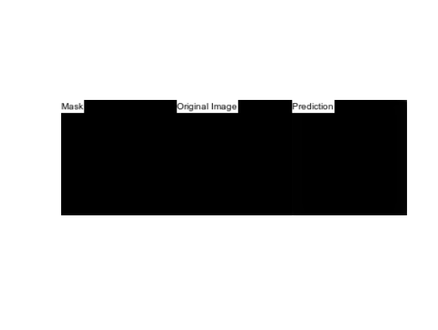

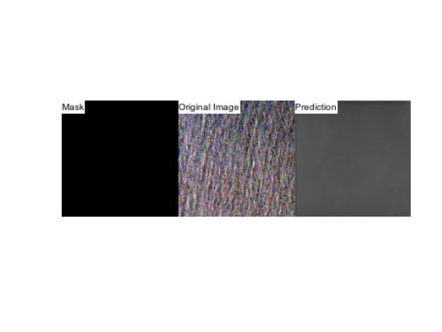

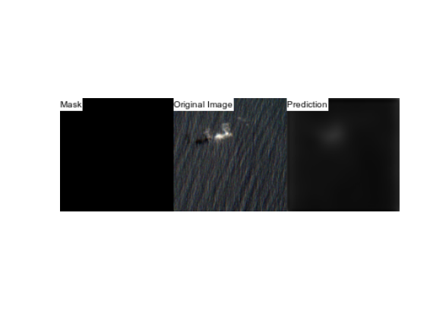

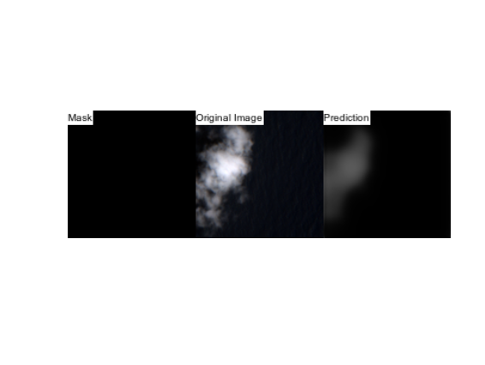

# function to rebuild your image rebuild_img <- function(pred_subsets, out_path, target_rst, model_name) { subset_pixels_x <- ncol(pred_subsets[1, , , ]) subset_pixels_y <- nrow(pred_subsets[1, , , ]) tiles_rows <- nrow(target_rst) / subset_pixels_y tiles_cols <- ncol(target_rst) / subset_pixels_x # load target image to determine dimensions target_stars <- st_as_stars(target_rst, proxy = F) #prepare subfolder for output result_folder <- paste0(out_path, model_name) if (dir.exists(result_folder)) { unlink(result_folder, recursive = T) } dir.create(path = result_folder) # for each tile, create a stars from corresponding predictions, # assign dimensions using original/target image, and save as tif: for (crow in 1:tiles_rows) { for (ccol in 1:tiles_cols) { i <- (crow - 1) * tiles_cols + (ccol - 1) + 1 dimx <- c(((ccol - 1) * subset_pixels_x + 1), (ccol * subset_pixels_x)) dimy <- c(((crow - 1) * subset_pixels_y + 1), (crow * subset_pixels_y)) cstars <- st_as_stars(t(pred_subsets[i, , , 1])) attr(cstars, “dimensions”)[[2]]$delta = -1 #set dimensions using original raster st_dimensions(cstars) <- st_dimensions(target_stars[, dimx[1]:dimx[2], dimy[1]:dimy[2]])[1:2] write_stars(cstars, dsn = paste0(result_folder, “/*out*”, i, “.tif”)) } } starstiles <- as.vector(list.files(result_folder, full.names = T), mode = “character”) sf::gdal_utils( util = “buildvrt”, source = starstiles, destination = paste0(result_folder, “/mosaic.vrt”) ) sf::gdal_utils( util = “warp”, source = paste0(result_folder, “/mosaic.vrt”), destination = paste0(result_folder, “/mosaic.tif”) ) } target_rst <- raster(file.path(“E:/Koralle/images/models/model_test_2018_bleaching/”,“coral_mask_bleaching_2018_test_target.tif”)) # make the actual prediction pred_subsets <- predict(object = unet_model, x = prediction_dataset) # name your output path model_name <- “unet_abc_bleaching_2018” # rebuild .tif from each patch rebuild_img( pred_subsets = pred_subsets, out_path = paste0(file.path(“E:/Koralle/images/prediction/”, “/”)), target_rst = target_rst, model_name = model_name )

image<-stack(“E:/Koralle/images/prediction/unet_abc_bleaching_2018/mosaic.tif”) plot(image)

