Name: Mufaddal Shiyaji

UID: 2021300122

**ADV EXP-2**

**Word Chart**

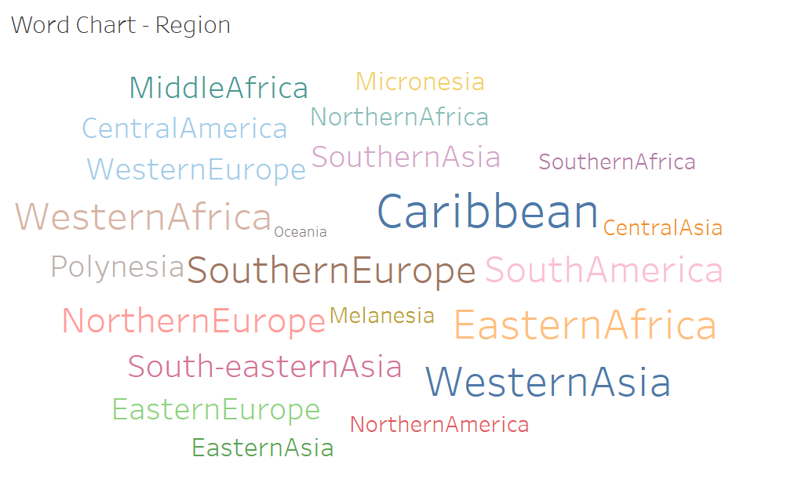

**Observation:**

Oceania and Melanesia are less frequent than most other regions such as Caribbean

**Box and Whisker Plot**

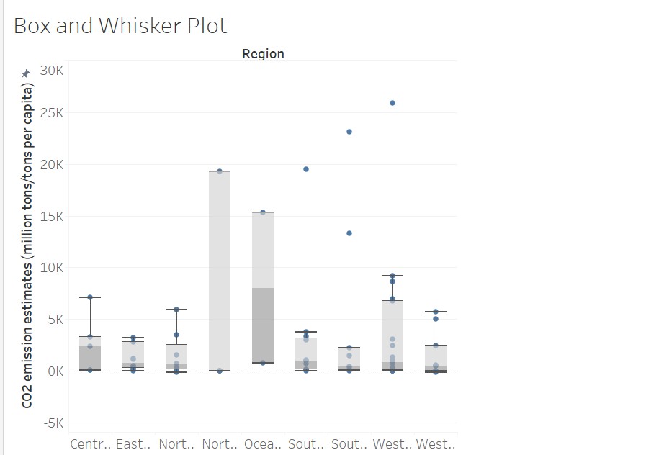

**Observations:**

Whisker Plot helps in specifying range and general metrics of the data. Here, the CO2 emission are highlighted, showing significant emissions in regions such as North America and Oceania.

**Violin Plot**

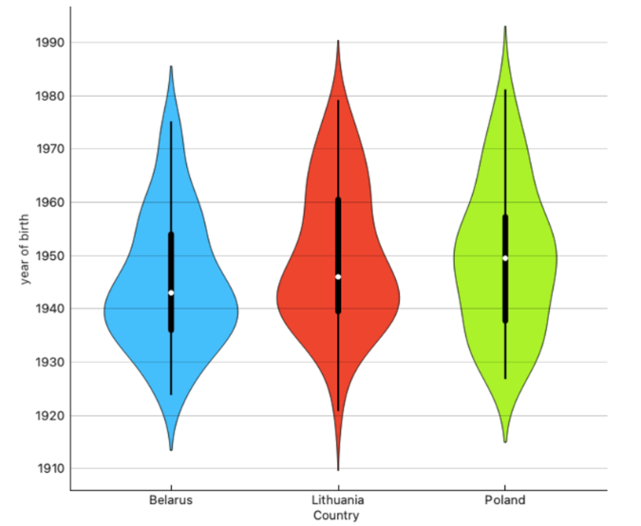

**Observations:**

Violin plots are an extension to box plots showing the density distribution through curves. From the analysis, we can infer that Belarus had a more concentrated and sharp curve tapering towards the end whereas Poland has a more symmetric distribution of life expectancy.

**Regression Plot – linear**

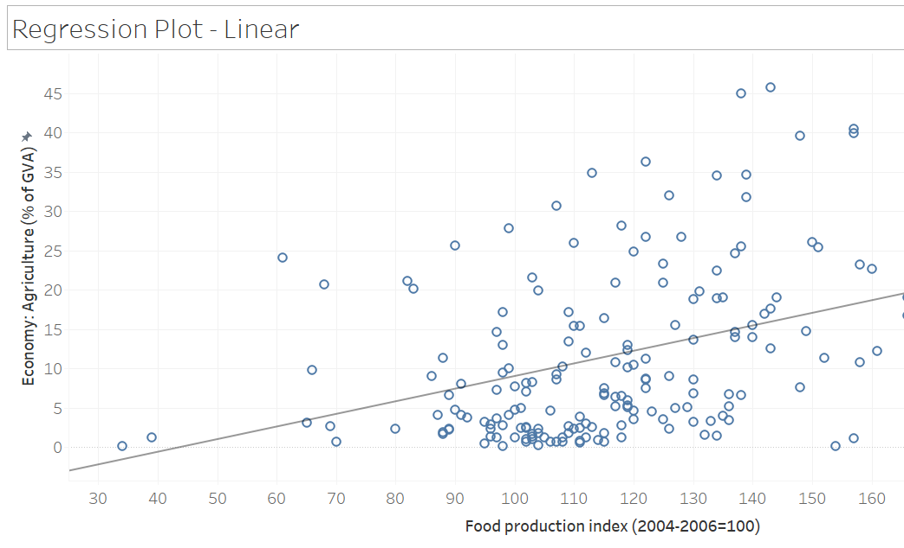

**Observation:**

The linear regression plot suggests a positive correlation between the Food Production Index and the percentage of the economy contributed by agriculture (as a percentage of GVA). As food production increases, the agricultural contribution to the economy also tends to increase.

**Regression Plot – Non Linear:**

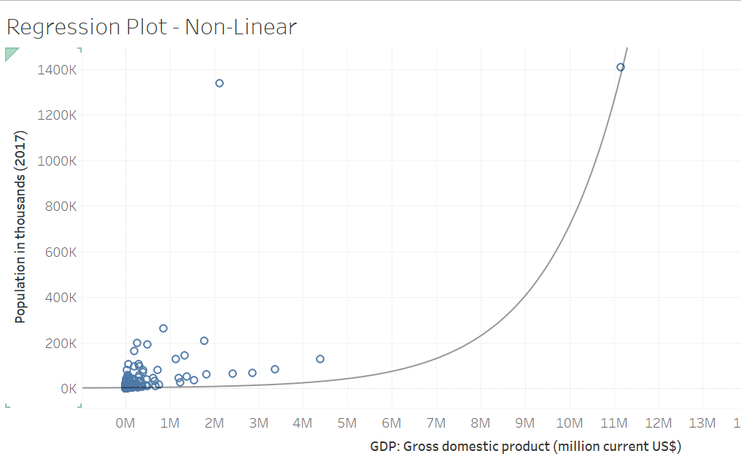

**Observation:**

The regression plot shows a non-linear relationship between population and GDP. As GDP increases, population growth accelerates at a faster rate, suggesting a strong positive correlation between the two variables.

**Jitter Plot:**

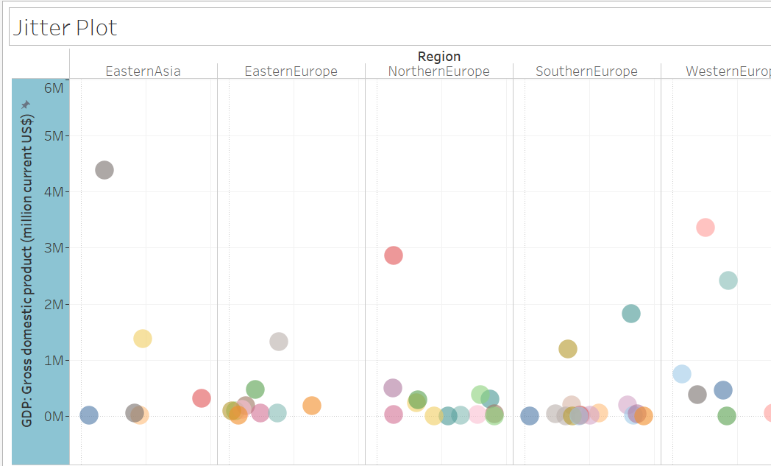

**Observation:**

The jitter plot reveals distinct GDP distributions across different regions. Eastern Asia and Western Europe appear to have higher GDPs compared to other regions. The overlap among regions indicates some variation within each region.

**Line Plot:**

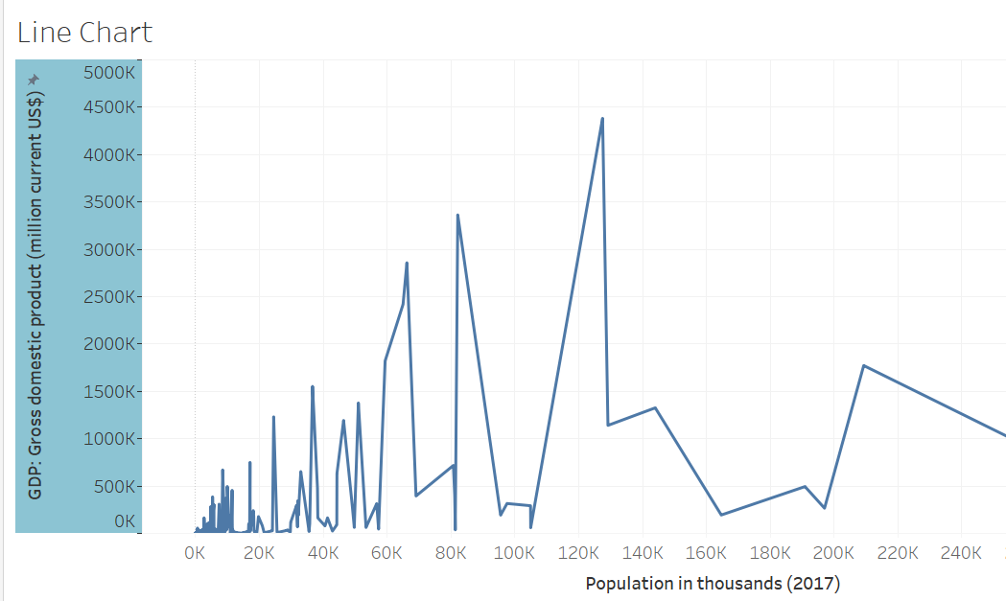

**Observation:**

The line chart illustrates a fluctuating relationship between GDP and population. As population increases, GDP experiences periods of growth and decline, suggesting a complex and dynamic correlation between the two variables.

**Area Plot:**

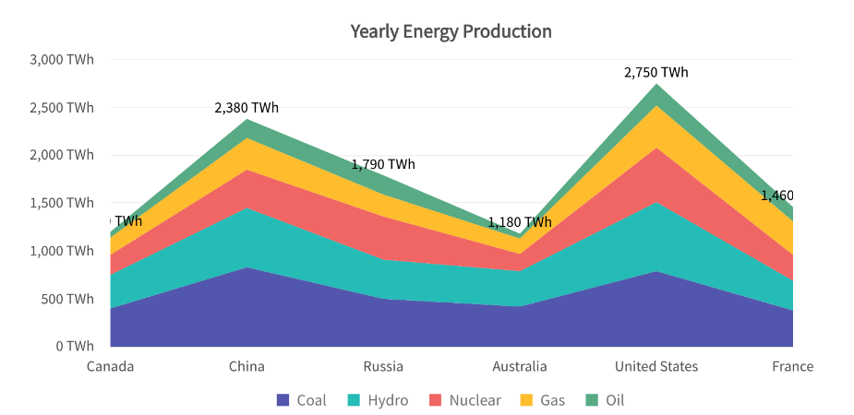

**Observation:**

The stacked area chart shows the yearly energy production of six countries across different energy sources. China and the United States dominate overall production, with a mix of sources. Russia relies heavily on oil and gas, while France primarily uses nuclear power.

**Waterfall:**

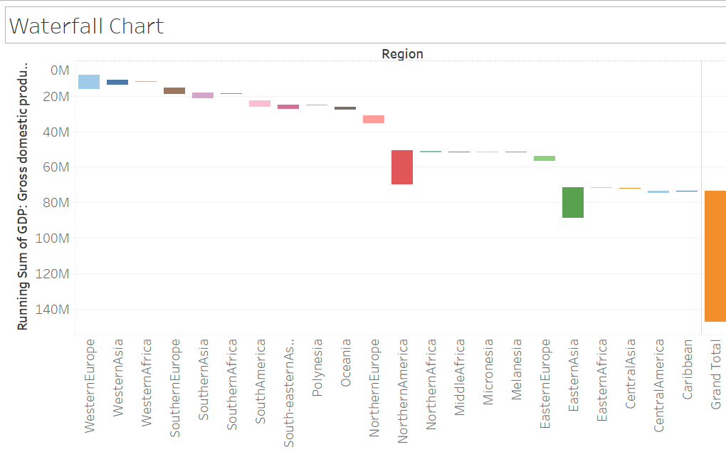

**Observations:**

The waterfall chart reveals the cumulative contribution of different regions to the grand total GDP. While Western Europe and North America contribute significantly, regions like Eastern Europe, Central America, and the Caribbean have negative contributions, potentially indicating trade deficits or economic challenges.

**\***3d charts are not supported in Tableau

**Donut:**

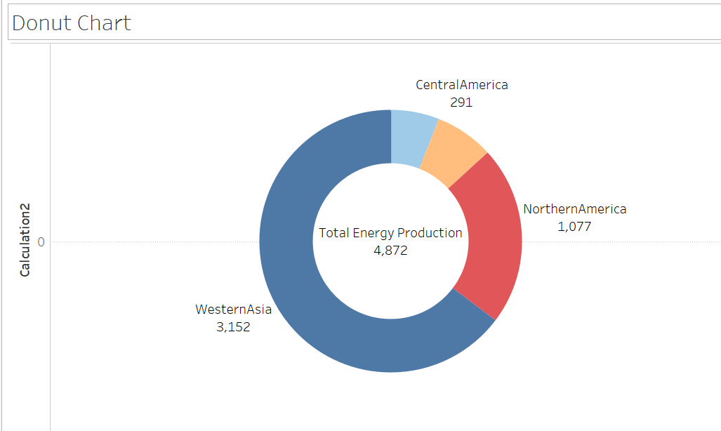

**Observations:**

The donut chart illustrates the distribution of total energy production across different regions. Western Asia dominates with the largest share, followed by Northern America. Central America has the smallest contribution.

**TreeMap:**

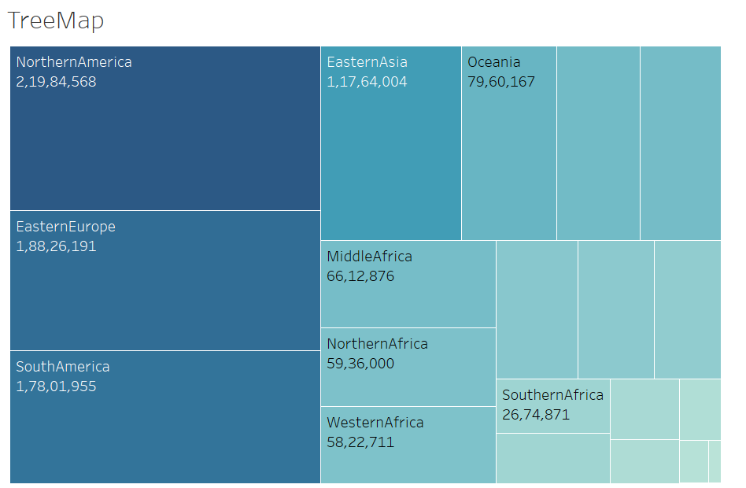

**Observations:**

The treemap visualizes the distribution of population across different regions. Northern America has the largest population, followed by Eastern Asia and Eastern Europe. Regions like Southern Africa and Middle Africa have relatively smaller populations.

**Funnel:**

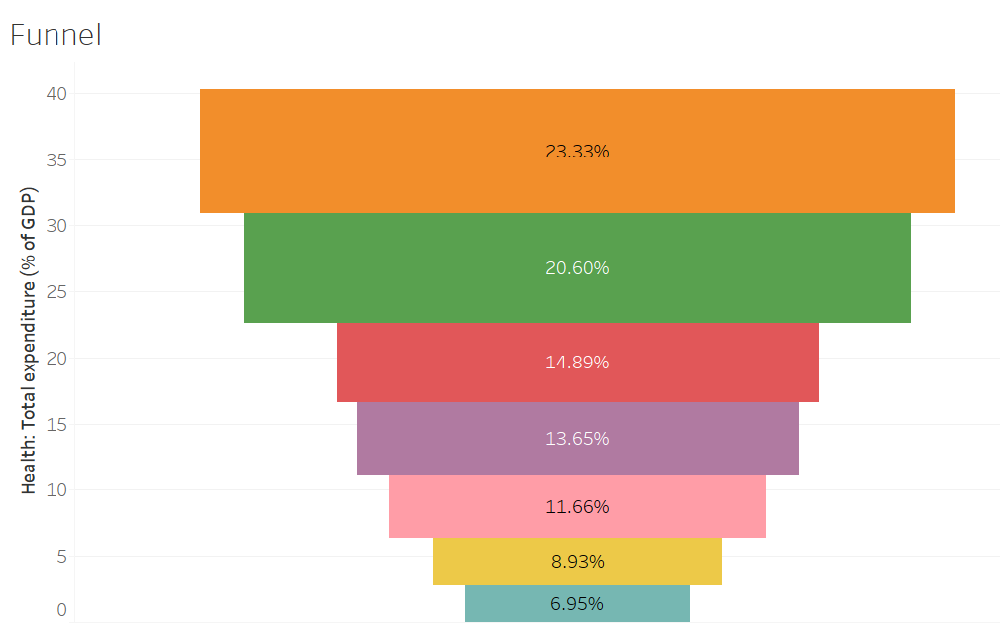

**Observations:**

The funnel chart illustrates the distribution of total health expenditure as a percentage of GDP across different categories. The largest percentage is allocated to the first category, with subsequent categories showing decreasing percentages, suggesting a potential drop-off in spending priorities.