Q.1 Plot class distribution for the chosen dataset(s). If you are working with different datasets, compare the distributions. Attach your plots and code snippets.

Initial screenshot of folder containing class wise image folder:

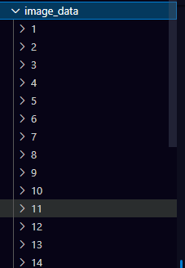

Code for creating a dictionary having count of each class with its respective name.

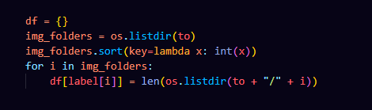

Sample output:

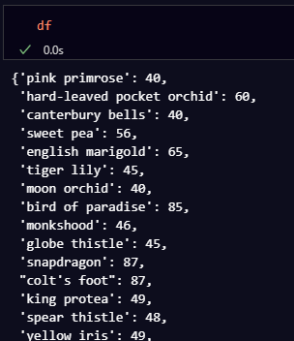

Code of category wise barplot:

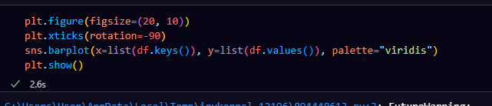

Class category bar plot:

