MINT
TECHNICAL AUDIT | ARCHITECTURE | CUTOVER RUNBOOK

Canonical returns and
rebalance evidence programme
From exact JSE closes to a certified public strategy ledger

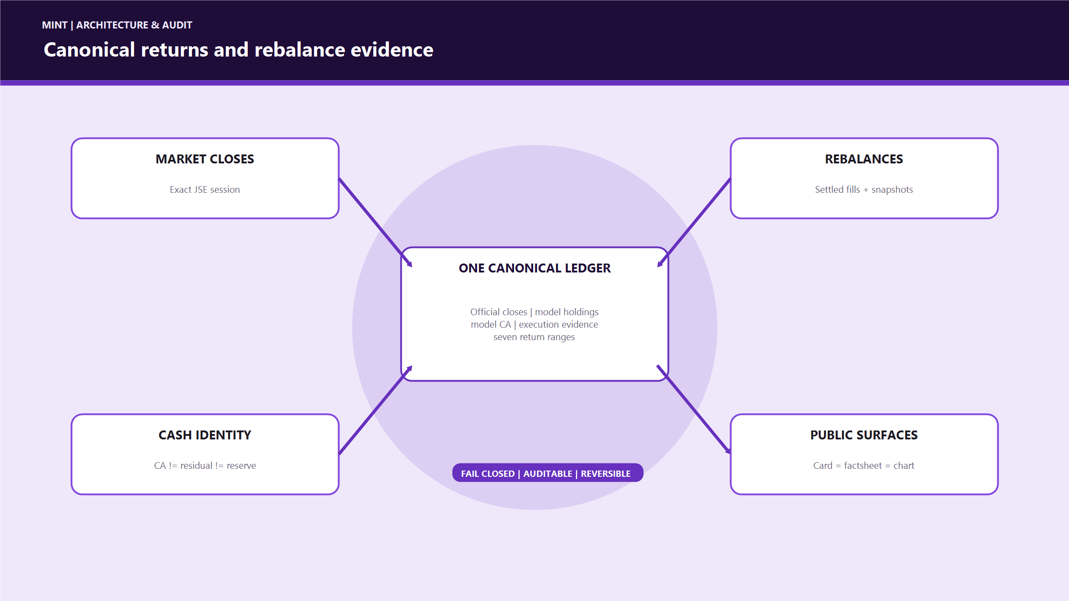
AS AT | 15 AUGUST 2026
SYSTEMS | WEALTH NAVIGATOR | RETAIL | INSTITUTIONAL | MINT LIVE

Contents
Contents 2
1. Executive answer: what happens after merge? 4
2. Why this programme was necessary 5
Before and after 5
3. Non-negotiable accounting identities 6
3.1 Strategy model value 6
3.2 Rebalance boundary identity 6
3.3 Three different cash concepts 6
4. Canonical return methodology 7
4.1 Per-leg P/L 7
4.2 Range/date mapping 7
5. System architecture 9
5.1 End-to-end data flow 9
5.2 Retail database ERD 9
5.3 Institutional-to-retail evidence chain 10
6. Table catalogue and ownership 10
Desired final state 11
7. Price correction and recurrence prevention 12
7.1 Historical correction performed 12
7.2 Rollback evidence 12
7.3 Unit and scale guard 13
7.4 Daily writer sequence 13
8. Rebalance-safe continuation 13
8.1 Required evidence 13
8.2 Boundary handling 14
8.3 Why this removes rebalance spikes 14
9. Current canonical ledger inventory 15
10. Strategy-specific reconstruction notes 16
MINT Famous Brands 16
ETF Basket 16
Yield Basket 17
Blended Focus 17
MyGrowthFund 17
MINT Diversified Basket and MINT Multi-sector 17
UCT 17
11. Source of Truth Ledger UI 17
12. Safeguards and failure behaviour 18
DRAFT replacement rule 18
13. Implemented scripts and operator controls 19
Important environment controls 19
14. Testing and verification evidence 20
Wealth Navigator 20
MINT Live 20
15. Deployment and cutover plan 21
Phase A — merge infrastructure 21
Phase B — promote one proven strategy 21
Phase C — public read migration 21
Phase D — resolve the other seven 21
Phase E — consolidation and cleanup 22
16. Rollback strategy 22
If PR #230 causes an EOD issue 22
If a historical close repair is questioned 22
If a public canonical cutover disagrees 22
17. AUM relationship 22
18. Known limitations and explicit non-claims 23
19. Developer runbook 23
Read-only family certification 23
Historical repair discipline 23
Acceptance checks after any ledger change 23
20. Commit and PR evidence 24
Wealth Navigator 24
MINT Live 24
21. Final definition of done 24
Present conclusion 24
22. Glossary 25

1. Executive answer: what happens after merge?
There are two separate pull requests and they do different jobs.
Repository / PR | Current status at 15 Aug 2026 | What the merge deploys | What it does not do
Wealth Navigator PR #96 (https://github.com/MINT-Developement/Wealth-Navigator/pull/96) | Already merged; Vercel passed | Canonical DRAFT ledger tooling, independent certification audit, Yahoo close repair and rollback tools, DRAFT replay, evidence-backed rebalance continuation, and the Source of Truth ledger UI | It does not promote DRAFT rows, replace public app values, or treat missing independent evidence as a pass
MINT Live PR #230 (https://github.com/MINT-Developement/MINT-LIVE/pull/230) | Open draft; mint and mint-dev Vercel checks passed | The recurrence fix: future EOD writes use an exact Yahoo daily market candle, normalize JSE units once, reject scale anomalies, and run later at 17:45 SAST | It does not rewrite all historical prices again, certify ledgers, or switch strategy cards/charts to the canonical table

After PR #230 is merged, the safe operational state is:
1. future eligible daily closes are written using the corrected EOD contract;
2. suspect or missing provider data is skipped and reported instead of being manufactured;
3. the canonical daily writer can continue each strategy's DRAFT ledger after exact closes exist;
4. the Source of Truth page can inspect those DRAFT ledgers;
5. public MINT cards, factsheets, and charts stay on the existing effective read path until a strategy is explicitly certified and cut over.
The merge is therefore safe by design: calculation and evidence infrastructure ships first; public publication remains a separate approval gate.
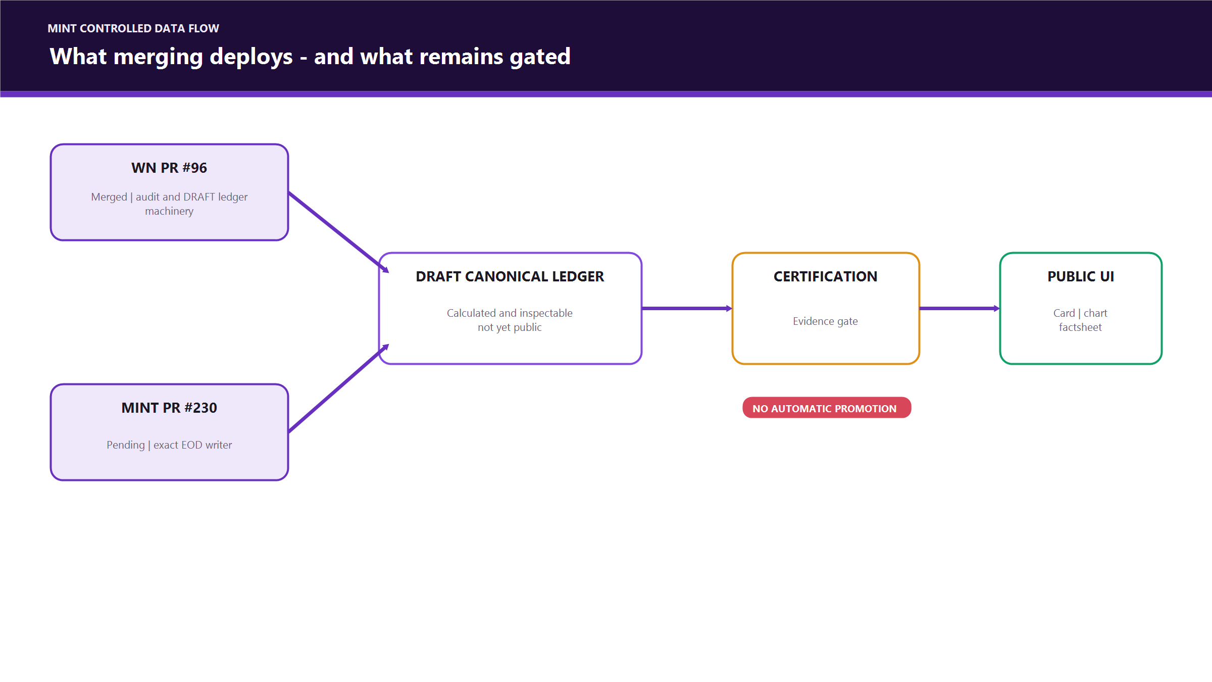
Figure 1 - Merge behaviour
________________________________________________________________________________

2. Why this programme was necessary
The old system had several individually reasonable calculations that did not share one immutable strategy history. This created four classes of risk:
Previous risk | Consequence | Correction
The EOD worker copied the latest intraday observation | A stored "close" could differ from the official closing candle | Fetch the exact market-date daily candle and reject missing dates
Some pages calculated directly from current basket value | A rebalance could look like a gain/loss spike because the composition changed | Maintain a leg-based, continuity-preserving strategy ledger
Legacy return seeds predated some strategies' true inception | YTD/SI could include time when the strategy did not exist | Start each canonical history at the actual strategy creation/inception date
Cash, residual proceeds, and the 8% reserve were easy to conflate | Capital could appear from nowhere or be counted twice | Store and reconcile model CA, owner residual, and execution reserve separately
Yahoo/JSE units were assumed rather than proven | A 100x price defect could enter the database | Normalize ZAc/ZAR exactly once and quarantine implausible provider ratios
Supabase reads silently capped at 1,000 rows | Later prices could appear stale even when they existed | Paginate all historical close and ledger reads
Missing rebalance execution evidence was bridged implicitly | A composition jump could be mistaken for performance | Fail closed unless settled batch, fills, snapshots, and CA reconciliation agree

Before and after
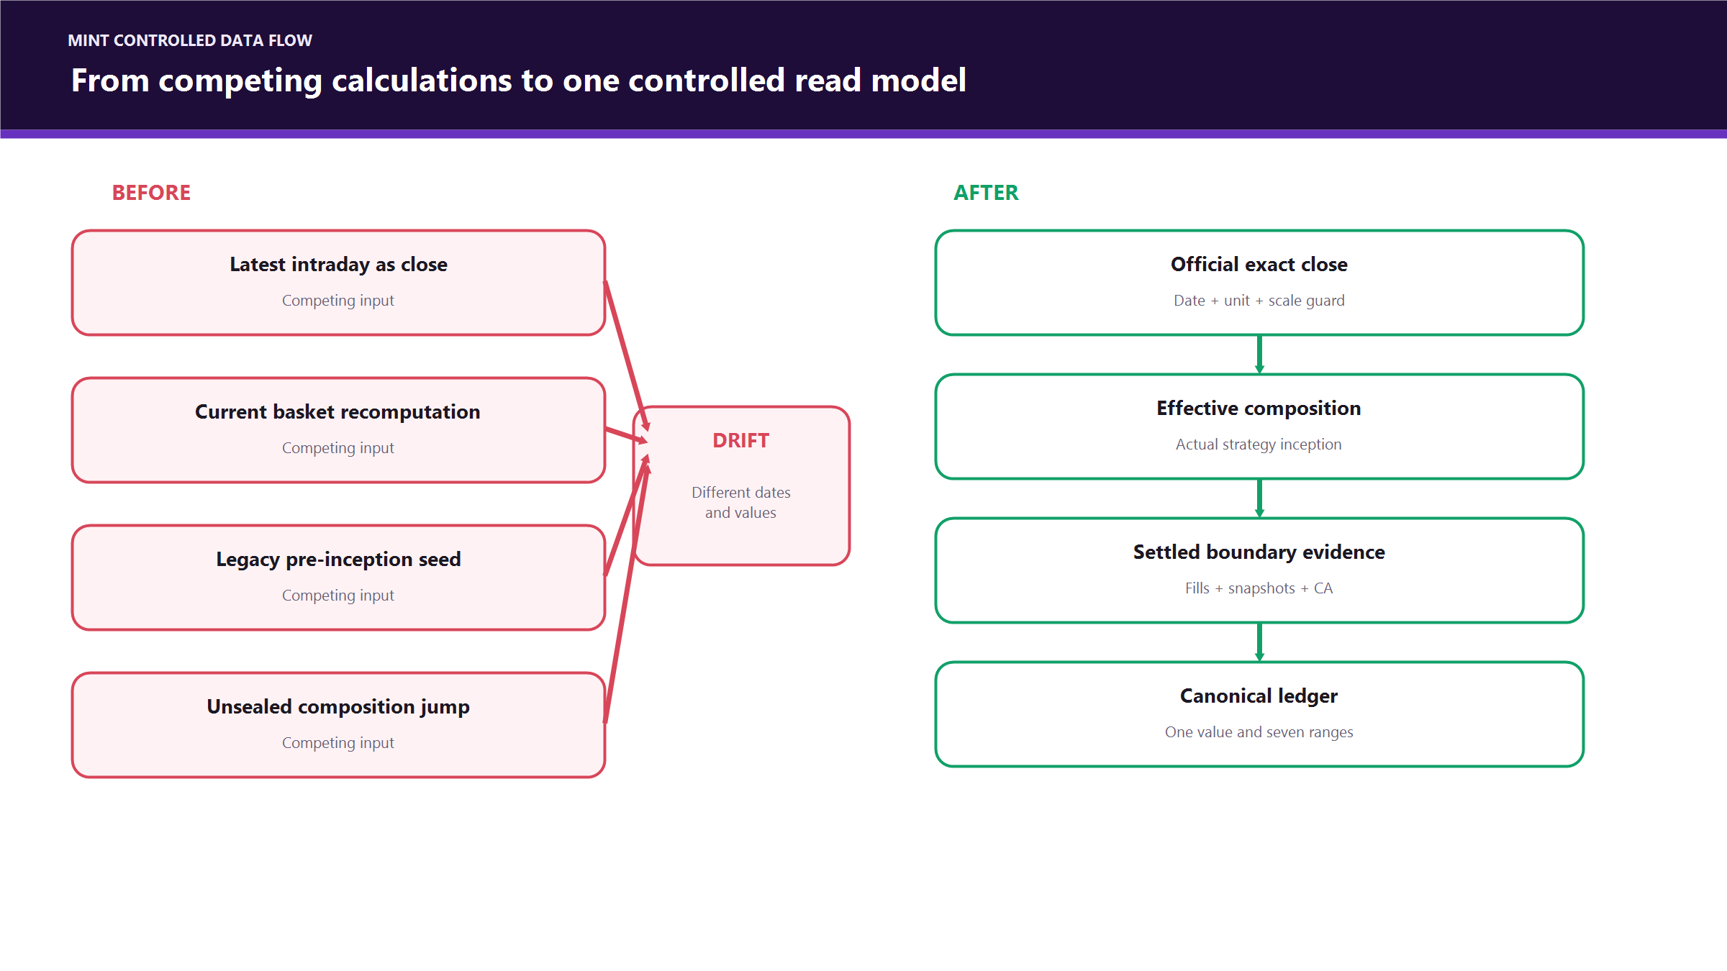
Figure 2 - Before and after architecture
________________________________________________________________________________

3. Non-negotiable accounting identities
All monetary database values in this programme are stored in integer cents unless a legacy field explicitly says otherwise.

3.1 Strategy model value
securities_value_cents
= SUM(model units for each active holding × official close in cents)

complete_value_cents
= securities_value_cents + continuity_cash_cents

continuity_cash_cents is the cash asset belonging to one model lot of the strategy. It is part of the strategy's investable composition and valuation.

3.2 Rebalance boundary identity
model_capital_cents
= securities_value_cents + strategy_ca_cents

The database constraint in strategy_rebalance_ca_reconciliation_c enforces this equality. It also requires:
affected_owner_count = reconciled_owner_count

3.3 Three different cash concepts
Concept | Table / field | Belongs to | Included in public strategy model value? | Purpose
Strategy/model CA | strategy_valuation_rules_c.continuity_cash_per_lot_cents | The model strategy | Yes | Deliberate cash sleeve retained by the strategy
Owner residual cash | strategy_rebalance_residuals.balance_cents and immutable cash events | A specific investor/family member | No, not automatically | Unspent or realised cash attributable to that owner
8% execution reserve | transactions.buffer_cents and reserve events | A specific purchase/owner | No | Fees and execution tolerance; must not be treated as strategy capital

The 8% reserve is allocated at purchase and is used for execution costs. It is not the same thing as model CA and must never be added to the strategy's published NAV.
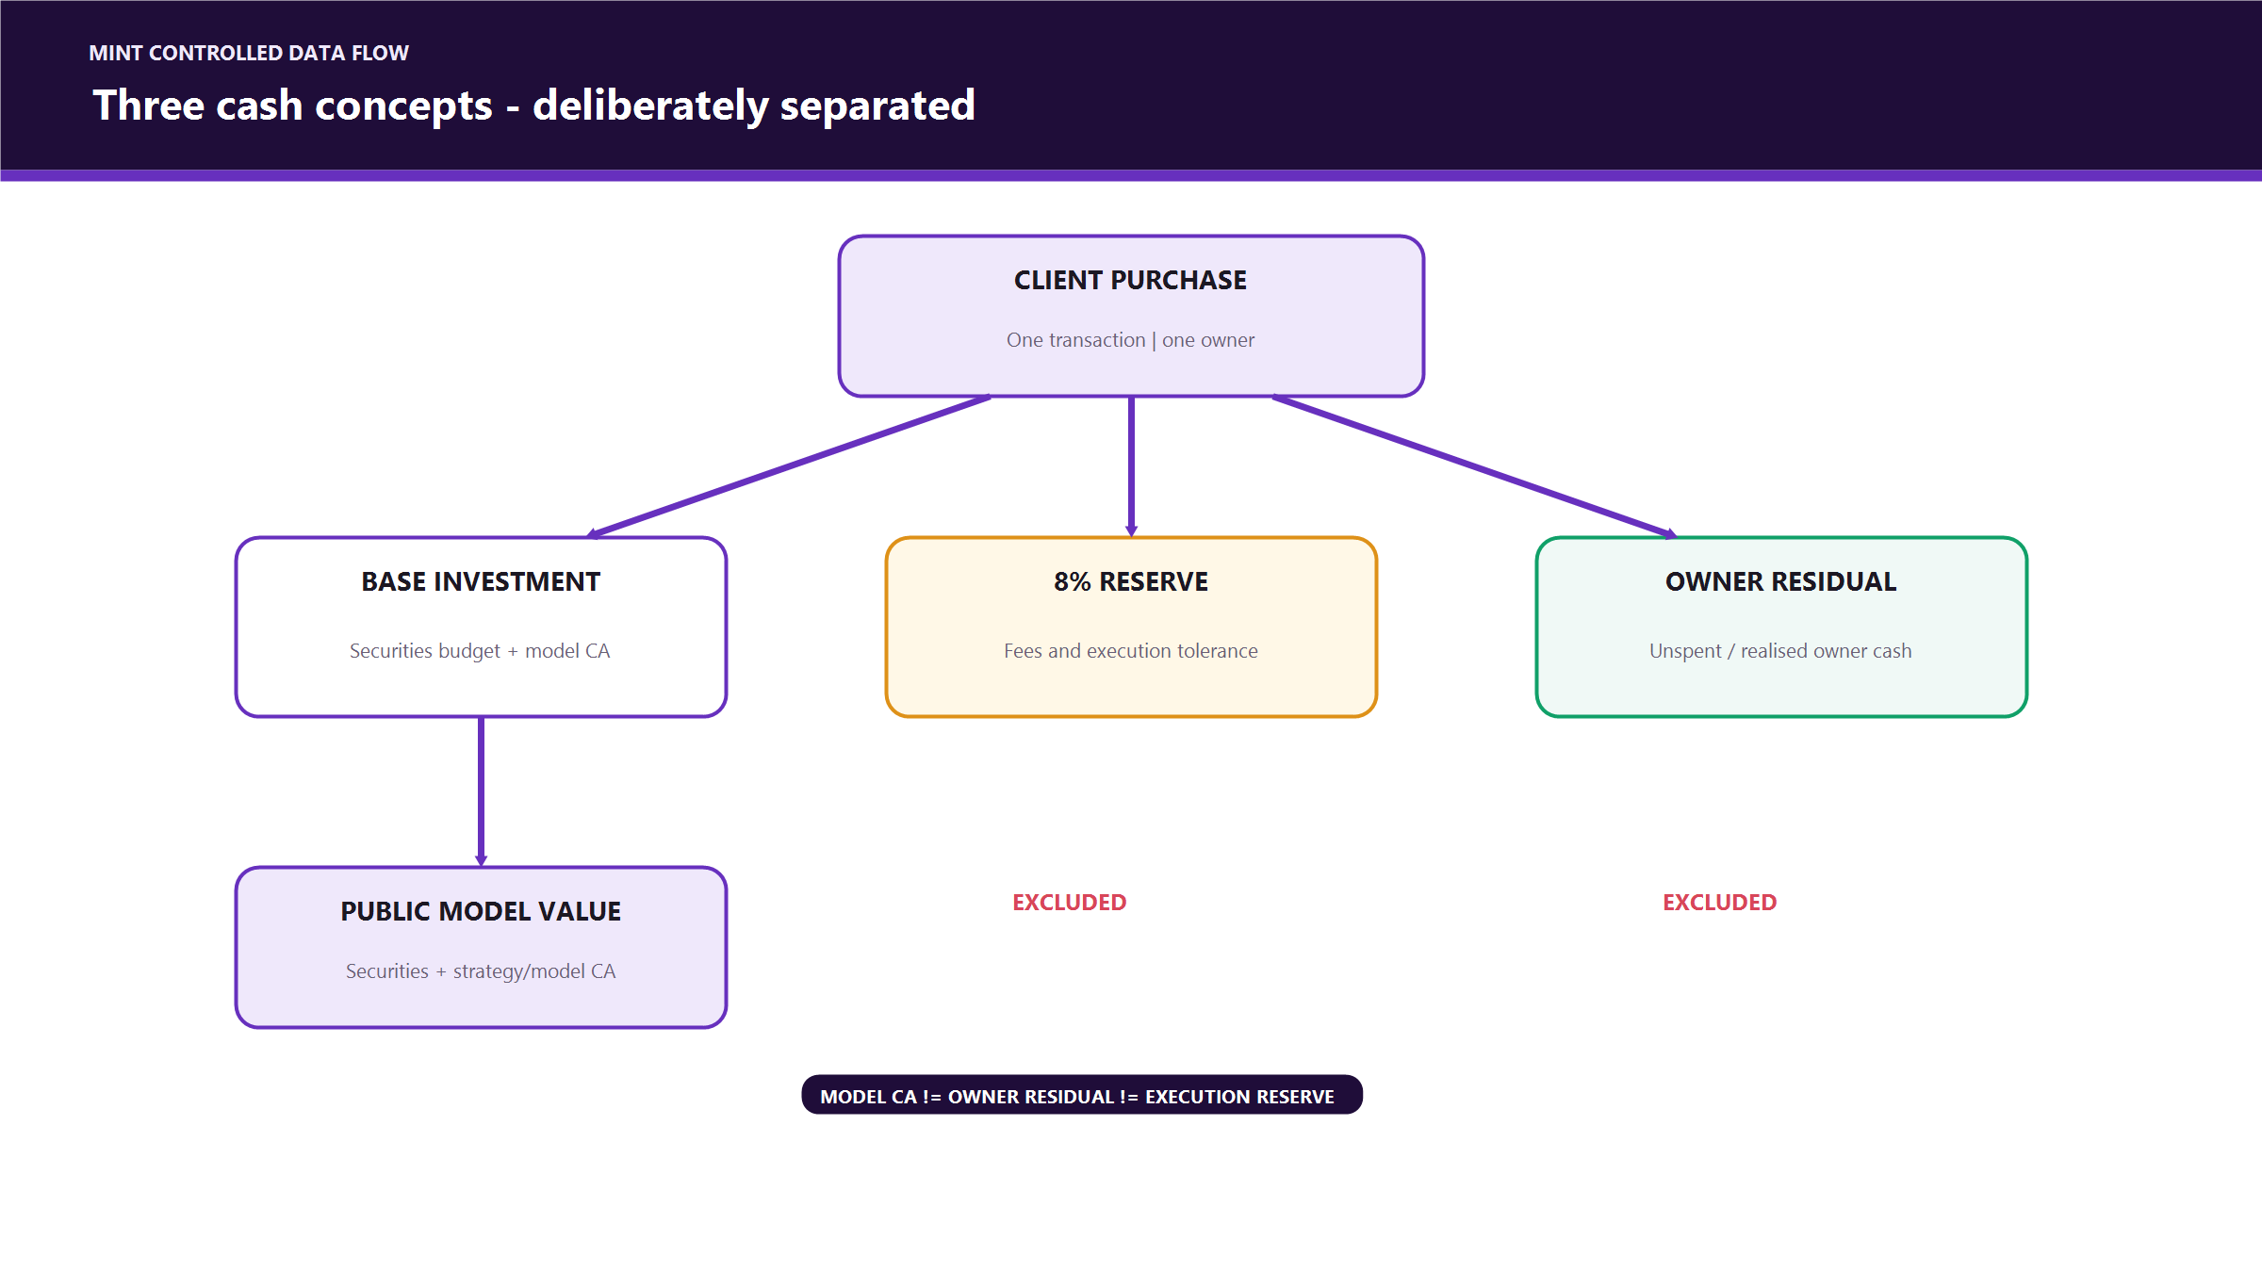
Figure 3 - Cash separation model
________________________________________________________________________________

4. Canonical return methodology
The supplied workbook's 06_Strategy_Ledger and 07_Public_Strategy_View are the methodological reference. The canonical ledger models each security or cash movement as a dated leg rather than pretending the current basket existed unchanged from inception.

4.1 Per-leg P/L
For a leg that is still open on the report date:
leg_current_value = units × report-date close
leg_benchmark_value = units × close on mapped benchmark date
leg_pnl = leg_current_value - leg_benchmark_value

For a leg sold after the benchmark date:
leg_exit_value = units × actual exit/fill price
leg_benchmark_value = units × close on mapped benchmark date
leg_pnl = leg_exit_value - leg_benchmark_value

For a new leg opened after the requested benchmark:
effective_benchmark_date = MAX(leg entry date, mapped period reference date)

The portfolio return for a range is:
period_return_pct
= SUM(all included leg P/L) / SUM(all included leg benchmark values) × 100

This prevents recycled capital from appearing as a gain and keeps realised sold-leg performance in the correct period.

4.2 Range/date mapping
Each daily ledger row contains the seven requested ranges derived from the same evidence:
Range | Requested reference | Mapping rule
1D | previous calendar day | last canonical trading row on or before requested date
1W | seven calendar days earlier | last canonical trading row on or before requested date
WTD | prior week end | last canonical trading row on or before the prior week-end reference
1M | one calendar month earlier | same day where possible, then last canonical row on or before it
3M | three calendar months earlier | same day where possible, then last canonical row on or before it
YTD | 31 December of prior year | last valid row on or before it; if the strategy began later, use inception
SI | actual strategy inception | first canonical strategy row

This explains cases such as a Monday or public holiday: the as-of date can be the reporting date while the applicable comparison close is the most recent JSE session. A future close is never used.
________________________________________________________________________________

5. System architecture

5.1 End-to-end data flow
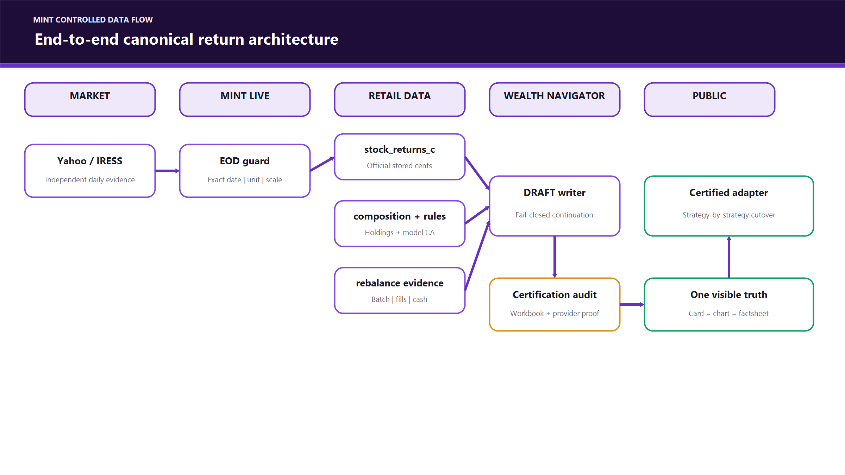
Figure 4 - End-to-end architecture

5.2 Retail database ERD
This ERD shows logical relationships relevant to returns and rebalances. Some evidence relationships are enforced through application checks where a direct foreign key is not present.
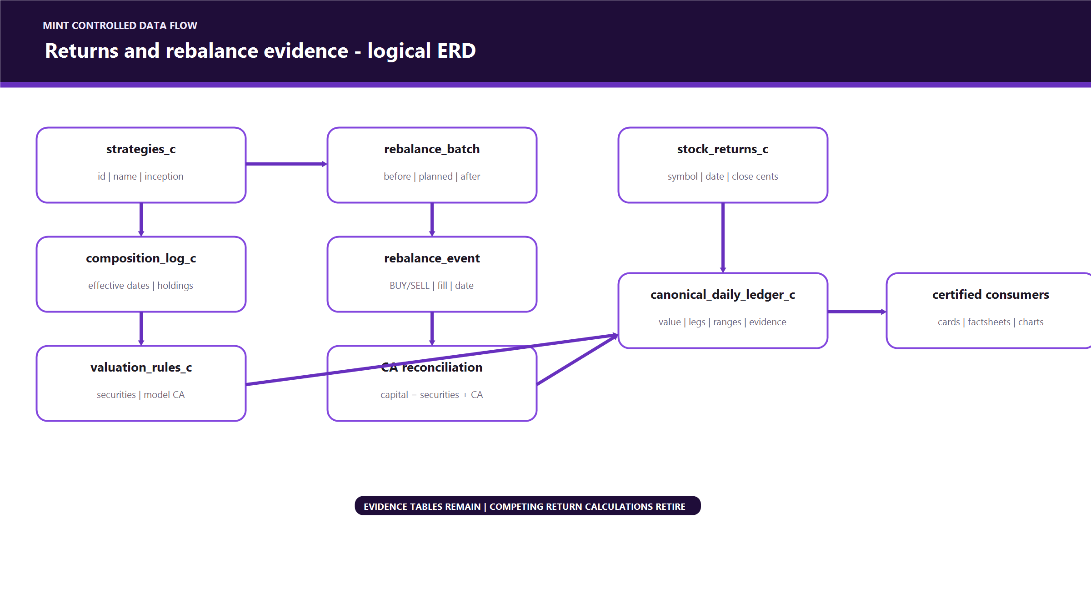
Figure 5 - Logical database ERD

5.3 Institutional-to-retail evidence chain
Institutional Supabase
rebalance_request_c
-> rebalance_vote_c
-> oems_order_audit
-> oems_fill_settlement_c

Retail Supabase
rebalance_batch
-> rebalance_event
-> strategy_rebalance_cash_events_c
-> strategy_rebalance_reserve_events_c
-> strategy_rebalance_ca_reconciliation_c
-> strategy_canonical_daily_ledger_c

The request/order records explain intent and institutional execution. The retail settlement records prove the model/owner state actually changed. Both are useful, but institutional intent alone is not sufficient evidence to invent a retail settlement boundary.
________________________________________________________________________________

6. Table catalogue and ownership
Table/view | Environment | Role | Writer / owner | Public source now?
stock_returns_c | Retail | Stored daily security closes | MINT EOD endpoint; historical repair tool only under explicit apply | Indirect input
jse_trading_calendar | Retail | JSE session/non-session truth | Annual market-calendar process | No
strategies_c | Retail | Strategy identity/current model metadata | Existing strategy management flow | Existing app dependency
strategy_composition_log_c | Retail | Effective-dated model holdings | Rebalance/model change flow | Calculation input
strategy_valuation_rules_c | Retail | Effective per-lot securities + model CA rule | Approved publication/reconciliation flow | Calculation input
strategy_canonical_daily_ledger_c | Retail | One row per strategy/session with values, legs, all ranges, and evidence | Canonical staging scripts and guarded DRAFT writer | Not yet public; DRAFT shadow source
strategy_return_publication_audit_c | Retail | Guarded legacy/effective publication evidence and boundaries | Existing return publisher | Existing chain input
strategy_returns_effective_c | Retail view | Current approved/effective strategy returns | Existing view chain | Current public strategy return path
client_strategy_returns_effective_latest_c | Retail view | Current approved owner-level values | Existing client return publisher/view | Current owner/AUM path
rebalance_batch | Retail | Settlement boundary and model snapshots | OEMS settlement | Evidence
rebalance_event | Retail | Immutable filled buy/sell legs | OEMS settlement | Evidence
strategy_rebalance_cash_events_c | Retail | Immutable owner cash movements | Atomic settlement | Evidence
strategy_rebalance_reserve_events_c | Retail | Fee reserve requested/consumed/shortfall | Atomic settlement | Evidence
strategy_rebalance_ca_reconciliation_c | Retail | Model capital identity and owner completeness | Reconciliation RPC / reviewed repair | Evidence and valuation rule input
strategy_rebalance_residuals | Retail | Current owner-specific residual balance | Purchase/rebalance settlement | Owner value, not model CA
transactions | Retail | Purchase plus separate model-cash allocation and 8% buffer | Purchase RPC | Purchase evidence
rebalance_request_c | Institutional | IC proposal, environment, composition | OEMS IC flow | Workflow only
rebalance_vote_c | Institutional | Immutable member vote | OEMS IC flow | Workflow only
oems_order_audit | Institutional | Orders/fills/audit | OEMS order book | Execution evidence
oems_fill_settlement_c | Institutional | Institutional settlement mirror | OEMS settlement | Execution evidence

Desired final state
The long-term public contract is one canonical read model, not many tables independently calculating performance. Evidence tables remain because they serve different accounting/audit purposes; they are not duplicate return tables. Once every strategy is certified and every consumer is migrated, obsolete return views/writers can be retired only after a dependency scan proves no active reader remains.
________________________________________________________________________________

7. Price correction and recurrence prevention

7.1 Historical correction performed
Scope: 42 securities used by the eight active, non-test strategies, from 30 January 2026 through 14 August 2026.
Pass | Result
Existing stored closes corrected to exact Yahoo daily close | 728
Missing official daily bars inserted | 139
Total first-pass changes | 867
Remaining exact-cent differences corrected on strict pass | 25
STXID rows restored after provider-scale defect discovered | 11
Final idempotency run | 0 changes

The correction modified the price input, then rebuilt the still-DRAFT canonical ledgers. It did not silently rewrite certified rows or the public return path.
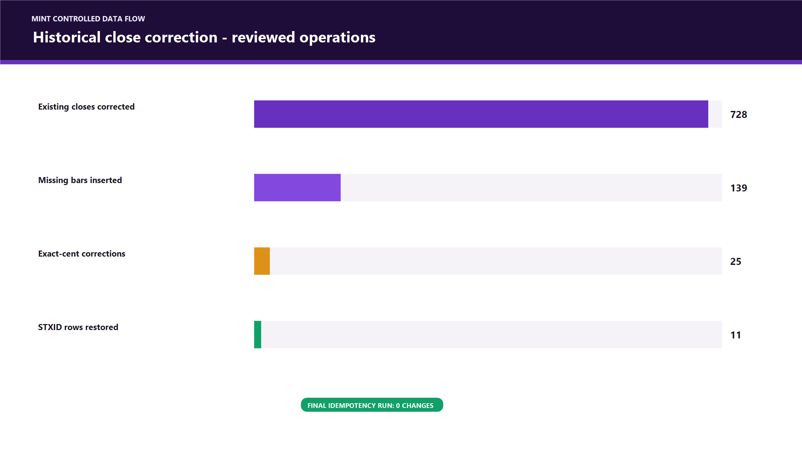
Figure 6 - Historical correction chart

7.2 Rollback evidence
Before each apply pass the tool generated a JSON backup in the operating-system temporary directory.
Backup | SHA-256
mint-stock-returns-backup-1786810047891.json | 0bf6f871127e3a02821fb3d79e46ec321f6b39351c613b5f82d77c5c35739822
mint-stock-returns-backup-1786811088806.json | 4c21fbce895d286fd1ae5d45d0de30069a429b03d476dbbb25a43f0e2712ab1c

Provider evidence for the repair run was hashed as:
02a5fe15862e66e2b73bd7e20b3a94560457db54ebcfc31d0b71a74b50edda01

The table above intentionally distinguishes the evidence hash from the backup-file hash; they prove different objects.

7.3 Unit and scale guard
The future writer applies these rules:
1. exact requested market date must exist in the Yahoo daily chart response;
2. ZAc is already cents and is not multiplied by 100;
3. ZAR is Rand and is multiplied by 100 once;
4. unsupported currency/unit is rejected;
5. compare candidate close to the latest guarded intraday reference;
6. reject the candidate if the price ratio is outside 0.2x to 5x;
7. never write a provider failure as zero or carry an arbitrary value.
STXID is the proof that this matters. Yahoo currently labels its series as ZAc while returning approximately 46.09, versus stored/market evidence around 4,630 cents. Its median overlap ratio is 0.009980472987632893 across 14 observations, so it is quarantined rather than accepted as a 99% crash.

7.4 Daily writer sequence
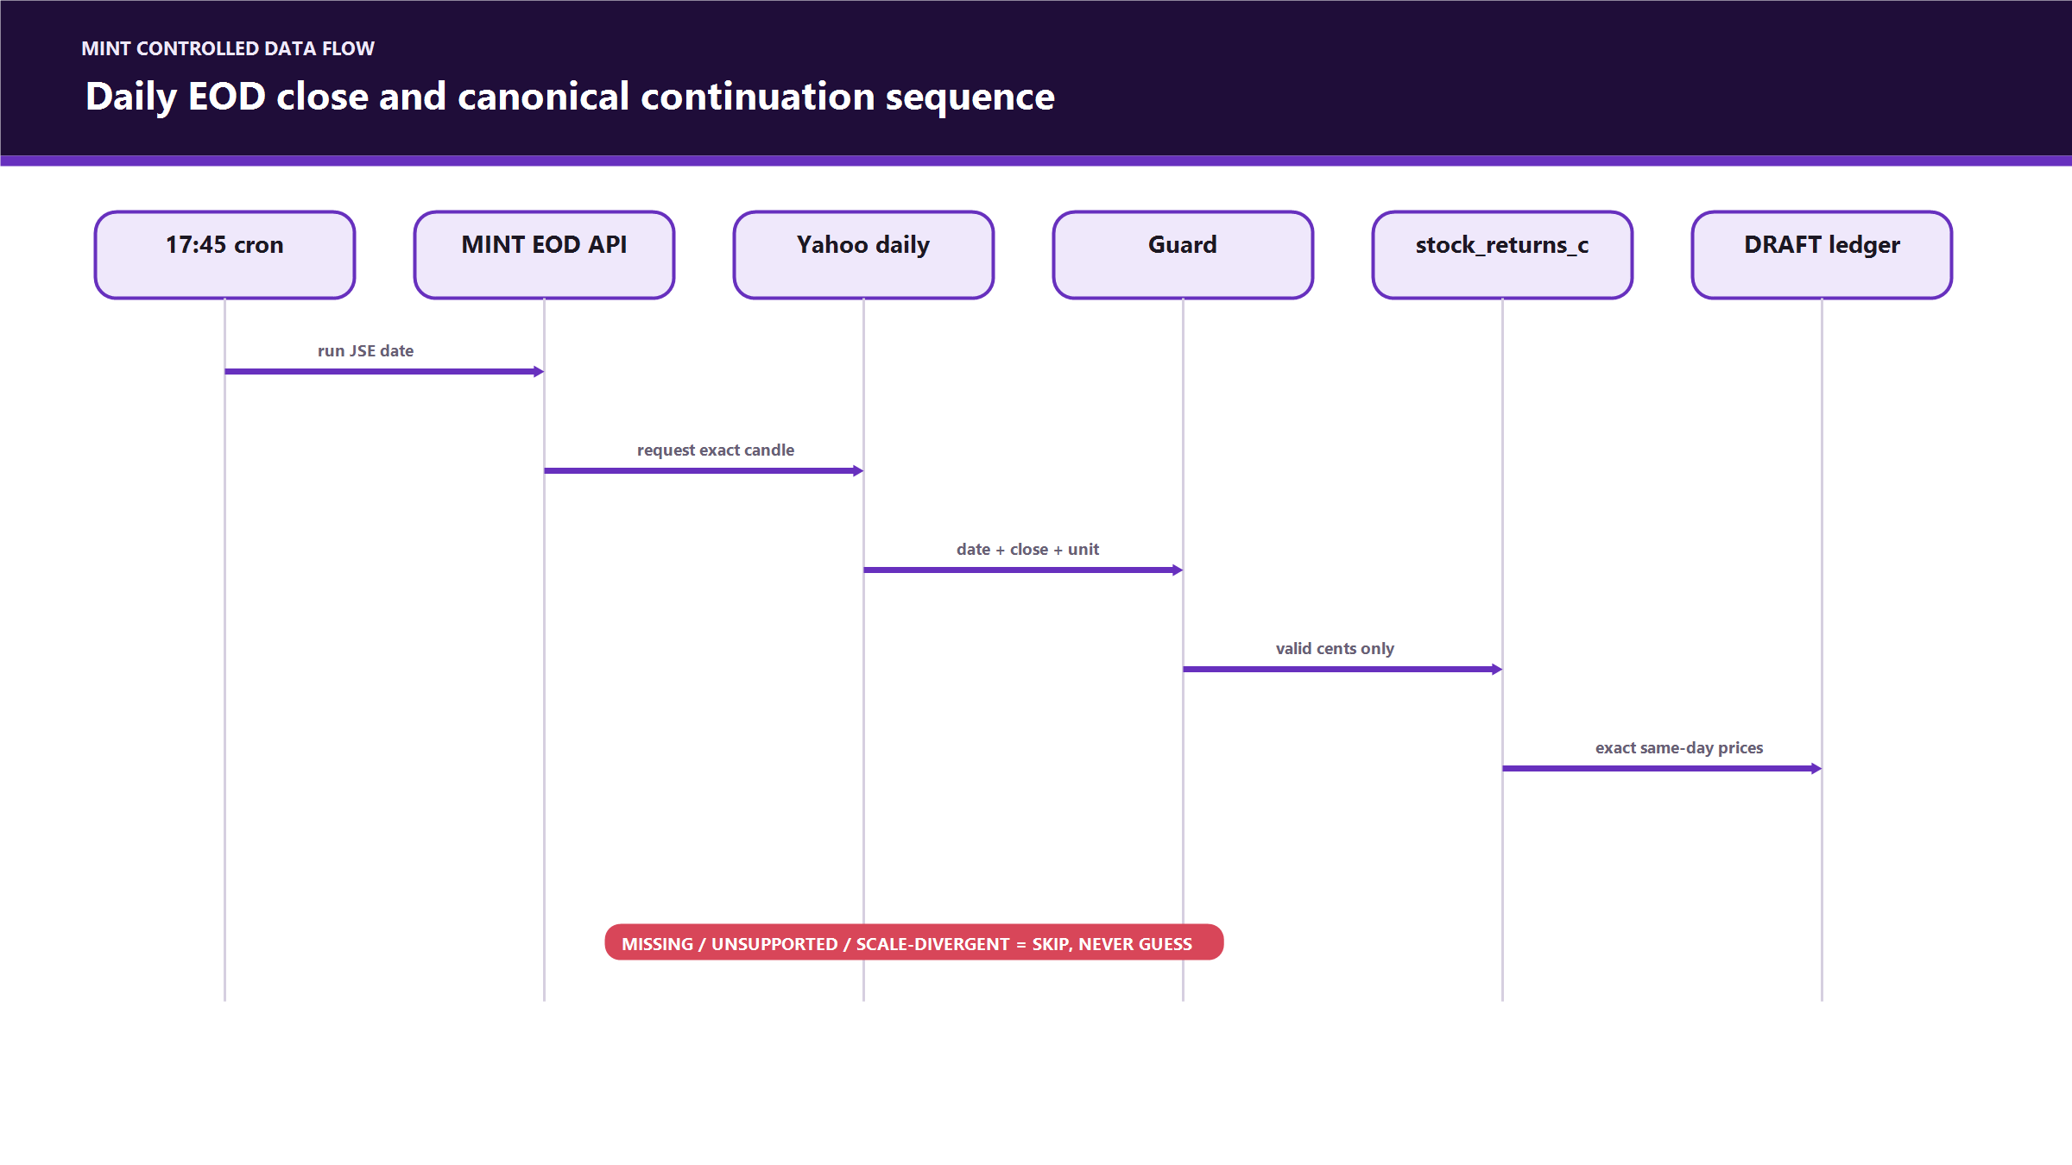
Figure 7 - Daily EOD sequence
________________________________________________________________________________

8. Rebalance-safe continuation
A daily strategy row may cross a composition boundary only when the writer can prove exactly what happened.

8.1 Required evidence
Required proof | Why
Exactly one non-reversed SETTLED / COMPLETE batch in the gap | Prevents collapsing multiple rebalances into one unexplained jump
Before and after/planned snapshots match old and new model baskets | Proves the batch belongs to this composition transition
Every changed ticker has a positive dated fill | Prevents using intent or proposed price as execution
Aggregate fills resolve to one consistent positive owner scale | Converts client-book execution totals back to a model-lot delta
Exactly one CA reconciliation | Establishes model capital = securities + strategy CA
Reconciled owner count equals affected owner count | Prevents partial settlement from becoming a public strategy boundary
Active valuation-rule CA equals reconciled strategy CA | Prevents a second, conflicting cash truth

8.2 Boundary handling
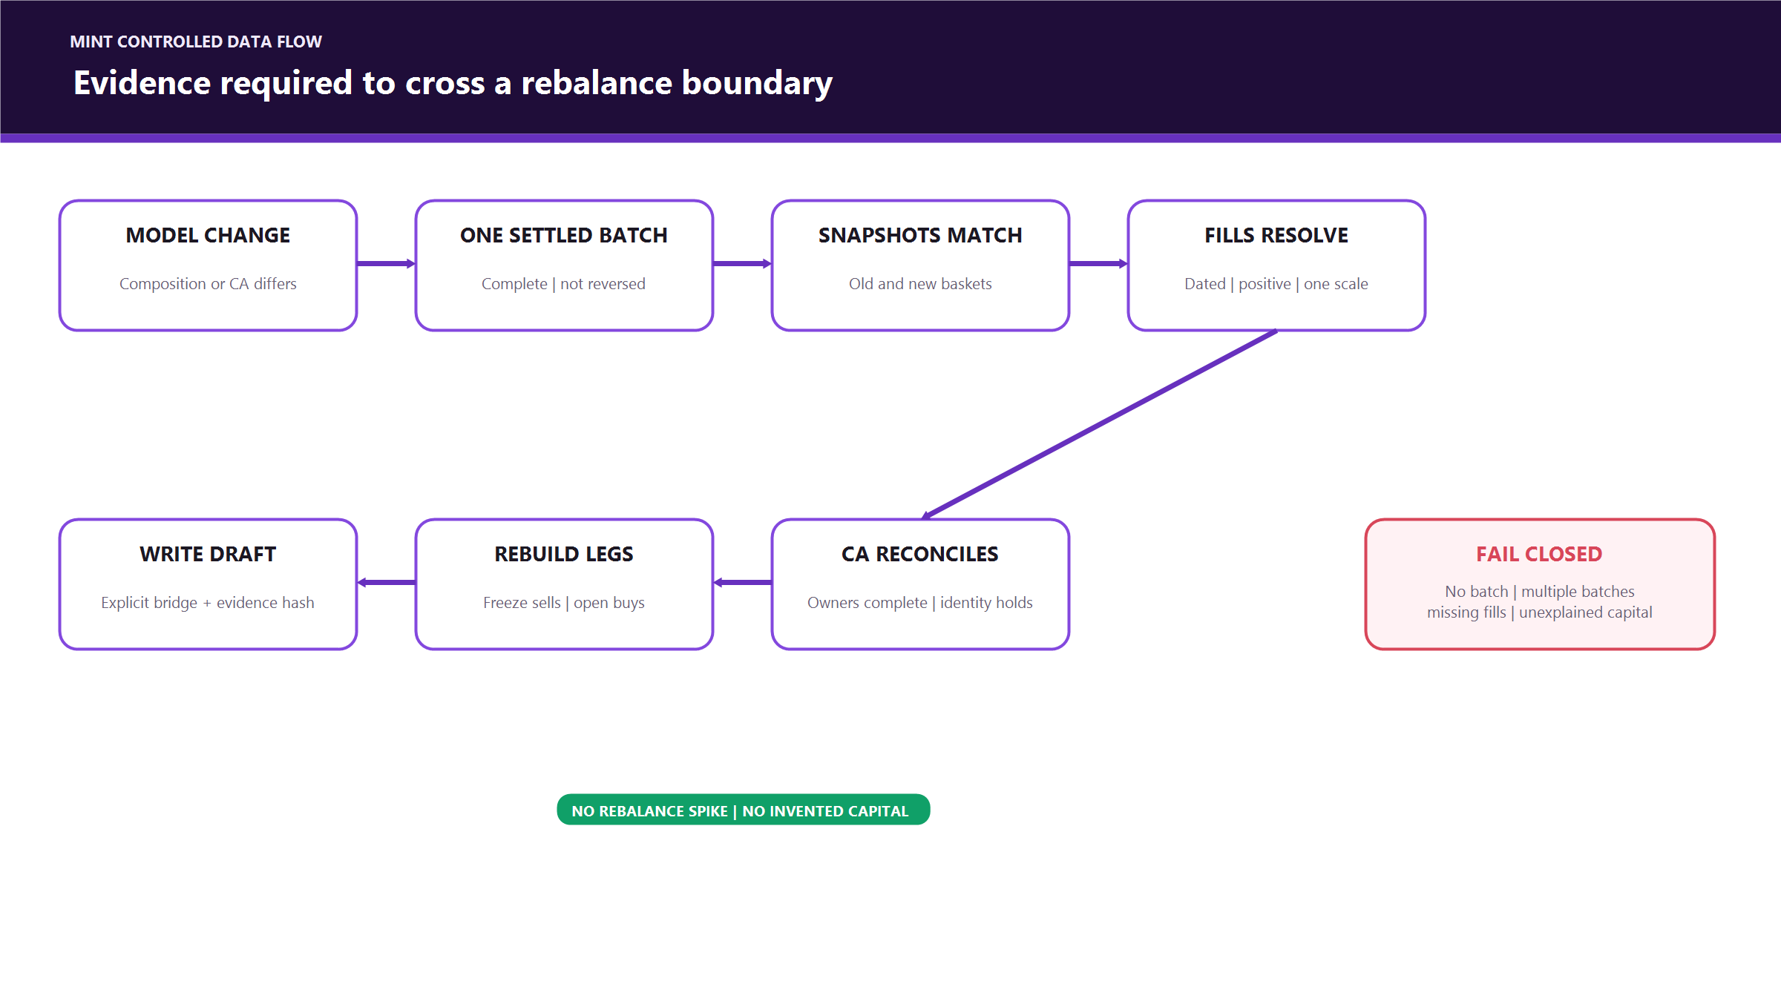
Figure 8 - Rebalance boundary flow

8.3 Why this removes rebalance spikes
A raw current-basket chart changes its basis when old assets are sold and new assets are added. The canonical method preserves the sold leg's realised result, starts the new leg at its actual fill, and carries only genuinely undeployed model cash. Sale proceeds reused to buy another asset are capital recycling, not performance.
________________________________________________________________________________

9. Current canonical ledger inventory
Fresh read-only certification audit run at 2026-08-15T17:22:51.009Z:
Strategy | Canonical rows | First date | Last date | Confirmed price mismatches | Missing independent price points | Formula failures | Automated certification
Blended Focus | 135 | 2026-01-30 | 2026-08-14 | 0 | 2 | 0 | Blocked by missing Aug-14 provider evidence
ETF Basket | 100 | 2026-03-20 | 2026-08-14 | 0 | 104 | 0 | Blocked by STXID quarantine + four Aug-14 provider gaps
MINT Diversified Basket | 135 | 2026-01-30 | 2026-08-14 | 0 | 2 | 0 | Blocked by missing provider evidence; boundary uses approved proxy classification pending sign-off
MINT Famous Brands | 135 | 2026-01-30 | 2026-08-14 | 0 | 0 | 0 | PASS — ready for controlled promotion review
MINT Multi-sector | 121 | 2026-02-19 | 2026-08-14 | 0 | 1 | 0 | Blocked by missing Aug-14 STX500 evidence; boundary proxy still needs sign-off
MyGrowthFund | 81 | 2026-04-20 | 2026-08-14 | 0 | 4 | 0 | Blocked by missing Aug-14 provider candles
UCT | 90 | 2026-04-07 | 2026-08-14 | 0 | 1 | 0 | Blocked by missing Aug-14 GLPROP provider candle
Yield Basket | 135 | 2026-01-30 | 2026-08-14 | 0 | 92 | 0 | Blocked by pre-29-Jun CLI independent history

Total canonical rows: 932.
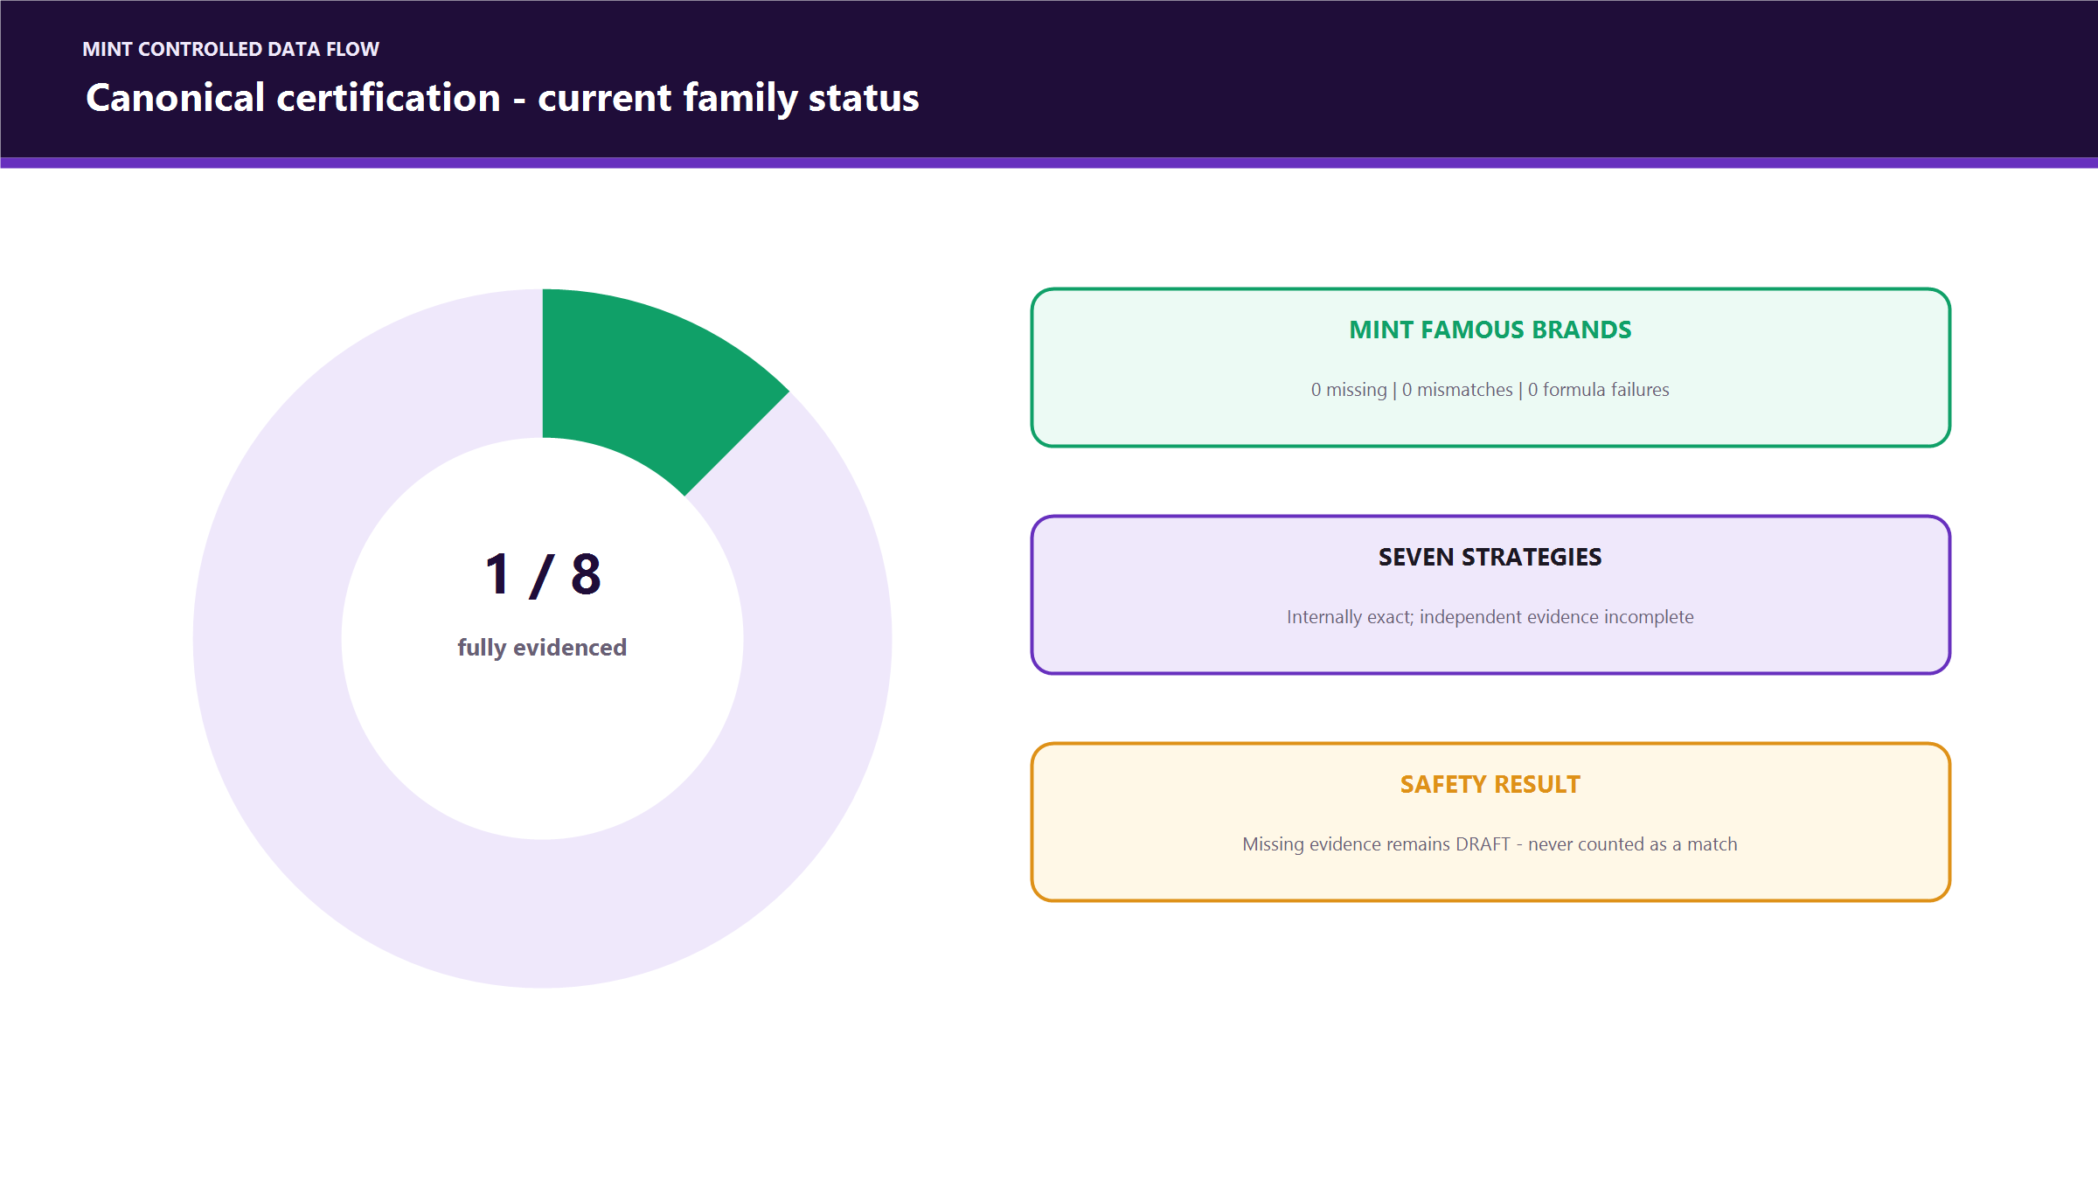
Figure 9 - Certification status
The most important interpretation is:
- zero mismatch means every available independent provider point agrees;
- missing means the provider did not supply evidence and is not counted as a match;
- zero formula failures means the stored ledger reproduces its workbook formula evidence exactly;
- certificationPass=false is a deliberate safety state, not proof that the value is wrong.
Audit evidence hashes:
Evidence | SHA-256
CEO workbook methodology | bde94581727f9a08232ec5e80f2672bde3a1ef73c733309ec8723fe78bcaa301
Current independent provider audit payload | c171b86d306fef657f00ed25f74c208c971c6fc6cecae4b6ace80913a6037c5e

________________________________________________________________________________

10. Strategy-specific reconstruction notes

MINT Famous Brands
- Static strategy family from actual inception.
- 135 JSE-session DRAFT rows.
- All available prices, valuation identities, workbook evidence, and formulas pass.
- First strategy eligible for a reviewed DRAFT -> CERTIFIED promotion.
- Promotion has not yet been performed.

ETF Basket
- Begins on actual 20 March 2026 creation date, not the legacy 2023 return seed.
- Five-leg composition produces 100 canonical JSE-session rows.
- Stored STXID prices remain intact; Yahoo's current STXID series is quarantined for a roughly 100x scale divergence.
- Obtain a reviewed Satrix/JSE/IRESS official history before certification.

Yield Basket
- Three completed evidence-backed boundaries were reconstructed; one reversed batch is excluded.
- Owner scales are 2, 3, and 3 model lots across the completed batches.
- Gross residual per model lot is 50,390 cents; authoritative model CA is 49,194 cents; the 1,196-cent difference is explicitly represented as an execution-cost bridge.
- CLI's older independent history is unavailable because the current provider series begins 29 June after the CLI leg ended. No price was invented.

Blended Focus
- The 11 May boundary is reproduced using actual OUT sale and STX500 buy fills.
- The leg ledger prevents the rebalance from creating a false performance cliff.
- Current blocker is two unavailable provider points, not a confirmed mismatch.

MyGrowthFund
- Full multi-boundary ledger uses the reviewed 23 July evidence repair plus two 3 August reconciled settlements.
- The 23 July repair records zero model CA because all surplus went to owner residual and fees came from execution reserve.
- Owner residual and reserve are explicitly excluded from public strategy CA.
- The currently missing four independent points are all 14 August provider gaps.

MINT Diversified Basket and MINT Multi-sector
- Retail and institutional audits found no valid execution record for their June model changes.
- Their DRAFT histories use clearly labelled composition/model-EOD proxy boundaries, never disguised broker fills.
- They cannot be certified until the proxy is formally approved or replaced with real execution evidence.

UCT
- Static inception-based reconstruction with 90 rows.
- Formula and all available provider comparisons pass.
- One missing 14 August GLPROP independent point blocks automatic certification.
________________________________________________________________________________

11. Source of Truth Ledger UI
The Wealth Navigator Source of Truth page now exposes the physical canonical ledger as an audit surface:
- one strategy per workbook-like tab;
- daily complete-value line chart;
- securities, model CA, and complete-value identity;
- all seven period returns and mapped reference dates;
- per-leg evidence and entry/exit values;
- certification status and missing requirements;
- paginated history beyond Supabase's 1,000-row cap;
- Yahoo-style CSV upload for read-only independent price proof;
- normalized provider-evidence SHA-256.
The CSV proof endpoint is authenticated and read-only. It accepts Date + Close, optionally Ticker/Symbol, converts currency units to cents, applies a one-cent comparison tolerance, and reports matches, mismatches, or missing stored rows. It never promotes a strategy or rewrites a price.
________________________________________________________________________________

12. Safeguards and failure behaviour
Situation | Required behaviour
Requested date is not a JSE trading day | Exit with not a JSE trading day; no write
No prior canonical baseline | Skip with NO_CANONICAL_BASELINE
Existing row is not DRAFT | Refuse replacement
Missing exact daily close | Fail that strategy with EXACT_CLOSE_MISSING:<ticker>
Composition changed with no settled batch | REBALANCE_REQUIRES_SETTLED_EVIDENCE_REBUILD
Multiple boundaries in one gap | MULTIPLE_REBALANCE_BOUNDARIES_REQUIRE_ORDERED_REBUILD
Missing/duplicate CA reconciliation | REBALANCE_CA_RECONCILIATION_REQUIRED
Snapshot mismatch or inconsistent fill scale | Reject boundary
New CA exceeds explained prior cash/fill residual | Reject as unexplained external capital
Provider scale outside 0.2x-5x | Quarantine ticker; do not write
Provider returns no exact candle | Skip; do not copy intraday or zero
Certification evidence is missing | Keep DRAFT; do not call it a match
Test Strategy | Excluded from historical canonical family audit/public cutover

DRAFT replacement rule
Late-arriving official closes sometimes require a same-date replay. replaceExistingDraft allows an upsert only when the existing canonical row is still DRAFT. A CERTIFIED row is immutable to this routine and requires a separately reviewed correction process.
________________________________________________________________________________

13. Implemented scripts and operator controls
Script / endpoint | Mode | Purpose
scripts/audit-canonical-certification.mjs | Read-only | Independent close, valuation, workbook-hash, formula, and certification report
scripts/repair-stock-returns-yahoo.mjs | Dry-run by default | Exact-date historical close audit/repair with scale quarantine and backup
scripts/restore-stock-returns-backup.mjs | Dry-run by default | Ticker-scoped restoration from repair backup
scripts/audit-canonical-ledger-family.ts | Read-only | Classify static vs evidence-dependent strategies
scripts/audit-historical-certification-gaps.ts | Read-only | Identify exact certification blockers
scripts/stage-static-canonical-ledger.ts | Dry-run by default | Build static inception-based DRAFT histories
scripts/stage-single-boundary-canonical-ledger.ts | Dry-run by default | Reconstruct one proven rebalance boundary
scripts/stage-composition-proxy-canonical-ledger.ts | Dry-run by default | Restricted, labelled proxy for unsupported Diversified/Multi-sector boundaries
scripts/stage-etf-canonical-ledger.ts | Dry-run by default | ETF-specific inception-safe reconstruction
scripts/stage-yield-canonical-ledger.ts | Dry-run by default | Yield multi-boundary execution-backed reconstruction
scripts/stage-mygrowth-canonical-ledger.ts | Dry-run by default | MyGrowth evidence-backed multi-boundary reconstruction
scripts/run-canonical-ledger-draft.ts | Dry-run unless apply env is set | Operate the shared daily DRAFT publisher
/api/cron/canonical-ledger-draft | Cron; dry unless explicitly enabled | Continue all eligible non-test DRAFT ledgers
/api/admin/source-of-truth/price-proof | Authenticated read-only | Compare uploaded provider evidence with stored exact closes
MINT /api/prices/eod-save | Production writer | Write future guarded exact Yahoo daily closes

Important environment controls
APPLY_YAHOO_CLOSE_REPAIR=1
Enables historical price repair. Without it, the tool is read-only.

REPAIR_DERIVED_STOCK_RETURNS=1
Separate opt-in for uncertain legacy derived columns. It is not implied by close repair.

APPLY_CANONICAL_LEDGER_DRAFT=1
Enables DRAFT ledger staging/writes for supported scripts.

REPLACE_EXISTING_CANONICAL_DRAFT=1
Allows same-date DRAFT replay; never permits CERTIFIED replacement.

CANONICAL_LEDGER_DRAFT_APPLY=1
Enables the scheduled daily canonical writer. Otherwise cron remains a dry-run/reporting path.

________________________________________________________________________________

14. Testing and verification evidence

Wealth Navigator
Check | Result
Canonical focused regression tests | 18 passed
TypeScript tsc --noEmit | Passed
Next.js 16.2.10 production build | Passed
11-14 August DRAFT replay | 32 writes; 0 skipped; 0 failed
Post-repair idempotency | 0 price changes
Latest independent certification | 0 confirmed price mismatches; 0 valuation mismatches; 0 formula failures
Vercel PR deployment | Passed

Focused suites covered the DRAFT writer, settled-boundary reconstruction, and Source of Truth audit surface.

MINT Live
Check | Result
Exact-close / unit / scale tests | 3 passed
ZAc and ZAR normalization | Covered
Missing exact candle rejection | Covered
STXID-like 100x anomaly rejection | Covered
Vite 7.3.3 production build | Passed
Vercel mint check | Passed
Vercel mint-dev check | Passed

________________________________________________________________________________

15. Deployment and cutover plan

Phase A — merge infrastructure
[x] Merge Wealth Navigator PR #96.
[ ] Review and merge MINT Live PR #230.
[ ] Confirm production cron uses the new 17:45 SAST EOD route.
[ ] Inspect the first production run for providerRejected, missing candle, or scale-quarantine results.

Phase B — promote one proven strategy
Start with MINT Famous Brands only.
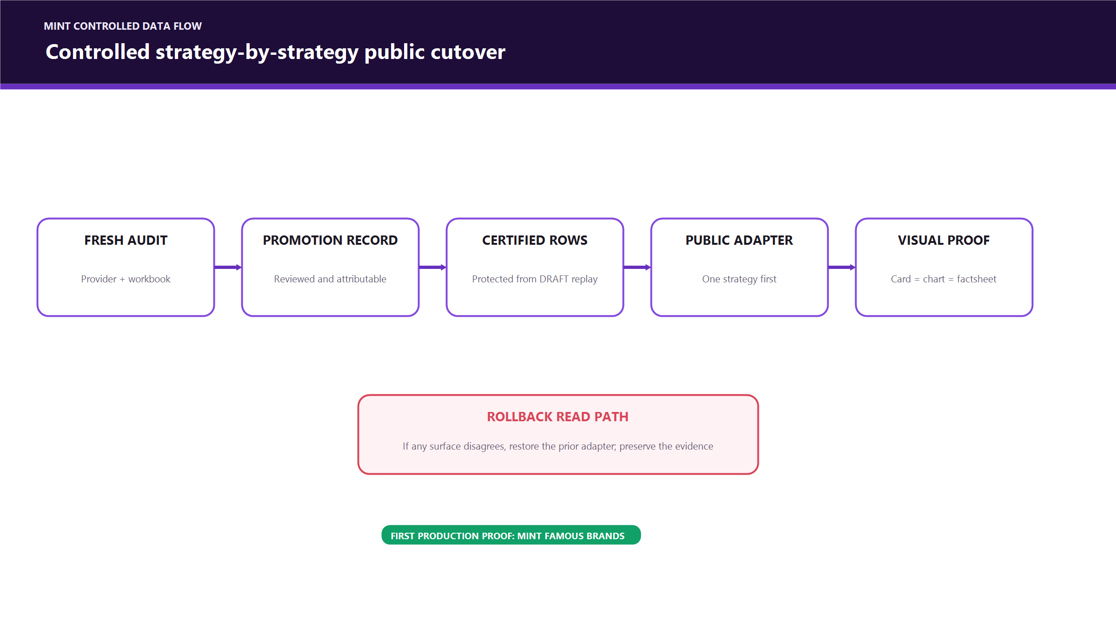
Figure 10 - Controlled promotion flow
Promotion must be auditable and strategy-specific. Do not bulk-update all DRAFT rows merely because one strategy passes.

Phase C — public read migration
For each promoted strategy:
1. card return and date read the latest approved canonical row;
2. factsheet ranges read that same row's period_metrics;
3. chart reads the same canonical daily history;
4. all surfaces show the same as-of date;
5. missing certified data fails closed or uses an explicitly labelled existing fallback—never a blended calculation;
6. compare values and chart shape in mint-dev before live deployment.

Phase D — resolve the other seven
Blocker | Resolution
STXID Yahoo scale defect | Obtain official Satrix/JSE/IRESS daily history and ingest it as reviewed independent evidence
CLI pre-29-Jun provider gap | Obtain delisted-security close history from an approved source
14-August missing Yahoo candles | Retry provider or use reviewed official IRESS/JSE export for those exact dates
Diversified/Multi-sector unsupported June executions | Obtain broker/execution evidence or formally approve and document the proxy methodology

Phase E — consolidation and cleanup
Only after every public consumer has moved:
1. inventory all reads of raw/legacy strategy return tables and views;
2. prove no app, OEMS, cron, export, or admin page depends on each candidate;
3. retire competing writers first;
4. preserve immutable execution, cash, reserve, and audit evidence tables;
5. remove redundant return projections in a separately reviewed migration;
6. retain rollback/export evidence according to financial-record policy.
________________________________________________________________________________

16. Rollback strategy

If PR #230 causes an EOD issue
Do not compensate by writing guessed prices. Disable or revert the new writer deployment, leave the affected date absent, and investigate the provider response. An absent close is safer than a false close.

If a historical close repair is questioned
1. run the restore tool in dry-run mode with the exact backup;
2. restrict restoration to the questioned ticker/date range;
3. review insert/delete/update counts;
4. apply only after approval;
5. replay only affected DRAFT ledger dates chronologically;
6. rerun the independent certification audit.

If a public canonical cutover disagrees
Use a read-path feature flag or adapter rollback to restore the prior effective view. Do not delete the canonical evidence. Compare the exact strategy/date/period and record the discrepancy before any data mutation.
________________________________________________________________________________

17. AUM relationship
AUM is an owner-level aggregation, not the model strategy NAV itself.
retail AUM
= SUM(latest approved owner basket value)
across real, non-test owners

The appropriate current input is client_strategy_returns_effective_latest_c, with test profiles/wallets excluded. Public strategy canonical returns establish the strategy model's performance; they do not replace owner quantities, residual balances, liabilities, or family-member ownership. When the canonical strategy read is promoted, AUM still requires its own owner-level reconciliation and must not be calculated by multiplying a public percentage by deposits.
________________________________________________________________________________

18. Known limitations and explicit non-claims
- Seven strategies are not yet independently certifiable through the automated gate.
- Missing Yahoo evidence is not proof that a stored close is wrong.
- Yahoo is not accepted as evidence for an actual rebalance fill.
- Composition proxy boundaries are clearly labelled and are not broker executions.
- The canonical table is a DRAFT shadow read model today; public cards/charts are not yet cut over.
- The historical repair targeted securities used by the eight real strategy families, not every security ever present in the database.
- Test Strategy is intentionally excluded from public historical certification.
- A successful build proves software integration, not financial approval.
- A merge is not a certification event.
________________________________________________________________________________

19. Developer runbook

Read-only family certification
npm.cmd run audit:canonical-certification

Expected safe result before promotion:
- no provider errors;
- no provider scale quarantines for holdings in the strategy being promoted;
- zero price mismatches;
- zero missing provider points;
- zero valuation mismatches;
- zero formula failures;
- workbook SHA equals the approved workbook hash;
- certificationPass: true for that strategy.

Historical repair discipline
npm.cmd run repair:stock-returns-yahoo

This is dry-run by default. Review the output and backup location before enabling APPLY_YAHOO_CLOSE_REPAIR=1. After an apply, rerun without the flag and require zero changes.

Acceptance checks after any ledger change
npm.cmd run typecheck
npm.cmd run build

Run the focused canonical and rebalance suites as well. Record the exact counts, commit SHA, provider evidence hash, and workbook hash in the handover.
________________________________________________________________________________

20. Commit and PR evidence

Wealth Navigator
- Branch: feat/Porting
- Head implemented commit: 7b88276d9c9b21fee0dc956cb1ddf49fd1824500
- PR: #96 — Certify canonical closes and replay draft ledgers (https://github.com/MINT-Developement/Wealth-Navigator/pull/96)
- Current status: merged; Vercel success.
Key continuation commits include:
Commit | Purpose
214e2b9 | Add fail-closed canonical ledger writer
0053248 | Continue canonical ledgers across verified rebalances
7b88276 | Certify exact closes, replay DRAFT ledgers, add audit/repair/rollback tooling

MINT Live
- Branch: port/gift-email-banners
- Head commit: cf612db8e58b12aab1e654c86e80ba3c6021acd2
- PR: #230 — Write verified official JSE closing prices (https://github.com/MINT-Developement/MINT-LIVE/pull/230)
- Current status: open draft; mint and mint-dev Vercel checks pass.
________________________________________________________________________________

21. Final definition of done
This programme is complete only when all of the following are true:
[x] Exact-close recurrence fix implemented and tested.
[x] Historical target universe repaired with backup and idempotency proof.
[x] All eight non-test canonical DRAFT histories constructed through 14 Aug 2026.
[x] All seven return ranges derive from one daily ledger method.
[x] Rebalance boundaries preserve leg P/L and explicit model cash.
[x] Current audit has zero confirmed price, valuation, and formula mismatches.
[x] Source of Truth Ledger audit surface exists.
[ ] MINT Live PR #230 merged and first production EOD run observed.
[ ] Controlled promotion mechanism reviewed and recorded.
[ ] MINT Famous Brands promoted and verified end-to-end first.
[ ] App card, strategy detail, factsheet, and chart all read the same certified rows.
[ ] Remaining seven independent evidence gaps resolved or formally approved.
[ ] All eight strategies certified strategy-by-strategy.
[ ] Owner-level AUM reconciled after public cutover.
[ ] Competing legacy return writers/read paths retired after dependency proof.

Present conclusion
The calculation engine, evidence model, price repair, safe DRAFT replay, and audit tooling are built and verified. The system is not yet at final public cutover. The correct next move is to merge PR #230, observe the next guarded EOD run, then promote and cut over MINT Famous Brands only as the first end-to-end production proof.
________________________________________________________________________________

22. Glossary
Term | Meaning
CA | Cash allocation / cash asset retained within the strategy model
Canonical ledger | One effective-dated strategy history used to derive value and every return range
DRAFT | Calculated shadow row; not approved for public display
CERTIFIED | Reviewed row eligible for the approved public read path
EOD close | Official market-date daily closing candle, not simply the latest intraday tick
Leg | A dated holding/cash/execution-cost component with entry and optional exit evidence
Owner residual | Cash attributed to a particular client/family member after execution
Execution reserve | The separate 8% owner reserve used for fees/tolerance
Boundary | A date where the model composition or model CA changes
Evidence hash | SHA-256 fingerprint of normalized inputs used to make tampering/drift detectable
Fail closed | Skip or block publication when evidence is incomplete instead of guessing

