# Problem Statement – Speed Breaker Detection

Develop a solution for speed breaker detection from the given historical data of vehicle driving profile .

Vehicle was driven on various routes having speed bumps and following parameters were recorded

1. Vehicle speed [“**VehSpeed”] (kmph)**
2. accelerometer readings in vertical direction [“**ActualAz”] (g )**
3. Timestamp in string format

Data is collected at every 100 ms meaning each observation Row is coming at 1s.

Given below is snapshot of data (2 observations) for more detail.

**Dataset** :

**Timestamp ActualAz VehSpeed**

13-07-2020 09:00 0.9765625 11.7578125

13-07-2020 09:00 0.6328125 12.3515625

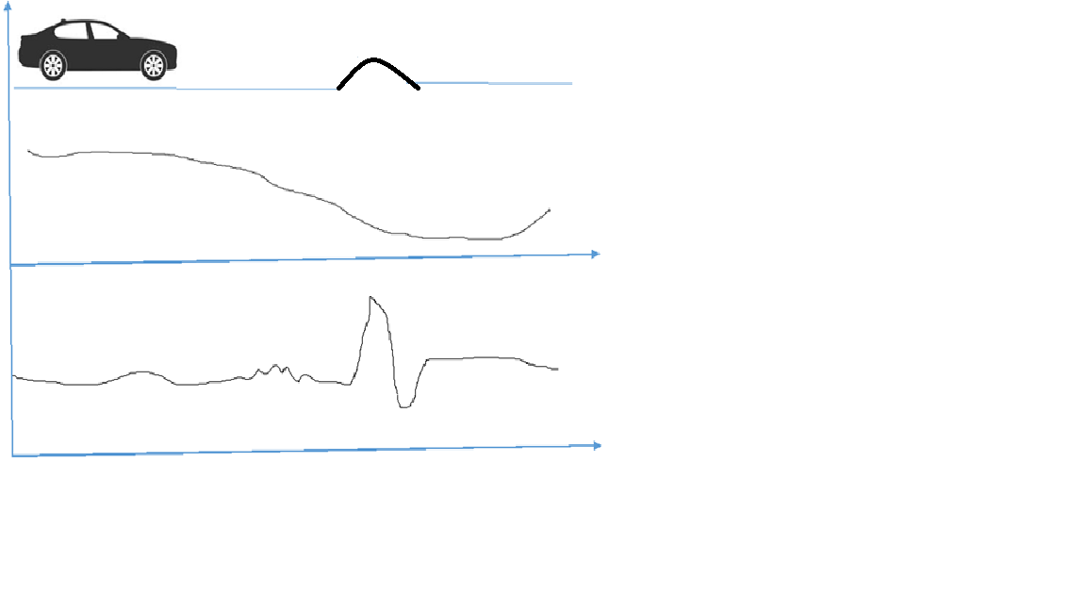

Vertical Acceleration (Az) 🡪

Speed (kmph) 🡪

Time (seconds) 🡪