Offroad Semantic Scene Segmentation Using Vision Transformers

Asmit Kumar Jena(leader)
ashmitjena@gmail.com
Subham Dutta
dsubh269@gmail.com
Ananya Raj
rajananya1612@gmail.com
Abhishek Dhal
abhishekdhalofficial@gmail.com

1. Introduction
Semantic segmentation is a fundamental task in computer vision that assigns a categorical label to every pixel in an image. While the field has seen significant advances in structured environments such as urban road scenes, the segmentation of offroad and desert terrain presents distinct challenges. Sparse, irregular structures, high intra-class visual variability, and significant class imbalance are among the primary difficulties encountered in unstructured natural environments.
This project addresses the task of pixel-level classification of offroad desert terrain images into ten semantic categories. The practical applications of this capability span autonomous off-road vehicle navigation, robotic terrain traversal, ecological monitoring, and military surveillance. Robust segmentation in such environments requires models capable of capturing both global context and fine-grained local texture.
The proposed approach leverages DINOv2, a Vision Transformer pretrained via self-supervised learning on large-scale diverse image corpora, as a fixed feature extractor. Its rich, hierarchical visual representations are well-suited to capturing the global structure of complex scenes. A ConvNeXt-style decoder head is appended to transform these features into full-resolution segmentation maps. This hybrid architecture deliberately combines the representational power of transformer-based pretraining with the spatial precision of convolutional decoding.

2. Methodology

2.1 Model Architecture
The segmentation model follows an encoder-decoder paradigm. The encoder is DINOv2 (ViT-B/14), a Vision Transformer trained with self-supervised DINO objectives on large-scale image datasets. The model processes images at a patch resolution of 14x14 pixels, producing patch-level feature tokens that encode semantically rich representations. The backbone weights are frozen during all training stages to preserve the generalization capability of the pretrained representations and reduce the risk of overfitting on a limited domain-specific dataset.

2.2 Loss Function
Training employs a composite loss function combining the Dice loss and Weighted Cross-Entropy loss. The Dice loss directly optimizes the overlap between predicted and ground-truth segmentation masks, making it particularly effective under class imbalance. The Weighted Cross-Entropy loss applies per-class weights computed as the inverse of the class pixel frequency, thereby amplifying gradient signals from underrepresented categories. The combined loss provides complementary supervision: Dice loss penalizes region-level disagreement while Cross-Entropy loss enforces per-pixel discriminability.

2.3 Data Augmentation
A comprehensive augmentation pipeline was applied during training to improve generalization across varied environmental conditions. The following transforms were employed:
- Horizontal flip with 0.5 probability
- Random rotation across a moderate angular range
- Color jitter: brightness, contrast, saturation, and hue perturbation
- Gamma correction to simulate exposure variations
- Gaussian blur for modelling camera defocus
- Synthetic shadow simulation to handle natural occlusion conditions
All augmentations were applied consistently to both the input image and its corresponding annotation mask to maintain label integrity.

2.4 Optimization Strategy
The AdamW optimizer was used with an initial learning rate of 3e-4 and weight decay of 0.01. Learning rate scheduling followed a cosine annealing protocol with a linear warmup phase during the initial epochs. Specifically, the learning rate was ramped from 1.5e-4 to 3e-4 over the first two epochs and subsequently decayed following a cosine curve to a minimum near zero by the final epoch. Mixed-precision training (AMP) was employed to reduce memory consumption and accelerate computation. Early stopping was enabled to prevent overfitting beyond the point of peak validation performance.

3. Results

3.1 Quantitative Results
The best-performing checkpoint was recorded at Epoch 23. Table 1 summarizes all key performance metrics at peak and final validation evaluation.
Metric | Score | Epoch
Best Validation mIoU | 0.3879 | Epoch 23
Best Validation Dice | 0.5496 | Epoch 23
Best Pixel Accuracy | 0.7299 | Epoch 23
Lowest Validation Loss | 0.7113 | Epoch 25
Final Val IoU | 0.3878 | Epoch 25
Final Val Dice | 0.5495 | Epoch 25
Final Pixel Accuracy | 0.7293 | Epoch 25
The model demonstrates steady convergence across all 25 training epochs. Both training and validation losses decrease monotonically from the initial epoch. No overfitting behaviour is observed, as validation metrics consistently match or slightly exceed training metrics, which is attributable to the frozen backbone and regularized training protocol.
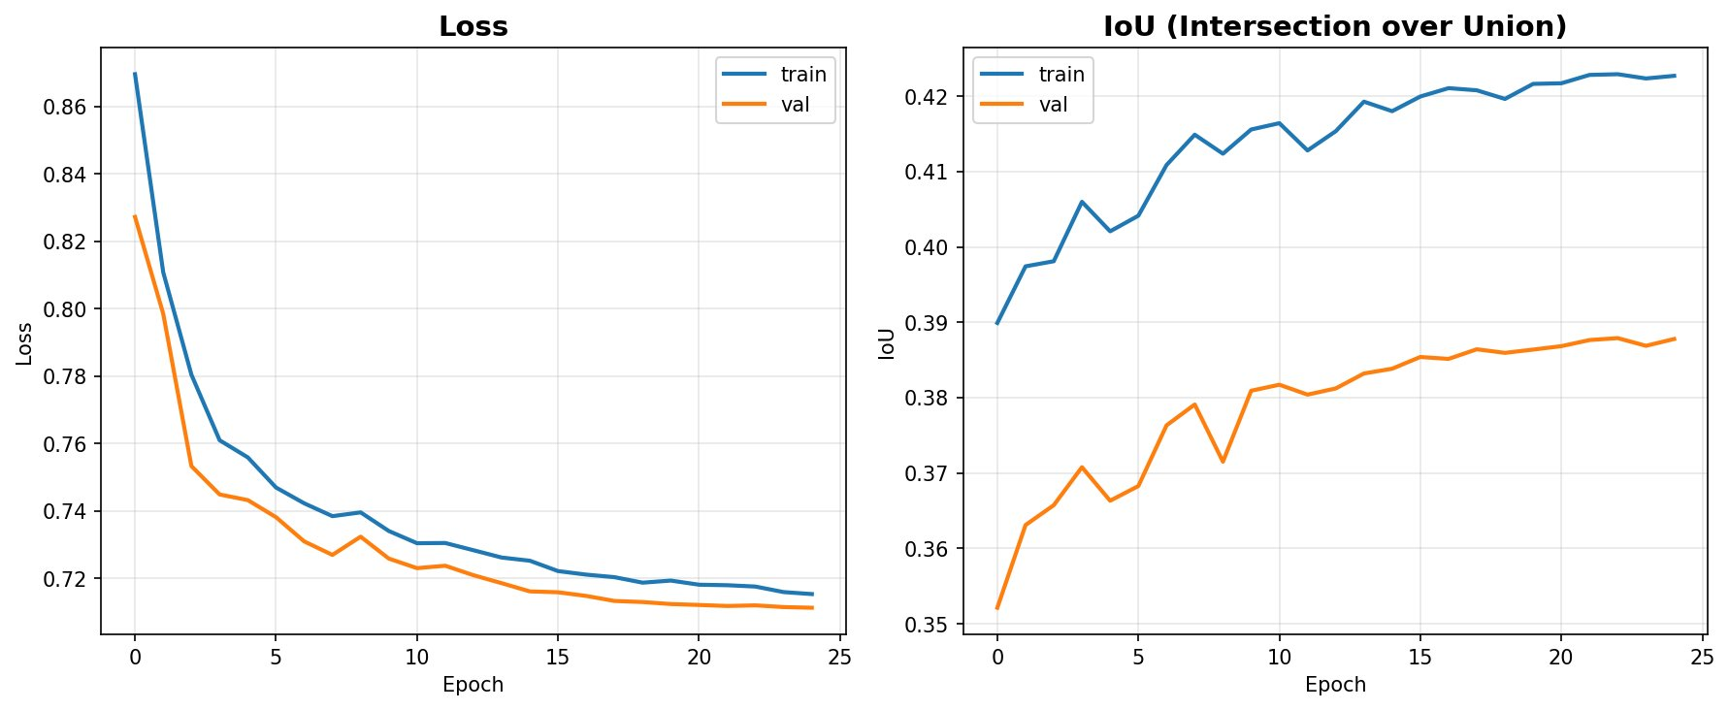
Training and Validation Loss (left) and IoU (right) across 25 epochs. Both metrics show consistent improvement with no signs of overfitting.
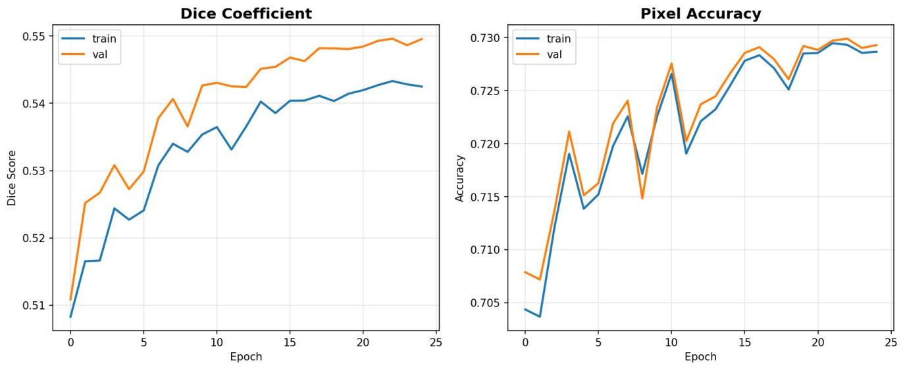
Dice Coefficient (left) and Pixel Accuracy (right) across 25 training epochs. Validation metrics marginally exceed training metrics throughout.

3.2 Per-Class Analysis
Table 2 presents the per-class IoU scores measured at Epoch 23. A clear performance stratification is visible across the ten classes, reflecting differences in pixel frequency, visual distinctiveness, and annotation consistency.
Class | IoU Score | Performance Level
Background | 0.4852 | Moderate
Trees | 0.4571 | Moderate
Lush Bushes | 0.4486 | Moderate
Dry Grass | 0.4743 | Moderate
Dry Bushes | 0.1758 | Low
Ground Clutter | 0.1263 | Low
Logs | 0.1105 | Low
Rocks | 0.1718 | Low
Landscape | 0.5473 | Good
Sky | 0.9765 | Excellent
Sky achieves a near-perfect IoU of 0.9765, benefiting from its visually homogeneous appearance and consistent representation across the dataset. Landscape and Background also achieve moderate-to-good scores of 0.5473 and 0.4852, respectively, owing to their relatively large pixel footprint and distinctive visual texture.
In contrast, Logs (0.1105), Ground Clutter (0.1263), and Rocks (0.1718) record the lowest IoU values. These classes are infrequent in the training distribution, visually ambiguous, and partially occluded in many scenes. The per-class IoU evolution across epochs, shown in Figure 4, confirms that these classes show minimal improvement over training, indicating that their difficulty is structural rather than a consequence of insufficient training duration.
The vegetation classes — Trees (0.4571), Lush Bushes (0.4486), and Dry Grass (0.4743) — achieve moderate scores despite their visual similarity to one another. The augmentation strategy, particularly color jitter and gamma correction, partially mitigated this confusion.
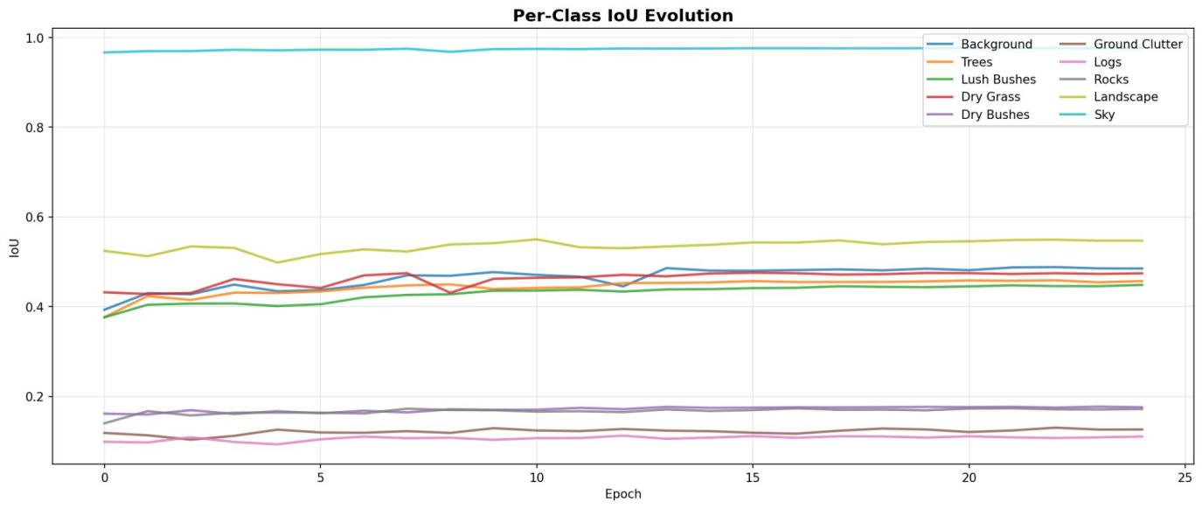
Per-Class IoU bar chart at Epoch 23. Sky dominates at 0.9765. Minor classes (Logs, Ground Clutter, Rocks, Dry Bushes) remain below 0.18.
Per-Class IoU Evolution across all 25 training epochs. Sky maintains stable high performance. Most classes show gradual improvement over training.

3.3 Qualitative Analysis
Visual inspection of prediction outputs, as shown in Figure 1, reveals that the model captures the coarse layout of desert scenes accurately. The sky region is segmented with near-perfect precision. Landscape and dry grass regions are broadly identified, although fine boundary delineation between visually similar ground classes remains imprecise.

The prediction overlay demonstrates that the model correctly identifies the large open landscape in the foreground, separates sky and horizon accurately, and partially segments scattered vegetation. Confusion is primarily concentrated at boundaries between Dry Grass, Dry Bushes, and Landscape, which is consistent with the quantitative per-class analysis. Minority class objects such as individual rocks and log fragments are frequently missed or misclassified, indicating a need for targeted handling strategies.

4. Challenges in Desert Terrain Segmentation
Semantic segmentation of desert terrain presents several challenges that distinguish it from benchmarks such as Cityscapes or ADE20K:
4.1 High Intra-Class Visual Variability
Classes such as Dry Grass and Landscape share similar color palettes across different lighting conditions. Shadows, dust haze, and overexposure further reduce the discriminability of texture features that would otherwise differentiate these categories.
4.2 Severe Class Imbalance
Sky pixels frequently account for a disproportionate area of the image, while minority classes such as Logs, Rocks, and Ground Clutter collectively occupy a small fraction of total pixels. Uncorrected, this distribution biases the model towards majority classes, suppressing recall on underrepresented categories.
4.3 Structural Ambiguity at Class Boundaries
Dense bush fields, mixed ground clutter, and partially occluded rock formations produce boundaries that are inherently ambiguous even to human annotators. This ambiguity propagates into annotation noise and contributes to low IoU scores for affected classes.
4.4 Lack of Structured Scene Geometry
Unlike urban segmentation, desert scenes lack consistent structural elements such as road lanes or building facades that provide strong prior cues. The model must rely on texture and appearance alone without geometric anchors.

5. Future Improvements
Based on the analysis of current results, the following directions are identified for future work:

5.1 Partial Backbone Fine-Tuning
Selectively unfreezing and fine-tuning the final transformer blocks of DINOv2 with a low learning rate could allow domain adaptation of the backbone representations without sacrificing generalization.
5.2 Hierarchical Feature Extraction
Incorporating a Feature Pyramid Network (FPN) or multi-scale attention mechanism to fuse features from multiple ViT layers could improve boundary delineation and spatial resolution of predictions.
5.3 Targeted Minority Class Handling
Oversampling training patches centered on minority class instances, or applying hard example mining, would increase the effective training frequency of Logs, Rocks, and Ground Clutter regions.
5.4 Semi-Supervised Learning
Leveraging unlabelled desert terrain images through pseudo-labeling or consistency regularization could expand the effective training dataset without additional annotation cost.
5.5 Test-Time Augmentation and Ensembling
Applying TTA (flips, scale variations) at inference time and ensembling predictions across multiple runs would likely yield incremental mIoU gains, particularly for ambiguous boundary regions.

6. Conclusion
This report presented a semantic segmentation system for offroad desert terrain, combining a frozen DINOv2 Vision Transformer backbone with a ConvNeXt-style convolutional decoder. Trained on a 10-class desert terrain dataset with a combined Dice and Weighted Cross-Entropy loss, the model achieved a best validation mIoU of 0.3879, a Dice coefficient of 0.5496, and a pixel accuracy of 72.99% at Epoch 23.
The system demonstrates strong performance on visually distinct classes such as Sky and Landscape, while confirming the inherent challenge of minority class segmentation in unstructured natural environments. The training process was stable, well-regularized, and exhibited no overfitting — validating the effectiveness of the frozen backbone approach combined with targeted loss weighting and augmentation.
The results establish a solid baseline for further development. Priorities for improvement include partial backbone fine-tuning, multi-scale feature integration, and augmented minority class representation. With these enhancements, the architecture has the potential to achieve competitive performance relative to specialist models trained end-to-end on domain-specific data.

