Join

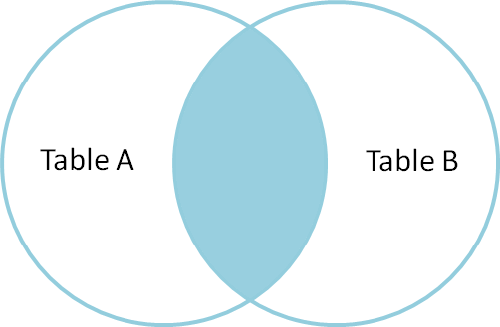

Fig. Inner Join

**Inner Join without condition**

select dept_name,budget,room_number, capacity from department inner join classroom;

**Inner join with condition**

select dept_name,budget,room_number,capacity from department inner join classroom on department.building =classroom.building;

**All tables record view**

select * from classroom;

select * from course;

select * from department;

select * from instructor;

select * from section;

select * from teaches;

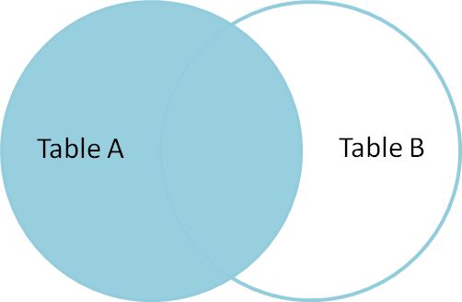

Left Join/Left Outer Join

select instructor.ID, instructor.name, department.building from instructor left join department on instructor.dept_name=department.dept_name;

select classroom.room_number, department.dept_name from classroom left join department on classroom.building=department.building;

Right join/Right Outer join

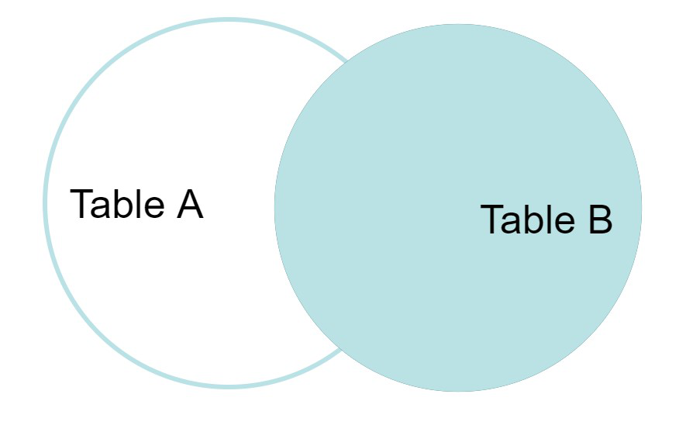

select teaches.course_id, teaches.sec_id,instructor.name from teaches right join instructor on teaches.ID=instructor.ID;

select department.building, department.budget, instructor.ID, instructor.name from department right join instructor on department.dept_name=instructor.dept_name;

**Full Join**

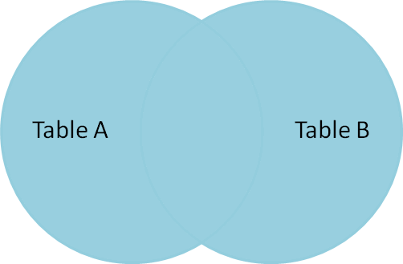

select * from department left join course on department.dept_name=course.dept_name union select * from department right join course on department.dept_name=course.dept_name;

Natural Join

select dept_name,budget,room_number,capacity from department natural join classroom;