**MAWLANA BHASHANI SCIENCE AND TECHNOLOGY UNIVERSITY**

SANTOSH, TANGAIL-1902



DEPARTMENT OF INFORMATION AND COMMUNICATION TECHNOLOGY

**Lab Report**

**Lab Report No : 01**

**Lab Report on :** Installation of MySQL

**Course Title :** Database Management System Lab

**Course Code :** ICT-2108

|  |  |
| --- | --- |
| Submitted By | Submitted To |
| Name: Kuldip Saha Mugdha  ID: IT-22018  2nd Year, 1st Semester  Session: 2021-2022  Dept. of ICT, MBSTU | Dr. Md. Abir Hossain  Associate Professor  DEPARTMENT OF INFORMATION AND COMMUNICATION TECHNOLOGY  MAWLANA BHASHANI SCIENCE AND TECHNOLOGY UNIVERSITY |

Date of Performance: 27/02/24Date of Submission: 05/03/24

**Experiment no :**  01

**Experiment name :** Installation of MySQL.

**Objectives:**

The main objective of this experiment is to download and setup MySQL Community Server in our personal computer. We will download MySQL Community Server 8.3.0 and will learn to install it and will come to know about the datatypes used in MySQL.

**Required Instruments**:

1. Computer (RAM-at least 4 GB)

2. Internet connection

3. Mouse, Keyboard

4. MySQL Community Server installer (available from the official MySQL website).

**Procedure :**

**Step 1 :**

Go to your chrome browser and download MySQL Community Server 8.3.0 Innovation for windows 64 bit operating system.

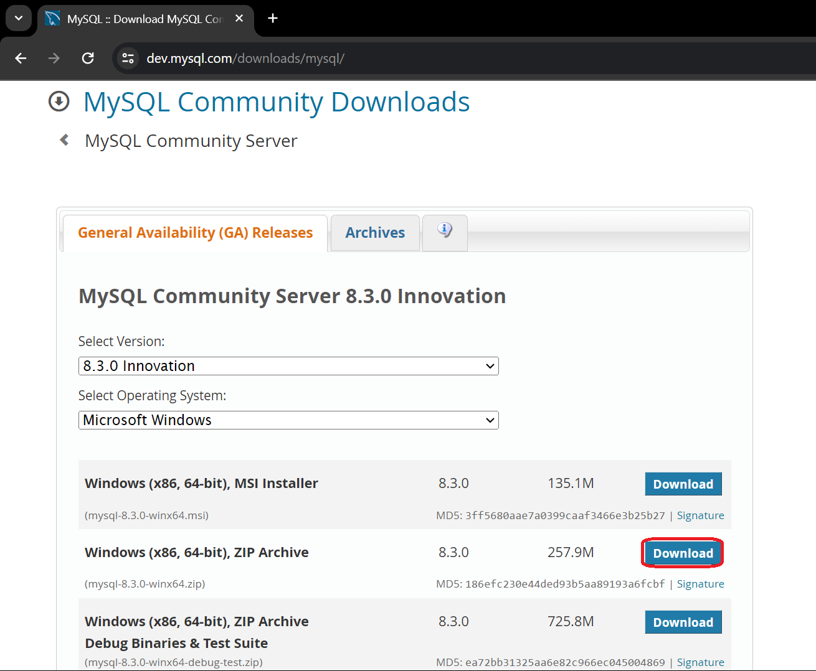

**Step 2 :** After download is completed then open the file and this will show the interface to start setup. Click on “Run” and next interface Click on “Next”.

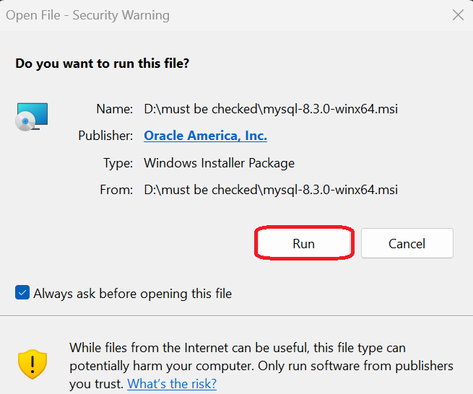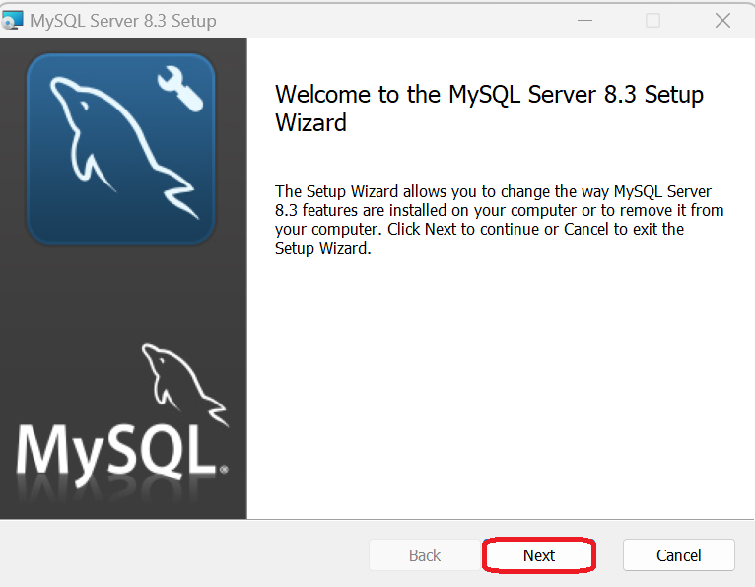

**Step 3 :**  Accept all the terms in the License Agreement and click on “Next”.

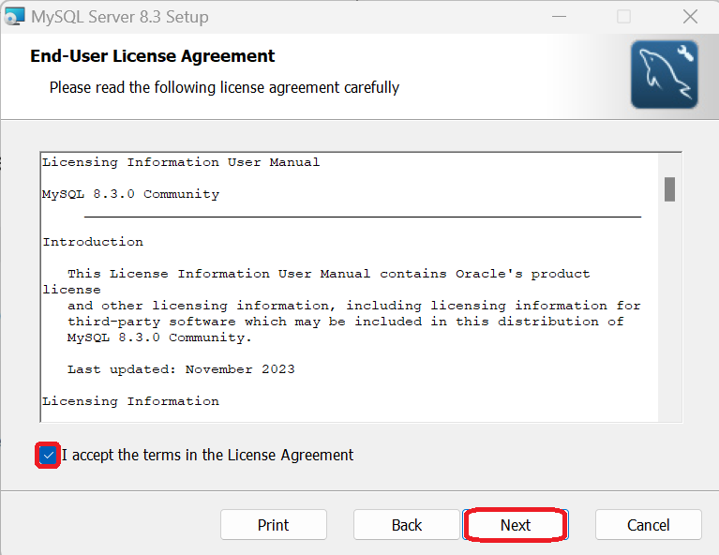

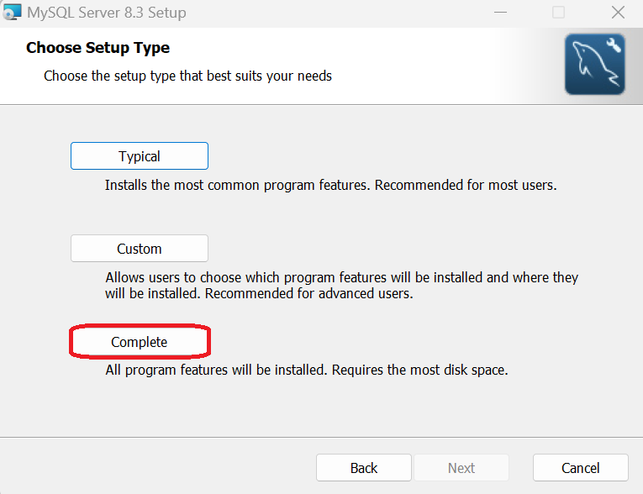**Step 4 :** Now select “Complete” and click on “Next”.

**Step 5 :** Now it is ready to install. Click on “Install”.

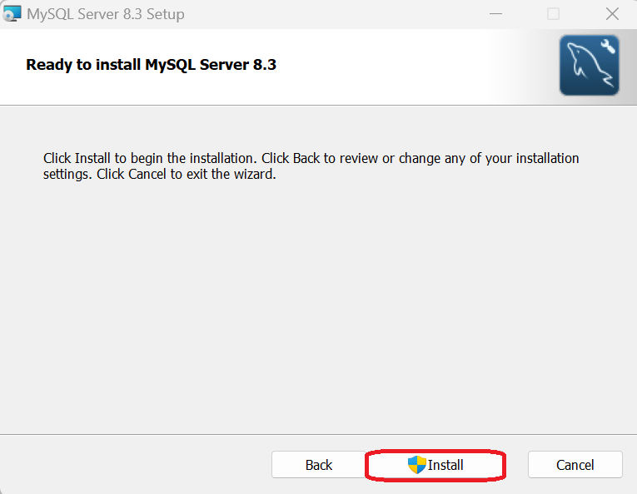

**Step 6 :**  After installation is finished ,checkout the option “Run MySQL Configuration” and click on “Finish”.

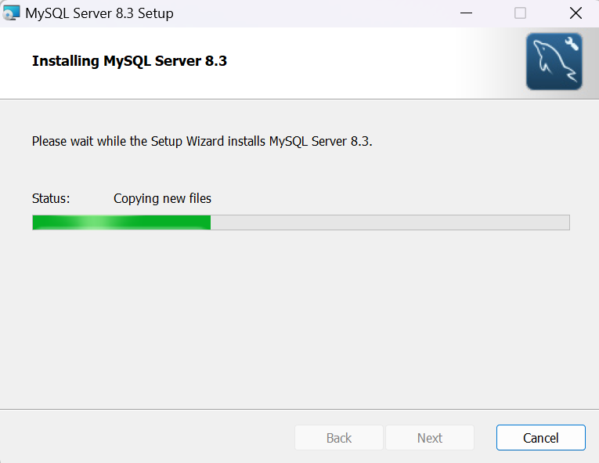

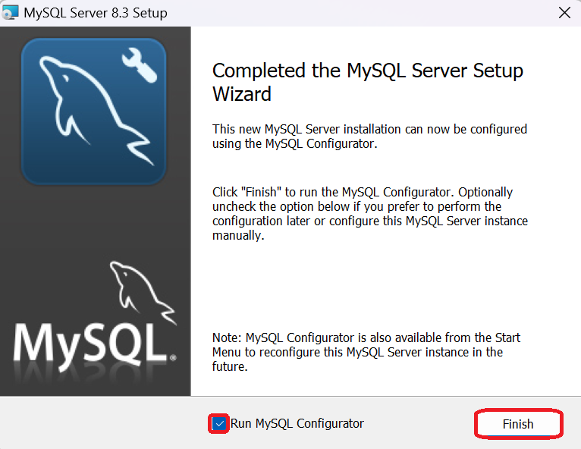

**Step 7 :**  Several times Click on “Next”.

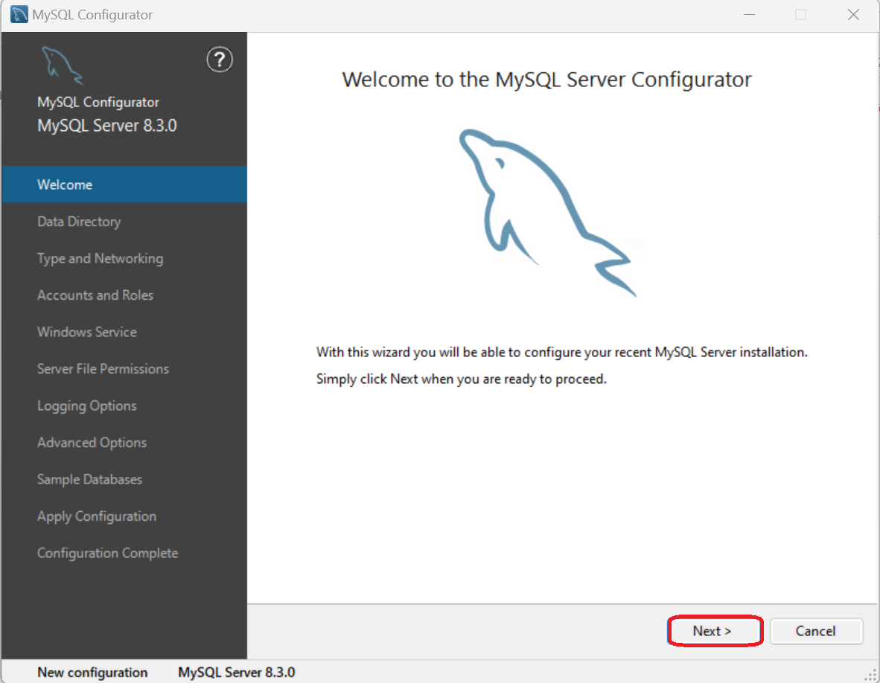

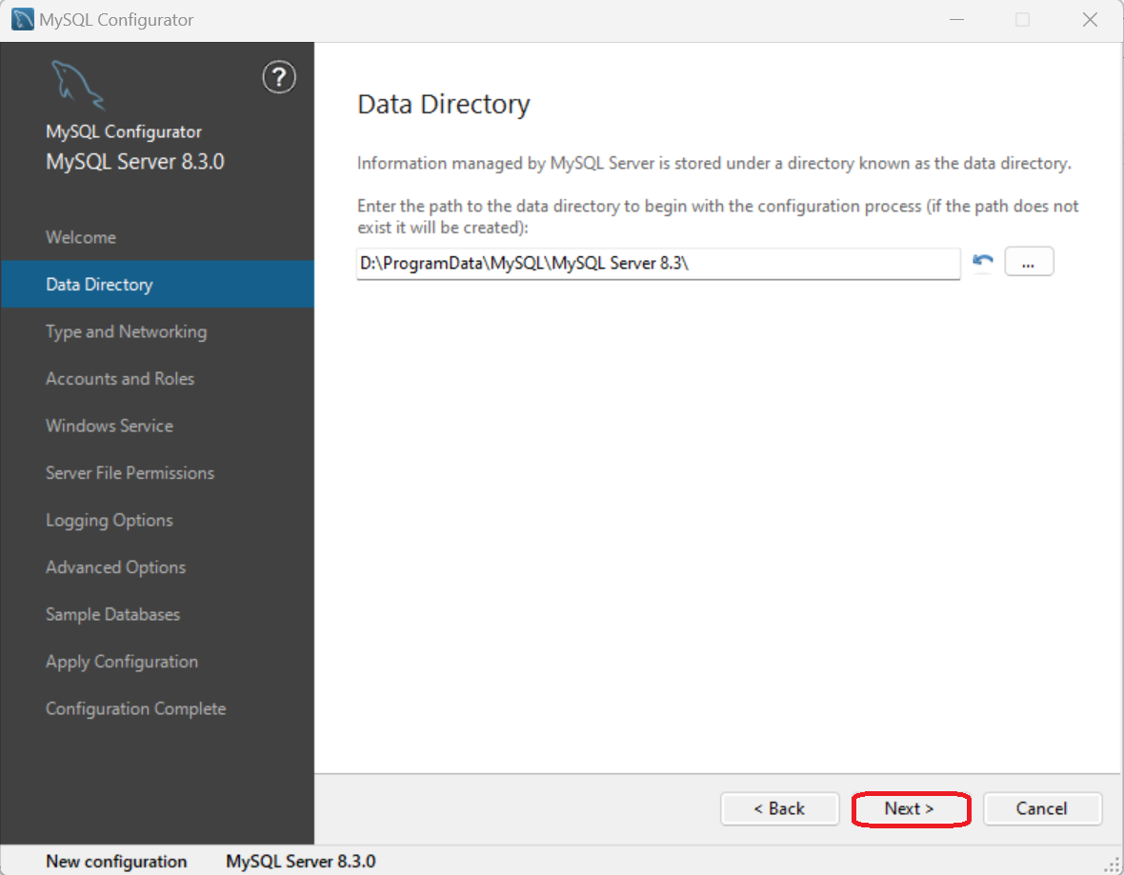

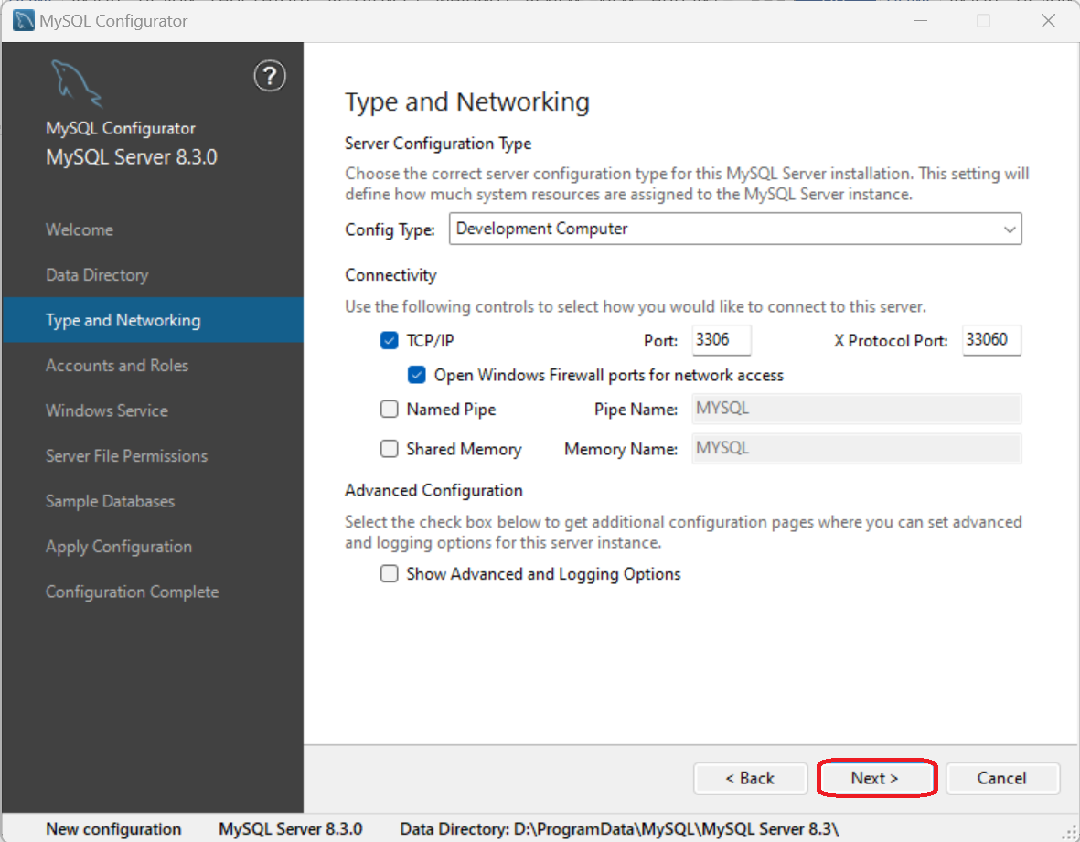

**Step 8 :** Create your own MySQL password and repeat to make it confirm. You can set your username for your own account and it is optional(Here the username is set as “Mugdha”).

Click on “Next” continuously.

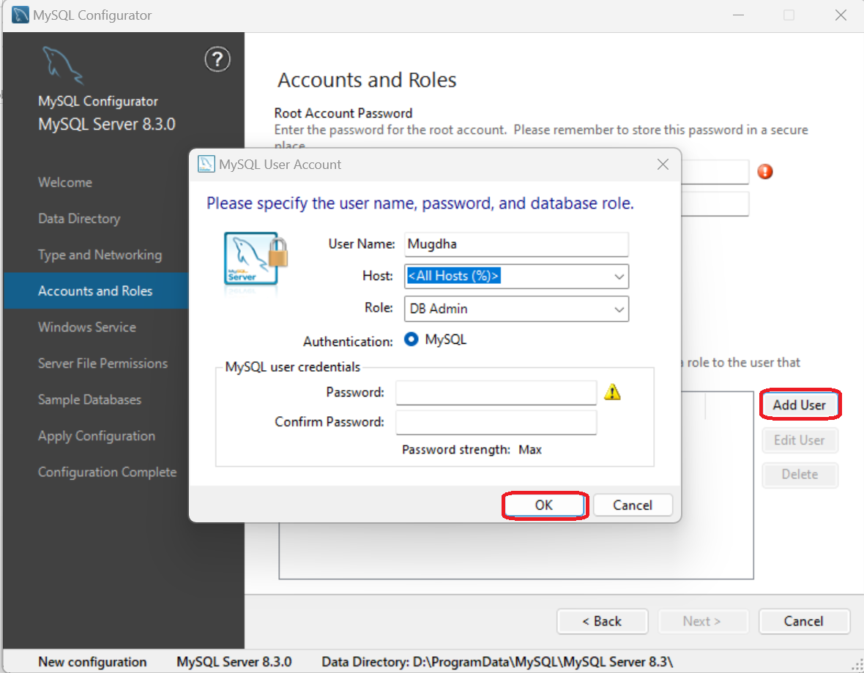

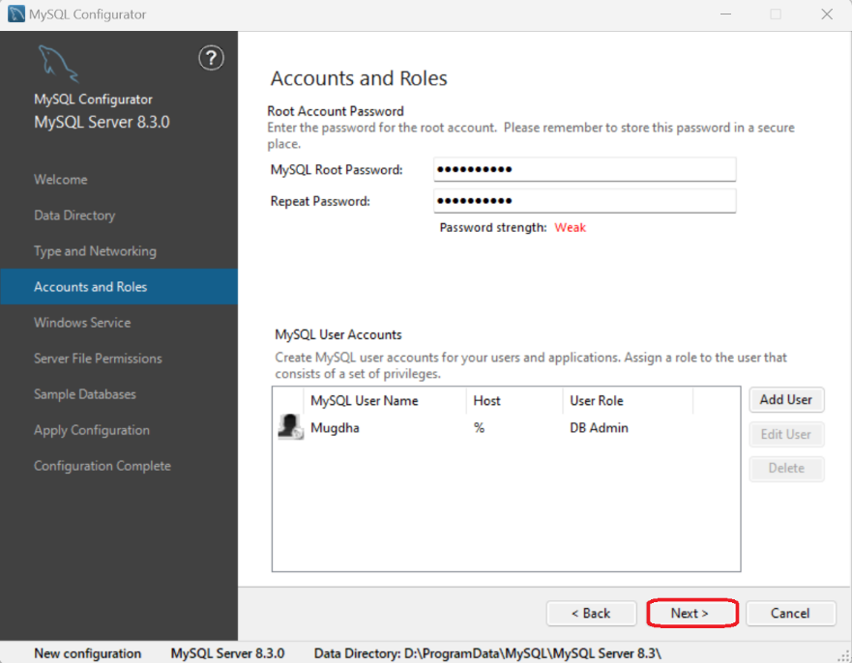

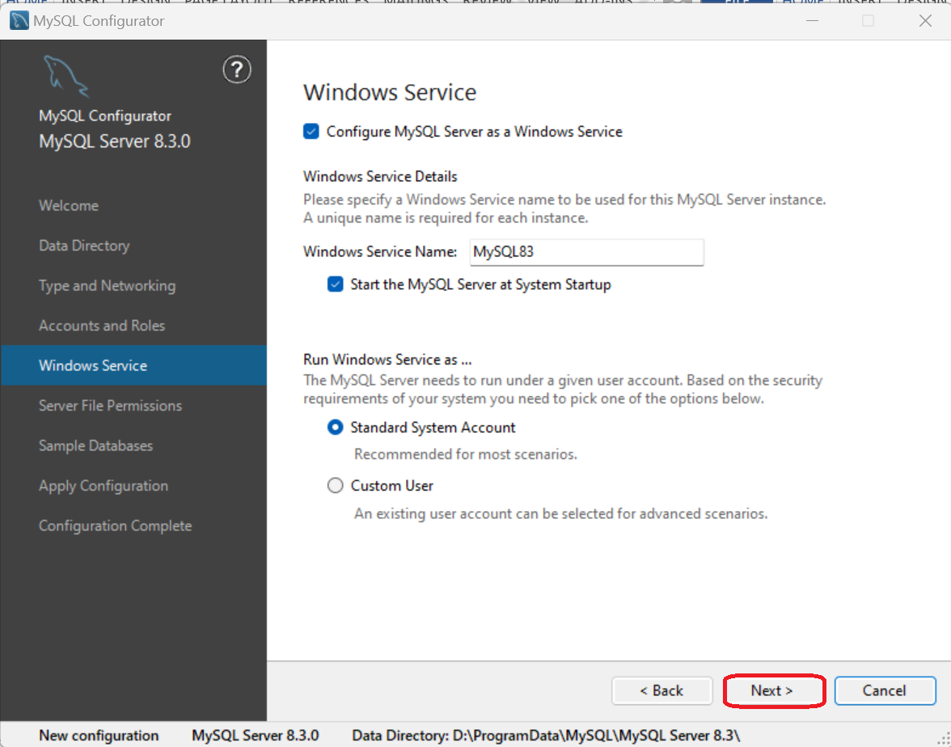

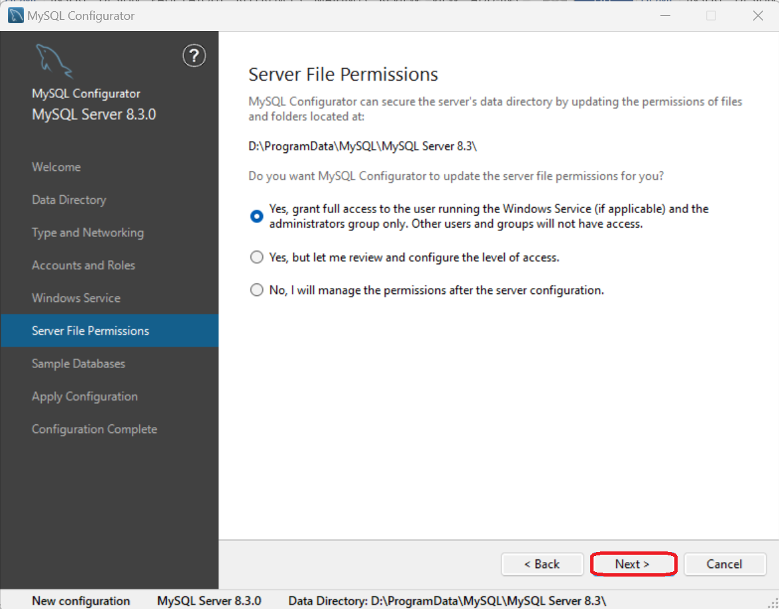

**Step 9 :** Checkout both options and click on “Next”.

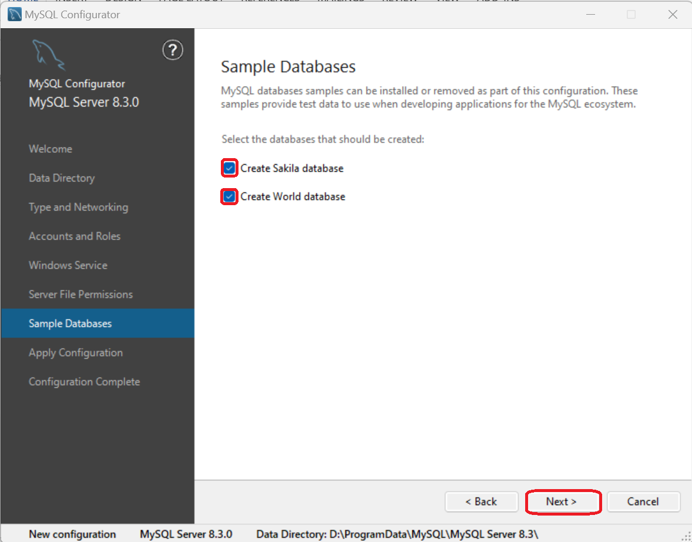

**Step 10 :** Click on “Execute” and the configuration will be executed one by one. This may take some time.

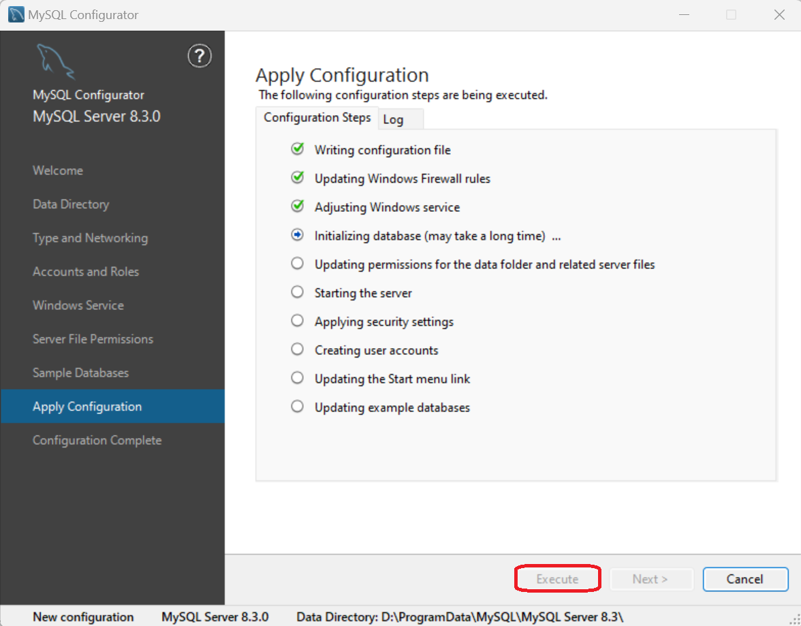

**Step 11 :** Once the execution of the configuration is completed click on “Finish”.

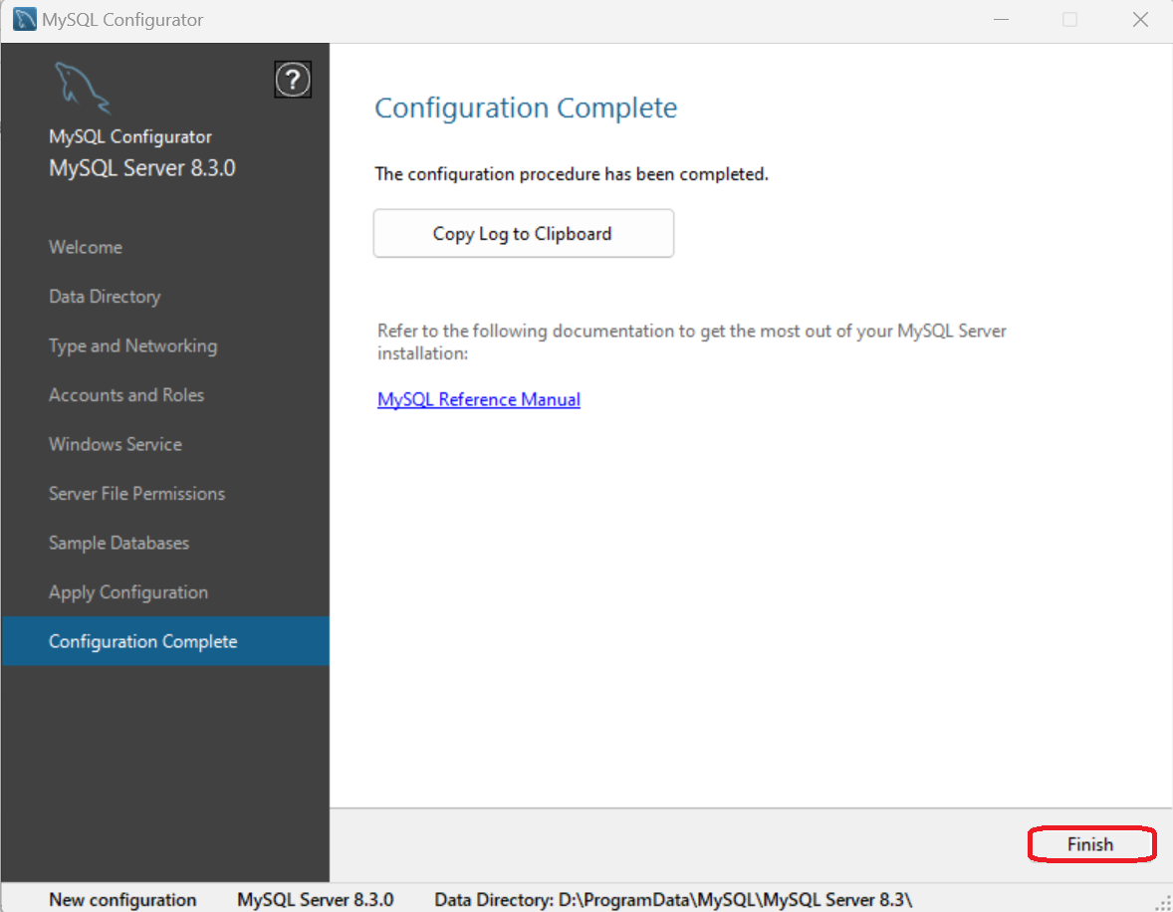

And the installation and setup of MySQL 8.3 is completed.

After installation, we go to the “MySQL Command Line Client” in our computer and we will find this window where we have to input our password.

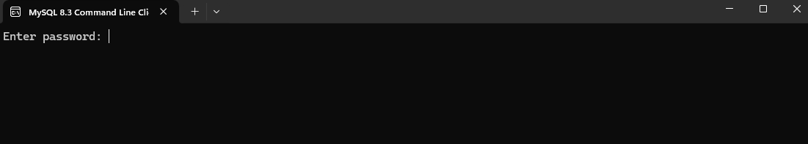

After inputting the password we will get the main view of MySQL. This look like this.

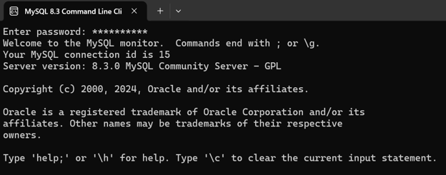

**Discussion:** Installing MySQL is relatively easy. After installing the software, now we can create databases, tables and make relations among them using MySQL.