**MAWLANA BHASHANI SCIENCE AND TECHNOLOGY UNIVERSITY**

SANTOSH, TANGAIL-1902



DEPARTMENT OF INFORMATION AND COMMUNICATION TECHNOLOGY

**Lab Report**

**Lab Report No : 02**

**Lab Report on :** Creation of Databases, Tables and Inserting Records.

**Course Title :** Database Management System Lab

**Course Code :** ICT-2108

|  |  |
| --- | --- |
| Submitted By | Submitted To |
| Name: Kuldip Saha Mugdha  ID: IT-22018  2nd Year, 1st Semester  Session: 2021-2022  Dept. of ICT, MBSTU | Dr. Md. Abir Hossain  Associate Professor  DEPARTMENT OF INFORMATION AND COMMUNICATION TECHNOLOGY  MAWLANA BHASHANI SCIENCE AND TECHNOLOGY UNIVERSITY |

Date of Performance: 05/03/24Date of Submission: 12/03/24

**Experiment no:**  02

**Experiment name:** Creating tables and inserting values in database.

**Objectives:**

The main objective of this experiment is to create a database on MySQL and create some tables and insert values on that tables.

**Required Instruments**:

1. Computer (RAM-at least 4 GB)

2. Internet connection

3. MySQL 8.3 command line client

**Procedure:**

**Create database:** First I use a query for create a new database.

**SQL expression:** create database Mugdha;

**Show database:** Then I use a query to show all database.

**SQL expression:** show databases;

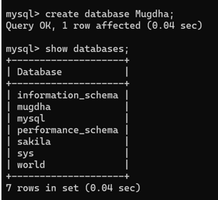

**Use database:** Then I use a query for use database Mugdha.

**SQL expression:** use mugdha;

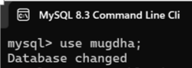

**Creating table department and describing it:**

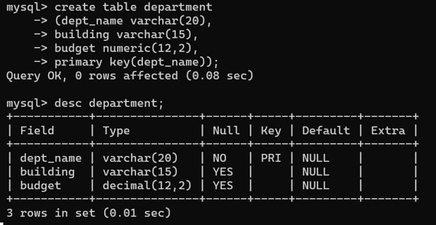

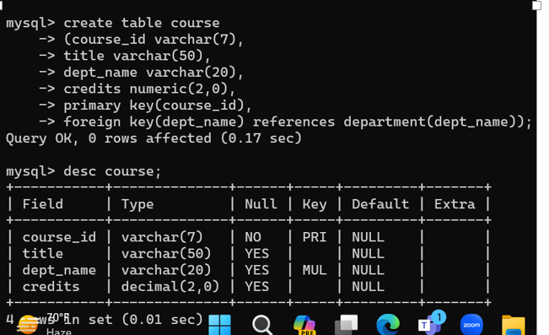**Creating table course and describing it:**

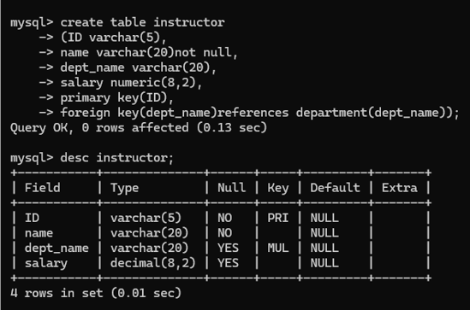**Creating table instructor and describing it:**

**Creating table section and describing it:**

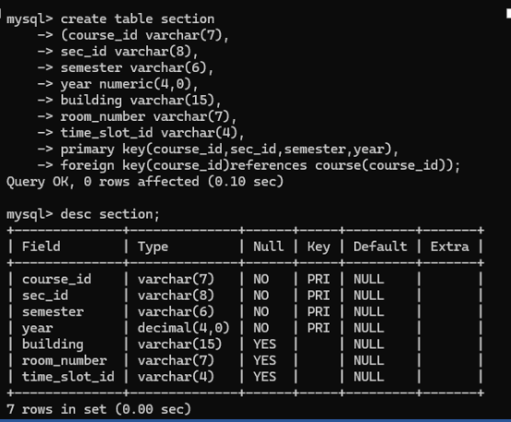

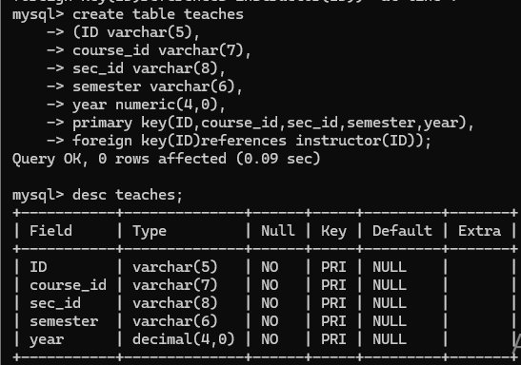**Create table teaches and describe it:**

**Data insert into department table:**

**SQL expression:** insert into department values(“ICT”, ”Academic-1”, 100000.00);

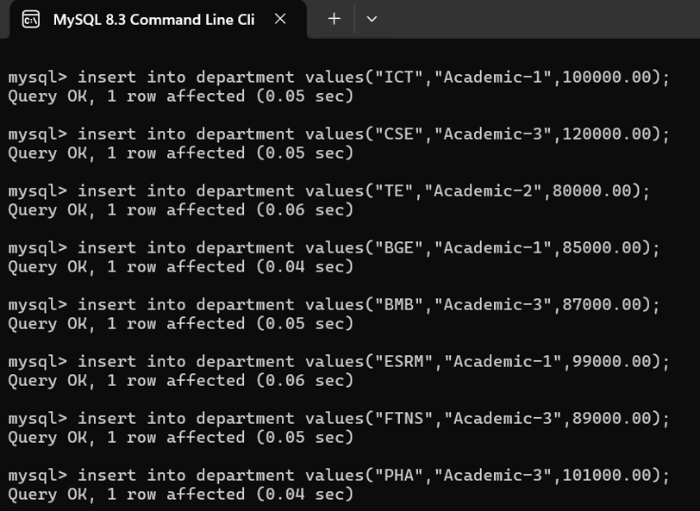

**Show all data from department:**

**SQL expression:** select * from department;

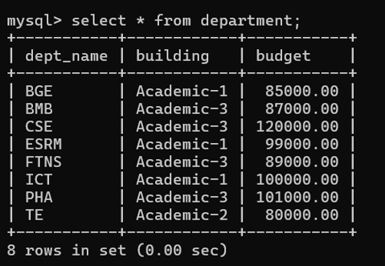

**Data insert into course table:**

**SQL expression:** inset into course values(“ICT-01”, “C programming”, “ICT”, 3.00);

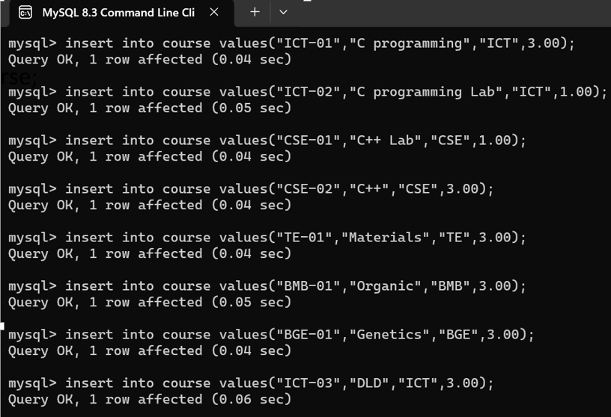

**Show all data from course:**

**SQL expression:** select * from course;

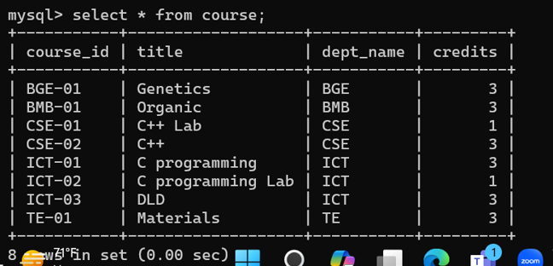

**Data insert into instructor table:**

**SQL expression:** insert into instructor values(“10000”, “Kuldip”, “ICT”, 50000.00);

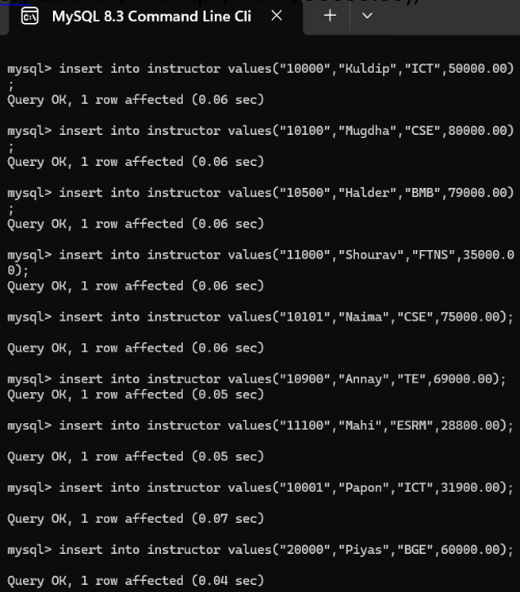

**Show all data from instructor:**

**SQL expression:** select * from instructor;

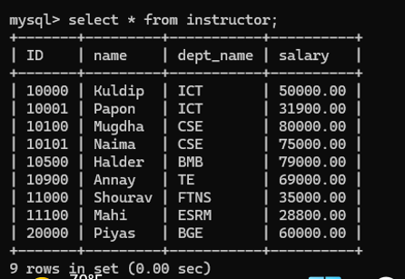

**Data insert into section table:**

**SQL expression:** insert into section values(“ICT-01”, “1”, “Fall”, “2023”, “Academic-1”, “216”, “2.00”);

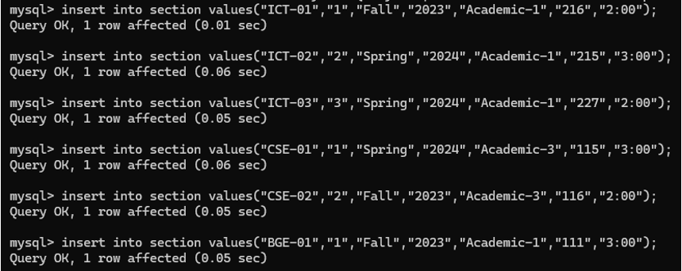

**Show all data from section:**

**SQL expression:** select * from section;

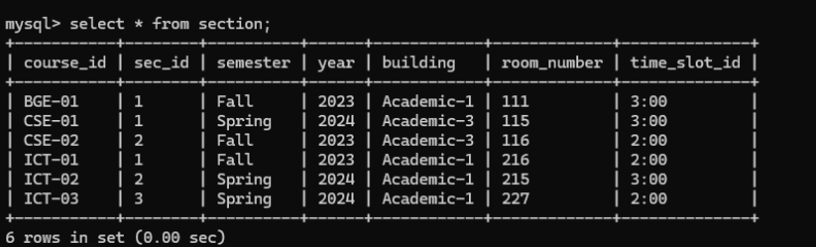

**Data insert into teaches table:**

**SQL expression:** insert into teaches values(“10000”, “ICT-01”, “1”, “Fall”, “2023”);

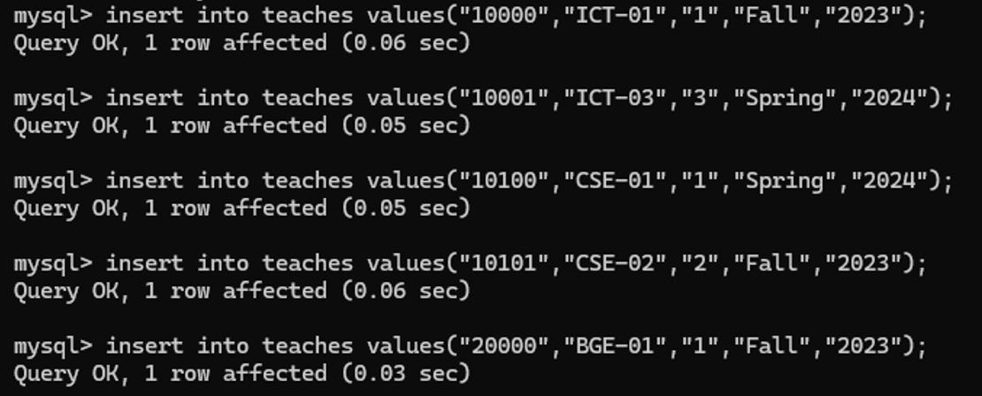

**Show all data from teaches:**

**SQL expression:** select * from teaches;

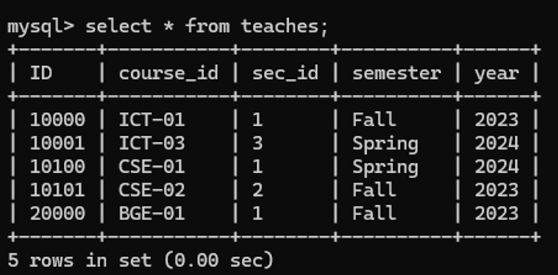

**Discussion:** Now we can easily create a database and also create table and insert values into those tables using above query. Using databases we can easily maintain our data.