**MAWLANA BHASHANI SCIENCE AND TECHNOLOGY UNIVERSITY**

SANTOSH, TANGAIL-1902



DEPARTMENT OF INFORMATION AND COMMUNICATION TECHNOLOGY

**Lab Report**

**Experiment no :** 03

**Experiment name :** Different Types of Select Operations in MySQL.

**Course Title :** Database Management Systems Lab

**Course Code :** ICT-2108

|  |  |
| --- | --- |
| Submitted by | Submitted to |
| Name: Kuldip Saha Mugdha  ID : IT22018  2nd Year, 1st Semester  Session: 2021-2022  Dept. of ICT, MBSTU | Dr. Md. Abir Hossain  Associate Professor ,  DEPARTMENT OF INFORMATION AND COMMUNICATION TECHNOLOGY  MAWLANA BHASHANI SCIENCE AND TECHNOLOGY UNIVERSITY |

**Date of performance : 12/3/2024**

**Date of submission : 19/3/2024**

**Experiment no :**  03

**Experiment name :** Different Types of Select Operations in MySQL.

**Objectives :** The main objective of this experiment is use some basic query of MySQL. We will learn how to show different attributes from database and also learn how to arithmetic expressions work in database.

**Required Instruments** :

1. Computer (RAM-at least 4 GB)

2. Internet connection

3. MySQL 8.3 Command line Client.

**Finding the names of all instructors:**

**SQL expression:** select name from instructor;

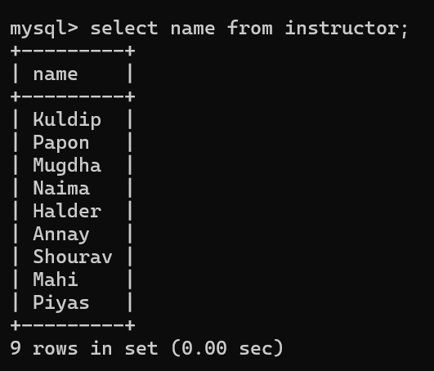

**Finding the department names of all instructors**:

**SQL expression:** select dept_name from instructor;

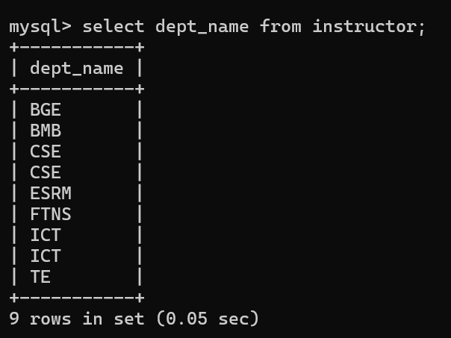

**Finding the distinct department names of all instructors:**

**SQL expression:** select distinct dept_name from instructor;

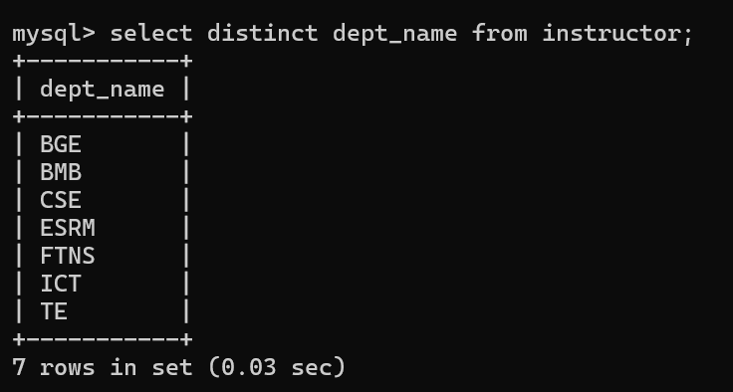

**Finding the names of all instructors in the ICT department who have salary greater than 40,000:**

**SQL expression:** select name from instructor where dept_name=’ICT’ and salary>40000;

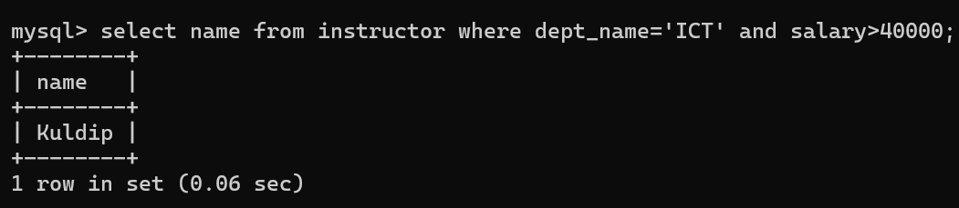

The select clause may also contain arithmetic expressions involving the operators +, −, ∗, and / operating on constants or attributes of tuples. For example, the query:

**SQL expression:** select ID, name, dept_name, salary *1.1 from instructor;

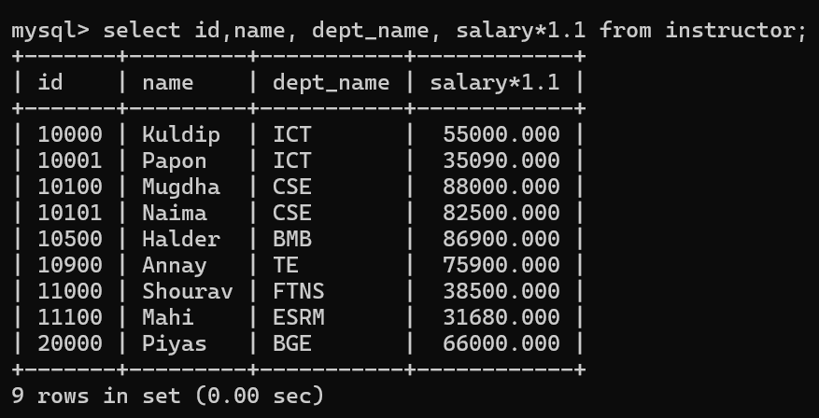

**Finding the names of all instructors, along with their department names and department building name.**

**SQL expression:** select name, instructor.dept_name, building from instructor, department where instructor.dept_name=department.dept_name;

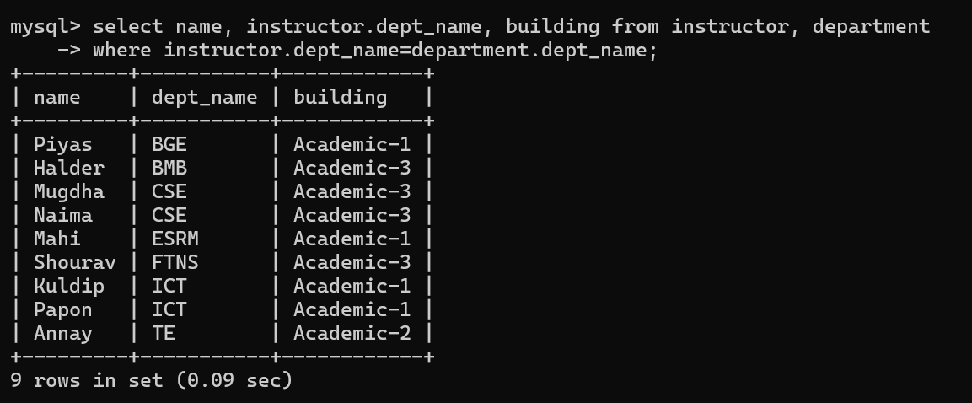

**Discussion:** Using the above queries we can easily find our desired attributes. We can use arithmetic expression to find desired values.