**MAWLANA BHASHANI SCIENCE AND TECHNOLOGY UNIVERSITY**

SANTOSH, TANGAIL-1902

DEPARTMENT OF INFORMATION AND COMMUNICATION TECHNOLOGY

**Course Title:** Microprocessor and Embedded System Lab

**Course Code:** ICT-2204

**Experiment Name:** Installation of EMU8086 Microprocessor Emulator

**Lab Report No: 01**

|  |  |
| --- | --- |
| Submitted By | Submitted To |
| Name: Kuldip Saha Mugdha  ID: IT-22018  2nd Year, 2nd Semester  Session: 2021-2022  Dept. of ICT, MBSTU | Dr. Md. Abir Hossain  Associate Professor  DEPARTMENT OF INFORMATION AND COMMUNICATION TECHNOLOGY  MAWLANA BHASHANI SCIENCE AND TECHNOLOGY UNIVERSITY |

Date of Performance: 13/11/2024 Date of Submission: 20/11/24

**Experiment no: 01**

**Experiment name:** Installation of EMU8086 Microprocessor Emulator

**Introduction:** EMU8086 is a comprehensive microprocessor emulator that enables users to write, compile, and debug assembly code for the 8086 microprocessors. It is commonly used in academic settings for teaching assembly language programming concepts and microprocessor architecture.

**Objectives:** To successfully download, install, and set up EMU8086, a microprocessor emulator used for learning and simulating Assembly language programming.

**Required Instruments:**

1. A computer with Windows operating system.
2. Internet connection.
3. EMU8086 installation package (can be downloaded from the official website or trusted sources).

**Procedure:**

**Step 1: Download EMU8086:** Open a web browser and navigate to the official EMU8086 website or another trusted source. Locate the latest version of EMU8086 and download the setup file. Click on Download button.

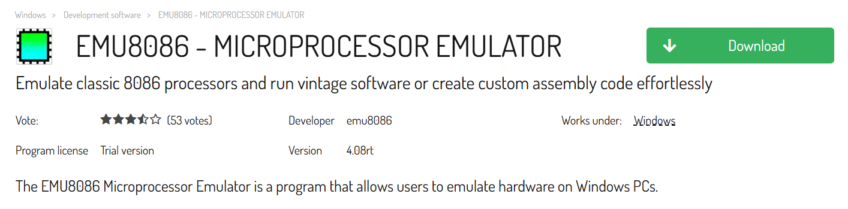

Click on Download for PC button.

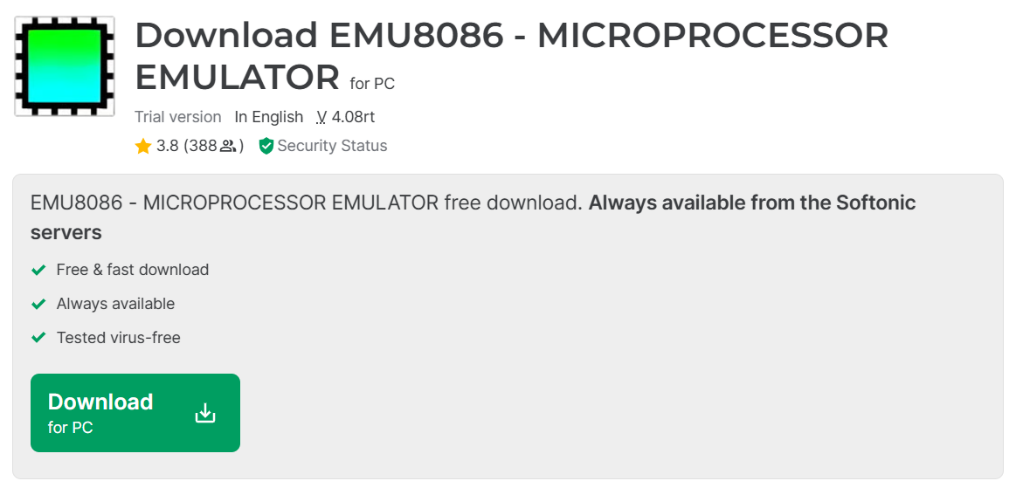

**Step 2:** Begin Installation: Double-click the downloaded setup file to launch the installation wizard. Then click on next.

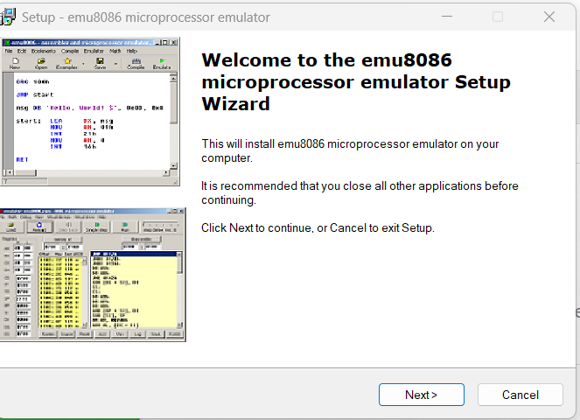

**Step 3:** Then I read the information and click on next.

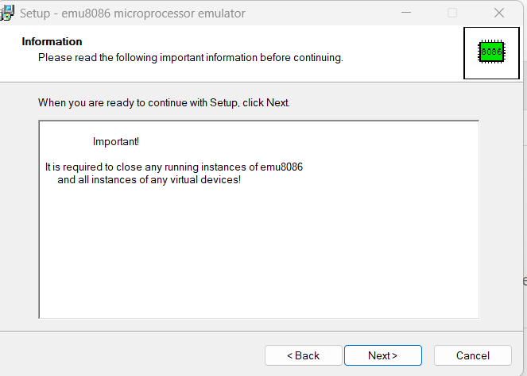

**Step 4:** Click on next.

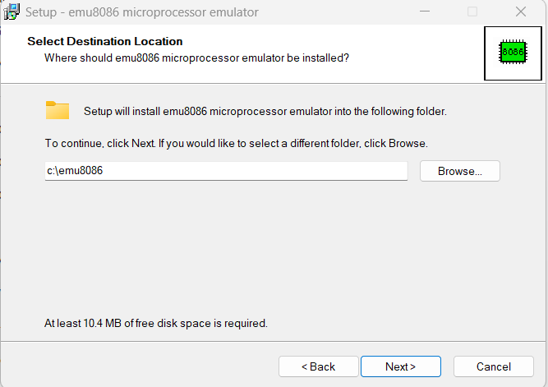

**Step 5:** Then emu8086 microprocessor emulator is ready to installation. Click on install.

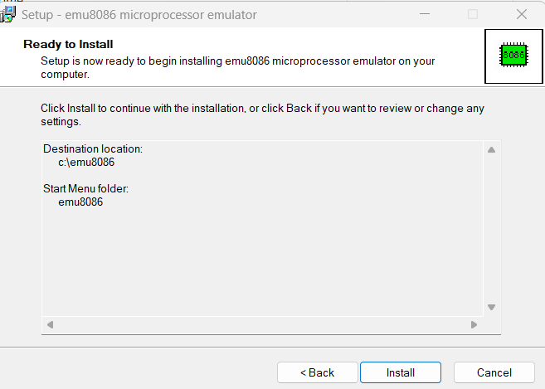

**Step 6:** Click on Finish for completing the emu8086 microprocessor emulator setup wizard.

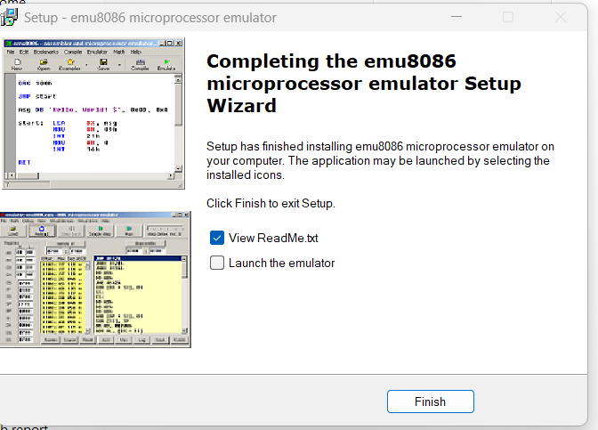

The installation of emu8086 microprocessor emulator is complete.

**Conclusion:** The installation of EMU8086 microprocessor emulator was successful, and the software is ready for use in assembly language programming and microprocessor emulation tasks.