**MAWLANA BHASHANI SCIENCE AND TECHNOLOGY UNIVERSITY**

SANTOSH, TANGAIL-1902

DEPARTMENT OF INFORMATION AND COMMUNICATION TECHNOLOGY

**Course Title:** Microprocessor and Embedded System Lab

**Course Code:** ICT-2204

**Experiment Name:** Problem Solving with Assembly Language - I

**Lab Report No: 02**

|  |  |
| --- | --- |
| Submitted By | Submitted To |
| Name: Kuldip Saha Mugdha  ID: IT-22018  2nd Year, 2nd Semester  Session: 2021-2022  Dept. of ICT, MBSTU | Dr. Md. Abir Hossain  Associate Professor  DEPARTMENT OF INFORMATION AND COMMUNICATION TECHNOLOGY  MAWLANA BHASHANI SCIENCE AND TECHNOLOGY UNIVERSITY |

Date of Performance: 20/11/2024 Date of Submission: 27/11/24

**Experiment no: 02**

**Experiment name:** Problem Solving with Assembly Language – I.

**Program 1:** A program that takes an input A and computes A = 5 – A

**Code:**

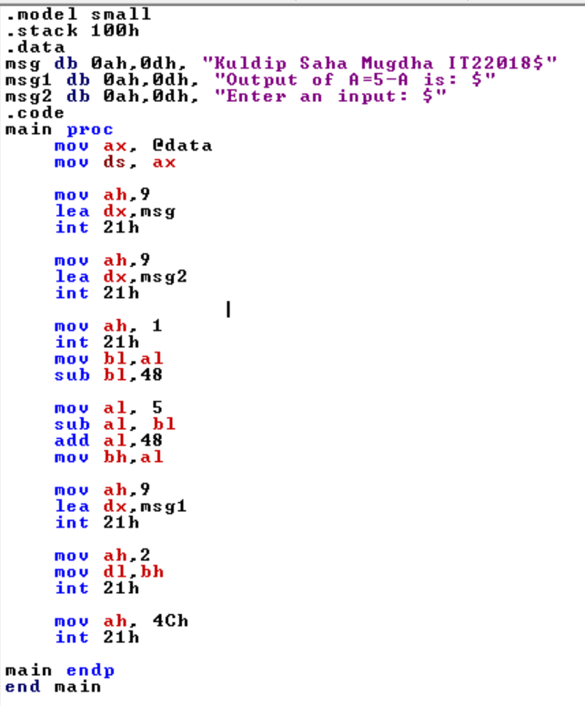

**Output:**

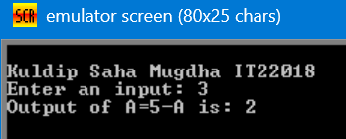

The program successfully updates the value of A to 5 - A.

**Program 2:** A program that takes two inputs A and B and computes A = B - 2A

**Code:**

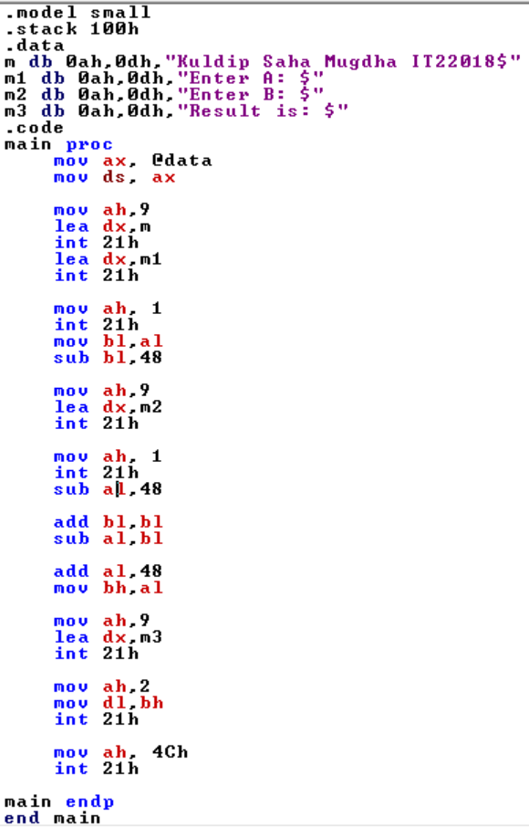

**Output:**

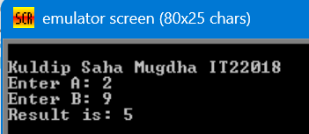

The program calculates A = B - 2A and stores the updated value in A.

**Program 3:** A program that shows a question mark (?), takes an input and prints the input text on a new line.

**Code:**

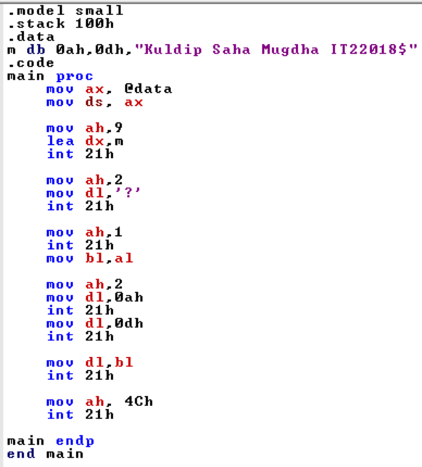

**Output:**

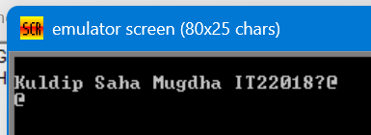

**Program 4:** A program that takes a lowercase letter and prints it in uppercase.

**Code:**

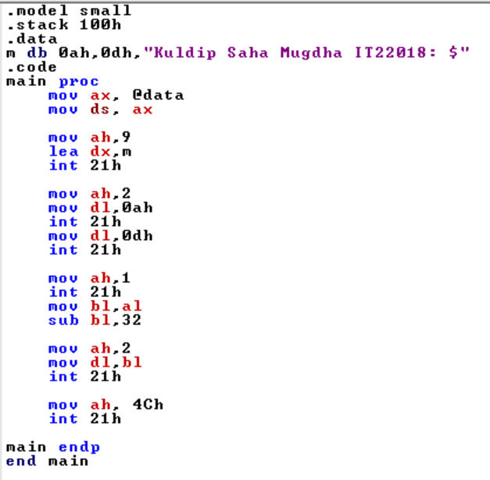

**Output:**

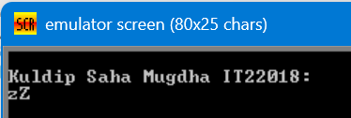

The program successfully converts lowercase characters to uppercase.

**Program 5:** Show a message: 'Enter a lowercase letter.' Then, on the next line, display the message: ‘In uppercase, it is ...’

**Code:**

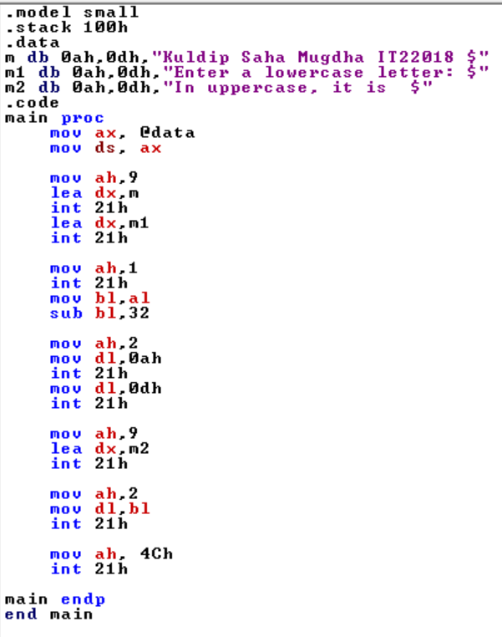

**Output:**

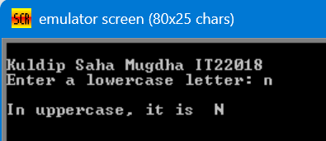

The program successfully converts lowercase characters to uppercase with massage.

**Conclusion:** This lab provided hands-on experience with basic assembly operations. The tasks demonstrated the use of arithmetic, input/output, and character manipulation, enhancing our understanding of low-level programming. Future improvements may include more complex operations or the integration of loops and conditional branches for extended functionality.