**MAWLANA BHASHANI SCIENCE AND TECHNOLOGY UNIVERSITY**

SANTOSH, TANGAIL-1902

DEPARTMENT OF INFORMATION AND COMMUNICATION TECHNOLOGY

**Course Title:** Microprocessor and Embedded System Lab

**Course Code:** ICT-2204

**Experiment Name:** Problem Solving with Assembly Language - II

**Lab Report No: 03**

|  |  |
| --- | --- |
| Submitted By | Submitted To |
| Name: Kuldip Saha Mugdha  ID: IT-22018  2nd Year, 2nd Semester  Session: 2021-2022  Dept. of ICT, MBSTU | Dr. Md. Abir Hossain  Associate Professor  DEPARTMENT OF INFORMATION AND COMMUNICATION TECHNOLOGY  MAWLANA BHASHANI SCIENCE AND TECHNOLOGY UNIVERSITY |

Date of Performance: 27/11/2024 Date of Submission: 4/12/24

**Experiment no: 03**

**Experiment name:** Problem Solving with Assembly Language – II.

**Program 1:** A program to (a) displays a "?", (b) read two decimal digits whose sum is less than 10, (c) display them and their sum on the next line, with an appropriate message.

Sample execution:

?27

The sum of 2 and 7 is 9

**Code:**

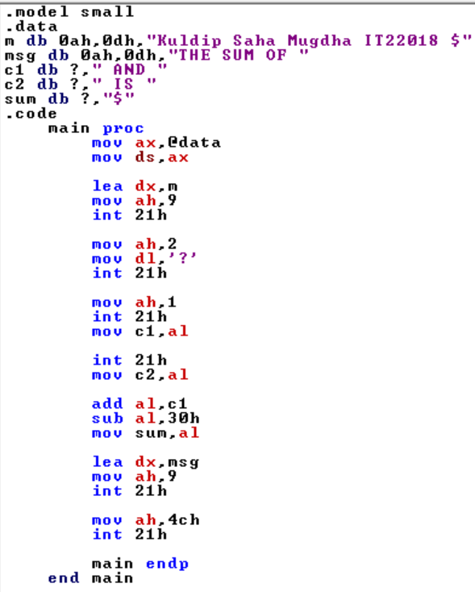

**Output:**

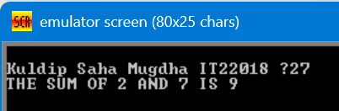

**Program 2:** A program to (a) prompt the user, (b) read first, middle, and last initials of a person's name, and (c) display them down the left margin.

Sample execution:

Enter three initials: JFK

J

F

K

**Code:**

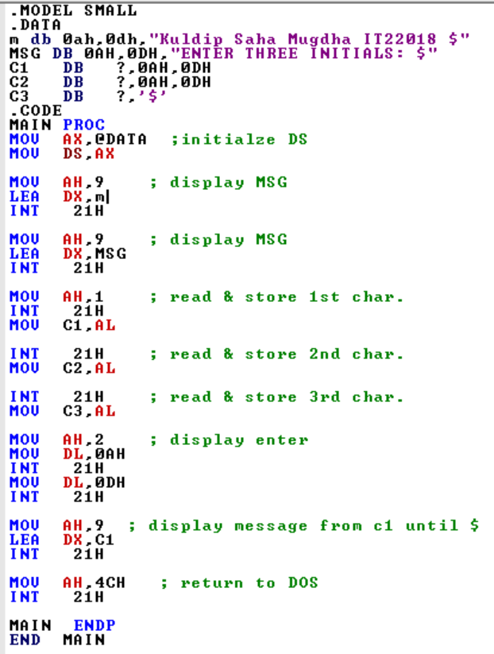

**Output:**

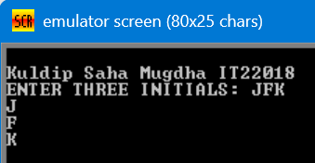

**Program 3:** A program to read one of the hex digits A-F, and display it on the next line in decimal. Enter a hex digit A-F: C

In decimal it is: 12

**Code:**

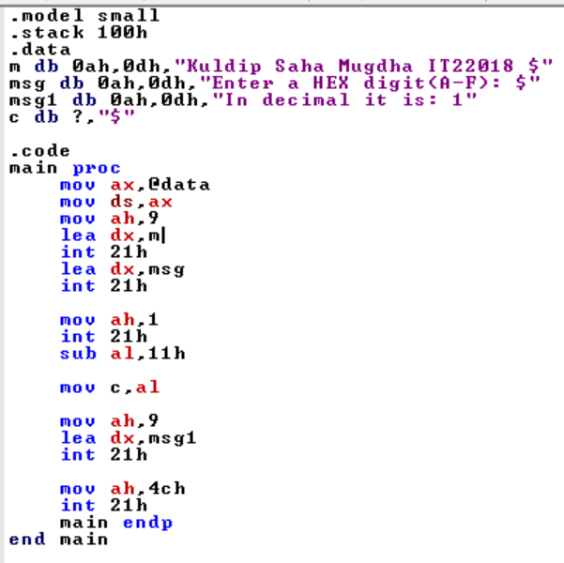

**Output:**

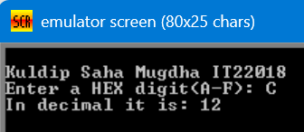

**Program 4:** A program to display a 10 x 10 solid box of asterisks.

Hint: declare a string in the data segment that specifies the box, and display it with INT 2lh, function 9h.

**Code:**

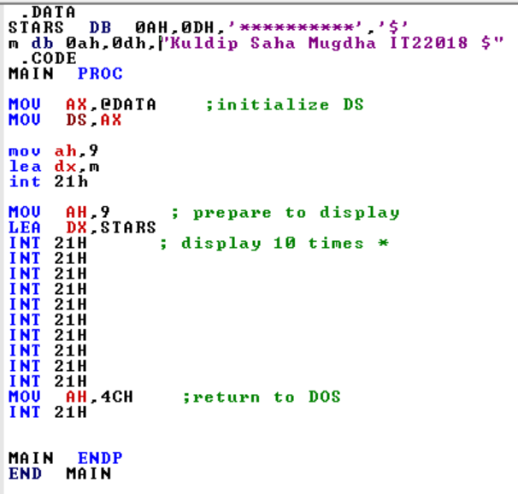

Output:

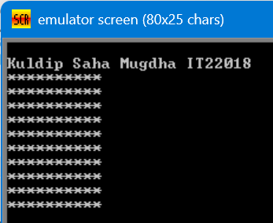

**Program 5:** A program to (a) display"?", (b) read three initials, (c) display them in the middle of an 11 x 11 box of asteriks, and (d) beep the computer.

**Code:**

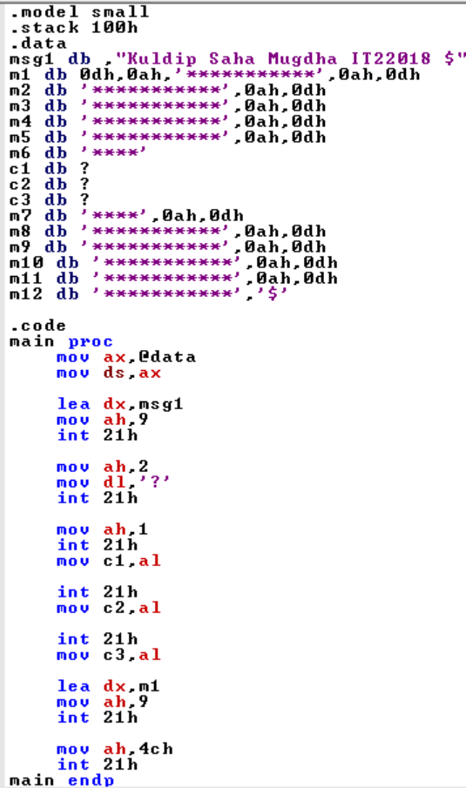

Output:

