**MAWLANA BHASHANI SCIENCE AND TECHNOLOGY UNIVERSITY**

SANTOSH, TANGAIL-1902

DEPARTMENT OF INFORMATION AND COMMUNICATION TECHNOLOGY

**Course Title:** Microprocessor and Embedded System Lab

**Course Code:** ICT-2204

**Experiment Name:** Problem Solving with Assembly Language - III

**Lab Report No: 04**

|  |  |
| --- | --- |
| Submitted By | Submitted To |
| Name: Kuldip Saha Mugdha  ID: IT-22018  2nd Year, 2nd Semester  Session: 2021-2022  Dept. of ICT, MBSTU | Dr. Md. Abir Hossain  Associate Professor  DEPARTMENT OF INFORMATION AND COMMUNICATION TECHNOLOGY  MAWLANA BHASHANI SCIENCE AND TECHNOLOGY UNIVERSITY |

Date of Performance: 04/12/2024 Date of Submission: 11/12/24

**Experiment no: 04**

**Experiment name:** Problem Solving with Assembly Language – III

**Program 1:** Ax and Bx contain signed numbers. A program to put the biggest one in Cx.

**Code:**

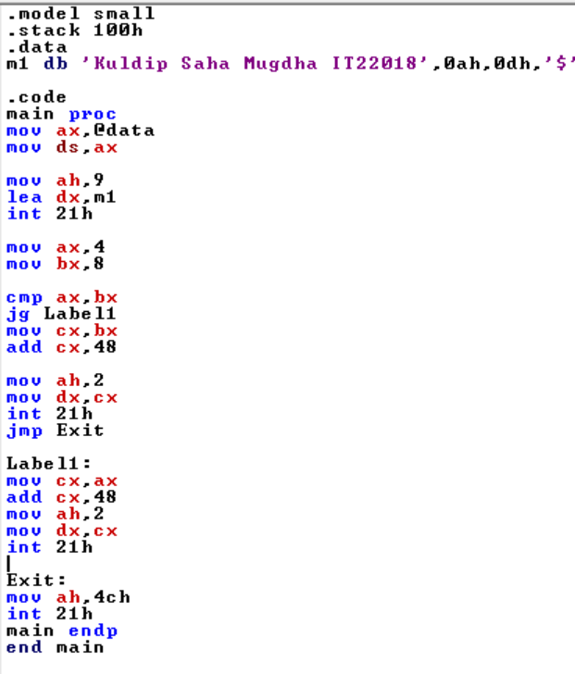

**Output:**

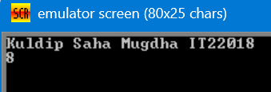

**Program 2:** AL and BL contain extended ASCII characters. A program to display the one that comes first in the character sequence.

**Code:**

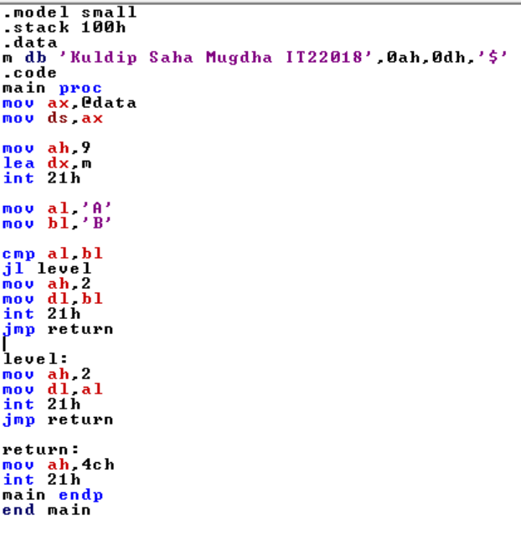

**Output:**

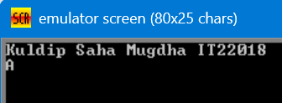

**Program 3:** If AX contains a negative number, put -1 In BX; if AX contains 0, put O In BX; if AX contains a positive number, put 1 In BX.

**Code:**

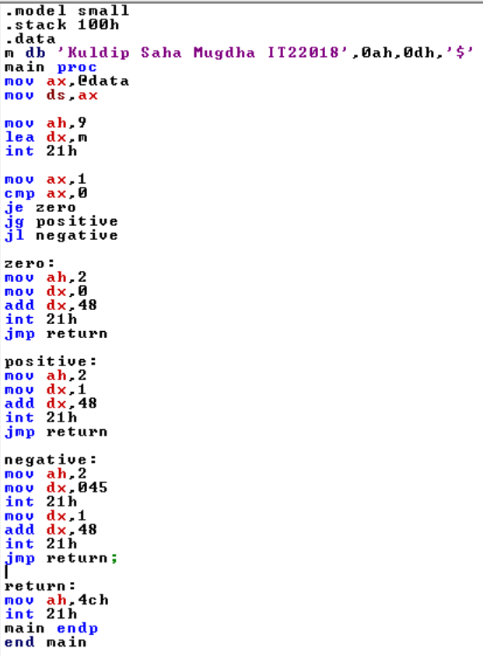

**Output:**

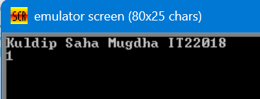

**Program 4:** A program which display “o” if AL contains 1 or 3; if AL contains 2 or 4, display "e".

**Code:**

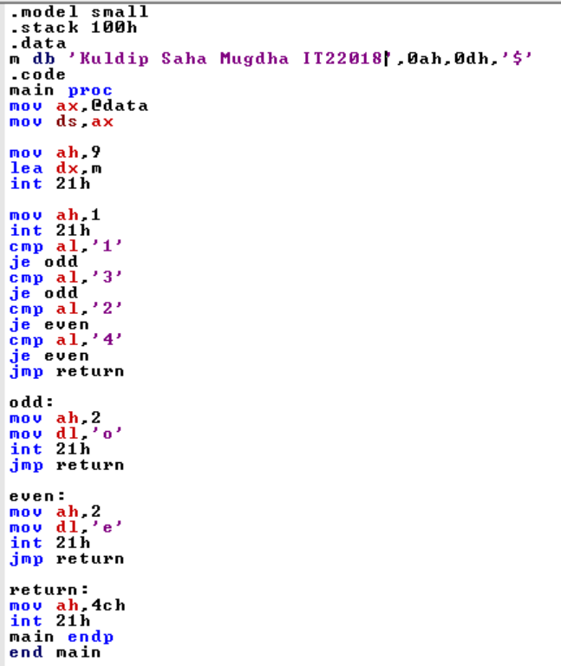

**Output:**

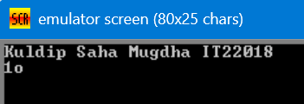

**Program 5:** A program which read a character, and if it's an uppercase letter, display it.

**Code:**

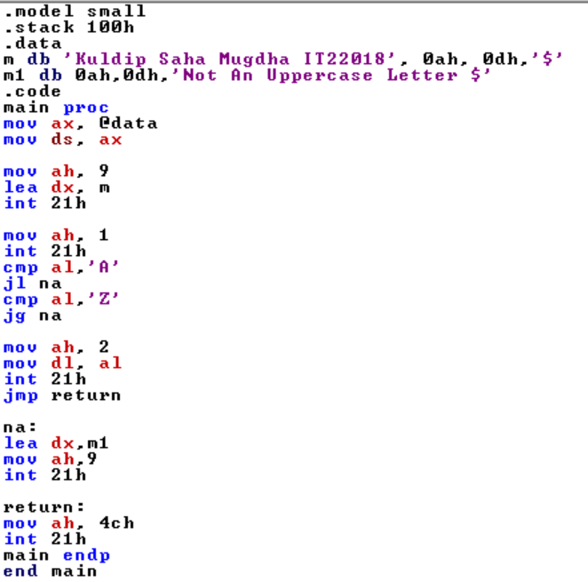

**Output:**

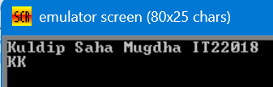

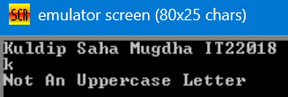

**Program 6:** A program which read a character. If it's "y" or "Y", display it; otherwise terminate the program.

**Code:**

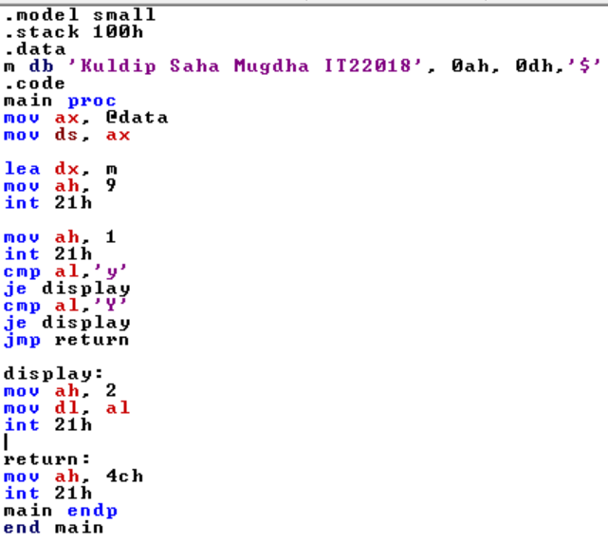

**Output:**

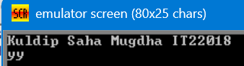

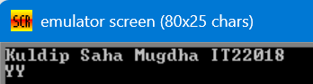

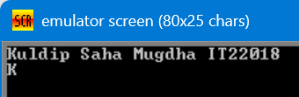

**Program 7:** A program to display a row of 80 stars by using count-controlled loop.

**Code:**

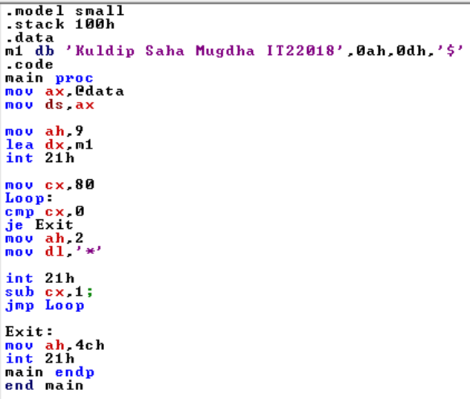

**Output:**

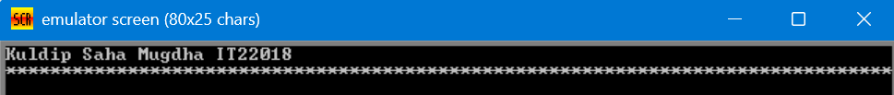

**Program 8:** A program to read characters until a blank is read.

**Code:**

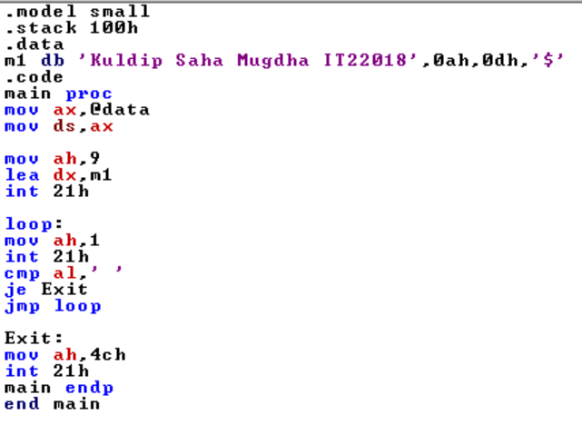

**Output:**

