**MAWLANA BHASHANI SCIENCE AND TECHNOLOGY UNIVERSITY**

SANTOSH, TANGAIL-1902

DEPARTMENT OF INFORMATION AND COMMUNICATION TECHNOLOGY

**Course Title:** Microprocessor and Embedded System Lab

**Course Code:** ICT-2204

**Experiment Name:** Problem Solving with Assembly Language - IV

**Lab Report No: 05**

|  |  |
| --- | --- |
| Submitted By | Submitted To |
| Name: Kuldip Saha Mugdha  ID: IT-22018  2nd Year, 2nd Semester  Session: 2021-2022  Dept. of ICT, MBSTU | Dr. Md. Abir Hossain  Associate Professor  DEPARTMENT OF INFORMATION AND COMMUNICATION TECHNOLOGY  MAWLANA BHASHANI SCIENCE AND TECHNOLOGY UNIVERSITY |

Date of Performance: 11/12/2024 Date of Submission: 18/12/24

**Experiment no: 05**

**Experiment name:** Problem Solving with Assembly Language – IV

**Program 1:** A program to display a "?", read two capital letters, and display them on the next line in alphabetical order.

**Code:**

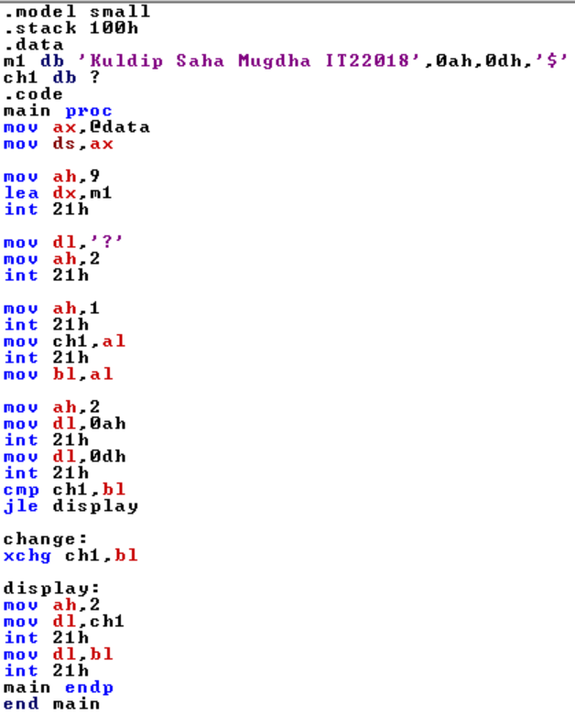

Output:

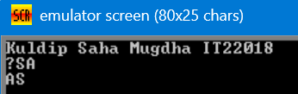

**Program 2:** A program to display the extended ASCII characters (ASCII codes 80h to FFh). Display 10 characters per line, separated by blanks. Stop after the extended characters have been displayed once.

**Code:**

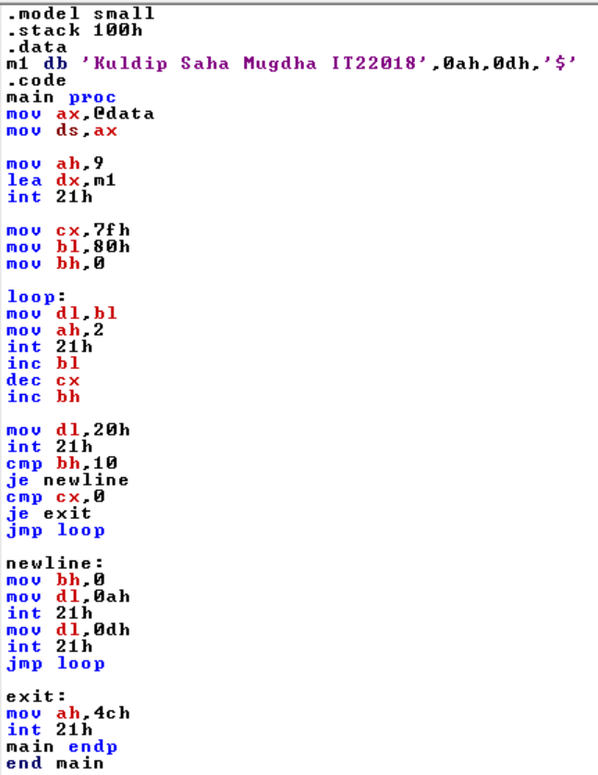

Output:

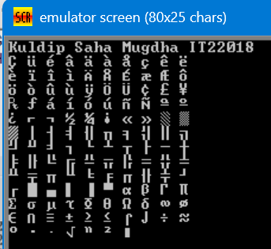

**Program 3:** A program that will prompt the user to enter a hex digit character ("0"· ... "9" or "A" ... "F"), display it on the next line in decimal, and ask the user if he or she wants to do it again. If the user types "y" or "Y", the program repeats; If the user types anything else, the program terminates. If the user enters an illegal character, prompt the user to try again.

**Sample execution:**

Enter a hex digit: 9

In decimal it is: 9

Do you want to do it again?: y

Enter a hex digit: c

Illegal character-Enter 0..9 or A..F: C

In decimal it is: 10

Do you want to do it again ?: n

Code:

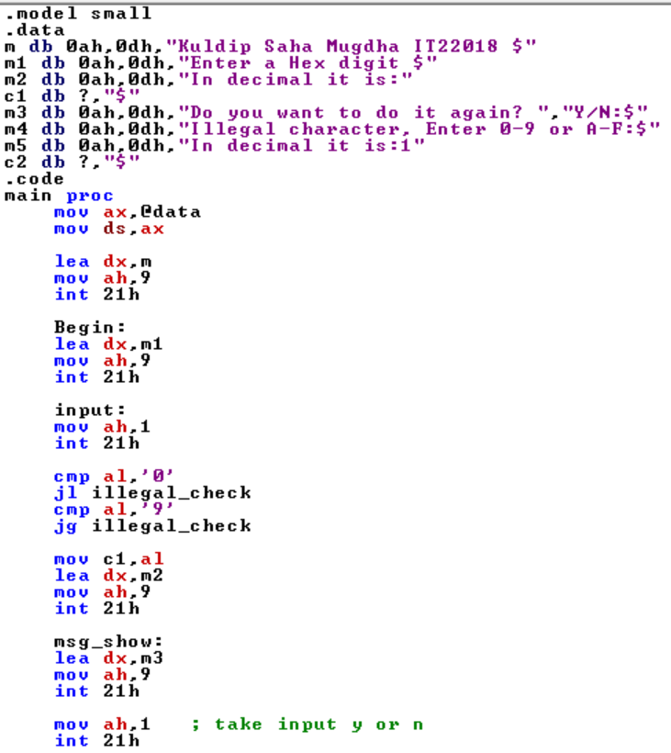

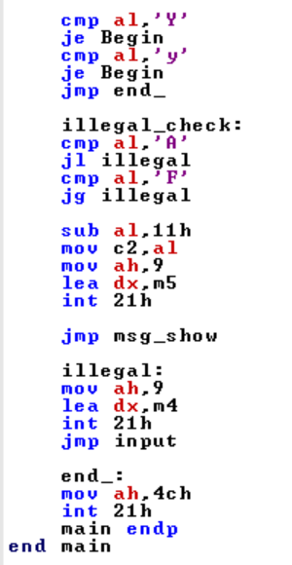

Output:

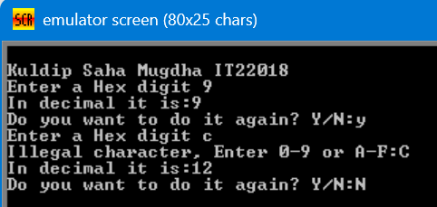

**Program 4: Write a program using a stack to input a string and reverse it.**

**Code:**

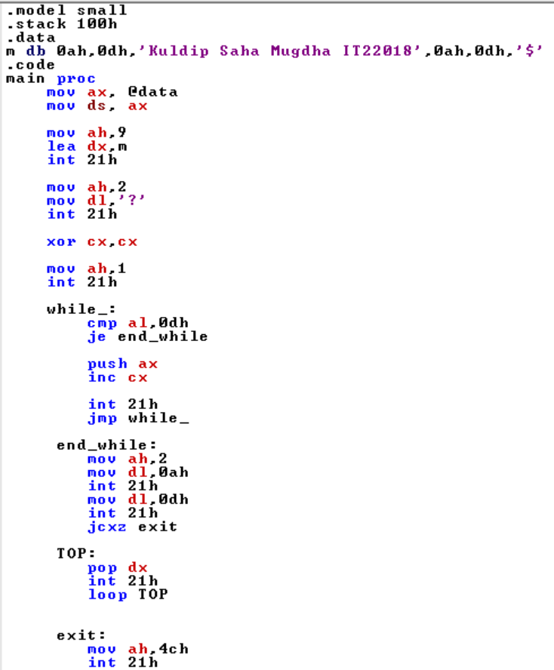

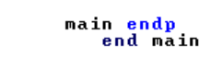

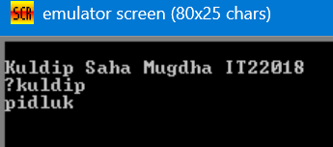Output: