**MAWLANA BHASHANI SCIENCE AND TECHNOLOGY UNIVERSITY**

SANTOSH, TANGAIL-1902



DEPARTMENT OF INFORMATION AND COMMUNICATION TECHNOLOGY

**Lab Report**

**Lab Report No : 01**

**Lab Report on :** Working of OS with Process

**Course Title :** Operating System Lab

**Course Code :** ICT-2202

|  |  |
| --- | --- |
| Submitted By | Submitted To |
| Name: Kuldip Saha Mugdha  ID: IT-22018  2nd Year, 2nd Semester  Session: 2021-2022  Dept. of ICT, MBSTU | Mr. Md. Anowar Kabir  Lecturer  DEPARTMENT OF INFORMATION AND COMMUNICATION TECHNOLOGY  MAWLANA BHASHANI SCIENCE AND TECHNOLOGY UNIVERSITY |

Date of Performance: 18/11/24Date of Submission: 25/11/24

**Introduction:**

Operating System (OS) play a crucial role in managing computer hardware and software resources. They enable processes to execute, allow user and system configurations through tools like **gpedit.msc** and **regedit,** and provide functionalities such as task management and file sharing. This report explores the mechanisms involved in process handling, system customization and file sharing, which are pivotal for understanding OS functionality.

**Objectives:**

* Understand the concept of processes and their management in an operating system (OS).
* Explore the uses of **gpedit.msc** and **regedit** tools.
* Learn the application of the **taskkill** command.
* Comprehend file-sharing mechanisms in a networked environment.

**Theory:**

**3.1 Processes in OS:** It processes an instance of a program in execution. The OS` is responsible for process creation, execution, and termination. Tools like task manager in Windows allow users to view and manage processes.

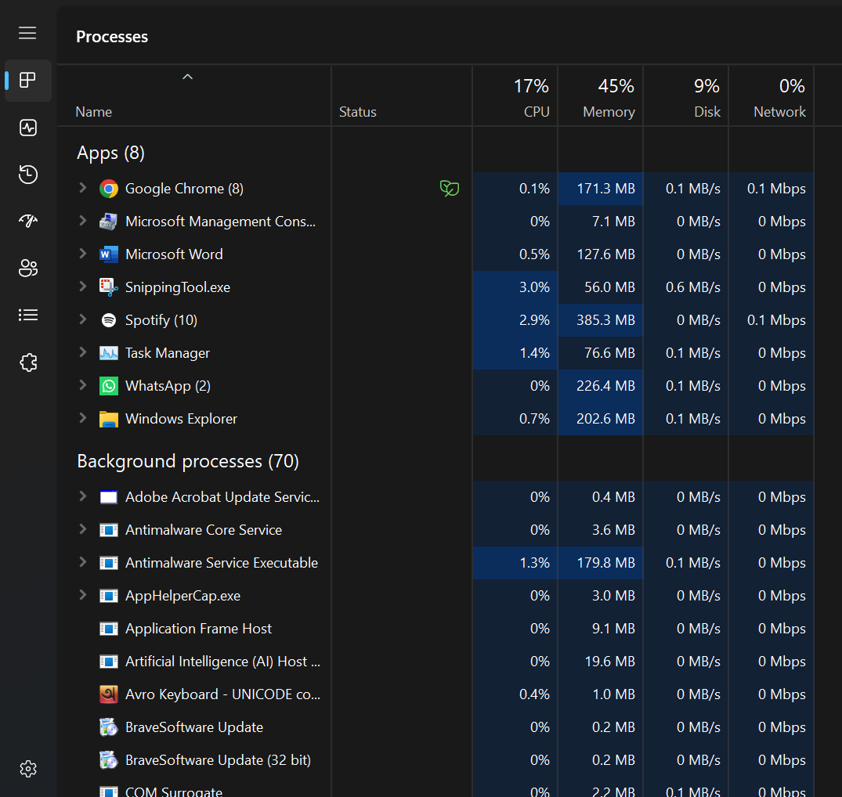

**3.2 gpedit.msc:** Group Policy Editor (gpedit.msc) is a Windows tools used to configure system settings and enforce administration policies. It allows granular control over user and computer settings. It affects local group policy, influencing system behavior without alerting registry values directly.

**#Example:** Disabling access to the Control Panel:

1. Open gpedit.msc via Run (**Win+R -> type gpedit.msc**).
2. Navigate to **User Configuration** **> Administrative Templates > Control Panel.**
3. Enable the policy Prohibit access to **Control Panel** and PC settings.

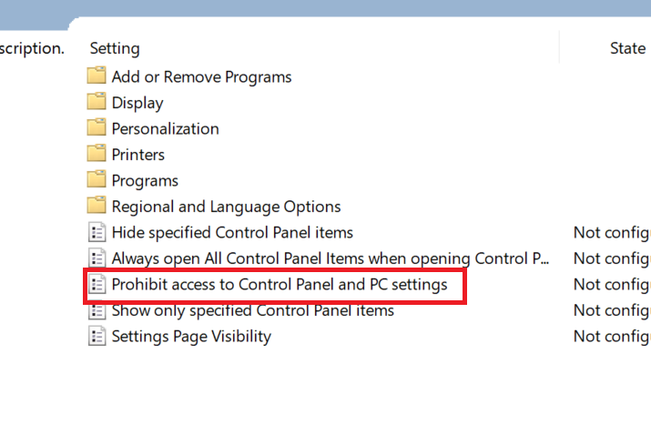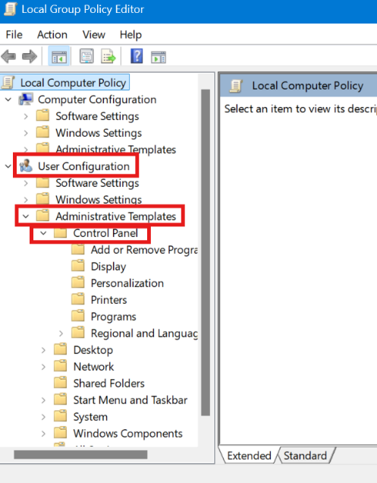

**3.3 regedit:** Registry Editor(regedit)is used to view and modify the Windows registry, a hierarchical database storing system and application settings. It provides a direct way to modify system configurations and troubleshoot issues.

**#Example:** Changing the default wallpaper:

1. Open regedit via Run (**Win+R -> type regedit**).
2. Navigate to **HKEY_CURRENT_USER\Control Panel\Desktop.**
3. Modify the value of wallpaper to the desired file path.
4. Refresh the desktop to apply changes.

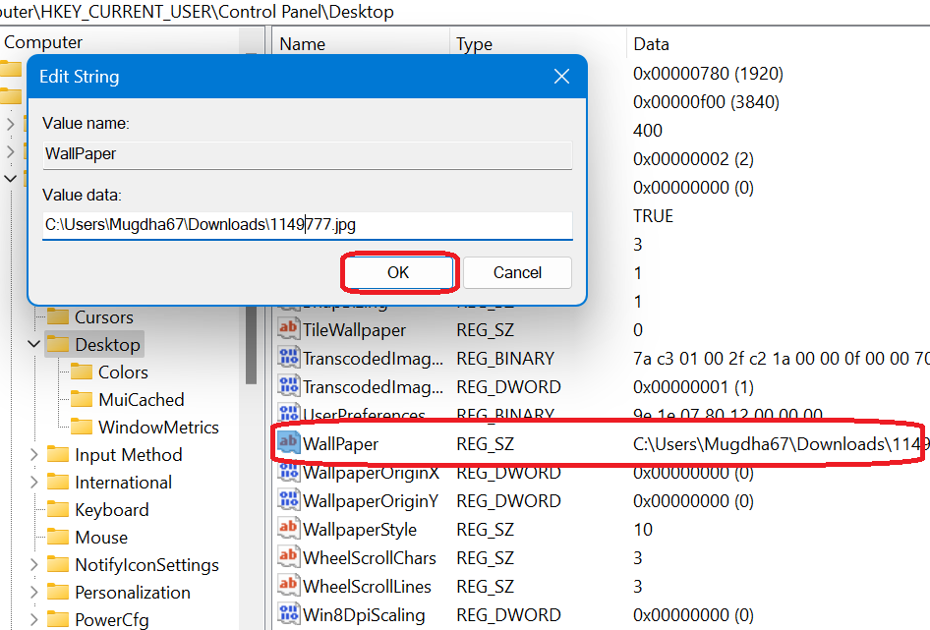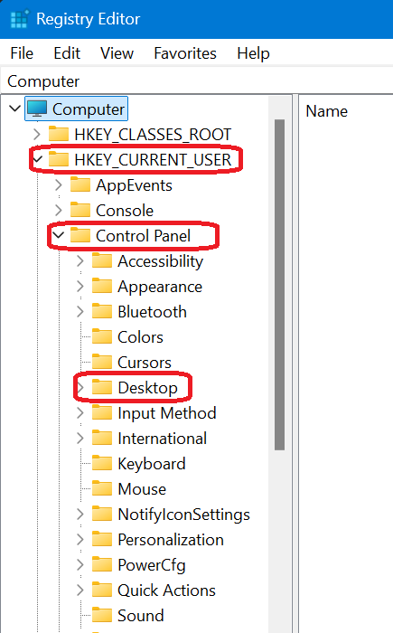

**3.4 Process/Task Kill:** The taskkill command terminates running processes by specifying their name or Process ID (PID).

**#Example:**

1. Open Command Prompt (**Win+R -> type cmd**).
2. Find the PID using tasklist.
3. Kill the process using taskkill /IM notepad.exe.

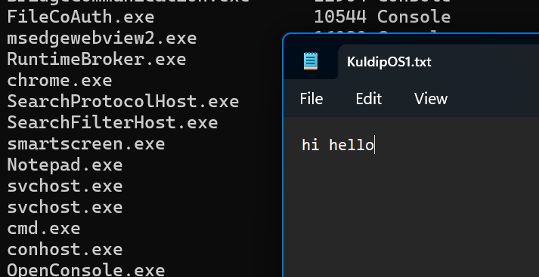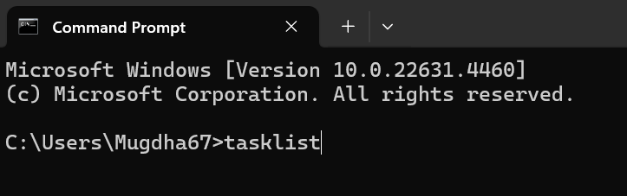



**3.5 File Sharing:** File sharing enables the transfer of files between devices over a network.

**#Steps:**

1. Open Command Prompt (**Win+R -> type cmd**).
2. Click Share and add everyone.
3. Provide access permission (I used Read).
4. Access the shared folder using network path (\\MUGDHA67\gift).

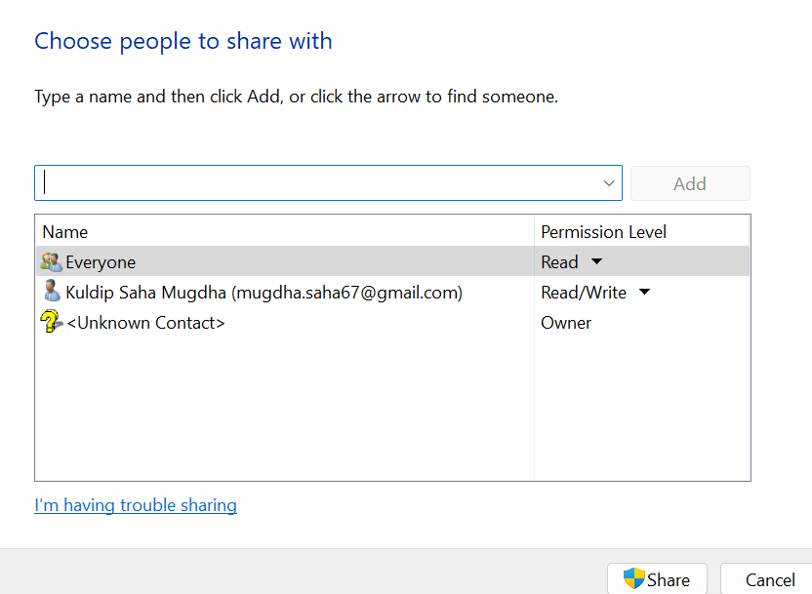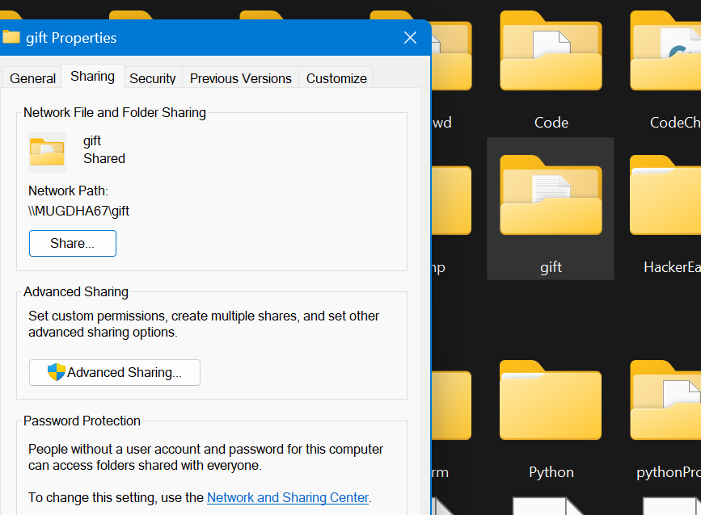

**Results:**

1. Successfully enabled the Control Panel using gpedit.msc.
2. Changed the default wallpaper using regedit.
3. Terminated a specific process (Notepad.exe) using taskkill command.
4. Shared a folder and accessed it on another laptop within the same network.

**Discussion:**

Understanding OS functionalities, such as process management and system customization, enhances troubleshooting and administrative capabilities. Tools like gpedit.msc and regedit provide advanced configuration options, but improper usage can lead to system instability. Similarly, the taskkill command is powerful method for managing unresponsive processes. File sharing demonstrates the collaborative aspect of modern operating systems. Future work could include exploring automation of these tasks using scripts for efficiency.