**MAWLANA BHASHANI SCIENCE AND TECHNOLOGY UNIVERSITY**

SANTOSH, TANGAIL-1902



DEPARTMENT OF INFORMATION AND COMMUNICATION TECHNOLOGY

**Lab Report**

**Lab Report No : 02**

**Lab Report on :** Windows Command Practice

**Course Title :** Operating System Lab

**Course Code :** ICT-2202

|  |  |
| --- | --- |
| Submitted By | Submitted To |
| Name: Kuldip Saha Mugdha  ID: IT-22018  2nd Year, 2nd Semester  Session: 2021-2022  Dept. of ICT, MBSTU | Mr. Md. Anowar Kabir  Lecturer  DEPARTMENT OF INFORMATION AND COMMUNICATION TECHNOLOGY  MAWLANA BHASHANI SCIENCE AND TECHNOLOGY UNIVERSITY |

Date of Performance: 18/11/24Date of Submission: 25/11/24

**Introduction:**

The Windows Command line interface (CLI) serves as a powerful tool for interacting with the operating system through text-based commands. It is accessible via command prompt or PowerShell, enabling users to execute a variety of commands for administrative tasks, troubleshooting, file management, networking, and automation. Gaining proficiency in using these commands can enhance productivity, streamline system management, and sharpen technical skills.

**Objectives:**

* **Learn Basic Commands:** Understand foundational commands for file and directory management.
* **Master Administrative Commands:** Explore commands used for system configurations and user management.
* **Troubleshoot with System Commands:** Use diagnostic and monitoring commands to identify and resolve issues.
* **Automate Tasks:** Learn how commands can be combined into scripts for repetitive tasks.
* **Enhance Networking Knowledge:** Explore network-related commands for communication and troubleshooting.
* **Develop Command-Line Proficiency:** Build confidence in using the CLI for routine and advanced tasks.

**All windows command and their execution on command prompts:**

1. **Cls:** Clears the Command Prompt screen.
2. **Cd:** Changes the current directory.

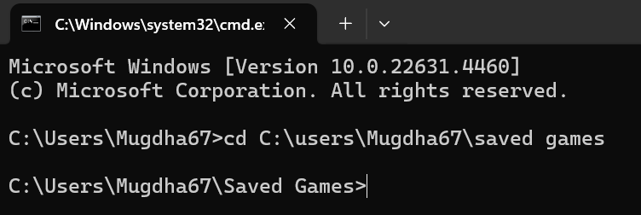

1. **Help:** Lists all available commands in the Command Prompt with a brief description.

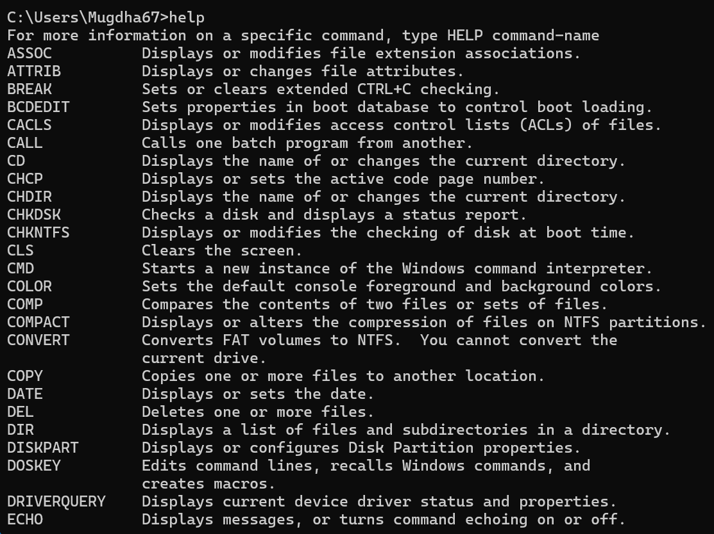

1. **Dir:** Lists all files and folders in the current directory.

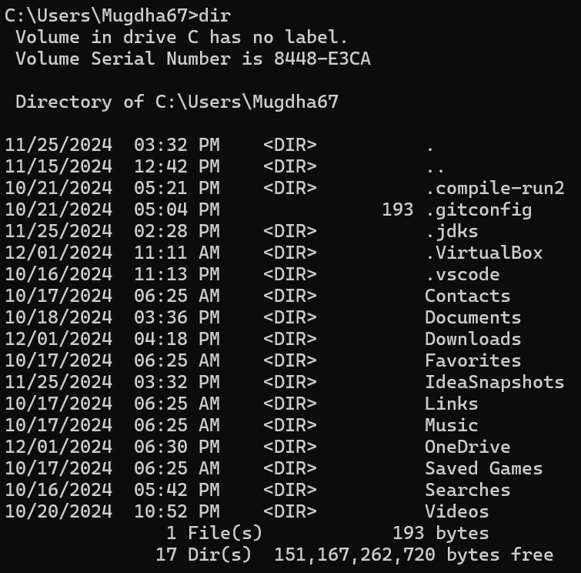

1. **Copy:** Copies files from one location to another.



1. **Move:** Moves files from one location to another.
2. **Del:** Deletes one or more files.



1. **Mkdir:** Creates a new directory.



1. **Rmdir:** Deletes a directory (folder).



1. 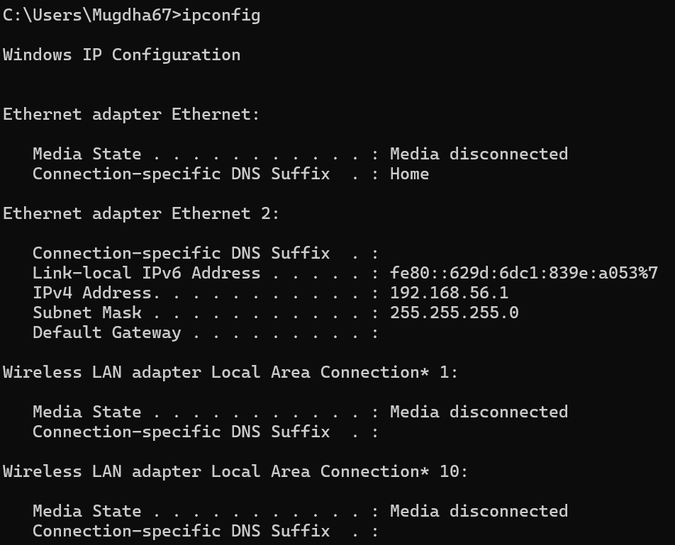 **Ipconfig:** Shows network configuration details, such as IP address and subnet mask.
2. 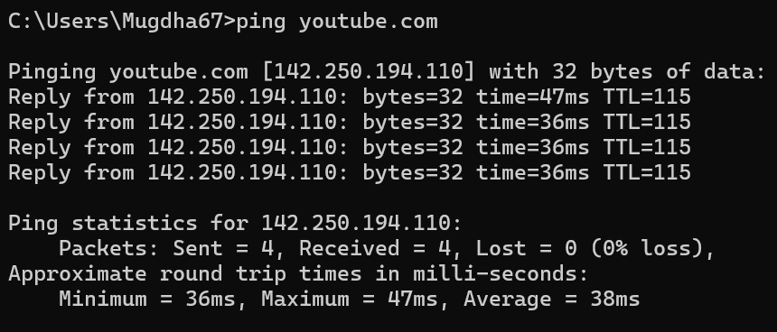 **Ping:** Tests network connectivity to a remote host.
3. **Tracert:** Shows the path taken to a destination IP address.

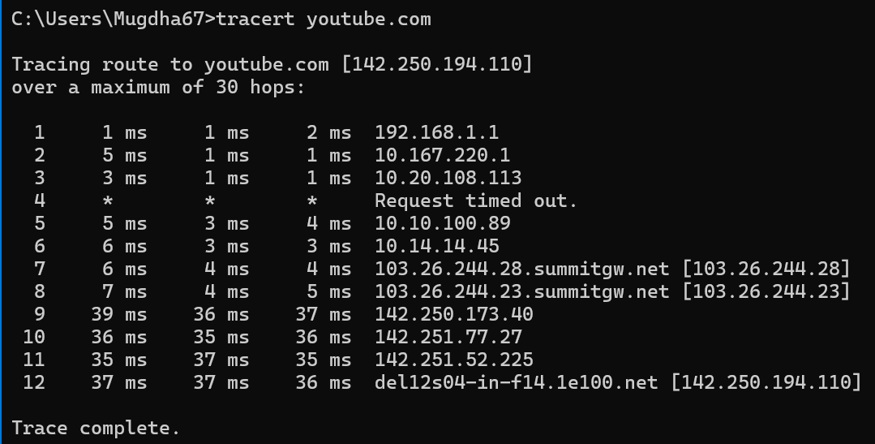

1. **Netstat:** Displays active network connections and listening ports.

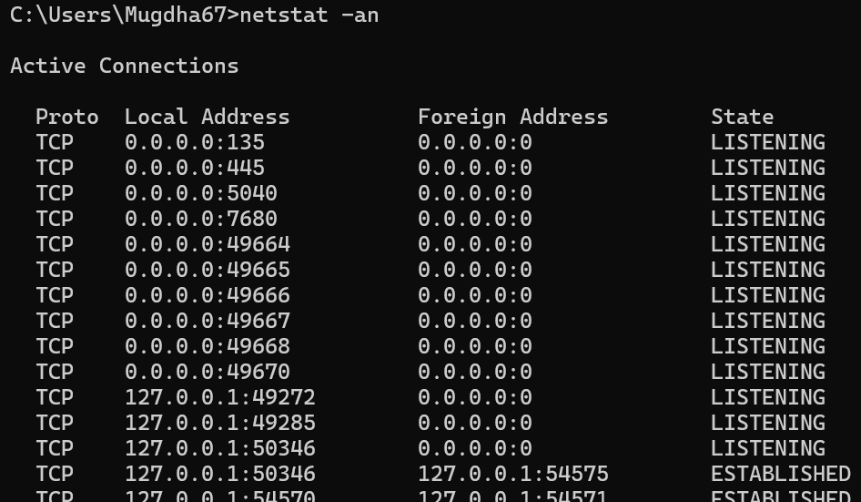

1. 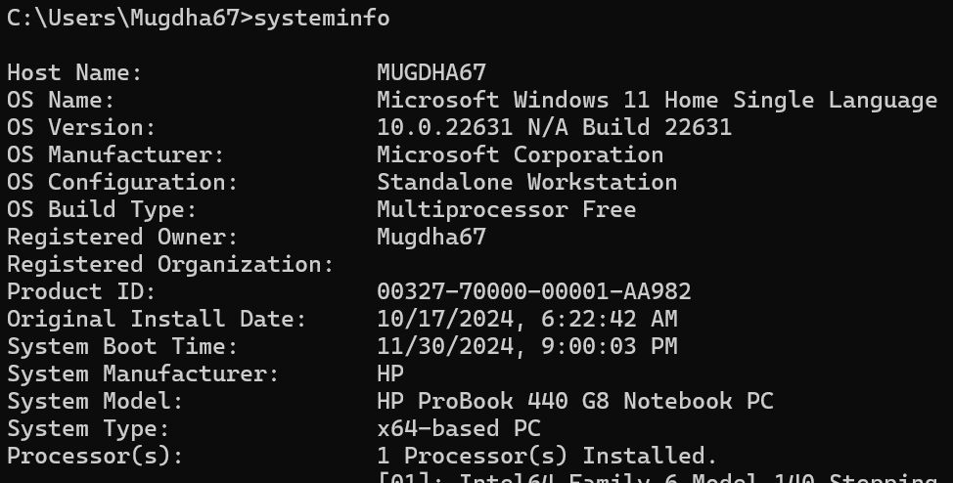 **Systeminfo:** Shows detailed system information.
2. **Sfc /scannow:** Scans and repairs corrupted system files.

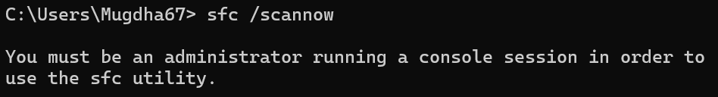

1. **Diskpart:** Manages disks, partitions, and volumes.
2. **Format:** Formats a disk for use with Windows.
3. **Shutdown:** Shuts down, restarts, or logs off the computer.
4. **Hostname:** Displays the computer’s hostname.

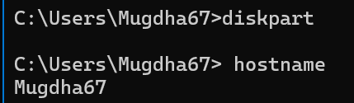

1. **Date:** Displays or sets the current date.

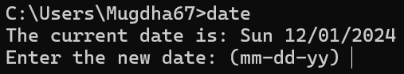

1. **Time:** Displays or sets the current time.

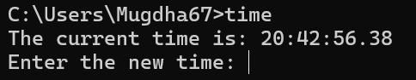

1. **Echo:** Displays a line of text.

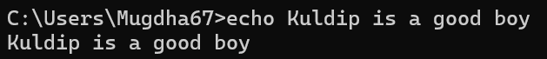

1. **Pause:** Pauses execution in a batch file.

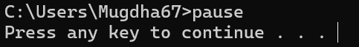

1. 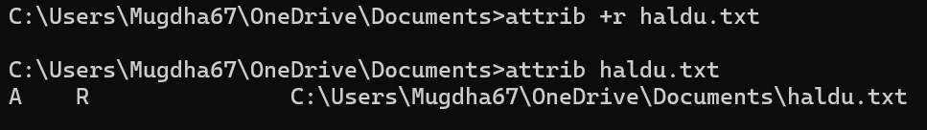 **Attrib:** Displays or changes file attributes.
2. 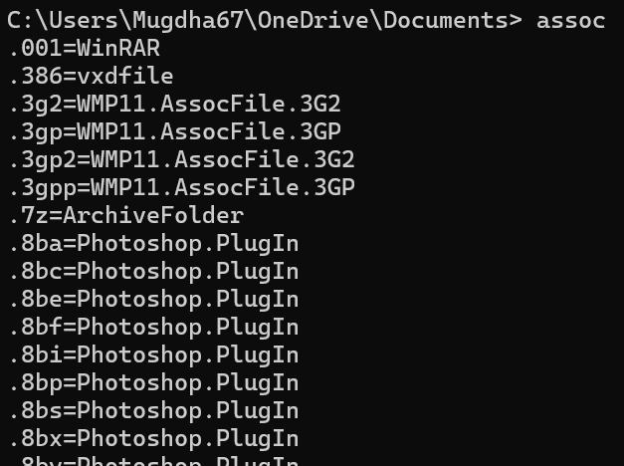 **Assoc:** Displays or modifies file type associations.
3. **Find:** Searches for text within files.

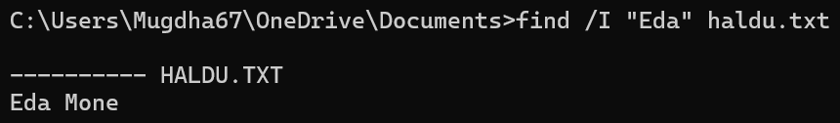

1. **Shutdown /s /f /t 0:** Instantly shuts down the computer.
2. **Title:** Sets the Command Prompt window title.
3. **Fc:** Compares two files and displays differences.

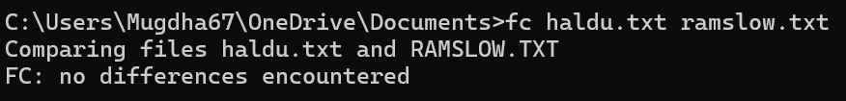

1. **Schtasks:** Manages scheduled tasks.

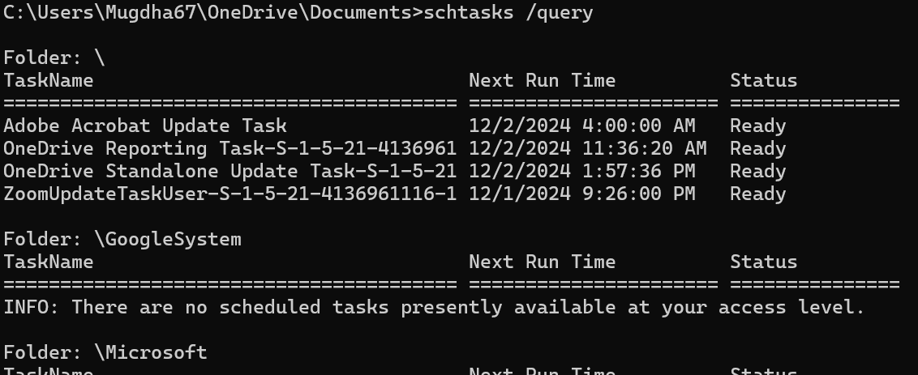

1. **Wmic:** Windows Management Instrumentation Command-line to get system info.



1. **Whoami:** Displays the current user and domain.

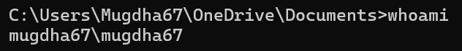

1. **Route:** Displays and modifies the IP routing table.

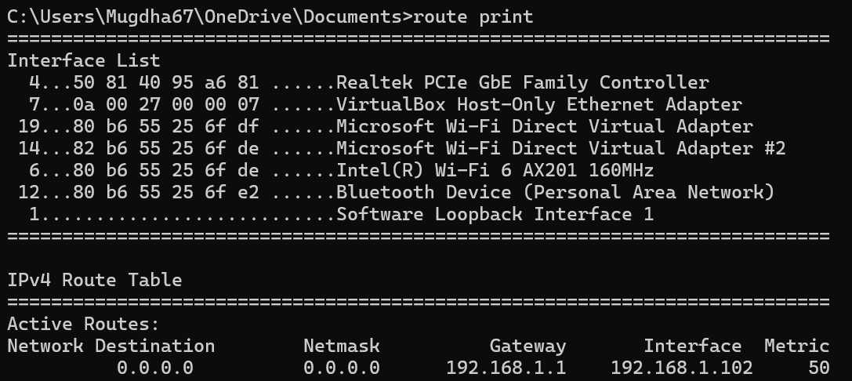

1. **Pathping:** Combines ping and tracert for a detailed path analysis.

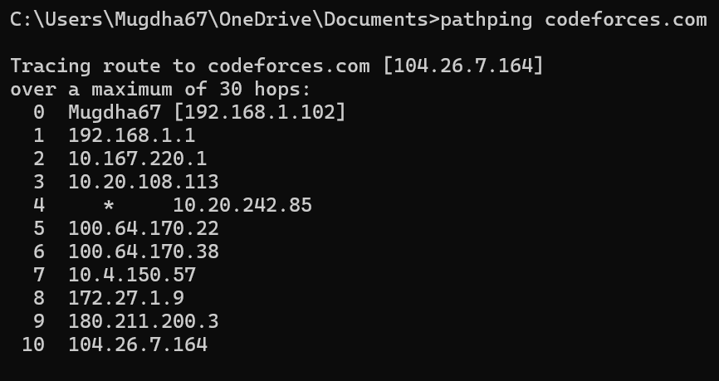

1. **Tasklist:** Lists all running processes on the system.

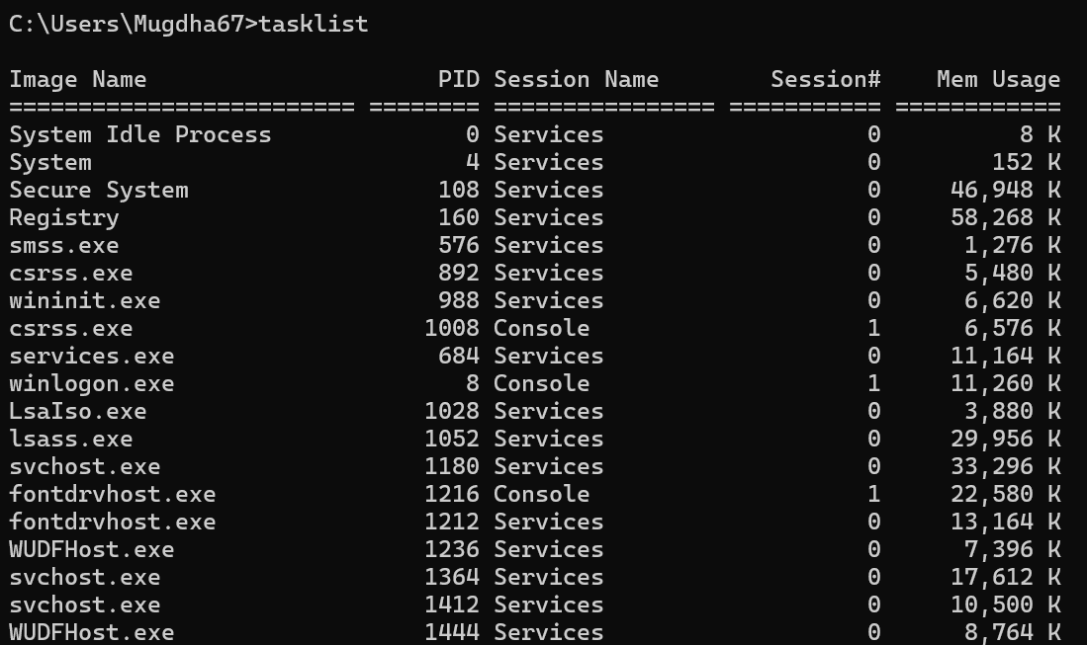

1. **Taskkill:** Ends a running process by its name or PID.

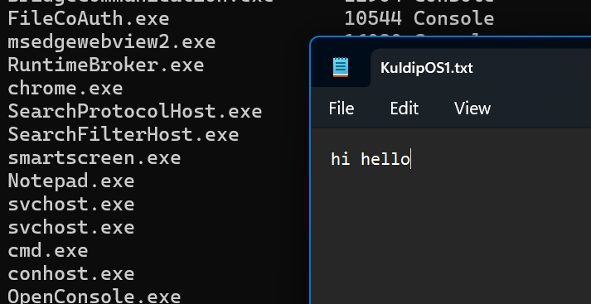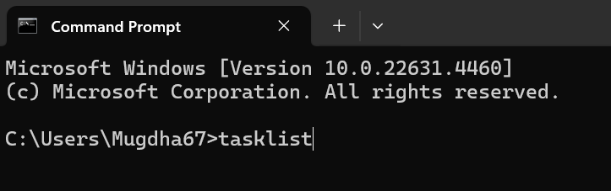



1. **Chkdsk:** Checks for disk errors and repairs them.

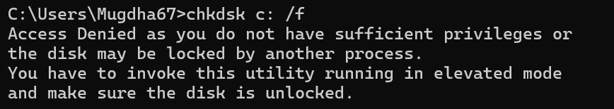

1. **Powercfg:** Configures power settings and displays energy efficiency details.



1. **Gpupdate:** Forces a Group Policy update.

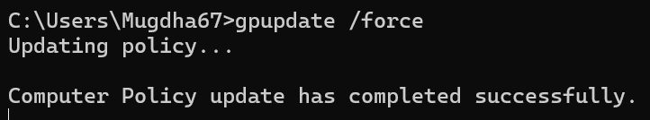

1. **Gpresult:** Displays applied Group Policy settings.

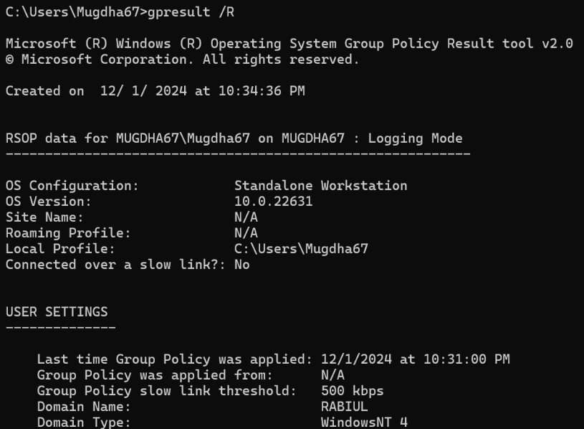

1. **Regedit:** Opens the Windows Registry Editor.

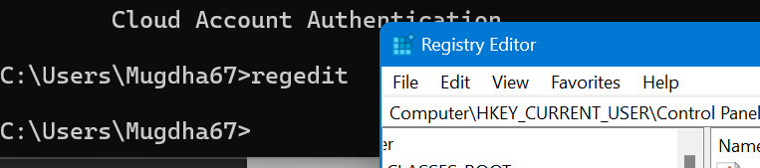

**Discussion:**

The Windows Command-Line Interface is an invaluable resource for performing system-related tasks efficiently. By learning a wide range of commands, users can optimize workflows, improve their troubleshooting capabilities, and master essential administrative operations. Developing command-line expertise empowers users to work faster, solve problems effectively, and fully harness the capabilities of the Windows operating system.