**MAWLANA BHASHANI SCIENCE AND TECHNOLOGY UNIVERSITY**

SANTOSH, TANGAIL-1902



DEPARTMENT OF INFORMATION AND COMMUNICATION TECHNOLOGY

**Lab Report**

**Lab Report No : 03**

**Lab Report on :** Linux Command Practice

**Course Title :** Operating System Lab

**Course Code :** ICT-2202

|  |  |
| --- | --- |
| Submitted By | Submitted To |
| Name: Kuldip Saha Mugdha  ID: IT-22018  2nd Year, 2nd Semester  Session: 2021-2022  Dept. of ICT, MBSTU | Mr. Md. Anowar Kabir  Lecturer  DEPARTMENT OF INFORMATION AND COMMUNICATION TECHNOLOGY  MAWLANA BHASHANI SCIENCE AND TECHNOLOGY UNIVERSITY |

Date of Performance: 2/12/24Date of Submission: 23/12/24

**Introduction:**

The Linux Command Line Interface (CLI) is a robust tool for interacting with the operating system through text-based commands. Accessible via a terminal emulator, the Linux CLI empowers users to perform a wide range of tasks, including system administration, file management, networking, troubleshooting, and automation. Mastering Linux commands enhances efficiency, simplifies system management, and builds valuable technical expertise for users and administrators alike.

**Objectives:**

* **Learn Basic Commands:** Gain a solid understanding of fundamental commands for navigating and managing files and directories.
* **Master Administrative Commands:** Explore commands for system configuration, user management, and process control.
* **Troubleshoot with System Commands:** Utilize diagnostic and monitoring tools to identify and resolve system issues effectively.
* **Automate Tasks:** Learn to create shell scripts for automating repetitive tasks and improving workflow.
* **Enhance Networking Knowledge:** Familiarize yourself with network-related commands for communication, diagnostics, and troubleshooting.
* **Develop Command-Line Proficiency:** Build confidence and competence in using the Linux CLI for both routine and advanced operations.

**All Linux command and their execution on command prompts:**

1. **pwd:** Displays the current directory’s full path.

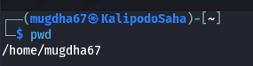

1. **ls:** Lists files and directories in the current directory.

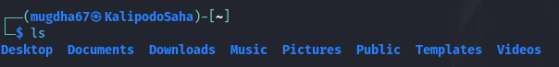

1. **cd:** Change the current working directory.

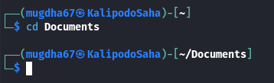

1. **mkdir:** Creates a new directory.

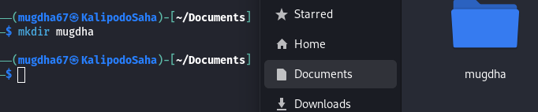

1. **rmdir:** Deletes an empty directory.Deletes files or directories.

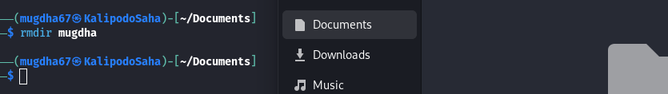

1. **rm:** Deletes files or directories.

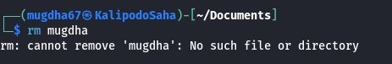

1. **touch:** Creates an empty file or updates the timestamp of an existing file.

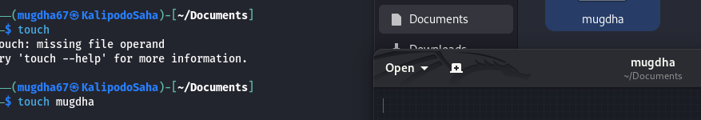

1. **cp:** Copies files or directories.

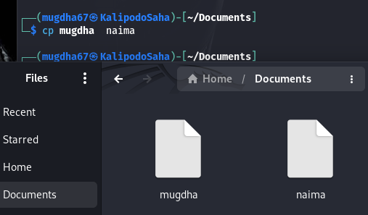

1. **mv:** Moves or rename files/directories.

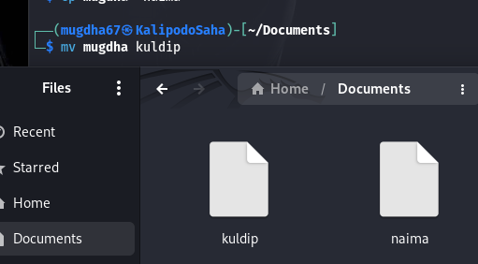

1. **cat:** Displays the content of a file.

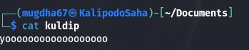

1. **nano:** Opens a file in the Nano text editor.

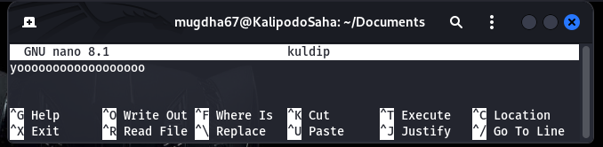

1. **echo:** Prints text or variables to the terminal.

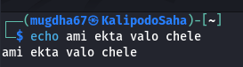

1. **find:** Searches for files or directories.

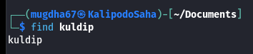

1. **grep:** Searches for text patterns in files.

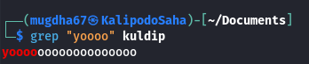

1. **chmod:** Changes file or directory permissions.



1. 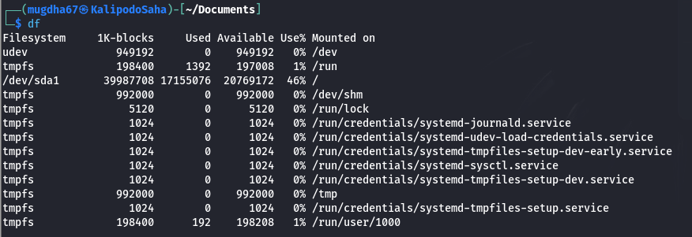 **df:** Displays disk space usage.
2. **du:** Displays the size of directories or files.

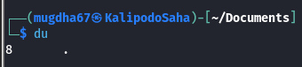

1. **ps:** Lists running processes.

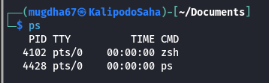

1. **top:** Monitors real-time system resource usage.

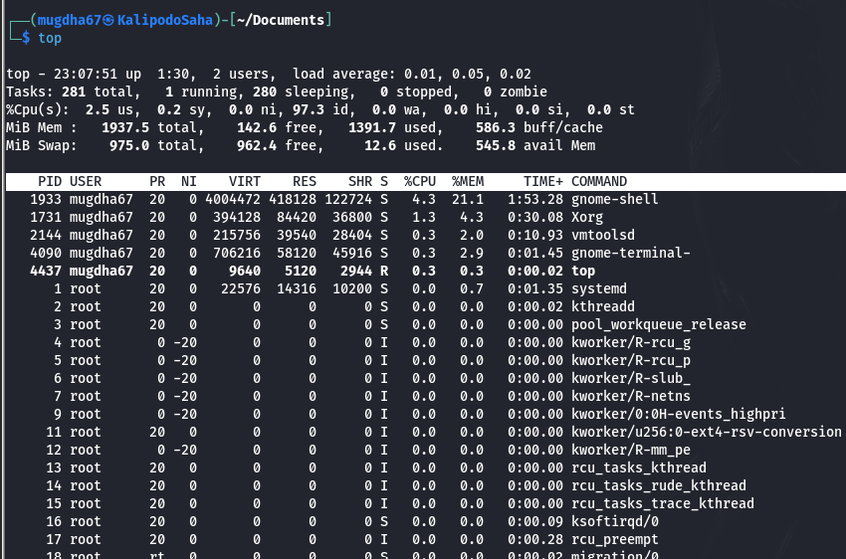

1. **kill:** Terminates processes by ID.

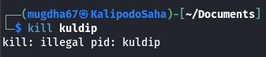

1. **tar:** Archives files or extracts archives.

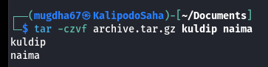

1. **zip:** Compresses files into a zip archive.

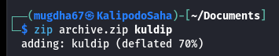

1. **unzip:** Extracts files from a zip archive.

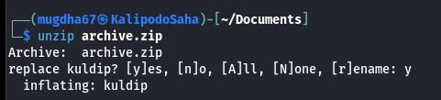

1. **wget:** Downloads files from the internet.

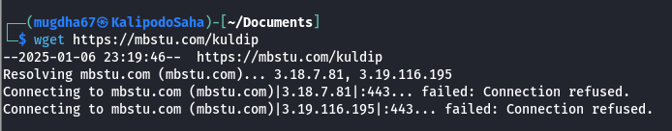

1. **curl:** Transfers data from or to a server.

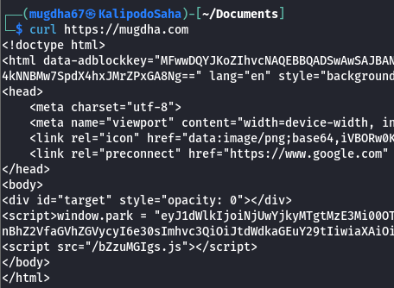

1. **ifconfig:** Displays or configures network interfaces.

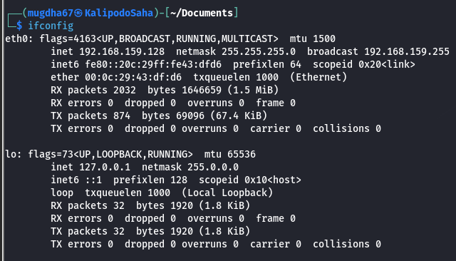

1. **ping:** Tests network connectivity to a host.

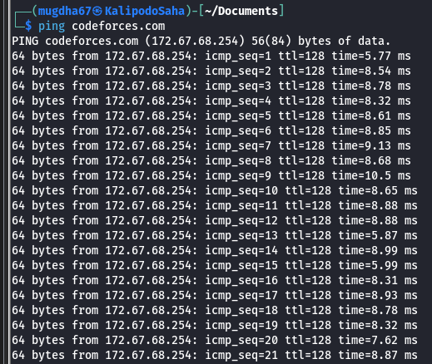

1. 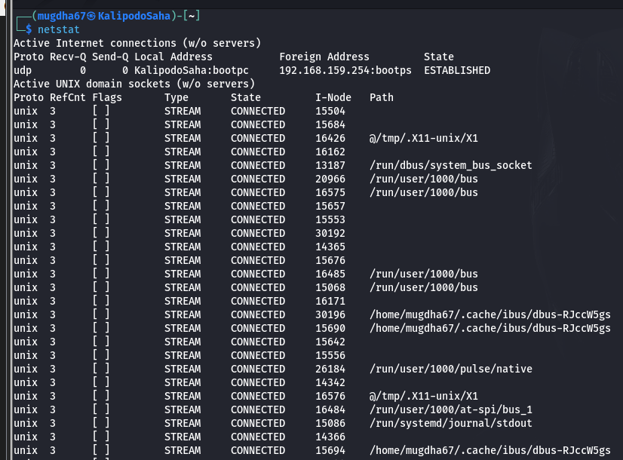 **netstat:** Displays network connections and statistics.
2. **ssh:** Connects to a remote machine securely.

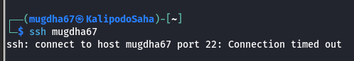

1. **man:** Displays the manual for a command.



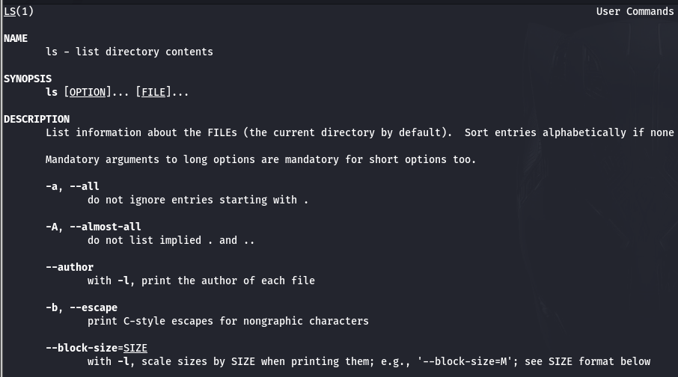

1. **alias:** Creates shortcuts for commands.

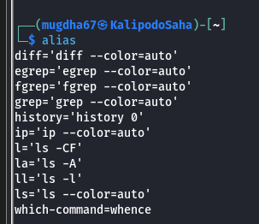

1. **history:** Displays previously executed commands.

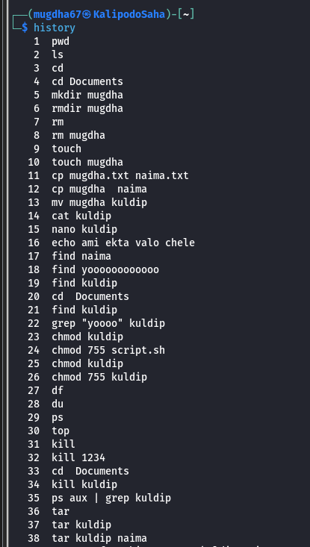

**Discussion:**

The Linux Command-Line Interface is an invaluable resource for efficiently performing system-related tasks. By mastering a wide range of commands, users can streamline workflows, enhance troubleshooting skills, and execute essential administrative operations with precision. Developing command-line expertise empowers users to work faster, solve problems effectively, and fully utilize the powerful capabilities of the Linux operating system.