**MAWLANA BHASHANI SCIENCE AND TECHNOLOGY UNIVERSITY**

SANTOSH, TANGAIL-1902



DEPARTMENT OF INFORMATION AND COMMUNICATION TECHNOLOGY

**Lab Report**

**Lab Report No : 04**

**Lab Report on :** Disk Management, Performance Monitor and WinHex.

**Course Title :** Operating System Lab

**Course Code :** ICT-2202

|  |  |
| --- | --- |
| Submitted By | Submitted To |
| Name: Kuldip Saha Mugdha  ID: IT-22018  2nd Year, 2nd Semester  Session: 2021-2022  Dept. of ICT, MBSTU | Mr. Md. Anowar Kabir  Lecturer  DEPARTMENT OF INFORMATION AND COMMUNICATION TECHNOLOGY  MAWLANA BHASHANI SCIENCE AND TECHNOLOGY UNIVERSITY |

Date of Performance: 9/12/24Date of Submission: 23/12/24

**Introduction:**

This lab focused on understanding basic system utilities in Windows, including Disk Management, Performance Monitor, and WinHex. The goal was to perform disk partitioning and merging using diskmgmt.msc, monitor system performance using Performance Monitor, and analyze raw disk data using the WinHex hex editor.

**Objective:**

The objective of this lab is to:

* Understand and perform basic operations in **Disk Management** such as partitioning and merging drives.
* Use **Performance Monitor** to track system performance.
* Explore the usage of **WinHex** for analyzing system memory and storage in hexadecimal format.

**Tools Used:**

* Windows Disk Management (diskmgmt.msc)
* Performance Monitor (perfmon.exe)
* WinHex Software

**1. Disk Management**

**Task:** Partition a drive and then merge it again.

**Steps Performed:**

1. **Accessing Disk Management**:
   * Press Windows + R.
   * Type diskmgmt.msc and press Enter.

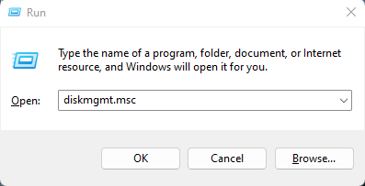

* + 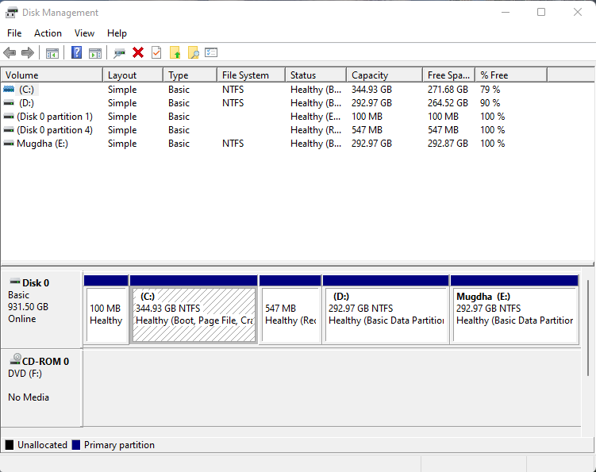The **Disk Management** window opened, showing all connected storage devices.

1. **Shrinking a Volume to Create a Partition**:
   * Right-clicked on a volume (e.g., (E:)).
   * Selected **"Shrink Volume..."**.

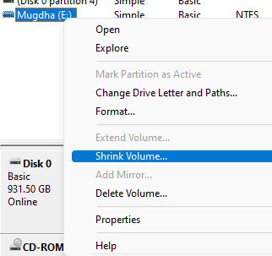

* + Entered the amount of space to shrink (e.g., 10240 MB).

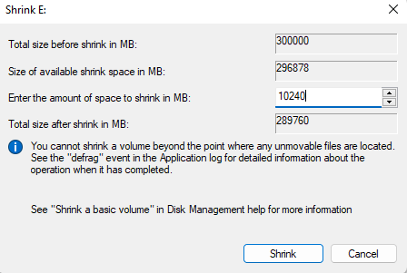

* + 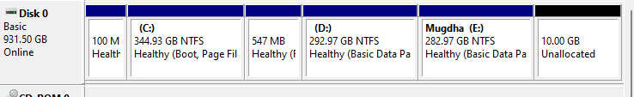A new unallocated space appeared in Disk Management.

1. **Creating a New Partition**:
   * Right-clicked the **unallocated space**.
   * Selected **"New Simple Volume..."**.

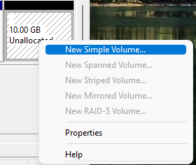

* + Assigned a drive letter (e.g., (N:)) and formatted the partition as **NTFS**.

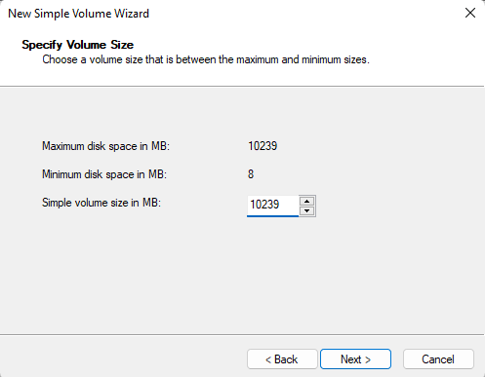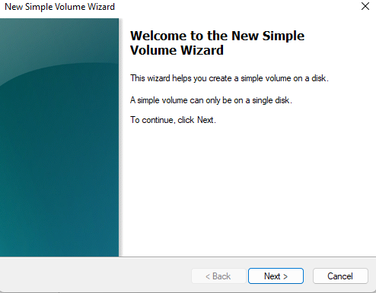

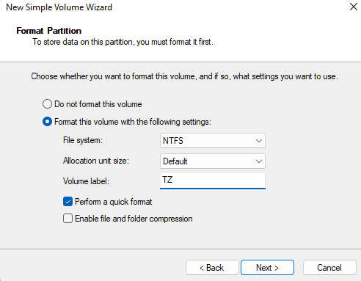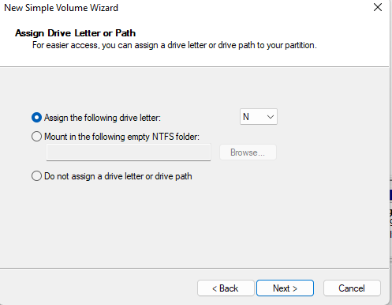

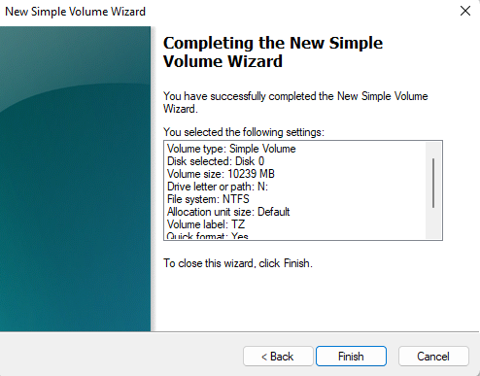

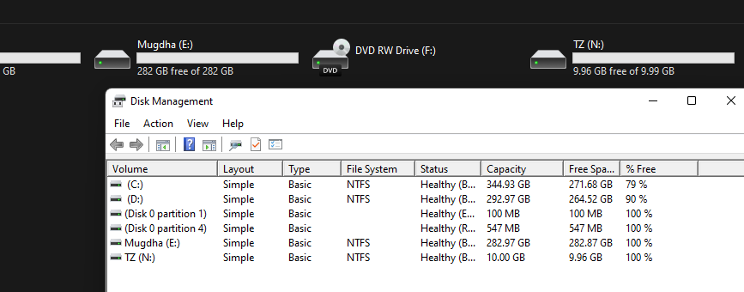

1. **Merging the Partition Back**:
   * Deleted the new volume (Right-click on (N:) → **Delete Volume**).
   * Right-clicked the original volume (E:)
   * 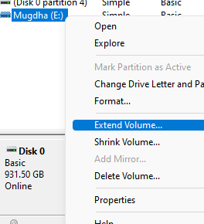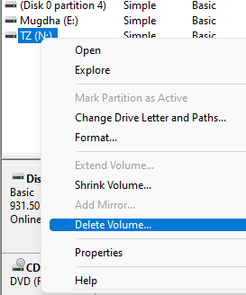Selected **"Extend Volume..."**.
   * Choose the unallocated space and completed the wizard.

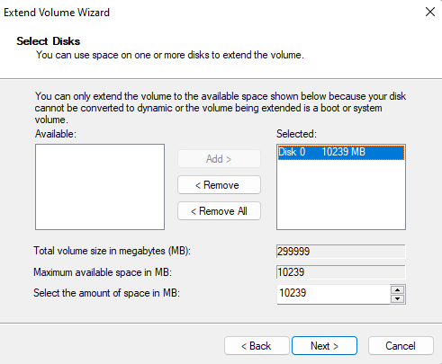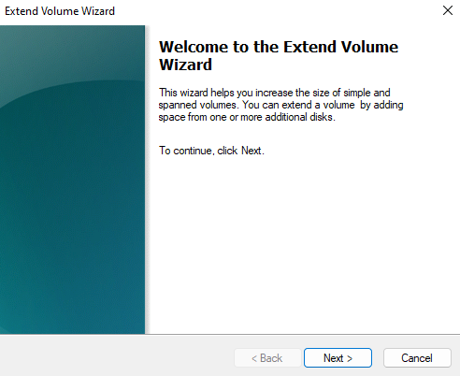

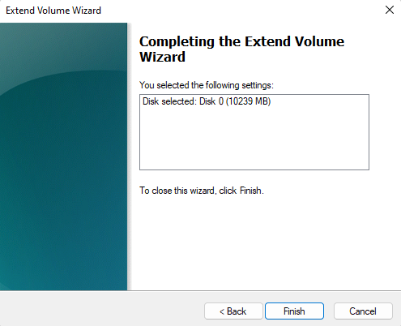

**2. Performance Monitor with WinHex**

**Task:** Monitor system performance while using WinHex.

**Steps Performed:**

1. **Launching Performance Monitor**:
   * Press Windows + R, type perfmon, and press Enter.

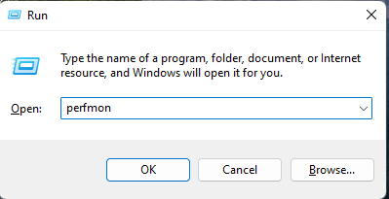

* + 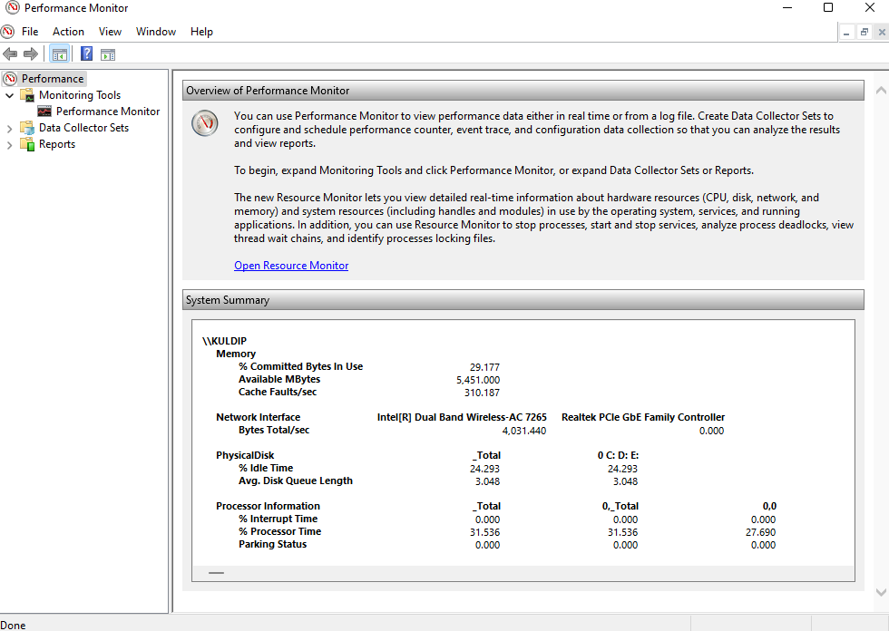The Performance Monitor window was opened.

1. **Adding Counters to Monitor**:
   * Clicked on **"Performance Monitor"** under **Monitoring Tools**.
   * Clicked the **green plus (+)** sign.

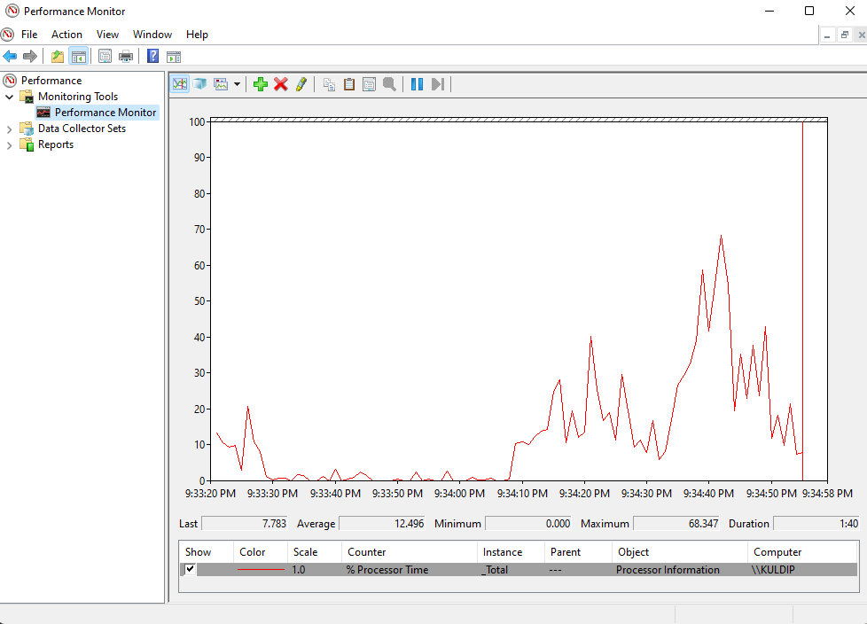

* + Added counters such as:
    - **Processor Time**
    - **Memory Usage**
    - **Disk Read/Write Bytes/sec**

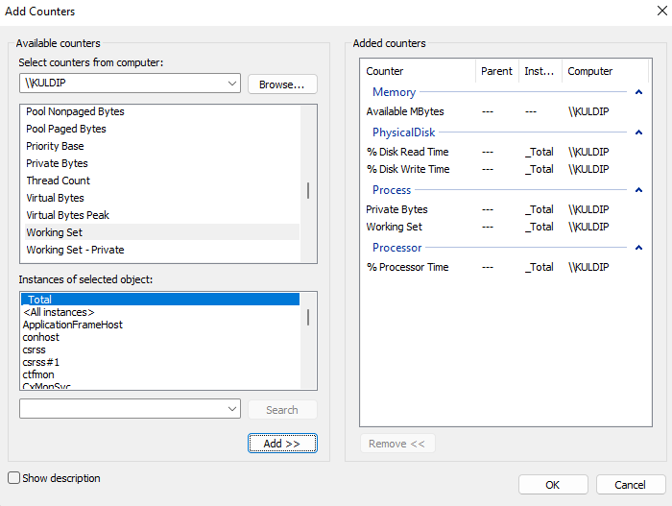

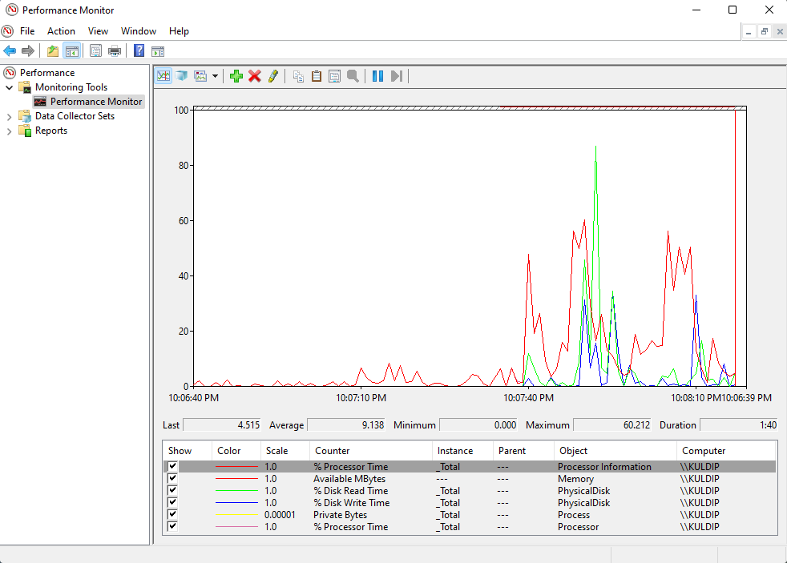

1. **Launching WinHex**:
   * Opened **WinHex** software.
   * Loaded a disk or memory dump (File → Open Disk → Select a physical or logical drive).

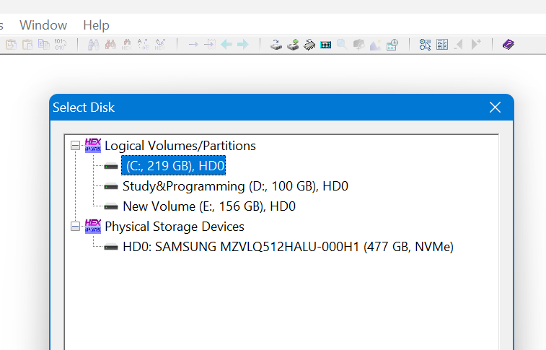

* + Performed basic operations such as:
    - Viewing raw hexadecimal data.
    - Searching for strings or byte patterns.
    - Editing sectors (Read-only mode for safety during lab).

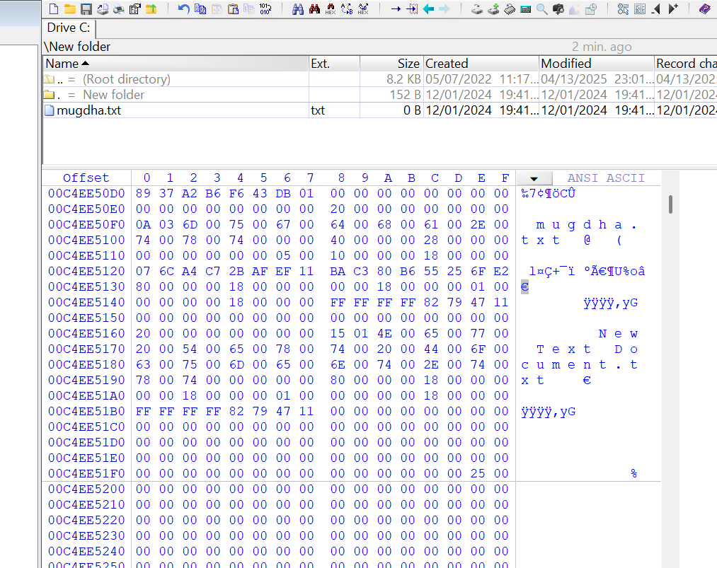

1. **Monitoring Performance in Real-Time**:
   * Observed spikes in **CPU usage**, **Memory load**, and **Disk I/O** when WinHex was used to scan or analyze large sectors.
   * Noted the difference in system resource usage when viewing vs editing in WinHex.

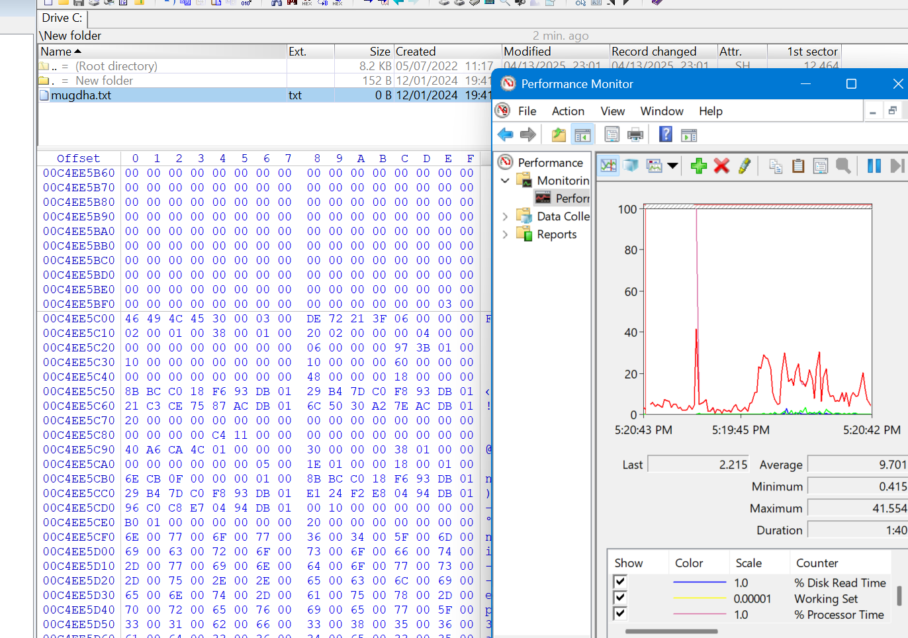

=

**Result:**

* Successfully accessed **Disk Management** using diskmgmt.msc.
* Created a new partition by shrinking an existing drive and later merged it back by deleting and extending the volume.
* Used **Performance Monitor** to track real-time CPU, memory, and disk activity.
* Launched **WinHex** and analyzed raw disk data in hexadecimal format.
* Noticed increased system resource usage in Performance Monitor while using WinHex for disk analysis.

**Discussion:**

Through this lab, I learned how to create and merge partitions using Disk Management. I also observed system resource usage while running WinHex using Performance Monitor. The activity showed that WinHex increases CPU and disk usage during disk analysis. Overall, the lab provided hands-on experience with essential system tools used for storage management and low-level data analysis.