MAWLANA BHASHANI SCIENCE AND TECHNOLOGY UNIVERSITY
SANTOSH, TANGAIL-1902



DEPARTMENT OF INFORMATION AND COMMUNICATION TECHNOLOGY

LAB REPORT

Course Title: Data Structure Lab
Course Code: ICT-1204

Submitted By | Submitted To
Name: Kuldip Saha Mugdha  ID: IT-22018  1st Year, 2nd Semester  Session: 2021-2022  Dept. of ICT, MBSTU | Bikash Kumar Paul  Assistant Professor  DEPARTMENT OF INFORMATION AND COMMUNICATION TECHNOLOGY  MAWLANA BHASHANI SCIENCE AND TECHNOLOGY UNIVERSITY

INDEX
SL | Name | Page No
1 | 1.1: A program to insert an element into array at a specific position.
 | 1.2: A program to delete an element into array at a specific position.
 | 1.3: A program to update an element into array at a specific position.
2 | 2.1: A program to spilit an array into two equivalent array(odd and even).
 | 2.2: A program to merge two sorted arrays into one sorted array.
3 | 3.1: A program to insert an element into a stack (push) and delete an element from a stack (pop).
4 | 4.1: Write a C program to determine maximum number using
5 | 5.1: A program to traverse of a linked list.
 | 5.2: A program to insert last into a linked list.
6 | 6.1: A program for deletion from a linked list.
7 | 7.1: A program for Insertion in a simple linked list.
8 | 8.1: A program for Insertion in a binary search tree.
9 | 9.1: A program to implement Quick Sort.
 | 9.2: A program to implement Merge sort.
10 | 10.1: A program to implement Insertion sort.
 | 10.2: A program to implement Selection sort.
11 | 11.1: A program to implement binary search.

MAWLANA BHASHANI SCIENCE AND TECHNOLOGY UNIVERSITY
SANTOSH, TANGAIL-1902

DEPARTMENT OF INFORMATION AND COMMUNICATION TECHNOLOGY

Course Title: Data Structure Lab
Course Code: ICT-1204

Lab Report No: 01

Submitted By | Submitted To
Name: Kuldip Saha Mugdha  ID: IT-22018  1st Year, 2nd Semester  Session: 2021-2022  Dept. of ICT, MBSTU | Bikash Kumar Paul  Assistant Professor  DEPARTMENT OF INFORMATION AND COMMUNICATION TECHNOLOGY  MAWLANA BHASHANI SCIENCE AND TECHNOLOGY UNIVERSITY
Date of Performance: 02/08/2023

Date of Submission: 09/08/2023

Experiment No: 01

Experiment Name:
  - : A program to insert an element into array at a specific position.

  - : A program to delete an element into array at a specific position

  - : A program to update an element into array at a specific position.

Objectives:

To study , write program and check its results that how an element insert , delete and update into array at a specific position.

Pseudo Code 1.1:

#include<stdio.h> main()  {  int n,i,j,v;  printf("Enter the number of element:\n"); scanf("%d",&n);  printf("Input %d element:\n",n); int a[n];  for(i=0;i<n;i++) scanf("%d",&a[i]); printf("Insert array position:\n"); scanf("%d",&i);  printf("Insert array value:\n"); | scanf("%d",&v); if(i>=n)  a[n]=v; else  {  for(j=n;j>i;j--)  a[j]=a[j-1]; a[j]=v;  }  printf("The present array is:\n"); for(j=0;j<n+1;j++) printf("%d\n",a[j]);  }

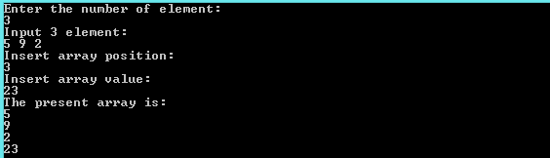
Result 1.1:

Pseudo Code 1. 2:

#include<stdio.h> int main()
{
int i,c,n;
printf("Enter the number of element an { array:\n");
scanf("%d",&n); int ara[n];
printf("Enter %d elements \n",n); for(c=0;c<n;c++)
scanf("%d",&ara[c]); }
printf("Enter the position to delete an element\n"); }

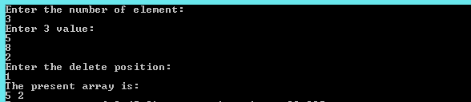
Result 1.2:
scanf("%d",&i); if(i>=n)
printf("delete is not possible\n"); else

for(c=i+1;c<n;c++) ara[c-1]=ara[c];
printf("Resultant array is\n"); for(c=0;c<n-1;c++) printf("% d",ara[c]);

return 0;

Pseudo Code 1. 3:

#include<stdio.h>  Int main()  {  int i,j,v,n;  printf("Enter the number of array element  \n");  scanf("%d",&n); int a[n];  printf("Enter the value\n"); for(i=0;i<n;i++) scanf("%d",&a[i]);  printf("Enter the update value\n"); scanf("%d",&v); | printf("Enter the position\n"); scanf("%d",&i);  if(i>=n)  printf("update is not possible\n"); else  {  a[i]=v;  }  printf("The update array is\n"); for(i=0;i<n;i++)  {  printf("%d \n",a[i]);  }  }

Result 1.3:

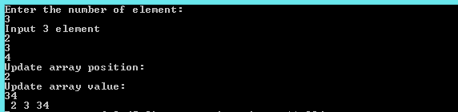

Discussion:
First I write algorithm of insert ,delete and update an element into array at a specific position.Finally I easily write and running the three programs. I learned that for insert,if the insert position is greater than the maximum size of array then it automatic inserted the last index of array because array is a sequenced of index.for delete,if the delete position is greater than the maximum size of array then delete is not possible.At last for update, if the update position is greater than maximum size of array then update is impossible.

MAWLANA BHASHANI SCIENCE AND TECHNOLOGY UNIVERSITY
SANTOSH, TANGAIL-1902
DEPARTMENT OF INFORMATION AND COMMUNICATION TECHNOLOGY

Course Title: Data Structure Lab
Course Code: ICT-1204
Lab Report No: 02
Submitted By | Submitted To
Name: Kuldip Saha Mugdha  ID: IT-22018  1st Year, 2nd Semester  Session: 2021-2022  Dept. of ICT, MBSTU | Bikash Kumar Paul  Assistant Professor  DEPARTMENT OF INFORMATION AND COMMUNICATION TECHNOLOGY  MAWLANA BHASHANI SCIENCE AND TECHNOLOGY UNIVERSITY
Date of Performance: 09/08/2023
Date of Submission: 16/08/2023

Experiment No: 02

Experiment name:
  - : A program to spilit an array into two equivalent array(odd and even).
  - : A program to merge two sorted arrays into one sorted array.

Objectives:
To study, write program and check its result that how to spilit an array into two equivalent array and merge two sorted array into one sorted array.

Pseudo code 2.1:

#include<stdio.h> main()  {  int b[100],c[100],i,j,k,n,even=0,odd=0; printf("Enter the number of element of the  array A:\n"); scanf("%d",&n); int a[n];  printf("\nEnter %d element:\n",n); for(i=0;i<n;i++) scanf("%d",&a[i]);  if(n==0)  printf("Array is empty.\n"); i=0,j=-1,k=-1;  for(i=0;i<n;i++)  {  if(a[i]%2==0)  {  j++; | b[j]=a[i]; even++;  }  else  {  k++;  c[k]=a[i]; odd++;  }  }  printf("\nAfter split The even array is B:\n");  for(j=0;j<even;j++) printf("%d ",b[j]);  printf("\n\nAfter split The odd array is C:\n");  for(k=0;k<odd;k++) printf("%d ",c[k]);  }

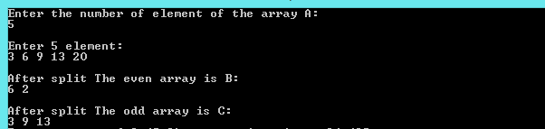
Result 2.1:

Pseudo code 2.2:

#include<stdio.h> main(){  int i,j,k,m,n,p,r;  printf("Enter the number of element of array B:\n");  scanf("%d",&m); int b[m];  printf("Enter the sorted %d element:\n",m); for(j=0;j<m;j++)  scanf("%d",&b[j]);  printf("Enter the number of element of array C:\n");  scanf("%d",&p); int c[p];  printf("Enter the sorted %d element:\n",p); for(k=0;k<p;k++)  scanf("%d",&c[k]); int a[m+p];  i=-1,j=0,k=0; M:  if(j<=m&&k<=p){  if(b[j]>c[k]){  i++;  a[i]=c[k]; k++;  } | else{  i++;  a[i]=b[j]; j++;}  goto M;  }  if(j<=m){  for(r=j;r<m;r++){  i++;  a[i]=b[r];  }  }  else{  for(r=k;r<=p;r++){  i++;  a[i]=c[r];  }  }  printf("The merge sorted array of A is:\n"); for(i=0;i<m+p;i++)  printf("\n%d ",a[i]);  }

Result 2.2:
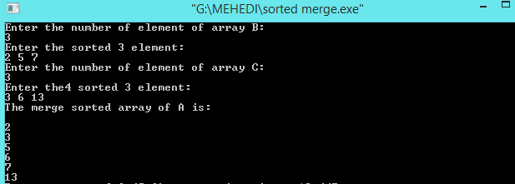
Discussion:
First I write two algorithm of split an array into two equivalent array and merge two sorted arrays into one sorted array .Then I easily write and running the two programs. I learned that for split,if the number of element is zero then array is empty. Otherwise array is split into two arrays(odd and even). At last for merge two sorted arrays,first two arrays must be sorted then two arrays compare each other and finally merge into one sorted arrays. So I solve two programs successfully.

MAWLANA BHASHANI SCIENCE AND TECHNOLOGY UNIVERSITY
SANTOSH, TANGAIL-1902

DEPARTMENT OF INFORMATION AND COMMUNICATION TECHNOLOGY

Course Title: Data Structure Lab
Course Code: ICT-1204

Lab Report No: 03
Submitted By | Submitted To
Name: Kuldip Saha Mugdha  ID: IT-22018  1st Year, 2nd Semester  Session: 2021-2022  Dept. of ICT, MBSTU | Bikash Kumar Paul  Assistant Professor  DEPARTMENT OF INFORMATION AND COMMUNICATION TECHNOLOGY  MAWLANA BHASHANI SCIENCE AND TECHNOLOGY UNIVERSITY
Date of Performance: 16/08/2023
Date of Submission: 23/08/2023

Experiment No: 03

Experiment name:
3.1: A program to insert an element into a stack (push) and delete an element from a stack (pop).

Objectives:
To study, write program and check its result that how to insert an element into a stack and delete an element from a stack.

Pseudo code 3.1:

#include<stdio.h> main()  {  int a[20],top=-1,maxsize=4,value,i,j,n; for( ; ;){  printf("Enter your option\n"); scanf("%d",&n);  if(n==1)  {  if(top==maxsize) printf("Overflow\n"); else  {  printf("Enter your value\n"); scanf("%d",&value); top=top+1;  a[top]=value;  printf("Data succesfully inserted\n");  }  }  else if(n==2) | {  if(top==-1) printf("Underflow\n"); else  {  a[top]=NULL; top=top-1;  printf("Data succesfully deleted\n");  }  }  else if(n==3)  {  printf("stack values are\n"); for(j=0;j<=top;j++) printf("%d\n",a[j]);  }  else exit(0);  }  }
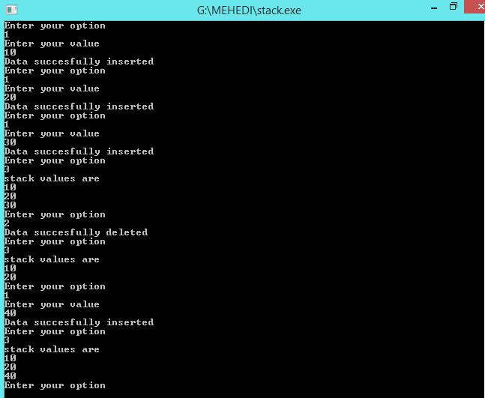
Result 3.1:

Discussion:
There are two types of stack.One is push another pop.Push is insert an element into a stack and pop is delete an element from a stack.In the push, if the top is equl to max size then stack is overflow,Otherwise value is inserted.In the pop, if the element is zero then stack is underflow or delete is impossible.Otherwise value is deleted.Firstly, I face many problems to solve this problems.Then our honorable teacher help us to solve this problems.Finally I easily solve this problems

MAWLANA BHASHANI SCIENCE AND TECHNOLOGY UNIVERSITY
SANTOSH, TANGAIL-1902

DEPARTMENT OF INFORMATION AND COMMUNICATION TECHNOLOGY

Course Title: Data Structure Lab
Course Code: ICT-1204

Lab Report No: 04
Submitted By | Submitted To
Name: Kuldip Saha Mugdha  ID: IT-22018  1st Year, 2nd Semester  Session: 2021-2022  Dept. of ICT, MBSTU | Bikash Kumar Paul  Assistant Professor  DEPARTMENT OF INFORMATION AND COMMUNICATION TECHNOLOGY  MAWLANA BHASHANI SCIENCE AND TECHNOLOGY UNIVERSITY
Date of Performance: 23/08/2023

Date of Submission: 30/08/2023

Experiment No: 04

Experiment name:
4.1: A program to insert an element into a queue and delete an element from a queue.

Objectives:
To study, write program and check its result that how to insert an element into a queue and delete an element from a queue.

Pseudo code 4.1:

#include<stdio.h>
int main ()
{
int a [20], top=-1, n, maxsize, value, j, front=-1, rear=-1, count=-1;
printf("Enter value of max size:\n");
scanf("%d", &maxsize);
for (j=0; j<=maxsize; j++)
a[j]=0;
for (; ;)
{
printf("\nEnter your option:\n");
scanf("%d",&n);
if(n==1)
{
printf("I am in insertion.\n");
if(count==maxsize)
printf("Overflow\n");
else
{
if(rear==-1)
{
front=0;
rear=0;
}
else if(rear==maxsize)
rear=0;
else
rear=rear+1;
printf("Enter your value:\n");
scanf("%d",&value);
a[rear]=value;
count++;
}
}
else if(n==2)
{
printf("I am in deletion\n");
if(count==-1)
printf("Underflow\n");
else
{
a[front]=0;
count--;
printf("Data successfully deleted.\n");
if(count==-1)
{
front=-1;
rear=-1;
}
else if(front==maxsize)
front=0;
else
front++;
}
}
else if(n==3)
{
printf("I am in display\n");
printf("The Queue values are\n");
for (j=0; j<=maxsize; j++)
printf("%d ",a[j]);
}
else
exit (0);
}
}

Result 4.1:

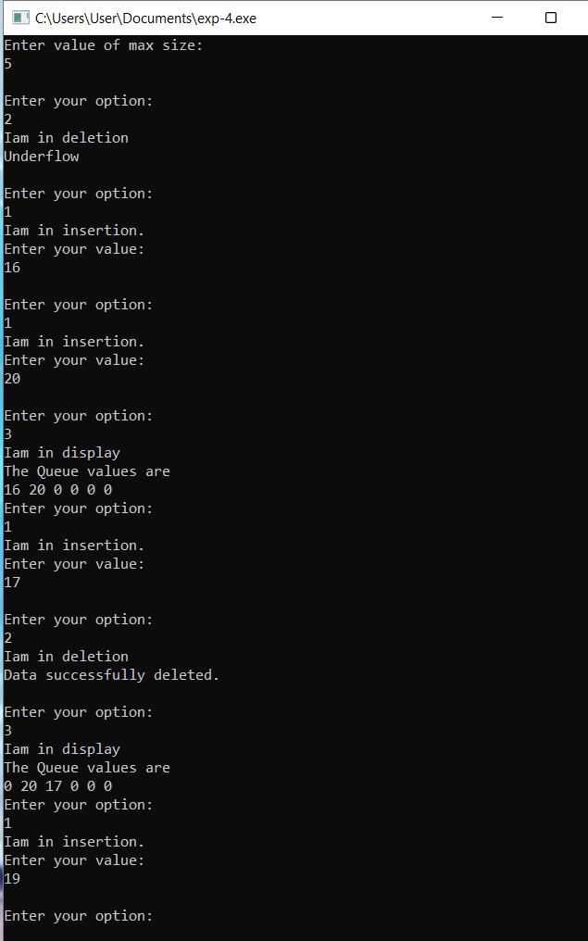

Discussion:
There are two types of queue.One is enqueue and another dequeue.Enqueue is insert an element into a queue and dequeue is delete an element from a queue.In the enque, if the count is equl to max size then queue is overflow,Otherwise value is inserted.In the dequeue, if the element is zero then queue is underflow or delete is impossible.Otherwise value is deleted.Firstly, I face many problems to solve this problems.Then our honorable teacher help us to solve this problems.Finally I easily solve this problems.

MAWLANA BHASHANI SCIENCE AND TECHNOLOGY UNIVERSITY
SANTOSH, TANGAIL-1902
DEPARTMENT OF INFORMATION AND COMMUNICATION TECHNOLOGY

Course Title: Data Structure Lab
Course Code: ICT-1204

Lab Report No: 05
Submitted By | Submitted To
Name: Kuldip Saha Mugdha  ID: IT-22018  1st Year, 2nd Semester  Session: 2021-2022  Dept. of ICT, MBSTU | Bikash Kumar Paul  Assistant Professor  DEPARTMENT OF INFORMATION AND COMMUNICATION TECHNOLOGY  MAWLANA BHASHANI SCIENCE AND TECHNOLOGY UNIVERSITY

Date of Performance: 30/08/2023

Date of Submission: 06/09/2023

Experiment No: 05

Experiment name:
  - : A program to traverse of a linked list.
  - : A program to insert last into a linked list.

Objectives:
To study write program and check its result that how to traverse of a linked list and insert last into a linked list.

Pseudo code 5.1:

#include<stdio.h> struct student  {  int value;  struct student *next;  };  int main()  {  struct student s1,s2,s3; s1.value=10; s1.next=&s2; s2.value=20; | s2.next=&s3; s3.value=30; s3.next=NULL; int *head=&s1;  struct student *ptr=head; while(ptr!=NULL)  {  printf("%d\n",ptr->value); ptr=ptr->next;  }  return 0;  }

Result 5.1:
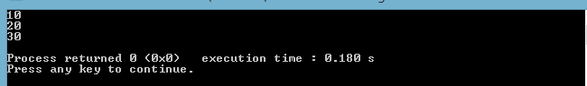

Pseudo code 5.2:

#include<stdio.h> #include<stdlib.h> struct student  {  int value;  struct student *next;  };  typedef struct student node; node *p,*q,*h;  int main()  {  int x; h=0,q=0;  for( ; ;)  {  printf("-99 to break\n"); scanf("%d",&x);  if(x==-99) break;  p=(node*)malloc(sizeof(node)); if(h==0)  { | p->value=x;  p->next=NULL; h=p;  q=p;  }  else  {  p->value=x;  p->next=NULL; q->next=p;  q=p;  }  }  node *ptr=h;  while(ptr!=NULL)  {  printf("%d\n",ptr->value); ptr=ptr->next;  }  return 0;  }

Result 5.2:
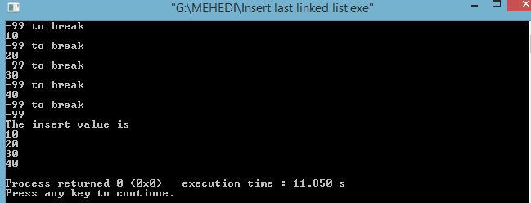
Discussion:
From study about traverse, insert last element into a linked list ,I will know how can I do it .First I write an algorithm ,then I write those program according to it.In traverse , I traverse a linked list by getting some element. In Insert, I can insert infinite element by a infinity loop into a linked list. Firstly, I face some problems to solve this problems.Then our honorable teacher help us to solve this problems.Finally I easily solve this problems.

MAWLANA BHASHANI SCIENCE AND TECHNOLOGY UNIVERSITY
SANTOSH, TANGAIL-1902

DEPARTMENT OF INFORMATION AND COMMUNICATION TECHNOLOGY

Course Title: Data Structure Lab
Course Code: ICT-1204

Lab Report No: 06
Submitted By | Submitted To
Name: Kuldip Saha Mugdha  ID: IT-22018  1st Year, 2nd Semester  Session: 2021-2022  Dept. of ICT, MBSTU | Bikash Kumar Paul  Assistant Professor  DEPARTMENT OF INFORMATION AND COMMUNICATION TECHNOLOGY  MAWLANA BHASHANI SCIENCE AND TECHNOLOGY UNIVERSITY

Date of Performance: 06/09/2023

Date of Submission: 20/09/2023

Experiment No: 06

Experiment name:
6.1: A program for deletion from a linked list.

Objectives:
To study, write program and check its result that how to delete from a linked list.

Pseudo code 6.1:

#include<stdio.h> #include<stdlib.h> struct student
{
int value;
struct student *next;
};
int main()
{
typedef struct student node;
node *h=0,*PTR,*q=0,*ptr,*PTR1; int v,delete_value;
printf("Press -99 for break.\n"); printf("Enter values:\n"); for(;;)
{
scanf("%d",&v); if(v==-99)
break; else
{
PTR=(node*)malloc(sizeof(node)); if(h==0)
{
PTR->value=v; PTR->next=NULL; h=PTR;
q=PTR;
}
else
{
PTR->value=v; PTR->next=NULL;
q->next=PTR;
q=PTR;
}
}
}
printf("The value is:\n"); PTR=h;
ptr=h; while(PTR!=NULL)
{
printf("%d\n",PTR->value); PTR=PTR->next;
}
printf("\n1 for delete first\n"); printf("2 for delete last\n"); printf("3 for delete middle\n"); int t;
for(;;)
{
scanf("%d",&t); if(t==0)
break; if(t==1)
{
printf("The value is:\n"); ptr=ptr->next;
PTR=ptr; while(PTR!=NULL)
{
printf("%d\n",PTR->value); PTR=PTR->next;
}
}
else if(t==2)
{
printf("The value is:\n"); PTR=h;
while(PTR->next!=NULL)
{
PTR1=PTR;
PTR=PTR->next;
}
PTR1->next=NULL; PTR=h;
while(PTR!=NULL)
{
printf("%d\n",PTR->value); PTR=PTR->next;
}
}
else if(t==3)
{
printf("Enter the delete value:"); scanf("%d",&delete_value); printf("The value is:\n"); PTR=h;
while(PTR->value!=delete_value)
{
PTR1=PTR; PTR=PTR->next;
}
PTR1->next=PTR->next; PTR=h;
while(PTR!=NULL)
{
printf("%d\n",PTR->value); PTR=PTR->next;
}
}
}
}

Result 6.1:

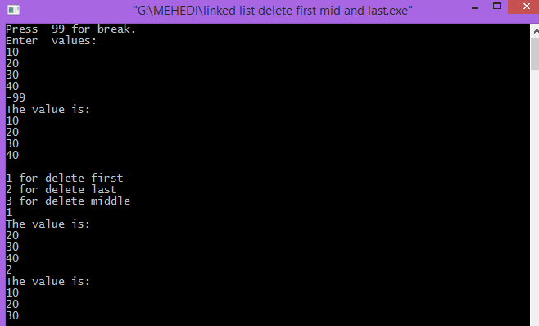

Discussion:

From study about traverse, delete first,second,and last element from a linked list ,I will know how can I do it .First I write an algorithm ,then I write those program according to it. Firstly, I face some problems to solve this problems.Then our honorable teacher help us to solve this problems.Finally I easily solve this problems.

MAWLANA BHASHANI SCIENCE AND TECHNOLOGY UNIVERSITY
SANTOSH, TANGAIL-1902

DEPARTMENT OF INFORMATION AND COMMUNICATION TECHNOLOGY

Course Title: Data Structure Lab
Course Code: ICT-1204

Lab Report No: 07
Submitted By | Submitted To
Name: Kuldip Saha Mugdha  ID: IT-22018  1st Year, 2nd Semester  Session: 2021-2022  Dept. of ICT, MBSTU | Bikash Kumar Paul  Assistant Professor  DEPARTMENT OF INFORMATION AND COMMUNICATION TECHNOLOGY  MAWLANA BHASHANI SCIENCE AND TECHNOLOGY UNIVERSITY

Date of Performance: 20/09/2023

Date of Submission: 27/09/2023

Experiment No: 07

Experiment name:
7.1: A program for Insertion in a simple linked list.

Objectives:
To study write program and check its result that how to insert in a simple linked list.

Pseudo code 7.1:
#include<stdio.h>
struct student
{
int value;
struct student *Next;
};
typedef struct student node;
node *p,*q,*h,*p1;
main()
{
int x,a,b,s;
h=0;
printf("Enter your value\n");
for(;;)
{
scanf("%d",&x);
if(x==-99)
break;
else
{
p=(node*)malloc(sizeof(node));
if(h==0)
{
h=p;
p->value=x;
p->Next=NULL;
q=p;
}
else
{
p->value=x;
p->Next=NULL;
q->Next=p;
q=p;
}
}
}
for(;;)
{
printf("Menu choice:");
scanf("%d",&x);
if(x==1)
{
printf("I am in insertion\n");
printf("Enter your insert value:\n");
scanf("%d",&a);
p=(node*)malloc(sizeof(node));
printf("Enter your insert option:\n");
scanf("%d",&b);
if(b==1)
{
printf("1st insertion\n");
p->Next=h;
p->value=a;
h=p;
}
else if(b==2)
{
printf("2nd insertion\n");
printf("Enter your search value:");
scanf("%d",&s);
p1=h;
while(p1->value!=s)
p1=p1->Next;
p->Next=p1->Next;
p1->Next=p;
p->value=a;
}
else
{
p->Next=NULL;
p->value=a;
p1=h;
while(p1->Next!=0)
p1=p1->Next;
p1->Next=p;
}
}
else if(x==2)
{
printf("I am in display\n");
p1=h;
while(p1!=NULL)
{
printf("\nVALUE %d | ADDRESS %d\n",p1->value,p1);
p1=p1->Next;
}
}
else
break;
}
}

Result 7.1:
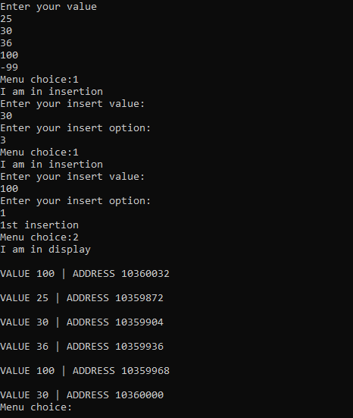
Discussion:
From study about traverse, insert first,second,and last element into a linked list ,I will know how can I do it .First I write an algorithm ,then I write those program according to it.In Insert, I can insert infinite element by a infinity loop into a linked list. Firstly, I face some problems to solve this problems.Then our honorable teacher help us to solve this problems.Finally I easily solve this problems.

MAWLANA BHASHANI SCIENCE AND TECHNOLOGY UNIVERSITY
SANTOSH, TANGAIL-1902

DEPARTMENT OF INFORMATION AND COMMUNICATION TECHNOLOGY

Course Title: Data Structure Lab
Course Code: ICT-1204

Lab Report No: 08
Submitted By | Submitted To
Name: Kuldip Saha Mugdha  ID: IT-22018  1st Year, 2nd Semester  Session: 2021-2022  Dept. of ICT, MBSTU | Bikash Kumar Paul  Assistant Professor  DEPARTMENT OF INFORMATION AND COMMUNICATION TECHNOLOGY  MAWLANA BHASHANI SCIENCE AND TECHNOLOGY UNIVERSITY

Date of Performance: 27/09/2023

Date of Submission: 04/10/2023

Experiment No: 08

Experiment name:
8.1: A program for Insertion in a binary search tree.

Objectives:
To study, write program and check its result that how to insert in a binary search tree.

Pseudo code 8.1:

#include<stdio.h> struct mynode  {  struct mynode *ll; int d;  struct mynode *rl;  };  typedef struct mynode node; int main()  {  node *t,*p,*q,*a[100]; int i,j,x,n;  // printf("I am main function"); t=0,n=0;  for( ; ;)  {  printf("Enter your value\n"); scanf("%d",&x);  if(x<0)  break; q=(node*)(malloc(sizeof(node))); printf("q=%x\n",q);  q->d=x; q->ll=0; q->rl=0; if(t==0) t=q;  else  {  p=t; for( ; ;)  {  if(p->d==x)  {  printf("Sorry duplicate value\n"); break; } | else  {  if(p->d>x)  {  if(p->ll==0)  {  p->ll=q; break;  }  else  p=p->ll;  }  else  {  if(p->rl==0)  {  p->rl=q; break;  }  else  p=p->rl;  }  }  }  }  n++;  a[n]=q;  }  for(i=1; i<=n; i++)  {  p=a[i];  printf("%4x %4x %4d %4x\n",p,p->ll,p-  >d,p->rl);  }  }

Result 8.1:
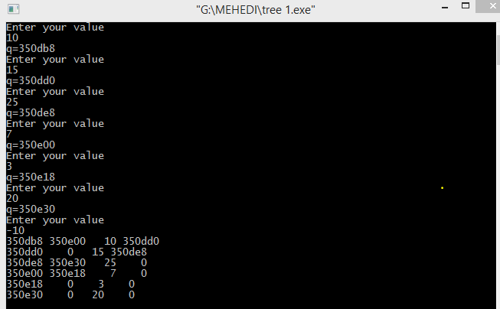

Discussion:

From study about insert element into a binary search tree ,I will know how can I do it
.First I write an algorithm ,then I write those program according to it. In Insert, I can insert infinite element by a infinity loop into a binary search tree. When negative value input then exit the program and show the output of display. Firstly, I face some problems to solve this problems. Then our honorable teacher help us to solve this problems. Finally I easily solve this problems

MAWLANA BHASHANI SCIENCE AND TECHNOLOGY UNIVERSITY
SANTOSH, TANGAIL-1902

DEPARTMENT OF INFORMATION AND COMMUNICATION TECHNOLOGY

Course Title: Data Structure Lab
Course Code: ICT-1204

Lab Report No: 09
Submitted By | Submitted To
Name: Kuldip Saha Mugdha  ID: IT-22018  1st Year, 2nd Semester  Session: 2021-2022  Dept. of ICT, MBSTU | Bikash Kumar Paul  Assistant Professor  DEPARTMENT OF INFORMATION AND COMMUNICATION TECHNOLOGY  MAWLANA BHASHANI SCIENCE AND TECHNOLOGY UNIVERSITY

Date of Performance: 04/10/2023

Date of Submission: 11/10/2023
Experiment No: 09
Experiment name:
9.1: A program to implement Quick Sort.
9.2: A program to implement Merge sort.
Objectives:
To study , write program to sort some elements by using quick and merge sort.

Pseudo code 9.1:

#include<stdio.h>
void quicksort(int number[25],int first,int last)
{
int i, j, pivot, temp;
if(first<last)
{
pivot=first;
i=first;
j=last;
while(i<j)
{
while(number[i]<=number[pivot]&&i<last)
i++;
while(number[j]>number[pivot])
j--;
if(i<j){
temp=number[i];
number[i]=number[j];
number[j]=temp;
}
}
temp=number[pivot];
number[pivot]=number[j];
number[j]=temp;

quicksort(number,first,j-1);
quicksort(number,j+1,last);
}
}

int main()
{
int i, count, number[25];
printf("Enter some elements (Max. - 25): ");
scanf("%d",&count);
printf("Enter %d elements: ", count);
for(i=0;i<count;i++)
scanf("%d",&number[i]);
quicksort(number,0,count-1);
printf("The Sorted Order is: ");
for(i=0;i<count;i++)
printf(" %d",number[i]);
return 0;
}

Result 9.1:
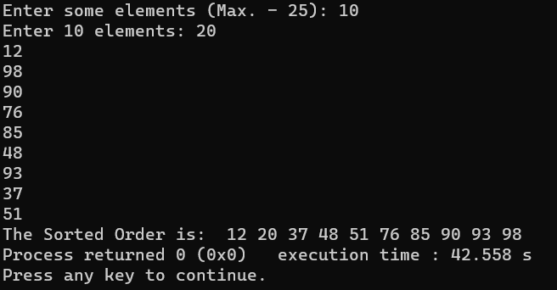

Pseudo Code 9.2:

#include <stdio.h>
void merge(int arr[], int start, int mid, int end) {
int len1 = mid - start + 1;
int len2 = end - mid;
int leftArr[len1], rightArr[len2];
for (int i = 0; i < len1; i++)
leftArr[i] = arr[start + i];
for (int j = 0; j < len2; j++)
rightArr[j] = arr[mid + 1 + j];
int i, j, k;
i = 0;
j = 0;
k = start;
while (i < len1 && j < len2) {
if (leftArr[i] <= rightArr[j]) {
arr[k] = leftArr[i];
i++;
} else {
arr[k] = rightArr[j];
j++;
}
k++;
}
while (i < len1) {
arr[k] = leftArr[i];
i++;
k++;}
while (j < len2) {
arr[k] = rightArr[j];
j++;
k++;
}
}
void mergeSort(int arr[], int start, int end) {
if (start < end) {
int mid = start + (end - start) / 2;
mergeSort(arr, start, mid);
mergeSort(arr, mid + 1, end);
merge(arr, start, mid, end);
}
}
void display(int arr[], int size) {
for (int i = 0; i < size; i++)
printf("%d ", arr[i]);
printf("\n");
}
int main() {
int arr[] = {6, 5, 12, 10, 9, 1};
int size = sizeof(arr) / sizeof(arr[0]);
printf("Original array\n");
display(arr, size);

mergeSort(arr, 0, size - 1);
printf("Sorted array\n");
display(arr, size);
}
Result 9.2:
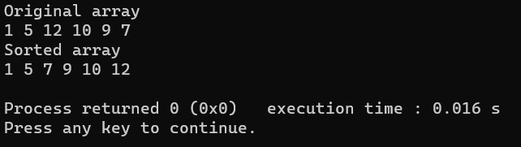

Discussion:
From study about sorting element into a given array ,I will know how can I do it
.First I write an algorithm ,then I write those program according to it. Firstly, I face some problems
to solve this problems. Then our honorable teacher help us to solve this problems. Finally
I easily solve this problems.

MAWLANA BHASHANI SCIENCE AND TECHNOLOGY UNIVERSITY

SANTOSH, TANGAIL-1902
DEPARTMENT OF INFORMATION AND COMMUNICATION TECHNOLOGY

Course Title: Data Structure Lab
Course Code: ICT-1204

Lab Report No: 10
Submitted By | Submitted To
Name: Kuldip Saha Mugdha  ID: IT-22018  1st Year, 2nd Semester  Session: 2021-2022  Dept. of ICT, MBSTU | Bikash Kumar Paul  Assistant Professor  DEPARTMENT OF INFORMATION AND COMMUNICATION TECHNOLOGY  MAWLANA BHASHANI SCIENCE AND TECHNOLOGY UNIVERSITY

Date of Performance: 11/10/2023

Date of Submission: 18/10/2023

Experiment No: 10
Experiment name:
10.1: A program to implement Insertion sort.
10.2: A program to implement Selection sort.

Objectives:
To study , write program to sort some elements by using insertion and selection sort.

Pseudo code 10.1:

#include <stdio.h>
void insertionSort(int arr[], int n)
{
int i, j , item;
for (i = 1; i < n; i++)
{
item = arr[i];
j = i - 1;
while (j >= 0 && arr[j] > item)
{
arr[j + 1] = arr[j];
j = j - 1;
}
arr[j + 1] = item;
}
}
void printArray(int arr[], int n)
{
int i;
for (i = 0; i < n; i++)
printf("%d ", arr[i]);
printf("\n");
}
int main()
{
int arr[] = {15, 13, 11, 14, 12};
int n = sizeof(arr) / sizeof(arr[0]);
insertionSort(arr, n);
printArray(arr, n);
return 0;
}

Result 10.1:
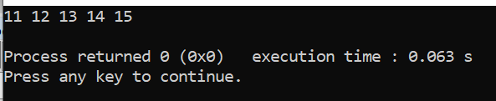

Pseudo Code 10.2:

#include <stdio.h>
int main()
{
int a[100], n, i, j, position, swap;
printf("Enter number of elements : ");
scanf("%d", &n);
printf("Enter %d Numbers : \n ", n);
for (i = 0; i < n; i++)
scanf("%d", &a[i]);
for(i = 0; i < n - 1; i++)
{
position=i;
for(j = i + 1; j < n; j++)
{
if(a[position] > a[j])
position=j;
}
if(position != i)
{
swap=a[i];
a[i]=a[position];
a[position]=swap;
}
}
printf("Sorted Array : \n");
for(i = 0; i < n; i++)
printf("%d\n", a[i]);
return 0;
}

Result 10.2:
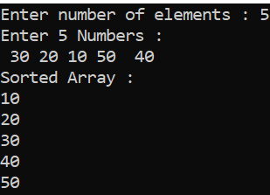

Discussion:
From study about sorting element into a given array, I will know how can I do it.
First I write an algorithm, then I write those program according to it. Firstly, I face some problems
to solve this problems. Then our honorable teacher help us to solve this problems. Finally I easily solve this problems.

MAWLANA BHASHANI SCIENCE AND TECHNOLOGY UNIVERSITY

SANTOSH, TANGAIL-1902
DEPARTMENT OF INFORMATION AND COMMUNICATION TECHNOLOGY

Course Title: Data Structure Lab
Course Code: ICT-1204

Lab Report No: 11
Submitted By | Submitted To
Name: Kuldip Saha Mugdha  ID: IT-22018  1st Year, 2nd Semester  Session: 2021-2022  Dept. of ICT, MBSTU | Bikash Kumar Paul  Assistant Professor  DEPARTMENT OF INFORMATION AND COMMUNICATION TECHNOLOGY  MAWLANA BHASHANI SCIENCE AND TECHNOLOGY UNIVERSITY

Date of Performance: 18/10/2023

Date of Submission: 25/10/2023

Experiment No: 11

Experiment name:
11.1: A program to implement binary search.

Objectives:
To study, write program and check its result that how we can find the position of any element in array using by binary search.

Pseudo code:

#include<bits/stdc++.h>
using namespace std;
int binarysearch(int arr[],int n,int key)
{
int l=0;
int r=n-1;
while(l<=r)
{
int mid =((l+r)/2);
if(arr[mid] == key )
return mid+1;
else if (arr[mid]>key)
{
r=mid-1;
}
else
{
l=mid+1;
}
}
return -1;
}
int main()
{
int n;
cout<<"Enter the size of array: ";
cin>>n;
int arr[n];
cout<<"Enter the value of array"<<endl;
for(int i=0; i<n; i++)
{
cin>>arr[i];
}
sort(arr, arr + n);
cout<<"\nThe New Sorted Array is:\n";
for(int i=0; i<n; i++)
cout<<arr[i]<<" ";
int key;
cout<<"\n\nEnter Element to be Search: ";
cin>>key;
cout<<"\nthe element in the position ";
cout << binarysearch(arr,n,key);
cout<<"\n";
return 0;
}

Result 11.1:

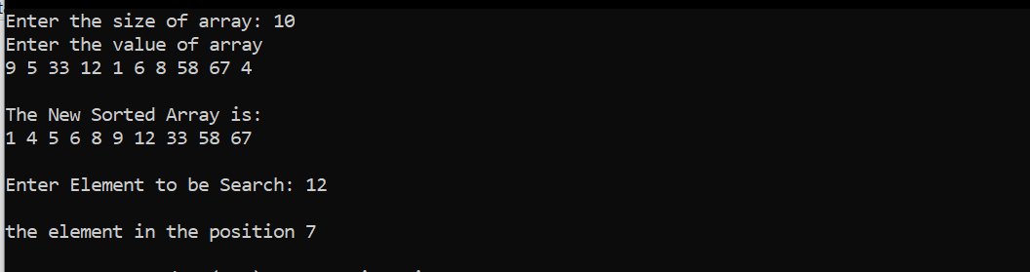

Discussion:

Binary Search is a searching algorithm for finding an element's position in a sorted array. In this approach, the element is always searched in the middle of a portion of an array. Binary search can be implemented only on a sorted list of items. If the elements are not sorted already, we need to sort them first.

