**High Level Design (HLD)**

**Deloitte Case Study**

**Document Version Control**

|  |  |  |  |
| --- | --- | --- | --- |
| **Date Issued** | **Version** | **Description** | **Author** |
| **28MARCH 2023** | **1.0** | **First Version of Complete HLD** | **Mugdha** |
|  |  |  |  |

**Contents**

**Document Version Control......................................................................................................... 2**

**Abstract ...................................................................................................................................... 4**

**1 Introduction ............................................................................................................................ 5**

**1.1 Why this High-Level Design Document? ......................................................................... 5**

**1.2 Scope ................................................................................................................................ 6**

**2 General Description ................................................................................................................ 6**

**2.1 Product Perspective & Problem Statement ..................................................................... 6**

**2.2 Tools used ......................................................................................................................... 7**

**3 Design Details ......................................................................................................................... 8**

**3.1 Functional Architecture .................................................................................................... 8**

**3.2 Optimization ...................................................................................................................... 9**

**4 KPIs ......................................................................................................................................... 10**

**5 Deployment ........................................................................................................................... 10**

**Abstract**

**It is used as a collective term to refer to a broad range of financial and economic services provided by the finance industry, which encompasses a broad range of organizations that manage money, including credit unions, banks, credit card companies, insurance companies, consumer finance companies, stock brokerages, investment funds. A banking domain comprises all the components needed to run a financial service end-to-end. It covers the transaction and distribution process; how customers interact with the system, the products, and services the organization offers; and the technology involved.**

**Accurately predicting the year-over-year (YoY) growth, inflation, and compound annual growth rate (CAGR) in different countries for different years with the help of given data sets CPI, EXCHANGE, and EXPORTS. Taking these 3 values allows us to visualize and create insights for YOY, CAGR, and INFLATION. we can also find some relations between them.**

**1 Introduction**

**1.1 Why this High-Level Design Document?**

**This High-Level Design (HLD) Document aims to add the necessary detail to the current project description to represent a suitable model for coding. This document is also intended to help detect contradictions before coding and can be used as a reference manual for how the modules interact at a high level.**

**The HLD will:**

**• Present all of the design aspects and define them in detail**

**• Describe the user interface is implemented**

**• Describe the hardware and software interfaces**

**• Describe the performance requirements**

**• Include design features and the architecture of the project**

**• List and describe the non-functional attributes like:**

**o Security**

**o Reliability**

**o Maintainability**

**o Portability**

**o Reusability**

**o Application compatibility**

**o Resource utilization**

**o Serviceability**

**1.2 Scope**

**The HLD documentation presents the system’s structure, including the database architecture, application architecture (layers), application flow (Navigation), and technology architecture. The HLD uses non-technical to mildly-technical terms, which should be understandable to the system administrators.**

**2 General Description**

**2.1 Product Perspective & Problem Statement**

**A banking domain comprises all the components needed to run a financial service end-to-end. It covers the transaction and distribution process; how customers interact with the system, the products, and services the organization offers; and the technology involved.**

**The project’s objective is to perform data visualization techniques to understand the insight of the data. This project aims to apply various Business Intelligence tools such as Tableau or Power BI to get a visual understanding of the data and helps in getting clear insights from the data.**

**2.2 Tools used**

**Business Intelligence tools such as Excel, MySQL, and Power BI are used to build the whole framework.**

**3 Design Details**

**3.1 Functional Architecture**

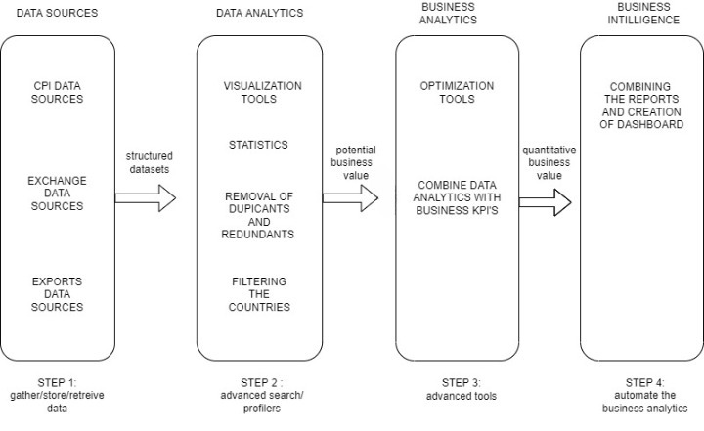

**3.2 Optimization**

* Removal of NA from the datasets.
* Conversion of monthly and quarterly data to yearly data.
* Filtering the countries
* Reshaping the data from broad data type to long data type for analysis

**4 KPIs**

**Key indicators displaying a summary of the effect on different countries by CPI, EXCHANGE, and EXPORTS rate**

**1. Impact of inflation on different countries**

**2. Calculation of compound annual growth rate in different countries for a different year (1998 to 2017)**

**3. Calculation of year-over-year growth rate in different countries for different year**

**4. Impact of exchange rate on different countries for different years**

**5. Impact of export rate on different countries for different years**

**5 Deployment**

**Loading data in Power BI and putting slicers will enable the user to select any country of her/his choice for the different years, from 1998 to 2018. After selecting the country and year, the user can quickly analyze the data, inflation in every country for every year. Users can also know CAGR and YOY growth.**

**6 Scope**

**Adding the new measure values to data sources where we can easily predict the rank of the different countries in business and economic growth. We should be able to know the investments in the country based on its rank, and also, we should know the factors which affect the inflation rate so that we can take action accordingly. Not only these by adding new measures users can analyze the data in a more beautiful way**