**A Beacon of Quality and Tradition in Barishal, Bangladesh**

Mithun Garments

**Submitted to**

MD. Mahbub-E-Noor

Assistant professor

Department of CSE,

University of Barishal

**Submitted by**

**Mithun Ghosh**

Roll: 15

Batch: 68

Contents

1 Introduction 2

2 The Genesis of Mithun Garments 2

3 Product Portfolio: A Blend of Tradition and Modernity 3

3.1 Shirts and Pants: 3

3.2 Jackets: 3

3.3 Arabian Dresses: 3

3.4 Festival Dresses: 4

3.5 Bed Sheets: 4

4 The Barishal Advantage 4

5 Commitment to Quality and Sustainability 4

6 Economic Impact and Community Engagement 5

7 Challenges and Future Prospects 5

8 Conclusion 6

Mithun Garments: A Beacon of Quality and Tradition in Barishal, Bangladesh

# Introduction

In the bustling city of Barishal, Bangladesh, where the rivers flow with stories of resilience and the air carries the scent of opportunity, Mithun Garments stands as a testament to the region's entrepreneurial spirit and commitment to quality. Established with a vision to provide high-quality garments to both local and international markets, Mithun Garments has grown into a reputable name in the textile and apparel industry. Specializing in the production of shirts, pants, jackets, Arabian dresses, festival dresses, and bed sheets, the company has carved a niche for itself by blending traditional craftsmanship with modern manufacturing techniques. With an average monthly sale of $36,305.20, Mithun Garments is not just a business; it is a symbol of Barishal's economic potential and cultural heritage.

# The Genesis of Mithun Garments

Mithun Garments was founded with a simple yet profound mission: to create garments that reflect the rich cultural heritage of Bangladesh while meeting the demands of contemporary fashion. The company's journey began in the heart of Barishal, a city known for its vibrant culture and skilled artisans. Recognizing the potential of the textile industry, the founders of Mithun Garments invested in state-of-the-art machinery and trained local workers to produce garments that could compete in both domestic and international markets.

From its inception, Mithun Garments has been committed to quality, sustainability, and ethical practices. The company sources its materials from trusted suppliers, ensuring that every piece of fabric meets the highest standards. By adhering to fair labor practices and providing a safe working environment, Mithun Garments has earned the trust and loyalty of its employees and customers alike.

# Product Portfolio: A Blend of Tradition and Modernity

Mithun Garments offers a diverse range of products, each designed to cater to the unique needs of its customers. The company's product portfolio includes:

|  |  |  |  |  |  |  |
| --- | --- | --- | --- | --- | --- | --- |
| **Date** | | **Product** | **Customer Name** | **Quantity** | **Unit Price** | **Amount** |
| 1-Feb-24 | Shirts | | Zenith Solutions Inc. | **270** | $10.50 | $2,835.00 |
| 5-Feb-24 | Pants | | Synergy Enterprises LLC | **430** | $14.25 | $6,127.50 |
| 10-Feb-24 | Bed Covers | | Peak Performance Partners | **610** | $12.80 | $7,808.00 |
| 13-Feb-24 | Shirts | | Catalyst Co. | **830** | $11.65 | $9,669.50 |
| 28-Feb-24 | Jackets | | Zenith Solutions Inc. | **550** | $13.40 | $7,370.00 |
| 7-Mar-24 | Arabian Cloth | | Nimbus Enterprises | **190** | $11.20 | $2,128.00 |
| 13-Mar-24 | Arabian Cloth | | Peak Performance Partners | **370** | $13.75 | $5,087.50 |
| 19-Mar-24 | Jackets | | Equinox Innovations | **750** | $10.90 | $8,175.00 |
| 25-Mar-24 | Festive Cloth | | Stellar Ventures Ltd. | **310** | $14.10 | $4,371.00 |
| 1-Apr-24 | Pants | | Catalyst Co. | **490** | $12.30 | $6,027.00 |
| 7-Apr-24 | Shirts | | Quantum Quotient Corporation | **670** | $11.95 | $8,006.50 |
| 13-Apr-24 | Arabian Cloth | | Nexus Dynamics Group | **910** | $13.60 | $12,376.00 |
| 19-Apr-24 | Pants | | Synergy Enterprises LLC | **130** | $10.75 | $1,397.50 |
| 25-Apr-24 | Festive Cloth | | Apex Strategies Ltd. | **890** | $12.50 | $11,125.00 |
| 2-May-24 | Arabian Cloth | | Nimbus Enterprises | **770** | $14.70 | $11,319.00 |
| 8-May-24 | Jackets | | Peak Performance Partners | **350** | $11.35 | $3,972.50 |
| 14-May-24 | Pants | | Equinox Innovations | **510** | $13.90 | $7,089.00 |
| 20-May-24 | Shirts | | Stellar Ventures Ltd. | **970** | $10.30 | $9,991.00 |
| 26-May-24 | Arabian Cloth | | Catalyst Co. | **630** | $14.85 | $9,355.50 |
| 2-Jun-24 | Bed Covers | | Quantum Quotient Corporation | **250** | $12.15 | $3,037.50 |
| 8-Jun-24 | Shirts | | Nexus Dynamics Group | **830** | $11.50 | $9,545.00 |
| 14-Jun-24 | Festive Cloth | | Synergy Enterprises LLC | **570** | $13.20 | $7,524.00 |
| 15-Jun-24 | Arabian Cloth | | Apex Strategies Ltd. | **810** | $10.65 | $8,626.50 |
| 17-Jun-24 | Pants | | Synergy Enterprises LLC | **690** | $14.40 | $9,936.00 |
| 15-Jun-24 | Arabian Cloth | | Apex Strategies Ltd. | **810** | $10.65 | $8,626.50 |

## Shirts and Pants:

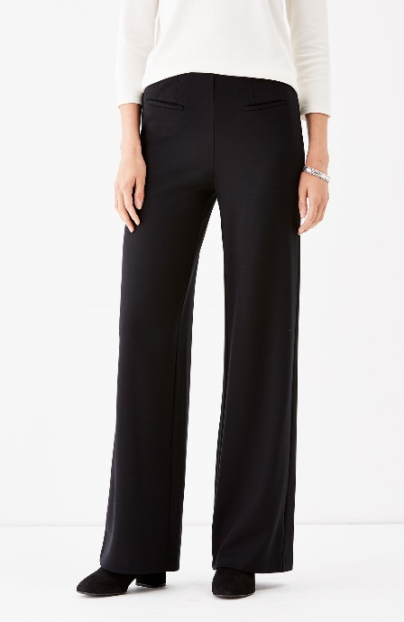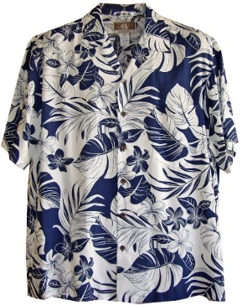 Mithun Garments produces a wide variety of shirts and pants, ranging from casual wear to formal attire. The company's designs are inspired by global fashion trends, ensuring that customers can stay stylish and comfortable.

## Jackets:

Whether it's a sleek blazer for a business meeting or a cozy winter jacket, Mithun Garments' collection of jackets is designed to provide both functionality and style.

## Arabian Dresses:

Recognizing the growing demand for traditional Arabian attire, Mithun Garments has developed a line of Arabian dresses that combine elegance with cultural authenticity. These garments are particularly popular in the Middle Eastern market.

## Festival Dresses:

Festivals are an integral part of Bangladeshi culture, and Mithun Garments celebrates this by offering a range of festival dresses. These vibrant and intricately designed garments are perfect for special occasions and cultural events.

## Bed Sheets:

In addition to apparel, Mithun Garments also produces high-quality bed sheets. Made from premium fabrics, these bed sheets are designed to provide comfort and durability, making them a favorite among households.

# The Barishal Advantage

Barishal, often referred to as the "Venice of the East," is a city with a rich history and a thriving economy. Its strategic location, coupled with a skilled workforce, makes it an ideal hub for the textile industry. Mithun Garments has leveraged these advantages to establish itself as a key player in the region's economy.

The city's proximity to major ports and transportation networks allows Mithun Garments to efficiently distribute its products to both domestic and international markets. Additionally, Barishal's cultural diversity and artistic heritage have inspired the company's designs, giving its products a unique identity that resonates with customers worldwide.

# Commitment to Quality and Sustainability

At the core of Mithun Garments' success is its unwavering commitment to quality. The company employs a team of skilled designers and technicians who oversee every stage of the production process, from fabric selection to final stitching. Rigorous quality control measures ensure that each garment meets the company's high standards before it reaches the customer.

In an era where sustainability is paramount, Mithun Garments has taken significant steps to minimize its environmental impact. The company has implemented eco-friendly practices, such as using organic fabrics, reducing water consumption, and recycling waste materials. By prioritizing sustainability, Mithun Garments not only contributes to the preservation of the environment but also appeals to the growing number of eco-conscious consumers.

# Economic Impact and Community Engagement

Mithun Garments plays a vital role in the local economy of Barishal. With an average monthly sale of $36,305.20, the company generates substantial revenue that contributes to the region's economic growth. The company's operations have created numerous job opportunities for local residents, empowering them with skills and stable incomes.

Beyond its economic contributions, Mithun Garments is deeply committed to giving back to the community. The company actively participates in social initiatives, such as providing scholarships to underprivileged students, supporting local healthcare facilities, and organizing cultural events that celebrate Barishal's heritage. Through these efforts, Mithun Garments has become more than just a business; it is a pillar of the community.

# Challenges and Future Prospects

Like any business, Mithun Garments faces its share of challenges. The global textile industry is highly competitive, with rapidly changing fashion trends and fluctuating market demands. To stay ahead, the company must continuously innovate and adapt to new technologies. Additionally, rising production costs and the need for sustainable practices pose ongoing challenges that require strategic planning and investment.

Despite these challenges, Mithun Garments is optimistic about the future. The company plans to expand its product line and explore new markets, particularly in Europe and North America. By leveraging digital marketing and e-commerce platforms, Mithun Garments aims to reach a wider audience and increase its global presence. Furthermore, the company is investing in research and development to create innovative designs and sustainable products that align with the evolving preferences of consumers.

# Conclusion

Mithun Garments is more than just a garment manufacturer; it is a symbol of Barishal's resilience, creativity, and ambition. Through its commitment to quality, sustainability, and community engagement, the company has established itself as a trusted name in the textile industry. As it continues to grow and evolve, Mithun Garments remains dedicated to its mission of providing exceptional garments that reflect the rich cultural heritage of Bangladesh while meeting the demands of the modern world.

In the heart of Barishal, where the rivers flow with stories of the past and the winds carry the promise of the future, Mithun Garments stands as a beacon of hope and progress. With its unwavering dedication to excellence and its deep-rooted connection to the community, Mithun Garments is poised to achieve even greater heights in the years to come.