

Bank Licensing & Compliance Portal
Design Document

Senior Associate Software Engineer Technical Challenge
Prepared by Yves Mugenga

This document explains the design decisions behind the Bank Licensing & Compliance Portal developed and built as part of the BNR Senior Associate Software Engineer Role recruitment process. It is written to show how the system was structured, the important rules implemented, what was intentionally kept simple, and what I would improve with more time.

1. Introduction
The problem I designed for is not only a technical problem/solution. It is also an ownership problem.
The current process depends on emails, spreadsheets, and informal follow-up. That means an application can move, pause, or change without a clear record of who owns the next step. It also means the organization can struggle later to prove who reviewed an application, who requested more information, and who made the final decision.
I designed the web application around that reality. Applicants should be able to submit an application, upload supporting documents, respond when more information is requested, and follow the progress of their own application without needing to understand the internal process. Officers should be able to review applications, check the documents, and request missing information where needed. Approvers should be able to make the final decision only after another person has reviewed the application. Administrators should be able to manage users, roles, and permissions because the internal workflow may still change as the organization improves the process.
That shaped one of the main design decisions. I created default roles based on the current understanding of the process, but I did not limit the system into only those roles. Since ownership and workflow boundaries are still not fully fixed at the organizational level, the system allows a superadmin to create new roles and assign permissions depending on how the process matures. The one rule I kept strict is separation of duties: the same user cannot review and approve the same application.
For this design, I created default users and assigned them clear responsibilities. These users make the system easy to test and review, but they are not meant to be the only structure the organization can use. As the process becomes clearer, the organization can create more roles, give ownership to more people, or adjust permissions without changing the whole system.

Roles

Applicant
Applicants are the commercial banks or financial institutions applying for a license. Their role is intentionally limited to their own applications. They can create an application, upload documents, submit it, respond when additional documents are requested, and follow the progress of their own application.
They cannot see other applicants’ applications. They also cannot review, approve, reject, or manage internal users. This boundary is important because applicants should be able to participate in the process without seeing or influencing the regulator’s internal work.

Officer
An officer is a person within the organization who handles the administrative and review work around applications. Officers can review submitted applications, check supporting documents, request additional information, and move an application forward when it is ready for a final decision.
I used the officer role because the current process needs someone to own the middle part of the workflow. Without this role, applications can easily sit between submission and decision with no clear person responsible for checking them.
Officers cannot approve or reject applications. That decision is kept separate so that the person who reviewed the file is not the same person making the final call.

Approver
An approver is a person within the organization who makes the final decision after an application has already been reviewed. Approvers can see the full application, review the documents and history, then approve or reject the application.
Approvers cannot start the review process or request additional documents. Their role is focused on the final decision.

Superadmin
The superadmin manages the setup of the system. This user can create users, create roles, and assign permissions. I included this because the organization’s process is not fully fixed yet, so the system needs room to adapt.
The superadmin can help the organization define better ownership over time without requiring code changes every time the process changes. For example, if the organization later creates a legal review role, a compliance manager role, or a document verification role, the superadmin can create those roles and assign the right permissions.

2. Architecture
The backend is organized using a domain-driven architecture. I chose this structure because it allows the codebase to follow the actual business process of the system instead of grouping everything only by technical layers. In this case, licensing applications, users, roles, documents, audit logs, authentication, and notifications each have their own space in the codebase.
Each domain contains its own routes, controllers, services, repositories, and schemas where needed. This makes the code easier to read, maintain, and extend because the rules that belong to a feature stay close to that feature. For example, the rules for submitting, reviewing, requesting documents, approving, and rejecting an application live inside the applications domain.

The rules for creating roles and assigning permissions live inside the roles domain. The rules for keeping audit logs permanent live inside the audit domain.
This approach also makes the backend feel closer to a microservice style without adding the overhead of actual microservices. The domains are separated enough that the logic is decoupled, but the system remains simple to run and review for the challenge. If the platform grows later, some domains could be separated into their own services more easily because the boundaries are already clear.

2.1 Backend domains (Modules)

Domain | Responsibility
Auth | Login, current user identity, JWT issuing, password verification.
Users | Creating and managing system users and applicant users.
Roles | Creating roles, assigning permissions, and blocking unsafe permission combinations.
Applications | Main workflow for creation, review, document requests, resubmission, and final decision.
Documents | Upload, metadata, download access, file size check, and document versioning.
Audit | Permanent record of workflow actions. No update or delete operations are exposed.
Notifications | Applicant email notification placeholder. Safe to skip when email is not configured.

3. Data model

I modeled the database around the same business rules that the backend modules and services depend on. The goal was to make the structure of the data reflect the structure of the process. Users, roles, permissions, applications, documents, and audit logs are separated because they do not behave the same way. An application moves through different states. Documents may be uploaded again when more information is requested, but older versions still need to remain available. Audit logs should not change at all. Roles and permissions need to stay flexible because the organization may adjust responsibilities over time. Keeping these parts separate makes the system easier to reason about and also reduces the chance of changing one part of the process and accidentally breaking another.

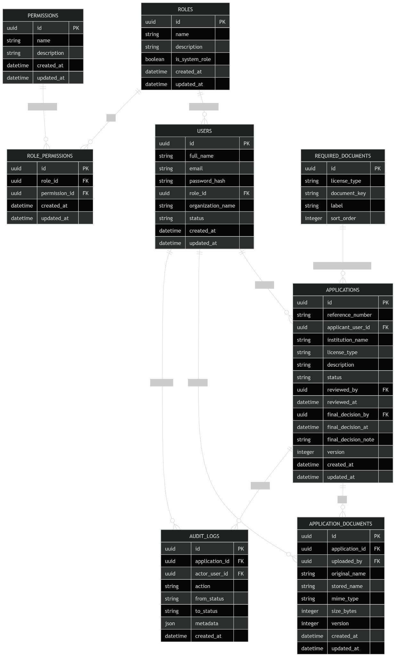

3.1 Main tables

Table | Purpose | Important fields
users | Stores applicants, officers, approvers, and administrators. | full_name, email, password_hash, role_id, organization_name, status
roles | Stores default and custom roles. | name, description, is_system_role
permissions | Stores actions the system understands. | name, description
role_permissions | Connects roles to permissions. | role_id, permission_id
applications | Stores the licensing application and its workflow state. | reference_number, applicant_user_id, status, reviewed_by, final_decision_by, version
application_documents | Stores metadata for uploaded documents. | application_id, uploaded_by, original_name, stored_name, size_bytes, version
required_documents | Stores the list of documents expected for each license type. | license_type, document_key, label, sort_order
audit_logs | Stores permanent evidence of application actions. | application_id, actor_user_id, action, from_status, to_status, metadata, created_at

One improvement I would make with more time is adding an institutions table. In this version, institution information is kept on the user and application records because it is enough for the challenge. In a fuller system, each bank or financial institution should have its own model, account, users, and ownership rules. That would allow one institution to manage several users under its own account instead of treating every applicant user as a standalone identity.

4. Application workflow
I did not allow users to change an application status directly. That would make the process too easy to break. Instead, users perform specific actions, and each action moves the application from one allowed state to the next.

For example, an applicant does not manually change an application from draft to submitted. They submit the application. An officer does not manually change the status to additional_documents_requested. They request additional documents. An approver does not edit the status field directly. They approve or reject the application.
This keeps the workflow closer to how the real process works. It also makes the backend easier to protect because every status change has a clear meaning, a clear actor, and a clear audit entry.
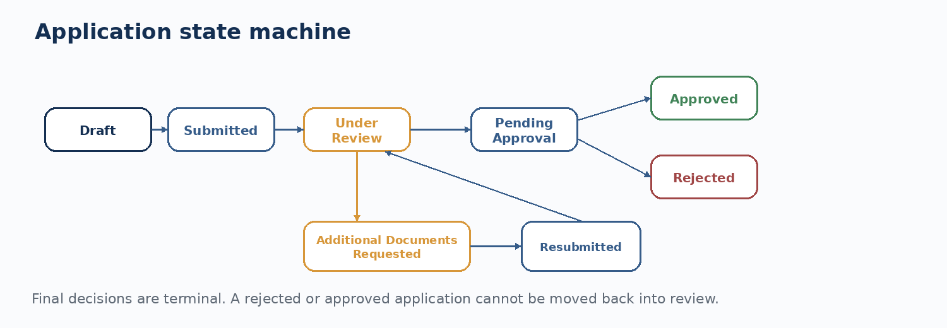

From state | Action | To state | Allowed actor
draft | Submit application | submitted | Applicant owner
submitted | Start review | under_review | Officer
under_review | Request additional documents | additional_documents_requested | Officer
additional_documents_requested | Resubmit application | resubmitted | Applicant owner
resubmitted | Start review again | under_review | Officer
under_review | Send to approval | pending_approval | Officer
pending_approval | Approve application | approved | Approver
pending_approval | Reject application | rejected | Approver

The final two states are approved and rejected. Once an application reaches either one, it cannot move again. I made this strict because a final licensing decision should not be changed quietly after the fact. If a final decision ever needs to be corrected in a real production system, that can be handled through a new controlled process, not by editing the old decision
.

4.1 Concurrency
I also had to protect the workflow from two people acting on the same application at the same time, especially at the final decision stage. Without protection, one approver could approve an application while another rejects it almost at the same time, leaving the system with inconsistent records.
To avoid that, workflow updates happen inside a database transaction. When a user starts an action like approval or rejection, the system locks the application row, checks the latest status, applies the update, and writes the audit log before the transaction is committed.
If another user tries to act on the same application at the same time, their request waits. Once the first action finishes, the second request checks the application again. If the application is no longer in the right state, the second action is rejected.
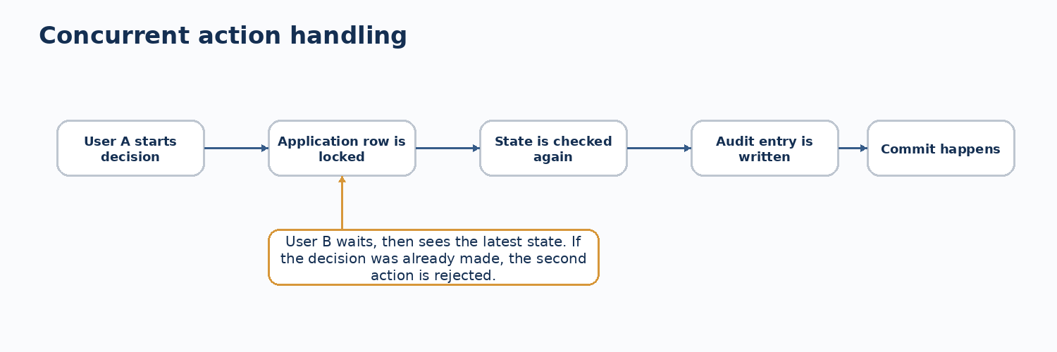

5. Roles and permissions
I created four default roles so the system can work immediately with the process described in the challenge. The roles are simple on purpose. An applicant applies. An officer checks the application and follows up when information is missing. An approver makes the final decision. A superadmin manages the system setup.
At the same time, I did not want the system to assume that the organization already has a perfect internal structure. The current process is still informal, so ownership may change as the organization starts using the system. For that reason, roles and permissions are configurable. The default roles give the organization a starting point, but the superadmin can create new roles later if different departments, teams, or seniority levels need different access.

Role | Can do | Cannot do
Applicant | Create applications, upload documents, submit, resubmit, and view their own applications. | Cannot see other applicants, review applications, or make final decisions.
Officer | View applications, start review, request additional documents, and move a reviewed application to pending approval. | Cannot approve or reject.
Approver | View pending applications and make the final approval or rejection decision. | Cannot be the same user who reviewed the same application.
Superadmin | Manage users, roles, permissions, and system setup. | Cannot use administration power to bypass workflow separation rules.

6. Audit trail
The audit log is treated as evidence, not as normal application data. Every important workflow action creates an audit entry with the acting user, action, timestamp, previous state, new state, and metadata where needed. The audit entry is written in the same transaction as the application update, so the system does not end up with a decision that has no record behind it.
The audit table is append-only. The API does not expose update or delete routes for audit logs, and the database has triggers that reject UPDATE and DELETE on that table. This means an administrator can manage the system, but cannot rewrite the history of an application from inside the application itself.

Action | Audit entry created
Create application | application_created
Submit application | application_submitted
Start review | review_started
Request additional documents | additional_documents_requested
Upload documents | documents_uploaded
Resubmit application | application_resubmitted
Send to approval | marked_pending_approval
Approve or reject | application_approved or application_rejected

7. Documents
Applicants can upload supporting documents while an application is still in draft or when an officer requests additional documents. Files are stored locally for this challenge, and the database stores their metadata, including file name, type, size, uploader, timestamp, and version.
I also added support for required document configuration. This allows the system to define which documents are expected for an application before the applicant submits it. Instead of leaving document requirements only in emails or informal instructions, the portal can show applicants the list of required documents directly in the application flow.
The required document list can be managed from the system side, so the organization can adjust the requirements as the licensing process becomes more defined. When an applicant is applying, the form and document upload section use that list to guide what needs to be submitted.

8. Notifications
I added a notification domain as a safe placeholder. The idea is that applicants should receive emails when their application is submitted, when additional documents are requested, when they resubmit, and when a final decision is made.
I did not fully complete the notification domain. The design is there so the service can be finished later without changing the application workflow. Email sending should happen after the main transaction commits, and email failure should not undo a valid review or approval action. If email is not configured, the system should skip it safely.

9. System trade-offs
Here I describe some of the trade-offs and decisions I took while working on this.
Decision | How I handled it
Configurable roles | Started with applicant, officer, approver, and superadmin, but allowed the admin to create new roles because the real process may change.
Separation of duties | Blocked the same user from reviewing and making the final decision on the same application. This is enforced in the service, not only in the UI.
Strict state | Users perform named actions instead of manually editing statuses. Invalid transitions fail at the API level.
Permanent final decision | Approved and rejected applications cannot move back into the workflow.
Audit log protection | Audit entries are inserted during workflow transactions and protected from update/delete at database level.

10. What I would improve with more time
The first improvement would be an institution model. Each commercial bank or financial institution should have its own account, profile, and users. That would make ownership cleaner and would support cases where several users from one institution collaborate on the same application.
The second improvement would be finishing the notification domain properly. I would add real email provider configuration, delivery logs, retry handling, and templates that are easier to maintain. For this version, I kept it as a safe placeholder so the main workflow remains stable even when email is not available.
The third improvement would be stronger evidence protection for the audit log. The current design blocks update and delete operations, which is already important. For a production system, I would add an external immutable storage option with hash chaining so the audit history can be verified independently.

11. Seed data

Role | Email | Password
Superadmin | superadmin@nrb.test | Password123!
Applicant | applicant@nrb.test | Password123!
Officer | officer@nrb.test | Password123!
Approver | approver@nrb.test | Password123!

