* **[MESSAGES](https://www.wikihow.com/Build-Self-Worth)**
* [**LOG IN**](https://www.wikihow.com/Build-Self-Worth)
* [**EXPLORE**](https://www.wikihow.com/Build-Self-Worth)
* [**HELP US**](https://www.wikihow.com/Build-Self-Worth)
* [**EDIT**](https://www.wikihow.com/Build-Self-Worth)

[](https://www.wikihow.com/Main-Page)

Top of Form



Bottom of Form

* [Home](https://www.wikihow.com/Main-Page)
* » [Categories](https://www.wikihow.com/Special:Categorylisting)
* » [Health](https://www.wikihow.com/Category:Health)
* » [Psychological Health](https://www.wikihow.com/Category:Psychological-Health)
* [**Article**](https://www.wikihow.com/Build-Self-Worth)
* [Edit](https://www.wikihow.com/index.php?title=Build-Self-Worth&action=edit)
* [Discuss](https://www.wikihow.com/Build-Self-Worth)

[Expert Reviewed](https://www.wikihow.com/Special:ArticleReviewers" \l "trudigriffin,lpc" \t "_blank)

[**How to Build Self Worth**](https://www.wikihow.com/Build-Self-Worth)

**Three Parts:[Getting Your Head Right](https://www.wikihow.com/Build-Self-Worth" \l "Getting_Your_Head_Right_sub)**[**Mastering a Positive Self-Image**](https://www.wikihow.com/Build-Self-Worth#Mastering_a_Positive_Self-Image_sub)[**Seeing Your Worth**](https://www.wikihow.com/Build-Self-Worth#Seeing_Your_Worth_sub)[**Community Q&A**](https://www.wikihow.com/Build-Self-Worth#Questions_and_Answers_sub)

Babies are born knowing their self-worth; as life moves on, the comments, expectations, and attitudes of other people can change this natural sense of self-worth. Self-worth is what enables us to believe that we are capable of doing our best with our talents, of contributing well in society, and that we deserve to lead a fulfilling life. Building it up again is therefore natural, essential, and healthy.

**Part 1**

**Getting Your Head Right**

[[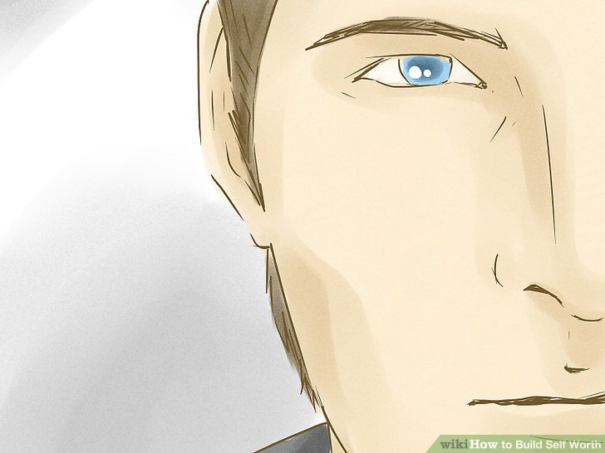](https://www.wikihow.com/Build-Self-Worth#/Image:Build-Self-Worth-Step-1-Version-2.jpg)](https://www.wikihow.com/Build-Self-Worth" \l "/Image:Build-Self-Worth-Step-1-Version-2.jpg)

**1**

**Understand the power of your attitude toward yourself.** How you perceive yourself, how you talk about yourself, and how you represent yourself eventually becomes the reality for you. And if it happens that you're putting yourself down, belittling your worth, and making light of your talents in the face of others, then you will come across as self-effacing, [low in self-esteem](https://www.wikihow.com/Overcome-Low-Self-Esteem), and almost a part of the wallpaper. There's a difference between humility and self-denial.

* + On the other hand, if you exaggerate your qualities, talents, and skills, you'll come across as egotistical and [arrogant](https://www.wikihow.com/Be-Arrogant). Oddly enough, this is not about overestimating your self-worth but about deceiving yourself through insecurity. There is a middle pathway and it is the one in which you recognize and celebrate the fact that you are a valuable person, equal to everyone else, and that your talents and thoughts are unique and worthy. Getting to this belief can be difficult if you have spent years underestimating your worth but it is *always* possible to change your thoughts and to learn to value yourself.

[[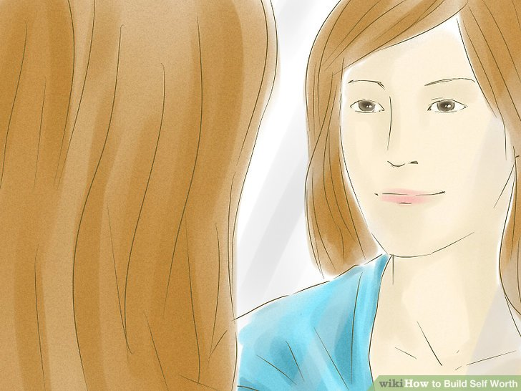](https://www.wikihow.com/Build-Self-Worth#/Image:Build-Self-Worth-Step-2-Version-2.jpg)](https://www.wikihow.com/Build-Self-Worth" \l "/Image:Build-Self-Worth-Step-2-Version-2.jpg)

**2**

**Learn to overcome a fear of self-love.** Self-love is often equated with [narcissism](https://www.wikihow.com/Identify-Being-a-Narcissistic-Extension), egotism, and some kind of one-way trip to a negative form of introversion. This is probably partly because the English language has a hard time dealing with the word "love" – it has to cover a lot of territory for the many different types of love out there. It is also mired in the confusion people feel about the message to do good unto others, to always be charitable, and to give of oneself. While these are noble intentions, they can often be taken out of proportion and used to downplay putting one's own needs and wants beneath those of others out of a fear of being perceived as selfish or inward-looking. Again, this is about getting the balance right through self-care.

* + [Healthy self love](https://www.wikihow.com/Maintain-Good-Spiritual-Health) is about being your own best friend. Self love is expressed not through preening oneself all day and constantly announcing how great you are (those are signs of intense [insecurity](https://www.wikihow.com/Overcome-Insecurity)); rather, self love is about treating *yourself* with the same care, [tolerance](https://www.wikihow.com/Be-Tolerant-of-Others), generosity, and compassion as you would treat a special friend.
  + Avoid obsessing over how other people see you. How does it help you to cater your personality to their idea of you? Only you can give yourself the esteem boost you need.

[[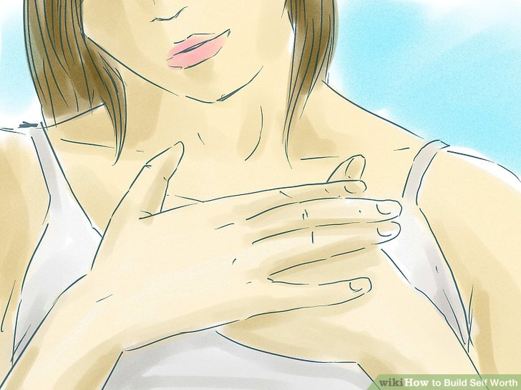](https://www.wikihow.com/Build-Self-Worth#/Image:Build-Self-Worth-Step-3-Version-2.jpg)](https://www.wikihow.com/Build-Self-Worth" \l "/Image:Build-Self-Worth-Step-3-Version-2.jpg)

**3**

**[Trust your own feelings](https://www.wikihow.com/Develop-Self%E2%80%90Esteem" \o "Develop Self‐Esteem).** Self-worth requires that you learn to listen to and rely on your own feelings and not automatically respond to the feelings of other people. When you trust your own feelings, you'll recognize unfair demands and be able to respond to them better.

* + Self-worth plummets when we let others [make decisions](https://www.wikihow.com/Make-Decisions) for us. Initially, this may seem like the easy route and one that allows you to avoid hard choices, however, our self-worth grows when we make decisions for ourselves. If you don't, you will always find yourself boxed in by what other people decide for you. When the people who make decisions for you disappear from your life, you are left alone and indecisive.

[[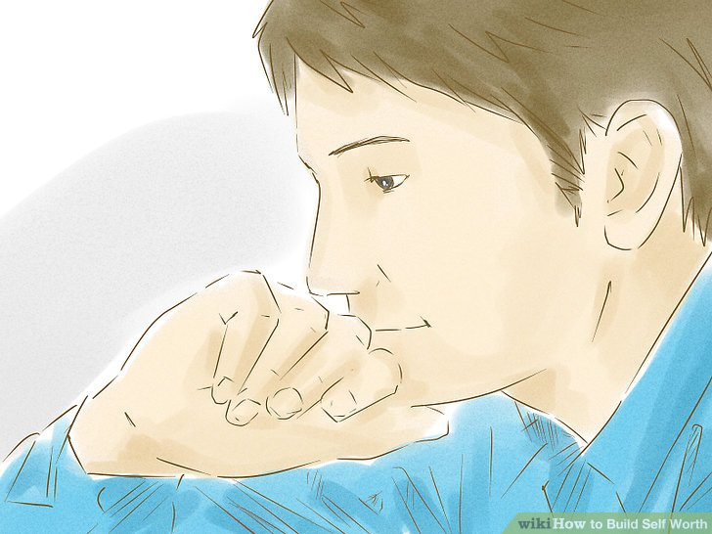](https://www.wikihow.com/Build-Self-Worth#/Image:Build-Self-Worth-Step-4-Version-2.jpg)](https://www.wikihow.com/Build-Self-Worth" \l "/Image:Build-Self-Worth-Step-4-Version-2.jpg)

**4**

**Analyze yourself.** Many of us live in a culture that is very fond of going to see someone else to analyze us. Here are some questions for your self-analysis:

* + What experience have I had? How has this experience informed my growth?
  + What are my talents? List at least five.
  + What are my skills? Remember that [talents](https://www.wikihow.com/Find-a-Talent) are innate, skills need to be worked on to perfect them.
  + What are my [strengths](https://www.wikihow.com/Identify-Your-Strengths)? Stop focusing on your weaknesses; you've probably done that long enough. Start looking at what your strengths are and start thinking about how you can make the most of them in the things you choose to do. Try taking the character strengths survey at www.viacharacter.org.
  + What do I want to be doing with my life? Am I doing it? If not, why not?
  + Am I happy with my health? If not, why not? And what can I do to move into wellness instead of living in sickness?
  + What makes me feel fulfilled? Am I working on that or am I busy working on other people's fulfillment?
  + What is important to me?

[[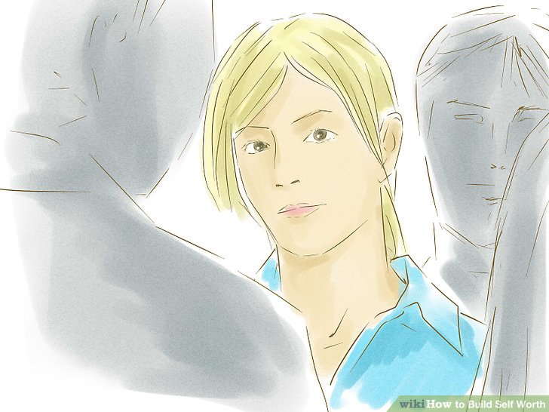](https://www.wikihow.com/Build-Self-Worth#/Image:Build-Self-Worth-Step-5-Version-2.jpg)](https://www.wikihow.com/Build-Self-Worth" \l "/Image:Build-Self-Worth-Step-5-Version-2.jpg)

**5**

**Stop making your self-worth conditional on other people.** If you try to live up to other people's expectations, you'll struggle to find your self-worth. Unfortunately, many people live this way, making such choices as what to study, [what career to choose](https://www.wikihow.com/Switch-Careers), where to live, and how many children to have -- all based on expectations from parents, spouses, friends, and the media.

* + Be very wary of listening too much to people who regret the choices that they made in life and who actively inflict their distress or [anger](https://www.wikihow.com/Control-Anger) upon others. They'll give you poor information, incorrect details, or simply omit to inform you at all.
  + People with healthy self-worth will share their insights and learning with you, and will be willing to guide you around life's many traps. Look for those people to mentor you.
  + Let go of the parts of your self-worth that are based on people's opinions from your childhood. Whether it was your parents, a caregiver, or kids at school, their opinions don't determine who you are as a person. If those people made you feel bad about yourself, look for evidence in your life that they're wrong so you can let go of their opinions.

**Score  
0 / 3**

Part 1 Quiz

**What can you do to enhance your state of mind and work towards building up your self-worth?**

Top of Form

Treat yourself like a friend.

Think about how other people see you.

Ask friends to help you make difficult decisions.

Seek a professional analysis.

Bottom of Form

**Part 2**

**Mastering a Positive Self-Image**

[[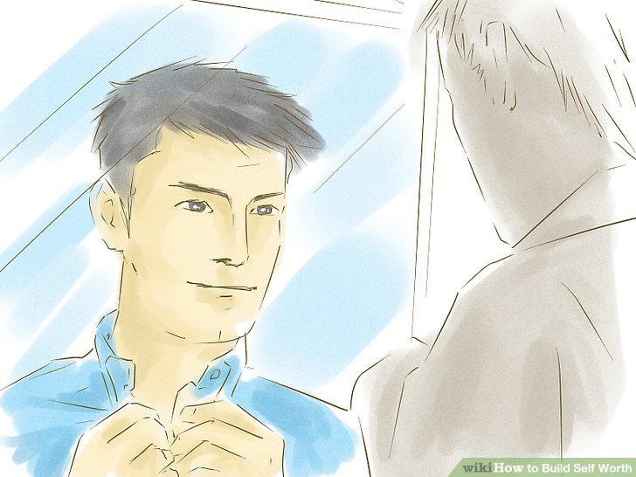](https://www.wikihow.com/Build-Self-Worth#/Image:Build-Self-Worth-Step-6-Version-2.jpg)](https://www.wikihow.com/Build-Self-Worth" \l "/Image:Build-Self-Worth-Step-6-Version-2.jpg)

**1**

**Tell yourself that you matter.** Realistic self [pep-talks](https://www.wikihow.com/Keep-Sales-Staff-Motivated-During-Holiday-Season) are great and affirming your self-worth openly to yourself can be a good way to start changing the negative self-talk that you might have developed over time. Make set times during the day to remind yourself that you're a great person. Tell yourself you're special, wonderful, [lovable](https://www.wikihow.com/Be-Lovable), and loved.

* + Affirmative talk is part of a range of methods for boosting yourself and for taking out time to acknowledge that you do matter -- just as much as every person around you.
  + Try to be specific with your self-affirmations. For example, instead of saying "I love myself," you could say "I love myself because I'm a smart, compassionate person."

[[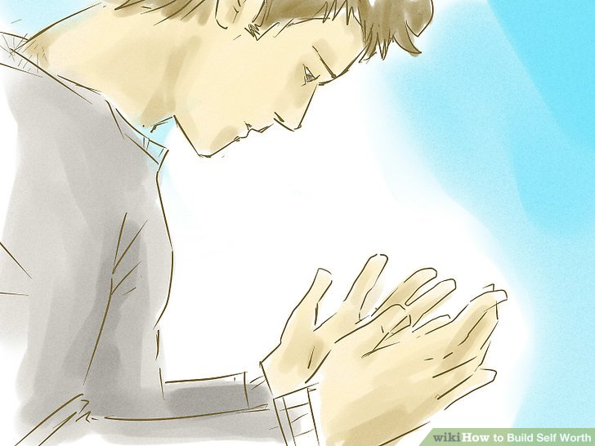](https://www.wikihow.com/Build-Self-Worth#/Image:Build-Self-Worth-Step-7-Version-2.jpg)](https://www.wikihow.com/Build-Self-Worth" \l "/Image:Build-Self-Worth-Step-7-Version-2.jpg)

**2**

**Prove to yourself that you matter.** One of the problems with [self-affirmations](https://www.wikihow.com/Use-Affirmations-Effectively) is that there is a sense that affirmations are magical, that they are all that's needed to improve your sense of self. When in reality, you also need to act on your sense of self-worth. This is achieved by recognizing and accepting responsibility.

* + [Responsibility](https://www.wikihow.com/Be-Responsible) is recognizing that you are in control of your attitude, your reactions, and your sense of worth. As Eleanor Roosevelt once said, "no one can make you feel inferior without your consent," and that is the crux of poor self-worth: letting other people and circumstances serve as the source of lowering your self-worth is going to keep you stuck.
  + Accept the responsibility for your circumstances. Make a decision to do something about them. Even if others appear to stand in your way, work around them.

1. **3**

**[Build your self-confidence](https://www.wikihow.com/Build-Self-Confidence" \o "Build Self Confidence).** Improving your self-confidence is a great way to work on a more positive self-image. There are several strategies you can use to improve your self-confidence including:

* + [Blocking negative thoughts](https://www.wikihow.com/Block-Bad-Thoughts). Every time you have a negative thought, turn it into something positive. For example, if you think to yourself, “I will never pass this test,” then change the thought to something like, “I will pass this test if I study hard for it.”
  + Removing negativity from your environment. Surround yourself with people who are uplifting and supportive. Steer clear of people who are negative and critical of themselves or other people.
  + [Being assertive](https://www.wikihow.com/Be-Assertive). Being assertive will help you to get your needs met and this will help you to feel happier.
  + [Setting goals](https://www.wikihow.com/Set-Goals). Set realistic goals for yourself, and make sure to reward yourself when you accomplish them.
  + Seeking mental health support. Working with a mental health professional, such as a therapist, can help you to develop your self-confidence.

**4**

**Forgive yourself and other people.** Responsibility also requires that you relinquish the need to use [blame](https://www.wikihow.com/Forgive) as a source of coping; blame alleviates the need to look at yourself and to change your own behavior. Blame will leave you stuck in time and stuck with your negative feelings, and it perpetuates feelings of helplessness. Blame implies that someone or something else has the power that *you* lack.

* + Don't blame your parents, the government, your next door neighbors. They may have made things difficult for you but don't use that as an excuse to reduce your self-worth. Avoid being a [martyr](https://www.wikihow.com/Overcome-Martyr-Syndrome); the responsibility to move on as a strong, whole person rests with you.

**5**

**Work on your** [**resilience**](https://www.wikihow.com/Develop-Your-Resilience)**.** Resilient people have the emotional strength to get through life's difficulties without falling apart. This isn't about belittling the hardships and challenges of life. It is about how *you* react and work your way through them. You always have a choice between demeaning yourself or always remembering your self-worth and staying firm in that resolve.

* + To do this, [focus your energy](https://www.wikihow.com/Project-to-Your-Mindscape) on what you need to do to change the situation or the circumstances. Realize that other people have been wrapped up in the circumstances too and are not necessarily directing the outcome.

**6**

**Break the habit of trying to please other people.** When you stop having to please everyone else, your desires will rise to the surface and you can start working on your own happiness and self-worth.

* + [Express your feelings](https://www.wikihow.com/Express-Your-Feelings) instead of bottling them up. In doing so, respect the feelings of others but don't be beholden to them.

**7**

**Heed opportunities.** [Opportunities](https://www.wikihow.com/Create-an-Abundance-Mentality) present themselves in all sorts of ways. Part of building self-worth is learning to recognize these opportunities, however small, and working *with* them.

* + [Turn challenges into opportunities](https://www.wikihow.com/Face-Challenges). Successful people tend to turn challenges into opportunities.
  + Try to think of challenges in your life as an opportunity to grow into a stronger person.

**8**

**[Budget your money](https://www.wikihow.com/Budget-Your-Money" \o "Budget Your Money).** Self-worth is often closely tied to one's financial situation. All financial opportunities that come your way should be assessed with care.

* + [Retirement savings](https://www.wikihow.com/Save-for-Retirement), investments, and savings in general are all things that will help ensure a sound life for you and financial freedom allows you the space to build self-worth away from financial pressures.

**Score  
0 / 3**

Part 2 Quiz

**True or False. Resilience is the ability to focus on solutions and avoid dwelling on your mistakes.**

Top of Form

True

False

Bottom of Form

**Part 3**

**Seeing Your Worth**

**1**

**Value yourself regardless of your job and earnings.** In societies that tend to value people by what they *do* rather than by who they *are*, there is a great risk of undervaluing your self-worth because it's tied up in earnings and job prestige. If you ever find yourself replying, "Oh I'm *just* a ..." in reply to the question, "So what do you do?", you're suffering from a self-worth deficit. You are not "just" anything – you are a unique, valuable, and wonderful human being who matters.

**2**

**Value your time.** If you're performing volunteer or low-paid support work that eats up your time beyond what you can afford, and you're neglecting other parts of your life, such as looking for a job, spending time with your family, or ensuring that your own life is running smoothly, then it's possible that you're caught up in competing value systems.

* + The first value system is that which tells us we must volunteer or contribute community service to others more needy in society because it is both noble and essential for our own sense of [well-being](https://www.wikihow.com/Maintain-Wellbeing-in-a-Mobile-World). The second value system is that which rewards us for knowing our self-worth and for expecting good compensation for what we contribute to society.
  + These two competing values create [tension](https://www.wikihow.com/Relieve-a-Tension-Headache) for many well-meaning people who want to give but find themselves caught up in the challenges of lack of time, lack of money, and a sense of inadequacy with all the juggling.
  + Eventually this will lead to one or more of the following: being sick, exploding, walking out for good, resenting the loss of your time, and/or perpetuating an unhealthy balance that would not only impact you but serve as a poor role model for your children, friends, and others that are watching you. When you feel a need to downplay your talents and skills and give them away freely or at little cost, take back your time and to start valuing yourself more.

**3**

**Balance the time you give away to others and time spent on your own life.** Could you be spending more time with your family and/or friends? If the answer to that is yes, then realize that your wealth resides in keeping that time for you and those you love, and reducing the amount of time you give away to others. When altered, this can easily spur you onto the path of increased self-worth.

* + This doesn't mean that you have to give up helping out completely, but you do need to put community service or commitments to helping others into perspective. At the end of the day, you matter more than anything.

**4**

**Follow through.** Maintain your focus on self-worth as an important part of what goes into making you whole. Make time on a regular basis to check on your progress in building your self-worth and [be patient](https://www.wikihow.com/Be-Patient). It takes time to change negative self-talk and putting yourself last. If your entire pattern of interacting with others has been based on effacing yourself as much as possible, it will take a lot of courage to make the changes needed. But it's 100% possible.

* + There will be some people who find the new, more [assertive](https://www.wikihow.com/Be-Assertive) you a little confronting. Don't let that worry you because it's about your journey, not theirs! You are seeking to gain respect as you go, something that people pleasers rarely have.

**5**

**[Live in the present](https://www.wikihow.com/Live-in-the-Moment" \o "Live in the Moment).** The past has its lessons, but the only moment that truly matters is now. It is the only moment that "is," after all. Nothing else is a sure thing. And if this moment isn't what you want to be, make it so the next moment is.

* + Keep a notebook of your achievements. Every time you feel tempted to put yourself down and to bemoan that you're getting nowhere, make a cup of coffee, sit down comfortably and take out this book and read through it. Can you update it with a new achievement while you're there?
  + Compete only with yourself, not with others. Those achievements are what *you* do and how they make *you* feel, not how others perceive them or what others have done just like it.

**Score  
0 / 3**

Part 3 Quiz

**What are some of the things you can do to start seeing your own worth?**

Top of Form

Thinking about your job and earning power.

Doing favors for other people.

Keeping track of your accomplishments in a notebook.

Competing with other people at work and in school.

Bottom of Form

**You're helping people by reading wikiHow**



**wikiHow's mission is to help people learn**, and we really hope this article helped you. Now you can help others, just by visiting wikiHow.

Recently, Indonesia’s island of Sulawesi was hit by a tsunami following a series of devastating earthquakes, affecting more than 1.5 million people. Our partner, Direct Relief, is working hard to supply Indonesia with much needed medical aid and supplies in response. If you **click below to let us know you read this article**, wikiHow will donate to Direct Relief on your behalf to support the relief effort for Indonesia.

If you would like to find other ways to help, you can read our wikiHow article on [How to Help Earthquake and Tsunami Victims in Indonesia.](https://www.wikihow.com/Help-Earthquake-and-Tsunami-Victims-in-Indonesia)

Thanks for helping us achieve our mission of helping everyone learn how to do anything.

[**Yes, I read the article**](https://www.wikihow.com/wikiHow:Gives-Back)

**Community Q&A**

**New! Make a stranger's day.** [**Answer a question.**](http://www.wikihow.com/Special:AnswerQuestions)

* **Question**

**Is it bad to please myself?**

**wikiHow Contributor**

**Community Answer**

Absolutely not. You are no good to others if you are not taking care of yourself.

[Not Helpful 1](https://www.wikihow.com/Build-Self-Worth) [Helpful 46](https://www.wikihow.com/Build-Self-Worth)

* **Question**

**How can I be more humble if I love being praised?**

**wikiHow Contributor**

**Community Answer**

If you can find out why you feel the need to be praised, you can find how to be humble. Also, praising others, so giving as well as receiving, and not only taking, can help.

[Not Helpful 4](https://www.wikihow.com/Build-Self-Worth) [Helpful 21](https://www.wikihow.com/Build-Self-Worth)

* **Question**

**How do get over my severe depression?**

**wikiHow Contributor**

**Community Answer**

Take your prescribed medication; if your medication isn't working for you, talk to your doctor about increasing dosage or changing to another. Talk to a therapist or counselor to help determine a good and healthy path to take. Try some yoga and meditation. Physical exercises are also proven to help people with depression. Eat healthy and sleep well. In order to regain your lost happiness, spend time with positive people, read motivational articles, and try watching upbeat TV shows and movies.

[Not Helpful 10](https://www.wikihow.com/Build-Self-Worth) [Helpful 30](https://www.wikihow.com/Build-Self-Worth)

* **Question**

**What is a simple thing I can do right now to increase my sense of self worth?**

**wikiHow Contributor**

**Community Answer**

Believe in yourself. You are valuable. Little by little, you will grow and change.

[Not Helpful 4](https://www.wikihow.com/Build-Self-Worth) [Helpful 16](https://www.wikihow.com/Build-Self-Worth)

* **Question**

**I think I have lost my importance in my family, with my partner and friend. All of them make me feel like I'm nothing to them. They interact with me when they want, not when I want. What should I do?**

**wikiHow Contributor**

**Community Answer**

You should focus on what is important for you and your life. Family and friends will always need you and they should determine you're worthy. Don't force anyone to talk to or like you. I am sure you will find someone who likes you, a friend or family member.

[Not Helpful 6](https://www.wikihow.com/Build-Self-Worth) [Helpful 16](https://www.wikihow.com/Build-Self-Worth)

* **Question**

**Why do people ask for my opinion and then get upset when I tell them the truth?**

**wikiHow Contributor**

**Community Answer**

It might be the way you're saying it, think carefully before you speak and imagine how you would feel if someone said to you exactly what you're about to say. Sometimes it is also best to tell a small fib to avoid hurting someone's feelings. If people get upset with you a lot, however, it's most likely got something to do with the way you're saying things.

[Not Helpful 10](https://www.wikihow.com/Build-Self-Worth) [Helpful 14](https://www.wikihow.com/Build-Self-Worth)

**Ask a Question**

Submit

**Answer Questions**

**Make a stranger's day. Answer a question.** Learn more

**Quick Summary**

If you want to build your self-worth, block out negative thoughts and practice self-affirmations instead. For instance, tell yourself that you matter, that you’re special, and that you are worthy of being loved. Try to be specific with your affirmations, praising yourself for your unique positive traits, like being compassionate, intelligent, creative, or whatever you like most about yourself. Then, act on these affirmations, behaving in ways that show yourself that they are true.

Did this summary help you?YesNo

**Tips**

* People tend to reinvent themselves every 10 years. Embrace change and think of all the wisdom you've gained and make use of that.
* Be careful of platitudes in place of affirmations. In the sense of self-worth, platitudes represent the sayings, pep-talk, or accepted wisdom that do not resonate with you at all.
* Everybody you meet is abundant with opportunities. Be interested in other people and be willing to spend time with them to learn new things. It also helps to listen to a broad range of people, to put your own troubles and angst into perspective.
* Let go of the past. Project your entire focus on the present moment. Humbleness is the mother of praise. Respect is the father of harmony. Indeed, love is above all. Treat others the way you want to be treated!

**Warnings**

* Setting yourself up to do a lot is overwhelming, and as the list builds up, it will depreciate your self-worth by reminding you what you haven't done. Sometimes, it may lead you to falsely believe that you can do things you can't and that you can't do things that you can. Take breathers and reassess your life's direction on a regular basis.

[Edit](https://www.wikihow.com/index.php?title=Build-Self-Worth&action=edit)**Related wikiHows**

**[How to](https://www.wikihow.com/Be-Happy-With-Yourself-and-Life-in-General)**

**[Be Happy With Yourself and Life in General](https://www.wikihow.com/Be-Happy-With-Yourself-and-Life-in-General)**

**[How to](https://www.wikihow.com/Build-Self-Confidence)**

**[Build Self Confidence](https://www.wikihow.com/Build-Self-Confidence)**

**[How to](https://www.wikihow.com/Become-a-Trustworthy-Person)**

**[Become a Trustworthy Person](https://www.wikihow.com/Become-a-Trustworthy-Person)**

**[How to](https://www.wikihow.com/Accept-Who-You-Are)**

**[Accept Who You Are](https://www.wikihow.com/Accept-Who-You-Are)**

**[How to](https://www.wikihow.com/Love-Yourself)**

**[Love Yourself](https://www.wikihow.com/Love-Yourself)**

**[How to](https://www.wikihow.com/Respect-Yourself)**

**[Respect Yourself](https://www.wikihow.com/Respect-Yourself)**

**[How to](https://www.wikihow.com/Develop-Self%E2%80%90Esteem)**

**[Develop Self‐Esteem](https://www.wikihow.com/Develop-Self%E2%80%90Esteem)**

**[How to](https://www.wikihow.com/Believe-in-Yourself)**

**[Believe in Yourself](https://www.wikihow.com/Believe-in-Yourself)**

**[How to](https://www.wikihow.com/Help-Someone-With-Low-Self-Esteem)**

**[Help Someone With Low Self Esteem](https://www.wikihow.com/Help-Someone-With-Low-Self-Esteem)**

**[How to](https://www.wikihow.com/Feel-Good-About-Yourself)**

**[Feel Good About Yourself](https://www.wikihow.com/Feel-Good-About-Yourself)**

**[How to](https://www.wikihow.com/Overcome-Low-Self-Esteem)**

**[Overcome Low Self Esteem](https://www.wikihow.com/Overcome-Low-Self-Esteem)**

**[How to](https://www.wikihow.com/Stop-Feeling-Useless)**

**[Stop Feeling Useless](https://www.wikihow.com/Stop-Feeling-Useless)**

**[How to](https://www.wikihow.com/Stop-Comparing-Yourself-to-Others)**

**[Stop Comparing Yourself to Others](https://www.wikihow.com/Stop-Comparing-Yourself-to-Others)**

**[How to](https://www.wikihow.com/Stop-Self-Destructive-Behaviors)**

**[Stop Self Destructive Behaviors](https://www.wikihow.com/Stop-Self-Destructive-Behaviors)**

**Made Recently**

Did you try these steps?  
Upload a picture for other readers to see.

**Article Info**

**Featured Article**

Categories: [Featured Articles](https://www.wikihow.com/Category:Featured-Articles) | [Self Esteem](https://www.wikihow.com/Category:Self-Esteem)

In other languages:

Italiano: [Migliorare l'Autostima](https://www.wikihow.it/Migliorare-l%27Autostima), Español: [aumentar tu valor propio como persona](https://es.wikihow.com/aumentar-tu-valor-propio-como-persona), Português: [Construir Autoestima](https://pt.wikihow.com/Construir-Autoestima), Deutsch: [Das Selbstwertgefühl stärken](https://de.wikihow.com/Das-Selbstwertgef%C3%BChl-st%C3%A4rken), Русский: [развить самоуважение](https://ru.wikihow.com/%D1%80%D0%B0%D0%B7%D0%B2%D0%B8%D1%82%D1%8C-%D1%81%D0%B0%D0%BC%D0%BE%D1%83%D0%B2%D0%B0%D0%B6%D0%B5%D0%BD%D0%B8%D0%B5), Français: [renforcer son estime de soi](https://fr.wikihow.com/renforcer-son-estime-de-soi), Bahasa Indonesia: [Mengembangkan Rasa Keberhargaan Diri](https://id.wikihow.com/Mengembangkan-Rasa-Keberhargaan-Diri), Nederlands: [Je eigenwaarde opbouwen](https://nl.wikihow.com/Je-eigenwaarde-opbouwen), العربية: [تعزيز شعورك الداخلي بالقيمة](https://ar.wikihow.com/%D8%AA%D8%B9%D8%B2%D9%8A%D8%B2-%D8%B4%D8%B9%D9%88%D8%B1%D9%83-%D8%A7%D9%84%D8%AF%D8%A7%D8%AE%D9%84%D9%8A-%D8%A8%D8%A7%D9%84%D9%82%D9%8A%D9%85%D8%A9), ไทย: [สร้างการตระหนักถึงคุณค่าของตัวเอง](https://th.wikihow.com/%E0%B8%AA%E0%B8%A3%E0%B9%89%E0%B8%B2%E0%B8%87%E0%B8%81%E0%B8%B2%E0%B8%A3%E0%B8%95%E0%B8%A3%E0%B8%B0%E0%B8%AB%E0%B8%99%E0%B8%B1%E0%B8%81%E0%B8%96%E0%B8%B6%E0%B8%87%E0%B8%84%E0%B8%B8%E0%B8%93%E0%B8%84%E0%B9%88%E0%B8%B2%E0%B8%82%E0%B8%AD%E0%B8%87%E0%B8%95%E0%B8%B1%E0%B8%A7%E0%B9%80%E0%B8%AD%E0%B8%87)

* [Print](https://www.wikihow.com/Build-Self-Worth)
* [Edit](https://www.wikihow.com/index.php?title=Build-Self-Worth&action=edit)
* [Send fan mail to authors](https://www.wikihow.com/index.php?title=Special:ThankAuthors&target=Build-Self-Worth)

Thanks to all authors for creating a page that has been read 715,068 times.

**Did this article help you?**

Yes No

**Expert Review By:**

****

**TG**

[**Trudi Griffin, LPC**](https://www.wikihow.com/Special:ArticleReviewers?name=trudigriffin,lpc#trudigriffin,lpc)

Licensed Professional Counselor

Co-authors: **29**

Updated: **12 days ago**

Views: **715,068**

**97%** of readers found this article **helpful**.

91 votes - 97%

Click a star to add your vote

**AM**

**Ayesha Maher**

Jun 15

"It motivates me and I learnt many things from it."

[Share yours!](https://www.wikihow.com/Build-Self-Worth)[**More success stories**](https://www.wikihow.com/Build-Self-Worth)

**Related Articles**

[[](https://www.wikihow.com/Be-Happy-With-Yourself-and-Life-in-General)](https://www.wikihow.com/Be-Happy-With-Yourself-and-Life-in-General)

**[How to](https://www.wikihow.com/Be-Happy-With-Yourself-and-Life-in-General)**

**[Be Happy With Yourself and Life in General](https://www.wikihow.com/Be-Happy-With-Yourself-and-Life-in-General)**

[[](https://www.wikihow.com/Build-Self-Confidence)](https://www.wikihow.com/Build-Self-Confidence)

**[How to](https://www.wikihow.com/Build-Self-Confidence)**

**[Build Self Confidence](https://www.wikihow.com/Build-Self-Confidence)**

[[](https://www.wikihow.com/Become-a-Trustworthy-Person)](https://www.wikihow.com/Become-a-Trustworthy-Person)

**[How to](https://www.wikihow.com/Become-a-Trustworthy-Person)**

**[Become a Trustworthy Person](https://www.wikihow.com/Become-a-Trustworthy-Person)**

[[](https://www.wikihow.com/Accept-Who-You-Are)](https://www.wikihow.com/Accept-Who-You-Are)

**[How to](https://www.wikihow.com/Accept-Who-You-Are)**

**[Accept Who You Are](https://www.wikihow.com/Accept-Who-You-Are)**

**Did this article help you?**

Yes

No

* [Home](https://www.wikihow.com/Main-Page)
* [About wikiHow](https://www.wikihow.com/About-wikiHow)
* [Jobs](https://www.wikihow.com/wikiHow:Jobs)
* [Terms of Use](https://www.wikihow.com/Terms-of-Use)
* [Site Map](https://www.wikihow.com/Special:Sitemap)
* [Mobile view](https://m.wikihow.com/Build-Self-Worth)