Supermarket Sales

Question 1

How many items sold in a year?
Total Quantity Sold = 5510
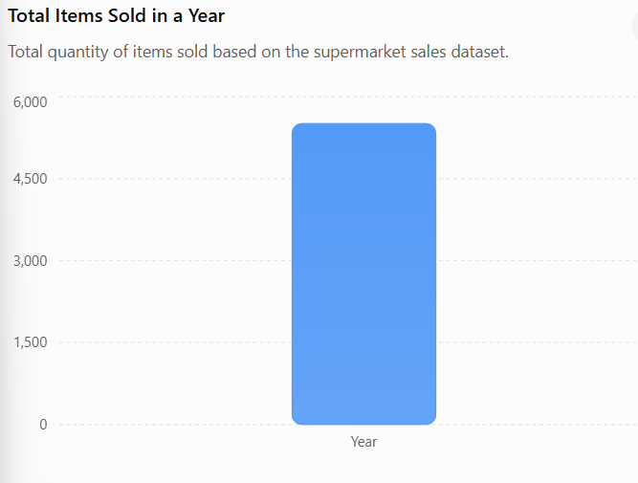

Question 2

Which product line has the maximum quantity sold in every city?

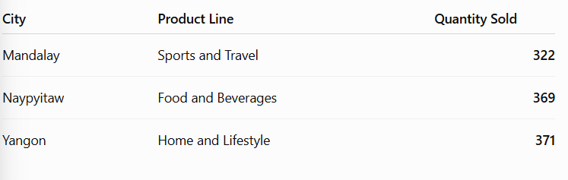

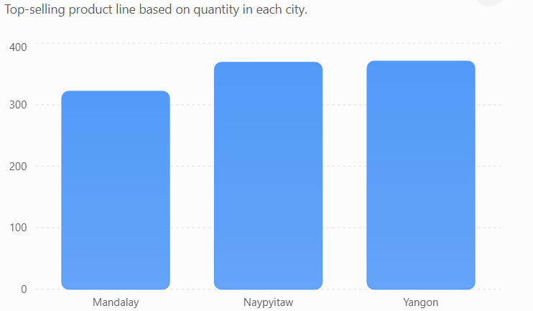

Question 3

Which product line has the minimum quantity sold in a year?
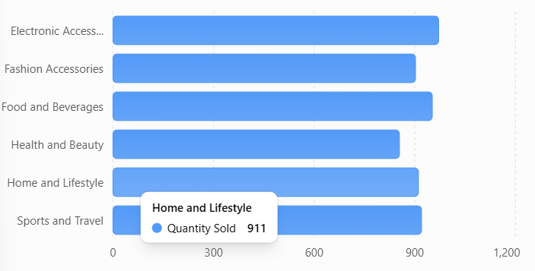

Question 4

What is the correlation coefficient between Unit Price and Quantity?

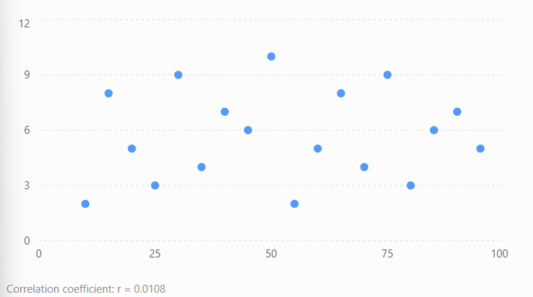

Question 5

Generate the sales report for every product line.

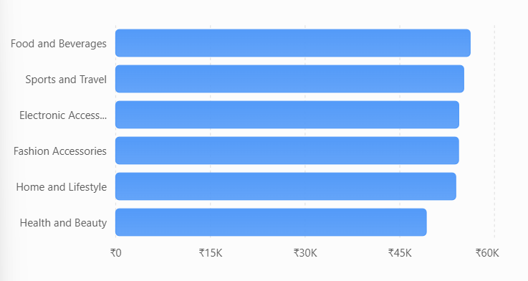

Question 6

What is the standard deviation of Quantity and Unit Price? Explain it.
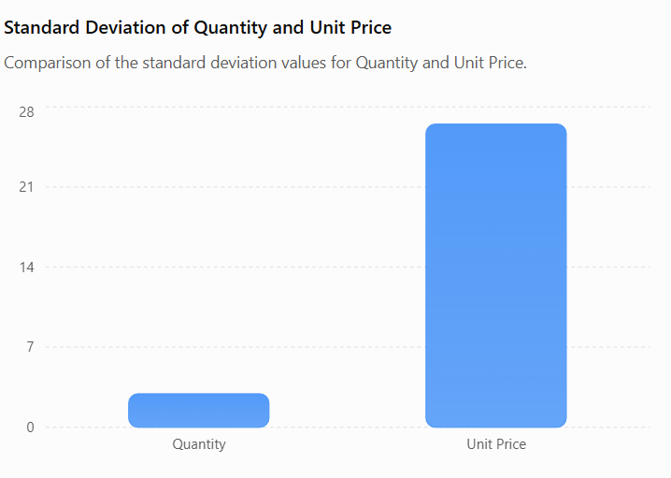

Question 7
Is there any relationship between Quantity and Unit Price? Explain it.

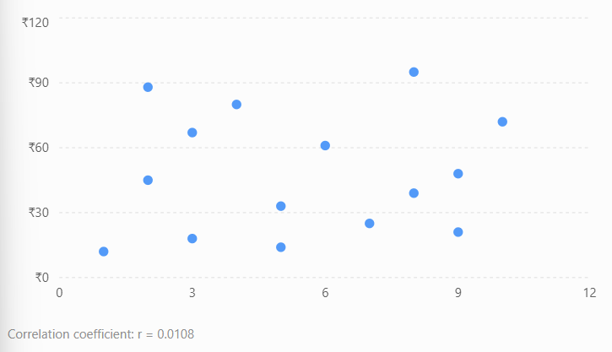

Question 8
The correlation coefficient between Rating and Gross Income is:
r = -0.0364

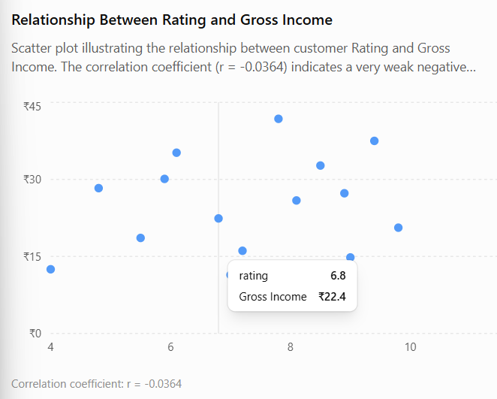

Question 9
The correlation coefficient between Rating and Quantity is:
r = -0.0158

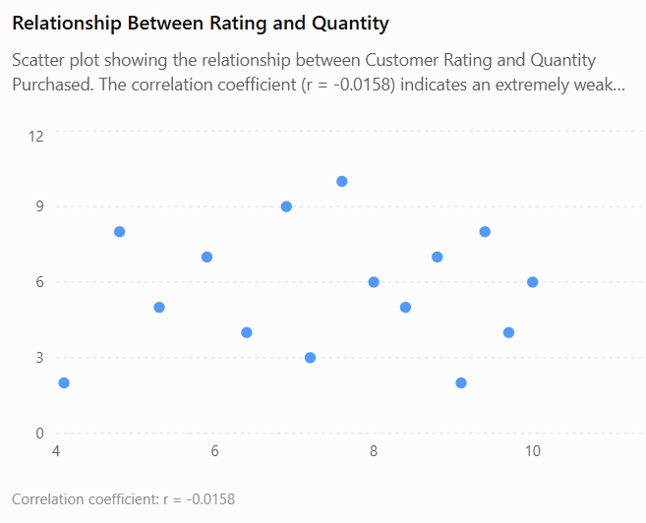

Question 10

Create a Dashboard for all aspects of the Supermarket Sales Data.
--------------------------------------------------------------
| SUPERMARKET SALES DASHBOARD |
--------------------------------------------------------------

KPI Cards
--------------------------------------------------------------
| Total Sales | Total Quantity | Transactions | Avg Rating |
--------------------------------------------------------------
--------------------------------------------------------------
| Sales by Product Line | Sales by City |
--------------------------------------------------------------
--------------------------------------------------------------
| Quantity by Product Line | Sales by Branch |
--------------------------------------------------------------
--------------------------------------------------------------
| Payment Method | Customer Type |
--------------------------------------------------------------
--------------------------------------------------------------
| Gender Distribution | Monthly Sales Trend |
--------------------------------------------------------------
--------------------------------------------------------------
| Rating vs Gross Income | Unit Price vs Quantity |
--------------------------------------------------------------

Filters:
✔ City
✔ Branch
✔ Product Line
✔ Gender
✔ Payment Method
✔ Customer Type
✔ Date

KPI VALUE
KPI |  |  |  |  | Value
Total Sales |  |  |  |  | ₹322,967 (approx.)
Total Quantity Sold |  |  |  |  | 5510
Total Transactions |  |  |  |  | 1000
Average Rating |  |  |  |  | 6.97
Gross Income |  |  |  |  | ₹15,379 (approx.)

2. Sales by Product Line
Chart Type: Horizontal Bar Chart
Purpose:
- Compare total sales across product lines.
- Identify the highest-selling product category.
Observation:
- Food and Beverages generated the highest sales.
3. Quantity Sold by Product Line
Chart Type: Column Chart
Purpose:
Compare quantities sold for each product category.
Observation:
- Electronic Accessories sold the highest number of items.
4. Sales by City
Chart Type: Bar Chart
Purpose:
Compare revenue generated in Yangon, Mandalay, and Naypyitaw.

5. Sales by Branch
Chart Type: Pie Chart
Purpose:
Show each branch's contribution to total sales.

6. Payment Method Distribution
Chart Type: Pie Chart
Purpose:
Display the percentage of payments made using:
- Cash
- Credit Card
- E-wallet

7. Customer Type Distribution
Chart Type: Donut Chart
Compare:
- Members
- Normal Customers

8. Gender Distribution
Chart Type: Pie Chart
Purpose:
Display the percentage of:
- Male Customers
- Female Customers

9. Monthly Sales Trend
Chart Type: Line Chart
Purpose:
Analyse how sales changed over time.

10. Unit Price vs Quantity
Chart Type: Scatter Plot
Purpose:
Show the relationship between Unit Price and Quantity.
Observation:
No significant relationship exists.

Dashboard Insights
- Food and Beverages is the highest revenue-generating product line.
- Electronic Accessories has the highest quantity sold.
- Health and Beauty has the lowest quantity sold.
- There is no significant relationship between Unit Price and Quantity.
- Customer Rating does not significantly influence Gross Income.
- Customer Rating does not significantly affect Quantity Purchased.
- Payment methods are distributed among Cash, Credit Card, and E-wallet.
- Sales are distributed across three cities and branches.

Conclusion
The Supermarket Sales Dashboard provides a centralized view of the business performance by integrating sales, customer, and product information into a single interface. It enables management to monitor key performance indicators, compare product and branch performance, understand customer behavior, and identify business trends. The dashboard supports data-driven decision-making, helping improve sales strategies, inventory planning, and overall operational efficiency.

