Question 1

A park café offers a choice of drink (Tea or Coffee) and a choice of snack (Cake or Biscuit).

The probability a visitor chooses Tea is 0.6.

If a visitor chooses Tea, the probability they choose Cake is 0.7.

If a visitor chooses Coffee, the probability they choose Cake is 0.4.
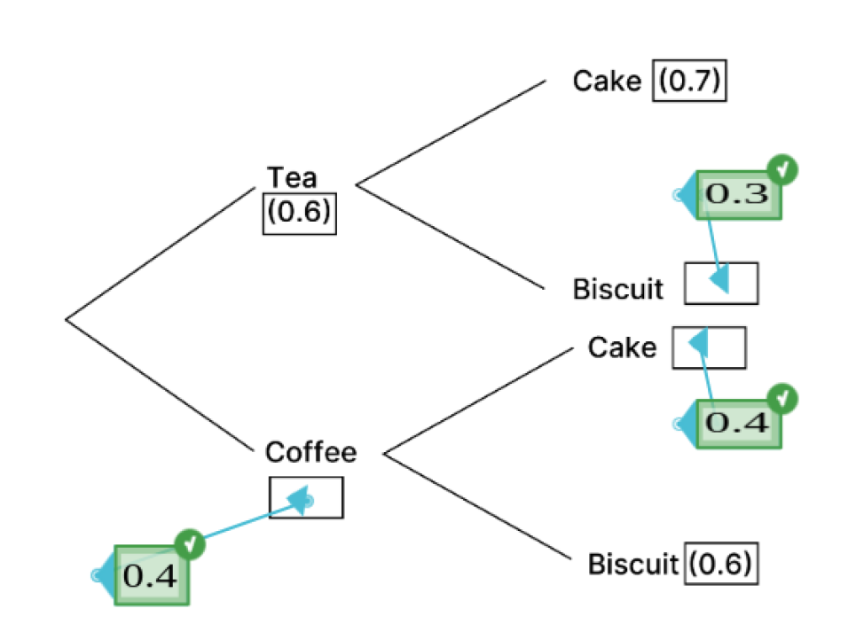

a) Complete the tree diagram below by writing down the missing probabilities on the branches. [3 marks]

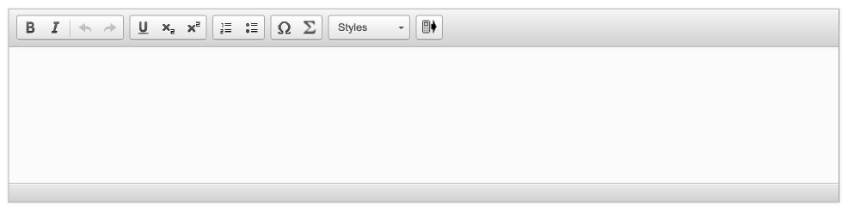

b) Determine the probability that a randomly selected visitor chooses Coffee and Cake. [2 marks]

c) Determine the probability that a visitor chose Tea given they chose Cake. [4 marks]

d) Find that the events "choosing Tea" (T) and "choosing Cake" (K) are independent or not. [3 marks]

