Hospital Doctor Appointment Booking System

Software Engineering Lab Report

1. Cover Page
ACADEMY OF CLINICAL & HEALTH SCIENCES (ACHS)
Software Engineering Lab

Hospital Doctor Appointment Booking System

A Full-Stack CRUD Application on PostgreSQL
Student Name | Saugat Bikram Thapa
Roll No. | 80117731
Course | BSc.CSIT
Subject | Software Engineering
Instructor | Saroja Bhandari
Submission Date
Repository | Mugetsu-1/Hospital-Booking-System

2. Introduction
Hospital appointment books are surprisingly easy to corrupt: two patients can be handed the same slot, doctors have no single view of their queue, cancellation policies are applied ad hoc, and the outcome of a consultation (diagnosis, prescription, notes) is frequently lost or left editable forever. These are classic software-engineering failure modes — unclear requirements, missing data-consistency constraints, and behaviour that cannot be verified.
The Hospital Doctor Appointment Booking System is a full-stack web application that addresses these problems end to end. Patients discover doctors, view computed availability slots, and book, reschedule, or cancel appointments under real-world business rules. Doctors run a day/week/month consultation queue, confirm or complete visits, and record medical notes inside a governed 24-hour edit window. Administrators manage the doctor directory, patient accounts, and the hospital-wide appointment ledger, including soft-delete and record-purge workflows.
The project was engineered as a software-engineering exercise rather than a mere coding task: requirements were captured and modelled (use cases, DFDs, ERD, class and sequence diagrams), the database was designed around a concurrency-safe slot model, the REST API was layered with authentication, role-based access control and request validation, and the whole system was verified with automated unit and end-to-end test suites, wired into a CI pipeline.
This report documents the system across the full software-engineering lifecycle, following the ACHS lab structure.

3. Objective
The objectives of the project are to:
- Provide a single doctor directory with searchable specialisation, fee, and weekday schedules.
- Expose computed availability slots from weekly working blocks — never free-text time entry — so the UI can only offer bookable times.
- Guarantee no double-booking, even under two simultaneous requests for the same slot.
- Enforce a documented appointment lifecycle — Pending → Confirmed → Completed, or Cancelled — together with a 2-hour cancellation cutoff and a 24-hour consultation-notes edit window.
- Separate patient, doctor, and administrator duties using JWT authentication and role-based access control (RBAC).
- Demonstrate full CRUD across four modules: Patients, Doctors & Schedules, Appointments, and Consultation Records.
- Verify every requirement with repeatable, automated tests and a continuous-integration pipeline.

4. Tools Used
All tools listed here are actually used by the repository; nothing is aspirational.
Category | Tool / Technology | Role in the project
Project management | GitHub Issues + GitHub Projects | Requirement breakdown into six capability epics, sprint-sized task lists, and per-task acceptance criteria
Scheduling / Gantt | GitHub Projects board | Backlog → In progress → In review → Done columns used as the sprint board; each column acted as a schedule gate before the next
Language / Runtime | Node.js 20+, JavaScript (ES2022) | Backend (CommonJS) and frontend (ES Modules)
Frontend framework | React 18 + Vite 5 | Single-page application, per-role dashboards
Routing / HTTP | React Router 6, Axios | Client-side routing, JWT-aware API client
Backend framework | Express 4 | REST API, middleware pipeline
Database | PostgreSQL | Relational store for users, doctors, appointments
ORM / DB access | Prisma 7 +  @prisma/adapter-pg | Type-safe queries, schema migrations, driver adapter
Authentication | jsonwebtoken  (JWT),  bcryptjs | Signed sessions, salted password hashing
Validation | express-validator | Per-route request body validation
Optional cache | Redis (  redis  ) | Read-through cache for directory & slot grids (fail-open)
Optional realtime | Socket.IO | Live slot / appointment refresh triggers (fail-open)
Optional e-mail | Nodemailer | Booking / status HTML notifications (fail-open)
Unit testing | Node built-in test runner (  node --test  ) | 21 offline unit tests (slot maths, transitions, dates)
E2E testing | Custom Node HTTP harness (  tests/e2e/api.e2e.js  ) | 72 end-to-end API assertions against PostgreSQL
Modeling / CASE | Mermaid | Use-case, class, DFD (L0–L2), ERD, sequence diagrams
Version control | Git + GitHub | Feature-branch iterative workflow,  main  kept deploy-free and always green
CI | GitHub Actions | .github/workflows/main.yml  — DB service, schema push, seed, unit + e2e tests, production build
Dev environment | VS Code, npm,  nodemon | Editing, scripts, hot-reload dev server

4.1 CASE tools
All models are authored in Mermaid inside docs/ and rendered automatically by GitHub; docs/build-docx.mjs rasterises the same sources to PNG via mermaid-cli for the submitted Word document, so the report and the diagrams can never drift apart.
Artefact | Source | Type
Use-case model | use-case.md | UML use case (actors,  «include»  relations)
Object model | class-diagram.md | UML class diagram + domain service
Behaviour | sequence-diagrams.md | UML sequence (book / confirm / cancel / notes)
Data flow | dfd-context.md  ,  dfd-level1.md  ,  dfd-level2-booking.md | Gane–Sarson DFD L0, L1, L2
Data model | erd.md | ERD with cardinality and the partial unique index

4.2 Development process
The project followed an iterative, feature-branch workflow on Git/GitHub: each capability (auth, directory, booking engine, lifecycle, notes, admin CRUD) was developed and verified before the next. Every push runs the GitHub Actions pipeline, which spins up a PostgreSQL service, pushes the Prisma schema, seeds demo data, runs the unit and end-to-end suites, and builds the production frontend bundle — so main is always in a known-good, test-passing state.

5. Requirements

5.1 User Requirements
- Patients must be able to register, sign in, search for doctors, see which time slots are actually available, book a slot with their symptoms, and later reschedule or cancel it within policy. They must be able to read their own appointment history and any consultation record left by the doctor, and to keep their own profile up to date.
- Doctors must be able to sign in, see their consultation queue by day, week, or month, confirm or complete visits, cancel when necessary, and record a diagnosis, prescription, and notes — editable for a limited time after the visit. They must be able to manage their own weekly schedule, fee, and leave/availability.
- Administrators must be able to create and edit doctor profiles, deactivate or reactivate doctors and patients (soft delete), browse the whole hospital appointment ledger, and correct or purge misfiled medical records.

5.2 System Requirements
Software environment
- Node.js 20 or newer and npm.
- A local PostgreSQL database.
- A modern web browser for the SPA.
- Optional: a Redis instance, an SMTP account — the system runs fully without either.
System-level capabilities
- Serve a REST API over HTTP with JSON payloads.
- Persist all state in PostgreSQL with referential integrity (foreign keys, enums, cascades) and a concurrency-safe unique constraint on live slots.
- Authenticate every protected request via a signed JWT and enforce role-based authorisation before any controller logic runs.
- Degrade gracefully: if Redis, Socket.IO, or SMTP are unavailable, core booking behaviour is unaffected (fail-open design).

5.3 Functional Requirements (CRUD per module)
Module A — Patient Management
CRUD | Requirement | Endpoint
Create | Register profile (name, email, password, phone, age, gender, address, emergency contact) | POST /api/auth/register
Read | View own profile; own appointment & consultation history | GET /api/patients/:id  ,  GET /api/appointments/my
Update | Edit contact info, address, emergency contact | PATCH /api/patients/:id
Delete | Soft-delete / deactivate account (records preserved) | DELETE /api/patients/:id  (admin)

Module B — Doctor & Schedule Management
CRUD | Requirement | Endpoint
Create | Admin creates doctor account + profile (specialisation, qualification, fee, weekly blocks) | POST /api/doctors  (admin)
Read | Search/filter by name, specialisation, weekday, fee ceiling; single profile; computed slot grid | GET /api/doctors  ,  GET /api/doctors/:id  ,  GET /api/doctors/:id/slots?date=
Update | Doctor edits own hours, fee, availability; admin edits names | PATCH /api/doctors/:id
Delete | Admin deactivates / reactivates (soft delete) | PATCH /api/doctors/:id/status

Module C — Appointment Booking Lifecycle
CRUD | Requirement | Endpoint
Create | Patient selects doctor, date + computed slot, submits symptoms | POST /api/appointments
Read | Patient history; doctor day/week/month queue; admin ledger | GET /api/appointments/my  ·  /doctor  ·  /appointments
Update | Patient reschedules (→ Pending); doctor/admin drive lifecycle | POST /:id/reschedule  ,  PATCH /:id/status
Delete | Cancel (releases slot); admin purges permanently | POST /:id/cancel  ,  DELETE /:id

Module D — Consultation & Medical Notes
CRUD | Requirement | Endpoint
Create | Doctor attaches diagnosis, prescription, notes when completing | PATCH /:id/status  + record fields
Read | Patient reads record for completed visits | GET /api/appointments/my  ,  GET /:id
Update | Doctor edits record within 24 h of visit end (admin anytime) | PATCH /:id/notes
Delete | Admin purges duplicate / misfiled entries | DELETE /:id

5.4 Non-Functional Requirements
NFR | Requirement | Evidence
Security | bcrypt hashing (10 rounds), signed JWT, RBAC role gates, inactive-account blocks | middleware/auth.js  ,  utils/serialize.js
Performance | Read-heavy endpoints served via optional read-through Redis cache (60 s TTL) | utils/cache.js
Usability | Responsive UI, toasts, confirm modals, skeleton loaders, realtime refresh | context/ToastContext.jsx  ,  components/Skeleton.jsx
Reliability | Atomic slot check + partial unique index; fail-open optional services | prisma/schema.prisma  ,  src/db.js  ,  services/*
Maintainability | Layered architecture, pure domain module, single serializer contract | src/domain/  ,  src/utils/serialize.js
Testability | Offline unit suite + full HTTP e2e suite in CI | tests/  (21 + 72 assertions)

6. Design & System Modeling
The design is captured as Mermaid models. The three most central diagrams are embedded inline below; the data-flow, entity-relationship, and architecture models are linked from docs/README.md.

6.1 Use Case Diagram
Actor boundaries for Patient, Doctor, and Administrator (source).

6.2 Class Diagram
The object model — entities, the SlotBlock value object, enumerations, and the AppointmentPolicy domain service (full notes).
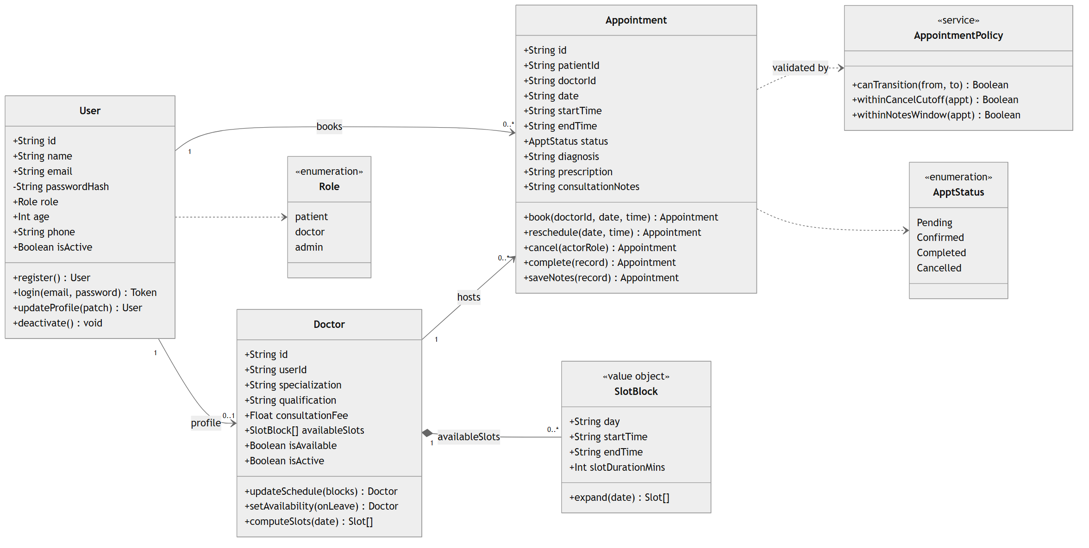

6.3 Sequence Diagram — Book an Appointment
The booking flow, showing validation, the free-slot check, the unique-index guard, cache invalidation, and realtime/e-mail side effects. The remaining flows (confirm/complete, cancel/reschedule, notes) are in sequence-diagrams.md.
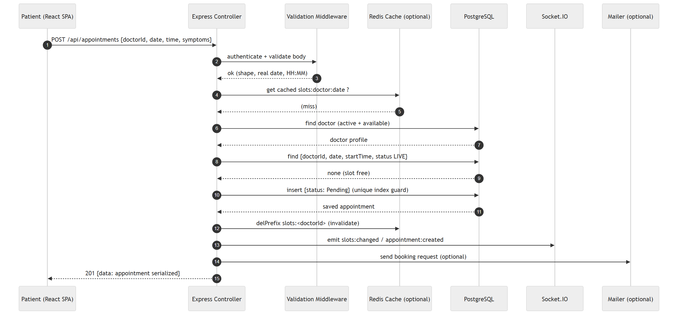

6.4 Supporting Models
Model | File | What it shows
DFD Level 0 (Context) | dfd-context.md | Actors ↔ booking engine data flows
DFD Level 1 | dfd-level1.md | Auth / Schedule / Booking / Records processes
DFD Level 2 (Booking) | dfd-level2-booking.md | Atomic slot validation + persistence
ERD | erd.md | users  ,  doctors  ,  appointments  + partial unique index
Architecture | architecture.md | React + Express + PostgreSQL + optional tiers

6.5 Database Design
Three PostgreSQL tables, defined once in backend/prisma/schema.prisma:
Table | Purpose | Key columns
users | Credentials + profile for all roles | name, email (unique), password_hash, role (enum), phone, is_active
doctors | Directory + schedule, linked to a user | user_id (unique FK), specialization, consultation_fee, available_slots (JSONB), is_available, is_active
appointments | Bookings + consultation records | patient_id FK, doctor_id FK, date, start_time, end_time, date_time, status (enum), diagnosis, prescription, consultation_notes, cancelled_by

Concurrency design decision. The (doctor_id, date, start_time) triple has a partial unique index covering only Pending / Confirmed rows. Cancelling an appointment therefore releases its slot automatically, and two simultaneous requests for the same slot can never both succeed — the second receives a unique-violation 409 (Prisma error P2002). Because Prisma cannot express a partial index in its schema language, the index is created idempotently by backend/scripts/db-setup.js during npm run db:setup.

7. Implementation

7.1 Layered architecture
The backend follows a clean layered design so that each concern is isolated and testable:
Request → Route → Auth/RBAC → Validation → Controller → Domain / Prisma → PostgreSQL
↘ Serializer → JSON response
backend/
prisma/schema.prisma PostgreSQL tables, enums, indexes
prisma.config.ts Prisma 7 config (DATABASE_URL, schema path)
src/
db.js Prisma 7 client + pg driver adapter + slot-index bootstrap
config/ env + policy knobs (cancel cutoff, notes window, cache TTL)
domain/ appointment lifecycle state machine (pure, unit-tested)
controllers/ auth, patients, doctors, appointments
middleware/ auth (JWT + RBAC), validate (express-validator), errorHandler
routes/ Express routers mounted under /api
utils/ slot-grid & date helpers, serializers, UUID checks, cache
services/ realtime (Socket.IO), mailer (Nodemailer)
scripts/
db-setup.js creates the partial unique index Prisma cannot express
seed.js demo hospital (1 admin, 4 doctors, 3 patients, sample bookings)
frontend/src/
pages/ patient/ (browse, appointments, profile), doctor/, admin/, Login, Register
components/ ui primitives, Protected route guard, ErrorBoundary, Skeleton loaders
context/ AuthContext (session), ToastContext (notifications)
api/ axios client (JWT interceptor, 401 cleanup)

7.2 The serializer contract
A single serializer (utils/serialize.js) governs the API's output shape: publicUser() strips the password hash, doctorSummary() and appointmentSummary() produce flat DTOs (e.g. doctorName, doctorConsultationFee, patientAge) rather than nested database rows. This single-contract approach keeps every client read site consistent and was the key insight behind fixing the migration bug described in §9.

7.3 Security implementation
- Passwords — bcrypt, 10 salt rounds; the hash is stripped by publicUser() before any row leaves the API (verified by e2e SEC-03).
- Sessions — signed JWT (HS256), 7-day expiry, Bearer header; requireAuth reloads the user and blocks deactivated accounts.
- RBAC — requireRole('patient' | 'doctor' | 'admin') layered on requireAuth; all cross-role cases asserted in e2e (SEC-06 … SEC-17).
- Validation — express-validator chains on every POST/PATCH, with nested rules for doctor weekly blocks; uniform 400 { error, details[] } shape.
- Concurrency — partial unique index backstop (§6.5), proven by a real two-request race test.

7.4 Optional-service wiring (fail-open)
- Redis cache — getJSON/setJSON/delPrefix become no-ops when REDIS_URL is unset; directory and slot grids are cached per query signature and invalidated on every relevant write.
- Socket.IO — JWT-verified handshake; mutations publish lightweight slots:changed / appointment:* triggers; clients refetch via REST.
- Nodemailer — transport built only when configured; otherwise messages log to the console and are skipped.

8. Testing
Testing combines an offline unit suite and a full HTTP end-to-end suite, backed by a documented black-box matrix, equivalence partitioning, and boundary-value analysis in backend/tests/TEST_MATRIX.md.

8.1 Types of testing performed
Type | Level | Tool | What it proves
Unit testing | Pure functions | Node built-in test runner (  node --test  ) | Slot-grid expansion, date validation, lifecycle state machine — no I/O, no database
Integration / E2E | HTTP + database | Custom Node harness (  tests/e2e/api.e2e.js  ) | Real routing, middleware, Prisma and PostgreSQL over live HTTP
Regression | Concurrency | Two simultaneous requests for one slot | The partial unique index holds under a genuine race
Security testing | RBAC / authz | Negative e2e cases  SEC-01 … SEC-17 | Unauthorised and cross-role access always returns 401/403/404
Validation testing | Boundary | express-validator chains | Malformed, out-of-range and past-date input is rejected uniformly
Build / smoke | Production bundle | vite build  +  /api/health  probe | The artefact compiles and the API boots cleanly
Continuous testing | CI | GitHub Actions | All of the above on every push and pull request

8.2 Test cases and results
Suite | Command | Coverage | Result
Unit (offline) | npm test | Slot-grid maths, date validation, lifecycle state machine | 21 / 21 pass
End-to-end | npm run test:e2e | Auth, RBAC (14 negative cases), directory & filters, slots, double-booking + race, lifecycle & 24 h window, cutoff, reschedule, purge, profile CRUD, registration — against PostgreSQL | 72 / 72 pass
Build | npm run build  (frontend) | Production Vite bundle | passes

Highlight assertions
- TC-13 — two concurrent HTTP requests for one slot: exactly one 201, the other 409 (unique-index backstop).
- TC-21 / TC-22 — the 24-hour notes window and 2-hour cancellation cutoff are exercised by back-dating rows through Prisma ("time travel"), so no real waiting is needed.
- SEC-01 … SEC-17 — every unauthorised-access class returns 401/403/404 as specified, including role-escalation attempts.
Test-design techniques
- Equivalence partitioning — e.g. booking date {valid future day | past day | impossible day 2026-02-30 | malformed}.
- Boundary-value analysis — password length 6 vs 5; cutoff exactly at 2 h; notes window exactly at 24 h; leap-February calendar days.
The same suites run automatically in CI on every push (.github/workflows/main.yml).

9. Observations & Discussion

9.1 Results achieved
Every requirement in §5 is implemented and verified by an automated assertion, and the pipeline is green on main. The final measured state:
Metric | Result
Automated assertions | 93 passing  (21 unit + 72 end-to-end)
Modules delivered with full CRUD | 4 (Patients, Doctors & Schedules, Appointments, Consultation Records)
UML / CASE artefacts | Use case, class, sequence, DFD L0–L2, ERD, architecture
Role-separated dashboards | Patient, Doctor, Administrator
CI status on  main | Green — schema, seed, unit, e2e and production build all pass

Screenshots of every role journey (registration, booking, queue, ledger, consultation records, admin CRUD) are submitted as Appendix A of this report and are enumerated in screenshots/README.md.

9.2 Challenges faced
- Concurrency vs. the slot model. The first instinct was an application-level "is this slot free?" query. That produces a friendly message but cannot survive a genuine race — two requests can both read "free" before either writes. Solving it properly required moving the invariant into the database as a partial unique index, which Prisma's schema language cannot express, so a raw-SQL bootstrap step was needed.
- A database migration under a live API. Moving from MongoDB/Mongoose to PostgreSQL/Prisma changed the response shape from nested, populated objects to flat DTOs. Frontend read sites still expected the old nesting (e.g. a.doctorId.consultationFee where doctorId is now a bare id), so the admin revenue KPI silently rendered Rs. 0 and the doctor queue lost patient age/gender/phone. Nothing threw — it degraded quietly, which is the dangerous failure mode.
- Time-based rules are hard to test honestly. A 2-hour cancellation cutoff and a 24-hour notes window cannot be validated by waiting. The suite instead back-dates rows through Prisma ("time travel") so the exact boundaries can be probed.
- A green local run that was red in CI. The suite passed locally for months but failed every CI run. The cause was a genuine runtime difference, not flakiness: node --test only gained glob support in Node 21, while CI pins Node 20, which treated the glob as a literal filename. Fixing it properly meant verifying the runner behaviour against real Node 20 and Node 24 binaries rather than trusting one environment.

9.3 Insights
- Concurrency is best solved at the database. The application check exists only to produce a good error message; the partial unique index is what actually makes the invariant true. Verified by a real two-request race, not by reasoning.
- A single serializer contract prevents whole classes of bugs. Routing every response through one utils/serialize.js is what made the migration bug findable — there was exactly one place to fix. The contract must live in one place or it will drift.
- Fail-open integrations keep the core deterministic. Redis, Socket.IO and Nodemailer each degrade to a no-op, so local setup and grading stay reproducible while still demonstrating production-shaped patterns.
- Knowing when to leave the ORM is a design skill. The one constraint Prisma could not model was handled with a small, idempotent raw-SQL step rather than by contorting the schema.
- CI is a different machine from your laptop. The pipeline should be treated as the source of truth; a feature is not finished until CI is green.

9.4 Improvements for future work
- Online payment and insurance claims tied to the Completed appointment state.
- Full-text search and faceted filtering (specialisation, fee band, language, rating) over a growing doctor directory.
- Push/email reminders one day and one hour before an appointment, using the existing fail-open mailer tier.
- Audit-log screens for admin so record corrections and purges are reviewable rather than only auditable in the database.
- Refresh-token sessions and role-level rate limiting for a production threat model.
- Containerisation (docker compose for API, web and database) so a reviewer can run the whole system with a single command.

10. Conclusion
A production-shaped hospital appointment booking system was architected, implemented, and verified end to end on a PostgreSQL foundation. The project exercises the complete software-engineering lifecycle: requirement capture and modelling (use cases, class diagram, DFD L0–L2, ERD, sequence diagrams), schema design with a concurrency-safe partial unique index, a layered REST implementation with JWT/RBAC and request validation, an optional performance/realtime/notification tier that is fail-open by design, and automated black-box verification with 93 passing assertions (21 unit + 72 end-to-end) wired into a CI pipeline.

Learning outcomes
- Turning a business rule ("a slot cannot be double-booked") into a database constraint plus an application check, and proving it under concurrency.
- Modelling a relational schema with real foreign keys, enums, and cascades — and recognising the one constraint the ORM cannot express.
- Designing state machines (lifecycle transitions, cancellation cutoff, notes window) and making them testable with time-travel fixtures.
- Layering authentication and authorisation — JWT sessions, RBAC gates, ownership checks — and verifying each with negative tests.
- Maintaining a single serializer/DTO contract across a database migration, and the debugging discipline that surfaces when that contract drifts.
- Using CASE notation (use case, class, sequence, DFD, ERD) before writing code, so the models drove the schema and the API surface rather than documenting them afterwards.
- Learning that continuous integration is a genuine engineering tool: the Node 20 vs Node 24 discrepancy proved that "works on my machine" is a hypothesis to be tested, not a conclusion.
Repository: Mugetsu-1/Hospital-Booking-System. See README.md for setup, docs/ for all diagrams, and backend/tests/TEST_MATRIX.md for the full QA matrix.

Appendix A — Application Screenshots
01 register
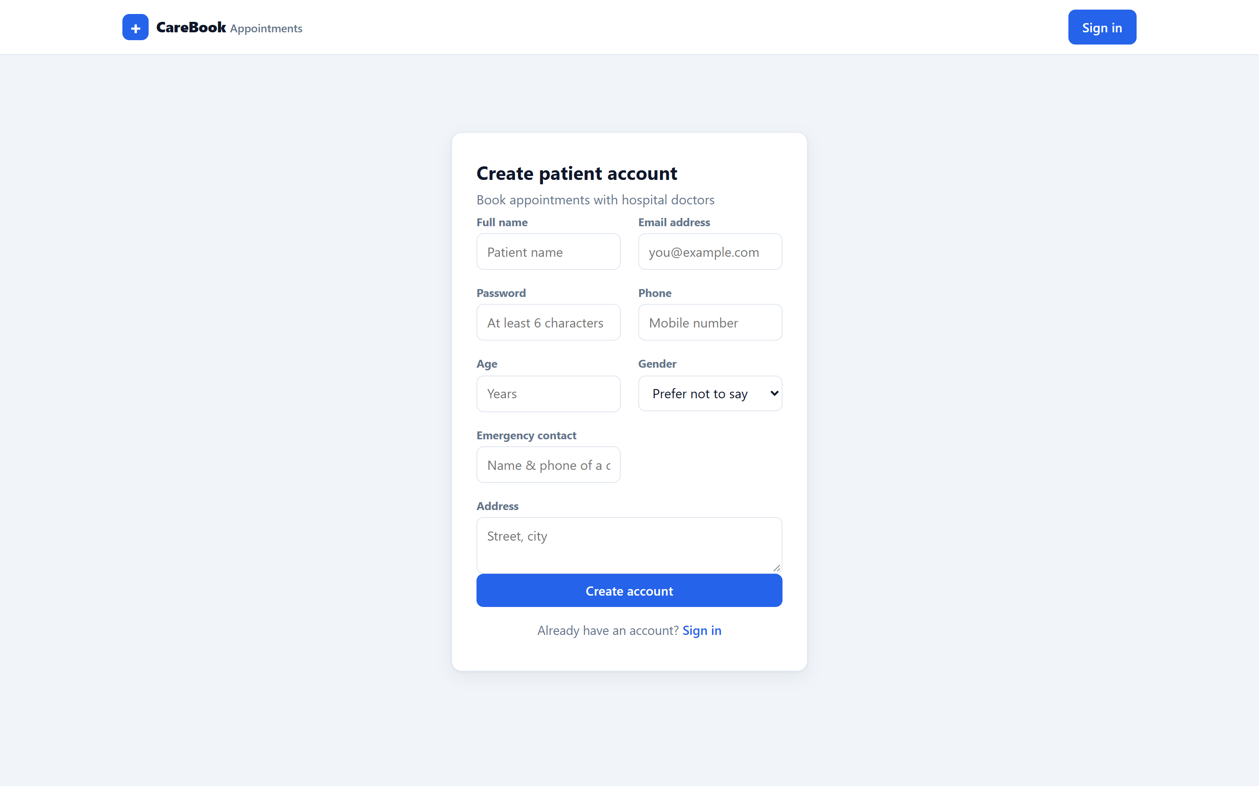
02 login
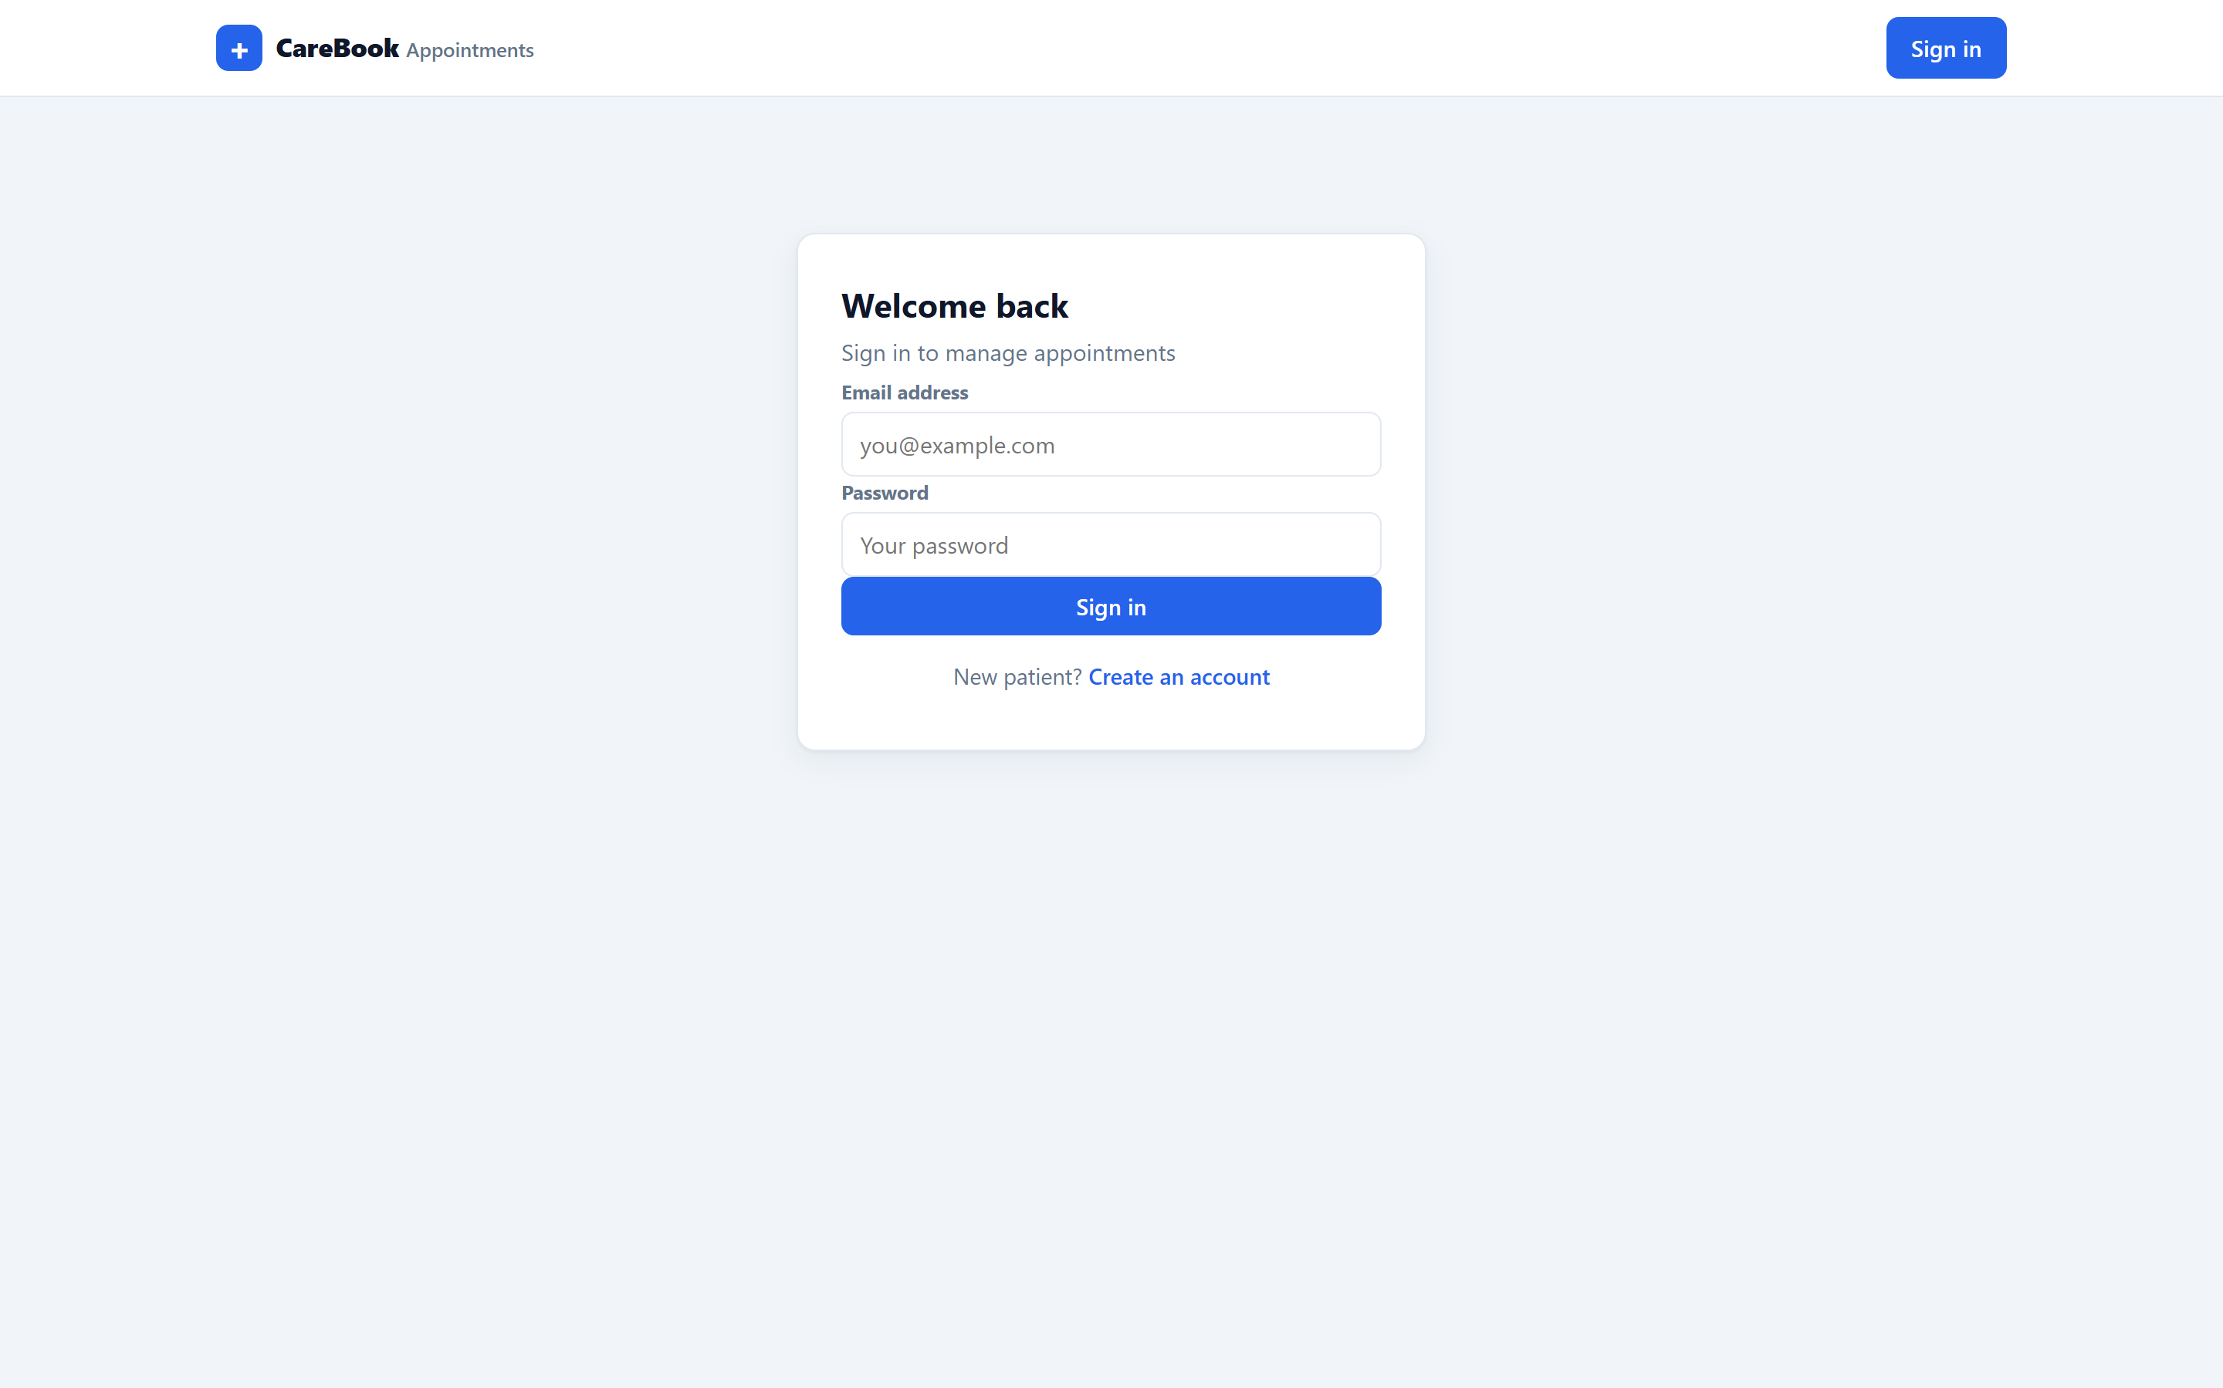
03 browse doctors
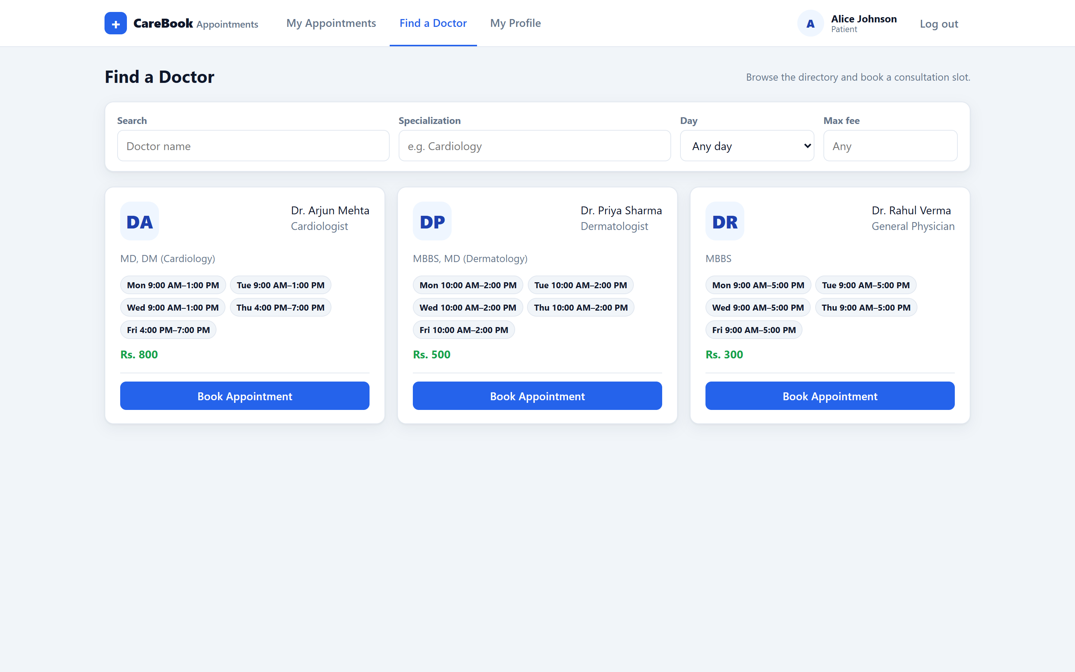
04 slot picker
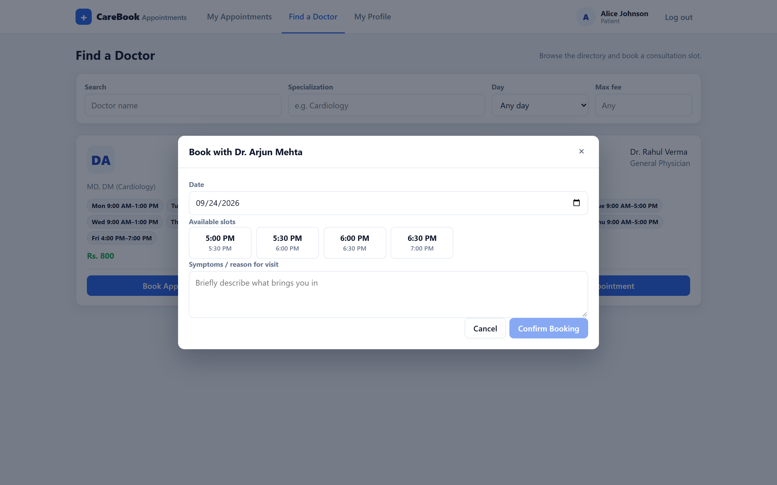
08 appointment history
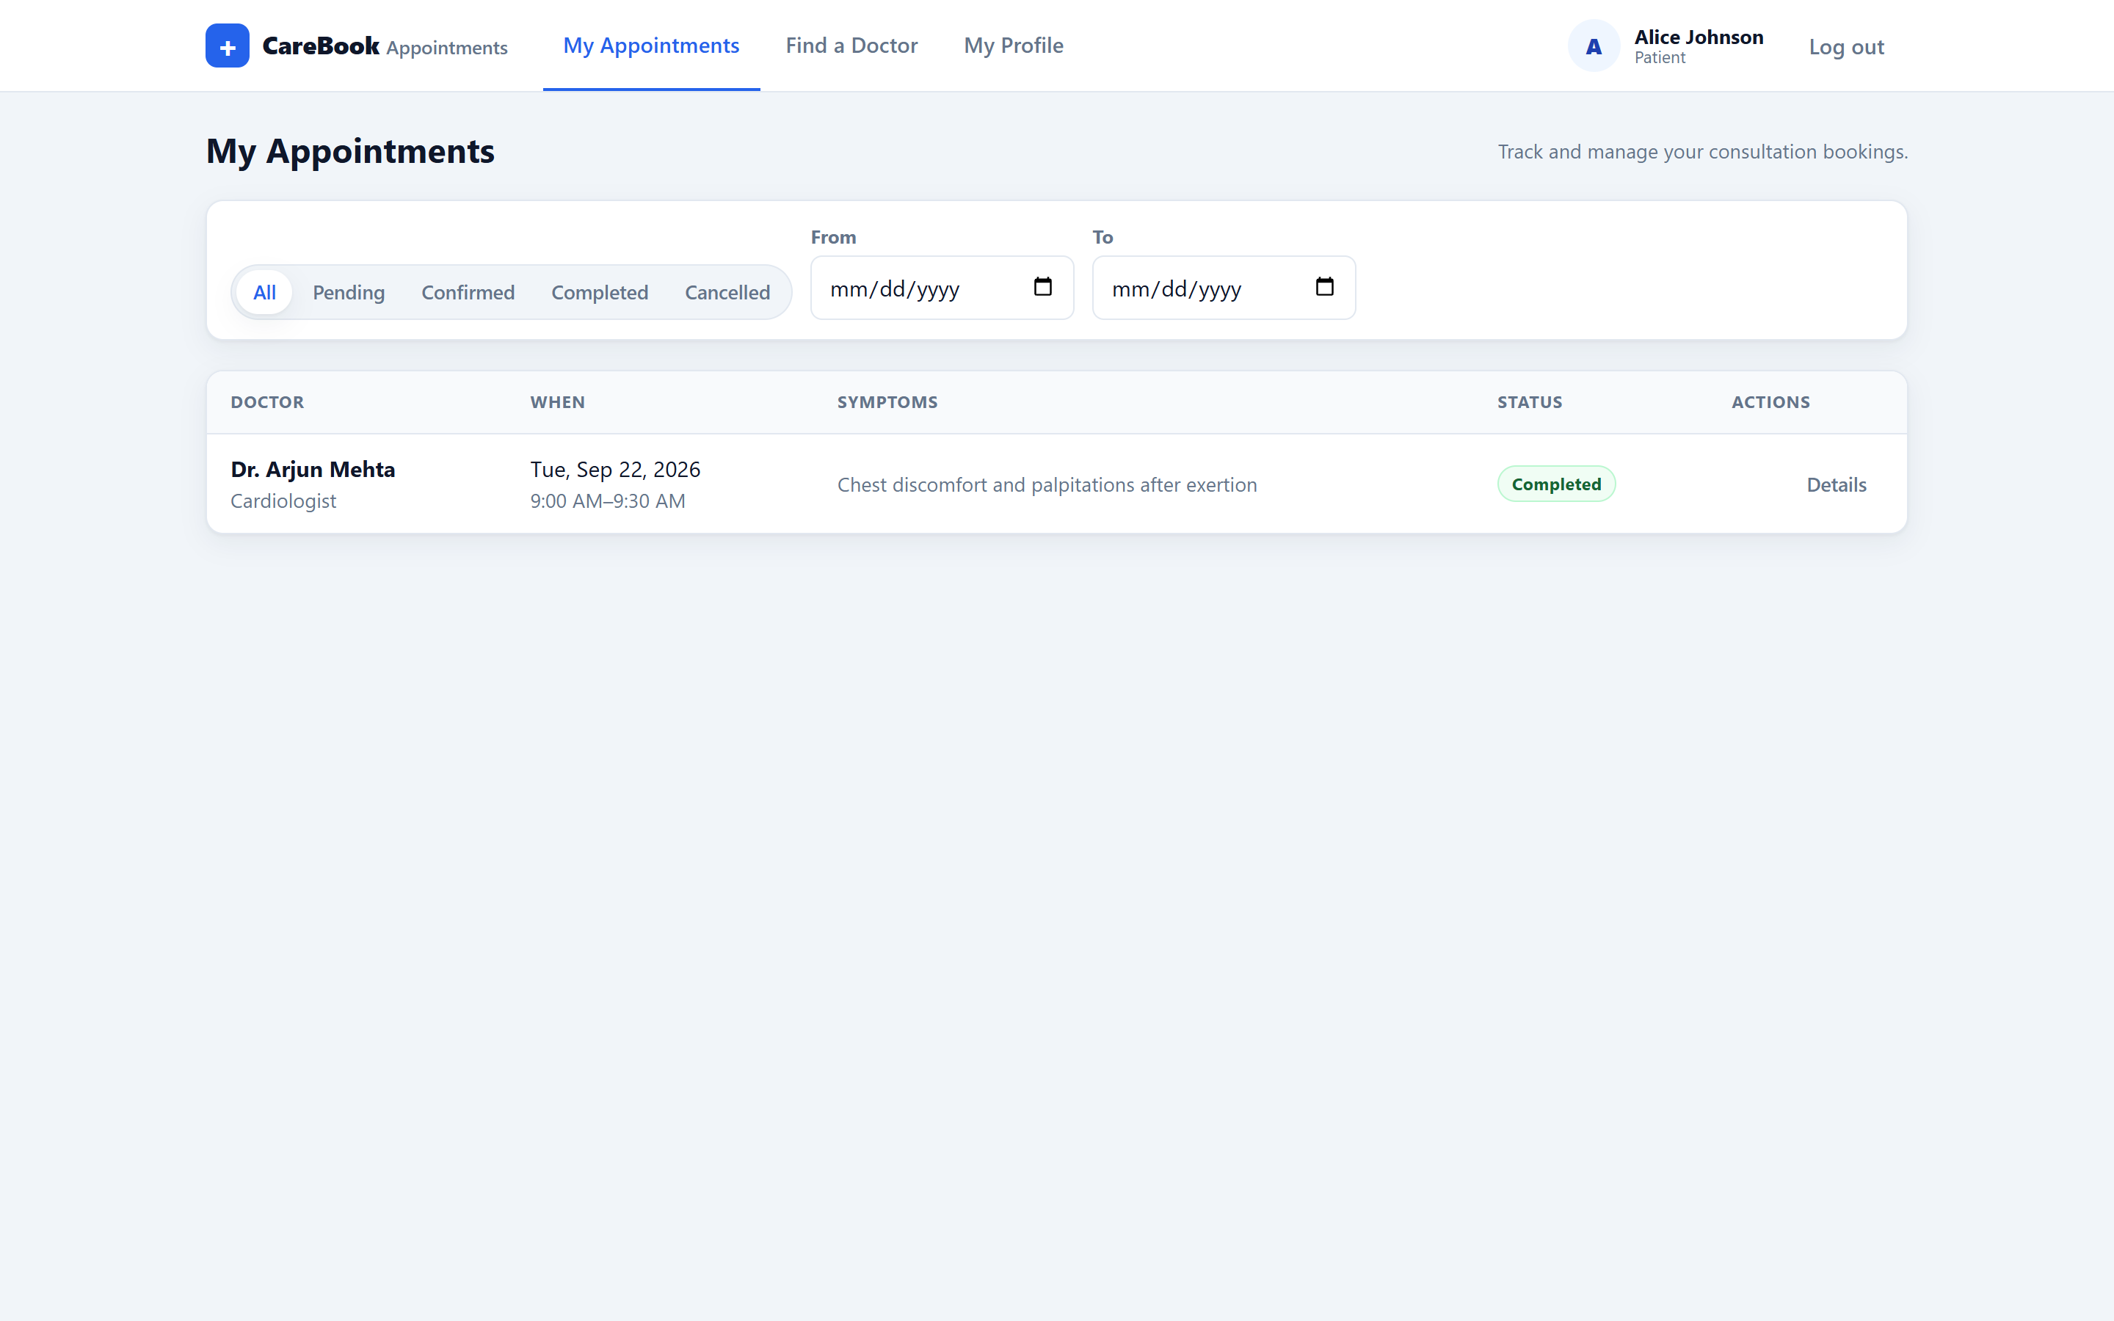
10 profile
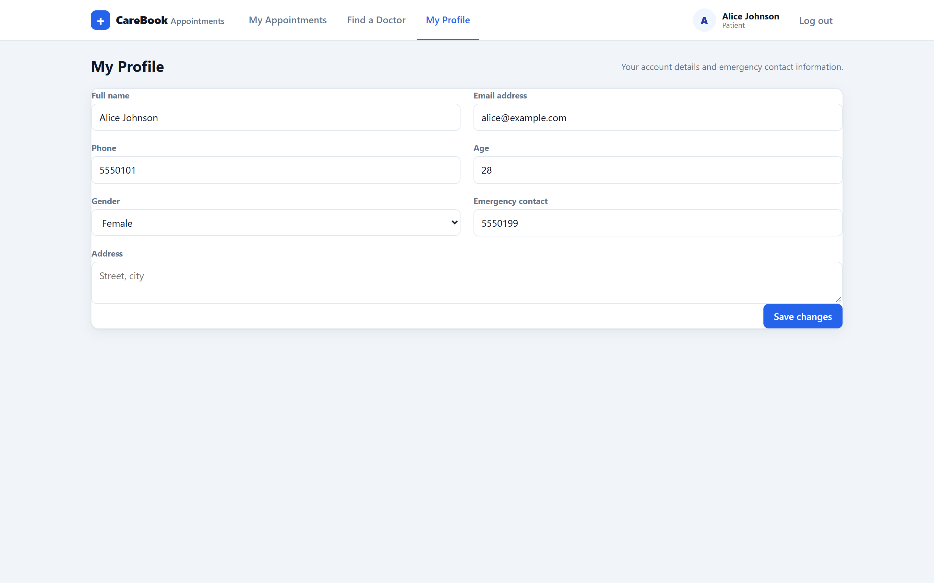
11 doctor queue day
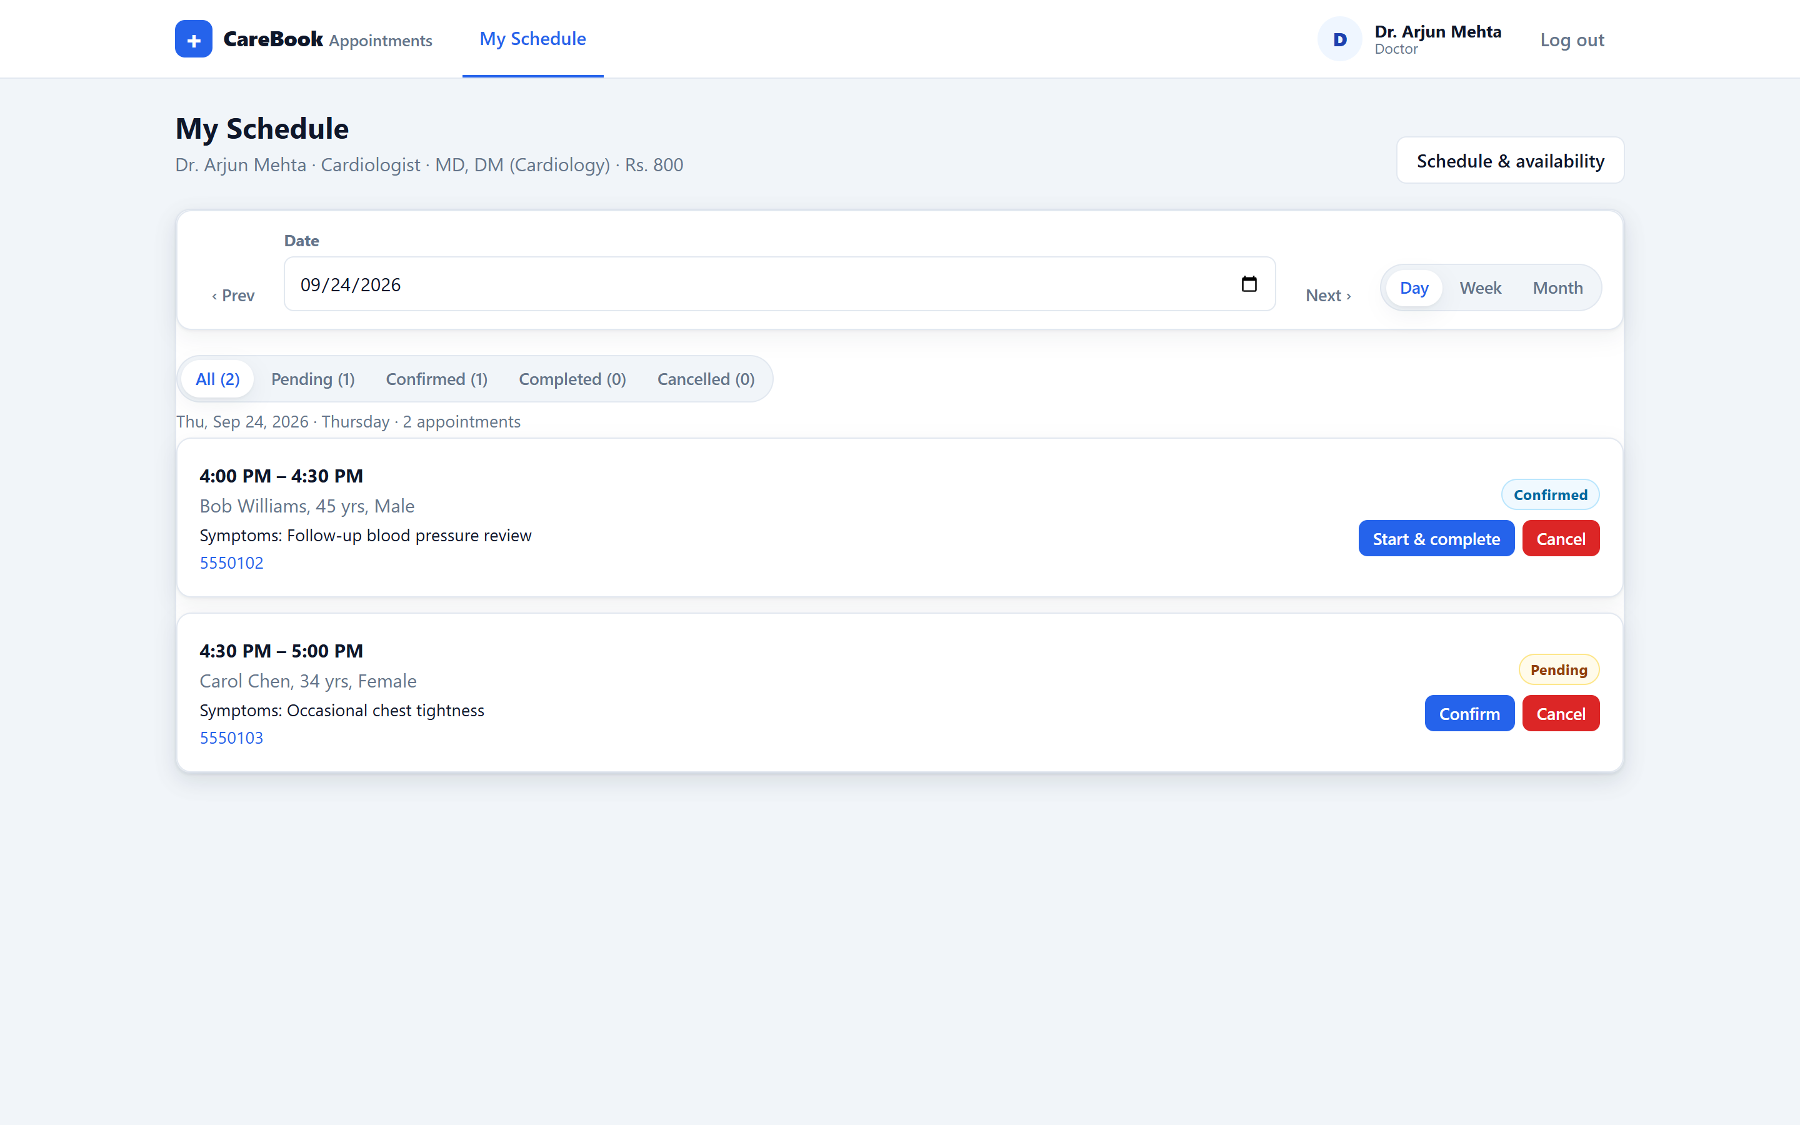
16 admin overview
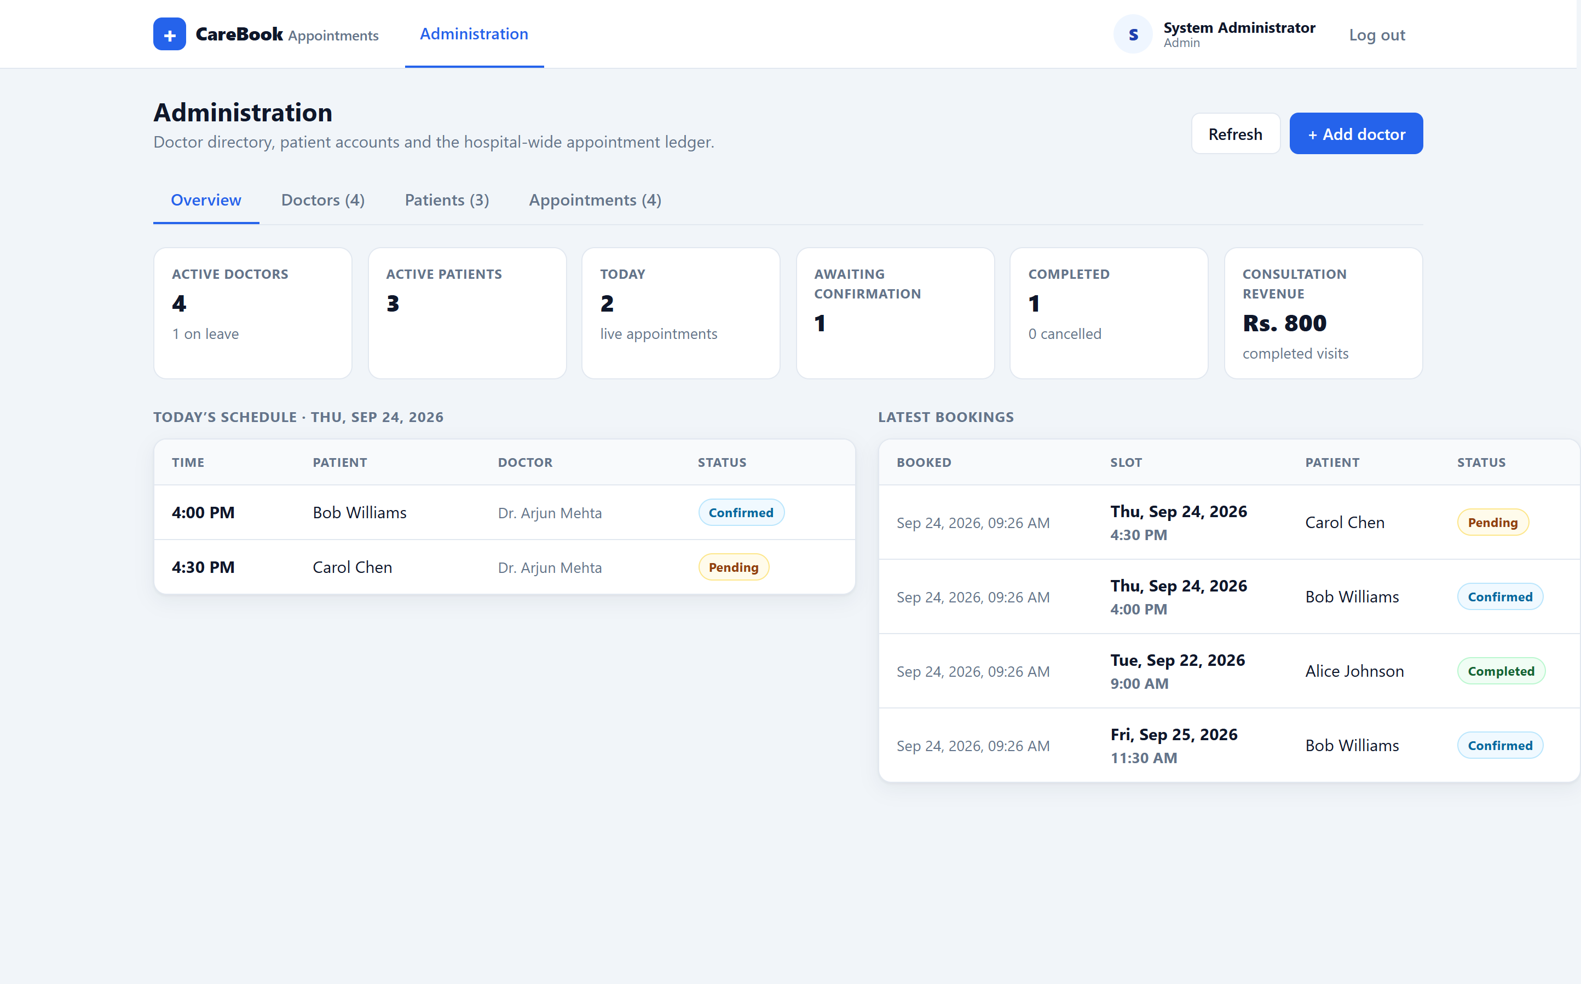
17 admin doctors
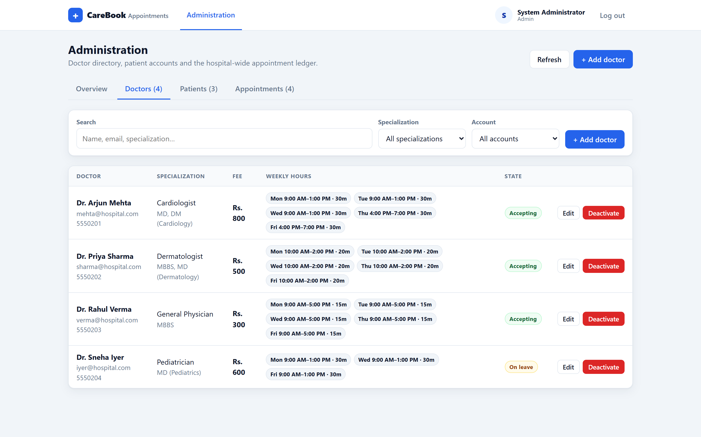
19 admin patients
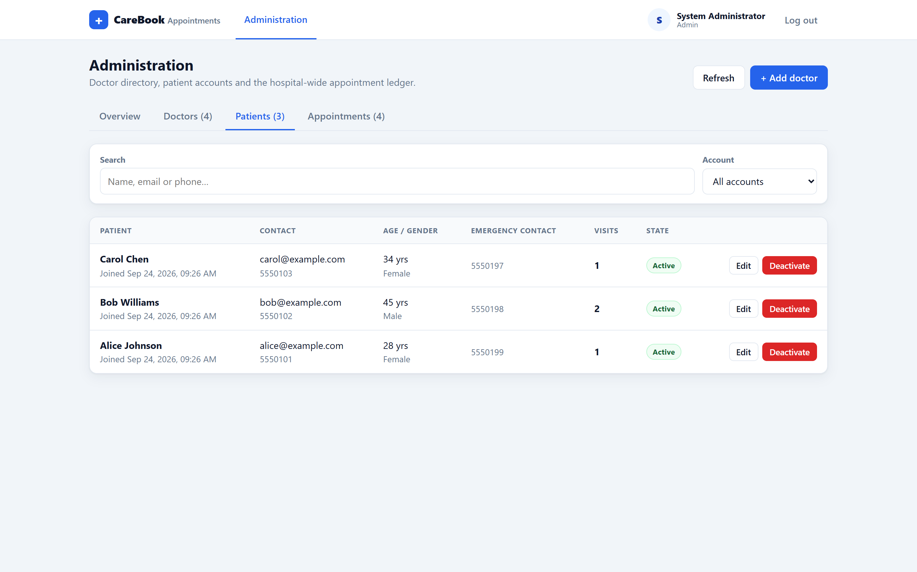
20 admin ledger
