Machine Learning Assignment 1

Q1: What were the most important things you learned from exploring the dataset? Refer to relevant statistics, missing values, distributions, unusual observations and visualizations.
The most important things we learned from exploring the were:
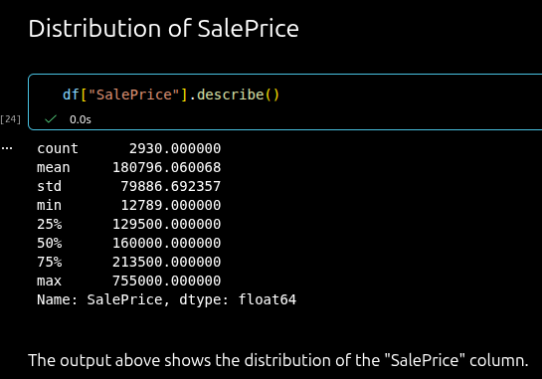
the distribution of SalePrice,
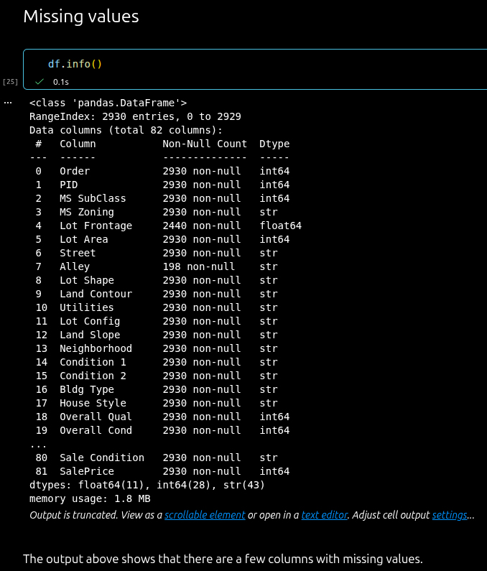
missing values, and
some useful relationships for predicting the house price.

Q2: Which features appeared to be useful for predicting house prices? What evidence led you to this conclusion? Refer to relevant visualizations, descriptive statistics, correlations or your understanding of the variables.
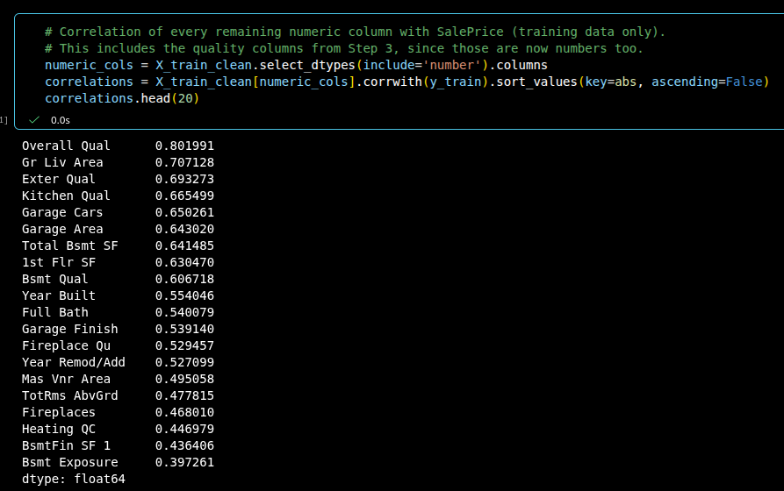
The features that we though appeared useful were picked from this analysis, where we found the correlation with “SalePrice”. The three features with the highest correlation were “Overall Qual”, “Gr Liv Area”, and “Exter Qual”.

Q3: How did you create the training and test sets? Why should the test set be kept separate during model development, and how does this help provide an unbiased evaluation on unseen data?
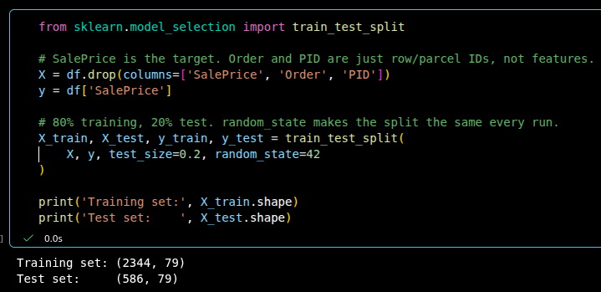
We used the train_test_split method from scikit-learn to create the training and test sets using a 80/20 split, where the majority of the data is in the training set. The test set should be kept separate during model development because it is our only way to check how the models perform on houses they have never seen.

Q4: How did you handle missing values and categorical variables? Explain your main preprocessing decisions, including scaling or transformations if used. Why should preprocessing be learned from the training data and then applied to the test data?
We used the dataset guide to decide what each missing value means:
- The feature is not there (For example no pool, garage or fireplace) we used the category “none”.
- The value was not recorded: numbers were filled with the median from the training data, and categories got the value “Unknown”.
Categories with a natural order, like quality ratings (Po < Fa < TA < Gd < Ex), were turned into numbers from low to high. Other categories, like Neighborhood, were one-hot encoded.
We also:
- Removed columns that were almost all the same value, and Garage Yr Blt
- Removed four very large, unusual houses from the training data
- Scaled the numerical columns
- Used log(SalePrice), because the prices are skewed to the right
Preprocessing is learned from the training data and then applied to the test data, so that no information from the test data leaks into the model. That way the test data works like new, unseen houses, and the test score gives a fair result.

Q5. Which features did you finally use for prediction? Did you remove any features or create new ones? Explain the reasoning behind your main feature-selection or feature-engineering decisions.
We used almost all the columns in the dataset. In total there were 77 features, which became 241 columns after one-hot encoding.
We removed:
- Order And PID, because they are only ID numbers
- Garage Yr Blt, because it is missing when there is no garage and is very similar to Year Built
- Street, Utilities, Condition 2, Pool Area and Pool QC, because almost every house has the same value
We created:
- Total SF: Basement, 1st floor and 2nd floor area added together
- House age: the year sold minus the year built
- Years since remodel: the year sold minus the year of the last remodel
- Total bathrooms: all bathrooms added together, with half baths counting as 0.5
The correlations showed that size, quality and age matter most for the price. Several columns described the size of different parts of the house, so we combined them into Total SF. It has a correlation of 0.81 with SalePrice, which is as strong as Overall Qual, the strongest single column. We kept the original columns as well, because the tree models are not hurt by overlapping features.

Q6. What RMSE and R² values did you obtain for each of the three models on the test data? Present your results clearly in a table.
Which model performed best on the test data?
Model | Test RMSE | Test R²
Linear Regression | 35168 | 0.846
Decision Tree Regression | 39224 | 0.808
Random Forest Regression | 27759 | 0.904

Random Forest performed best on the test data. It had the lowest RMSE, so its predictions were on average about 28,000 off, and the highest R². The Decision Tree performed worst. It fit the training data perfectly (R² = 1.000), which shows that it overfits.

Q7. Based on what you learned from the analysis, what could you change in the preprocessing or features to potentially improve the prediction results without changing to a different model?
A few changes to the preprocessing or features could improve the results:
- Handle unusual sales better. Most of the largest errors were “Partial” sales of unfinished houses. For example, Linear Regression predicted about $900,000 for a very large house that sold for $184,750. We could handle these houses differently, or add a feature that helps the model recognize them.
- Log-transform skewed features. Features like Lot Area and Gr Liv Area have a few very large values. Taking the log of them would stop very large houses from getting extreme predictions, which especially affects Linear Regression.
- Remove overlapping features. We kept both Total SF and the columns it is made from. Keeping fewer features could make Linear Regression more stable.
- Group rare categories. Some categories only have a few houses, which gives the models little to learn from. Grouping them together into an “Other” category could make predictions more reliable.

